**BENARD KIPKIRUI: EDV2/04736/21**

**CAT 2 ASSIGMENT**

**a.**

|  |  |  |  |
| --- | --- | --- | --- |
| **SOURCE CODE** | | **OBJECT CODE** | |
| Source code is written by programmer | It is produced when source code is combined | |
| Source code is in form of plain text | Object code is in form of binaries | |
| Source code is readable by human | Object code is readable by computer | |
| Source code can be easily be modified | Object code is only modified when updated source code is compiled | |

b.

(I) START:

Input “Enter persons age”

Read Age

IF >=18

Display” eligible to vote”

Else

Display “not eligible to vote”

STOP:

(ii)

INPUT AGE

AGE>=18

Display” you are not eligible”

Display eligible to vote

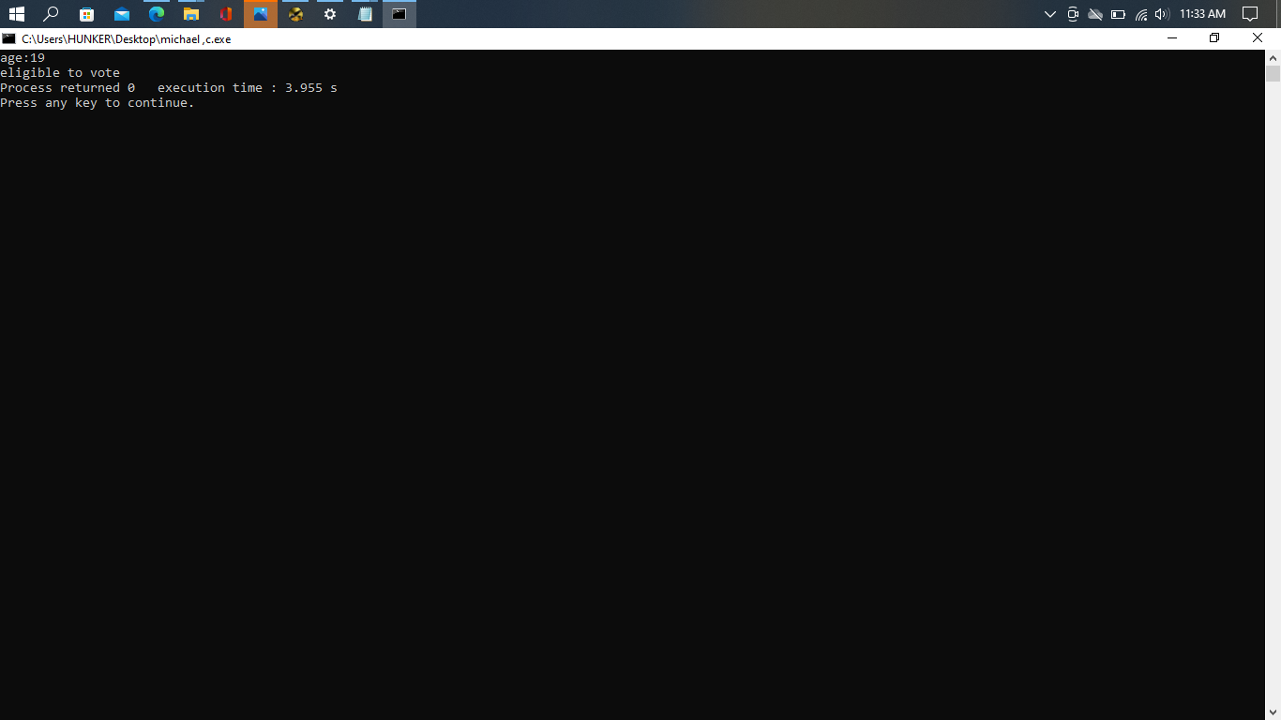(iii)

