

**FACULTY OF PHYSICAL SCIENCE ENGINEERING AND TECHNOLOGY**

**DEPARTMENT OF COMPUTER SCIENCE AND ICT**

**DIPLOMA IN COMPUTER SCIENCE**

**THARAKA UNIVERSITY ONLINE VOTING SYSTEM**

**BY**

**FARHAN KEYNAN YUSSUF**

**EDST1/05161/21**

**NAME OF SUPERVISOR:**

**MR. KEVIN TUEI**

**UNIT CODE: C0SC 0282**

**UNIT NAME: SOFTWARE PROJECT II**

**A project documentation Submitted to the Department of Computer Science and ICT**

**Fulfillment of the Requirement for the Award of the Diploma of Science in**

**Computer science**

**December, 2022**

# DECLARATION

I, **Farhan Keynan** with registration number **EDST1*/05161/21***hereby declare that the work contained in the project report for my DIP. IN CS (Honors) project, entitle:

#### “THARAKA UNIVERSITY ONLINE VOTING SYSTEM”,

Is my own original work and that I have not previously in its entirety or in part submitted it at any university or other higher education institution for the award of a diploma.

Signature: Date:

#### SIGNATURE OF THE SUPERVISOR

I , here with declare that I accept this proposal for my supervision

Signature: Date:

### CERTIFICATION

We, the undersigned, certify that we have read and hereby recommend for acceptance by the Tharaka University, a project report entitled THARAKA UNIVERSITY ONLINE VOTING SYSTEM**,** in fulfillment of a requirement for award of the Diploma of Science in computer science.

…………………………… .………………………..

##### Major Supervisor Date

................................................................ ...........................................................

##### Internal Examiner Date

Accepted for the Board of the Department of Computer Science and ICT

.......................................................................

**DEAN**

# DEDICATION

This project is dedicated to the Almighty God, to my mother, to Al furqan orphanage center, to the department of computer science and ICT in faculty of physical science Technology and Engineering at Tharaka University (TU) and to my fellow students who supported and guided me throughout this course.

### ACKNOWLEDGEMENT

I register my appreciation and acknowledgement to the Almighty God for sustaining me, giving me life, enabling me to finish this work through His strength, My mother (Amina Ibrahim Ali), My sisters (Zeynab Keynan and Habiba Keynan ), My younger brother (Abdullahi Keynan) And My friend (Abdi Hamid Haji) for their moral and spiritual support, Tharaka university for providing me with such a conducive environment under which I could do my work and not forgetting my supervisor Mr. Kevin Tue for the technical support that she has offered unto me throughout the entire process. My Lecturers; Mr. Kevin Tue, Mr. Misheck Murimi, Mr. Gabrel Mutava, Mr. Francis Kairaria , Mr. Kennedy Githaiga, Mr. Jomba, Ms. Eva Njiru , and others . My regards goes to all my classmates for the assistance and guidance that they have offered unto me.

Thanks to the management of Al furqan orphanage center for playing a great role in supporting my studies since I began my primary education. When I said Al furqan I could not skip the names Sheikh Farah,sheikh Abdirashid and sheikh yussuf bahar.

Thanks also to Aden Ibrahim for his support and advice on my studies.

Special thanks goes to, my happiness, Ramlo sheikh Aden for her courage during my study as well as during doing this work, my roommates Siyat Issack, AbdiHafid Nasib, without forgetting family friends Abdi Fatah Bashir, Dr Ali Dahir, Issa Ibrahim, Liban Idris, Nimco Mohamed, Amal Farah, Rahmo Ibrahim, Abdi Fatah Abdirahman and Mr. Ahmed Sambur.

Finally, I apologize for all other unnamed who helped me in various ways to have a good training and please, in the sequence I laid the lines of appreciation does not imply that the first mentioned is the most important than the later ones.

# ABSTRACT

This study deal with a design, build and test online voting system to the Tharaka university electoral commission (TUEC) that will facilitate user (person who votes), candidates (people who are going to stand for the election or contesting for leading position from any course that offered by Tharaka university)

The word “vote” means to choose from a list, to elect or to determine. The main goal of voting (in a scenario involving the citizens of a given country) is to come up with leaders of the people’s choice.

TUEC is not an exception since it has problems when it comes to voting. Some of the problems involved include ridging votes during election, insecure, inadequate polling materials , running expenses , also inexperienced personnel, as well as over votes or under votes compared to the number of registered student to vote and those who votes .

This online voting/polling system seeks to address the above issues. It should be noted that with this system in place the users; students in this case shall be given ample time during the voting period. They shall also be trained on how to vote online before the election time.

The system is secured so that only registered voter may be able to vote and only once, that means no ridging votes, no double votes as well as no over votes or under votes system generates report according to the number of student vote on each candidate and finds the percentage of each candidate.

Table of contents

DECLARATION 2

CERTIFICATION 3

DEDICATION 4

ACKNOWLEDGEMENT 5

ABSTRACT 1

CHAPTER ONE: Introduction and Problem description 4

Background 4

Problem history, Problem statement 5

Research objectives and Questions 6

Research Questions 7

Constraints 7

Significance 7

CHAPTER TWO: Literature Review 8

Topic review/Methodology/Technology 8

E-Government 9

E-Services 9

E-Democracy 10

E-voting 10

Technology 11

Domain review 11

Problem Conclusion and conceptual framework 17

CHAPTER THREE: Requirement Elicitation and System Analysis 18

Introduction 18

Specification of functionalities and service of the system 18

Functional Requirements 21

Non-Functional Requirements 22

CHAPTER FOUR: System Design 25

Introduction to system design 25

System design methodology object; waterfall model 25

Adopted architectural and design orientation 27

DATABASE 28

USER INTERFACE DESIGN SKETCH OF DESIGN 29

The login page 29

The Registration form 29

The voting page 30

CHAPTER FIVE: SYSTEM IMPLEMENTATION 31

Introduction 31

Functionalities and Service implementation 31

Back end and Database implementation 31

VOTER REGISTRATION CODES 32

Front end and user interface implementation 33

Form input and Reports Design 33

System testing and evaluation 33

Shortcomings with the System 33

CHAPTER SIX: CONCLUSIONS AND RECOMMENDATIONS 34

Introduction and summary of achieved results 34

Achievement of research objectives 34

Future work 35

Conclusion and recommendations 35

Recommendations 35

Conclusion 35

REFERENCES 36

# CHAPTER ONE: Introduction and Problem description

### Background

This document describes the initial design strategies and structural properties of the **Tharaka University Online voting system** whichwill be developed based on the software requirement. It explains the data and interface designs of the project with system. Voting is a process at the heart of a democratic society. Voting schemes have evolved from counting hands in early days, to systems that

Include paper, punch card, mechanical lever, and Optical-scan machines. (Chinna V.Gowdar, 2011)

One basic feature of democracy that cuts across all divides of people is the act of election. Democracy thus encourages individual freedom according to the rule of law, so that people may behave and express themselves as they choose. This not only gives people a chance to choose their leaders, but also to freely express their views on issues. In response to the 1948 Universal Declaration of Human Rights which puts import on the necessity of free elections, nations aim at new and improved voting procedures which are of relevance to elections in the 21st century .With the passage of time, voting, which was mainly manual, has been influenced by Information Technology, with debates arising about the relevance or not, of computerized/online voting (G.O. Ofori- Dwumfuo, August 27, 2011)

Indicate that electronic voting is the next logical step in applying online information- gathering and retrieval technologies to e-government. (Smith, 2005)

Developing an online voting system will based on current voting procedures in Tharaka University

Tharaka University currently has four faculties which are faculty of physical science, Engineering and technology (FPET), faculty of life sciences and natural resources management (FLIN), faculty of business (FOB) and faculty of education, humanities and social sciences (FEHS).

Tharaka university Student association (TUSA) made of president and his vice president faculty representative and congress. After every year TUSA do general election to choose leaders of the association in three categories President and his vice, congress and as well faculties representatives. Formerly when elections were made traditionally, organizers determine who is eligible to vote and to be voted (registered student).

TUSA electoral commission (TUEC) announcing the post for president and his vice as well as congress and faculties representative to apply for the posts.

### Problem history, Problem statement

The major problem of this research is publishing election results with either containing over votes or under votes results compared to the number of voters (student) registered and who votes. As the statistics shows that the percentage of polling on the elections day is not satisfactory as majority of students are not coming to vote and they see this is just as wastage of time. The manual voting system takes long time as there is a lot of paper work and human effort is also there for counting of the votes.

Manual voting system have been deployed for many years in Tharaka University student association, however some challenges that are long lines and wastage of time.

With the Online voting system to Tharaka university student association The Elections will be done online such that there is no need to come at the university on the time of elections and the student can vote from the home or from any other place. The implementation of this system will allow the university students to vote at any geographical areas by using the proposed system.

### Research objectives and Questions

**General Objective**

The aim of the study is to analyze the current election system and suggest and develop the online Voting system in such a way that Voter may cast votes in a more convenient way, by using available resources which could facilitate the voters during elections.

**Objectives of the project**

The specific objectives of the project include:-

* + - * Generate and summaries the results of the election
      * Validating the system to ensure that only legible voters are allowed to vote.
      * To solve the problem of publishing election results with over votes or under votes

### Research Questions

In this study we will try to find out the answers of the following question:

* + - * Is automated voting system is a better replacement of current manual system in Elections of Tharaka student association (TUSA)?
      * Why do voters hesitate to cast the vote in current system?
      * Does automated Voting system solve the problem of publishing election results with over votes or under votes?

### Constraints

Time factor was the greatest barrier to the successful completion of this exercise since it had to be done within the semester while having also some other six units needed to be covered.

I also had financial constraints since all the activities involved were self-sponsored.

### Significance

The significance of Tharaka university online voting system to the TUSA includes the following:

* + - * Give Authority and Confidence to Voters: - Election is the most powerful way for student of Tharaka University to have the voice in leadership and direction of the TUSA. When allowed to vote in fair and open election, Student of Tharaka University will feel greeter sense of value, ownership and responsibility. This is why it is important to reach as many Students as possible with different election methods – including online voting.
      * Accessibility – Tharaka university network, online voting is a convenient option for many Students, allowing them to access ballots anytime, anywhere.
      * Cost effectiveness – Online elections are cost effective, especially when considering production costs of printing, postage, and mailing ballots.
      * Feeling secure and intended be kept secret – The design Online Voting system has safeguard in place to assure security of ballots and protection of voter identities.
      * Transparency – Online elections, particularly those run by a third-party, eliminate the chance of election mismanagement or fraud. An audible trail helps increase voter confidence.
      * Accuracy and expedience – Since online voting utilizes electronic ballots, there are no rejected, mismarked, or invalid votes. Results are automatically calculated, eliminating the need for manual tabulation or dread the records

# CHAPTER TWO: Literature Review

### Topic review/Methodology/Technology

This chapter views various theoretical and empirical studies on the Online Voting system, to see the results obtained by other researchers and working papers published to give more insights on various phenomena crucial for understanding, especially for this study.

##### Topic Review

Internet was invented by the department of defense of United States of America in 1960s as a communication Network for defense research purposes, no one could have foreseen how it

would transform society three decades later .Today, the internet has become a part of the daily life of many people around the world. Computer scientists who have done work in, or are interested in, electronic voting all seem to agree on two things: Internet voting does not meet the requirements for public elections and currently widely-deployed voting systems need improvement (Evers, 2004)

They advocate using the Online Voting system since it reduces cases of uncounted, unmarked, and spoiled ballots and the cost of travelling to cite polling stations. Kenyans’ are expected to vote in Los Angeles New Delhi, Beijing, London and New York. Their report even proposes a framework for a new voting system with a decentralized, modular design.

Other researchers have done work in electronic voting; while they may not explicitly mention voting from remote poll sites, their work is nonetheless relevant to any effort at designing or implementing a remote poll site voting system. (Garfunkel, 2005) acknowledges the problems inherent in each kind of voting apparatus, but doesn't make an overt recommendation on her site for one technology over the rest. Some other academicians like *(Peter Neumann, 1993)* focus on the immensity of the problem one faces when trying to design and implement a truly secure voting system. They often remind us *of (Ken Thompson's, 2002)*.

Turing acceptance speech and the fact that we really can't trust any code which we did not create ourselves. Neumann gives a list of suggestions for "generic voting criteria" which suggests that a voting system should be so hard to tamper with and so resistant to failure that no commercial system is likely to ever meet the requirements, and developing a suitable custom system would be extremely difficult and prohibitively expensive.

A voting machine must produce human-readable hardcopy paper results, which can be verified by the voter before the vote is cast, and manually recounted later if necessary (V.R.Udupi, 2013).

### E-Government

E-government applies concepts of electronic commerce (e.g. information and marketing through Web sites, selling to customers on-line) to government operations’-Government is simply defined as the use of ICT to improve the process of government. In a narrow sense it is sometime define as citizens’ services, re-engineering with the technology, or procurement over the Internet. (Komba, 2012)

### E-Services

The use of electronic delivery for government information, programs, strategies and services can named as e-services. These are available on-line “24h/7days”. It also refers to Electronic Service Delivery (ESD) and such expression as ‘one-stop service centers”. The latter describes situation in which citizen needs are met through a single contact with the government. In many cases it assumes a modernized front office but not necessarily redesigned back office capacity. At the same time, e-services emphasize innovative forms of citizen involvement and offer services that demonstrate serious valuation of citizens as customer of administration. The strategic challenge is to deliver services to members of public along with dimensions such as quality, convenience and cost (Voogd, 2007)

### E-Democracy

This is the most difficult to generate and sustain feature of e-Governance. In framework of E- democracy ICT is used as an instrument to help set agendas, establish priorities, make important policies and participate in their implementation in a deliberative way. It refers to activities that increase citizen involvement including virtual town meeting, open meeting, cyber campaigns, feedback polls, public surveys and community forums *(such as through e-consultation, e-voting)*. In short, if e-government is successfully implemented new empowered citizens may emerge. They are able to form the Internet biased alliance to respond to various issues and achieve economic and social objectives (Khalil, 2002)

### E-voting

E-voting combines technology with the democratic process, in order to make voting more Efficient and convenient for voters. E-voting (or electronic voting) allows voters to either vote by computer from their homes or at the polling station

**Online voting at the polling booth**

This is form of online voting that virtually the same as regular voting but replaces the ballot paper with ballot machine or computer. These machine or computer are connected to private and server when the voting proceed and close after election done

**Online voting**

This is the form of voting which allow voters to cast their votes from anywhere in internet access. The Internet is viewed as a platform and delivery medium for tools that help to eliminate some of the distance constraints in direct democracy. Technical media for e- democracy can be expected to extend to mobile technologies such as phones

### Technology

INTERNET

Internet originate day back nearly 40 years back, with the U.S. Military’s funding of a research network dubbed Arpanet in 1969 From then the internet has undergone more than just a name changes. The number of computer connected has increase together with the user number has risen. The network reach has expanded beyond United States to every corner of the universe.

A worldwide system of linked computers that allows users to send and receive e-mail and documents from one computer to another (P.K. Kannan, 2001)

### Domain review

A voting system, whether using paper, electronic recording or networks such as the Internet, needs thus to satisfy various requirements

**Fail-safe voter privacy -** Definition: “Voter privacy is the inability to link a voter to a vote.”

Voter privacy MUST be fail-safe that means it MUST be assured even if everything fails,

Everyone colludes and there is a court order to reveal all election data. Voter privacy MUST be preserved even after the election ends, for a time long enough to preserve backward and forward

**Election integrity -** (e.g., to prevent future coercion due to a past vote, which possibility might be used to influence a vote before it is cast).

**Collusion-free vote secrecy** - definition: “Vote secrecy is the inability to know what the vote is.” Vote secrecy MUST be assured even if all ballots and decryption keys are made known by collusion, attacks or faults (i.e., vote secrecy MUST NOT depends only on communication protocol and cryptographic assumptions or on a threshold of collusion for the key holders).

**Verifiable election integrity-**: “Election Integrity is the inability of any number of parties to influence the outcome of an election except by properly voting.” The system MUST provide for verifiability of election integrity for all votes cast. For any voter the system MUST also provide for direct verifiability that there is one and only one valid ballot cast by the voter at the ballot box.

**Fail-safe privacy in verification-**If all encrypted ballots are verified, even with court order and/or with very large computational resources, the voter’s name for each ballot MUST NOT be revealed.

**Physical recounting and auditing *-*** MUST provide for reliability in auditing and vote recounting, with an error rate as low as desired or, less strictly, with an error rate comparable or better than conventional voting systems *(http://* [*www.mcg.org.br/coherence.txt).*](http://www.mcg.org.br/coherence.txt))The auditing and vote proofs MUST be capable of being physically stored, recalled and compared off-line and in real-time during the election, without compromising election integrity or voter privacy, and allowing effective human verification as defined by election rules.

**100% Accuracy-**Every vote or absence of vote (blank vote) MUST be correctly counted, with zero error [*(http://w*](http://www.mcg.org.br/coherence.txt))*w*[*w.mcg.org.br/coherence.txt)*](http://www.mcg.org.br/coherence.txt))

**Represent blank votes-** MUST allow voters to change choices from ‘vote’ to ‘blank vote’ and

Vice-versa at will, for any race and number of times, before casting the ballot.

**Prevent over votes*-***As defined by election rules. MUST provide automatic “radio button” action for single-vote races. If over voting is detected in multiple-vote races, MUST warn the voter that a vote has to be cleared if changing choices is desired. This warning MUST be made known only to the voter, without public disclosure.

**Provide for null ballots*-*** As defined by election rules, MAY allow voters to null races or even the entire ballot as an option (e.g., to counter coercion; to protest against lack of voting options). Over voting, otherwise prevented by Requirement #8, MAY be used as a mechanism to provide for null ballots.

**Allow under votes-**As defined by election rules, the voter may receive a warning of under voting. However, such a warning MUST NOT be public and MUST NOT prevent under voting.

**Authenticated ballot styles*­­-***The ballot style and ballot rotation to be used by each voter MUST be authenticated and MUST be provided without any other control structure but that given by the voter authentication process itself.

**Manifold of links-**MUST use a manifold of redundant links *and* keys to securely define, authenticate and control ballots. Must avoid single points of failure even if improbable, if networks are used, MUST forestall Denial-of-Service (DOS) and other attacks with an error rate comparable or better than conventional voting systems

**Off-line secure control structure-**Must provide for an off-line secure end-to-end control structure for ballots. May use digital certificates under a single authority; Ballot control MUST be data-independent, representation independent and language-independent.

**Technology independent-**Must allow ballots and their control to be used off-line and/or in dial- up and/or in networks such as the Internet, with standard PCs or hand-held devices used to implement their components in hardware or in software, alone or in combination for each part.

**Authenticated user-defined presentation -** Must enable the ballots to dynamically support multiple languages, font sizes and layouts, so that voters could choose the language and display format they would be most comfortable with when voting as allowed by law and required by Voters with disabilities, without any compromise or change to the overall system, from an authenticated list of choices defined by election rules.

**Open review, open code -** Allow all source code to be publicly known and verified (open source code, open peer review). The availability and security of the system must not rely on keeping its code or rules secret (which cannot be guaranteed), or in limiting access to only a few people (who may collude or commit a confidence breach voluntarily or involuntarily), or in preventing an attacker from observing any number of ballots and protocol messages (which cannot be guaranteed). The system SHOULD have zero knowledge properties (i.e., observation of system messages do not reveal any information about the system). Only keys MUST be considered secret.

##### Examples of E-voting implemented internationally

Electronic voting has been a hot issue for many states worldwide and lately some of these states implemented this as a replacement to their conventional electoral systems in practice.

##### 

##### Brazil

Brazil is a world leader in electronic elections, having conducted them since 1990. The elections in October 1998, was one of the largest electronic elections in history, with over sixty million voters casting ballots by computer for local and national candidates. 57 percent of the voting population voted electronically in elections for local, state and 30 national offices. In accordance with Brazilian law, an initial election involving all candidates was held in October, and a run-off election between the top two vote-getters for each office was held in November. When the results were tabulated, Brazil had elected its President, 27 Senators, 27 Governors, and over 2000 State and local officials (Zafar, 2007)

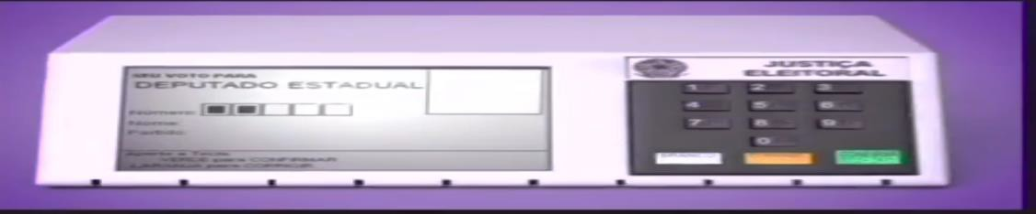

**Figure 1 Online voting system in Brazil**

##### Australia

The ACT's electronic voting system, which was first used at the October 2001 election and was again used in the October 2004 election, is the first of its kind to be used for parliamentary elections in Australia. The system uses standard personal computers as voting terminals, with voters using a barcode to authenticate their votes. Voting terminals are linked to a server in each polling location using a secure local area network. No votes are taken or transmitted over a public network like the Internet. The voting system is used in the pre-poll voting centers, which are open for 3 weeks before polling day, and in a limited number of polling places on polling day. In polling 31 places that do not have electronic voting, voters still use traditional paper ballots. In electronic polling places, voters are given a choice of voting electronically or on paper. Electronic counting, which combines the counting of electronic votes and paper ballots,

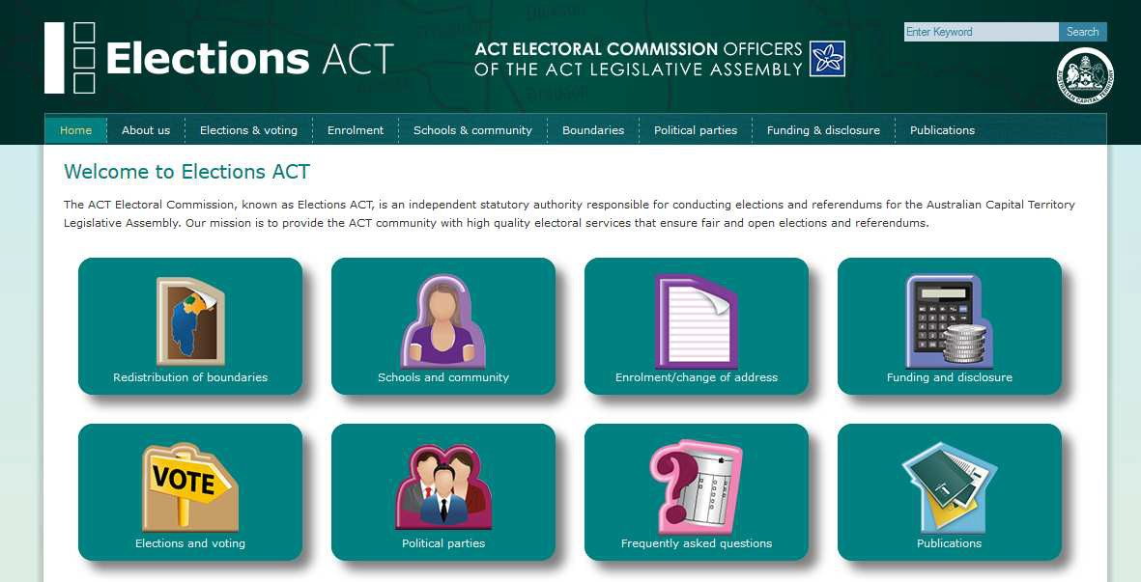Was first used in the ACT at the October 2001 election and was again used in the October 2004 election. Preferences shown on paper ballots are data-entered by two independent operators, electronically checked for errors, and manually corrected if required. This data is then combined with the results of the electronic voting, and the computer program distributes preferences under the ACT’s Hare-Clark electoral system. The software for the electronic voting and counting system was built using Linux open source software, which was chosen specifically for this electoral system to ensure that election software is open and transparent and could be made available to stakeholders, candidates and other participants in the electoral process.

**Figure 2 Online voting system in Australia**

##### New Zealand

Most developments are in providing electronic voting facilities in polling places particularly replacing paper ballots in jurisdictions with complicated ballots and multiple languages for example in Belgium, the Netherlands, and the United States. There are also some ambitious remote e-voting trials taking place over the next year which was monitored closely. In particular, registered overseas New Zealand voters voted online at the parliamentary election in the Netherlands in November 2006

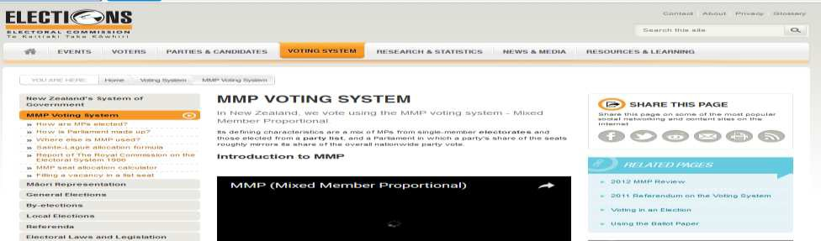

**Figure 3 Online Voting System in New Zealand**

Voting equipment’s which were widely adopted in many countries may **be divided into five types**

* **Direct recording electronic voting machine**: This type, which is abbreviated to DRE, integrates with keyboard; touch screen, or buttons for the voter press to poll. Some of them lay in voting records and counting the votes is very quickly. But the other DRE without keep voting records are doubted about its accuracy.
* **Lever voting machine**: Lever machine is peculiar equipment, and each lever is assigned for a corresponding candidate. The voter pulls the lever to poll for his favorite candidate. This kind of voting machine can count up the ballots automatically. Because its interface is not user-friendly enough, giving some training to voters is necessary.
* **Paper-based voting**: The voter gets a blank ballot and use a pen or a marker to indicate he want to vote for which candidate. Hand-counted ballots is a time and labor consuming process, but it is easy to manufacture paper ballots and the ballots can be retained for verifying, this type is still the most common way to vote.
* **Punch card**: The voter uses metallic hole-punch to punch a hole on the blank ballot. It can count votes automatically, but if the voter’s perforation is incomplete, the result is probably determined wrongfully.

### Problem Conclusion and conceptual framework

Voting is the most powerful way for citizen to have a voice in leadership and the direction of their nation or organization, When they allowed to vote in free , fair and open election, citizen will feel greeter sense of value ,ownership and responsibility. This is why it is important to reach as many members as possible with different election methods including online voting.

With the surge of mobile devices, online voting is a convenient option for many members, allowing them to access ballots anytime, anywhere.

A properly designed online voting system has safeguards in place to assure security of ballots and protection of voter identities.

Online elections, particularly those run by a third-party, eliminate the chance of election mismanagement or fraud. An audible trail helps increase voter confidence.

Since online voting utilizes electronic ballots, there are no rejected, mismarked, or invalid votes. Results are automatically calculated, eliminating the need for manual tabulation or dreaded recounts.

On my design I will include the Online campaign, voters can be able to ask questions to the contestants and get answer from them during the election campaign, system also limit the time of starting and closing the voting day so that no vote can be cast before the voting time as well as after the voting closed and the system allow the candidate to apply for the post of any position if and only if he/she met the TUSA qualification according the constitution

The system will differ in from the other formers system because no physical travel to find polling station then Voters cast their votes from any geographical area by using internet.

# CHAPTER THREE: Requirement Elicitation and System Analysis

### Introduction

In this chapter, the source of data methods of collection, the evaluation of the existing system and the organization structure of the system problem are presented. It includes specific methods which were used in order to achieve the objectives of the project, particular requirements for implementation of the project and a brief explanation of why such methods were used for implementing the proposed system, also included is a brief description of the current system of voting.

##### Requirement elicitation

When carrying out the Analysis of an Online Voting system, the initial step is to find out how the current system works. This help to get better understand of the problem that existed and whether they can be fixed with the proposed system or the existing system can be upgraded and modified.

The advent of information society enabled people to perform their activities in direct, electronically automated and efficient way. This means system analysis is the process of investigating a system, identifying and using the information to recommended improvement to system analysis is supposed to define how the system will be implemented. Information system developers approach of electronic Voting with identification of fundamental problem associated with adequate level of security (anonymity, authentication, data security as well as tractability) The security issue is most taken attention since majority of literature concentrate on ability of electronic voting system to handle them This distinction is apparent since requirements are identified as legal, technical and user oriented (Gennaro, 1997)

### Specification of functionalities and service of the system

##### Requirement Specification

The process of requirements specification for a software product since it plays a great role toward the acceptability and effectiveness of the developed software .Requirements engineering and analysis is difficult task especially the large projects. The scope of the system may also be misunderstood that may lead to assumption of key components of the system that would later call for reengineering the system which is costly in terms of financial resources labor and time.

The challenges encountered in requirements engineering inspired some revile and sawyer to suggest a set of detailed guidelines for requirements elicitation for doing the following

* + - * Assessing the business and technical feasibility for the proposed system
      * Identify the people who will help to specify requirements and understand their organization
      * Define the technical environment into the system or product to be developed
      * Accost the participation from all stakeholders
      * Understand the ambiguous requirements as candidate for prototyping
      * Develop the usage scenarios to help the users better identify key requirements

The main purpose of this project is to allow the student (user/voters) to vote for the leader through web application

##### Overview of System requirements and Description of information

The information required to system includes the following:-

* + - * The voter identification ;- all information voter username, student email ,security password
      * The candidate information :- voters ID, course ,faculty ,year of study and candidate photo
      * Voting day details voter details, candidate of choice ,time casted

##### Users of the Information

* User identification Username and Voter security password
* Voter’s choice candidates necessary for voting process

##### 

##### User objectives

The following are the some important that user would like to see from the system

* Convenient Vote casting through internet
* Secured voting system

##### User Access Restrictions

Admin will access the details of the voters who have registered to vote via Interne

##### Data collection

##### INTERVIEW

Structured and unstructured interviews have been conducted between the researcher and other stakeholders such as students the TUSA management as to solicit information, ideas, views, and opinions about exactly the kind of the system that may be favored to the Association. Through this method data are collected directly from the user, from the method service of functionality are defined

#### DOCUMENTARY SOURCES

Made some review from different articles and reports concerning the Online Voting system in case of getting the secondary data so that the system developed met the objective and provide the same expectation

### Functional Requirements

The function requirements of the system describe the functionality or service that system is expected to provide

* To vote through internet
* The system provide the appropriate error messages and users shall accorded sufficient help on how to carry on task
* Provide the information of open the voting time and close the voting
* Limit the voter to vote more than one candidate and limit the Voters to cast vote only ones
* Authentication and verification of users:- system should identify each authorized voters every time they use the system using student username
* Make vote counting convenient

### Non-Functional Requirements

The plan for implementing non- functional requirements is details in the system architecture. Non- functional requirements define how a system is supposed to be. Some of the expectation of the system when implemented as follows

##### Reliability

* + The online voting system shall be enough to have high degree of fault tolerance for example if there is an invalid entry, system should not crash and shall identify the invalid input and produce a suitable error massage
  + The Online voting system shall be able to recover from hardware failure
  + The Online voting system shall impose a successful voter determination strategy in order to determine a successful votes to avoid multi voting
  + The Online Voting system should available during the voting hours of the voting day

##### Security

The application need to be secured enough and should enable users to access it depending to the level user rank, either as administrator, student (voters) candidates. The election system must be sufficiently to withstand Variety of fraudulent behaviors and must be sufficiently transparent and comprehensible that voter and candidates can accept the results of an election

##### Performance

* + The voting process should be less than 10 seconds most the time, the response time refer to the time that user should waiting for getting a respond from the system after querying
  + Online voting system should show visible deterioration

##### Integrity

Administrator should be authenticated before having the access to system

##### Scalability

The system should be able to expand to meet future needs of the organization and still be able to serve the purpose for which it was built

**f) Usability**

* + Users should be able to understand the menu and options provided by the system
  + The system should provide an easy to use interface so that the users don’t strain to interact with the system

##### g) Availability and accessibility

The system should be able to running whenever needed

##### h) Interoperability

The system should be able to work with other existing system. I should ensure backward and forward compatibility

##### i) Political and Legal Requirement

* + The system should not be used to impersonate any candidates and should not show any favor among candidates.
* The system will not allow any activities which is against Tharaka university students by- laws and those rule which guide the Election process

##### k) Other constraints

* + To prevent data loss in case of system failure, the result of votes that are polled till then have to be saved in database.
  + In case TUSA election commission detects any security problem in the system, he should be able to shut down the system and prevent all connection to the server immediately to preserve already polled votes.
  + The system will be able to recover itself from previous crashes and continue the voting process.

# CHAPTER FOUR: System Design

### Introduction to system design

The design of a system is essentially a blueprint or a plan for a solution for the system. A design methodology is a systematic approach to creating a design approach; a system is viewed as a transformation function, transforming the inputs to the desired outputs. High level design identifying the system processes, functional components and their interfaces

Online voting is a form of voting in which the individuals are able to cast their votes through a web pages. Through the use of online voting, the voter navigates to the designated election site using a web browser on an ordinary PC. The students are permitted to select their selected candidates, and then cast the votes which would then be sent to the database server for processing.

**USER CASE DIAGRAM**

Admin

User

### System design methodology object; waterfall model

Software development Life cycle (SDLC) is a process followed for a software project, within a software organization. It consists of a detailed plan describing how to develop, maintain, replace and alter or enhance specific software. The life cycle defines a methodology for improving the quality of software and the overall development process

The Waterfall Model was first Process Model to be introduced. It is also referred to as a linear - sequential life cycle model. It is very simple to understand and use. In a waterfall model, each phase must be completed before the next phase can begin and there is no overlapping in the phases

Waterfall approach was first SDLC Model to be used widely in Software Engineering to ensure success of the project. In "The Waterfall" approach, the whole process of software development is divided into separate phases. In Waterfall model, typically, the outcome of one phase acts as the input for the next phase sequentially.

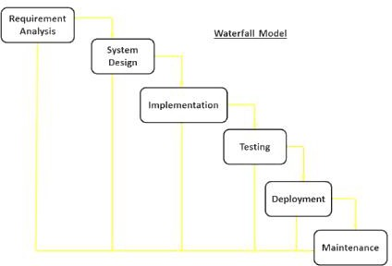

**Figure 5 Waterfall Model**

The process of problem discovery, Situation assessment and Planning for the solution, I designed to improve the chances of the solution success by define the risk and challenges present in early stages of the implementation process. Solution Envisioning embraces a business botany approach to designing.

##### Solution Capability envisioning

Data flow diagram show the whole process ,which include Admin register voters and candidates to the TUSA then voter and candidate login ready to vote for the president of his/her choice the waiting for the results

Administrator of the system carries all task of register and validates the right voter before registered to the system for TUSA. All student and candidate should provide their student Identification card that show his detail and picture to prove its illegibility the figure below show how data flow to the system component

### Adopted architectural and design orientation

The architecture of a computer system is the high-level (most general) design on which the system is based this architectural features include components, collaborations and connectors Common architectural patterns include Client-Server, Layered, Peer-to-peer, Pipes and Filters and others. Typically, when you are browsing the Internet, you will be using web browser software such as Internet Explorer, Mozilla Firefox or chrome. The computer which is running a browser is called a client, whilst the machine which is providing Web pages is called a server. For my case the system archliberal used is three -tier architecture. Generally computing applications consist of three different and distinct types of functionalities.

* **Presentation Services**: These manifest themselves in the form of information display and user data input facilities. Generally the front-end for user interaction. For example logging in requires interaction in the form of collecting username and password information using a HTML-form.
* **Functional logic**: Every application includes some data processing and this may also involve database interactivity. For example user authentication requires the logic unit to read username-password combinations from a database and compare until a good comparison (hopefully) is arrived at.

**DATA BASE**

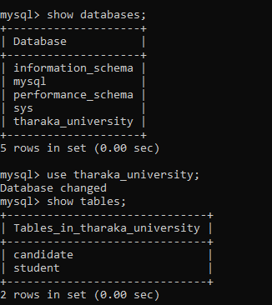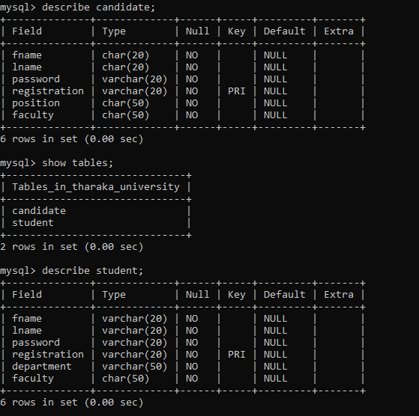

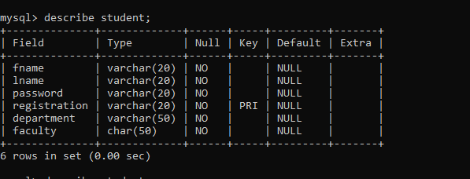

### 

### USER INTERFACE DESIGN SKETCH OF DESIGN

### The login page



This is where a new user/voter starts; the individual is required to provide registration number and password. When this is provided the system validates the user if the entered information tallies with what is in the database. He/she is then logged in otherwise the voter/user isn’t logged in

### The Registration form

### 

### 

### The voting page

### 

### 

### 

### 

### 

### CHAPTER FIVE: SYSTEM IMPLEMENTATION

### Introduction

This chapter gives an overview of the implementation and explains how users can navigate through the system and how to use the system.

### Functionalities and Service implementation

The system was implemented as a web-based online voting and modification solution using MYSQL server, PHP server site , Microsoft Edge as the main browser and accessible on the World Wide Web; other web browsers such as Internet explorer and Opera are also applicable. The implementation and deployment was made successfully using three -tier architecture. Web security and accessibility to the system is ensured. the system offer the following services register voters, internet voting, computation of casted votes.

# Back end and Database implementation

On the back end the system was developed by PHP, Java script and CSS programming language by using the visual studio text software and the database was developed by SQL language using the MYSQL DBMS withWampserver64 which contain PHP version 5.0.2, Apache version 2.4.46 and MYSQL version 5.7.31and HTML5

### VOTER REGISTRATION CODES

This is part of the PHP and HTML codes for registering the student registration.php

<?php

$vote = $_POST['vote'];

//connect to database

$con = mysqli_connect('localhost:3307', 'username', '', 'tharaka_university');

$sql = "UPDATE candidates SET votes = votes + 1 WHERE id = $vote";

$result = mysqli_query($con, $sql);

$sql = "SELECT * FROM candidates";

$result = mysqli_query($con, $sql);

$candidates = array();

while($row = mysqli_fetch_assoc($result)) {

    $candidates[] = $row;

}

mysqli_close($con);

?>

<html>

<head>

<title>Result Page</title>

</head>

<body>

<?php foreach($candidates as $candidate): ?>

<p>

<?php echo $candidate['name']; ?><br>

<img src="<?php echo $candidate['photo']; ?>"><br>

<?php echo $candidate['votes']; ?> votes

</p>

<?php endforeach; ?>

</body>

</html>

### 

### Front end and user interface implementation

### Form input and Reports Design

The system was developed as an interactive mechanism between the user at the interface and the database using the web-browser. This tool enables a user through a web browser to interact with the MYSQL database to enter, edit, view and retrieve such data as per the privileges granted. These activities were achieved using Java servlets. HTML forms offer the best layout to enter data, change and view the database. These forms were also kept as short and simple as possible for easy public awareness on the use of the tool, some of the forms and report interfaces created include the following:

# System testing and evaluation

Traditional software testing procedures were used for the web-based TUOVS where testing took place throughout the development process.

Since the system hosted locally and then tested through the following computer with the following specification

Desktop or laptop with at least 2.0 GHz Processor speed, At least 40 GB Hard Disk Capacity and 512 RAM running window 7/8/10,linux,Ubuntu and mac ox with the following web browser Google Chrome,Operamin, Mozilla Firefox, safari, baidu and through mobile browsers.

# Shortcomings with the System

The System implemented is hindered by the following factors:

• There are limited finance resources to fully implement the system.

• There is resistance from; commissioners who believe their work will all be done by the tool,

And voters who do not believe it is a secure way to go about with voting online.

• In case one stolen the user credential that allow his vote to be cast there is no chance of the original owner of the account can vote again because system will count that I already voted and vote cannot casted twice

### CHAPTER SIX: CONCLUSIONS AND RECOMMENDATIONS

### Introduction and summary of achieved results

The system is developed using PHP, html and Java script codes to meet its functional requirements. User’s data are stored in tables within the system database .The user interface proposed system is user friendly that will allow user to have effective and excellent interaction with the system. The buttons and language used in designing and implanting the system bring interactivity and understanding to a user on how to access the system effectively and efficiently. The main aspect behind the TUOVS is that enabled to bring the new ideas that were sustained within many days .The project offers the voters to cast easily through internet. Vote counting is also made so easy by using the system since it is just matter of querying the database. The architecture of the system and data representation is stated through the document. Furthermore the design of the system is prepared better approach for the Tharaka universities student organization.

### Achievement of research objectives

The research objectives that were required to mate are

• Implementing a an automated voting system

• Generate and summaries the results of the election

• Print the report (election results)

• To solve the problem of publishing election results with over votes or under votes

### Future work

This study will improve the former work that suggest to implement from the former researcher online campaign, online candidate application as well as Time limit for opening and closing voting day then other researcher may improve the this work and deploy the project in more mobile form such may come with the android version and iOS version so that can more accessible in all platform of internet devices

### Conclusion and recommendations

### Recommendations

My view in t online voting represents an opportunity to modernize and enhance the operation of local democracy in Tharaka University as my study case. I just asking myself if people can bank online then why we may not vote online. Online banking has checks and balances, visibility, liability, and recourse. If an unauthorized banking transaction occurs, you can see it in your statement. The bank is responsible for losses, and has the ability to reverse an erroneous transaction. And, above all, you and your bank both know that the transaction was on your account, and where to return the money! With voting, your votes might be incorrectly tallied, but that’s not visible to you. Your local election authority should not be able to tell which ballot is yours. And once your ballot is incorrectly tallied and the election results are finalized, there is no way to reverse or redo that tallying. Cryptographic voting methods can help with visibility by providing a Web site where voters can go after the election to verify that their votes were included in the total. Then I recommend TUSA to use the online voting because it offer Accessibility, Cost effectiveness,

Transparency, Give Authority and Confidence to Voters and Feeling secure and intended be kept secret.

### Conclusion

People always want to find the way to make their life easy and comfortable. Currently, we depend on the web pages much for everything such as- searching; purchase desire goods etc. as there are many web applications depend on various requirements. Today’s web applications are rich internet applications and developers are much concerned about applications security issues while they are developing their products. A user friendly system becomes popular rapidly and thus benefits both the system developer and its users

### 

### REFERENCES

Chinna V.Gowdar, A. R. (2011). Convient Voting Machine.

Evers, J. (2004). Experts Challenge US Online Voting.

Evers, J. (2004). Experts Challenge US Online Voting, <http://www.infoworld>.

G.O. Ofori-Dwumfuo, E. P. (August 27, 2011). The Design of an Electronic Voting System.

Garfinkel, L. F. (2005). Designing Secure Systems That People Can Us, 714.

Gennaro, R. C. (1997). A Secure and Optimally Efficient Multi-Authority Election Scheme.

Khalil, M. A. (2002). E-government handbook for developing nations a visory.

Komba, M. M. (2012). FACTORS INFLUENCING ACCESS TO ELECTRONIC GOVERNMENT INFORMATION AND E-GOVERNMENT ADOPTION IN SELECTED DISTRICTS OF TANZANIA . UNIVERSITY OF SOUTH AFRICA.

Libertà, P. M. (2002). An Overview of E-Government.

P.K. Kannan, P. K. (2001). Dynamic Pricing on the Internet: Importance and Implications for Consumer Behavio.

Smith, A. a. (2005). Revolutionizing the voting process through online strategies. The constitution of mzumbe university students organization . (2014). The constitution of mzumbe university students organization .

V.R.Udupi, J. M. (2013). Online Polling System Based on Visual Cryptography.

Voogd, M. (2007). A manual for delivering E-services as a local government in the digital information society.