THARAKA UNIVERSITY

PROJECT TITLE: **ONLINE RENTAL MANAGEMENT SYSTEM**

NAME: ISAIAH KIPKOECH

REG NO: EDV2/04741/21

PREPARED FOR; MARK KAMANJA

PREPARED BY; ISAIAH KIPKOECH

DECLARATION

I hereby declare that the online rental house management system was done by Isaiah supervised by MR mark presented to the faculty of physical science and engineering technology.

DEDICATION

I would like to dedicate my project to my dear parents Mr. & Mrs. TOWETT, and my siblings Jane, Millicent

And Dylan

ACKNOLEGEMENT

At this time, I would like to thank my lecture MR. mark for supervising the whole project that I created with this effort am creatfull to the teacher.

ABSTRACT

This paper present design and implementation of online rental management system. The system deal with online rental between the renter and the tenant. with the current perception shift, in the technological field there is a vital necessity to involve and value the power of technology. the segment remains wary to the face that facilitate easy management of the rental houses there is need to develop an online rental management system that simplify work for the users all their work like searching for rental and house owners property deals can be efficient and effective .To get information about how the process for people who are searching the house for rent and how the owner and how owners of rental manage currently, prepared a questionaries and due to the visit to my school there was difficulty in finding a house thus was difficulty in finding a house thus I decide to come up with the project though it has been done before with this it can be linked up with the school system so that students will not have difficulty in finding a house. This is done online way where by tenant log in to the account by signing up the log in and rent the house and receive application. The system will help students from THARAKA university to locate the house in a systematic position and more saver because features and photos of the house itself so it will be easy for the tenants to see it and book it online and this will help students who are first time in campus especially the new students. So, I recommend the system to be integrated with the school so to be easy for students

TABLE OF CONTENT

Contents

CHAPTER 1 7

1.0 INTRODUCTION 7

1.1 BACKGROUND OF THE STUDY 7

1.2 STATEMENT OF THE PROBLEM. 7

1.3 PROBLEM FOUND IN THE ONLINE RENTAL MANAGMENT SYSTEM. 7

CHAPTER 2 9

2.0 LITERATURE REVIEW 9

3.0 OBJECTIVES. 9

4.0 SCOPE AND LIMITATION OF THE PROJECT. 9

4.1 Scope of the project 9

CHAPTER3 11

5.0 SYSTEM DEVELOPMENT METHODOLOGY 11

5.2.3SIGNIFICANTS OF THE PROJECT 11

6.0 FEASIBILITY STUDY OF THE SYSTEM 12

CHAPTER 4 13

7.0 SYSTEM DEVELOPMENT AND METHODOOGY 13

7.5 DISCRIPTION OF THE EXISTING SYSTEM 14

CHAPTER 5 15

8.0 PROPOSED SYSTEM 15

8.3USER CLASS AND CHARACTERISTICTS 15

CHAPTER 6 18

9.1SYSTEM MODEL 18

CHAPTER 7 21

9.5 SYSTEM DESIGN. 21

10.0 CONCLUSION AND RECOMENTATION 23

10.1CONCLUSION 23

10.2RECOMMENDATION 24

REFERENCE 24

# CHAPTER 1

1.0 INTRODUCTION

1.1 BACKGROUND OF THE STUDY

Online rental house management system is a system that will work with in THARAKA university since the university has not enough room to gather for their students so I would recommend this system to be integrated with the school portal so that students will not have difficulties in finding a house considering the weather.

Home is one of the basic needs for human being from the four needs of human being as it need people who have more houses. But what we Have to understand is that the relation between the person who rented house and the renter. There are different renters with different behaviour that show the different characteristics or rented people. some renters may have positive relation others that may not. here those renters who have bad behaviour may show unpleasant or bad behaviour or rented people. but here we have though is that how those rented people for renter that have bad behaviour we live together. renting a home may have advantage as well as disadvantage we live together. Renting a home may have an advantage as well as disadvantage. advantages of rented person from particular house have rented may work other kind of work with the time of contrasting that house, he /she may get difficulties or disadvantage from a particular house are payment of period call may enter into bankrupt, the renter may ask him to leave his house with an expected time. He/she may not have full freedom to wonder in the compound of particular house, even he/she may consume match time to get with the renter, he/she pays admission for intermediate protects human beings from the harmful things. home is a necessity and for some people support is a necessity to social homing is rented homing provided for the people who cannot afford to buy or pay private rented sector rent out system considered the problem and solve in the available time

1.2 STATEMENT OF THE PROBLEM.

Students in THARAKA university have difficulties in renting a house for one who want to rent a home get a lot of trouble to find the house even if the home is available.

This is no properly allocate home and the system is not easy arranges according to their user internet. And also, the home rental management system almost is done through the manual system.

The administrative system does not have rental management system through online and the most time the work done through illegal intermediate person without awareness of administrative and make complex and more cost to find home for the customer. this led to customer into more trouble, cost dishonest and time wastage.

1.3 PROBLEM FOUND IN THE ONLINE RENTAL MANAGMENT SYSTEM.

* Complexity of finding house is not easy and more tedious.
* And also, extra money to find house
* The system needs more human power
* The user cannot get information about house when the need
* There is to match time consumption find home
* Complexity for the system

Management has become difficult because of the issues that include I. Data growth

Data increase day to day storing and maintaining all data manually is very difficult.

II. Lack of computerized system

Currently most landlords use the manual system in recording and maintaining the property and customer data

III. Data security is not assured

In manual way, data is recorded on books which may easily get damage leading to loss of data.

IV. There is no database to store information

Potential of data loss or damage is very high because is stored on tangible files

Lack of these crucial requirements make management of the tenants and honest very difficult as some tenants may end up not paying,

# CHAPTER 2

2.0 LITERATURE REVIEW

Is a text written by someone to consider the critical point of current knowledge including substantive findings as well as theoretical and methodological contributions to a particular topic. main goals are to situate the current study within the body of literature and to provide context for particular reader.

2.1ACCORDING TO BANSAL (2011) SUGGESTED that the use of GIS for retrieving information from a database can assist architects to engineer in decision making. The use of GIS has already been explored in site selection: however, SSS using GIS has not been investigated in depth. Site selection of building in hilly region where topography plays a major role cannot be done without geospatial modelling and analysis capabilities that are available in GIS the he did not suggest the solution for online house services.

2.2ACCORDING TO MARY HABERSTROH (2011) property management system that can

operate single hotel property or several hotel properties that allow them to share single database, it can operate from the desk and back-office operation. it can efficiently integrate guest profiles and contain room management that the house in keeping guest request.

3.0 OBJECTIVES.

3.1 General objectives

The main objective of the system is to develop an online house rental management system

3.2 Specific objectives

In order attain the general objectives, the following are the list specific objective.

1. To facilitate house recording keeping for who want house and for administrative management system
2. Prepare an online home rental system for the home finders
3. Allow for admin to view house finder
4. To provide a fully functional automated rental management system that will be an online system
5. To provide a complete organized and reliable system with least possibility of any errors.
6. Minimum time needed for the various activities in the home rental management system

4.0 SCOPE AND LIMITATION OF THE PROJECT.

4.1 Scope of the project

There are several motivations to develop the new web-based home rental management system and one-line home rental

* The proposed system is concerned searching a home rental payment and account controls in online way
* The system will remove the tedious task of customer for searching house for rental
* The system will to the house administrative staff i.e., the house rental to keep the daily and the history record details of details the customer at customer at the time.
* Will generates proper available house for customer at the time
* The customer will allow remote access to house rent from the database only for customer and make rent home as they need
* Customer can also give feedback

4.1.1LIMITATION OF THE PROJECT

When there many advantages of a system advantages of a system there is also many problems also with the .in performing this project there are may face many constraints like lack of availability of enough secondary data and it may be inconsistent with the project

1. The error may occur if the transaction cancels of the sever is down
2. Lack of adequate in order to get the addiction secondary data
3. Lack of reference materials

Our system could:

1. Electric dependent
2. If there is no internet service our system cannot appropriate

# CHAPTER3

5.0 SYSTEM DEVELOPMENT METHODOLOGY

Methodology specifies the method and technology used to developed the web application system to gather data, approach used to design the software system and hardware requirement used to implement system and hardware requirement used to implement the system.

5.1Data gathering 5.1.0interview

while interviewed about the problem that problem that they are facing on not having a computer-based system of the rental.

5.1.1Observation

I used observation as a tool of gathering information of an existing home rent system, we choose the observation technique since this is the cheapest and highly advanced in providing information about the existing have rent system

.5.1.2Approach

The system is designed is not the bases of object-oriented system approach.

Why we used object oriented is among the different methodologies available we plan to use the object-oriented methodologies available we plan to use the object-oriented design methodology for the development of our system. Because is the best way to construct, manage and assemble object that are implement in our system, and assemble object that are implemented in our system, and the composition and collaboration between object on the system format, so that we will use this phase to refine the case model to reflect the implementation environment.

. Object oriented design methodology has two phases

Object oriented analysis: During this phase model object interactions and behaviour that support the use case scenario and finally update object model to reflect the implementation environment

And also transform the conceptual model produced in object-oriented analysis to take account of the constraints imposed to our system

Software requirement tools

|  |  |
| --- | --- |
| Activities tool | tools |
| Documentation | MS word |
| Design |  |
| Editing | A dope photoshop |
| Script language | JavaScript, CSS, html |
| Web server | xamp |
| Data base server | My sql database |
| Device | Pc flash, memory 2 gb ram |

5.2.3SIGNIFICANTS OF THE PROJECT

The new web-based application is very important for both users and customers and for house administrative by solving complex data recording and data sharing system problem, since the new system is very flexible and easy and use friendly web application to use related with house rental system for customers. The online house rental system starts to serve who needs to rent home easily without any kind of confusion, wastage of time and interruption.

This project house the following significances.

* Fast development
* Integration with existing
* Secure payment services
* Reduce need of manpower
* Enhance system performance
* Reduce require of resource (minimize need for cost)
* Manage all data of the organization in the central database
* Tenants’ landlords of the agency

6.0 FEASIBILITY STUDY OF THE SYSTEM

Feasibility study is the preliminary study that determine whether a proposed system project is financially, technical and operational feasibility. Feasibility study is essential to benefits of the system. the alternative analysis usually include as part of the feasibility study, identifies viable alternative for the design and development

6.1OPERATIONAL FEASIBLITY

The system to be developed with provide accurate active, secured service and decrease. labour of workers and also it is not limited to particular group or body. The system will easily operational, as it does not affect the existing organization structure and support the current system so the system will be operational feasible.

6.2TECHNICAL FEASIBILITY

The system to be developed by using technological system development techniques such as PHP,

JAVASCRIPT, SQL database without any problem and the group members have enough capability to develop the project. Our focus is to develop well organized dynamic is web site that technically efficient and effective for managing the online trade interaction system. therefore, it can be conducing that that the system is technically feasible

6.3ECONOMIC FEASIBILITY

The system to be developed is economically feasible and the benefits is out weighting the cost since this project already computerizes the existing system and more advanced that current system reduce and change the labour force to computerize system. Reduce the cost of the material used.

6.4LEGAL AND CONTRACTUAL FEASIBILITY

The system is free from any legal and contractual.

CHAPTER 4

7.0 SYSTEM DEVELOPMENT AND METHODOOGY

System development methodology is a technique that is used to show how the proposed system will be developed used will be a waterfall model.

7.1 WATERFALL MODEL

It is comprised of the stages that the developer will use when development the system.it is a sequential to finish with one stage before going to stage to the next one. It comprises of the feasibility study, analysis phase, design phase, coding phase, testing phase implementation phase and the finally the maintenance face .it simple model and easy to use and understand with waterfall development-based methodology the analyst and users proceed sequentially from one phase are voluminous are presented to the project for approval as the project moves for the sponsor it ends and the next phase voluminous begin

7.3BUDGETING SCHEDULLING

For this project the estimated budget plan from the begin to the end of the project is described on the table below.

requirement

design

implementation

verification

maintainace

|  |  |  |  |  |
| --- | --- | --- | --- | --- |
| No | Materials | No of quantity | Price of birr | Total place |
| 1 | Pen | 1 dozen | 50 | 50 |
| 2 | Paper | 2 Ream | 120 | 240 |
| 3 | Taxi | - | 500 | 500 |
| 4 | Paper copy and print | - | 500 | 500 |
| 5 | Coffee and tea | - | 400 | 400 |
| 6 | Laptop | 1 | 15000 | 15000 |
| TOTAL |  |  |  | 16690 |

7.5 DISCRIPTION OF THE EXISTING SYSTEM

Introduction of existing system

Currently the most popular manager property and tenants’ details on paper one customer find a vacant house, they can call or email manager of the house indicating the size of the house they would like to rent them.

The property manager can email them back giving them all details about the house they are requesting

* Details include:
* Rent per month
* Deposit paid
* Terms and conditions to follow acceptances.

7.5.1 User of existing system\ The user of existing system is:

* Renter
* Tenant
* Broker

CHAPTER 5

8.0 PROPOSED SYSTEM

8.1INTRODUCTION

Proposed system that we are going to implement has interactive user interface to use and has capability to avoid most of the problem is the current system by having:

1. There are prescheduled user input text boxes to fill home records
2. A specific ID number or any other primary key to search to specific house record. This makes easy and fast data access
3. To allocate home the system easy arranges according to their order to be registered
4. The system avoid data lose by using relational database for example house allocation table has relation with resources

Allocation table in order to avoid data redundancy by using one primary key and relate table and easy data access is implemented.

The system upload photos of house with available information the user can see the photos about he/she need.

8.2PRODUCT OVERVIEW.

8.3USER CLASS AND CHARACTERISTICTS

It entails user involvement and establishment on facts and assumptions that define the expectation of the system term of mission objectives, environment, constraints and measures of effectiveness and suitability

Basically, the user:

* A system that improves on the efficiently of information storage and retrieval
* A system that is easy to learn and use
* A system that is fast in processing transactions
* A system that is flexible, safe and convenient

8.3.1Reequipments analysis

Requirement analysis defending customer defining customer needs and objectives in the context of planned customer, user, environment and Identity system characteristics to determine requirement for system function

8.3.2Function requirements

This is necessary task, action or activity that was accomplished the proposed system is able to

1. Allow administrator to add house, tenants and defaulter details
2. Allow the administrator to delete house, tenants and defaulters’ details
3. Allow the administrator to search data in a database 4. Allow the administrator to add data in the database

|  |  |
| --- | --- |
| Actors | Function |
| Tenants | Advertise the house  Adding information about the house |
| Renter | Search the house  Select the house they want  Register to rent the house |
| Agent |  |
| Administrator | Edit data in the database  Delete data in the database  Update data in the database Delete tenants, agent and  renters |

8.3.4Process requirements

* Input related requirement
* Output related requirement
* Storage related requirement

8.4NONFUCTIONAL REQUIRMENTS

The official definition for a nonfictional requirement specific how the system should behave. A nonfunction requirement is a statement of how a system must behave, it is a constraint upon the system behaviour, non-functional requirement specific all the remaining requirement specify all the remaining requirement not covered by the fictional requirement. The specify criteria that judge the operational of the system at which it is capable with software framework.

8.4.1another non-functional requirement 1. Security requirements

Privacy and security requirement are concerned with keeping the information private and confidential. the online trade interaction needs to provide for all the sessions conducted between two parties or more the complete and ultimate privacy, way from the interreference’s of outsiders.

The data and the information exchange between any two peers or more in the online trade interaction are considered highly private and some of the information is inaccessible, even for the retailer to look at them, moreover, the system should only permit the parties or peers that their username and password match the ones saved in the database from logging in the system unauthorized peer cannot log in or access the system .as this stem is called authentication

* Software quality attribute
* System shall be intuitively usable
* Input fields shall be clearly labelled with the terms meaningful to the tenants, renter, agents and administrator
* Buttons shall be clearly labelled with the term meaningful to the tenants, renter, agent, and administrative.

8.4.2Business rule- (security issue)

Any of the system user should never log in another system user. this secured for each system interface for accessing authorized users through authorized user through authorized the database table only for those users who have special privileged

8.4.3Hardware requirements

Processor 2.0 GHZ processor speed

Memory 2 GB ram

Visual display unit

8.4.3Software requirements

Operating system windows 10

Microsoft power point – used during presentation /Microsoft visual basic 6

# CHAPTER 6

9.0 SYSTEM ANALYSIS

9.1SYSTEM MODEL

User case model

A use case model (unified modelling language) which is the factor standard for object -oriented, so use and use-case based elicitation is increasingly use for requirement elicitation. model of how different types of users interact with system to solve problem. as such, it describes the goal of the user, the interaction between the user and the system and the required behaviour of the system in satisfying the goals. a use case model consist of a number of model elements are: use case actors and the relationship between them.

Actor identification

An actor is something that accomplishes use cases upon a system, it is just an entity, meaning it can be human or other system.

In our system there are four actors, those are administrators, tenants, tenants, renter, and agent

Administrators

* Use managements
* Can view print all landlord tenant’s agreement
* Add a house, tenant and defaulters’ details
* Search data in the data
* Edit data in a database

Tenants

✓ Add a house and remove rented house ✓ Receive appointment and rent house

Renter

Finally, login the system and search the house they want and send the request and the agent or admin send the appointment back to the renter. if they reach agreement, they will rent the house.

Agents

The agent adds the house it’s not rented and receive the application

If they are agreeing send them appointment to the renter to confirm and rent to the renters.

Use case identifies the individual interaction with the system, so in our case project we identified the following user cases

Use case diagram

* Add house
* Remove house
* Receive appointment
* Rent house
* Search house

.2DYNAMIC MODEL

9.3ACTIVITY DIAGRAM

Its show the control flow of one activity to another. Activity diagram is another important diagram to describe dynamic behaviour. Activity diagram consist of activities, links, relationship. It models all types of flow like parallel, single, construct. activity diagram describes flow control from one activity to another without any message. These diagrams are used to model high level view of business requirement

Add house

Receive

appointme

nt

Remove

house

Search

house

Rent house

Tenant

Renter of the

house

9.4

RENTAL PROCESS

RECEIVE

APPLICATION



START



SEARCH

HOUSE



LOGIN



SIGN UP



VIEW

HOUSE



EDIT



CONFIRM

HOUSE



FILL

APPLICATION

FORM

CHAPTER 7

9.5 SYSTEM DESIGN.

9.6 INTRODUCTION

System design is a process of defining the architecture, components, module, interface, and data for system to satisfy specific requirement.

9.6.1 System overview

The system was a view a visual basic system. The database is updating each time the administrator, add, delete date on the system.

It’s only the administrator who access to the system to view make changes when necessary. The system is designed to allow the administrator to view, edit delete, and add data to the database.

Each time a customer comes, he/she register in the tenant registration table of database with other relevant details about the tenants

System design involve design requirement into an architecture that described its top-level structure and identified the software components and developed a product.

9.7 PURPOSE

The new system of house rental management system is an online rental management system used to automate the current manual home rental management system. The system basic purpose is to maximize the accessibility, speed and save the time for both home owner and the rentals.

9.7.1 SYSTEM DESIGN GOALS

The first problem in designing a system is to be define goals and specification. Based on our requirement specification we identified the two based group of goals user goals and system goals, the system will help to eliminate the need to do filling, keep hard copies and also for more efficient retrieval of data since all the data are kept in centralized database. Security of this system can be ensured as different users will be given different access to the right to the system.

9.7.1 Object design trade-off

Online trade interaction system has different interface with their corresponding functionalizes the system is unimaginable so even though its costly we have to concentrate on the functionalities rather that the development cost.

9.7.2 Under stability verse efficiency

Under stability and efficiency have direct relationship. Because if the system is understandable and easy to implement then it will have on our scopes. This that user has to enter into the txt boxes, for what purpose specific inputs is needed and so on so then the user will enter a valid input that the program is waiting for here the program will proceed soon

9.7.3 Security verse availability

In online trade interaction: the user must be authorized to connect to the system from web, and unauthorized people should not be able to access the system. Each sub admin will be able to login to the system by using the username and password that is assigned by the system by using the username and password that is assigned by administrator. And availability is degree to which a system or component is operational and accessible when required for use. We know that if the system is available, discussing about the security is nothing. Though the system can be available but the system has money transaction so we focus on the security part a little more than on availability

9.7.4 Architecture of system

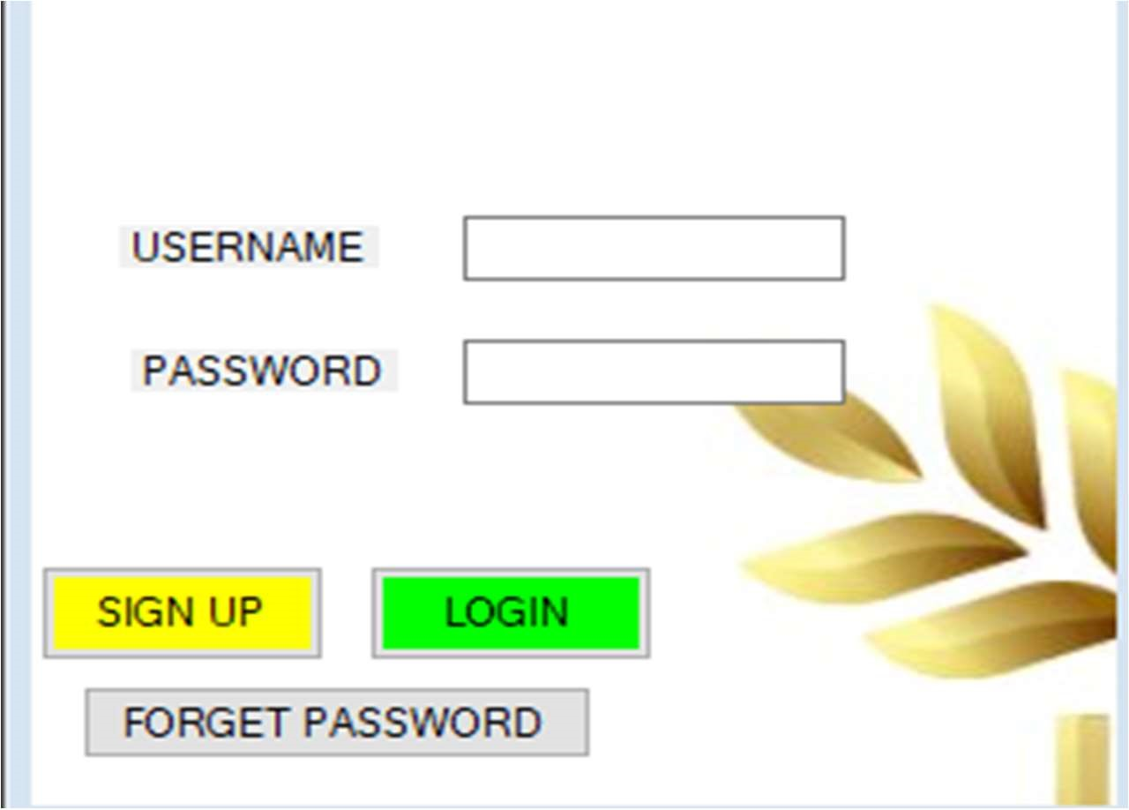

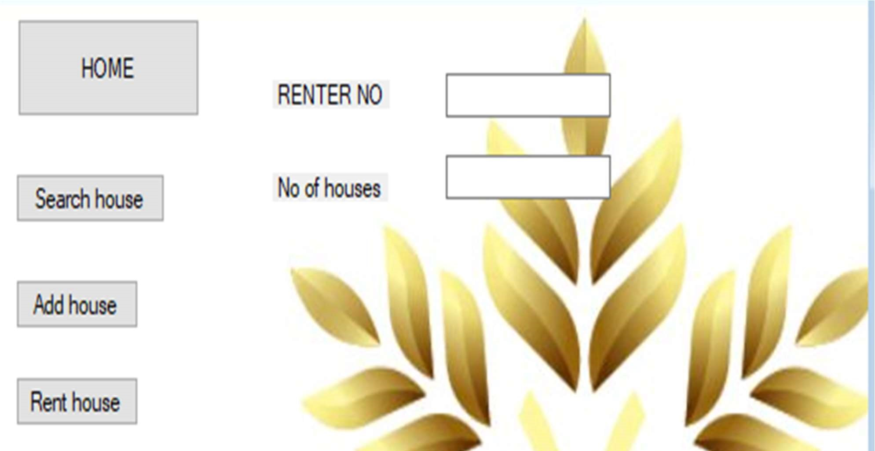

10.0 CONCLUSION AND RECOMENTATION

10.1CONCLUSION

In conclusion, online house rental has merged with new a new perk compared to the experiences where every commotion concerning renting a house was limited manually and physical location only. Even though the functions are achieved has been reshaped by the power of the technology. now days house owners can reserve a book by sell house online, rent a house online and have the house contracted successfully without any sweat once the customer is registered member of the online house rental management system

10.2RECOMMENDATION

I hereby recommend this project of online rental management system to be use in the school since there is scarce resources within the school management thus parents have difficulties in find a house for their children so this project maybe link up with the school and students will access the house for renting online within and outside the school

REFERENCE

HASNAT: IFRAD, NISHAT: DEBABRATA “BACHELOR HOUSE RENTAL

MANAGEMENT SYSTEM “2019