HOME HIDDEN SECURITY E-COMMERCE(HHS)

**SCHOOL:**

**THARAKA UNIVERSITY**

**FACULTY OF PHYSICAL SCIENCE ENGINEERING AND TECHNOLOGY**

**DEPARTMENT OF COMPUTER SCIENCE**

BY: Joseph Peter

REG NO: EDS1/04910/21

Table of Contents

**Title page1**

Dedication2

Acknowledgement3

Problem statement4

Abstract5

Declaration6

**DEDICATION**

It is my honor and pleasure to dedicate this project to the community to better our future.

**ACKNOWLEDGEMENT**

I hereby acknowledge Madam Eva my lecture who happens to be my supervisor, for the guidance and constant development of this project by providing useful information on the same.

**Problem Statement**

Many homesteads have challenges of theft thus increasing insecurity in the community and I saw it good to have security improved in our homes so that people can have peace in their minds. This project enables the society to safeguard its environment from attacks and also theft of items from people’s homesteads

**Abstract**

The issue of insecurity as become a major problem to our society, people have been losing properties mostly due to lack of good security. In order to secure our items in our community I came up with this project (Home Hidden Security accessories) which helps the community to safeguard its enviros from intruders by supplying accessories which can be used to monitor their enviros at all times. The accessories include the CCTVs, Sensors, sound detectors and siren devices as well. The system will enable the community to access the devices more easily and at affordable prices. Once they are installed in one’s compound, our system also has the ability to offer a back up storage of anything that is captured/recorded so that incase of any data lose one can refer in our systems for back up. This system will help to escape many crimes that have been occurring in our compounds behind our backs. One will not again tire employing guards to guard his compound or be worried to know what has been happening when he/she is not around for the system works 24/7 as long as there is continuous power supply. We also grand our customers a one-year warrant on our accessories, and we also offer door delivery to our clients. The system allows the client to shop all the items online, and also make all the payment there.

**Declaration**

I declare this project has been done by Joseph K. Peter. In the mean while no one has presented the project in Tharaka University, so I have worked on it to the best of my level.

**INTRODUCTION**

Home hidden security e-commerce system is a project that is aided to help the community in safe guarding their homestead. The project offers services such as: selling CCTVs, Sensors, sound detectors and also siren devices, also allows the users to shop the items online allowing them to choose all the accessories they need and also do the payment online. The customer can add more items to the cart or even reduce an item. The project also guarantees a warranty of one year on its products and also it does a door delivery to its customers.

A customer seeking services from the system is required to provide personal details. The details are captured and the customer is required to make full payments for services sought. Once the payment has been verified, services are approved and offered.

**STSTEM ANALYSIS**

**Problem Definition**

Home hidden security project provides the best home security gadgets for various families registered under the manual system. The manual system has numerous limitations which press for the existence of a computerized system.

Some of the limitations of the manual system include: The use of human security guards is not fully secured for anybody who sneaks in unauthorized. The use of manual system is tiresome and time consuming. Loose of items in your compound even the workers may attempt to steal. The CCTVs installed can be seen where they are located such that a person can try to escape their area of capture. One can be lied to when pauses a question of what happened after a certain scenario.

Here are some of the examples in picture of our appliances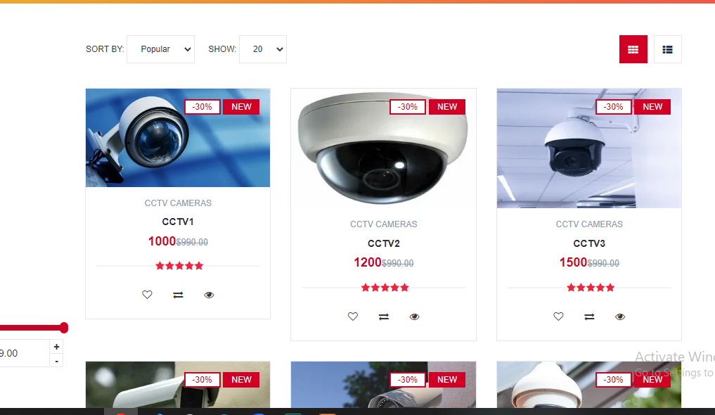

**PROPOSED SYSTEM**

**OBJECTIVES**

Due to all inconveniences brought about by the use of the existence system, I would like to recommend this computerized system which aids in the improvement of the security of most compounds by getting security gadgets easily on online.

The objectives of the computerized system are: Enable all the people in the community get access of the security devices by shopping them online. Allowing them to add or reduce items in the shopping cart. Allowing one to make his/her payment online. 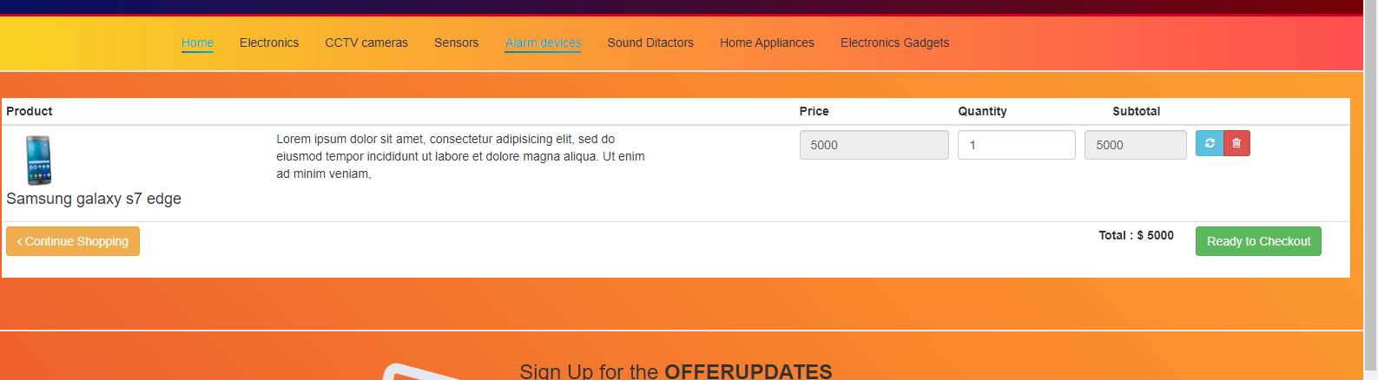

An example of items in the shopping cart



An example of logged user

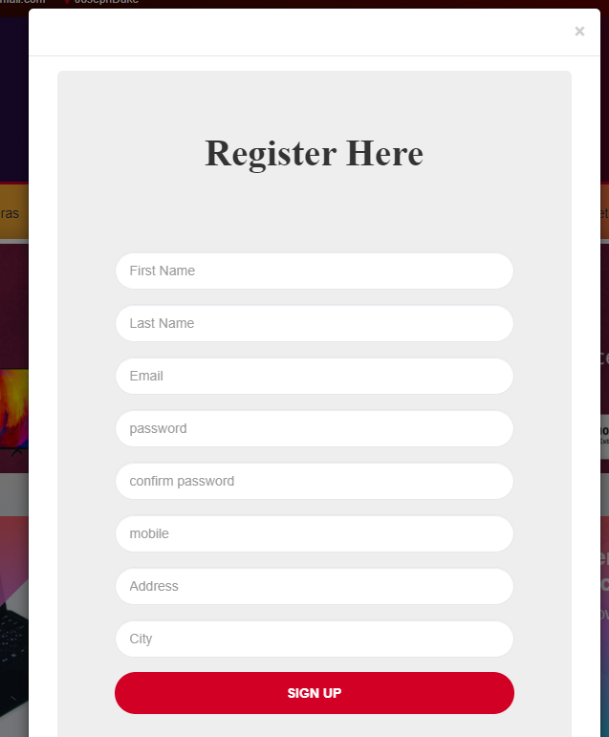

An example of registering new user

**BENEFITS**

The proposed system has the following benefits: It will increase security, it will offer backup for stored data, it will enhance data accuracy, it will eradicate instances of data redundancy, it will save on space and time.

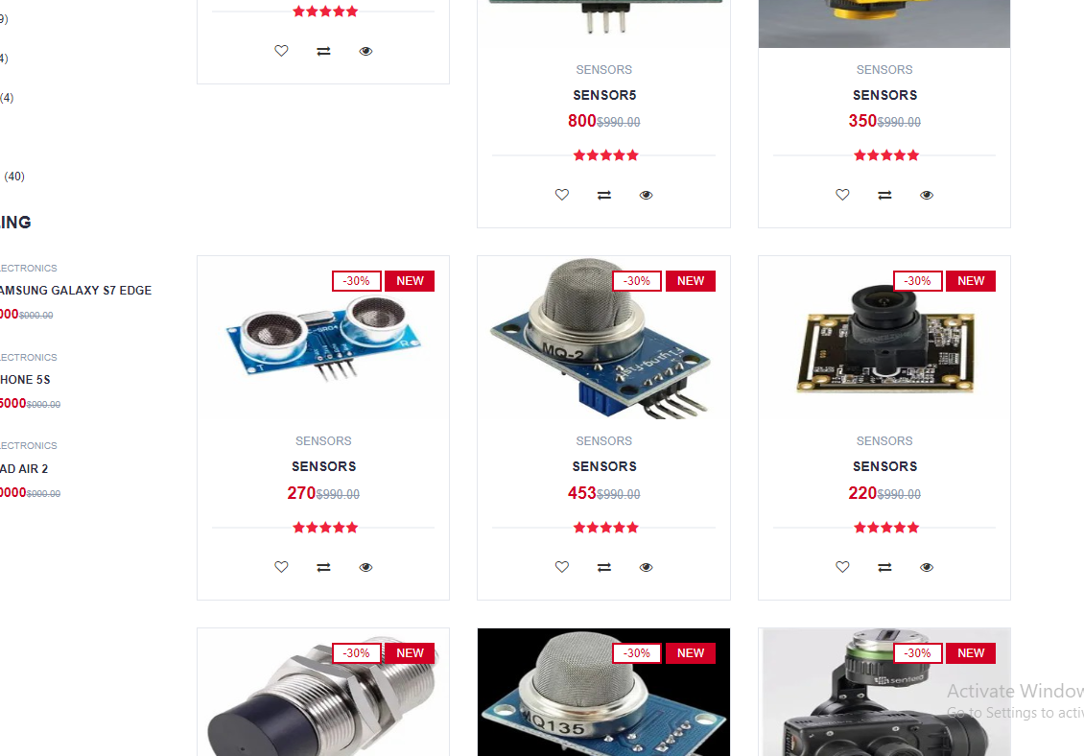

**FEASIBILITY STUDY**

**Technical feasibility**

The organization will be required to purchase computers, CCTVs and other accessories and hire a database administrator, a computer technician and a system analyst

**Social Feasibility**

The company will have to train its staff on operation to be carried out.

**Economic Feasibility**

The amount of money spent in the development and maintenance of the system is as shown in the table below:

|  |  |  |
| --- | --- | --- |
|  | MANUAL SYSTEM IN SHILLINGS | COMPUTERIZED SYSTEM IN SHILLINGS |
| Transportation fee | 83000 | 45000 |
| Electricity bills | 7000 | 14000 |
| Salaries | 80000 | 60000 |
| Relevant stationery | 60000 | 45000 |
| maintenance | 9000 | 18500 |
| TOTAL | 182800 | 126500 |

Economic feasibility

**Operational feasibility**

The system will function accordingly in proper working condition.

**Legal Feasibility.**

The proposed system is legally authorized for use by the government.

**Schedule Feasibility**

The proposed system can be developed and made operational over a six months period as shown below.

|  |  |
| --- | --- |
| ACTIVITY | DURATION |
| System analysis | 1 month |
| System design | 1 month |
| System construction | 2 weeks |
| System testing and debugging | 2 weeks |

**System analysis by use of flow charts**

START

Capture services offered

Capture package details

Test for package

If package_15000?

If package _120000?

If package_190000?

Package records

And services

Generate package and service report

1

1

Capture company purchase

Records of company purchase

Sales <=

20000

Sales <80000

Sales>=

80000

Not negligible

Payment in cash

Payment by mobile money transfer

Payment paid via electronic fund transfer

Payment records

Exit purchase

2

2

Capture customer details

Full payment

Not eligible for services

Offer service

Provide schedule

Customer details records

Customer details report

3

3

Capture transport services

Transport service record

Exit system

STOP

Transport service report

|  |  |  |
| --- | --- | --- |
| Table name | Fieldname | Data type |
| Home Hidden security customer table | Reg No(p.k) | Text |
| IDNO | Text |
| Customers Name | Text |
| Tel No | Text |
| DOR | Date/time |
| Address | Text |

Home hidden security customer table

|  |  |  |
| --- | --- | --- |
| Table Name | Fieldname | Data type |
| Services and products sold | Service code(p.k) | Text |
| Service type | Text |
| Service cost | Number |
| Transport code | Text |
| Transport type | Text |
| Transport cost | Number |

Services and products table

|  |  |  |
| --- | --- | --- |
| Table Name | Fieldname | Data type |
| Transport Table | Reg No(p.k) | Text |
| IDNO | Text |
| Customers Name | Text |
| Tel No | Text |
| Address | Text |
| Destination | Text |
| Approximate KM | Number |
| Service rendered | Text(Look up wizard) |
| Service code | Text |
| Service cost | Number |
| Transport code | Text |
| Transport cost | Number |
| Total No of items | Number |
| No of packages | Number |

Transport table

|  |  |  |
| --- | --- | --- |
| Table name | Fieldname | Data type |
| Package cost table | Package code(p.k) | Text |
| Package type | Text(Look up wizard) |
| Package cost | Number |

Package cost table

|  |  |  |
| --- | --- | --- |
| Table name | Fieldname | Data type |
| Income from sales and services table | Service code(p.k) | Text |
| Service type | Text |
| Service cost | Number |
| Transport code | Text |
| Transport type | Text |
| Transport cost | Number |
| Package code | Text |
| Package type | Text |
| Package cost | Number |

Income from sales and services table

|  |  |  |
| --- | --- | --- |
| Table name | Fieldname | Data type |
| Purchase from customers table | Reg No(p.k) | Text |
| IDNO | Text |
| Farmers Name | Text |
| Tel No | Text |
| Product code | Text(look up wizard) |
| Product type | Text |
| Product cost | Number |
| Payment mode | Text(look up wizard) |

Purchase from customers table

**ENTITY RELATIONSHIP DIAGRAM**

Services and products table

customer table

Customer table

Income from sales and services table

Purchase from customer table

Entity relationship diagram **CONCLUSION AND RECOMMENDATION**

**CONCLUSION**

With the completion of this project I conclude that it has achieved its purpose. The whole project provides a base for customers who at most are the community people to safeguard their homes from thieves and other offendors. The system is developed using java programming and data are saved in the database.

The system helps to save on cash since once one has it will not be bounded to paying it at the end of each month and also it will not ask for resting days because it doesn’t have life thus cannot get tired.

**RECOMMENTATIONS**

The project has been accomplished and an application was developed to solve the aforementioned problems. For further development, there are some recommendations on this project:

The application should support an automatic sensor that should be able to recognize the owner.

**REFERENCES**

[1] Nijaz (2000) Dynamic web-based Application Development New York Prentice Hall

[2] Ritchey, Tim and Shobe, Matt, “JavaScript For Macintosh”,1996

[3] Bryan, J,( 2006). Technology for physics instruction Contemporary issues in Technology

[4]Harod, Elliote Rusty, “java Network Programming”, 1997