#### 

**THARAKA UNIVERSITY**

TITLE: ONLINE HOSPITAL APPOINTMENT WEB APPLICATION

Prepared by:

NAME: LEON MUSUNGU

REG NO: EDV2/04680/21

PROGRAMME: INFORMATION TECHNOLOGY

A REARCH SUBMMITTED TO THE FACULTY OF SCIENCE ENGINEERING AND TECHNOLOGY IN PARTIAL FUILFILLMENT OF REQUIREMENT FOR AWARD OF DIPLOMA IN INFORMATION TECHNOLOGY OF THARAKA UNIVERSITY

AUGUST 2022

# Declaration and Approval

I hear hereby declare that, to the best of my knowledge, this project has not been submitted to any other University for the award of a Diploma certificate.

Student Number:

Sign: ________________________ Date: ________________________

Supervisor Name:

Sign: ________________________ Date: ________________________

## Acknowledgement

My sincere acknowledgement goes to the almighty God for the guidance and protection through the proposal writing.

I kept all my efforts for the success of my project. However, it would not be possible to get this success without the kind support and help of our beloved lecturer and Guide Mr. Mark Kamanja, Mr. Kevin Tuei, and many other computer science lecturers. I would like to extend my heartfelt gratitude to all of them.

I’m highly indebted for their guidance, constant supervision and also providing me necessary information regarding the project. Thank you for your support in helping us to completing the project.

# Abstract

Booking an appointment online has grown in popularity over the past few years. Many different types of businesses use some type of Web-based online appointment management system to help make the appointments setting process more streamlined. An online appointment management system allows patients to register and book appointments with their doctors. This proposal gives details of the development process of an online appointment Web-based management system to be used within hospital. We have conducted some experimentation to show the effectiveness of our system. According to the existing system, patients schedule appointments by going in person to the doctor and request for an appointment. This process is very tedious and time taking. In our project we will build an online appointment scheduling web application for patient to schedule an appointment by them self whenever and wherever they are. This system helps to lessen the burden of going to hospitals or to conserve time and use it in an efficient manner we will bring this appointment scheduling process online. All this process is available online through our web application "ONLINE HOSPITAL APPOINTMENT WEB APPLICATION". Any changes in the scheduled appointments such as cancellation of visiting hours will be notified through email.

# Table of Contents

CONTENTS

Declaration and Approval i

Acknowledgement ii

Abstract iii

Table of Contents iv

List of Tables vi

List of Figure vii

CHAPTER 1: INTRODUCTION 1

1.1 Background 1

1.2 Statement of the problem 2

1.3Research question 3

1.3.1Goal of the project 3

1.4 OBJECTIVE 3

1.4.1 General objective 3

1.4.2 Specific objective 3

1.5 Justification/significance 4

Significance 4

Justification 4

Scope and Limitation 5

1.6 Scope of the project 5

1.7 Limitation 5

CHAPTER 2: LITERATURE REVIEW 6

2.1 Related areas accessed or read 6

CHAPTER 3: METHODOLOGY 8

3.1. Introduction 8

3.1.2The methodology that the developer will use 8

3.2. Software Development Methodology 8

3.2.1 Agile methodology 8

3. 2.2 Time of activities schedule table 9

3.2.3 Software requirement tools 9

3.2.4Feasibility Study of the System 10

3.2.5 Analysis 11

3.2.5.1 Assumptions 11

3.2.5.2 Future Enhancements 11

3.2.5.3 Technical Descriptions 11

3.2.5.4 Application Information flows 12

3.2.5.5 Capabilities 13

3.2.5.6 Operations, Administration and programming method used 13

CHAPTER 4: SYSTEM DESIGN 14

4.2 System Overview 14

4.3 Budget scheduling 14

4.4 System architecture 15

4.5 Project design description 16

4.6 Implementation 17

CHAPTER 5: EMPATHY AND PROBLEM DEFINITION 18

5.1 Empathy 18

5.2. Problem Definition 19

5.4 Conclusion 19

References 20

# List of Tables

*Table 1: Time of activities schedule table*

*Table 2: Software requirement tool table*

Table 3: Budget scheduling

# List of Figure

Figure 1 Agile methodology 8

Figure 2:Application information flow 12

Figure 3:system architecture 15

Figure 4 home page 16

Figure 5:creating an account interface 17

Figure 6:Appointment interface 17

Figure 7:percentage of patients 19

Figure 8: I can book an appointment 19

Figure 9:Email reminder 20

# CHAPTER 1: INTRODUCTION

## Background

Web application have helped in streaming many of the task we perform and has made our lives easier. These applications help us minimize problems with scheduling appointments with doctors. In the past these appointments were done manually and because of this there were prone to errors, as the saying goes ‘human is to error’ because of this there were cases of over booking, forgetting to cancel a meeting which could create space for other patients and forgetting to attend the given appointment.to free human errors due to making/booking appointment manually;

An online **hospital appointment web application** will be created to make it easier and efficient to the run of activities. Also, given the busy schedule that many of us lead today to make ends meet, an online appointment within a hospital or any organisation makes perfect sense as it frees up valuable time. The purpose of the project is to develop an **online hospital appointment web application** for patients where all appointments management such as reservations, confirmations and cancellations

This online hospital appointment web application will be used by the Hospital to manage, reserve, confirm and cancel patient’s appointment, so as to reduce the number of paper files in their registry; by developing a Graphical User Interface (GUI) that will enable the patient, registrar and doctor the ability to book an appointment, register a patient and provide diagnostics all within several clicks of a button. The system allows storage of information to be done over cloud services, thus allowing the doctor the ability to access patient records remotely. The software will also keep track of the new patients and old patient appointments. Deployment of this software will reduce the time required for a patient to see a doctor. It will also reduce the long queues

## 1.2 Statement of the problem

In the past these appointments were done manually and because of this there were prone to errors, as the saying goes ‘human is to error’ because of this there were cases of over booking, forgetting to cancel a meeting which could create space for other patients and forgetting to attend the given appointment.to free human errors due to making/booking appointment manually;

Problems found in the current system

* Difficulty in booking appointments
* Difficulty for the hospital management to keep trace and record of appointments due to paper filling system

What the current system will do

The **online hospital appointment** is a web-based meeting scheduler system to schedule various types of meetings. It would efficiently schedule meetings and determine the available resources such as location and free-time-slots suitable for all attendees which are necessary for the meeting to be initiated. The purpose of this system is to support the hospital in scheduling meetings by determining each attendee’s free time slot, date. The system will monitor meetings, plan meetings under constraints expressed by the participants, reschedule meetings based on constraints, and manages all the interactions among participants. Since **online hospital appointment web application** is an online system, it can be easily accessed from web-browser with internet access, thus removing any constraints of time or place. The system also sends relevant notifications and information to respective users through emails. The system will have a user-friendly interface which will make it easier for all kinds of participants

## 1.3Research question

* How To help the hospital keep record of the patient visiting list
* How can we help patients book appointments in a hospital without necessarily going to the hospital?
* How can a patient cancel or reserve an appointment without necessarily going to hospital?

## 1.3.1Goal of the project

The aim of the project is to develop an **online hospital appointment web application** for patients where all appointments management such as reservations, confirmations and cancellations, more so it aims at keep the information of the patient and prevent unauthorized access to the accounts of the patient.

## 1.4 OBJECTIVE

## 1.4.1 General objective

The main objective is to develop the **online hospital appointment web application**

That will help both patient and hospital to keep record of their appointments

## 1.4.2 Specific objective

1. To enable patients to login into the system
2. To help patients booking appointments in a hospital
3. To help the hospital keep record of the patient visiting list
4. To help patients create their own accounts

## 1.5 Justification/significance

## Significance

The aim of the project is to develop an **online hospital appointment web application** for patients where all appointments management such as reservations, confirmations and cancellations, more so it aims at keep the information of the patient and prevent unauthorized access to the accounts of the patient.

## Justification

**online hospital appointment web application** has the following importance that will add to the community at large as state below;

1. To facilitate patients record keeping for those who wants to see the doctor and for administrative management system
2. To reduce the cost of travel to the hospitals for booking appointments
3. To to reduce the number of paper files in their registry
4. To reduce wasted time to the hospital to book appointment

## Scope and Limitation

## 1.6 Scope of the project

 There are several motivations to develop the new web-based online appointment system:

* The proposed system is concerned in booking, reservations, confirmations and cancellation

Of appointments

* The system will remove the tedious task for patients to reserve an appointment or forget a given appointment.
* The system will help to the hospital administrative staff i.e., the Hospital records to keep the daily and the history record details of the patients need in proper Database.
* Will generate proper available home for customers at the time.
* The patient will allow remote access to the online appointment system from the database only for patient and make reservations, cancellation and confirmation
* The patient can also give feedback.

## 1.7 Limitation

As a study and research, we have come with various limitation also many problems also with the system. In performing this project there may face many constraints like lack of availability of enough secondary data and it may be inconsistent with the project

*This study is limited to…*

* The error may occur if the transaction cancels or if the server is down.
* Lack of adequate time in order to get the additional secondary data.

.

# CHAPTER 2: LITERATURE REVIEW

## 2.1 Related areas accessed or read

Lately there have been many different trends in web application development. Web application development is a fast- and ever-growing field. **Jazayeri** said “*Web applications have a user interface based on the browser that interacts with the user and can manage large amounts of data*” They are popular because a new version of the application can be released without the necessity of installing the new version on the client computers. This is very different from desktop applications where either a new version has to be installed, or there must be the installation of a patch

Web applications of an online hospital appointment application within a hospital setting is an area of rapid growth because it is a more efficient way of handling and keep track of patient records as well as for scheduling appointments

Online appointments management systems have been around for a few years. They are used extensively in colleges, university and business settings for administrative issues. Although this system will be developed for an hospital, it is helpful to obtain ideas on how other areas of business have used such systems. UCLA developed a web-based data management system that is used in hospitals across the country, and although the system does have its limitations, it is still performing quite well

Lu and Ab Hamid (2007) have developed an appointment management system called WBAMS which uses Web Modelling Language (WEBML) and -.Net four-tier architecture. According to them, their system will allow appointment scheduling to be more efficient and effective.

The main purpose of the web application “online hospital web appointment application “is to ease the patient experience in making appointments with doctors. The users can easily fin a doctor in a particular hospital and book an online at their desired time based on the specific doctor’s availability. The Patients are free to cancel their appointments with stipulated time which benefits other patients to get that particular time slot.

The application facilitates the doctors by providing them with the upcoming schedule of consultation for the following week.it also enables them to create a new schedule with their available time period. Each doctor will have a customized profile of their own along with their list of patient’s medical records whom they treated

# CHAPTER 3: METHODOLOGY

## 3.1. Introduction

Methodology specifies the method and technology used to develop the web application system such as, the methods used to gather data, approach used to design the software system, software and hardware requirements used to implement the system

## 3.1.2The methodology that the developer will use

* **Interview**

We interviewed patients about the problem that they are facing on not having a computer-based system of scheduling appointment

* **Observation**

We used observation as a tool of gathering information of the existing hospital online appointment system, we choose the observation technique since this is the cheapest and highly advanced in providing information about the existing appointment system

* **Questionnaire**

We used questionaries as a tool of gathering information of the existing hospital appointment system. We choose the method since in some hospital it was very hard to get the IT specialist

## 3.2. Software Development Methodology

System development methodology is the way how or the method the system was created; in my case we used waterfall model

## 3.2.1 Agile methodology

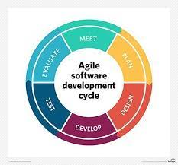

Figure Agile methodology

## 3. 2.2 Time of activities schedule table

|  |  |  |  |
| --- | --- | --- | --- |
| Task name | Start | Finish | Duration |
| System definition | April | may | 4weeks |
| Analysis | may | July | 10 weeks |
| Design | July | July | 3 weeks |
| Coding | august |  | 3weeks |
| Testing | September |  | 1 week |
| Implementation | September |  |  |

*Table 1:* *Time of activities schedule table*

## 3.2.3 Software requirement tools

|  |  |
| --- | --- |
| ACTIVITIES | TOOLS |
| Documentation | MS word 2013 |
| Editing |  |
| Design |  |
| Script language | Php, JavaScript, CSS, |
| Data base serve | MySQL database |
| Web server | Xamp server |
| Devices | Pc laptop |

Table 2: Software requirement tool table

## 3.2.4Feasibility Study of the System

The feasibility study is the preliminary study that determines whether a proposed system project is financially, technically and operationally. Feasibility study is essential to evaluate the cost and benefits of the new system. The alternative analysis usually include as part of the feasibility study, identifies viable alternatives for the system design and development.

* **Operational Feasibility**

The system to be developed will provide accurate, active, secured service and decreases labour of workers and also it is not limited to particular groups or body. The system will easily operational, as it doesn’t affect the existing organizational structure and support the current system. So, the system will be operationally feasible.

* **Technical Feasibility**

 The system to be developed by using technologically system development techniques such as PHP, Java script, CSS and MySQL database without any problems and the group members have enough capability to develop the project. Our focus is to develop well organized dynamic web site that is technically efficient and effective for managing the Online Trade interaction system. Therefore, it can be concluding that the system is technically feasible.

* **Economic Feasibility**

 The system to be developed is economically feasible and the benefit is outweighing the cost. Since this project already computerizes the existing system and more advanced than the current system reduces and change the labour force to computerize system. Reduces the cost of the material used

## 3.2.5 Analysis

## 3.2.5.1 Assumptions

This system is supposed to be a web-based application which can be accessed 24/7. Network connection should be available to use the application. System assumes that all the participants will be actively involved in responding to meeting requests. The health records officer must decide about the agency of patient’s appointment. The system can only schedule a meeting, not the priority of patient. Priorities of meetings also has to be done by health records officer; the system is not responsible for the importance level of meetings.

## 3.2.5.2 Future Enhancements

* In this research the system developer has limited to a hospital online appointment for a hospital but this system is intended for many different types of organizations where a scheduling or booking appointments is necessary, it is very important for the code to be customizable due to the distinct needs of different organizations. For example, some organizations only need to schedule appointment with same time, where time is not an issue during each appointment, and some places need to schedule workers with different time frame for each project. Also, some organizations make their schedules once a month, and others more frequently. For the above reasons, the system needs to be schedule very well in close detail, and the system should be easy to reuse, and customize for future usage. Future customization will include features that will simplify time entry and reduce opportunity for time entry errors
* Moreso enhancing it to an android application where it can be access by many people and used it for efficiency

## 3.2.5.3 Technical Descriptions

The objective of the project is to develop an online hospital appointment application within allocated time, budget and specified quality. The project is prioritized due to high benefits to the hospital. One of the important usages of this project is that it will automate the process of meeting scheduling and thus save the time and efforts of health record officers. More advantages will be further discussed ahead. The primary focus of our team is the reliability, usability, and quality. Satisfying requirements with precision is very important to us while the products intend to meet all the user's need

## 3.2.5.4 Application Information flows

*Login as main admin*

*Login as admin*

registration

Login

Book appointment

Time allocation

Cancel appointment

Change preference

Confirmation of appointment

Decline

request

booked

Figure :Application information flow

## 3.2.5.5 Capabilities

* Scheduling the meeting in efficient way.
* Gathering the feedback from attendee.
* Cancelling the meeting.
* Changing the meeting schedule.
* Scheduling concurrent meetings in timely manner.
* Confirming the time of the appointment

## 3.2.5.6 Operations, Administration and programming method used

Online hospital Appointment is a web-based application. The Client-Side Design is developed using java script and Server-Side Validation is done by using JavaScript for storing patient details, doctor’s details and time slots. We are using SQL server 2019. If students want to use this web application, they need a web browser (Chrome, Firefox, Safari, Internet Explorer) of any versions. Those who are registered for the web application they can perform the following operations based on their role:

a) doctor:

* Creating Appointment Slots
* Verifying patient Appointment.
* Communicating with the patient/giving feedback

b) patients

* Registration for the Available time slot
* Selecting Slots for the Appointment.
* Managing user accounts
* Cancel appointment

## CHAPTER 4: SYSTEM DESIGN

Systems design is the process of defining the architecture, components, modules, interfaces, and data for a system to satisfy specified requirements.

## 4.2 System Overview

The system was a visual basic system/application. The database was updated each time the administrator; add, deletes or deletes data on the system. It’s only the administrator who has overall access to the system to view or make changes when necessary. The system was designed to allow the administrator to view, to approve appointments, send feeds to the patients and add data to the database Each time a patient requests for an appointment, he/she is registered in the hospital registration table of the database with other relevant details about the patient. System design involved transforming the software requirements into an architecture that described its top-level structure and identified the software components and developed a product.

## 4.3 Budget scheduling

For this project the estimated budget plan from the beginning to end of the project is described on the table below.

|  |  |  |  |  |
| --- | --- | --- | --- | --- |
| No | Material | No of Quantity | price | Total price |
| 1 | PC laptop | 1 | 70,000ksh | 70,000 |
| 2 | pen | 2 dozen | 60ksh | 120 |
| 3 | papers | 1 rim | 120ksh | 120 |
| 4 | Flash drives | 1 | 1500ksh | 1500 |
| Total | | | | 71,740ksh |

Table 3: Budget scheduling

## 4.4 System architecture

Figure :system architecture

## 4.5 Project design description

The online hospital Appointment is a web-based meeting scheduler system to schedule various types of meetings but more specifically in the hospital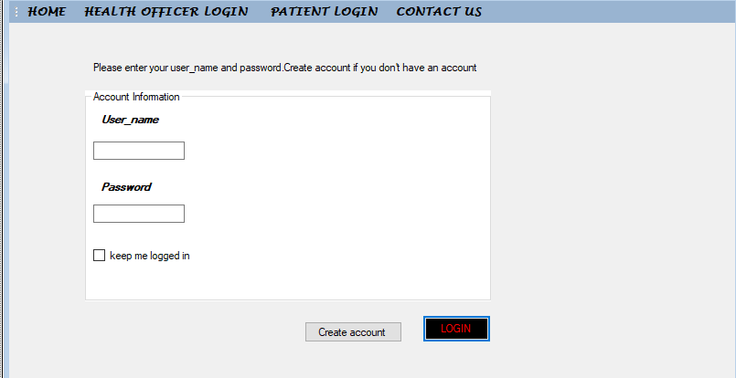

Figure home page

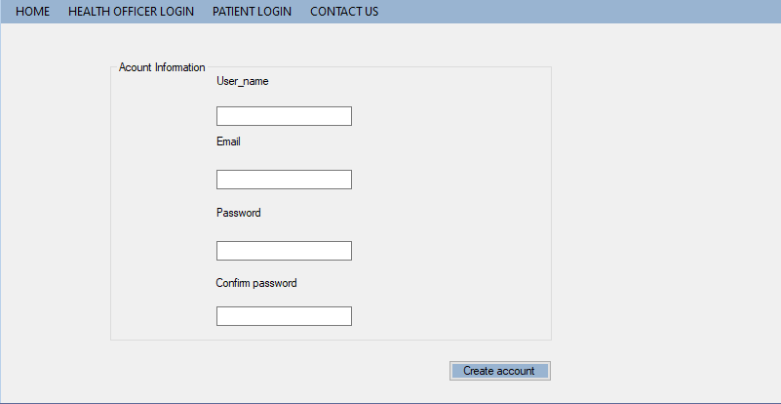

Figure :creating an account interface

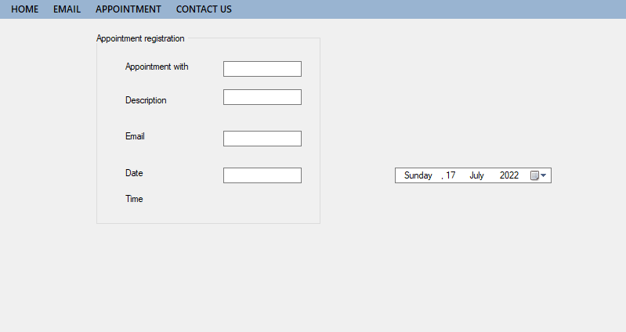

Figure :Appointment interface

## 4.6 Implementation

In this section, the implemented pages as can be seen during the browsing on the online hospital appointments application are displayed figure 1 Implementation in General The implementation and development of an online system to manage appointments between patients and the hospital is the main goal of this research. The content of this system should adapt to the users’ requirements. For instance, reservations, confirmations and cancellations have to be implemented in this system. In this system, patients can register in and they can also reserve appointments with doctors, in addition, they can manage their account

# CHAPTER 5: EMPATHY AND PROBLEM DEFINITION

## 5.1 Empathy

So, the impact assessment was carried out through interviews and questionnaires to see how it has impacted the people around the society

Figure :percentage of patients

A survey was carried out among 28 patients. Most of them were not for not for an online hospital appointment application, while 3.2 were for the for an online hospital appointment application as shown in Figure 4. Table 1 also shows the demographic information about the

Figure : I can book an appointment

In addition, the participants were asked if they can book an appointment. 80% of them strongly agreed while around 20% all participants said they can book appointment as indicated above

Figure :Email reminder

In addition, the participants were asked if the e-mail reminders related to booking appointments were one of the most important features in this system. 43% of them strongly agreed while around 39% agreed as indicated in Figure 7.

## 5.2. Problem Definition

So, we through the field work and interview of various members of the society we noticed that they we having difficulties in keep and conserving of appointment

## 5.4 Conclusion

We felt that the development of an online appointment management system was necessary because of the antiquated way in which many schools register and schedule student appointments. In order to keep up with growing technology, we must seek ways to make certain processes less time consuming, more error free and more user friendly. We have built the system using ASP.NET 2008. A field study has been carried out to observe the features of our system and stakeholders’ usage. Furthermore, our online appointment management system has been compared with another static appointments system.

## References

1. Liu, W., & Meng, X. (2006). *Web Database Integration*, Seoul: Proceedings of the VLDB2006 Ph
2. Ding, J. 2008. MSc Project in A web 2.0 approach to a fashionista website. Heriot-Watt University...D. Workshop, 2006.
3. O'Reilly, T. 2005, What Is Web 2.0? Available at: http://oreilly.com/lpt/a/6228. Last Accessed 13 May 2010.
4. Unutzer, J., Choi, Y., Cook, I. A. and Oishi, S. 2002. A Web-Based Data Management System. Psychiatric Services
5. Tutorialspoint.com. (n.d.). JavaScript Form Validation. Retrieved from https://www.tutorialspoint.com/javascript/javascript_form_validations.htm
6. The first Regular Expression Library on the Web! (n.d.). Retrieved from http://regexlib.com/
7. Krunal. (2019, January 06). Angular 7 CRUD Example: MEAN Stack Tutorial From Scratch. Retrieved from https://appdividend.com/2018/11/04/angular-7-crud-example-mean-stack-tutorial/.
8. /@daouda.diallo.cisse. (2019, June 13). Creation of Web Application with Node JS and Angular V6 - Part 2 (FRONTEND). Retrieved from https://medium.com/code-divoire/creation-of-web-application-with-node-js-and-angular-v6-part-2-frontend-2de5eba06b5a

# 