Crop heterogeneity can enhance multi-trait diversity of beneficial insect taxa
*Corresponding author. E-mail: tharakas001@ntu.edu.sg; tharakas.priyadarshana@gmail.com.

Table of contents
1. Appendixes
Appendix S1: Extended hypotheses ………….…………………...…………………....………... 4
Appendix S2: Field margins ………………………….…………………………………………. 5
Appendix S3: Insect sampling protocol and species identification ……………………..………. 5
Appendix S4: Seasonal dynamics of crop types …………………………………...……………. 7
Appendix S5: Trait measuring protocol and ecological relevance …………………………….... 7
Appendix S6: R-packages used for the analysis ……………………………………….………. 12
Appendix S7: Overall functional diversity indices …….………………………………………. 12
Appendix S8: Variance and spatial autocorrelation structures ………………………………… 13
Appendix S9: Model averaging procedure ………………………………………………….…. 14
2. Supplementary Tables
Table S1: Model fit for each analysis ….………………………………………………………. 15
Table S2: Complete results of both full and best models …………………………………...…. 16
Table S3: Contrast between each habitat category …………………………………………..… 17
3. Supplementary Figures
Figure S1: A map of the study site network ……………………………………………………. 25
Figure S2: An example diagram of local scale and landscape scale ………………………...…. 26
Figure S3: Temporal dynamics of each insect group ……………………………………...…… 27
Figure S4: Crop list and crop percentages in summer and spring …………………………..…. 28
Figure S5: Correlations between dung beetle functional traits ……………….……………...… 29
Figure S6: Correlations between bee functional traits ……………………….……………….... 30
Figure S7: Correlations between dragonfly/damselfly functional traits …………….…………. 31
Figure S8: Correlations between butterfly functional traits ………………….……………...…. 32
Figure S9: Correlations between species richness and functional dispersion in summer ……… 33
Figure S10: Correlations between species richness and functional dispersion in spring ........… 34
Figure S11: Correlations between species richness of each insect group in summer ………….. 35
Figure S12: Correlations between species richness of each insect group in spring ……………. 36
Figure S13: Relationships between the functional traits of multiple beneficial insects identified by the Principal Component Analysis (PCA) ………………………………………………..… 37
Figure S14: Correlations between different types of overall functional diversity indices in summer ……………………………………………………………………………………….… 38
Figure S15: Correlations between different types of overall functional diversity indices in spring …………………………………………………………………………………………...……… 39
Figure S16: Effects of local scale and landscape variables on different types of dung beetle functional traits in summer and spring …………………………………………………………. 40
Figure S17: Effects of local scale and landscape variables on different types of bee functional traits in summer and spring …………………………………………………………………….. 41
Figure S18: Effects of local scale and landscape variables on different types of dragonfly/damselfly functional traits in summer and spring ………………………………...… 42
Figure S19: Effects of local scale and landscape variables on different types of butterfly functional traits in summer and spring …………………………………...……………….……. 43
4. Supplementary References ……………………………………………………………….... 44
1. Appendixes
Appendix S1: Extended hypotheses
We hypothesized that different crop types in our region are able to provide various resources (e.g. food, nesting/breeding and hiding habitats) required by the beneficial insect taxa. Therefore, both compositional heterogeneity (Shannon–Wiener crop diversity) and configurational heterogeneity (field margin length) may have a positive effect on multiple beneficial insect communities as a whole.
Previous studies showed that species with sensitive traits (e.g. larger body, higher-dispersal) cannot adjust to highly intensified systems (de Palma et al., 2015; Purvis, Gittleman, Cowlishaw, & Mace, 2000). Therefore, in highly intensified systems, only generalist species with adapted traits will maintain and trait diversity will be low. By contrast, we hypothesized that different crop types provide diverse resources for both specialists and generalists. Ahigher crop diversity (i.e. compositional crop heterogeneity) will therefore benefit species with different traits and support higher trait diversity in insect communities. Therefore, compositional heterogeneity will have a positive effect on trait diversity across multiple beneficial insect communities.
A higher configurational heterogeneity corresponds to landscapes with a high quantity of semi-natural/weedy field margins, that have often low levels of management. In addition, it corresponds to landscapes where habitats (i.e. crop and non-crop) are well-connected (Fahrig et al., 2011). Therefore, a higher configurational heterogeneity can facilitate both specialist and generalist traits. As a result, we expected positive effects of configurational heterogeneity on trait diversity across multiple insect taxa.
We further hypothesized that the trait diversity of multiple insect taxa in our region varies between the different crop habitats and in non-crop weedy vegetation. In addition, we expected trait diversity differences between the different crop types (e.g. Rice, sugarcane/corn, vegetable, see section 2.4. in the main text). We also expected a higher trait diversity in weedy vegetation than in crop habitats, due to their greater habitat quality.

Appendix S2: Field margins
Field margins are the boundaries of both crop and non-crop fields, but not the internal boundaries within the crop fields. Farmers use these field boundaries day-to-day, to access their crop fields, and they were composed with non-crop weedy vegetation without any crops on them. The non-crop vegetation on field margins was typically composed with native and non-native grasses, such as Digitaria sanguinalis (Poaceae), Echinochloa crusgalli (Poaceae) and Eleusine indica (Poaceae), and herbs, such as Alternanthera philoxeroides (Amaranthaceae), Lindernia crustacea (Linderniaceae ) and Ludwigia hyssopifolia (Onagraceae) (see Zhou, Lee, & Goodale, 2018).

Appendix S3: Insect sampling protocol and species identification
Dung beetle sampling
Following Larsen (2005), we set up three pitfall traps (10-cm diameter plastic cups with a bait) along three 50-m long transects (i.e. along field margins), at two ends and in the middle. The traps were left in place for two days. The bait consisted of 30 g of human feces per trap from a person with a fish diet continuously through the study period and wrapped in a 2-mm mesh. The plastic cups were buried along the transects and filled with ca. 40 ml NaCl solution with a few drops of dish soap as a surfactant.
Bees
Following Fahrig et al. (2015), we set up three pan traps painted in three different colors (yellow, blue, and white) along each 50-m long transect (i.e. along field margins). We used 45-cm height plastic poles to attach the pans, which allowed us to placed pans abovethe surrounding vegetation, except in sugarcane and corn. The pan was 2/3 filled with water, and a few dish soap drops were added to break surface tension. The pan traps were located at each end of the transect and in the middle. These traps were left in place for two days.
Dragonflies/Damselflies and Butterflies
We adapted the survey methodology from Fahrig et al. (2015). We walked along the 50-m long transects (i.e. along field margins) at a rate of 2 m per minute (without accounting for the time catching and identifying insects). The sampling was performed when the weather was favorable (i.e.sunny, no rain and no strong wind). All morphospecies encountered during the survey were collected using a sweep net within an imaginary 5-m³ box. Since the sampling timecan have an influence on the abundance or the activity of these groups (Janzen, 1973), each site was visited twice at two different times of the day (morning vs. afternoon), and the order of the first visit was randomized.
Insect Identification
We first selected one individual of each morphospecies, and pinned them. The remaining sampleswere preserved in 100% ethyl alcohol. We then made macrophotographs of the pinned-morphospecies from several angles with visible defining traits and sent to regional experts for identification, along with the body-size measurements. We further posted photos on Facebook specialists’ groups and iNaturalist.org, allowing other experts to comment on species identity. We were able to identify > 90% of dung beetle, dragonfly/damselfly and butterfly samples to the species level with only a few to genus level. For bees, we identified > 40% of specimens to species level and the rest to genus or subgenus level.

Appendix S4: Seasonal dynamics of crop types
There were 21 and 24 crop types observed respectively in summer and in spring, totaling 26 crop types across both seasons (Fig. S4). Rice (83%) and sugarcane (75%) dominated across farmlands in summer. Rice planting generally happens at the end of the spring in our region, hence only 15% of sites corresponded to rice-fields during our spring fieldwork, whereas 70% of farmlands were composed of sugarcane at that season. As for other crops, corn, peanut, chili and bean were fairly common crops (> 50% of the sites in some seasons), followed by other vegetables such as watermelon, luffa, pumpkin, bottle gourd, bitter gourd, and lettuce (> 35% of the sites in some seasons). In spring, harvested sugarcane-fields were replaced with watermelon, and newly added sugarcane fields were planted on formerly harvested corn fields.

Appendix S5: Trait measurement protocol and ecological relevance of the measured traits
Measurements were taken from all the species. If possible, different morphs including both males and females were measured. One to ten specimens of dung beetle and one to three specimens of bee, dragonfly/damselfly and butterfly per species collected at each site (depending on availability) were measured with aid of Leica M205 A stereomicroscope, and Leica Application Suite software (version 4.9.9). The proboscis length of butterflies was measured on live specimens with aid of a Vernier caliper, while all other measurements were taken from dry specimens. The weight of all measured specimens was assessed using a Mettler Toledo XS204 analytical balance.
(1) Body length
Body length was measured as the total lateral length from anterior of head to the apex of abdomen (in mm). Body length is a measure of body size, and has been shown to be associated with microhabitat conditions and resource-use related traits (e.g. Barton et al. 2011, Dias et al. 2017, Grab et al. 2019, Woodcock et al. 2019, Micó et al. 2020, Provosta et al. 2020).
(2) Body mass
Body mass was measured as the dry weight in mg. Body mass is associated with size-related traits, and it is associated with species metabolism and microhabitat conditions (e.g. Saint-Germain et al. 2007, Woodcock et al. 2010, 2019, Nervo et al. 2014, Dias et al. 2017, Piccini et al. 2018)
(3) Eye size
Eye size relative to the body length was measured, i.e. eye size = eye length (mm)/body length (mm). Eye size is a sensory trait, which can help a species to visually orientate (Dias et al., 2017). Eye size is also a trait involved in prey and/or predator recognition, and can be associated with the species activity period (e.g. Bauer and Kredler 1993, Raine et al. 2018, Neff et al. 2019, Micó et al. 2020)
(4) Wing aspect ratio
Wing aspect ratio is a trait related to dispersal ability and disturbance avoidance. The wing aspect ratio was calculated as the wing width (mm)/wing length (mm) (e.g. Berwaerts et al. 2002, Raine et al. 2018).
(5) Body robustness
Body robustness was measured by regressing 10 individual measures on body length (mm) for each taxon and averaging the residuals of these regressions for each species. These 10 individual measures included: forewing length, hindwing length (except for dung beetles), forewing width, hindwing width (except for dung beetles), head length, head width, thorax width, thorax length, abdomen length, abdomen width (except for butterflies). A more robust species will have higher residuals, indicating higher values in these variables than expected for its body length. This trait is independent of body length, and is associated with microhabitat use (see Barton et al. 2011, Micó et al. 2020). For example, species living in confined microhabitats have flattened body shapes, while species living in open microhabitats have generally more rounded shapes bodies (Barton et al., 2011). It is therefore affecting their defenses against predation and environmental factors.
(6) Hindwing-forewing ratio
Hindwing-forewing ratio was calculated as the hindwing length (mm)/forewing length (mm). Forewing–hindwing interaction is essential for insects to control their flight (Jantzen & Eisner, 2008; Ji & Sun, 2005; Salcedo, Hoffmann, Donoughe, & Mahadevan, 2019), and therefore it is a measure of dispersal ability and disturbance avoidance.
(7) Abdomen size
Abdomen size is associated with reproductive capacity of dung beetles. Abdomen size was measured as the thorax length (mm)/abdomen length (mm). This trait is also associated with survival rates in modified lands (e.g. Srygley and Chai 1990, Raine et al. 2018).
(8) Hind leg size
Hind leg size is associated with nesting and dung relocation (dung transporting and burying) for dung beetles. It was measured as the hind leg length (mm)/body length (mm). Species with greater leg sizes have greater digging abilities (e.g. Raine et al. 2018, Ortega-Martínez et al. 2020).
(9) Wing-loading
Wing-loading is associated with dispersal and flight ability, and facilitate locating the food source, for dung beetles in particular. Wing-loading was measured as the wing area (mm²) /body area (body area = body length in mm × thorax width in mm) (e.g. Raine et al. 2018, Ortega-Martínez et al. 2020).
(10) Mandible size
Mandible size was measured relative to the head size, i.e. mandible width (mm)/head width (mm). Mandible size is ássociated with hunting efficiency for predator species (see de la Mora et al. 2008). It can also be a predictor of prey types/sizes consumed by dragonfly/damselfly (e.g. Rüppell and Hilfert-Rüppell 2013, Blanke et al. 2017). This trait is related to resource use and consumption (see Dias et al. 2017).
(11) Proboscis length
Proboscis length of pollinators determines flower visitation and foraging efficiency (see Kunte 2007, Bauder et al. 2013, Cariveau et al. 2016, Klumpers et al. 2019, Woodcock et al. 2019). It can also be a predictor of the plant-pollinator network structure by being a measure of host nectar plant specialization and/or generalization, where a species with longer proboscis has greater specialization (see Goulson et al. 2005, Cariveau et al. 2016, Jain et al. 2016, Klumpers et al. 2019, Woodcock et al. 2019). Proboscis length was measured relative to the body size, i.e. proboscis length (mm)/body length (mm). For butterflies, proboscis length was measured on live specimens, following Jain et al. (2016) – a needle was inserted in the center point of the coiled proboscis, and the proboscis was straightened. For bees, proboscis length was measured based on the intertegular distance and their family, using “tonguelength” function in the pollimetry package (Kendall, Bartomeus, & Sutter, 2018). R-codes are available in Kendall et al. (2019).
(12) Hairiness index
Hairiness is a powerful predictor of pollinator effectiveness, and strongly link to pollen uptake and transportation (see Stavert et al. 2016, Woodcock et al. 2019, Roquer-Beni et al. 2020). In bees, it has been shown that body hairs can detect electromagnetic fields emitted by flowers as pollination cues (Sutton, Clarke, Morley, & Robert, 2016). We therefore measured hairiness index for bees following Woodcock et al. (2019). The index for each bee species was measured by giving scores to body parts, i.e. a score of 0: hairy (coarse setae or extremely short hairs); a score of 1: somewhat hairy (short (c. basal tibiae 1 diameter) but dense hairs); a score of 2: very hairy (dense long (>basal tibiae 1 diameter) dense hairs. These scores were given for the body parts that were likely to be in contact with flower stigmas (head, thorax, abdomen underside, femora 1, 2 and 3, tibiae 1,2 and 3 and meta-tarsus 1, 2 and 3). We then added up the score given for each body part (0,1,2) out of a maximum score of 24 (12 body parts x 2) and gave this as a proportion.
(13) Nectar load
Nectar load is related to diet and foraging requirements for a nectar feeding species (e.g Harano and Nakamura 2016, Henry and Rodet 2018, Rodney and Purdy 2020). It was measured in μl based on the body length (mm), using “nectarload” function in the pollimetry package (Kendall et al., 2018). R-codes are available in Kendall et al. (2019).
(14) Antenna length
Antenna length is a sensory trait, which can help a species to apprehend the surrounding environmental conditions (both physical and chemical), associated with tactile and visual orientation (e.g. Bauer and Kredler 1993, Schütz et al. 1999, Neff et al. 2019). We measured the antenna length of butterflies relative to the body size, i.e. antenna length (mm)/body length (mm).

Appendix S6: Details on the R-packages used can be found in the following references
For functional diversity metrices, the FD package (Laliberté, Legendre, & Shipley, 2015). For model averaging, “dredge” function in the MuMIn package (Barton, 2019). For figure construction, the visreg package (Breheny & Burchett, 2018). For other packages, see the section 2.6.3 and references in the main text.

Appendix S7: Disentangling the overall functional diversity across all the insect taxa
We decomposed the overall functional diversity index (FD_{overall}, see section 2.6.2 in the main text) into core sets of independent functional traits across all the different taxa. To do so, we performed a principle component analysis (PCA) considering all traits measured. The PCA was run for each taxon separately (see Fig. S13). This allowed us to identify five sets of independent trait indices (see Fig. S14, S15 for Pearson correlations between each index) across multiple beneficial insect taxa:
(1) Overall body size functional diversity index (FD_{size})
This was calculated considering body mass and body length of each taxon, see Appendix S5.
(2) Overall body robustness functional diversity index (FD_{robustness})
This was measured by regressing 10 individual measures of four body parts (i.e. wing, head, thorax, abdomen) across each taxon on their body length and averaging the residuals of these regressions for each species, see Appendix S5 for more details.
(3) Overall resource-acquisition functional diversity index (FD_{res-acqui})
This includes traits related to resource-use, i.e. mandible size for predatory dragonflies/damselflies, proboscis length for pollinators (bees and butterflies), hairiness index and nectar load for bee pollinators, and the hind leg size of decomposer/nutrient recycler dung beetles were included. Note thatall the dung beetles sampled were tunnelers. Therefore, hind leg size may not be a good predictor of dung-removal activities for our dataset. It has also been suggested that body mass is highly corelated to dung removal efficiency for tunneler dung beetles (Nervo et al., 2014). We therefore also included body mass of dung beetles to our FD_{res-acqui} index (see Appendix S5 for more details).
(4) Overall tactile and visual orientation functional diversity index (FD_{tactics})
This index included eye size of all the functional groups, and Antenna length for butterflies (see Appendix S5 for more details).
(5) Overall mobility functional diversity index (FD_{mobility})
This index included wing aspect ratio of all the functional groups and hindwing-forewing ratio. For dung beetles, wing-loading was included in this index (see Appendix S5 for more details).

Appendix S8: Variance and spatial autocorrelation structures
For the Generalized Least Squares (GLS) modeling using the nlme package, we used the variance structures varFixed, varIdent, varPower, varExp, varConstPower, and varComb, and for spatial autocorrelation structures, we used corSpher, corLin, corRatio, corGaus, and corExp (see Pinheiro et al., 2019).

Appendix S9: Model averaging procedure
This procedure allows us to freely select any combination of explanatory variables in the full model, including the null model (i.e., intercept only model) under a given ΔAICc cutoff threshold, and average the regression coefficients across the selected models. When only one model was selected in the model-averaging procedure with ΔAICc < 4, this model was used as the best model. When there were multiple best models, conditional-averaged coefficients were calculated across all selected models.

For references, see page 44
2. Supplementary Tables
Table S1. Model fit for each analysis, analyzing the full models. FD_{overall} = Overall functional diversity, FD_{size} = Overall functional body size functional diversity, FD_{tactics} = Overall tactile and visual orientation functional diversity, FD_{res-acqui} = Overall resource-acquisition functional diversity, FD_{mobility} = Overall mobility functional diversity, FD_{robustness} = Overall body robustness functional diversity, FD_{beetles} = Overall dung beetle functional diversity, FD_{bees} = Overall bee functional diversity, FD_{odonates} = Overall dragonfly/damselfly functional diversity, FD_{butterflies} = Overall butterfly functional diversity
Overall functional diversity indices | Cox and Snell pseudo R²
Overall functional diversity indices | Summer | Spring
FD_{overall} | 0.249 | 0.329
FD_{size} | 0.103 | 0.242
FD_{tactics} | 0.129 | 0.319
FD_{res-acqui} | 0.161 | 0.189
FD_{mobility} | 0.183 | 0.340
FD_{robustness} | 0.244 | 0.435
FD_{beetles} | 0.109 | 0.419
FD_{bees} | 0.265 | 0.154
FD_{odonates} | 0.244 | 0.162
FD_{butterflies} | 0.145 | 0.205

Table S2. Complete results of both full and best models, the effect size (standardized) of all the explanatory variables (local and landscape) on overall functional diversity across multiple beneficial insect taxa. FullMod = full model, BestMod = best model, NI = the variable was not included in FMod/BMod. Explanatory variables: CropComHet = crop compositional heterogeneity, CropConHet = crop configurational heterogeneity, CropPre100 = percentage of crop area inside a 100 m radius area (local scale), HabTypes = habitat types inside a 100 m radius area (local scale) where insects were sampled, CropPre500 = percentage of crop area inside a 500 m radius area (landscape scale). Response variables: Overall functional diversity indices, details as in Figure S1.
 |  | Summer |  | Spring
Response variable | Explanatory variable | Significance in  FullMod  X², df, P-value | Coefficient in FullMod, SE | Coefficient in  BestMod, SE | Significance in  FullMod X², df, P-value | Coefficient in FullMod, SE | Coefficient in  BestMod, SE
FD_{overall} | CropComHet | 5.048, 1, < 0.05 | *0.247 ± 0.109 | **0.274 ± 0.09 | 7.012, 1, < 0.01 | **0.398 ± 0.150 | ***0.470 ± 0.136
FD_{overall} | CropConHet | 9.66, 1, < 0.01 | **0.0001 ± 0.00004 | **0.0001 ± 0.00004 | 4.683, 1, < 0.05 | *0.0001 ± 0.00006 | *0.0001 ± 0.00006
FD_{overall} | CropPre100 | 0.359, 1, 0.548 | 0.001 ± 0.001 | NI | 1.828, 1, 0.176 | 0.003 ± 0.002 | NI
FD_{overall} | HabTypes | 30.632, 5, < 0.001 | ***+ | ***+ | 47.179, 3, < 0.001 | ***+ | ***+
FD_{overall} | CropPre500 | 1.653, 1, 0.198 | -0.003 ± 0.002 | NI | 0.987, 1, 0.320 | -0.003 ± 0.003 | NI
FD_{size} | CropComHet | 0.059, 1, 0.806 | -0.025 ± 0.105 | NI | 9.873, 1, < 0.01 | **0.310 ± 0.098 | ***0.336 ± 0.090
FD_{size} | CropConHet | 0.6302, 1, 0.427 | 0.00003 ± 0.00004 | NI | 7.012, 1, < 0.01 | **0.0001 ± 0.00004 | NI
FD_{size} | CropPre100 | 0.352, 1, 0.552 | -0.001 ± 0.001 | NI | 0.027, 1, 0.869 | 0.0002 ± 0.001 | NI
FD_{size} | HabTypes | 13.616, 5, < 0.05 | *+ | *+ | 24.971, 3, < 0.001 | ***+ | ***+
FD_{size} | CropPre500 | 1.337, 1, 0.247 | -0.002 ± 0.002 | NI | 0.017, 1, 0.894 | 0.0002 ± 0.002 | NI
FD_{tactics} | CropComHet | 5.017, 1, < 0.05 | *0.329 ± 0.147 | *►0.327 ± 0.133 | 6.718, 1, < 0.01 | **0.261 ± 0.100 | **►0.314 ± 0.103
FD_{tactics} | CropConHet | 0.354, 1, 0.551 | 0.00004 ± 0.00006 | NI | 8.330, 1, < 0.01 | **0.0001 ± 0.00006 | NI
FD_{tactics} | CropPre100 | 0.868, 1, 0.351 | 0.002 ± 0.002 | NI | 1.811, 1, 0.178 | -0.003 ± 0.002 | NI
FD_{tactics} | HabTypes | 14.378, 5, < 0.05 | *+ | NI | 40.934, 3, < 0.001 | ***+ | ***+
FD_{tactics} | CropPre500 | 0.032, 1, 0.857 | 0.0006 ± 0.003 | NI | 0.252, 1, 0.615 | -0.001 ± 0.003 | NI
FD_{res-acqui} | CropComHet | 0.111, 1, 0.738 | -0.030 ± 0.090 | NI | 1.266, 1, 0.260 | 0.155 ± 0.137 | NI
FD_{res-acqui} | CropConHet | 2.131, 1, 0.144 | 0.00006 ± 0.00004 | NI | 5.826, 1, < 0.05 | *0.0001 ± 0.00006 | **0.0001 ± 0.00005
FD_{res-acqui} | CropPre100 | 1.152, 1, 0.282 | 0.001 ± 0.001 | NI | 0.051, 1, 0.821 | 0.002 ± 0.003 | NI
FD_{res-acqui} | HabTypes | 21.746, 5, < 0.001 | ***+ | **+ | 22.852, 3, < 0.001 | ***+ | ***+
FD_{res-acqui} | CropPre500 | 1.056, 1, 0.304 | 0.002 ± 0.002 | NI | 0.699, 1, 0.413 | 0.002 ± 0.003 | NI
FD_{mobility} | CropComHet | 0.233, 1, 0.629 | 0.056 ± 0.116 | NI | 13.108, 1, < 0.001 | ***0.387 ± 0.106 | ***0.516 ± 0.096
FD_{mobility} | CropConHet | 8.412, 1, < 0.01 | **0.0001 ± 0.00005 | **0.0001 ± 0.00004 | 7.270, 1, < 0.01 | **0.0001 ± 0.00004 | NI
FD_{mobility} | CropPre100 | 0.304, 1, 0.581 | -0.001 ± 0.002 | NI | 0.657, 1, 0.417 | 0.001 ± 0.001 | NI
FD_{mobility} | HabTypes | 24.529, 5, < 0.001 | ***+ | ***+ | 35.620, 3, < 0.001 | ***+ | ***+
FD_{mobility} | CropPre500 | 0.680, 1,  0.409 | -0.002 ± 0.003 | NI | 3.013, 1, 0.082 | -0.004 ± 0.002 | NI
FD_{robustness} | CropComHet | 9.094, 1, < 0.01 | **0.358 ± 0.119 | ***►0.432 ± 0.104 | 24.725, 1, < 0.001 | ***0.559 ± 0.112 | ***0.552 ± 0.108
FD_{robustness} | CropConHet | 5.563, 1, < 0.05 | *0.0001 ± 0.00005 | NI | 1.424, 1, 0.232 | -0.00008 ± 0.00007 | NI
FD_{robustness} | CropPre100 | 0.267,1, 0.604 | 0.0009 ± 0.002 | NI | 1.855, 1, 0.173 | 0.003 ± 0.002 | NI
FD_{robustness} | HabTypes | 50.033, 5, < 0.001 | ***+ | ***+ | 78.715, 3, < 0.001 | ***+ | ***+
FD_{robustness} | CropPre500 | 1.470, 1, 0.225 | -0.003 ± 0.002 | NI | 0.149, 1, 0.699 | -0.001 ± 0.003 | NI
FD_{beetles} | CropComHet | 3.921, 1, < 0.05 | *0.213 ± 0.107 | **0.235 ± 0.089 | 37.251, 1, < 0.001 | ***0.855 ± 0.140 | ***0.628 ± 0.101
FD_{beetles} | CropConHet | 0.125, 1, 0.723 | 0.00002 ± 0.00006 | NI | 1.569, 1, 0.210 | -0.0001 ± 0.00008 | NI
FD_{beetles} | CropPre100 | 0.062, 1, 0.803 | 0.0005 ± 0.002 | NI | 0.269, 1, 0.604 | 0.001 ± 0.003 | NI
FD_{beetles} | HabTypes | 11.235, 5, < 0.05 | *+ | *+ | 81.325, 3, < 0.001 | ***+ | **+
FD_{beetles} | CropPre500 | 0.4337, 1, 0.510 | -0.001 ± 0.002 | NI | 0.913, 1, 0.339 | 0.004 ± 0.004 | NI
FD_{bees} | CropComHet | 5.734, 1, < 0.05 | *-0.343 ± 0.143 | **-0.370 ± 0.121 | 0.0003, 1, 0.985 | -0.003 ± 0.184 | NI
FD_{bees} | CropConHet | 8.089, 1, < 0.01 | **0.0001 ± 0.00005 | **0.0001 ± 0.00005 | 16.300, 1, < 0.001 | ***0.0003 ± 0.00008 | ***0.0003 ± 0.00007
FD_{bees} | CropPre100 | 0.386, 1, 0.534 | -0.001 ± 0.002 | NI | 0.909, 1, 0.340 | 0.003 ± 0.003 | NI
FD_{bees} | HabTypes | 28.402, 5, < 0.001 | ***+ | ***+ | 3.143, 3, 0.370 | + | NI
FD_{bees} | CropPre500 | 1.993, 1, 0.209 | 0.004 ± 0.003 | NI | 0.375, 1, 0.539 | -0.002 ± 0.004 | NI
FD_{odonates} | CropComHet | 5.424, 1, < 0.05 | *0.316 ± 0.135 | **►0.318 ± 0.116 | 16.669, 1, < 0.001 | ***0.543 ± 0.133 | ***0.465 ± 0.107
FD_{odonates} | CropConHet | 0.014, 1, 0.905 | 0.000007 ± 0.00006 | NI | 0.411, 1, 0.521 | 0.00003 ± 0.00006 | NI
FD_{odonates} | CropPre100 | 0.424, 1, 0.514 | 0.001 ± 0.002 | NI | 7.072, 1, < 0.01 | **-0.005 ± 0.001 | NI
FD_{odonates} | HabTypes | 37.934, 5, < 0.001 | ***+ | ***+ | 8.869, 3, < 0.05 | *+ | *+
FD_{odonates} | CropPre500 | 0.517, 1, 0.471 | -0.002 ± 0.003 | NI | 0.003, 1, 0.955 | -0.00001 ± 0.002 | NI
FD_{odonates} | OpenWat500 | 0.028, 1, 0.867 | 0.002 ± 0.013 | NI | 0.958, 1, 0.327 | -0.014 ± 0.015 | NI
FD_{butterflies} | CropComHet | 2.774, 1, 0.095 | 0.269 ± 0.161 | NI | 0.008, 1, 0.927 | 0.014 ± 0.163 | NI
FD_{butterflies} | CropConHet | 4.192, 1, < 0.05 | *0.0001 ± 0.00006 | **0.0001 ± 0.00006 | 6.071, 1, < 0.05 | *0.0001 ± 0.00007 | *0.0001 ± 0.00006
FD_{butterflies} | CropPre100 | 0.492, 1, 0.482 | 0.001 ± 0.002 | NI | 1.571, 1, 0.210 | 0.003 ± 0.002 | NI
FD_{butterflies} | HabTypes | 10.723, 3, < 0.05 | *+ | *+ | 24.774, 3, < 0.001 | ***+ | ***+
FD_{butterflies} | CropPre500 | 0.336, 1, 0.562 | -0.002 ± 0.003 | NI | 2.020, 1, 0.155 | -0.005 ± 0.003 | NI

► Model conditional-averaged coefficients; for all model with ΔAICc < 4.0. HabTypes is a categorical variable with four levels in summer (i.e. RICE, POAC, VEGI, WEED) and three levels in spring (POAC, VEGI, WEED). +: The categorical variable (HabTypes) with different levels. Statistical significance is indicated with asterisk (***: p < 0.001, **: p < 0.01, *: p < 0.05).

Table S3. Contrast between each habitat category in the full model, based on Tukey-HSD method. AP = RICE-RICE, both sides had rice, AM = RICE-VEGE, one side had rice and other side had vegetable, BP = POAC-POAC, both sides had sugarcane/corn, BM = POAC-VEGE, one side had sugarcane/corn and other side had vegetable, CP = VEGE-VEGE, both sides had vegetables, and WE = WEED, both side had weedy vegetation.
 |  | Summer |  | Spring
Response variable | Contrast between HabTypes | t-statistic | p-value | t-statistic | p-value
FD_{overall} | AM - AP | 0.535 | ns | NI | NI
 | AM - BM | -0.685 | ns | NI | NI
 | AM - BP | 0.442 | ns | NI | NI
 | AM - CP | 0.037 | ns | NI | NI
 | AM - WE | -3.042 | * | NI | NI
 | AP - BM | -1.142 | ns | NI | NI
 | AP - BP | 0.008 | ns | NI | NI
 | AP - CP | -0.598 | ns | NI | NI
 | AP - WE | -4.002 | ** | NI | NI
 | BM - BP | 0.994 | ns | 3.131 | *
 | BM - CP | 0.788 | ns | 4.296 | ***
 | BM - WE | -1.503 | ns | -1.078 | ns
 | BP - CP | -0.463 | ns | -0.608 | ns
 | BP - WE | -2.925 | * | -3.862 | **
 | CP - WE | -4.080 | ** | -5.903 | ***
FD_{size} | AM - AP | 0.092 | ns | NI | NI
 | AM - BM | -0.519 | ns | NI | NI
 | AM - BP | -0.713 | ns | NI | NI
 | AM - CP | -1.145 | ns | NI | NI
 | AM - WE | -3.239 | * | NI | NI
 | AP - BM | -0.571 | ns | NI | NI
 | AP - BP | -0.756 | ns | NI | NI
 | AP - CP | -1.239 | ns | NI | NI
 | AP - WE | -3.158 | * | NI | NI
 | BM - BP | -0.331 | ns | 3.212 | **
 | BM - CP | -0.792 | ns | 1.041 | ns
 | BM - WE | -2.719 | ns | -1.668 | ns
 | BP - CP | -0.337 | ns | -2.801 | *
 | BP - WE | -1.829 | ns | -4.807 | ***
 | CP - WE | -1.515 | ns | -3.227 | **
FD_{tactics} | AM - AP | 1.497 | ns | NI | NI
 | AM - BM | 0.835 | ns | NI | NI
 | AM - BP | 2.033 | ns | NI | NI
 | AM - CP | -0.026 | ns | NI | NI
 | AM - WE | -1.024 | ns | NI | NI
 | AP - BM | -0.397 | ns | NI | NI
 | AP - BP | 0.752 | ns | NI | NI
 | AP - CP | -1.259 | ns | NI | NI
 | AP - WE | -2.695 | ns | NI | NI
 | BM - BP | 1.022 | ns | 3.988 | ***
 | BM - CP | -0.771 | ns | 4.710 | ***
 | BM - WE | -1.754 | ns | 0.744 | ns
 | BP - CP | -1.791 | ns | 0.056 | ns
 | BP - WE | -3.182 | * | -3.899 | ***
 | CP - WE | -0.811 | ns | -4.717 | ***
FD_{res-acqui} | AM - AP | -2.333 | ns | NI | NI
 | AM - BM | -0.429 | ns | NI | NI
 | AM - BP | 2.064 | ns | NI | NI
 | AM - CP | -0.648 | ns | NI | NI
 | AM - WE | -1.800 | ns | NI | NI
 | AP - BM | 1.574 | ns | NI | NI
 | AP - BP | 4.180 | *** | NI | NI
 | AP - CP | 1.347 | ns | NI | NI
 | AP - WE | 0.822 | ns | NI | NI
 | BM - BP | 2.194 | ns | 2.552 | ns
 | BM - CP | -0.196 | ns | 2.485 | ns
 | BM - WE | -1.025 | ns | -0.904 | ns
 | BP - CP | -2.385 | ns | -0.893 | ns
 | BP - WE | -3.878 | ** | -3.403 | **
 | CP - WE | -0.777 | ns | -4.023 | ***
FD_{mobility} | AM - AP | 0.604 | ns | NI | NI
 | AM - BM | -1.031 | ns | NI | NI
 | AM - BP | -0.277 | ns | NI | NI
 | AM - CP | -0.538 | ns | NI | NI
 | AM - WE | -3.046 | * | NI | NI
 | AP - BM | -1.632 | ns | NI | NI
 | AP - BP | -0.847 | ns | NI | NI
 | AP - CP | -1.276 | ns | NI | NI
 | AP - WE | -3.936 | ** | NI | NI
 | BM - BP | 0.720 | ns | 1.346 | ns
 | BM - CP | 0.721 | ns | 4.647 | ***
 | BM - WE | -1.730 | ns | -1.132 | ns
 | BP - CP | -0.176 | ns | 0.955 | ns
 | BP - WE | -2.527 | ns | -1.949 | ns
 | CP - WE | -3.480 | ** | -4.840 | ***
FD_{robustness} | AM - AP | -4.475 | *** | NI | NI
 | AM - BM | -0.265 | ns | NI | NI
 | AM - BP | -1.343 | ns | NI | NI
 | AM - CP | 1.040 | ns | NI | NI
 | AM - WE | -4.130 | *** | NI | NI
 | AP - BM | 3.750 | ** | NI | NI
 | AP - BP | 2.505 | 0.129 | NI | NI
 | AP - CP | 5.131 | *** | NI | NI
 | AP - WE | 0.496 | ns | NI | NI
 | BM - BP | -1.032 | ns | 3.856 | **
 | BM - CP | 1.248 | ns | 4.901 | ***
 | BM - WE | -3.522 | ** | -1.610 | ns
 | BP - CP | 2.228 | ns | 0.448 | ns
 | BP - WE | -2.180 | ns | -6.041 | ***
 | CP - WE | -4.862 | *** | -7.730 | ***
FD_{beetles} | AM - AP | 1.443 | ns | NI | NI
 | AM - BM | -0.603 | ns | NI | NI
 | AM - BP | 0.014 | ns | NI | NI
 | AM - CP | -0.557 | ns | NI | NI
 | AM - WE | -2.014 | ns | NI | NI
 | AP - BM | -1.840 | ns | NI | NI
 | AP - BP | -1.317 | ns | NI | NI
 | AP - CP | -1.861 | ns | NI | NI
 | AP - WE | -3.255 | * | NI | NI
 | BM - BP | 0.662 | ns | 5.252 | ***
 | BM - CP | 0.072 | ns | 5.726 | ***
 | BM - WE | -1.341 | ns | -0.971 | ns
 | BP - CP | -0.587 | ns | -1.002 | ns
 | BP - WE | -2.060 | ns | -6.447 | ***
 | CP - WE | -1.424 | ns | -6.917 | ***
FD_{bees} | AM - AP | 0.926 | ns | NI | NI
 | AM - BM | -1.316 | ns | NI | NI
 | AM - BP | 0.311 | ns | NI | NI
 | AM - CP | -2.766 | ns | NI | NI
 | AM - WE | -3.449 | ** | NI | NI
 | AP - BM | -2.032 | ns | NI | NI
 | AP - BP | -0.502 | ns | NI | NI
 | AP - CP | -3.412 | * | NI | NI
 | AP - WE | -4.061 | ** | NI | NI
 | BM - BP | 1.458 | ns | 1.407 | ns
 | BM - CP | -1.755 | ns | -0.135 | ns
 | BM - WE | -1.516 | ns | -0.400 | ns
 | BP - CP | -2.761 | ns | -1.590 | ns
 | BP - WE | -3.201 | * | -1.589 | ns
 | CP - WE | 0.092 | ns | -0.322 | ns
FD_{odonates} | AM - AP | -2.711 | ns | NI | NI
 | AM - BM | 1.925 | ns | NI | NI
 | AM - BP | 2.283 | ns | NI | NI
 | AM - CP | 2.662 | ns | NI | NI
 | AM - WE | 1.548 | ns | NI | NI
 | AP - BM | 4.191 | *** | NI | NI
 | AP - BP | 4.720 | *** | NI | NI
 | AP - CP | 4.902 | *** | NI | NI
 | AP - WE | 4.457 | *** | NI | NI
 | BM - BP | 0.166 | ns | 0.198 | ns
 | BM - CP | 0.660 | ns | 0.521 | ns
 | BM - WE | -0.792 | ns | -2.271 | ns
 | BP - CP | 0.536 | ns | 0.229 | ns
 | BP - WE | -1.077 | ns | -2.298 | ns
 | CP - WE | -1.578 | ns | -2.960 | *
FD_{butterflies} | AM - AP | -0.630 | ns | NI | NI
 | AM - BM | 0.256 | ns | NI | NI
 | AM - BP | 0.953 | ns | NI | NI
 | AM - CP | 0.287 | ns | NI | NI
 | AM - WE | -1.842 | ns | NI | NI
 | AP - BM | 0.822 | ns | NI | NI
 | AP - BP | 1.556 | ns | NI | NI
 | AP - CP | 0.843 | ns | NI | NI
 | AP - WE | -1.107 | ns | NI | NI
 | BM - BP | 0.630 | ns | 1.918
 | BM - CP | 0.032 | ns | 4.023 | ***
 | BM - WE | -1.936 | ns | -0.070 | ns
 | BP - CP | -0.581 | ns | 0.515 | ns
 | BP - WE | -2.893 | * | -1.938 | ns
 | CP - WE | -1.924 | ns | -4.191 | ***

***: p < 0.001, **: p < 0.01, *: p < 0.05
3. Supplementary Figures
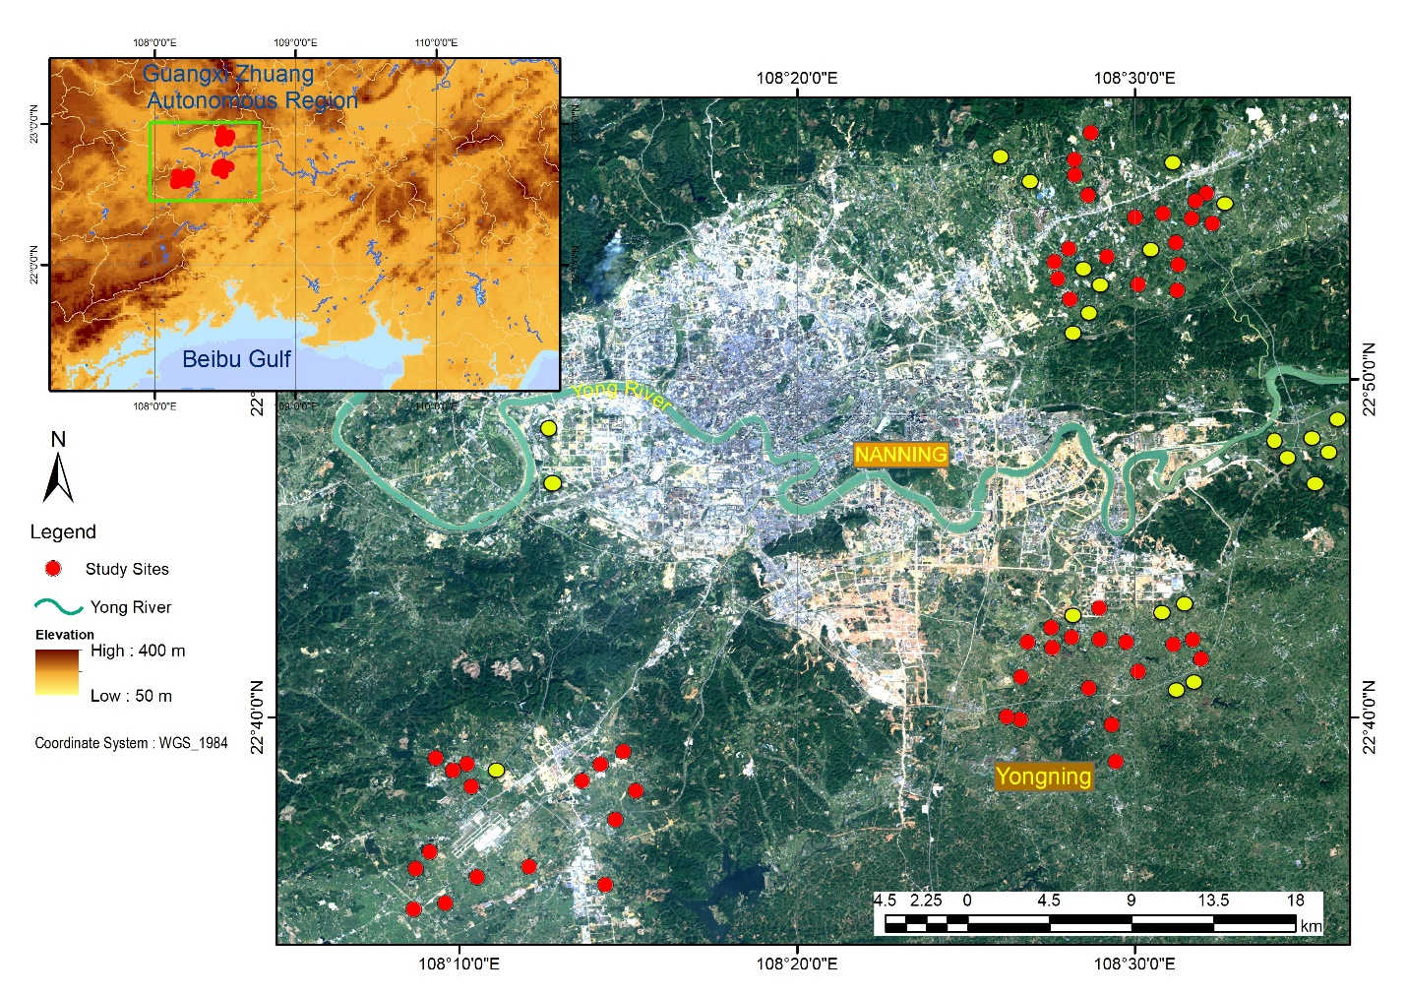
Figure S1. A map of the study site network (75 = 52 red circles + 23 yellow circles) near the city of Nanning, the capital of Guangxi Zhuang Autonomous Region in southern China. Red circles represent the sites where insect data was collected.

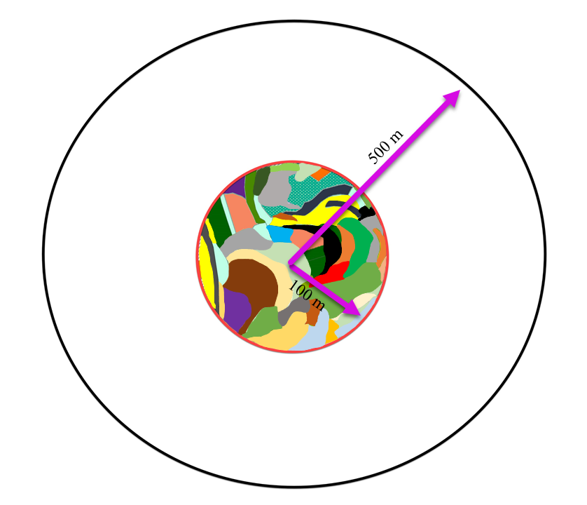
Figure S2. An example diagram of local scale (100 m radius) and landscape scale (500 m radius). Different colors in the 100 m radius cycle represent local scale features (e.g. different crop types, non-crop weedy vegetation).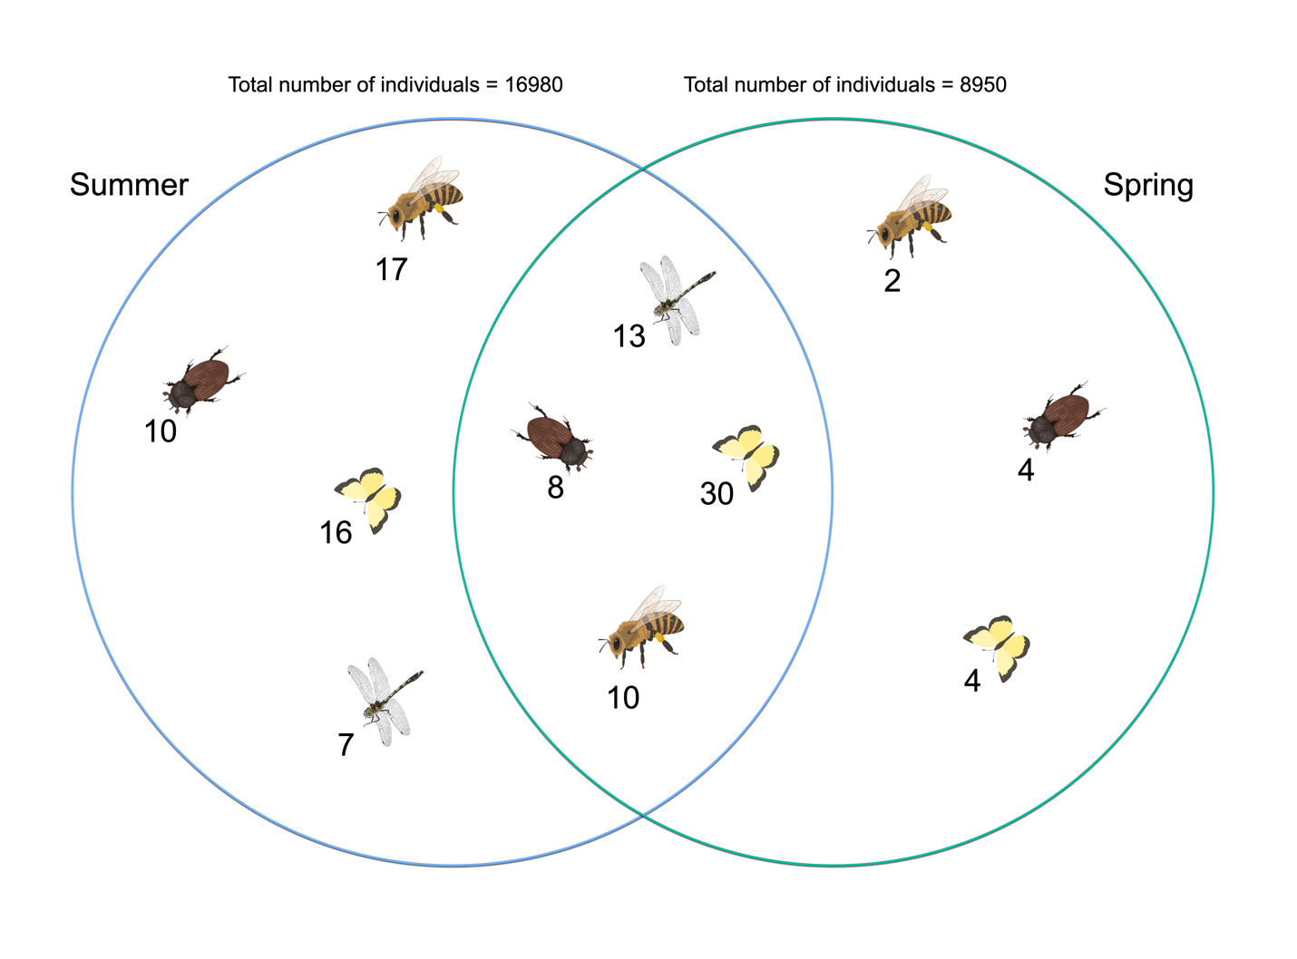Figure S3. A Venn diagram describing the temporal dynamics of each insect group, showing the total number of species that were shared between seasons or were unique to them. In summer: 13238 individuals of dung beetles from 18 species, 611 individuals of bees from 27 species, 1274 individuals of dragonflies/damselflies from 20 species, and 1857 individual of butterflies from 46 species. In spring: 6402 individuals of dung beetles from 12 species, 298 individuals of bees from 12 species, 823 individuals of dragonflies/damselflies from 13 species, and 1427 individuals of butterflies from 34 species.

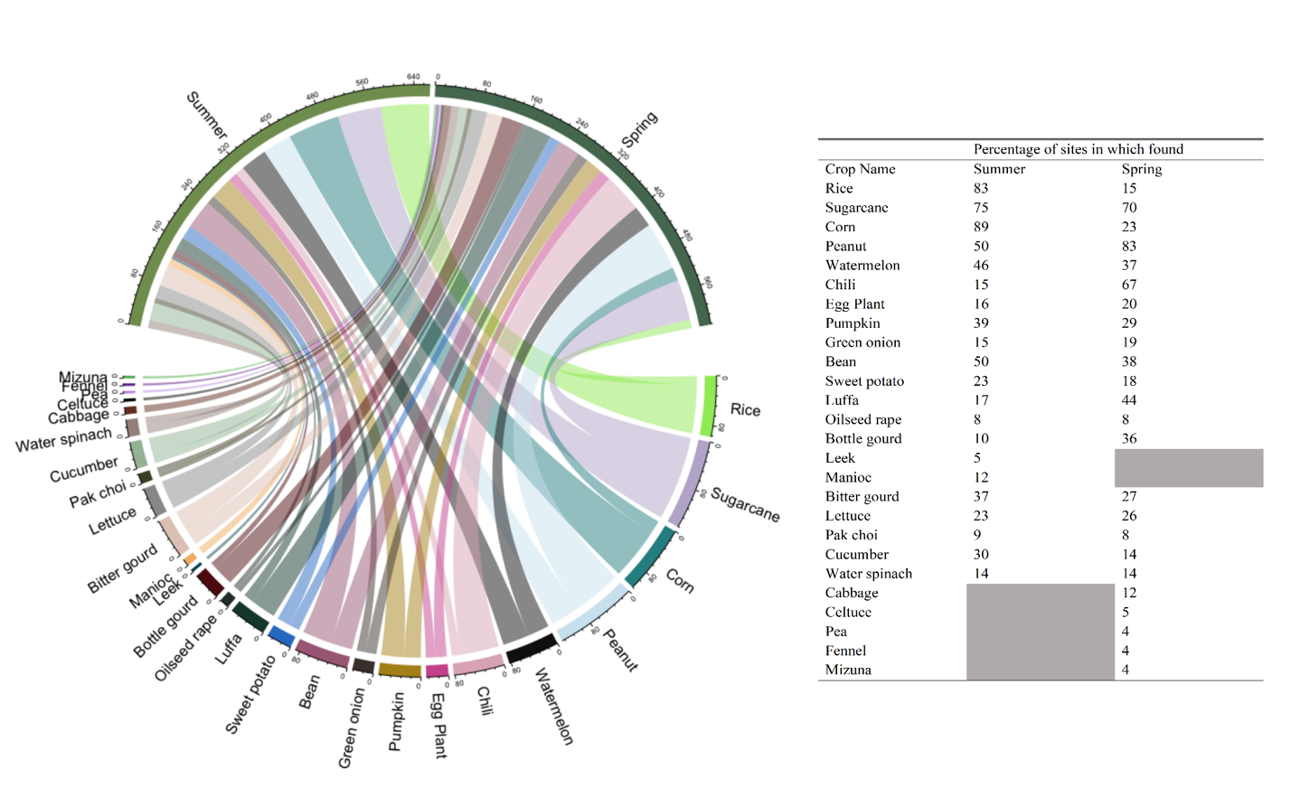
Figure S4. Crop list for summer and spring with site occupancies of each crop as a percentage.
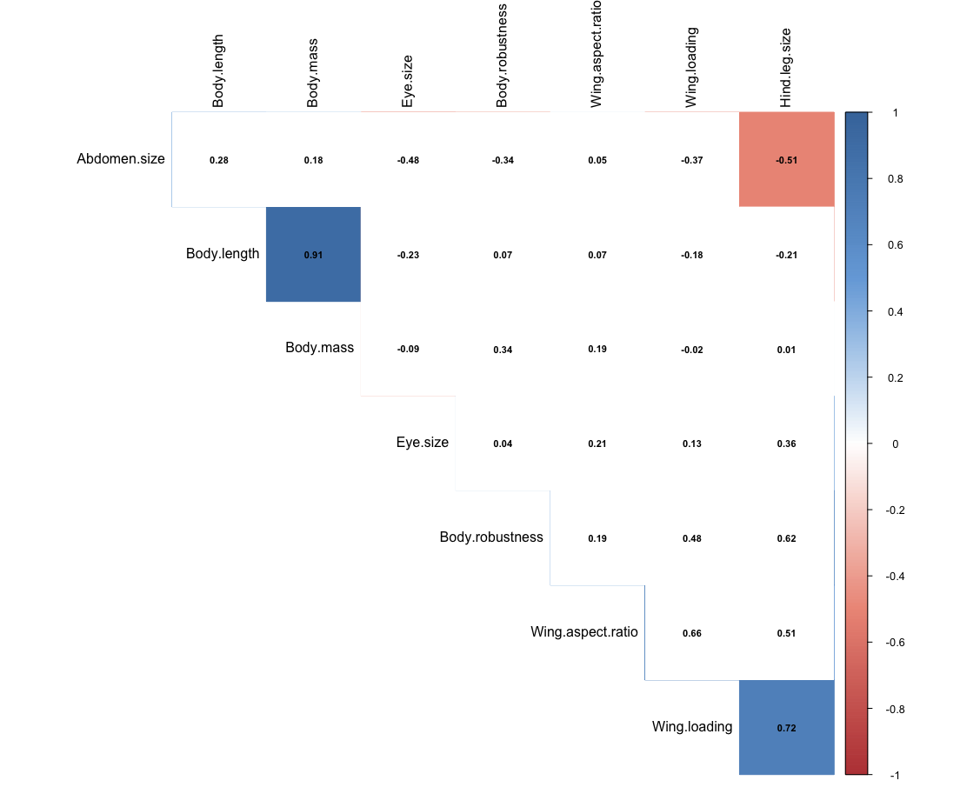

Figure S5. Pearson correlation values between dung beetle functional traits. Functional traits that are highly corelated at α-level of 0.01 are highlighted, see the colored scale on the right side.

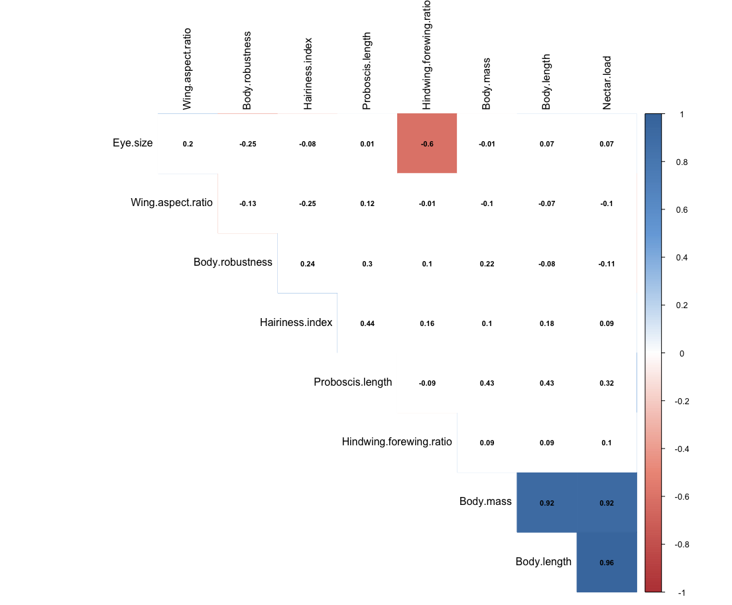

Figure S6. Pearson correlation values between bee functional traits. Details as in Figure S5.

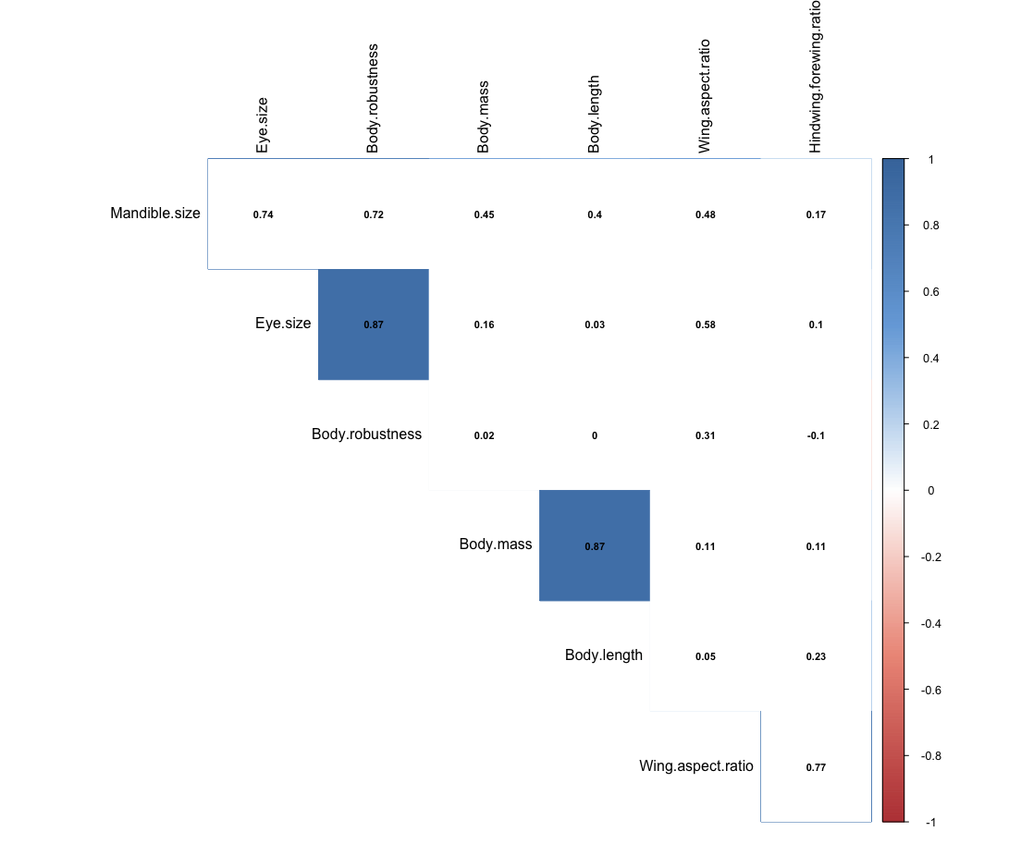

Figure S7. Pearson correlation values between Dragonfly/Damselfly functional traits. Details as in Figure S5.

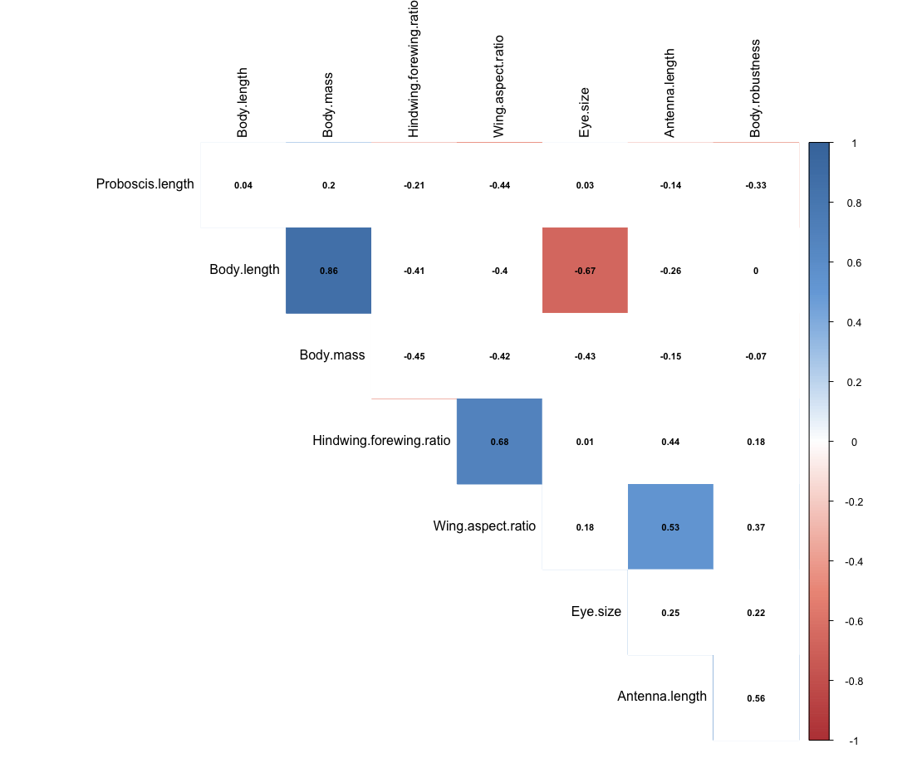

Figure S8. Pearson correlation values between butterfly functional traits. Details as in Figure S5.

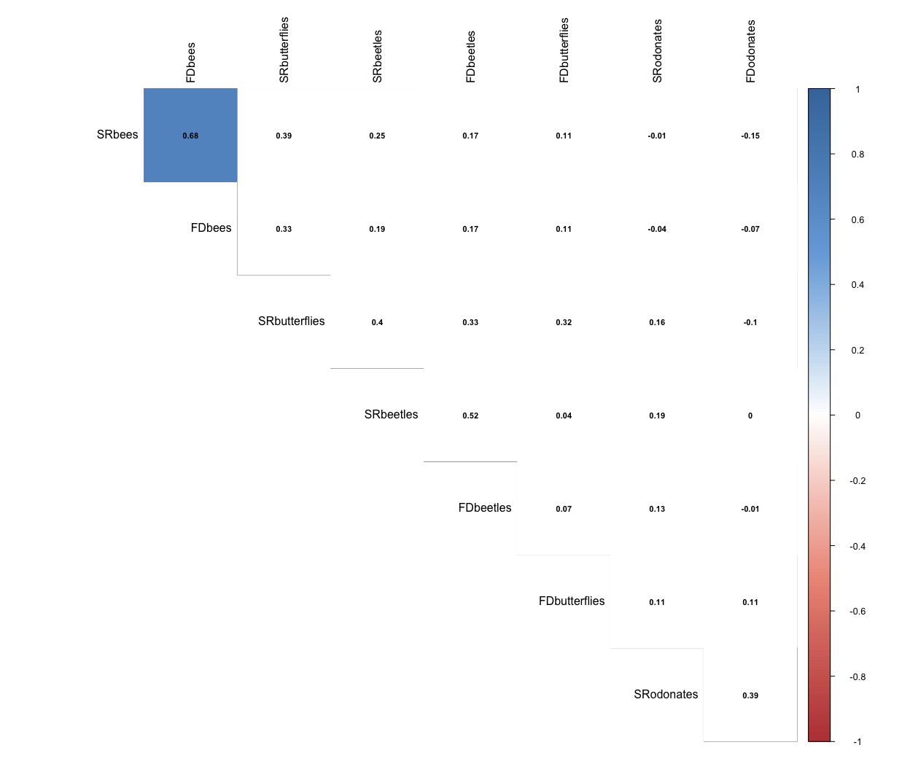
Figure S9. Pearson correlation values between species richness (SR) and functional dispersion (FD) indices in summer. Details as in Figure S5.
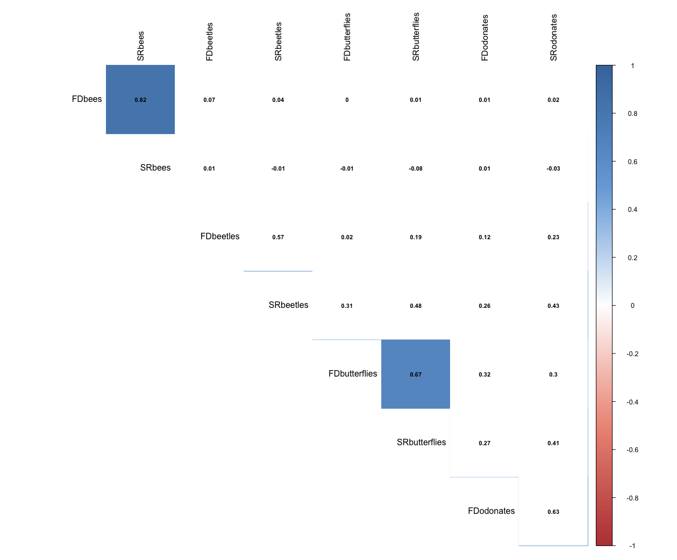
Figure S10. Pearson correlation values between species richness (SR) and functional dispersion (FD) indices in spring. Details as in Figure S5.
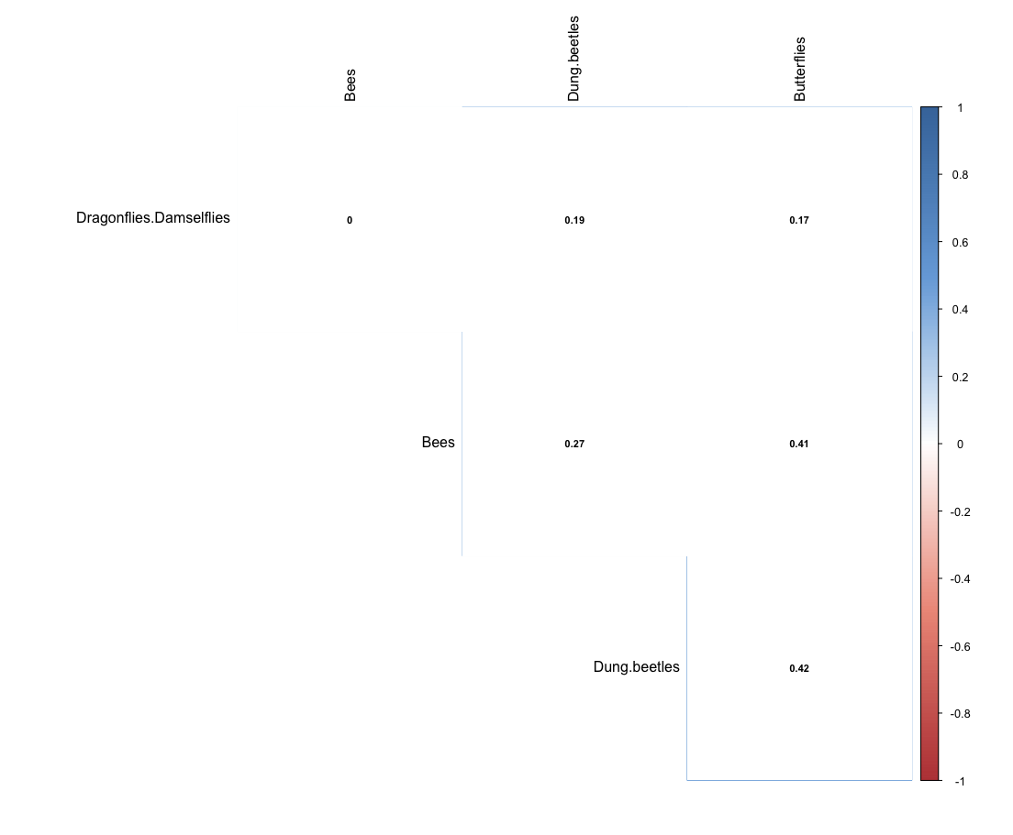
Figure S11. Pearson correlation values between species richness of each insect group in summer. Details as in Figure S5.

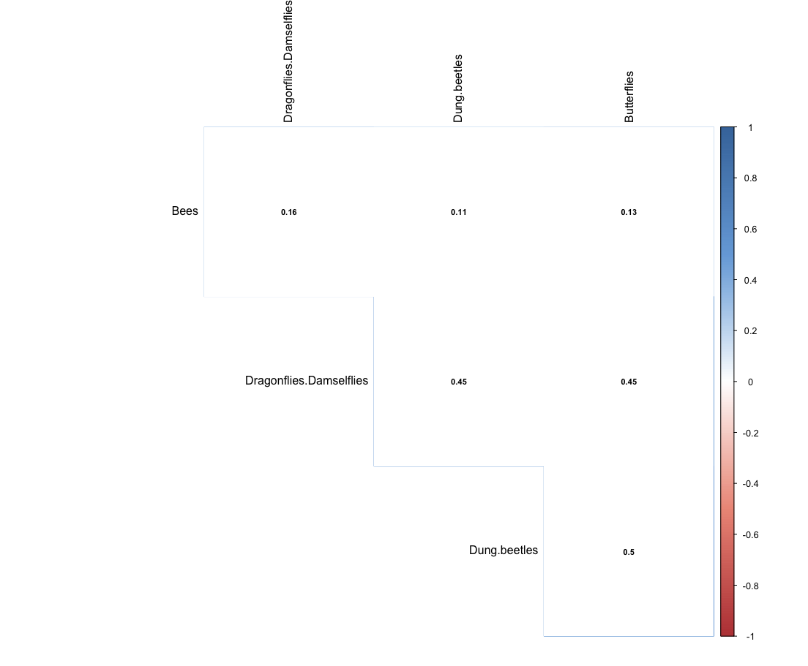
Figure S12. Pearson correlation values between species richness of each insect group in spring. Details as in Figure S5.

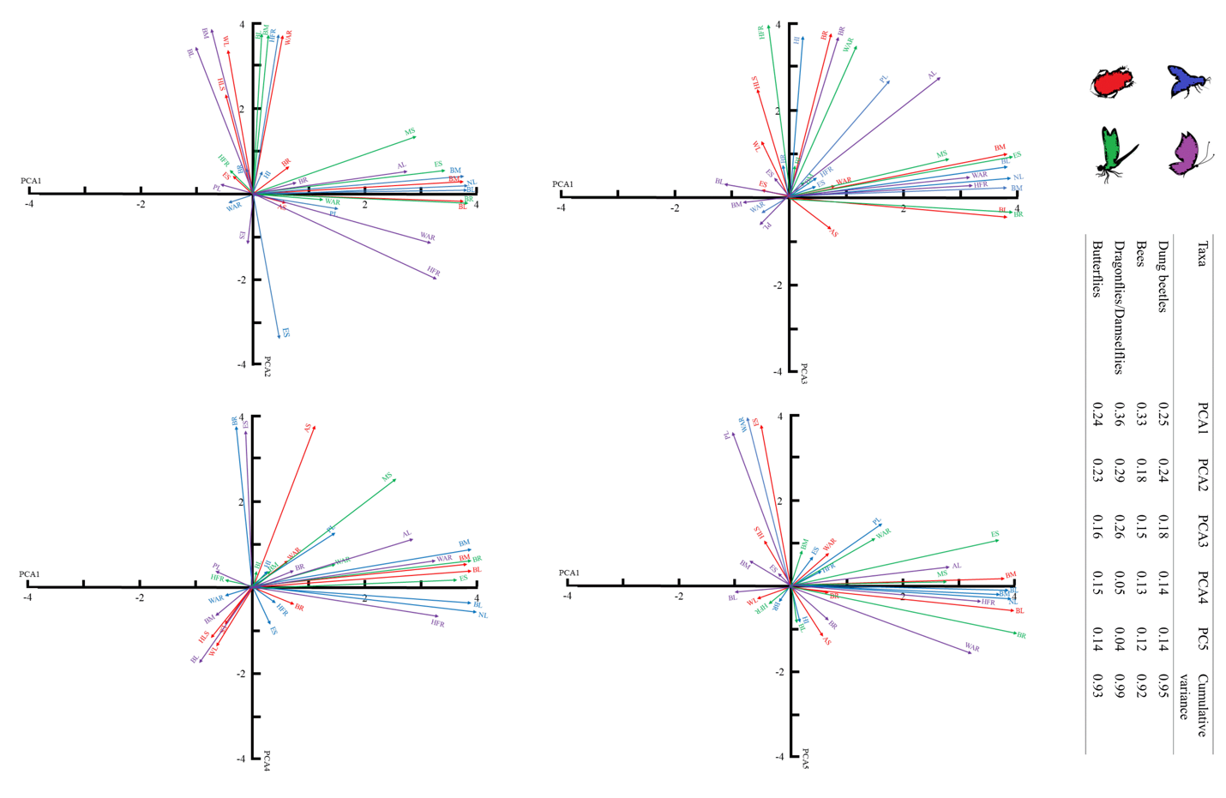
Figure 13. Relationships between the functional traits of multiple beneficial insects identified in a Principal Component Analysis (PCA) analysis (). BL = Body length, BM = Body mass, ES = Eye size, WAR = Wing aspect ratio, BR = Body robustness, HFR = Hindwing-forewing ratio, AS = Abdomen size, HLS = Hind leg size, WL = Wing-loading, MS = Mandible size, PL = Proboscis length, HI = Hairiness index, NL = Nectar load, AL = Antenna length. Variance explained by each PCA axis is presented in the table next to PCA diagrams. Red arrows for dung beetle traits, blue arrows for bee traits, green arrows for dragonfly/damselfly traits and purple arrows for butterfly traits.

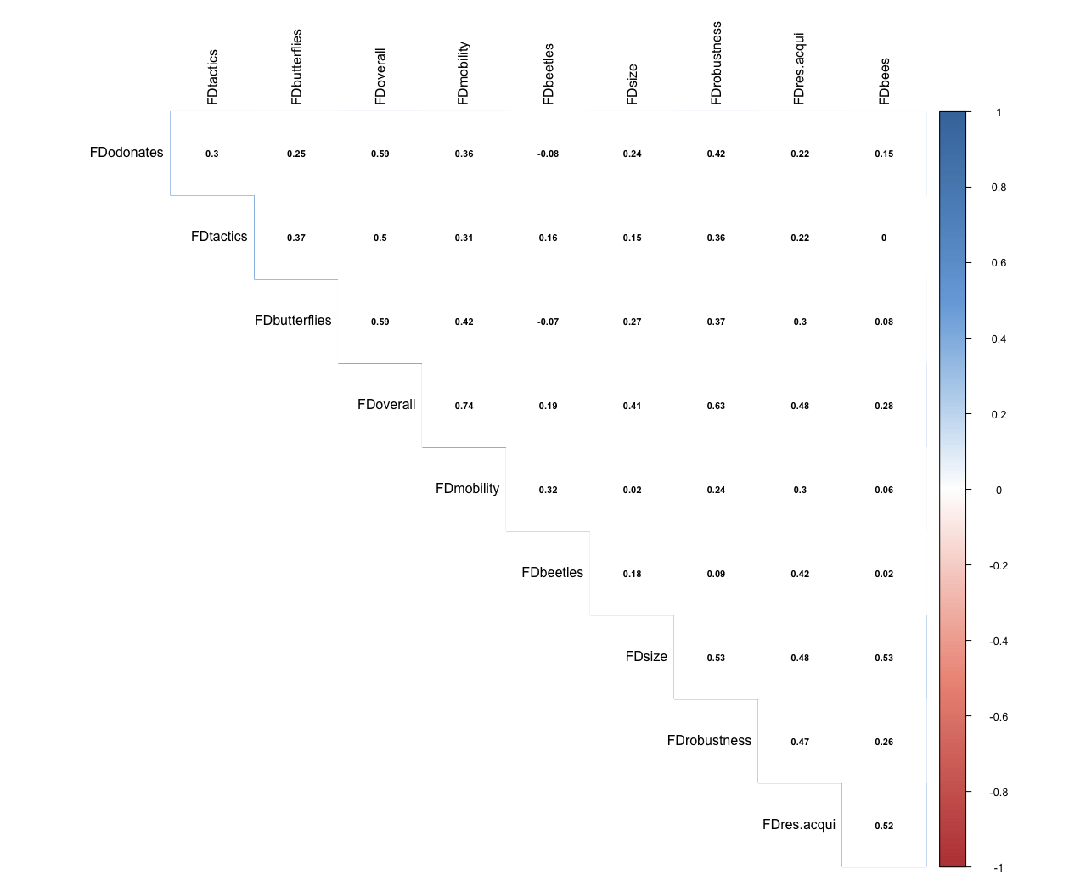
Figure S14. Pearson correlation values between different types of overall functional diversity indices (see section 2.6.2) in summer. Details as in Figure S5.
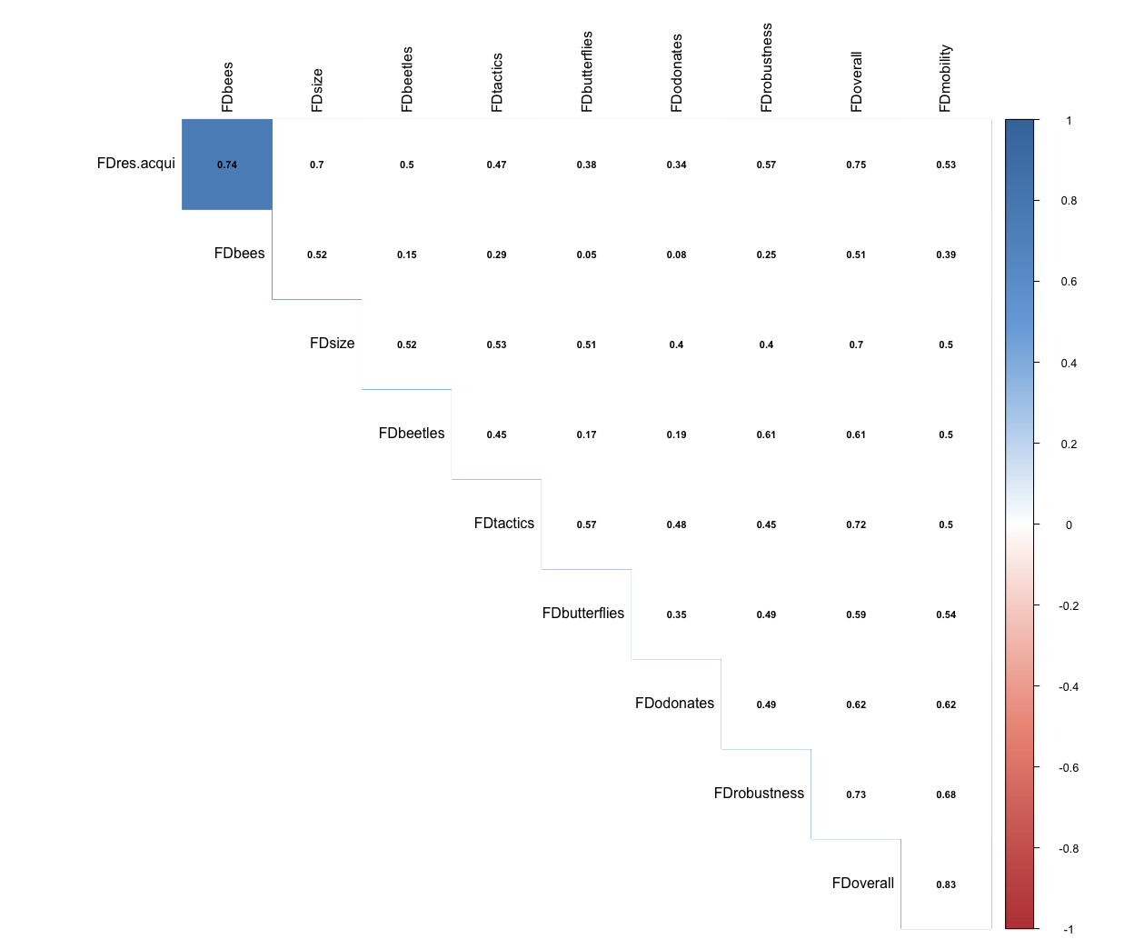
Figure S15. Pearson correlation values between different types of overall functional diversity indices (see section 2.6.2) in spring. Details as in Figure S5.
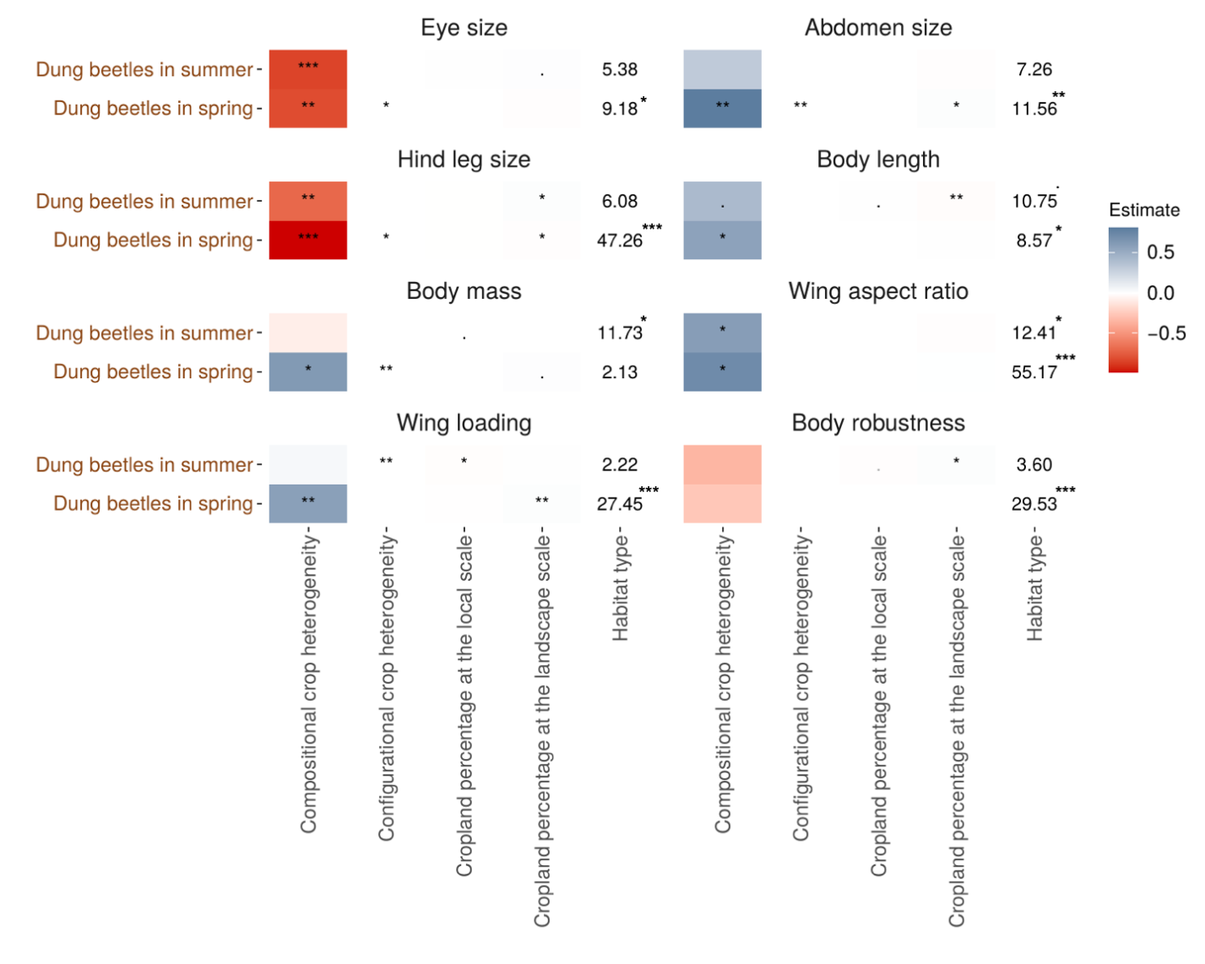
Figure S16. Effects of local scale and landscape variables (see section 2.6.3) on different types of dung beetle functional traits (standardized) in summer and spring (see Appendix S5). Habitat type is a categorical variable (see section 2.4), thus X² values are presented. Significance codes (p-values): 0 ‘***’ 0.001 ‘**’ 0.01 ‘*’ 0.05 ‘.’ 0.1. Symbols in grey and/or white indicate nonsignificant effects after controlling for false discovery rates (20% threshold).

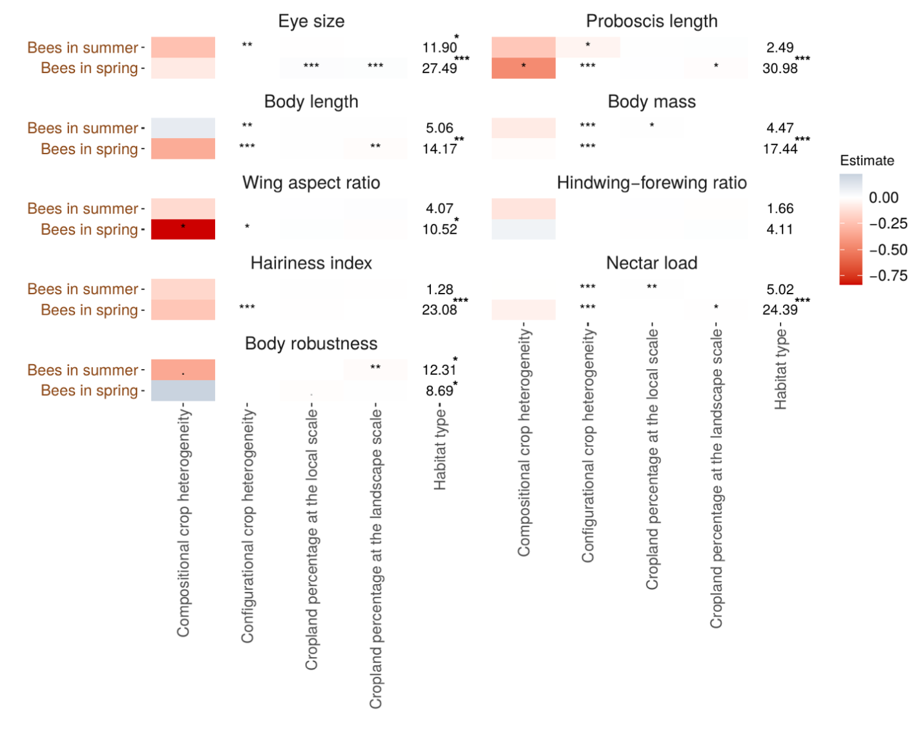
Figure S17. Effects of local scale and landscape variables (see section 2.6.3) on different types of bee functional traits (standardized) in summer and spring (see Appendix S5). Details as in Figure S16.
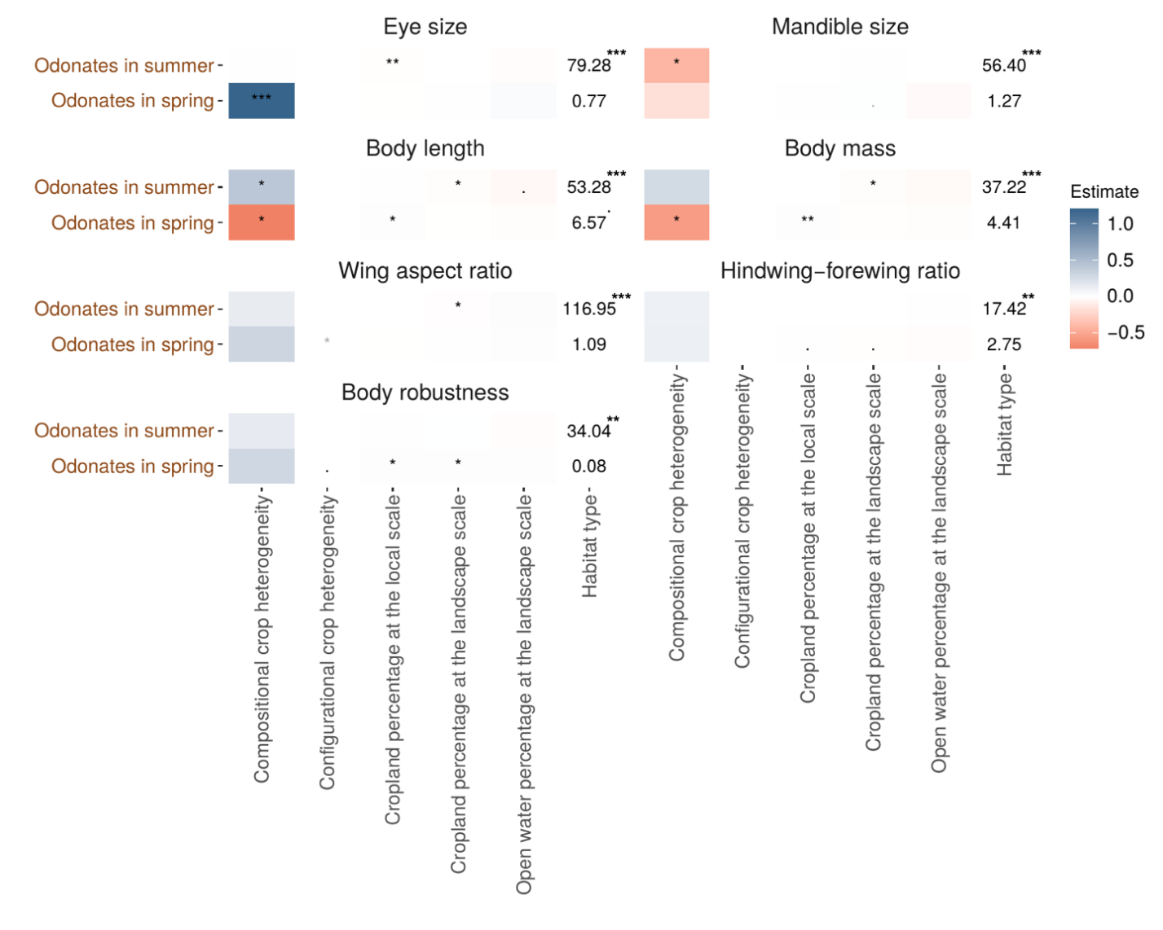Figure S18. Effects of local scale and landscape variables (see section 2.6.3) on different types of dragonfly/damselfly (odonates) functional traits (standardized) in summer and spring (see Appendix S5). Details as in Figure S16.
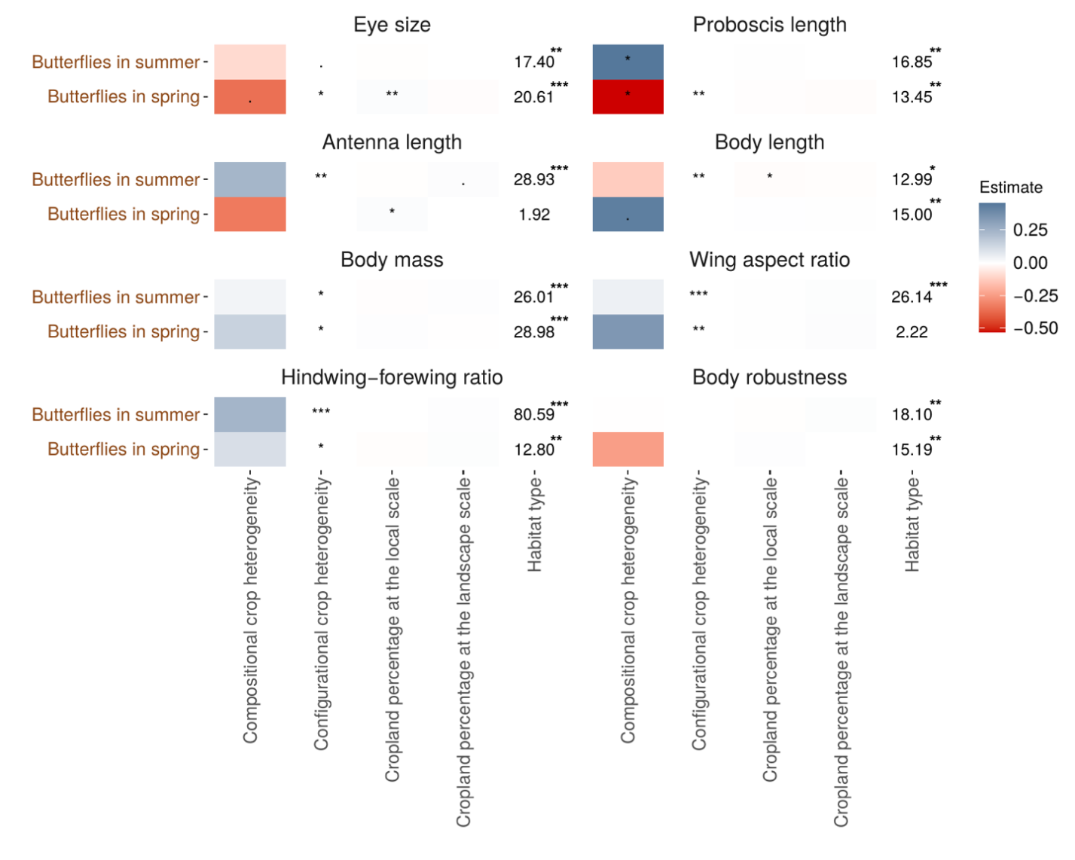
Figure S19. Effects of local scale and landscape variables (see section 2.6.3) on different types of butterfly functional traits (standardized) in summer and spring (see Appendix S5). Details as in Figure S16.
4. Supplementary References
Barton, K. (2019). MuMIn: Multi-model inference. R package version 1.42.1 (pp. 1–75). pp. 1–75. Retrieved from https://cran.r-project.org/web/packages/MuMIn/MuMIn.pdf
Barton, P. S., Gibb, H., Manning, A. D., Lindenmayer, D. B., & Cunningham, S. A. (2011). Morphological traits as predictors of diet and microhabitat use in a diverse beetle assemblage. Biological Journal of the Linnean Society, 102(2), 301–310. doi: 10.1111/j.1095-8312.2010.01580.x
Bauder, J. A. S., Handschuh, S., Metscher, B. D., & Krenn, H. W. (2013). Functional morphology of the feeding apparatus and evolution of proboscis length in metalmark butterflies (Lepidoptera: Riodinidae). Biological Journal of the Linnean Society, 110(2), 291–304. doi: 10.1111/bij.12134
Bauer, T., & Kredler, M. (1993). Morphology of the compound eyes as an indicator of life-style in carabid beetles. Canadian Journal of Zoology, 71(4), 799–810. doi: 10.1139/z93-105
Berwaerts, K., Van Dyck, H., & Aerts, P. (2002). Does flight morphology relate to flight performance? an experimental test with the butterfly Pararge aegeria. Functional Ecology, 16(4), 484–491. doi: 10.1046/j.1365-2435.2002.00650.x
Blanke, A., Schmitz, H., Patera, A., Dutel, H., & Fagan, M. J. (2017). Form-function relationships in dragonfly mandibles under an evolutionary perspective. Journal of the Royal Society, Interface, 14(128). doi: 10.1098/rsif.2016.1038
Breheny, P., & Burchett, W. (2018). visreg: visualization of regression models. R package version 2.5-0 (pp. 1–15). pp. 1–15. Retrieved from https://cran.r-project.org/web/packages/visreg/visreg.pdf
Cariveau, D. P., Nayak, G. K., Bartomeus, I., Zientek, J., Ascher, J. S., Gibbs, J., & Winfree, R. (2016). The allometry of bee proboscis length and its uses in ecology. PLoS ONE, 11(3), 1–13. doi: 10.1371/journal.pone.0151482
de la Mora, A., Pérez-Lachaud, G., & Lachaud, J. P. (2008). Mandible strike: the lethal weapon of Odontomachus opaciventris against small prey. Behavioural Processes, 78(1), 64–75. doi: 10.1016/j.beproc.2008.01.011
de Palma, A., Kuhlmann, M., Roberts, S. P. M., Potts, S. G., Börger, L., Hudson, L. N., … Purvis, A. (2015). Ecological traits affect the sensitivity of bees to land-use pressures in European agricultural landscapes. Journal of Applied Ecology, 52(6), 1567–1577. doi: 10.1111/1365-2664.12524
Dias, T. C., Bello, F. De, Altermatt, F., Moretti, M., Bell, J. R., Fournier, B., … Berg, M. P. (2017). Handbook of protocols for standardized measurement of terrestrial invertebrate functional traits. Functional Ecology, 31(3), 558–567. doi: 10.1111/1365-2435.12776
Fahrig, L., Baudry, J., Brotons, L., Burel, F. G., Crist, T. O., Fuller, R. J., … Martin, J.-L. (2011). Functional landscape heterogeneity and animal biodiversity in agricultural landscapes. Ecology Letters, 14(2), 101–112. doi: 10.1111/j.1461-0248.2010.01559.x
Fahrig, L., Girard, J., Duro, D., Pasher, J., Smith, A., Javorek, S., … Tischendorf, L. (2015). Farmlands with smaller crop fields have higher within-field biodiversity. Agriculture, Ecosystems and Environment, 200, 219–234. doi: 10.1016/j.agee.2014.11.018
Goulson, D., Hanley, M. E., Darvill, B., Ellis, J. S., & Knight, M. E. (2005). Causes of rarity in bumblebees. Biological Conservation, 122(1), 1–8. doi: 10.1016/j.biocon.2004.06.017
Grab, H., Brokaw, J., Anderson, E., Gedlinske, L., Gibbs, J., Wilson, J., … Poveda, K. (2019). Habitat enhancements rescue bee body size from the negative effects of landscape simplification. Journal of Applied Ecology, 56(9), 2144–2154. doi: 10.1111/1365-2664.13456
Harano, K. ichi, & Nakamura, J. (2016). Nectar loads as fuel for collecting nectar and pollen in honeybees: adjustment by sugar concentration. Journal of Comparative Physiology A: Neuroethology, Sensory, Neural, and Behavioral Physiology, 202(6), 435–443. doi: 10.1007/s00359-016-1088-x
Henry, M., & Rodet, G. (2018). Controlling the impact of the managed honeybee on wild bees in protected areas. Scientific Reports, 8(1), 1–10. doi: 10.1038/s41598-018-27591-y
Jain, A., Kunte, K., & Webb, E. L. (2016). Flower specialization of butterflies and impacts of non-native flower use in a transformed tropical landscape. Biological Conservation, 201, 184–191. doi: 10.1016/j.biocon.2016.06.034
Jantzen, B., & Eisner, T. (2008). Hindwings are unnecessary for flight but essential for execution of normal evasive flight in Lepidoptera. Proceedings of the National Academy of Sciences of the United States of America, 105(43), 16636–16640. doi: 10.1073/pnas.0807223105
Janzen, D. H. (1973). Sweep samples of tropical foliage insects: effects of seasons, vegetation types, elevation, time of day, and insularity. Ecology, 54(3), 687–708. doi: 10.2307/1935359
Ji, K. W., & Sun, M. (2005). A computational study of the aerodynamics and forewing-hindwing interaction of a model dragonfly in forward flight. Journal of Experimental Biology, 208(19), 3785–3804. doi: 10.1242/jeb.01852
Kendall, L. K., Rader, R., Gagic, V., Cariveau, D. P., Albrecht, M., Baldock, K. C. R., … Bartomeus, I. (2019). Pollinator size and its consequences: Robust estimates of body size in pollinating insects. Ecology and Evolution, 9(4), 1702–1714. doi: 10.1002/ece3.4835
Kendall, M. L., Bartomeus, I., & Sutter, L. (2018). pollimetry: estimate pollinator body size and co-varying ecological traits. R package version 1.0.1 (pp. 1–10). pp. 1–10. doi: 10.1101/397604>.Depends
Klumpers, S. G. T., Stang, M., & Klinkhamer, P. G. L. (2019). Foraging efficiency and size matching in a plant–pollinator community: the importance of sugar content and tongue length. Ecology Letters, 22(3), 469–479. doi: 10.1111/ele.13204
Kunte, K. (2007). Allometry and functional constraints on proboscis lengths in butterflies. Functional Ecology, 21(5), 982–987. doi: 10.1111/j.1365-2435.2007.01299.x
Laliberté, E., Legendre, P., & Shipley, B. (2015). FD: measuring functional diversity from multiple traits, and other tools for functional ecology. R package version 1.0-12. R Package, p. Version 1.0-12.
Larsen, T. H. (2005). Trap spacing and transect design for dung beetle biodiversity studies. Biotropica, 37(2), 322–325. doi: 10.1111/j.1744-7429.2005.00042.x
Martin, A. R., & Isaac, M. E. (2018). Functional traits in agroecology: advancing description and prediction in agroecosystems. Journal of Applied Ecology, 55(1), 5–11. doi: 10.1111/1365-2664.13039
Micó, E., Ramilo, P., Thorn, S., Müller, J., Galante, E., & Carmona, C. P. (2020). Contrasting functional structure of saproxylic beetle assemblages associated to different microhabitats. Scientific Reports, 10(1), 1–11. doi: 10.1038/s41598-020-58408-6
Neff, F., Blüthgen, N., Chisté, M. N., Simons, N. K., Steckel, J., Weisser, W. W., … Gossner, M. M. (2019). Cross-scale effects of land use on the functional composition of herbivorous insect communities. Landscape Ecology, 34(8), 2001–2015. doi: 10.1007/s10980-019-00872-1
Nervo, B., Tocco, C., Caprio, E., Palestrini, C., & Rolando, A. (2014). The effects of body mass on dung removal efficiency in dung beetles. PLoS ONE, 9(9), 1–9. doi: 10.1371/journal.pone.0107699
Ortega-Martínez, I. J., Moreno, C. E., Rios-Díaz, C. L., Arellano, L., Rosas, F., & Castellanos, I. (2020). Assembly mechanisms of dung beetles in temperate forests and grazing pastures. Scientific Reports, 10(1), 1–10. doi: 10.1038/s41598-019-57278-x
Piccini, I., Nervo, B., Forshage, M., Celi, L., Palestrini, C., Rolando, A., & Roslin, T. (2018). Dung beetles as drivers of ecosystem multifunctionality: are response and effect traits interwoven? Science of the Total Environment, 616–617, 1440–1448. doi: 10.1016/j.scitotenv.2017.10.171
Pinheiro, J., Bates, D., DebRoy, S., Sarkar, D., Heisterkamp, S., van Willigen, B., & Maintainer, R. (2019). nlme: linear and nonlinear mixed effects models. R package version 3.1-138 (pp. 1–337). pp. 1–337. Retrieved from https://cran.r-project.org/web/packages/nlme/nlme.pdf
Provosta, G. Le, Badenhausser, I., Bagousse-pinguet, L. Y., Clough, Y., Henckela, L., Viollei, C., … Gross, N. (2020). Land-use history impacts functional diversity across multiple trophic groups. Proceedings of the National Academy of Sciences, 1–7. doi: 10.1073/pnas.1910023117
Purvis, A., Gittleman, J. L., Cowlishaw, G., & Mace, G. M. (2000). Predicting extinction risk in declining species. Proceedings of the Royal Society B: Biological Sciences, 267(1456), 1947–1952. doi: https://doi.org/10.1098/rspb.2000.1234
Raine, E. H., Gray, C. L., Mann, D. J., & Slade, E. M. (2018). Tropical dung beetle morphological traits predict functional traits and show intraspecific differences across land uses. Ecology and Evolution, 8(17), 8686–8696. doi: 10.1002/ece3.4218
Rodney, S., & Purdy, J. (2020). Dietary requirements of individual nectar foragers, and colony-level pollen and nectar consumption: a review to support pesticide exposure assessment for honey bees. Apidologie, 51(2), 163–179. doi: 10.1007/s13592-019-00694-9
Roquer-Beni, L., Rodrigo, A., Arnan, X., Klein, A. M., Fornoff, F., Boreux, V., & Bosch, J. (2020). A novel method to measure hairiness in bees and other insect pollinators. Ecology and Evolution, 10(6), 2979–2990. doi: 10.1002/ece3.6112
Rüppell, G., & Hilfert-Rüppell, D. (2013). Biting in dragonfly fights. International Journal of Odonatology, 16(3), 219–229. doi: 10.1080/13887890.2013.804364
Saint-Germain, M., Buddle, C. M., Larrivée, M., Mercado, A., Motchula, T., Reichert, E., … Webb, A. (2007). Should biomass be considered more frequently as a currency in terrestrial arthropod community analyses? Journal of Applied Ecology, 44(2), 330–339. doi: 10.1111/j.1365-2664.2006.01269.x
Salcedo, M. K., Hoffmann, J., Donoughe, S., & Mahadevan, L. (2019). Computational analysis of size, shape and structure of insect wings. Biology Open, 8(10), 1–9. doi: 10.1242/bio.040774
Schütz, S., Weissbecker, B., Hummel, H. E., Apel, K. H., Schmitz, H., & Bleckmann, H. (1999). Insect antenna as a smoke detector. Nature, 398(6725), 298–299. doi: 10.1038/18585
Srygley, R. B., & Chai, P. (1990). Flight morphology of Neotropical butterflies: palatability and distribution of mass to the thorax and abdomen. Oecologia, 84(4), 491–499. doi: 10.1007/BF00328165
Stavert, J. R., Liñán-Cembrano, G., Beggs, J. R., Howlett, B. G., Pattemore, D. E., & Bartomeus, I. (2016). Hairiness: the missing link between pollinators and pollination. PeerJ, 2016(12), 1–18. doi: 10.7717/peerj.2779
Sutton, G. P., Clarke, D., Morley, E. L., & Robert, D. (2016). Mechanosensory hairs in bumblebees (Bombus terrestris) detect weak electric fields. Proceedings of the National Academy of Sciences of the United States of America, 113(26), 7261–7265. doi: 10.1073/pnas.1601624113
Wood, S. A., Karp, D. S., Declerck, F., Kremen, C., Naeem, S., & Palm, C. A. (2015). Functional traits in agriculture : agrobiodiversity and ecosystem services. Trends in Ecology & Evolution, (9), 1–9. doi: 10.1016/j.tree.2015.06.013
Woodcock, B. A., Garratt, M. P. D., Powney, G. D., Shaw, R. F., Osborne, J. L., Soroka, J., … Pywell, R. F. (2019). Meta-analysis reveals that pollinator functional diversity and abundance enhance crop pollination and yield. Nature Communications, 10(1), 1–10. doi: 10.1038/s41467-019-09393-6
Woodcock, B. A., Redhead, J., Vanbergen, A. J., Hulmes, L., Hulmes, S., Peyton, J., … Heard, M. S. (2010). Impact of habitat type and landscape structure on biomass, species richness and functional diversity of ground beetles. Agriculture, Ecosystems and Environment, 139(1–2), 181–186. doi: 10.1016/j.agee.2010.07.018
Zhou, W., Lee, M.-B., & Goodale, E. (2018). The relationship between the diversity of herbaceous plants and the extent and heterogeneity of croplands in noncrop vegetation in an agricultural landscape of south China. Global Ecology and Conservation, 14, 1–10. doi: 10.1016/j.gecco.2018.e00399

