SOLUTION

DOCUMENT


Project Name – School Management

Client Name/Company – SkoolBag

Address –

Contact -

ABOUT ME


Tharaka Madhusanka - BSc(Hons) Information Technology - University of Moratuwa, Sri Lanka.

6+ Years On-Hand Experience -FullStack Developer | Professional Software Engineer & a Freelancer.

Technopreneur | GeeK WolF | NooB | CoffeE | MusicK

MY STACK

Web Applications Mobile Applications API Develop & Integrations
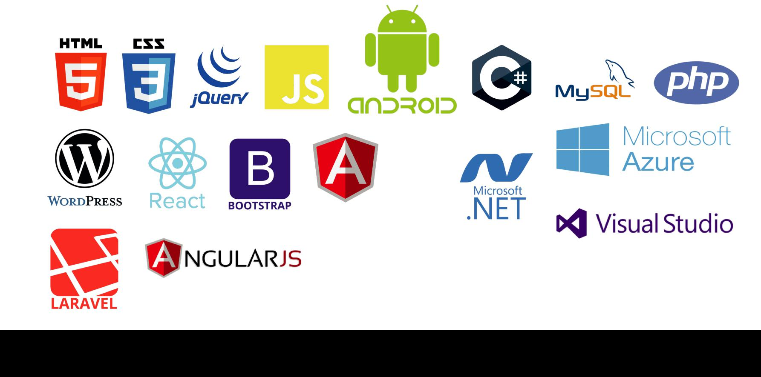

Reach Me: madhusanka.tharaka@outlook.com | +94715196105

- Project Description & Category

Develop & Design Front End & Back End API for School Management System.

Features –

- Displays List of Schools
- Schools can be added, edited, deleted & searched.

Project Category – Web Application Development

2 Architecture & Overview

- Web API Middleware – This is RESTFUL web API Middleware which manages the data transactions between the web application and the database.
This is developed using Node.js & Express.js.
This is developed according to the Singleton Design Pattern & Repository Design Pattern.
Overall application architecture is MVC.

Web API Design Overview

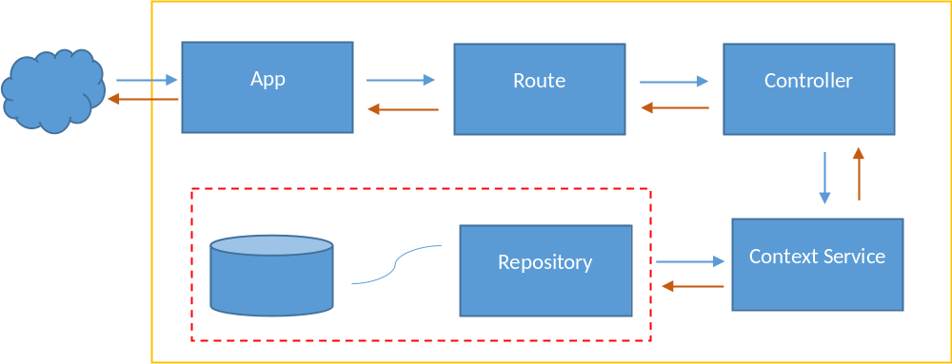

Reach Me: madhusanka.tharaka@outlook.com | +94715196105

Reach Me: madhusanka.tharaka@outlook.com | +94715196105

Item | Purpose/Task
App
Route | Specific type of Route Handler
Controller | Controller for specific Entity where Handle all the Entity Specific Business Logic
Context Service | Service Class which handles all the DB Transactions. Generic Service.
Repository | Create DB Instance. Set up the Connectivity Bridge with the Db.

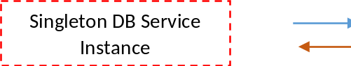

Response (Success) | Status Code – 200 OK
 | Response Body – JSON Object Array
Response (Failure) | Status Code – 404 Internal Server Error
 | Response Body – Not Found…

Data Transmission

API Details

- Get List Of Schools

Returns the Active list of schools, with or without Filtering by Page Number, No of Rows & Search by Parameters.

This API doesn’t bring all the schools list at once, else it brings schools list block wise (Pagination Enabled).

This API returns only the ‘Active’ schools list, which are not deleted.

API Name | GetListOfSchools
URL | api/school/
Type | GET
Query Parameters | searchFor | This parameter used to filter our schools by Name or Address.  This is an Optional Parameter  Case-Sensitive
 | pageNumber | The Page Number you want to list down the schools (Pagination)  Optional Parameter  Case-Sensitive
 | noOfRows | This is to decide how many number of rows to be displayed in the page  Optional Parameter  Case-Sensitive
Headers | Content-type : application/json | Required

Success Test Scenario Postman

- Without Parameters

Tested Environment – localhost

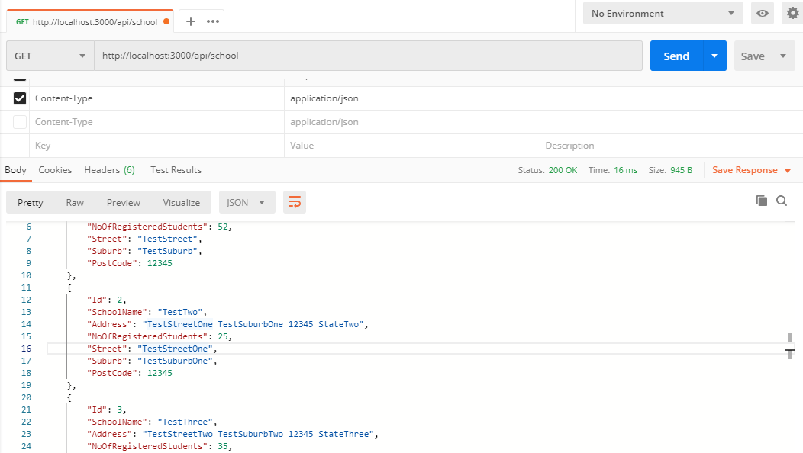

- With Parameters

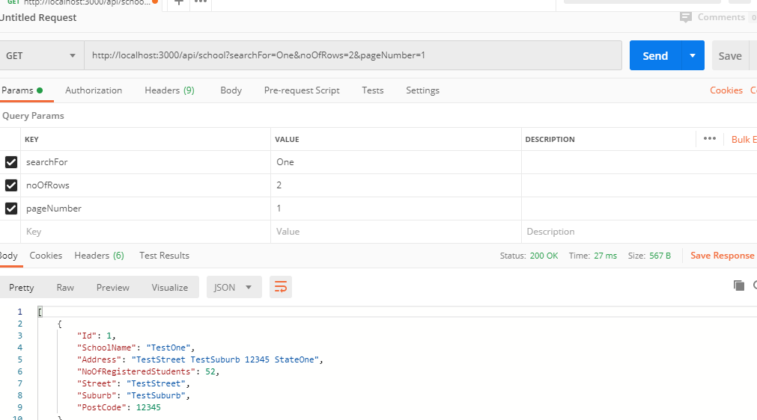

Failure Test Scenario

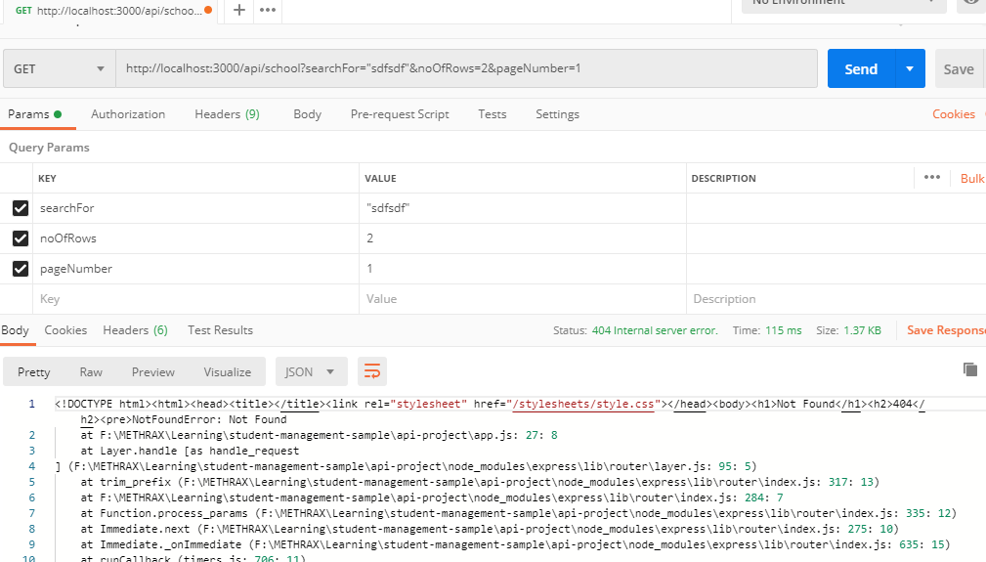

2. Add/Edit/Delete School

For these CRUD operation use Flagged API.

API Name | Update School
URL | api/school/UpdateSchool
Type | POST
Query Parameters | -
Body Parameters | School Id | This is for the School Id  Required only for Delete or Edit School  Case Sensitive
 | Street | This is Street details of School  Required only when Add or Edit  Case Sensitive
 | SchoolName | Name of the School  Required only for Add or Edit
 | StateId | Required only when Add or Edit  Case Sensitive
 | PostCode | Required only when Add or Edit  Case Sensitive
 | NoOfRegisteredStudents | Required only when Add or Edit  Case Sensitive
 | Type | Required  1 – Add  2 - Edit  3 - Delete
Headers | Content-type : application/json | Required
Response (Success) | Status Code – 200 OK
 | Response Body – JSON Object Array
Response (Failure) | Status Code – 404/500 Internal Server Error
 | Response Body – Not Found…/ Stack Trace

Success Response

- Add School

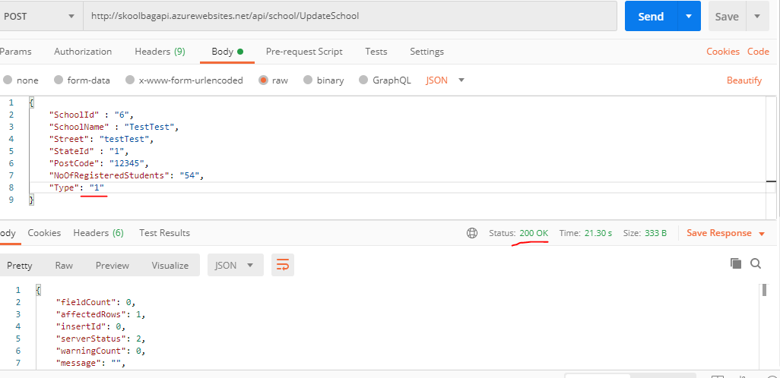

- Update School

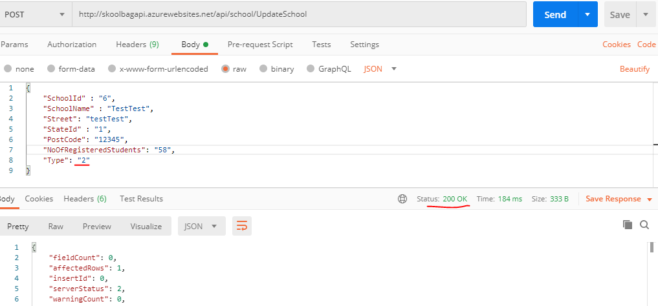

- Delete School

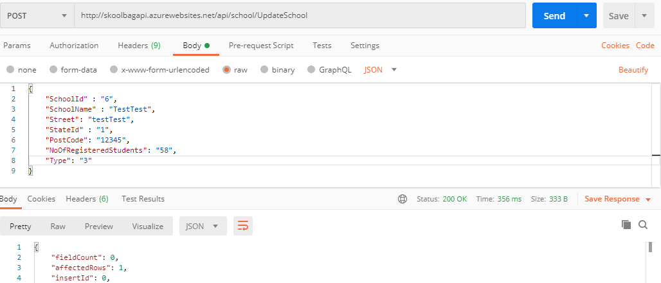

Note – When Delete, School is not completely deleted from the Table, instead maintain ‘IsActive’ flag for each record, by default this flag is set to 1, mean School is active (not deleted). When deleting a school this flag is set to 0.

Failure Response

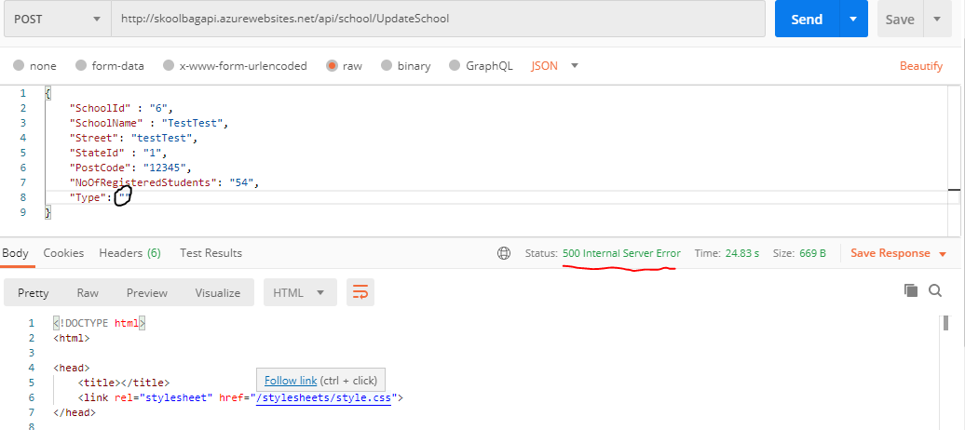

3. Api GetStatesList

This API is to retrieve all the States List.

API Name | GetStates
URL | api/school/getstates
Type | GET
Query Parameters
Headers | Content-type : application/json | Optional
Response (Success) | Status Code – 200 OK
 | Response Body – JSON Object Array
Response (Failure) | Status Code – 404 Internal Server Error
 | Response Body – Not Found…

Success Response

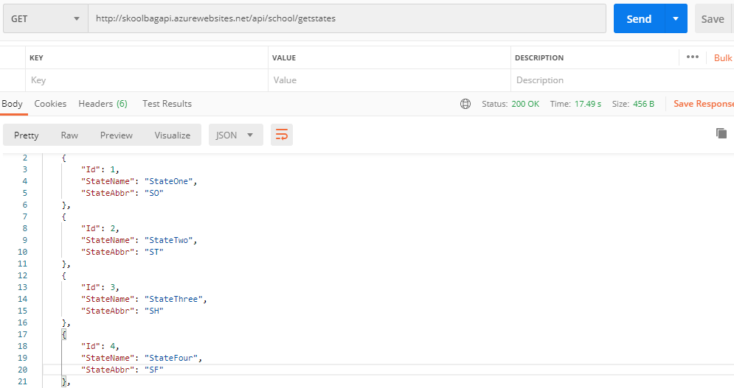

Note – All the above APIs are public and open. No authentication or security enabled

Front End Details

Front End Application is developed on Angular 8.

Application is built with feature modules, thus in the design pattern Angular Lazy Loading.

This has mainly two feature modules.
- Home module – which works as the home of the application
- School Details Module – this manages the data for schools

Each module has its own service class, as in this scenario does not needed to implement common service interface to communicate with internet.

The application is not ‘fully responsive’ or not fully optimized to be fully responsive.


Home Page – Click Enter button to go to School Details

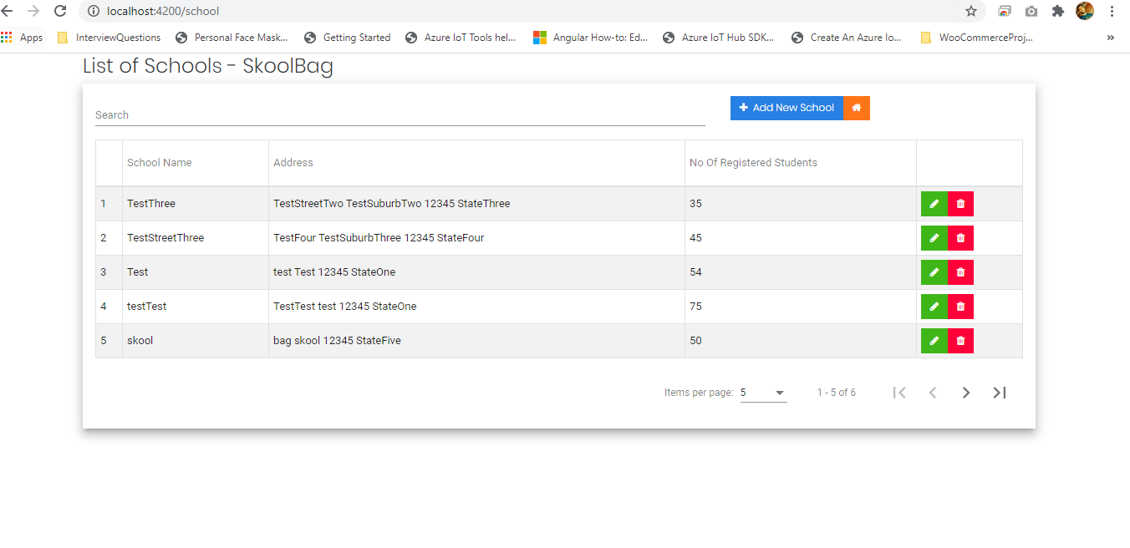
School Details Module

In this module, added following features.

- User can search data, by School Name, Address etc.
- User can add new school
- User can edit existing school details
- User can delete existing school
- Pagination is enabled.

Deployment Details & High-level Architecture

High-level architecture & deployment structure

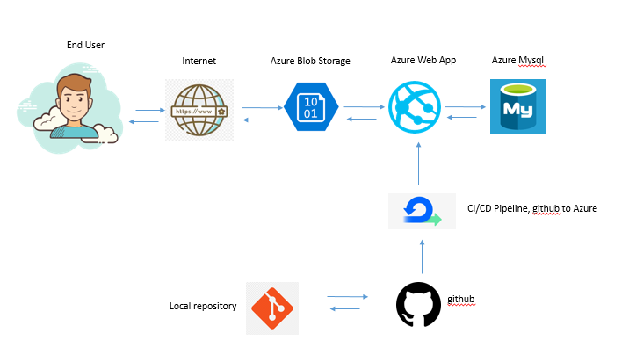

Communication direction

Item | Description & Usage
Azure Blob Storage | To host static web site (Angular web site)
Azure Web App | To host API
Azure Mysql | Mysql Database (Persistence layer)
Github | Code maintain repository

Production Live URLs

Web Site – https://skoolbagweb.z23.web.core.windows.net/

Web API (REST API Base URL) - https://skoolbagapi.azurewebsites.net/api/school/

Repository URL

Web Site – https://github.com/TharakaMadhusanka/school-management-sample-web

Web API - https://github.com/TharakaMadhusanka/school-management-sample
Technology Stack & Versions
3

Technology | Version
Node Js | 10.16.0
Express Js | 4.16.1
Angular | 8
Angular Material | 8.0.1
MySql
Azure

Here mentioned core technology stack used.

Tasks Completed

- Architecture Design & Solution Design
- Designed UI & Implemented
- Front End Development
- REST API Development (Middleware)
- Database Design & Implementation
- Deployment & Service Publishing (DevOps)


Reach Me: madhusanka.tharaka@outlook.com | +94715196105

