

DBMS ASSIGNMENT

**Title:** **Online Vehicle Booking Management System**

By

Team Members:

Devaram Sohan – 21BCE8402

Tharakanadh Sanjay – 21BCE8336

Abdul Aziz – 21BCE8621

Badrinath – 21BCE7620

Team Lead: Devaram Sohan

Slot Number: C1+TC1

Submission Date: 15-03-2023

Course Teacher: Dr.E. Anupriya

School of Computer Science and Engineering

**Problem Statement:**

The system required is for managing the process of purchasing and selling vehicles through a network of dealers and showrooms. The system should be capable of handling tasks such as storing customer information such as their name, address, and mobile number, and assigning a unique customer ID to each customer.

The system should also allow dealers to search for vehicles based on customer specifications such as price, color, and mileage. It should be able to display vehicle images, prices, discounts, and services available from various showrooms.

Once the customer and dealer agree on a vehicle, the system should allow the dealer to finalize the deal with the showroom seller. Customers should be able to pay for the vehicle through the showroom, and the system should record the purchase information in the sales section.

Additionally, the system should calculate taxes based on the price of the vehicle and store the tax information in the tax ID section. It should also register the purchased vehicle with the registration office and store registration ID, vehicle number, driver's license, and customer details.

The system should be capable of handling vehicle maintenance records, including maintenance ID, date, mileage, type, and cost. Every vehicle should have an associated insurance policy that includes insurance ID and coverage.

Furthermore, the system should allow customers to sell their old vehicles to a resale showroom and store information such as vehicle condition, model name, vehicle number, and customer details.

**Problem Summary:**

Based on the provided problem statement, it appears that a system is needed to manage the process of buying and selling vehicles through a network of dealers and showrooms. The system should be able to handle the following tasks:Customer Management: The system should be able to store customer information such as name, address, and mobile number, and assign a unique customer ID to each customer.Vehicle Search and Selection: The system should allow dealers to search for vehicles based on customer specifications such as price, color, and mileage. The system should also display vehicle images, prices, discounts, and services available from various showrooms.Sales and Payment Processing: Once the customer and dealer agree on a vehicle, the system should allow the dealer to make the final deal with the showroom seller. The customer should be able to pay for the vehicle through the showroom, and the system should record the purchase information in the sales section.Taxation: The system should calculate taxes based on the price of the vehicle and store the tax information in the tax ID section.Vehicle Registration: The system should register the purchased vehicle with the registration office and store registration ID, vehicle number, driver's license, and customer details.Maintenance and Insurance: The system should be able to handle vehicle maintenance records, including maintenance ID, date, mileage, type, and cost. Additionally, every vehicle should have an associated insurance policy that includes insurance ID and coverage.

Resale: The system should allow customers to sell their old vehicles to a resale showroom. The system should store information such as vehicle condition, model name, vehicle number, and customer details.Overall, the system should be able to handle the buying and selling process of vehicles, including search and selection, payment processing, taxation, registration, maintenance, and resale.

**Business Rules:**

Based on the provided problem statement, the following business rules can be defined:

* Each customer can have one or more vehicles.
* Each dealer can have one or more customers.
* Each vehicle can be associated with one or more showrooms.
* Each showroom can have one or more vehicles.
* Each vehicle can have one or more services associated with it.
* Each service can be associated with one or more vehicles.
* Each vehicle can have one or more maintenance records associated with it.
* Each maintenance record is associated with only one vehicle.
* Each vehicle can have one or more insurance policies associated with it.
* Each insurance policy is associated with only one vehicle.
* Each vehicle can be associated with one or more sales transactions.
* Each sales transaction is associated with only one vehicle.
* Each tax ID can be associated with one or more sales transactions.
* Each sales transaction can be associated with only one tax ID.
* Each customer can sell one or more vehicles.
* Each resale showroom can purchase one or more vehicles from customers.
* Each purchased vehicle can be registered with only one registration ID.
* Each registration ID is associated with only one purchased vehicle.
* Each customer can have only one registration ID for each purchased vehicle.
* Each customer can have only one insurance policy for each purchased vehicle.
* Each vehicle can have only one resale record associated with it.
* Each resale record is associated with only one vehicle.

These business rules help to ensure data integrity and consistency in the online vehicle booking management system by defining relationships and constraints between various entities and their attributes. They also help to ensure that the system operates in a way that is consistent with the business processes involved in buying, selling, registering, and maintaining vehicles.

**Entity – Relationship (E-R) Diagram:**

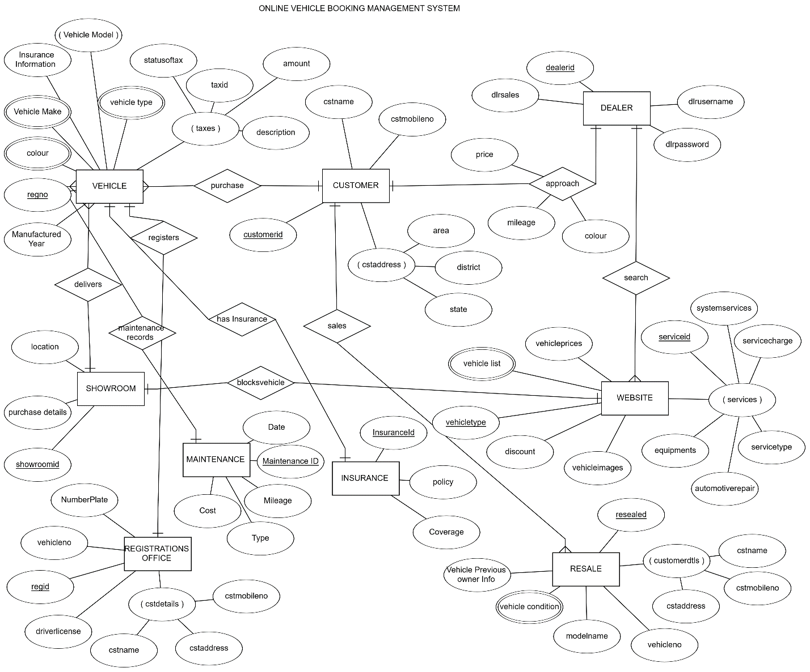

**E-R To Relational Schema:**

