PolyVote
A Multi-Tenant, Ranked-Choice Election Platform with a Tamper-Evident Audit Trail
Project Review 3
Course: BACSE202 | Database Systems
Submitted by:
Tharakesharasu Thennarasu - 25BCE2699
M Pavan Durga Karthik - 25BCE2712
Shivam Malge - 25BCE0386
Faculty: Dr. Katari Balakrishna
Updated edition, 4 November 2026: adds the voter-roster seal, salted password storage and an extended evaluation (Section 6.11). The edition submitted for Review 3 is unchanged and kept separately.
Abstract
Campus and organisational elections are usually run on a general-purpose database that the election officer, or anyone with database access, can edit without leaving a trace. PolyVote is a database-centric election platform that addresses this at the data layer. Relational constraints and a trigger enforce one vote per voter; the voter roster and the anonymous ballots are stored so that no column links them; every ballot is sealed in a hash-chained ledger kept in a separate document store (MongoDB Atlas); and an integrity sweep reconciles ballots, receipts and voter flags to expose tampering by someone with direct storage access. Ranked-choice (instant-runoff) tallying is built in, and one schema serves many organisations. This report presents the final system, with a keyed (HMAC) ledger chain, a sealed candidate roster, a keyed voter-roster seal, salted PBKDF2 password storage, an extended six-rule sweep, a standalone email one-time-password module for voter authentication, a MongoDB Atlas ledger backend and public hosting. We evaluate the system with an executable suite of 47 scenarios (attacks, abuse cases and functional tests) and repeatable benchmarks. Against a conventional hash-chain-only baseline, the number of rogue-administrator tampering scenarios detected automatically rises from 6 of 13 to 13 of 13. A further evaluation (Section 6.11) with 31 storage-level scenarios detects all 28 that lie inside the stated attacker model, with no false alarms on 399 clean sweeps, and reports the three that lie outside it. We compare the design with published verifiable-voting systems and state precisely what it does and does not claim: it improves integrity enforcement and auditability at the database layer, but it is not an end-to-end verifiable cryptographic voting system. The final build, with the email one-time code and QR-code voting, was demonstrated live in class and completed the whole voter journey successfully; screenshots of that demonstration are included as proof. A free public demo is available at https://polyvote-bacse202.onrender.com.
Keywords: electronic voting, instant-runoff voting, database integrity, hash chain, HMAC, tamper-evident logging, polyglot persistence, MongoDB, multi-tenancy, one-time password.
1. Introduction
Elections for student councils, clubs, housing societies and professional bodies are rarely run on purpose-built, audited software. They are run on spreadsheets, survey forms or small web applications backed by a single relational database. In such a setup the person who administers the database is also the person who can change the outcome, and nothing in the system can show that a result has been altered. The literature on electronic voting has concentrated on cryptographic protocols that avoid trusting the server at all [1]-[5], and on the failures of deployed internet voting systems [6]-[9]. Between those two poles sits a large practical population of small elections for which cryptographic end-to-end verifiability is not available, yet where a much better job can be done simply by using the database properly.
PolyVote is our attempt at that middle ground. It treats the database as the place where election rules are enforced, rather than as a passive store behind application code, and it adds an independent, append-only audit trail that can be checked against the database after the fact.
1.1 Problem statement
A conventional election application suffers from three weaknesses that a database course is well placed to address:
- Algorithmic deficiency. Plurality counting can declare a winner who is opposed by most voters. Ranked-choice (instant-runoff) counting avoids that but is rarely implemented in small systems, and its rounds are hard to explain without a transcript.
- Structural rigidity. Each election is built as a one-off schema. Reusing the platform for a second organisation means duplicating it, which multiplies the administrative surface.
- Database vulnerability. Anyone with write access can modify, delete or insert ballots, reset a voter's "has voted" flag, or rename candidates, and a conventional application will not notice.
A fourth weakness is easy to overlook: sign-in relies on a single password, so a leaked or shared credential was enough to cast someone else's vote. The evaluators asked for a second factor, and this report responds with one.
1.2 Contributions
This report documents the final design and implementation and makes the following contributions:
- A database-centric design in which uniqueness, range, referential and one-vote rules are enforced by the schema and a trigger, and in which voter identity and ballot content are stored without any linking column (Sections 4.2 to 4.4).
- A keyed, hash-chained audit ledger stored in MongoDB Atlas, with a sealed candidate roster and a file fallback. The chain can be extended only by a holder of the application secret (Section 4.5).
- An extended integrity sweep that detects modified, deleted and injected ballots, renamed candidates and disagreement between voter flags, ballots and receipts (Section 4.6).
- A standalone email one-time-password module with its own database, hashed single-use codes, expiry, attempt limits and rate limits, kept apart from the election data (Section 4.8).
- A reproducible evaluation: 7 database-level prevention tests, 13 API abuse tests, 13 tampering scenarios run against both a plain hash-chain baseline and the final design, 14 OTP tests and benchmarks up to 10,000 ballots (Section 6).
- A scoped comparative study against published verifiable-voting systems part by part against related projects, each verdict backed by our own test results, with explicit statements of what is not claimed (Section 7).
1.3 Scope and non-goals
PolyVote targets small and medium elections whose officers are trusted to run the election but not trusted to leave no trace. It does not attempt coercion resistance, receipt-freeness against vote buyers, or protection against an adversary who controls the application host and its secrets. Those limits are discussed in Sections 3 and 9. PolyVote does not claim to compete with end-to-end verifiable systems on cryptographic strength; its claim is that, for the class of elections described, it removes the easiest and most likely attacks and makes the remaining ones detectable.
1.4 Organisation
Section 2 reviews related work. Section 3 states the threat model and goals. Section 4 describes the design and Section 5 the implementation. Section 6 reports the evaluation, Section 7 the comparative study, Section 8 the final implementation status, Section 9 limitations and future work, and Section 10 concludes.
2. Background and Related Work
2.1 Verifiable electronic voting
Helios introduced web-based open-audit voting, in which ballots are encrypted in the browser and anyone can verify the published tally [1]. Belenios builds on a similar idea with stronger guarantees on eligibility and privacy [2], and Civitas adds coercion resistance at the cost of considerably more complex procedures [3]. Prêt à Voter [4] and Scantegrity II [5] aim at voter-verifiable paper-based elections, using randomised candidate orderings and confirmation codes respectively. These systems rest on cryptographic protocols and, in most cases, on trusted setup such as key ceremonies and independent trustees. They provide properties PolyVote does not: a voter can check that their ballot was recorded as intended without trusting the server. They also carry a procedural and operational burden that small organisations seldom accept.
2.2 Deployed internet voting
Security analyses of deployed systems are sobering. The Estonian internet voting system, widely regarded as the most mature, was found to have significant weaknesses in its operational and procedural security [6]. Mobile and web voting products used in United States elections have been shown to contain vulnerabilities that could expose or alter votes [7], [8]. A National Academies study concluded that internet voting could not currently be secured [9], and Park et al. argue that blockchain-based voting, often proposed as a remedy, combines the problems of internet voting with new ones [14]. We take two lessons from this body of work. First, a design must state its threat model explicitly rather than advertise a technology. Second, claims about "immutable" ledgers must be examined: a ledger is only as trustworthy as the party who can write to it.
2.3 Tamper-evident logging and ledger databases
Hash chaining for time-stamping was introduced by Haber and Stornetta [10], and Schneier and Kelsey showed how to build secure audit logs in which an attacker who compromises the logging machine cannot undetectably alter earlier entries [11]. Crosby and Wallach later gave efficient data structures for tamper-evident logging with logarithmic proofs [12], and Certificate Transparency applies Merkle trees to public logs [13]. In the database community, Snodgrass et al. studied tamper detection in audit logs [28] and Pavlou and Snodgrass the forensic analysis of database tampering [27]. Commercial and research ledger databases, such as SQL Ledger in Azure SQL Database, add cryptographically verifiable history to a relational engine [26]. PolyVote uses the simplest member of this family, a linear hash chain, and adds a keyed variant so that an attacker with access to the stored chain but not to the key cannot rebuild it.
2.4 Ranked-choice voting and its auditing
Instant-runoff voting (IRV) eliminates the weakest candidate round by round until one holds a majority of continuing ballots. Its outcome can hinge on a small number of ballots, and computing how many ballots would have to change to alter it is a research problem in its own right [15], [17]. Risk-limiting audits for IRV have been developed [16], [18]. PolyVote does not implement a statistical audit. It provides a deterministic tally with a round-by-round transcript, and it flags the one source of arbitrariness in the algorithm, ties for last place, in the interface.
2.5 Multi-tenancy and polyglot persistence
Aulbach et al. compare schema-mapping techniques for multi-tenant databases and show that a shared schema with a tenant identifier is the most economical approach [19], [20]. PolyVote follows that approach: one schema, with the organisation and election identifiers partitioning all data. Polyglot persistence, the use of different storage technologies for different kinds of data [21], [22], is a well-known response to the observation that no single data model fits all needs [23], [24]. PolyVote uses a relational store for rule-heavy transactional data and a document store for the append-only audit log.
2.6 Database security and integrity enforcement
Bertino and Sandhu survey database security and list integrity constraints, access control and auditing as the foundations [25]. Declarative constraints and triggers are the standard mechanisms for enforcing integrity inside the engine [29], [30]. Their value for voting is that they apply to every client, including a database administrator's console, provided the engine is configured to enforce them. Section 6.2 shows one case where it is not, and discusses the consequence.
2.7 Authentication factors
NIST SP 800-63B treats a memorised secret as one factor and requires a separate factor, such as a one-time code delivered to an authenticator the claimant controls, for higher assurance [31]. HOTP and TOTP define counter- and time-based one-time passwords [32], [33]. Email as an authentication channel is convenient but only as strong as the mailbox [37], and SMS or mobile channels have documented weaknesses [36]. Guidance on password storage recommends salted, slow key-derivation functions [34], [35]. PolyVote adds an emailed code as a second factor, and its passwords were stored with plain SHA-256 in the first edition of this report; the updated build stores them with salted PBKDF2, which follows that guidance (Section 4.6).
2.8 Receipts and ballot secrecy
Voter receipts that prove a vote was counted without revealing its content were studied by Chaum [38]. Benaloh and Tuinstra showed that receipts must not allow a voter to prove how they voted if vote selling is to be resisted [39], and Juels et al. formalised coercion resistance [40]. PolyVote's receipt is deliberately weak in this respect: it proves that a ballot is recorded and still counted, but does not allow a voter to verify the ballot's content, and a voter who reveals the token reveals nothing about the ranks without database access. It is neither receipt-free in the strong sense nor verifiable end to end.
2.9 Positioning
The systems above optimise for cryptographic assurance. The database literature offers tamper-evident structures but rarely applies them to a complete, usable election workflow. PolyVote occupies the gap: a complete multi-tenant ranked-choice application whose integrity story is built from database features, whose threats are enumerated, and whose claims are tested by an executable suite.
3. Threat Model and Security Goals
3.1 Assets
The assets to protect are (i) the correctness of the tally, (ii) the secrecy of each voter's ranking, (iii) the one-person-one-vote property, (iv) the eligibility of those who vote, and (v) the ability of an independent party to detect that any of these has been violated.
3.2 Adversaries
We consider the adversaries in Table 1. They are ordered by capability. The first is addressed by authentication, the middle ones by the database and ledger design, and the last two mark the boundary of what the design claims.
ID | Adversary | Capability | Treatment
A1 | Voter with a leaked or guessed password | Can sign in as someone else | Email one-time code; one-vote trigger
A2 | Network observer | Reads or alters traffic | Out of scope beyond TLS at the tunnel
A3 | Rogue database administrator | Read/write on the election database only | Integrity sweep detects
A4 | Ledger-store administrator | Read/write on the ledger store only | Hash chain with HMAC detects
A5 | Insider with both stores, no secrets | Edits both stores consistently | Keyed chain and sweep detect
A6 | Insider with both stores and the key | Can forge valid blocks | Not covered; needs external anchoring
A7 | Roster injection via the admin path | Adds a ghost voter, votes as them | Detected by the keyed voter-roster seal (rule 6), unless the attacker holds the key
Table 1: Adversary model and how each adversary is treated.
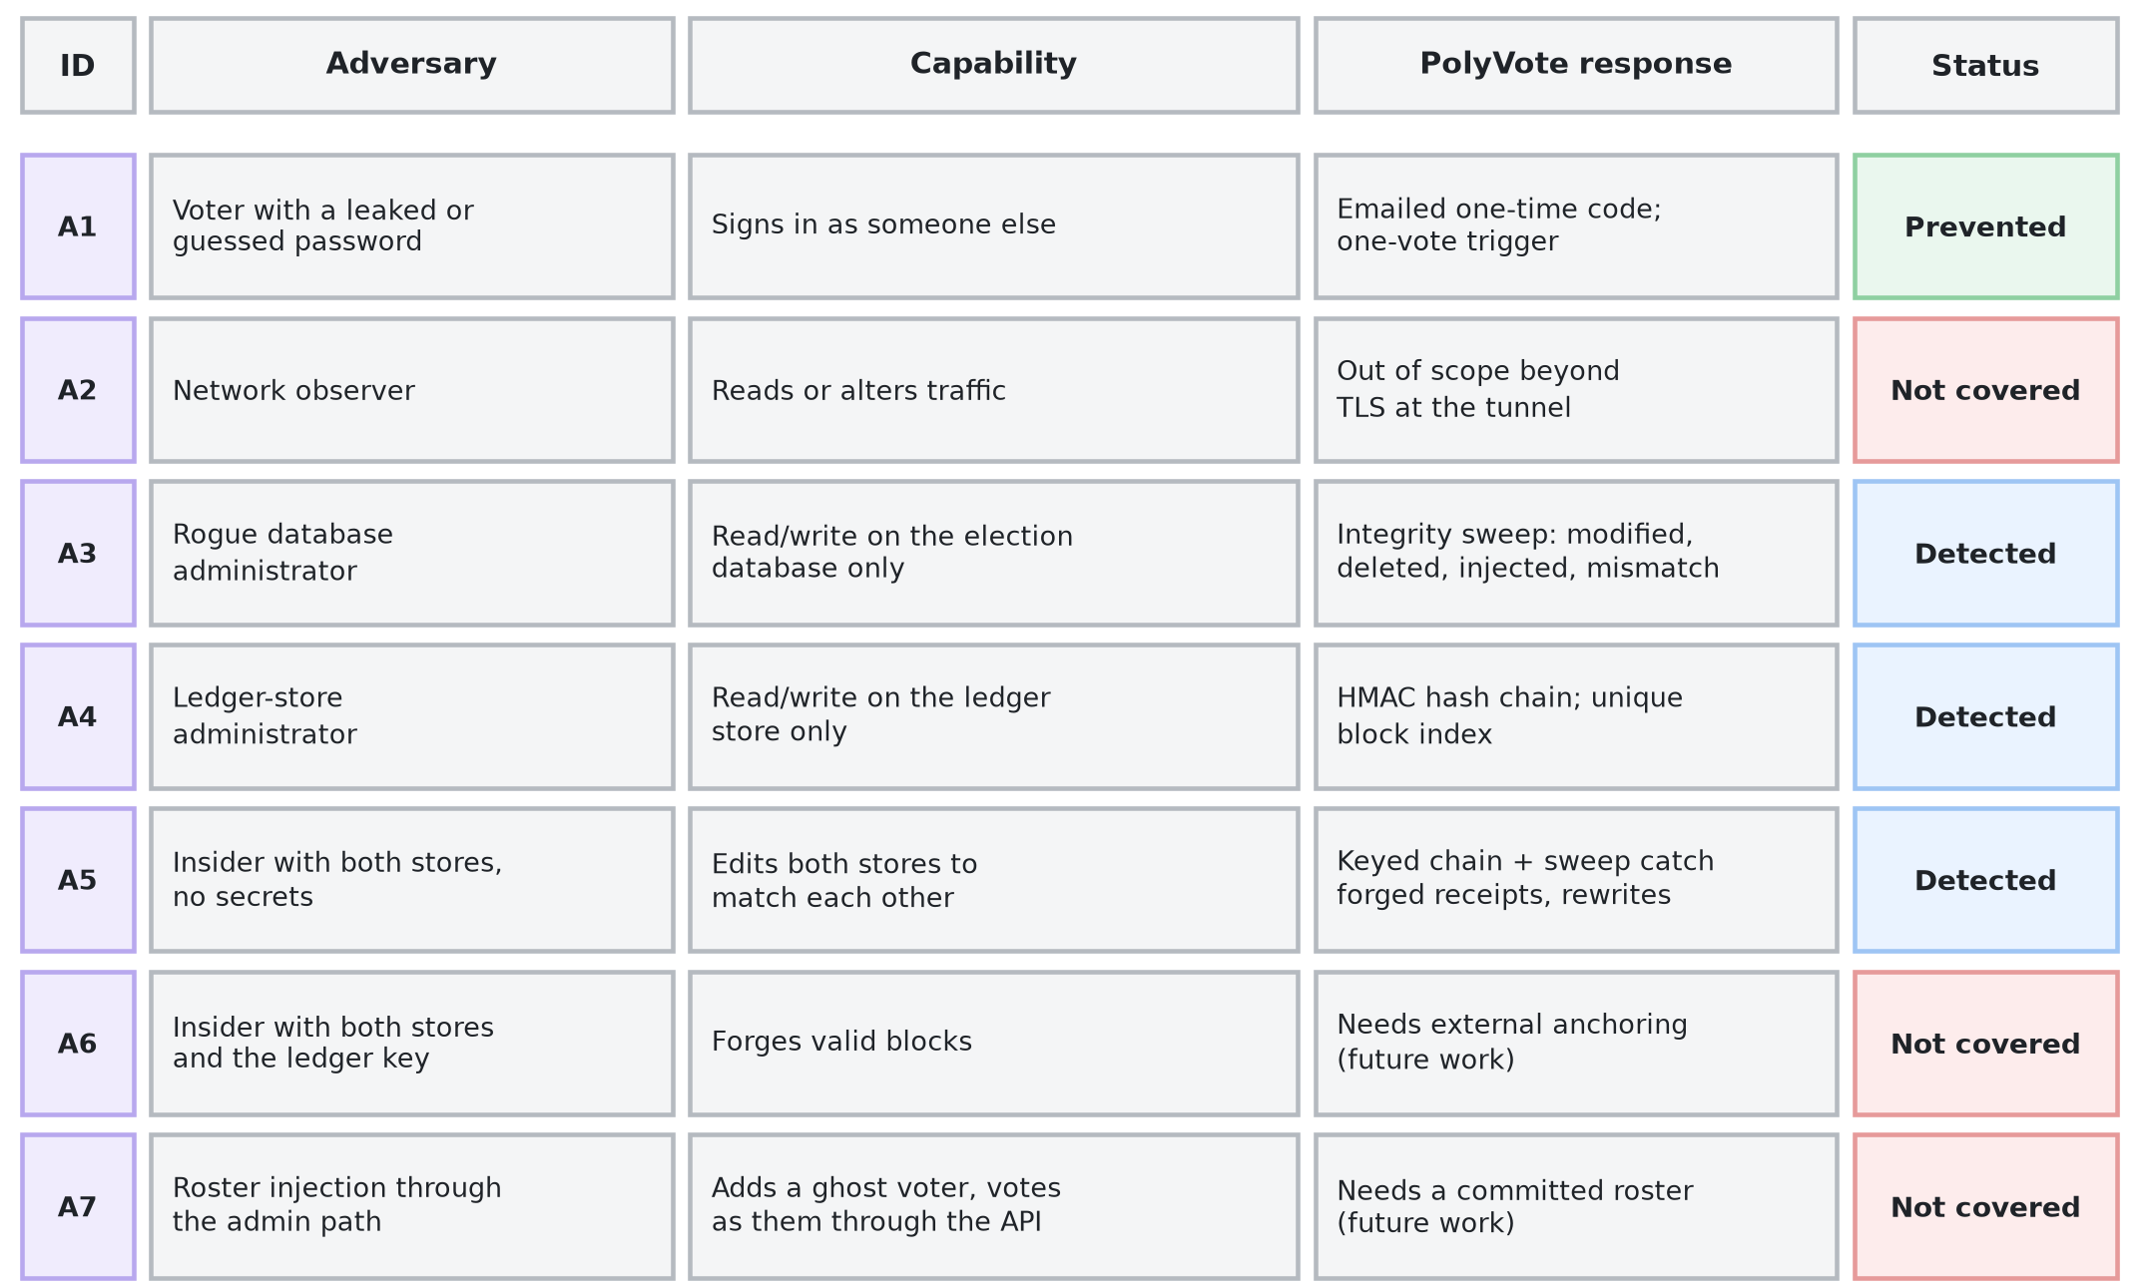
Figure 1: Threat model overview: adversaries, capabilities and treatment.
In plain words. Think of this table as a list of people who might try to cheat. Green means PolyVote stops them. Blue means PolyVote cannot always stop them but will catch them afterwards. Red means PolyVote does not protect against them yet. We show the red rows on purpose, so nobody is surprised later.
3.3 Security goals
Goal | Statement | Mechanism
G1 | No voter can vote twice | Trigger, has_voted CHECK, per-election UNIQUE roster, single-use sessions, write lock
G2 | Only rostered, verified voters vote | Roster lookup, password, emailed one-time code
G3 | Ballots are anonymous in storage | No column links BALLOT_RANKS to VOTER_PARTICIPATION; random ballot tokens
G4 | Malformed ballots are rejected | CHECK, composite PK, FK, API validation
G5 | Modification, deletion or insertion of stored ballots is detectable | Per-ballot ledger receipt, integrity sweep
G6 | The ledger cannot be silently rewritten by someone without the key | HMAC chain, unique block index, store separate from the database
G7 | Candidate attribution cannot be changed after voting | Roster hash sealed in each block
G8 | A voter can confirm their ballot is recorded and counted | Receipt token and public receipt check
Table 2: Security goals and the mechanisms that serve them.
3.4 Assumptions and non-goals
- The application host and its environment secrets (MONGO_URI, LEDGER_KEY, SMTP_PASS) are not controlled by the adversary, except for A6.
- A voter's mailbox is under that voter's control. Email is a weaker factor than a hardware token, and we say so.
- The election officer chooses the roster honestly at registration. The keyed voter-roster seal detects later changes to the roster, but cannot tell whether the roster was right when it was sealed (A7).
- We do not address coercion, vote selling, denial of service, or compromise of the voter's own device.
4. System Design
4.1 Architecture
PolyVote is a single Python service built on FastAPI that exposes a REST interface and serves the React front end. Behind it are three stores, deliberately separated by what each is trusted with (Figure 2). The election database is a relational SQLite file that holds the roster, candidates and anonymous ballots. The verification database is a second SQLite file that holds voter email addresses and one-time-code challenges. The audit ledger is a MongoDB Atlas collection, with a local JSON file used when no connection string is configured. Secrets (database connection string, ledger key, SMTP credentials) live in environment variables, outside every store.
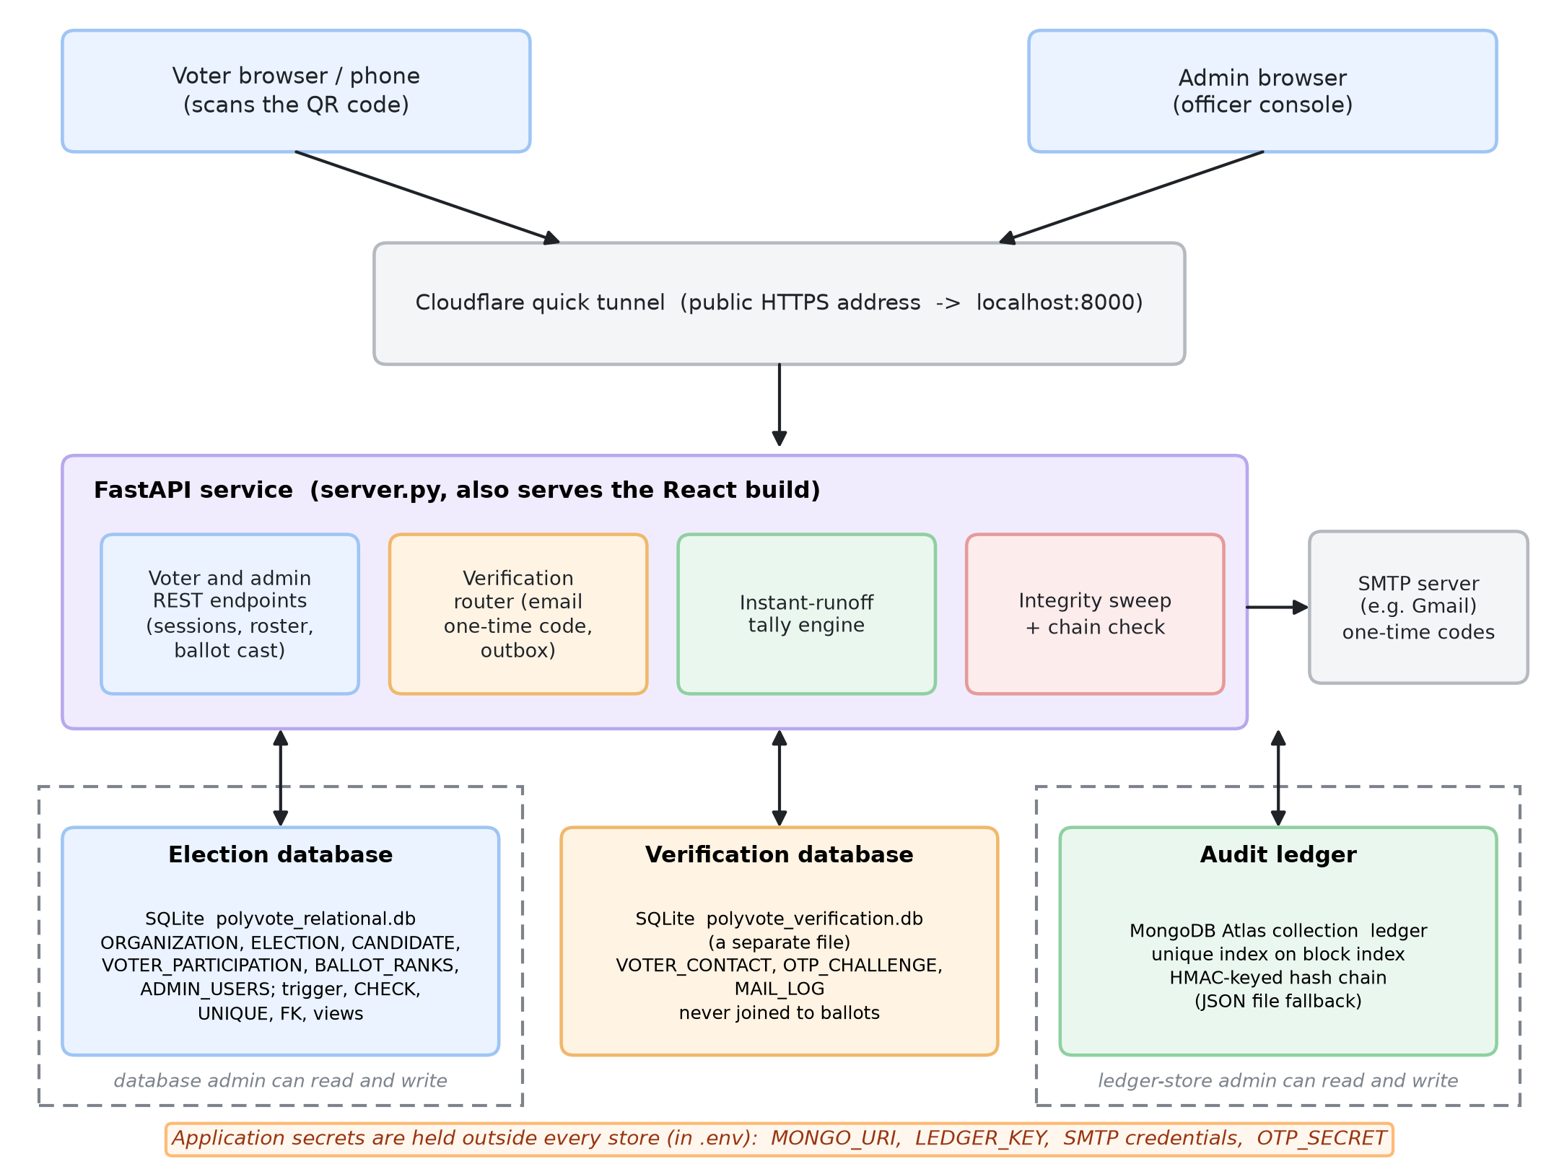
Figure 2: Architecture of the final system with trust boundaries.
In plain words. Read the picture from top to bottom. A voter's phone or the officer's browser talks to one program, the FastAPI service. That program keeps its information in three separate places: the ballots in one database, the voters' email addresses and one-time codes in a second database, and the audit chain in MongoDB. They are kept apart so that someone who can open one of them cannot read or change the others. The secrets (database password, the key for the chain, the email password) are stored in a separate settings file that is not part of any database.
The separation matters for the threat model. An administrator of the election database cannot touch the ledger or the verification data, an administrator of the ledger store cannot touch ballots, and neither holds the secrets. Only the application host sees all three, which is why compromise of the host is outside the model (A6).
4.2 Data model
The election schema has six tables (Figure 3). ORGANIZATION hosts ELECTION rows, which own CANDIDATE, VOTER_PARTICIPATION and BALLOT_RANKS rows. ADMIN_USERS is a stand-alone table for officer sign-in. Multi-tenancy follows the shared-schema pattern [19]: all tenant data hangs off the election, and every query is scoped by election_id.
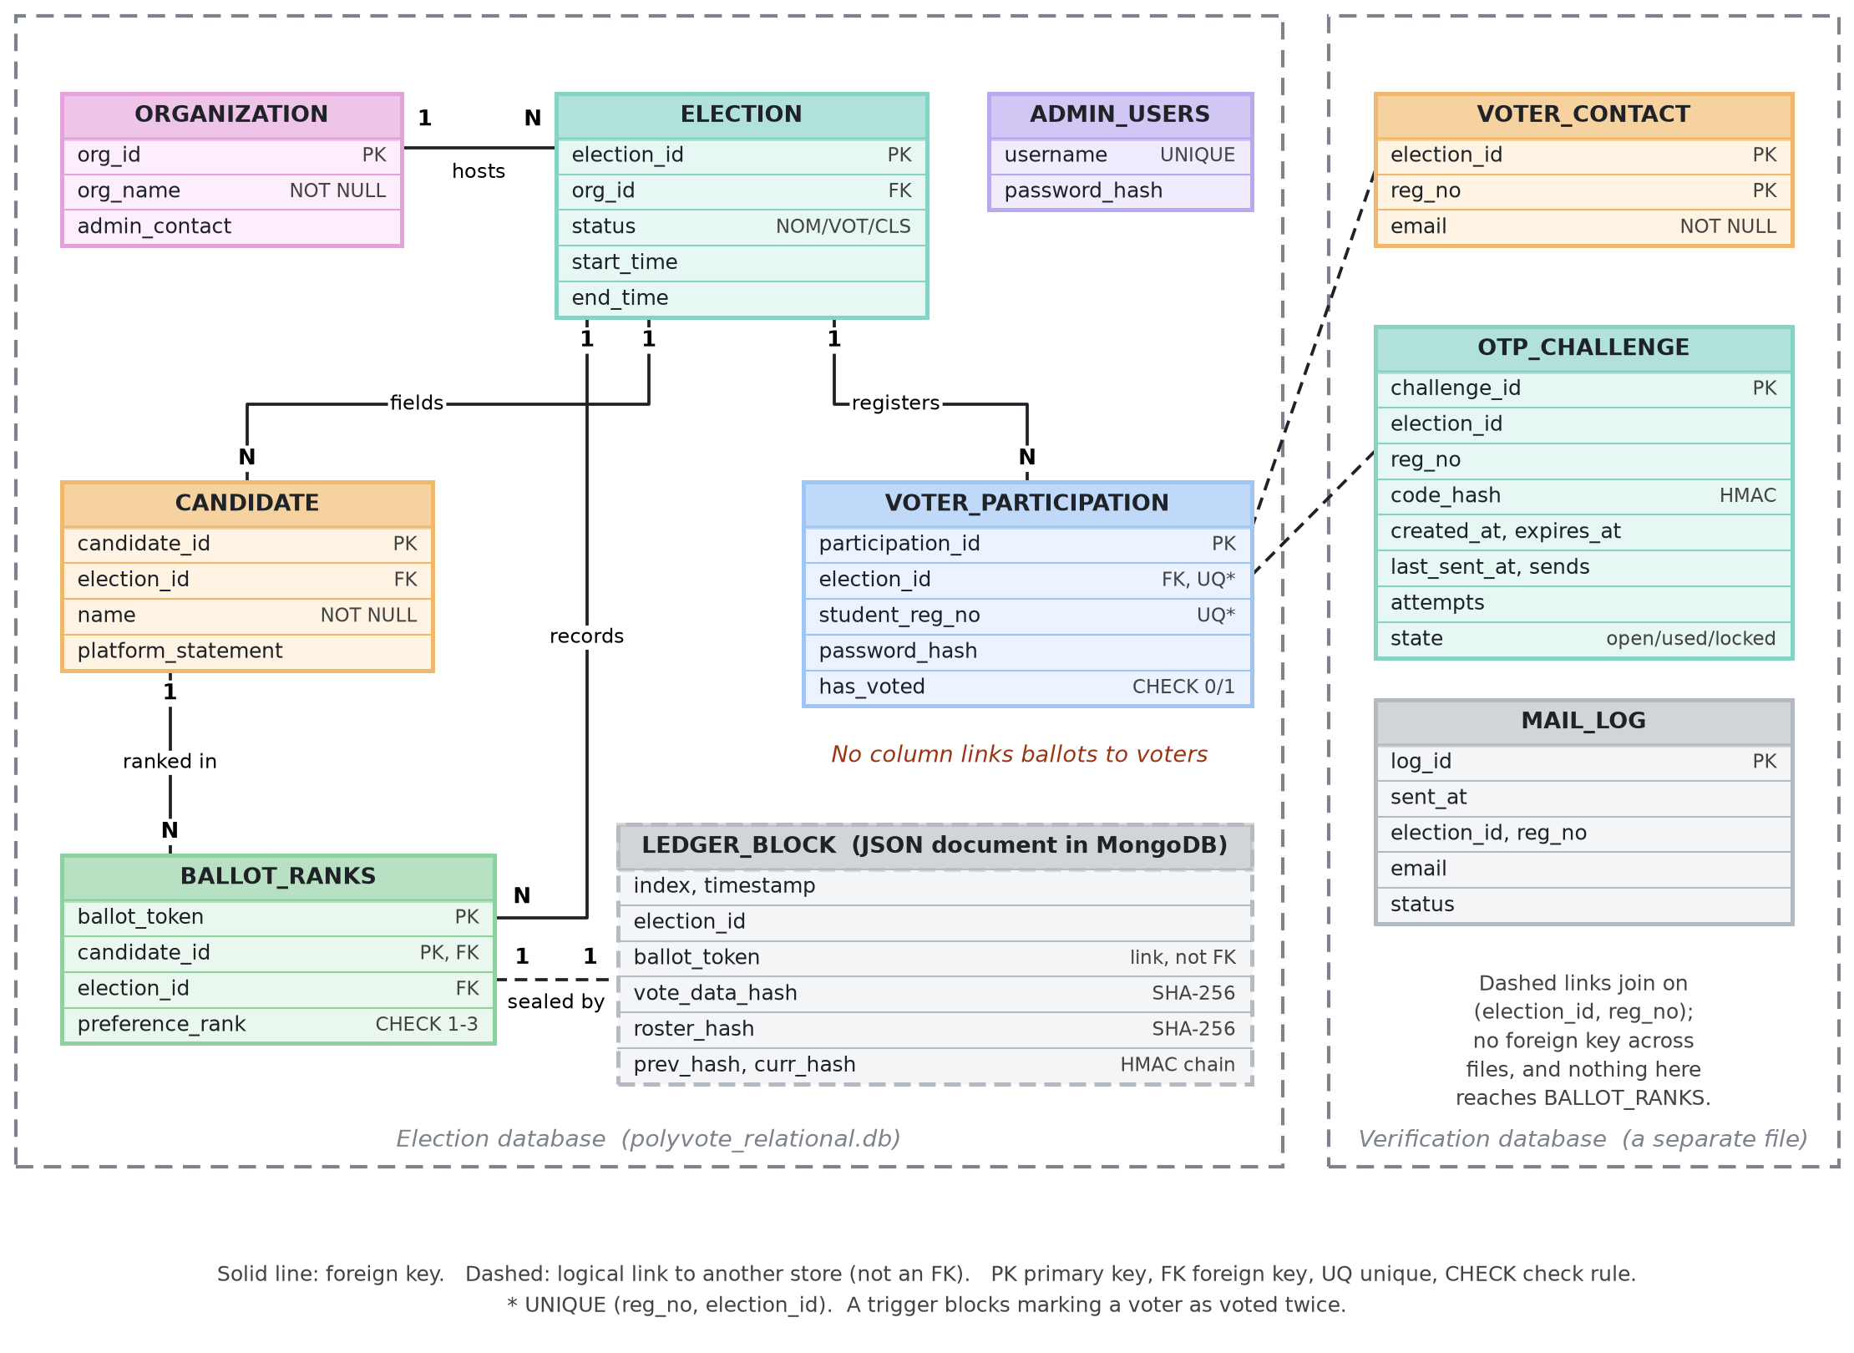
Figure 3: Entity-relationship diagram: election database, verification database and ledger block.
In plain words. Each box is a table and each line shows how two tables are linked. The important point is what is missing: the ballot table has no line to the voter table, so nobody can look up who voted for whom. The dashed box is one block of the audit chain, and the right-hand frame is the separate database for emails and codes.
The rules the schema enforces are listed in Table 3. They are the first line of defence and apply to any client that speaks SQL, including an administrator console, provided foreign-key enforcement is switched on for the connection (Section 6.2).
Rule | Mechanism | Where
A voter cannot be marked as voted twice | BEFORE UPDATE OF has_voted trigger raises ABORT when old and new are both 1 | VOTER_PARTICIPATION
has_voted is 0 or 1 | CHECK | VOTER_PARTICIPATION
One roster entry per voter per election | UNIQUE (student_reg_no, election_id) | VOTER_PARTICIPATION
A ballot ranks 1 to 3 choices | CHECK (preference_rank BETWEEN 1 AND 3) | BALLOT_RANKS
A candidate appears once per ballot | Composite PK (ballot_token, candidate_id) | BALLOT_RANKS
Ballots reference real candidates and elections | Foreign keys | BALLOT_RANKS, CANDIDATE, ELECTION
One verification record per voter contact | PK (election_id, reg_no) | VOTER_CONTACT
A challenge is open, used or locked | CHECK on state | OTP_CHALLENGE
Table 3: Integrity rules enforced inside the database engines.
4.3 Separating the voter from the ballot
A ballot is stored under a random UUID, the ballot token, and the roster stores only whether a voter has voted. There is no column in BALLOT_RANKS that appears in VOTER_PARTICIPATION, other than the election identifier, and no timestamp on the roster row that could be matched to the order of ballots. A database administrator reading both tables can see that 45 voters voted and that 45 ballots exist, but not which ballot belongs to whom. The voter's email address is held in a different database again, keyed by registration number, so it cannot be joined to a ballot even if the election database is compromised. Table 12 reports the automated check of this property.
4.4 Casting a ballot
Casting is the only operation that touches all the structures, so it is serialised and transactional (Figure 4). After authentication the server takes a process-wide write lock, re-checks the election status, validates the ranking, and verifies that the voter has not already voted. In a single database transaction it sets has_voted, inserts the ranked rows under a new random token, and commits. It then computes the candidate roster hash, appends a sealed block to the ledger, invalidates the session and returns the token to the voter.
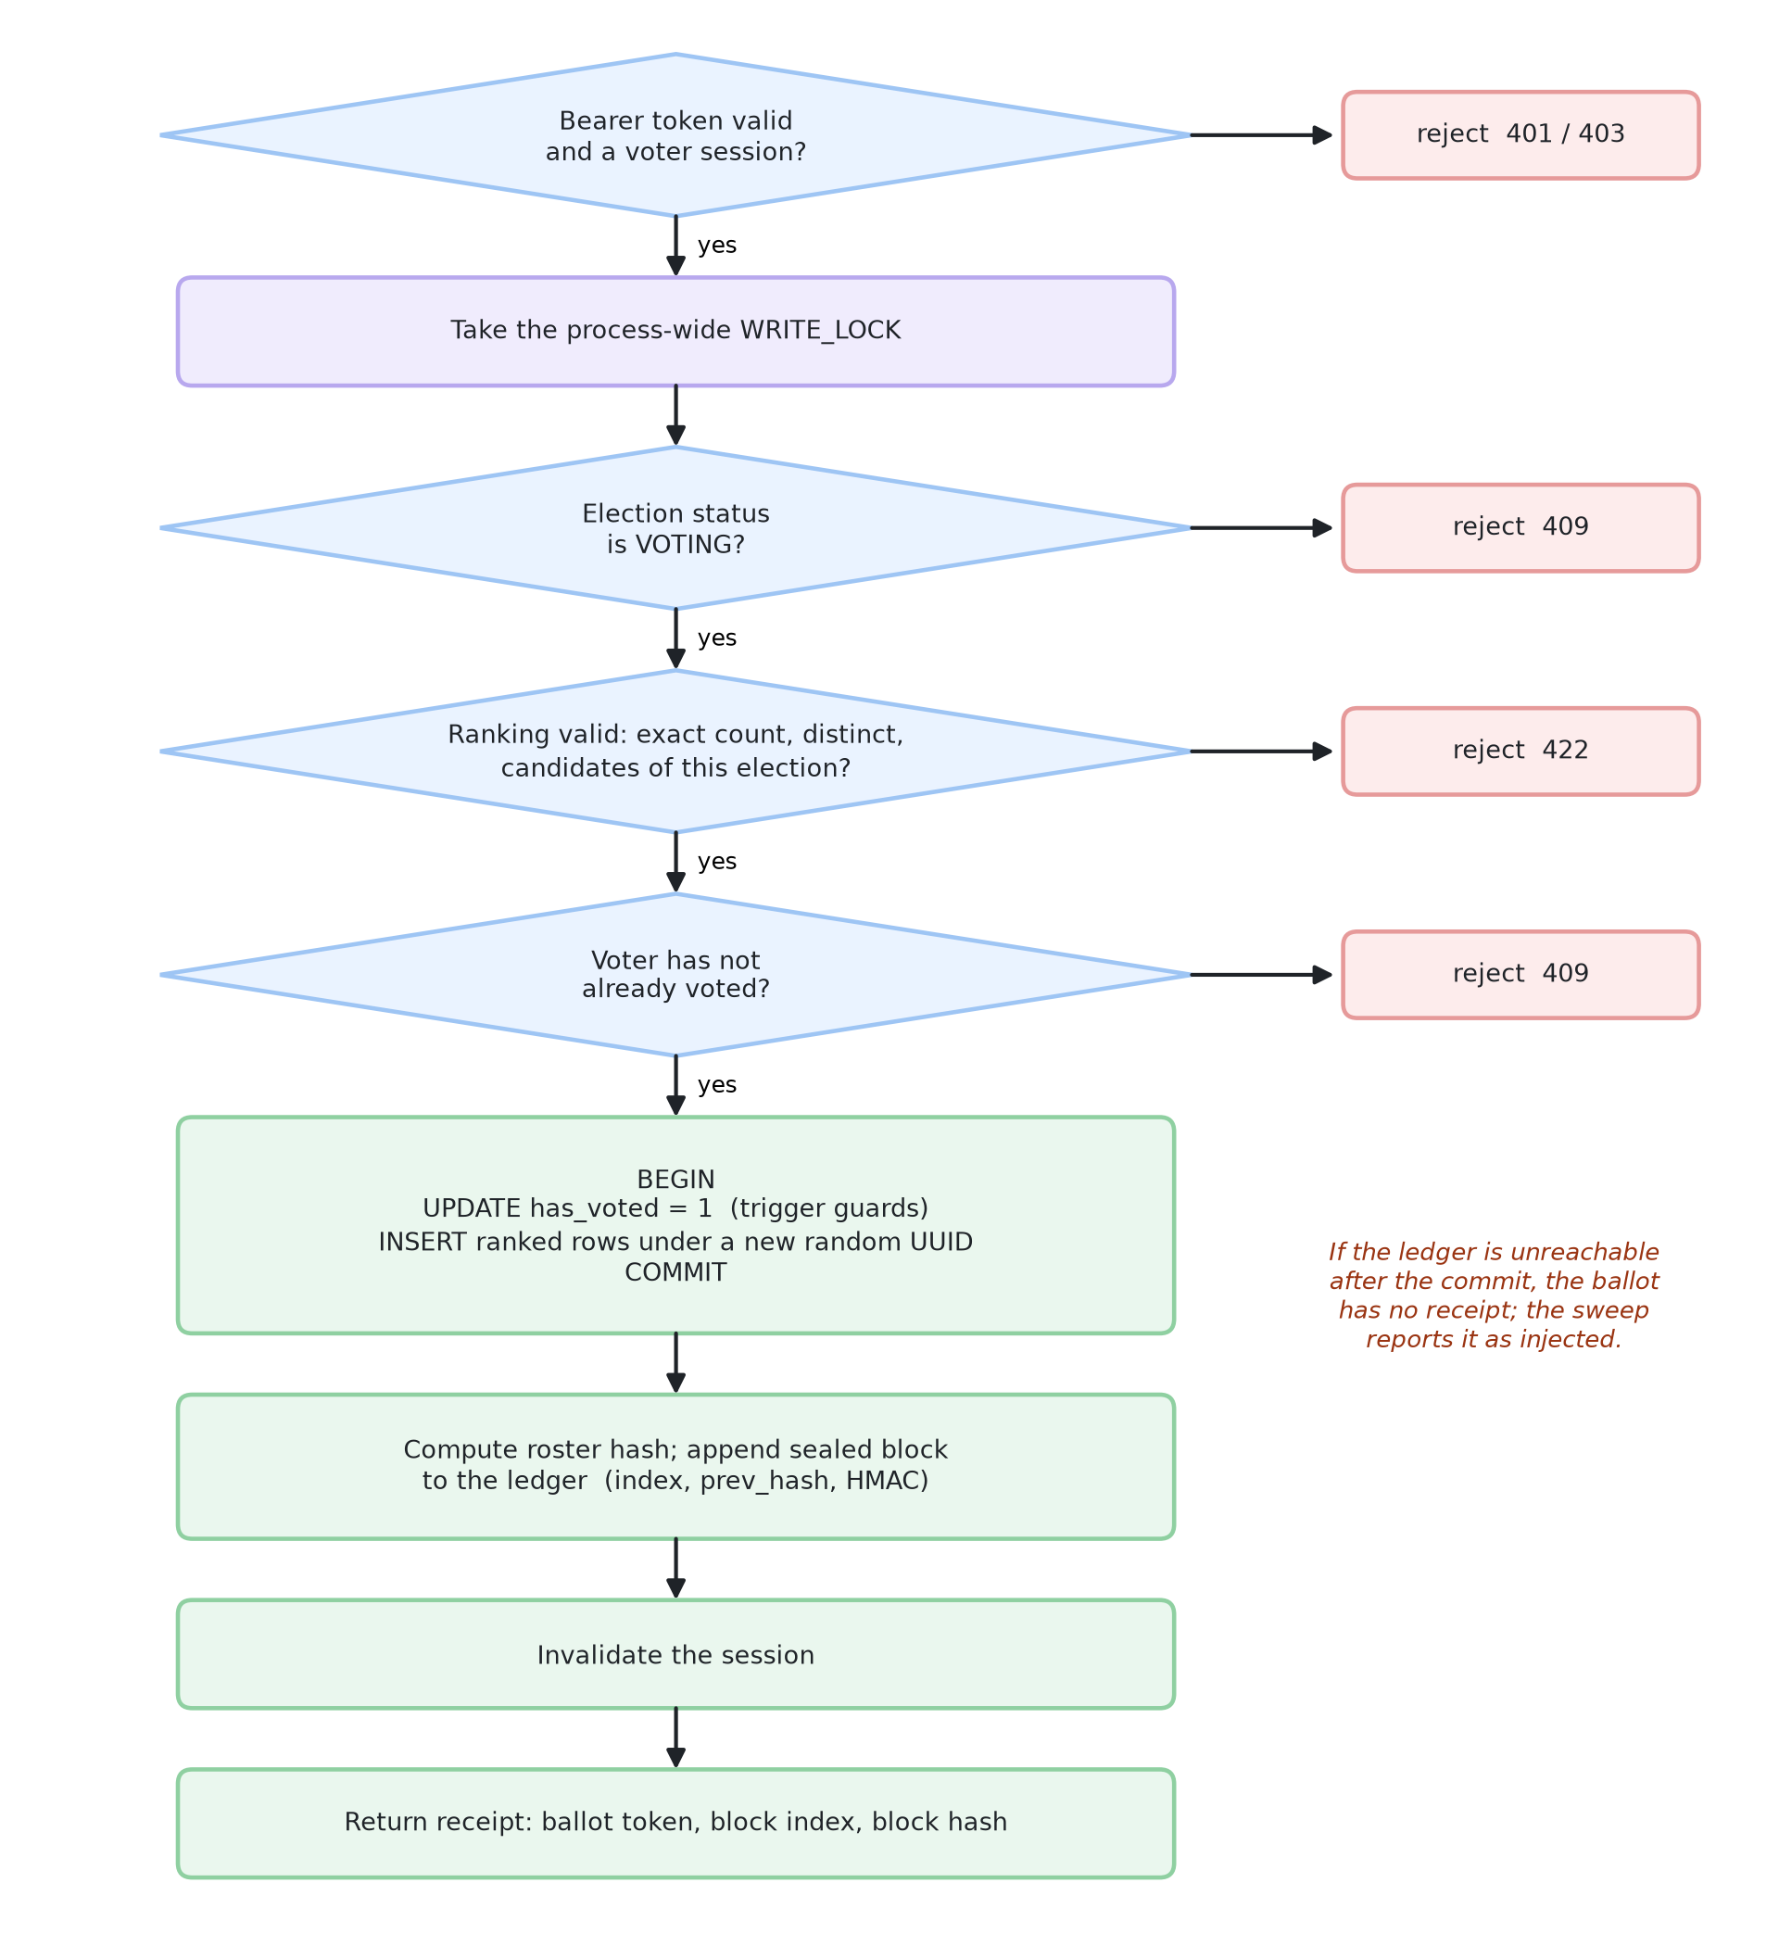
Figure 4: Flow of a ballot cast, with the failure exits.
In plain words. Follow the arrows downward. Each diamond is a check, and if a check fails the vote is rejected (the red boxes on the right). Only a ballot that passes every check is saved, sealed in the audit chain and given a receipt.
The ledger append happens after the database commit. If the ledger were unreachable at that moment the ballot would exist without a receipt. The extended sweep detects exactly that situation (Section 4.6), and the receipt-lookup page shows a voter whether their token is present. A two-phase scheme that writes the receipt first would trade this for orphan receipts; we chose the variant that fails visibly.
4.5 The audit ledger
Each ballot produces one block: its position in the chain (index), a timestamp, the election, the ballot token, vote_data_hash, roster_hash, the previous block's hash (prev_hash) and the block's own hash (curr_hash). vote_data_hash is the SHA-256 of the ordered (candidate, rank) pairs. roster_hash is the SHA-256 of the election's (candidate id, name) pairs at the time of the vote. curr_hash is computed over all other fields.
A conventional chain computes curr_hash with plain SHA-256 and no key. That makes the chain self-consistent but not authenticated: anyone who can write the ledger store can change a ballot's hash and then recompute every later block. The final design therefore computes curr_hash as HMAC-SHA-256 under a secret key (LEDGER_KEY) held outside the ledger and database. Verification recomputes each block with the same key and compares with a constant-time comparison. Blocks written before the key was introduced remain valid because the first LEDGER_LEGACY_UNTIL blocks are verified with plain SHA-256, which keeps old elections readable.
Two storage backends sit behind the same interface. With MONGO_URI set, blocks are documents in a MongoDB collection with a unique index on index. The unique index serves as a compare-and-swap: two concurrent appenders that compute the same next index cannot both insert, so the chain cannot fork. Without a connection string, blocks go to a local JSON file, protected by an in-process lock. The backend is chosen once at start-up and reported by /api/health.
4.6 The integrity sweep
The sweep recomputes the state of an election from the database and compares it with the ledger. The first two rules are the basic checks; the other four close gaps the evaluation exposed in a basic sweep (Table 4).
Rule | Detects | How
1. Modified | A ballot whose ranks changed after sealing | Recompute SHA-256 of the ballot's ranks; compare with the block's vote_data_hash
2. Deleted | A sealed ballot missing from the database | A block exists for a token that has no rows in BALLOT_RANKS
3. Injected (new) | A ballot with no receipt | Rows exist in BALLOT_RANKS for a token with no block
4. Roster changed (new) | Candidate names altered after voting | Current roster hash differs from the hash sealed in the blocks
5. Count mismatch (new) | Flags, ballots and receipts disagree | Compare voted flags, distinct ballot tokens and blocks for the election
6. Voter roster changed (new) | A voter added, deleted or edited outside the application, or the seal removed or forged | Recompute a keyed HMAC tag for each voter and a signature over the set; compare with the seal kept in the ledger store
Table 4: Rules applied by the integrity sweep.
In addition, the chain check verifies every block's link and hash across the whole ledger. The two checks are complementary: the chain check finds edits inside the ledger, and the sweep finds edits to the database relative to a trusted ledger.
Voter-roster seal (added after the first edition). The first edition could not detect a ghost voter, a voter added to the roster by someone with database access who then votes as them, because the ballot is valid and the system held no independent record of the roster. The application now writes a keyed seal whenever it registers voters: one HMAC tag per voter (registration number and election) and an HMAC signature over the set of tags, stored in the ledger store, with the key outside both stores. Each later block records whether the election was sealed, so deleting the seal is itself detected. Rule 6 recomputes the tags from the database and compares them; a voter added, deleted or renamed outside the application, a deleted seal and a seal forged without the key are all reported. A voter whom the officer genuinely adds after voting opens goes through the application, which re-seals. Elections created before the seal existed show the state "not sealed" rather than a false alarm.
Passwords (changed after the first edition). Passwords are now stored as PBKDF2-HMAC-SHA256 with a random 16-byte salt and 600,000 rounds (pbkdf2_sha256$rounds$salt$digest). Older unsalted hashes still verify and are upgraded at the next successful sign-in; verification uses a constant-time comparison. The measured effect is in Section 6.11.
4.7 Instant-runoff tally
The tally loads ballots as ordered lists of candidates and repeats three steps: count first preferences among continuing candidates, declare a winner if one holds more than half of the continuing ballots, otherwise eliminate the candidate with the fewest and transfer their ballots to the next surviving preference. Ballots that run out of preferences are exhausted. The engine returns a transcript of every round. Ties for last place are broken by candidate order, which is arbitrary; the interface marks any round where that happens so it is not mistaken for a principled result.
4.8 Email one-time-password verification
A password alone no longer opens a ballot. When the OTP setting is enabled, a correct password produces a challenge instead of a session (Figure 5). The server generates a six-digit code with a cryptographically secure generator, stores only an HMAC of it, and emails the plain code from a background thread so the page never waits on the mail server. The voter enters the code, and only then does the server issue the voting session.
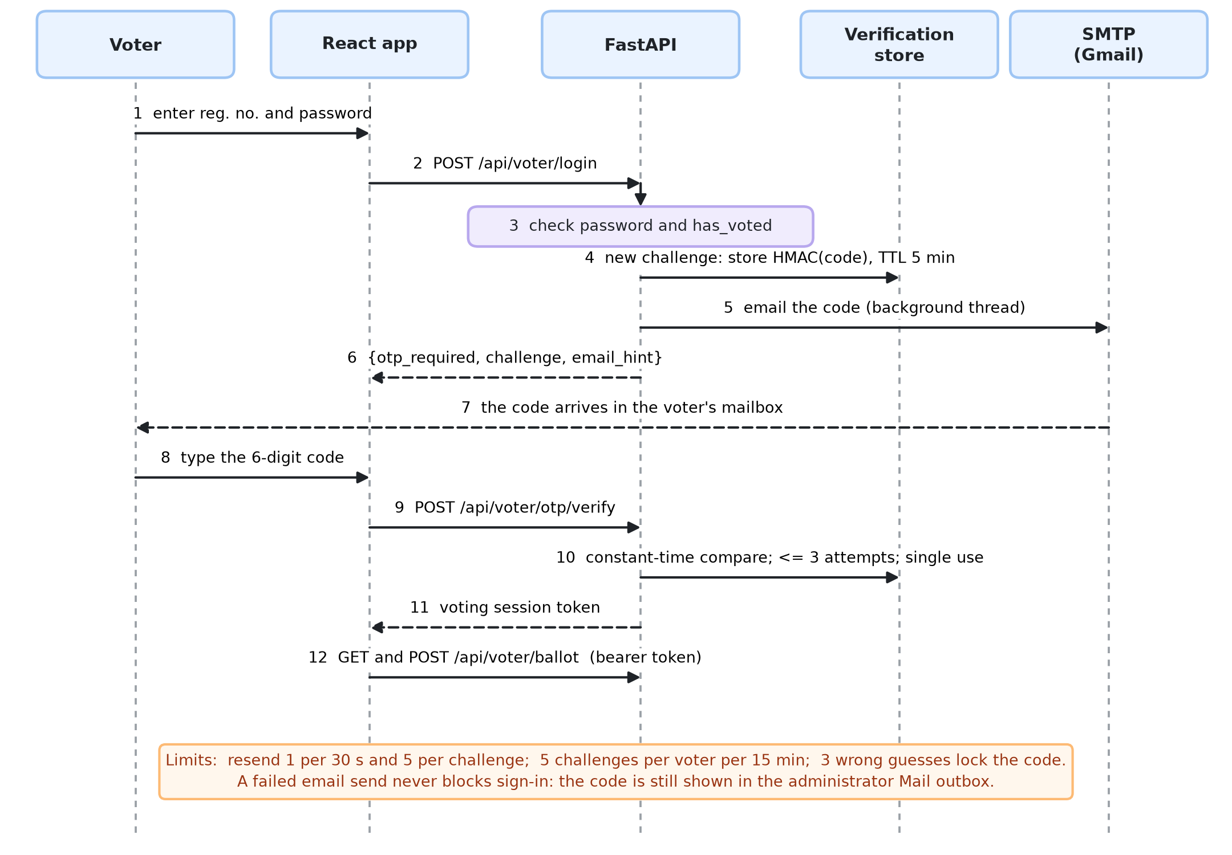
Figure 5: Sign-in with a one-time code: sequence of messages.
In plain words. Time runs from top to bottom. The voter types a password, but the server does not let them in yet. It emails a 6-digit code and waits. Only when the voter types the right code does the server hand over the ballot. A stolen password alone is therefore not enough.
Parameter | Value | Purpose
Code | 6 digits, secrets.randbelow | Unpredictable; zero-padded
Storage | HMAC-SHA-256 of challenge:code under a server secret | The database never holds a usable code
Validity | 5 minutes | Limits the window for theft or guessing
Guesses | 3 per code, then locked | About 3 in 10^6 chance per code
Resends | 1 per 30 s, at most 5 per challenge | Resend cannot be used to keep guessing
Challenges | 5 per voter per 15 minutes | Slows repeated password-then-guess attempts
Use | Single use | A captured code cannot be replayed
Delivery | SMTP over STARTTLS; failure logged, never blocks sign-in | The admin outbox still shows the code
Table 5: Parameters of the one-time-code mechanism.
Voter addresses are entered per voter, or generated in bulk from one base mailbox using plus-addressing (you+25bce0001@domain), which lets a single inbox receive every code during a demonstration. Contacts, challenges and the mail log live in polyvote_verification.db, a different file from the election database. An administrator page, the Mail outbox, lists every code issued; plaintext codes are kept in memory only and are hidden after ten minutes.
4.9 Election lifecycle and multi-tenancy
An election moves through Nomination, Voting and Closed, one step at a time and never backwards. Candidates may change only in Nomination, the roster may grow in Nomination and Voting, and ballots are accepted only in Voting. Because the lifecycle is stored in the database and enforced by the API, a closed election is read-only for voters. Many organisations share the platform; each election belongs to one organisation, and administrators see all of them, which is the model for a campus election office.
4.10 Deployment and operation
The service runs from one command (python -m uvicorn server:app --port 8000) and serves the compiled front end from the same port. For the review it is exposed to the internet through a Cloudflare quick tunnel, which gives a temporary public HTTPS address without opening ports; the voter page shows a QR code for that address so a phone can open the ballot. The ledger is hosted on a free MongoDB Atlas cluster. All configuration is read from a git-ignored .env file (Table 6). We describe this honestly as public hosting from a laptop rather than cloud deployment: the tunnel address changes when it restarts, and the host must stay on.
For a link that does not depend on the laptop, the repository also builds as a Docker image (Dockerfile) and includes a Render blueprint (render.yaml) for a free public demo at https://polyvote-bacse202.onrender.com. On a free plan the service sleeps after about 15 minutes idle (the next visit takes about a minute) and its disk is wiped on every restart, so the demo seeds a fresh election at start-up. A public demo has no mailbox the visitor can open, so in demo mode (a setting that a real deployment leaves off, because a code shown on the screen would no longer prove that the voter owns the mailbox) the one-time code is shown on the screen, a banner says so, and factory reset puts the sample election back instead of leaving the demo empty. The /demo page lists every page of the application with a link and a one-line description, and gives a three-minute tour. The same blueprint can send real emailed codes through an SMTP relay on port 2525 (the free plan blocks the usual mail ports), with the code also shown on screen and a daily limit on real emails, and can keep the ledger in its own MongoDB Atlas database so the demo never touches the project ledger.
Variable | Effect
MONGO_URI | Use MongoDB Atlas for the ledger (file fallback if unset or unreachable)
LEDGER_KEY, LEDGER_LEGACY_UNTIL | Enable the keyed (HMAC) chain; number of earlier blocks that use plain SHA-256
OTP_REQUIRED | Require the emailed code at voter sign-in
SMTP_HOST, SMTP_PORT, SMTP_USER, SMTP_PASS | Send real email; otherwise codes appear only in the admin outbox
PUBLIC_URL | Address encoded in the voter-page QR code when opened on localhost
ADMIN_PASSWORD | Replace the default administrator password
Table 6: Configuration read from the environment.
5. Implementation
5.1 Technology and code size
The back end is Python 3.12 with FastAPI, SQLite through the standard library, pandas for the tally and pymongo for the ledger. The front end is React 19 with TypeScript, built by Vite. The Streamlit interface from Review 1 is retained for comparison. Table 7 lists the size of each part.
Part | Lines
Backend (Python) | 1,735
Frontend (TypeScript/TSX) | 3,280
Styles (CSS) | 473
Experiments (Python) | 875
Total | 6,363
Table 7: Source size (non-generated, including blank lines).
5.2 Selected listings
The duplicate-vote trigger is the first line of defence for G1:
CREATE TRIGGER trg_block_duplicate_vote
BEFORE UPDATE OF has_voted ON VOTER_PARTICIPATION
FOR EACH ROW
WHEN OLD.has_voted = 1 AND NEW.has_voted = 1
BEGIN
SELECT RAISE(ABORT, 'DBMS Trigger Violation: Voter has already submitted a ballot.');
END;
The ledger keys its chain with an HMAC when a key is configured, and falls back to plain SHA-256 for legacy blocks:
def _block_hash(index, block):
data = json.dumps(block, sort_keys=True).encode()
if LEDGER_KEY and index > LEGACY_UNTIL:
return hmac.new(LEDGER_KEY, data, hashlib.sha256).hexdigest()
return hashlib.sha256(data).hexdigest()
Appending to the MongoDB ledger relies on the unique index on the block position, retrying if another writer won the slot:
for _ in range(5):
last = _coll.find_one({}, {'_id': 0}, sort=[('index', -1)])
block = _seal(election_id, ballot_token, ranked_payload,
(last['index'] + 1) if last else 1,
last['curr_hash'] if last else GENESIS, roster_hash)
try:
_coll.insert_one(dict(block))
return block
except DuplicateKeyError:
continue
The sweep's three additions are short, because the data they need is already in hand:
report["injected"] = [t for t in grouped if t not in ledger_dict]
sealed = {b['roster_hash'] for b in blocks if b.get('roster_hash')}
report["roster_changed"] = bool(sealed) and sealed != {current_roster}
counts = {"voted_flags": int(voted_flags), "ballots": len(grouped), "receipts": len(ledger_dict)}
if len(set(counts.values())) > 1:
report["count_mismatch"] = counts
Verifying a one-time code compares in constant time and records every failed attempt:
if not hmac.compare_digest(row['code_hash'], _hash(challenge_id, code)):
attempts = row['attempts'] + 1
locked = attempts >= MAX_ATTEMPTS
c.execute('UPDATE OTP_CHALLENGE SET attempts=?, state=? WHERE challenge_id=?',
(attempts, 'locked' if locked else 'open', challenge_id))
if locked:
raise OtpError(410, "Too many wrong codes. Please sign in again.")
raise OtpError(401, f"Incorrect code. {MAX_ATTEMPTS - attempts} attempts left.")
5.3 A defect found by the test suite
The first version of the OTP module passed its logic review but failed test F4 ("three wrong codes lock the challenge"). The cause was subtle: the attempt counter was updated inside a database context manager, and the handler then raised an HTTP error. The standard SQLite context manager rolls back when an exception leaves it, so every failed guess was recorded and then undone, and the attempt limit never took effect. A voter, or an attacker holding a password, could have guessed codes without limit. The fix is a small context manager that commits state changes before the exception propagates. We include this case because it shows the value of executable tests over review for security logic, and because the defect would not have been visible in normal use.
5.4 Running the system
Setup is three steps: install the requirements and build the front end once, copy .env.example to .env and fill in the values needed, and start the server. Existing ledger entries can be copied to MongoDB with migrate_ledger_to_mongo.py, which refuses to overwrite a non-empty collection. The experiment suite (experiments/run_experiments.py) runs against a throwaway copy and never touches real data (Appendix C).
6. Evaluation
6.1 Method
We evaluate the system with an executable suite (experiments/run_experiments.py) rather than by argument. The suite copies the application into a temporary directory, so it never touches real data, uses the file ledger so it never touches Atlas, drives the real HTTP API through FastAPI's test client, and models a rogue administrator by editing the SQLite file and the ledger file directly, with foreign keys off, as a database console would. It has five groups:
- A. Database-level prevention (7 tests): statements that should be rejected by the schema.
- B. API abuse (13 tests): wrong passwords, injection, replay, cross-election ranks, concurrency.
- C. Tampering (13 scenarios): edits by someone with direct storage access, each followed by the three checks an auditor has: the integrity sweep, the chain verification, and the three headline counters shown in the administrator interface.
- D. Privacy structure: an automated check that ballots cannot be linked to voters by schema.
- E. OTP (14 tests) and F. Benchmarks at 100, 1,000 and 10,000 ballots.
Each tampering scenario is run twice. The baseline is the plain hash-chain design (plain SHA-256 chain, two-rule sweep) that represents the conventional approach [10]-[12]; it is the earlier version of PolyVote, checked out from version control and run unchanged. The final design is the current code with the keyed chain enabled. The attacker scripts never receive the key. A scenario counts as Detected if the sweep or the chain check reports it, as Counters only if the only evidence is a disagreement between the three counters that an officer would have to notice by eye, and as Not detected otherwise. Benchmarks are the median of three repeated runs. Tampering outcomes were identical across the repeated runs.
6.2 Prevention at the database layer
ID | Attempt | Mechanism | Result
A1 | Mark an already-voted voter as voted again | trigger | Prevented
A2 | Insert a rank outside 1-3 (rank 4) | CHECK | Prevented
A3 | Rank the same candidate twice on one ballot | composite PK | Prevented
A4 | Rank a candidate that does not exist (FK enforcement on) | FK | Prevented
A5 | Rank a nonexistent candidate from a default connection (FK pragma off) | FK | Not prevented
A6 | Register the same reg. number twice in one election | UNIQUE | Prevented
A7 | Set has_voted to an invalid value (2) | CHECK | Prevented
Table 8: Statements submitted directly to the election database.
Six of the seven statements are rejected by the engine with its own error message. The exception, A5, is informative: SQLite enforces foreign keys only on connections that enable the setting, and a console opened with default settings does not. A rogue administrator can therefore insert a ballot that references a candidate that does not exist. Application connections enable the setting, and the extended sweep reports such a ballot as injected because it has no receipt, but the finding is a reminder that a constraint is only as strong as the engine's enforcement. A server database where the setting cannot be disabled per connection, which is the intended move to Oracle or PostgreSQL, removes this gap [29].
6.3 Abuse through the API
ID | Attempt | Expected | Result
B1 | Log in with a wrong password | rejected (401) | Prevented
B2 | Log in with a reg. number not on the roster | rejected (404) | Prevented
B3 | SQL injection in the reg. number field | rejected | Prevented
B4 | Replay a session token after the ballot was cast | rejected (401) | Prevented
B5 | Log in again after voting | rejected (409) | Prevented
B6 | Cast a ballot with no session | rejected (401) | Prevented
B7 | Use a voter token on an admin endpoint | rejected (403) | Prevented
B8 | Rank another election's candidates | rejected (422) | Prevented
B9 | Rank the same candidate twice via the API | rejected (422) | Prevented
B10 | Submit an incomplete ranking | rejected (422) | Prevented
B11 | 20 simultaneous casts from the same voter | exactly one accepted | Prevented
B12 | Log in after the election is closed | rejected (409) | Prevented
B13 | Re-open a closed election | rejected (409) | Prevented
Table 9: Requests made against the public API.
All thirteen are refused. B11 is the one that depends on concurrency control: twenty browser sessions of the same voter, opened before any of them voted, submit at the same instant behind a barrier, and exactly one ballot is stored. The write lock and the has_voted check inside the transaction together prevent the race that would otherwise let several of them pass the check at once.
6.4 Tampering by someone with storage access
This is the central experiment. Table 10 lists the thirteen scenarios and the outcome under each design, and Figure 6 summarises them.
ID | Scenario | Baseline (plain chain) | PolyVote (final)
C1 | Swap the 1st and 2nd choice on one ballot | Detected | Detected
C2 | Replace the first-choice candidate on one ballot | Detected | Detected
C3 | Delete one ballot | Detected | Detected
C4 | Delete a ballot and clear a voted flag to hide the gap | Detected | Detected
C5 | Inject a ballot with no receipt | Counters only | Detected
C6 | Ballot stuffing: inject ballot, forge receipt, set a voted flag | Not detected | Detected
C7 | Edit a ledger block without repairing the chain | Detected | Detected
C8 | Delete a block from the middle of the ledger | Detected | Detected
C9 | Truncate the last block of the ledger | Counters only | Detected
C10 | Change a ballot and rebuild the whole chain consistently (attacker has no secret key) | Not detected | Detected
C11 | Swap two candidates’ names after voting | Not detected | Detected
C12 | Reset a voted flag, then let that voter cast a second ballot | Counters only | Detected
C13 | Add a ghost voter to the roster and vote as them through the API | Not detected | Detected
Table 10: Outcome of each tampering scenario under the two designs.
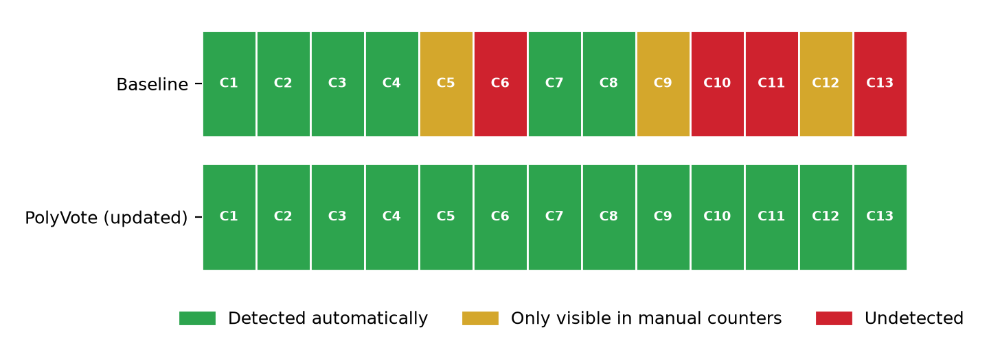
Figure 6: Detection outcome per scenario: plain hash-chain baseline versus PolyVote.
In plain words. Each square is one attack, C1 to C13. Green means PolyVote found it automatically, yellow means it was only visible if someone compared the numbers by eye, and red means it was not found. The top row is the plain hash-chain baseline (6 green) and the bottom row is PolyVote (13 green). C13, adding a ghost voter to the roster, was the one red square in the first edition of this report; the keyed voter-roster seal now detects it (Section 6.11).
Under the plain hash-chain baseline, 6 of 13 scenarios were detected automatically, 3 were visible only as counter mismatches, and 4 were not detected at all. Under the final design, 13 are detected automatically, none rely on the counters, and 0 are not detected. The scenarios behave as follows.
- C1 to C4 (change, replace or delete ballots in the database): detected by both designs, because the sweep compares each ballot with its receipt. In C4 the attacker also clears a voted flag to hide the gap; the deleted ballot is still found.
- C5 (inject a ballot with no receipt) and C9 (truncate the last ledger block): the baseline sweep looked only at ballots that had a receipt, so neither was flagged; both were visible only because the ballot and receipt counts differ. The new "injected" rule and the reconciliation rule detect both automatically.
- C6 (ballot stuffing: inject a ballot, forge its receipt, and set a spare voter's flag so all counters agree) and C10 (alter a ballot and rebuild the whole chain consistently) were completely undetected by the baseline. They are exactly the attacks a plain hash chain cannot stop, because the attacker can recompute every hash. With the keyed chain the forged or rebuilt blocks fail verification at the first block whose hash the attacker could not compute.
- C7, C8 (edit or delete a block): detected by both, by the chain check.
- C11 (swap two candidates' names after voting): undetected by the baseline because names were outside the sealed data; the sealed roster hash now reveals it.
- C12 (reset a voted flag so the voter can vote again): both ballots have valid receipts, so only the disagreement between flags, ballots and receipts exposes it. It was visible only to a careful reader in the baseline and is now reported by the sweep.
- C13 (add a ghost voter to the roster and vote as them through the API) was undetected in the first edition: the ballot is valid, sealed and counted, and the system held no independent record of the roster. The keyed voter-roster seal (rule 6, Section 4.6) now reports it, together with deleted or renamed voters and a deleted or forged seal. An insider who holds the ledger key can still re-seal; that case is outside the threat model (Section 9).
6.5 One-time-password verification
ID | Test | Expected | Result
F1 | Correct password alone does not create a voting session | no token issued; challenge id is not a session | Passed
F2 | Correct emailed code unlocks the ballot | session issued, ballot accepted | Passed
F3 | A used code cannot be replayed | rejected (410) | Passed
F4 | Three wrong codes lock the challenge | 401, 401, 410 then the right code is refused | Passed
F5 | An expired code is refused | rejected (410) | Passed
F6 | Resend is rate-limited to one per 30 seconds | immediate resend 429, later resend 200 | Passed
F7 | A resent code invalidates the previous one | old code rejected | Passed
F8 | A challenge allows at most 5 codes | sixth send refused (429) | Passed
F9 | A voter with no email on file cannot proceed | 409 with a clear message | Passed
F10 | Plaintext codes are absent from the verification database | code not found in any table | Passed
F11 | Repeated sign-ins are rate-limited | sixth challenge in 15 min refused (429) | Passed
F12 | Codes are 6 digits including leading zeros | all length 6, mostly distinct | Passed
F13 | A failed email send does not break sign-in | challenge still issued; failure logged; code stays in the outbox | Passed
F14 | Voter email is not stored in the election database | no email column in any election table | Passed
Table 11: Tests of the email one-time-code module.
All fourteen pass. F1 and F2 establish the basic contract: a correct password alone yields no session and the challenge identifier is not accepted as a bearer token, while the correct code does open the ballot. F3 to F8 cover replay, guess limits, expiry, resend limits and the cap on codes per challenge. F10 and F14 are privacy properties: no plaintext code is stored in the verification database, and the election database has no email column. F13 injects an unreachable mail server and confirms sign-in is not blocked and the failure is logged. F4 initially failed and exposed the rollback defect described in Section 5.3.
6.6 Voter and ballot separation
Check | Result
Columns shared by BALLOT_RANKS and VOTER_PARTICIPATION, excluding election_id | none
Fields stored in a ledger block | ballot_token, curr_hash, election_id, index, prev_hash, roster_hash, timestamp, vote_data_hash
Voter email stored in the election database | no (F14)
Voter identifier present in any ledger block | no
Table 12: Automated check of the voter/ballot separation.
A new field, roster_hash, was added to ledger blocks in the final design. It is a hash of the candidate list and carries no information about any voter.
6.7 Performance
All benchmarks use synthetic elections with five candidates. Ballots are seeded directly into the database and the ledger so that large sizes can be built quickly; the timed operations are the real ones. Results are medians of three runs on a laptop.
Ballots | Cast (ms) | Sweep (ms) | Chain verify (ms) | Tally (ms) | Receipt lookup (ms) | File (KB)
100 | 9.38 / 10.0 | 1.82 / 4.19 | 0.82 / 1.75 | 8.16 / 11.69 | 4.45 / 10.06 | 48.0
1,000 | 33.48 / 28.52 | 16.98 / 11.86 | 7.36 / 9.7 | 10.95 / 8.75 | 7.77 / 7.2 | 448.8
10,000 | 204.85 / 207.49 | 128.74 / 147.41 | 80.4 / 102.5 | 57.2 / 60.21 | 42.53 / 49.21 | 4,465.4
Table 13: File-ledger timings, baseline / PolyVote (median of three runs).
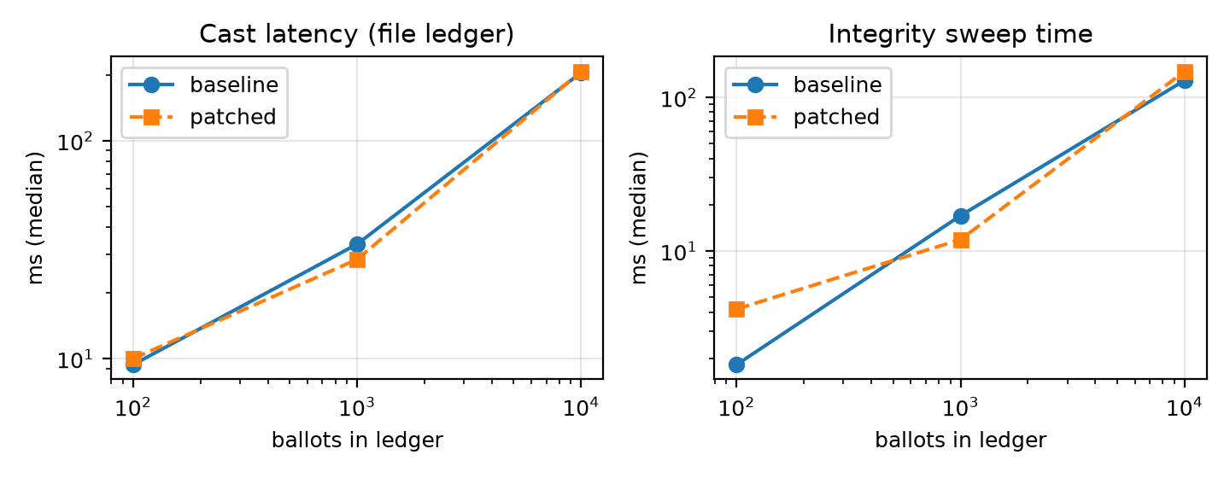
Figure 7: Cast latency and sweep time against ledger size (log scales).
In plain words. The left graph shows how long it takes to cast one ballot as the ledger grows. The right graph shows how long the integrity check takes. Both scales are logarithmic, so each step to the right is ten times more ballots. The two lines (old and final design) sit almost on top of each other, which shows the extra protection costs very little time.
Three observations follow. First, every read-side operation grows linearly with the number of ballots, which is expected from a design that recomputes rather than caches: at 10,000 ballots the sweep takes about 147 ms and the tally about 60 ms, which is acceptable for the target scale. Second, the extra checks and the HMAC add little: the sweep is roughly 15% slower and chain verification 27% slower at 10,000 ballots. Third, cast latency with the file ledger grows from 9.38 ms at 100 ballots to 205 ms at 10,000, because each append rewrites the whole JSON file. That growth is the practical argument for a real document store.
Ballots already in ledger | Append, median (ms) | Append, 90th percentile (ms) | Verify whole chain (ms)
100 | 135.9 | 157.4 | 231
1,000 | 147.2 | 170.4 | 703
10,000 | 139.4 | 163.5 | 3,046
Table 14: Ledger operations against MongoDB Atlas over a mobile hotspot (20 appends per row).
Against Atlas, appending costs about 147 ms whatever the chain length, because the append reads only the last block and inserts one document, so the cost is one or two network round trips. At small sizes the local file is faster, and the crossover is near ten thousand ballots on this network. The reasons to prefer Atlas are therefore not raw speed but flat growth, concurrency control through the unique index, and holding the ledger outside the machine that runs the application. Whole-chain verification reads every block over the network and grows with the chain, from about 0.2 s at 100 blocks to 3.0 s at 10,000. A production system would verify incrementally from a trusted checkpoint.
6.8 Application outputs
The figures below are screenshots from the running application. Names and addresses are demonstration values.
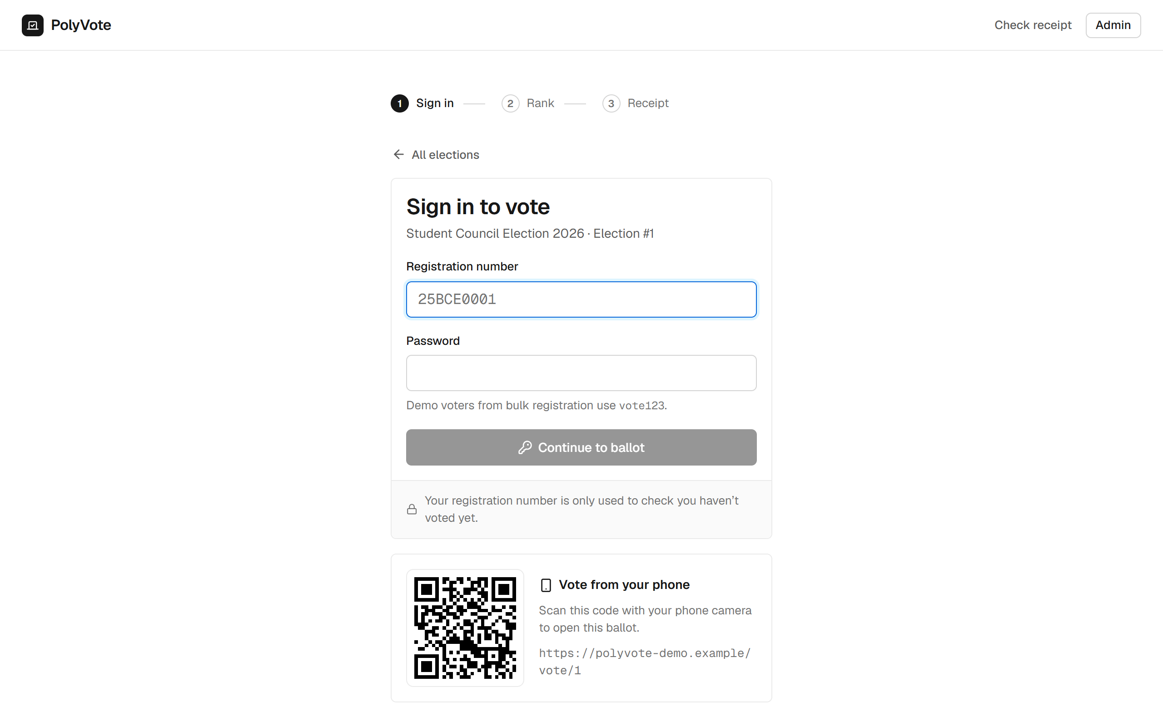
Figure 8: Voter sign-in, with the scan-to-vote QR code for phone voting.
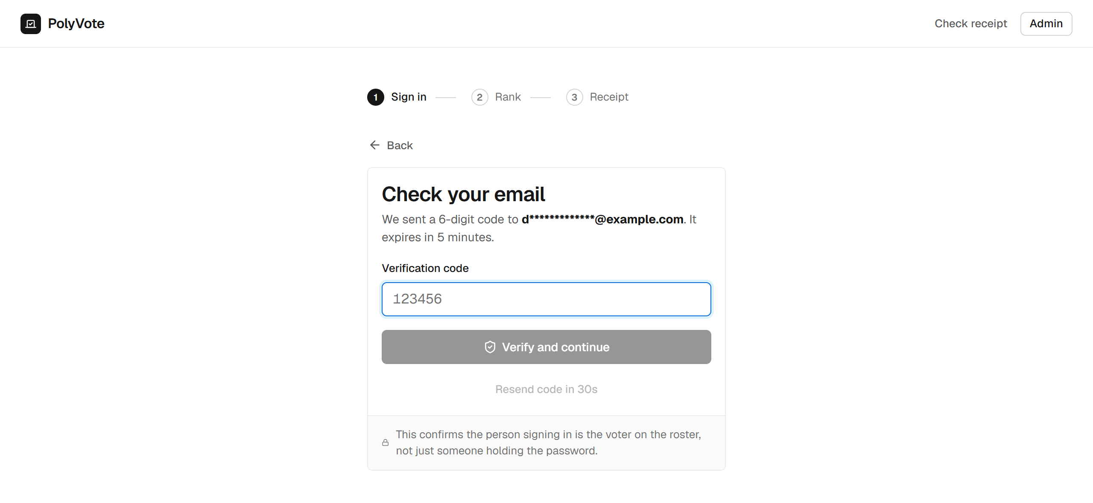
Figure 9: Second factor: the voter enters the six-digit code sent to the address on file.
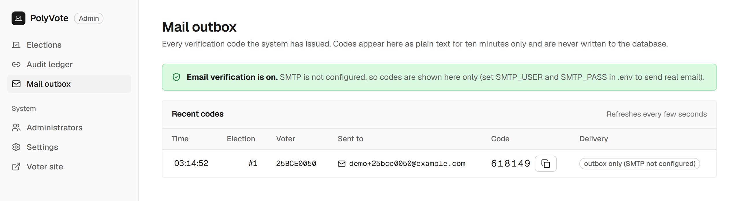
Figure 10: Administrator Mail outbox: each code issued, its recipient and delivery status.
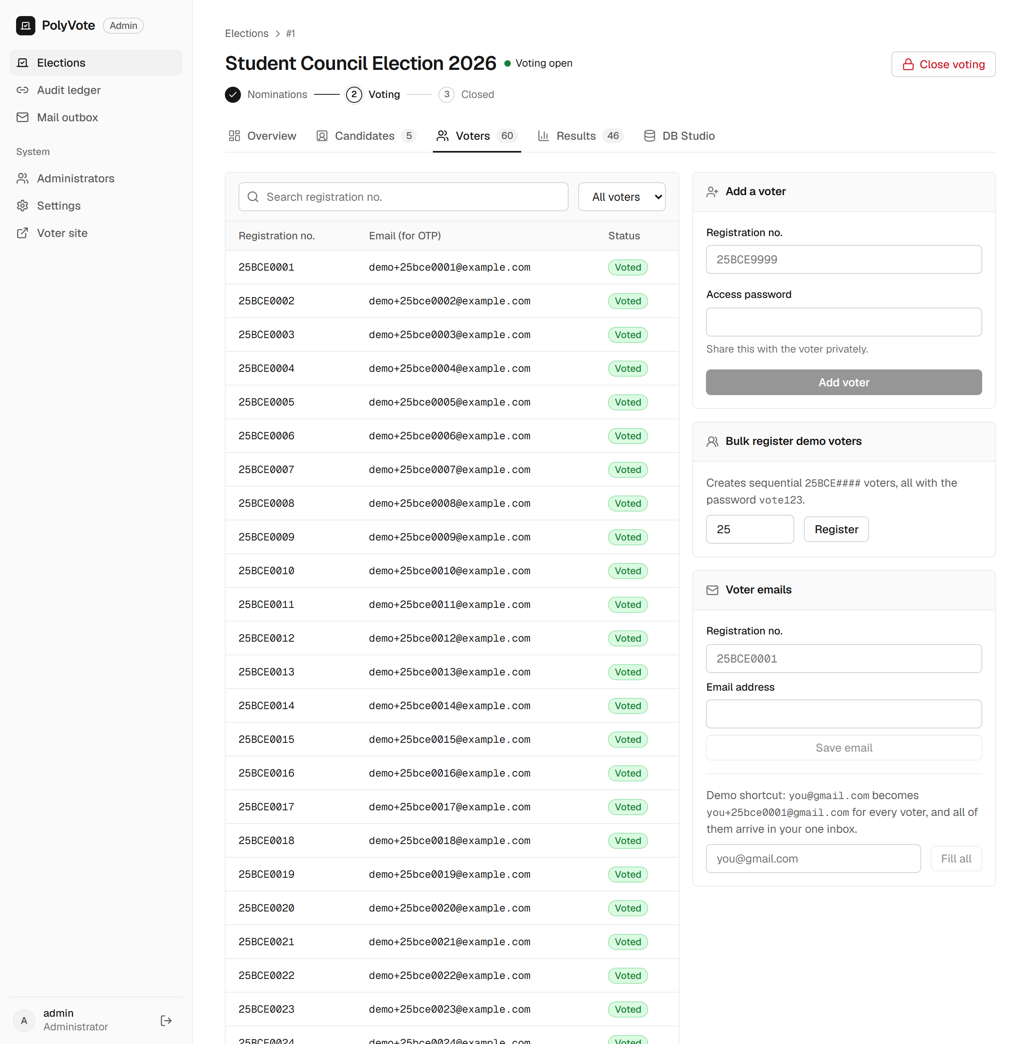
Figure 11: Voters tab with the email column and the bulk plus-address tool.
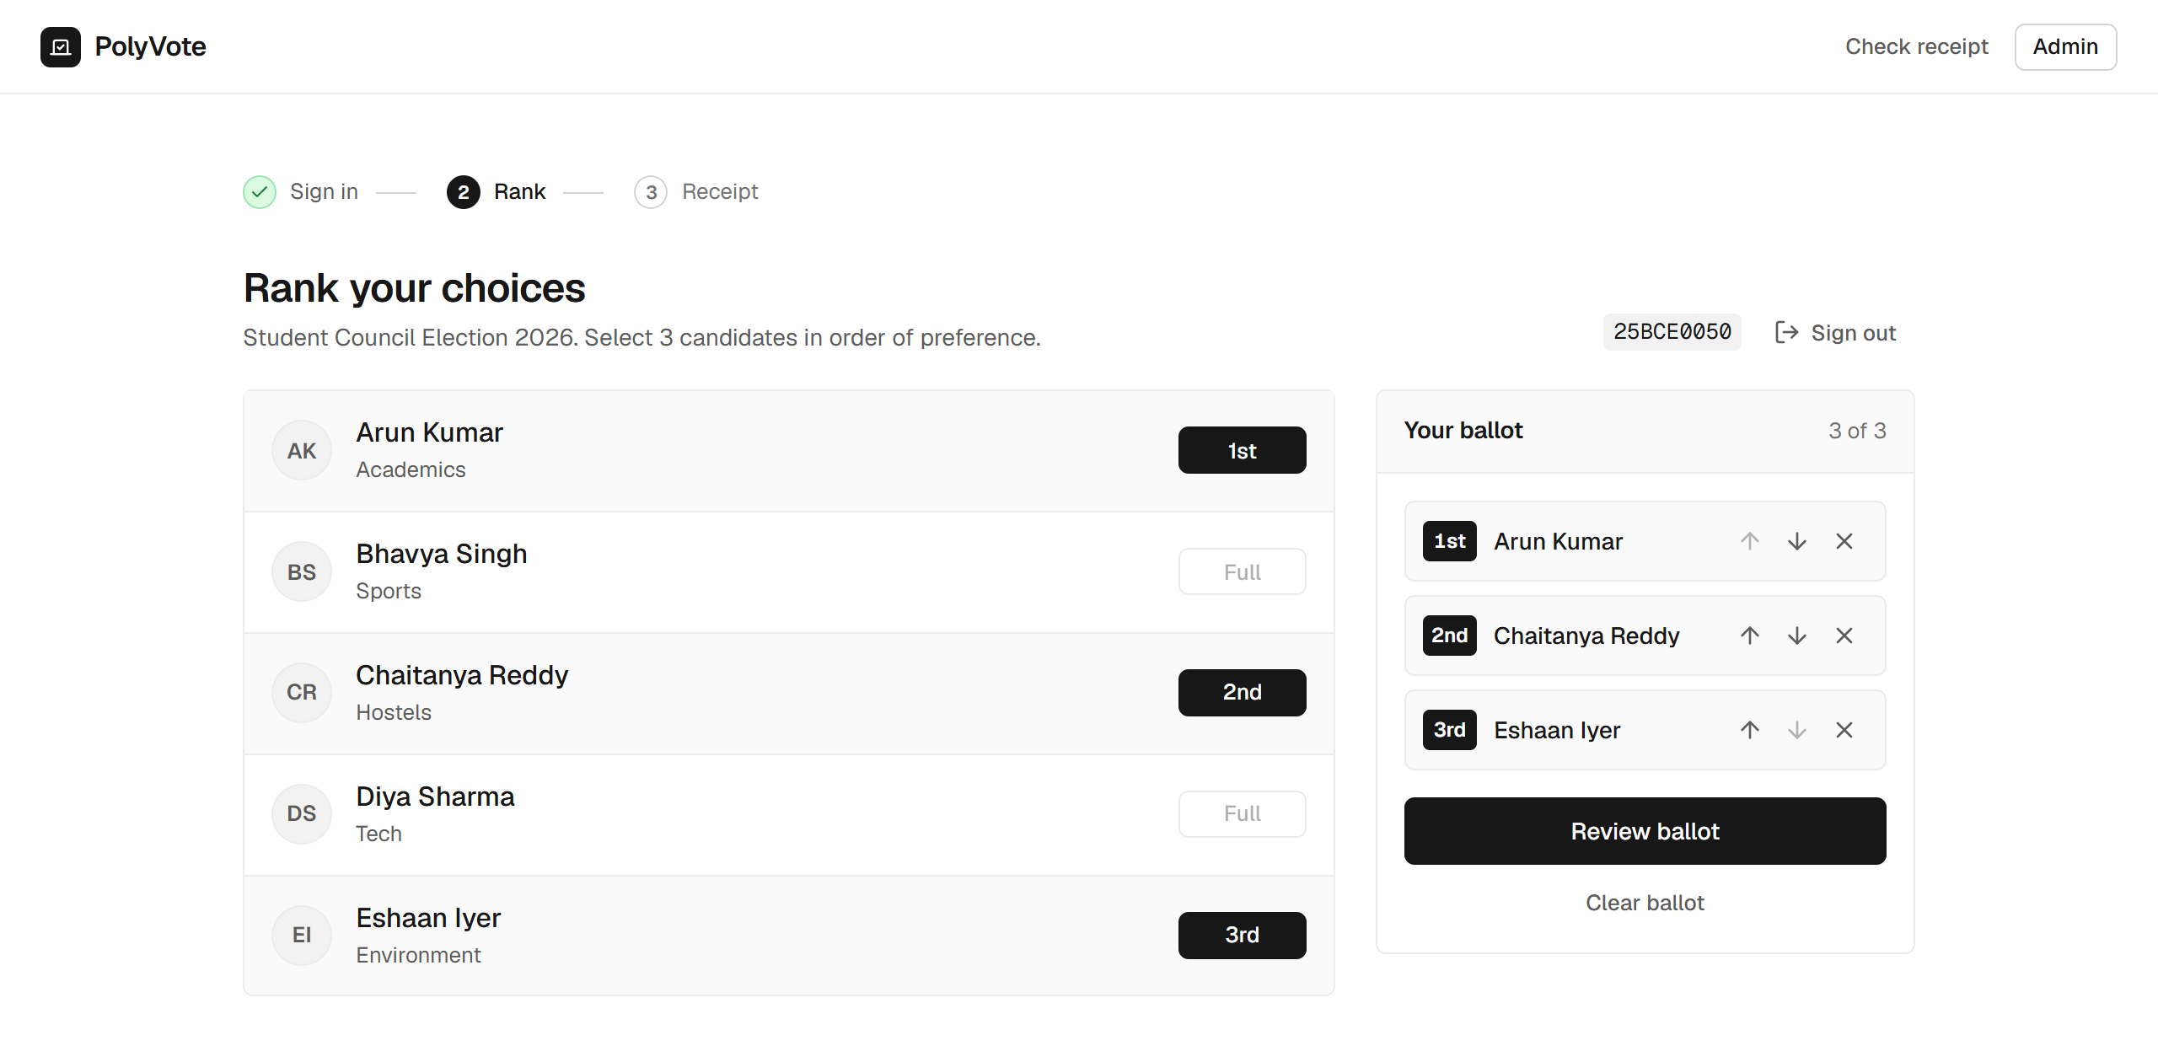
Figure 12: Ranking the ballot on a desktop.
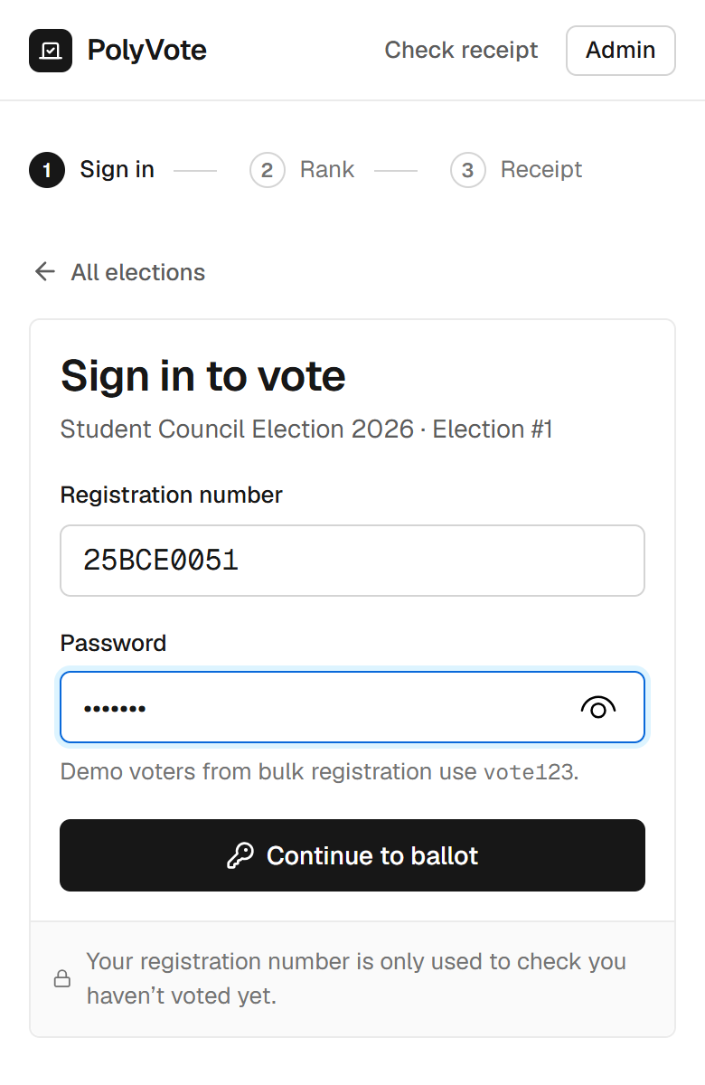 | 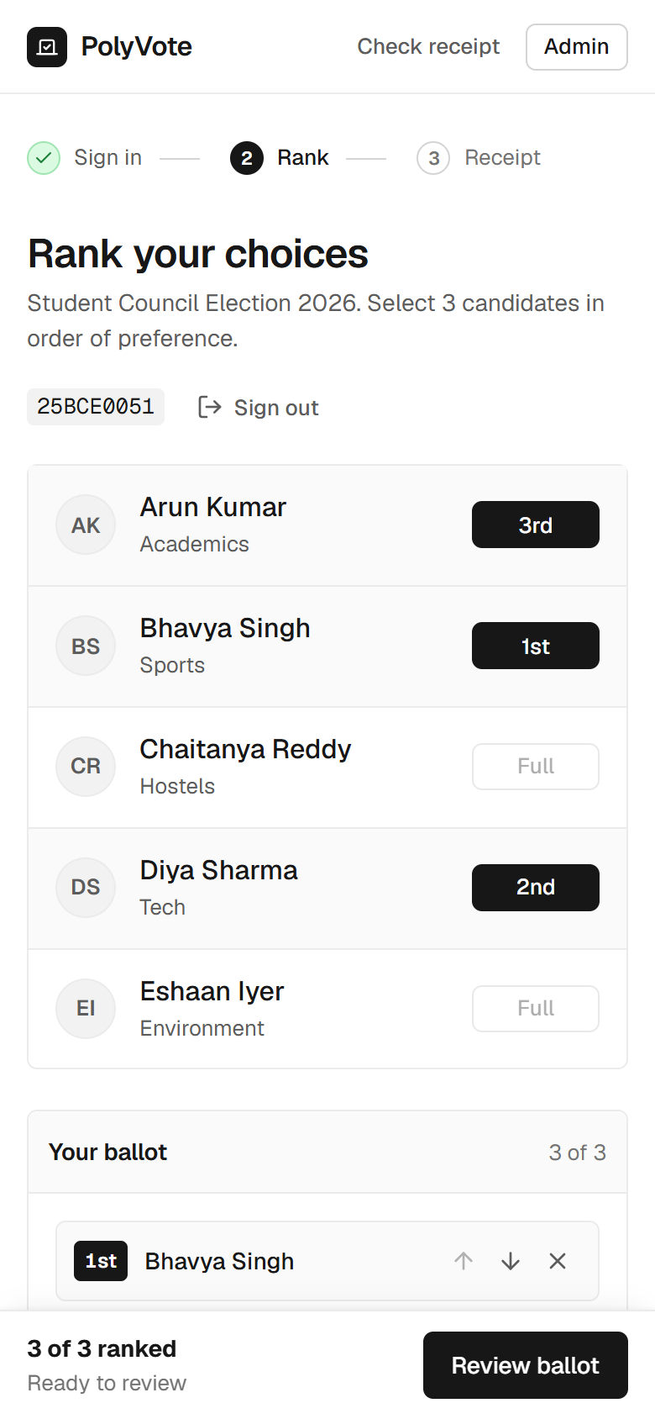
Figure 13: The same flow on a phone-sized screen.
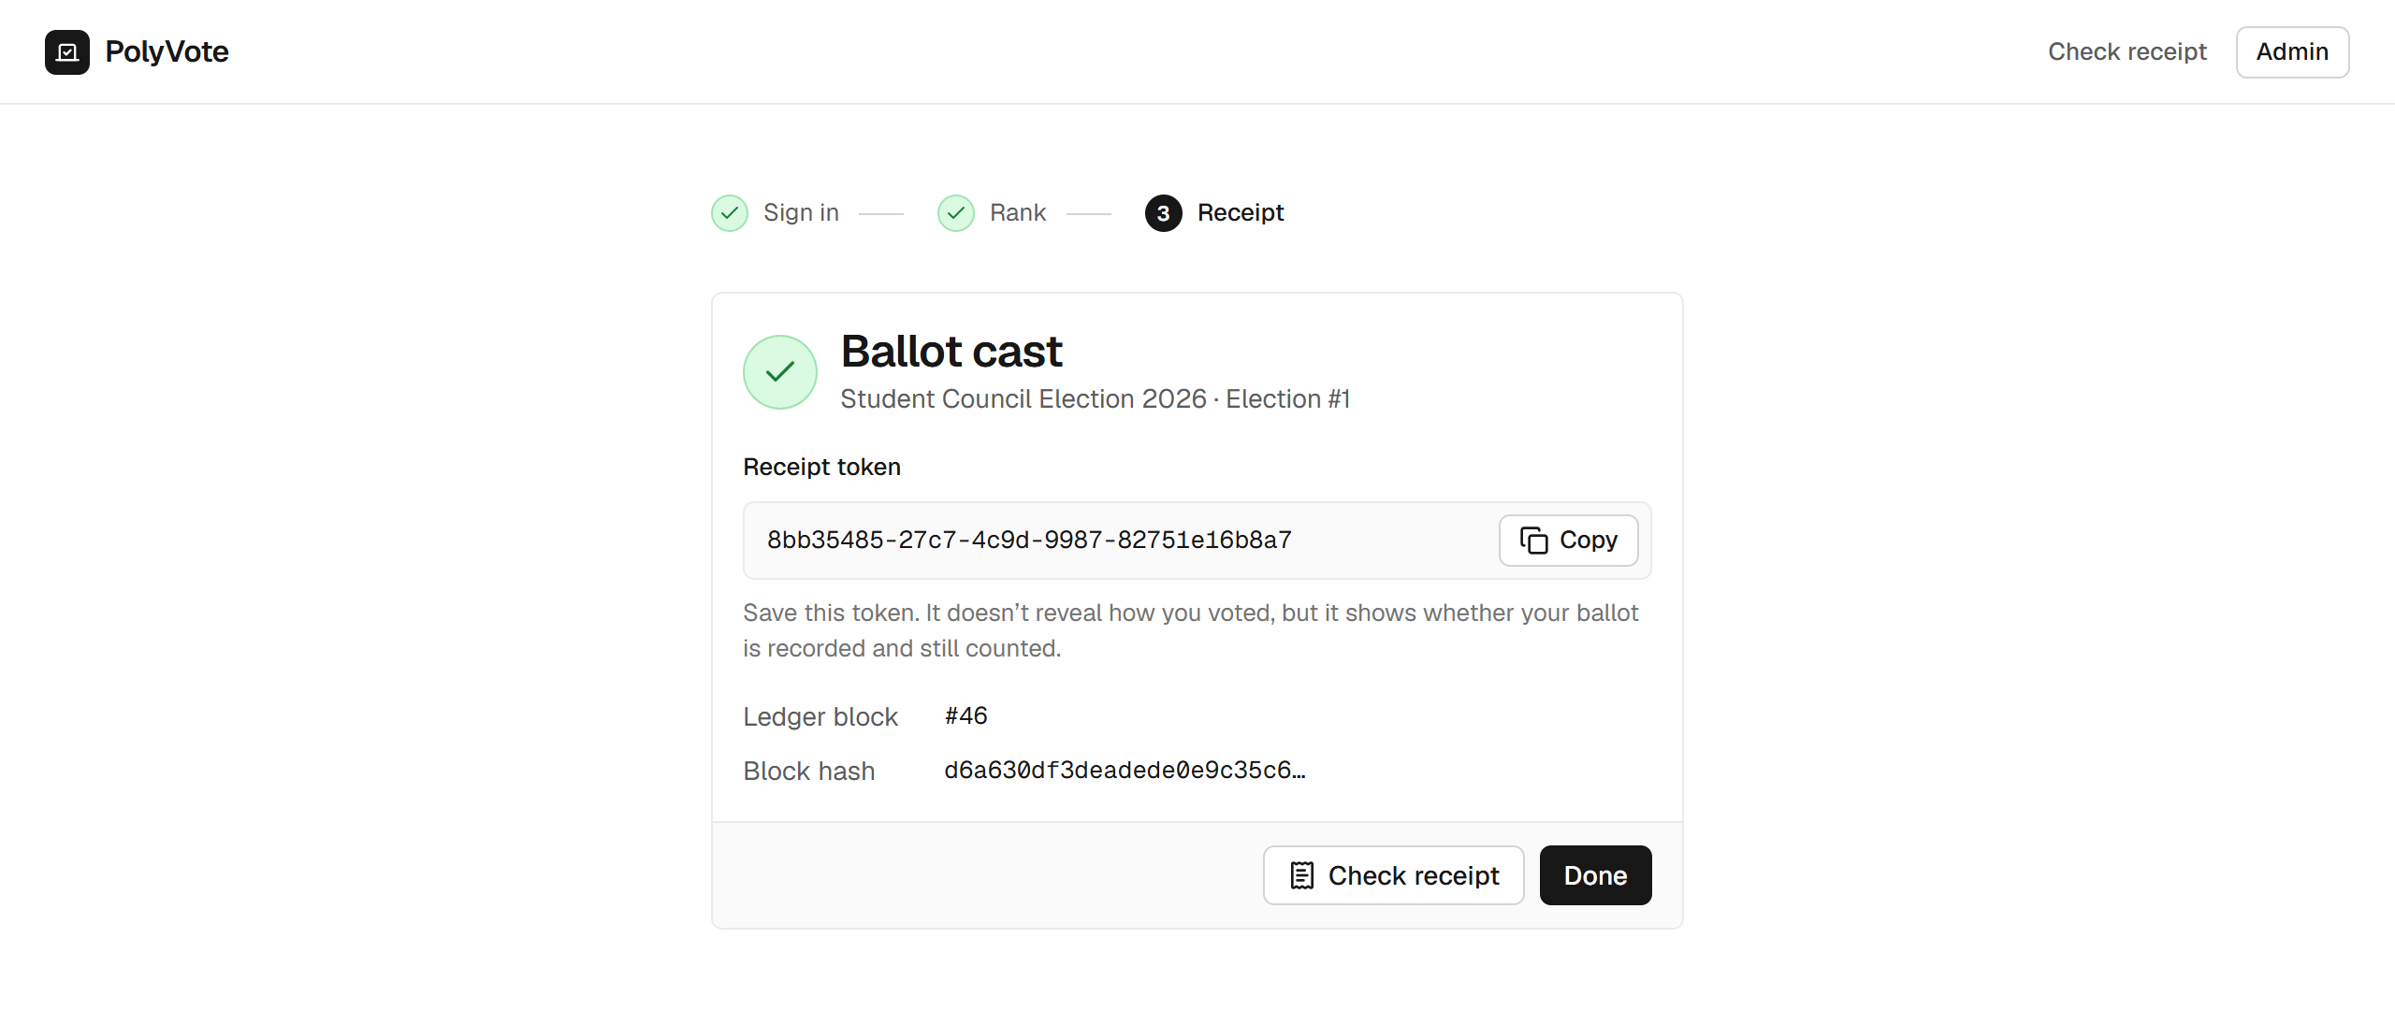
Figure 14: Receipt token and ledger block returned after the ballot is sealed.
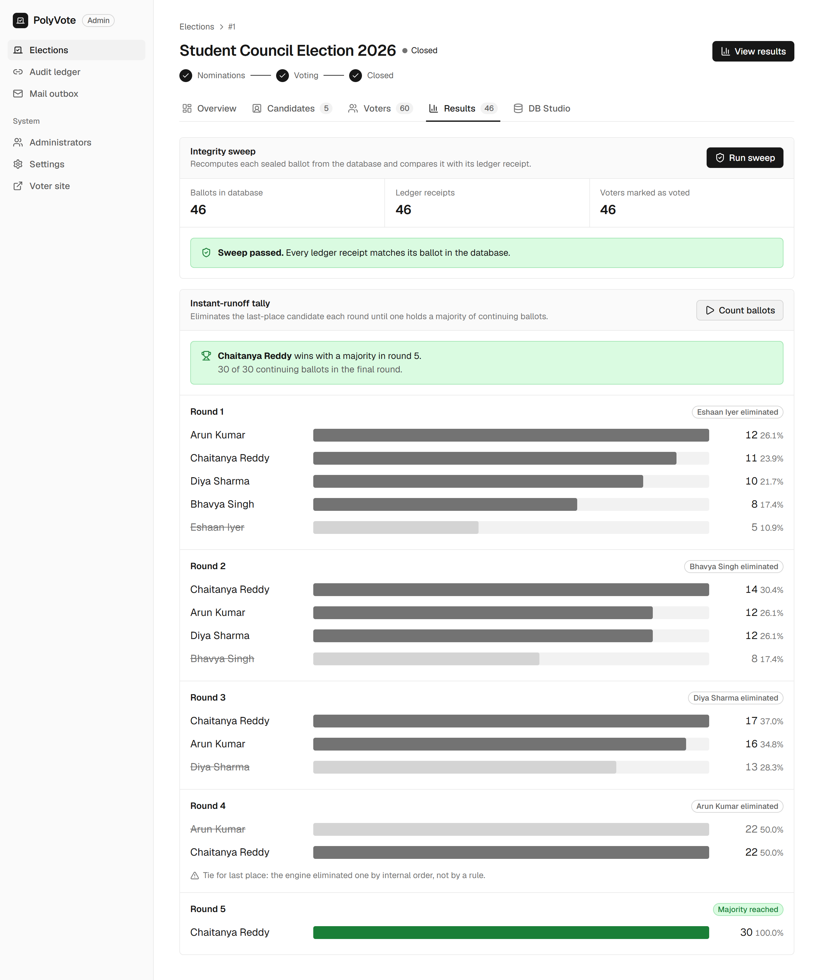
Figure 15: Results before tampering: sweep passed, instant-runoff rounds.
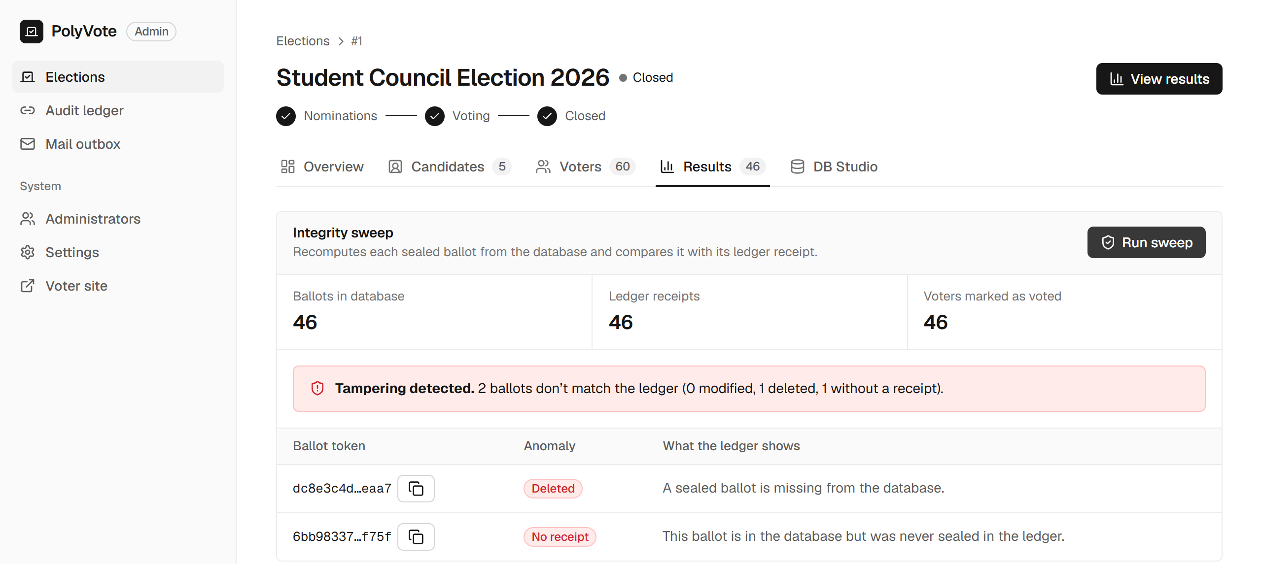
Figure 16: Sweep after one ballot was deleted and another injected: both are reported even though the three counters still read 46 / 46 / 46.
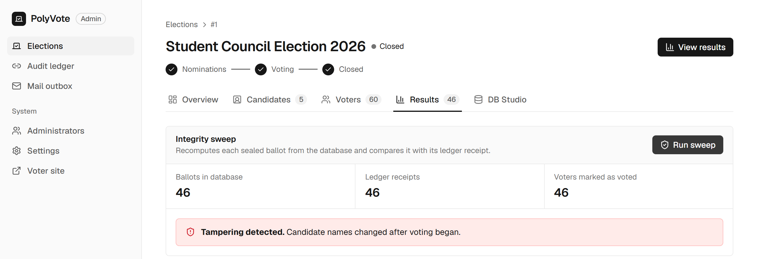
Figure 17: Sweep after two candidate names were swapped.
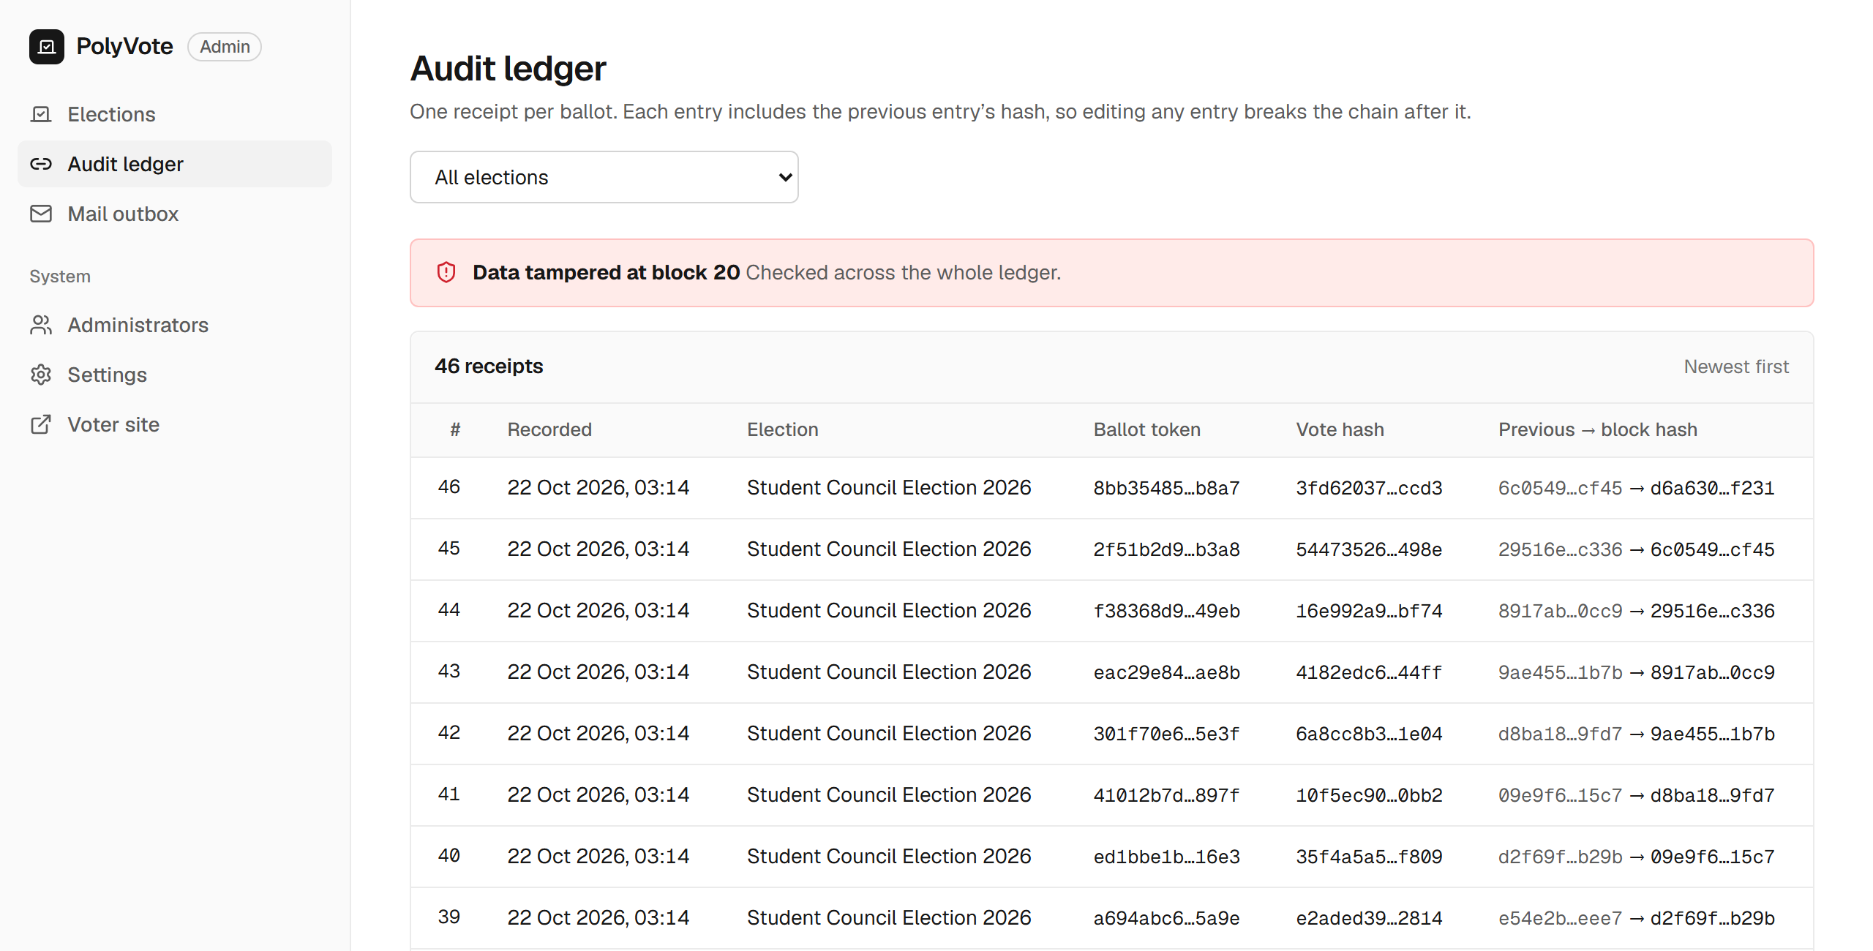
Figure 18: Audit ledger after a block was edited: the chain check fails.
6.9 Live demonstration
The final build, Sample PolyVote, has the email one-time code switched on and was demonstrated live in class. The demonstration went through the complete voter journey and it worked end to end. Table 15 lists each step, what was shown and the screenshot that serves as evidence.
Step | What was shown | Result | Evidence
1 | Officer adds voters and their email addresses | Roster with an Email column; emails stored in a separate database | Figure 11
2 | Voter opens the vote page; QR code shown | Phone opens the ballot by scanning the QR code | Figure 8, Figure 13
3 | Voter signs in with the correct password | No ballot yet: the page asks for the emailed code | Figure 9
4 | Code is issued and sent | Code appears in the Mail outbox and arrives by email | Figure 10
5 | Voter enters the code and ranks three candidates | Ballot screen opens only after the right code | Figure 12
6 | Voter casts the ballot | Receipt token and ledger block returned | Figure 14
7 | Officer closes the election, runs the sweep and counts | Sweep passes; instant-runoff rounds shown | Figure 15
8 | Tamper test: ballot deleted and another injected | Sweep names both even though the counters still match | Figure 16
9 | A ledger block is edited | Chain check shows a red "tampered" banner | Figure 18
Table 15: Steps of the live demonstration and the evidence for each.
The screenshots in Figures 8 to 18 come from the same build that was demonstrated. They show the one-time code stopping a password-only sign-in, the QR code opening the ballot on a phone, the receipt after voting, and the sweep and chain check catching tampering.
6.10 Threats to validity
- Synthetic workload. Elections are generated; real turnout patterns and larger rosters might differ. We used up to 10,000 ballots, which exceeds any single election we target.
- One machine and one network. Timings come from a laptop, and Atlas timings from a mobile hotspot, so absolute values will differ elsewhere. We report ratios and trends.
- Attacker models are ours. Scenarios C1 to C13 are the attacks we thought of, expressed against our own design. They are not a complete catalogue, and an author tends to test what the design handles. Section 6.11 extends the set to 31 scenarios, but we wrote those too.
- The baseline is our own earlier version. We did not run Helios, Belenios or the commercial systems, so the comparison with them in Section 7 is qualitative and based on their published designs.
- Detection depends on running the sweep. The system detects tampering when the officer runs the checks; it does not prevent it or alert automatically.
6.11 Extended evaluation (updated edition, November 2026)
The first edition of this report evaluated 13 tampering scenarios and found one it could not detect (C13, a ghost voter). This updated edition changes the system in two ways and widens the evaluation. Changes to the system: a keyed voter-roster seal and sweep rule 6 close the C13 gap (Section 4.6), and passwords are stored with salted PBKDF2 instead of plain SHA-256. Changes to the evaluation: 31 scenarios instead of 13, each run once under a keyed and once under a plain chain with a record of which detector fires; ablations and comparisons with other designs read from that record; and measurements of accuracy, correctness, passwords, scaling, concurrency, security probes and code quality. The first edition, as submitted, is unchanged. Everything below is reproducible with experiments/full_eval/run_all.py, and a 32-page dossier with 21 figures, 18 tables and 20 screenshots is in docs/evaluation/.
6.11.1 Method
Attacker model. The attacker has write access to the election database, the ledger store or both, and does not hold the ledger key. Three scenarios are deliberately outside this model and are reported anyway: two in which the attacker holds the key (C28, C29) and one that edits a candidate's platform text, which is not sealed (C23).
Detector record. Each scenario runs against a throwaway copy of the application. The record stores which of eight detectors fired: the chain check, sweep rules 1 to 6, and an officer comparing counters by eye. A design profile is a subset of detectors plus a key mode, so the behaviour of other designs is read from the record rather than re-implemented. To validate this, the first edition's design was emulated from the record and compared with the real first-edition code on C1 to C13: they agreed on 13 of 13.
ID | Attack | In the model | Detectors that fire (final design)
C1 | Swap the 1st and 2nd choice on one ballot | Yes | modified
C2 | Replace the first-choice candidate on one ballot | Yes | modified
C3 | Delete one ballot | Yes | deleted, count mismatch
C4 | Delete a ballot and clear a voted flag to hide the gap | Yes | deleted, count mismatch
C5 | Inject a ballot with no receipt | Yes | injected, count mismatch
C6 | Ballot stuffing: inject ballot, forge a plain-hash receipt, set a voted flag | Yes | chain
C7 | Edit a ledger block without repairing the chain | Yes | chain, modified
C8 | Delete a block from the middle of the ledger | Yes | chain, injected, count mismatch
C9 | Truncate the last block of the ledger | Yes | injected, count mismatch
C10 | Change a ballot and rebuild the whole chain (attacker has no key) | Yes | chain
C11 | Swap two candidates' names after voting | Yes | candidate seal
C12 | Reset a voted flag, then let that voter cast a second ballot | Yes | count mismatch
C13 | Add a ghost voter to the roster and vote as them through the API | Yes | voter seal
C14 | Delete an unvoted voter from the roster (disenfranchise) | Yes | voter seal
C15 | Rename an unvoted voter's registration number | Yes | voter seal
C16 | Delete the roster seal, then add a ghost voter and vote | Yes | voter seal
C17 | Forge the roster seal without the key, then add a ghost voter and vote | Yes | voter seal
C18 | Wipe the whole ledger | Yes | injected, count mismatch
C19 | Append a copy of an existing ledger block (replay a receipt) | Yes | chain
C20 | Swap two ledger blocks (reorder) | Yes | chain
C21 | Edit the timestamp of a ledger block | Yes | chain
C22 | Change a ballot and its block hash but leave the chain unrepaired | Yes | chain
C23 | Edit a candidate's platform statement | No | none
C24 | Add a candidate after voting | Yes | candidate seal
C25 | Delete a candidate row after voting (foreign keys off) | Yes | candidate seal
C26 | Mark an unvoted voter as voted with no ballot (disenfranchise) | Yes | count mismatch
C27 | Erase a vote completely: delete the ballot, its block and the flag, rebuild the chain | Yes | chain
C28 | Insider WITH the ledger key: change a ballot and rebuild the chain with the key | No | none
C29 | Insider WITH the key: add a ghost voter and ballot, forge the receipt, re-seal the roster | No | none
C30 | Roll the ledger store back to an older backup | Yes | injected, count mismatch
C31 | Roll the election database back to an older backup | Yes | deleted, count mismatch
Table 16: The 31 attack scenarios and what detects them in the final design.
6.11.2 Detection by design
Profile | Design | All 31 | In the model (28)
P0 | CRUD app: officer compares the counters | 11 of 31 | 11 of 28
P1 | CRUD app + automatic count check | 10 of 31 | 10 of 28
P2 | Plain hash chain only | 6 of 31 | 6 of 28
P3 | Plain chain + receipt sweep (Review 2 design) | 11 of 31 | 11 of 28
P4 | Plain chain + full sweep | 24 of 31 | 24 of 28
P5 | Keyed chain only | 9 of 31 | 9 of 28
P6 | Keyed chain + sweep rules 1-5 (previous final design) | 23 of 31 | 23 of 28
P7 | PolyVote final (keyed chain + 6 sweep rules) | 28 of 31 | 28 of 28
Table 17: Attack scenarios detected by each design profile.
The final design detects all 28 scenarios inside the attacker model (and 28 of 31 overall). The first edition's design detects 23 of 31, a plain chain with a receipt sweep 11, and a conventional application whose officer compares counters 11. With a plain SHA-256 chain, the same six rules would detect 24 of 31, so the key is what stops forged and rebuilt chains. Append-only database triggers prevent 8 of 31 against a writer who cannot drop them, but they do not stop injection, ledger tampering or roster changes, and a writer with schema rights removes them.
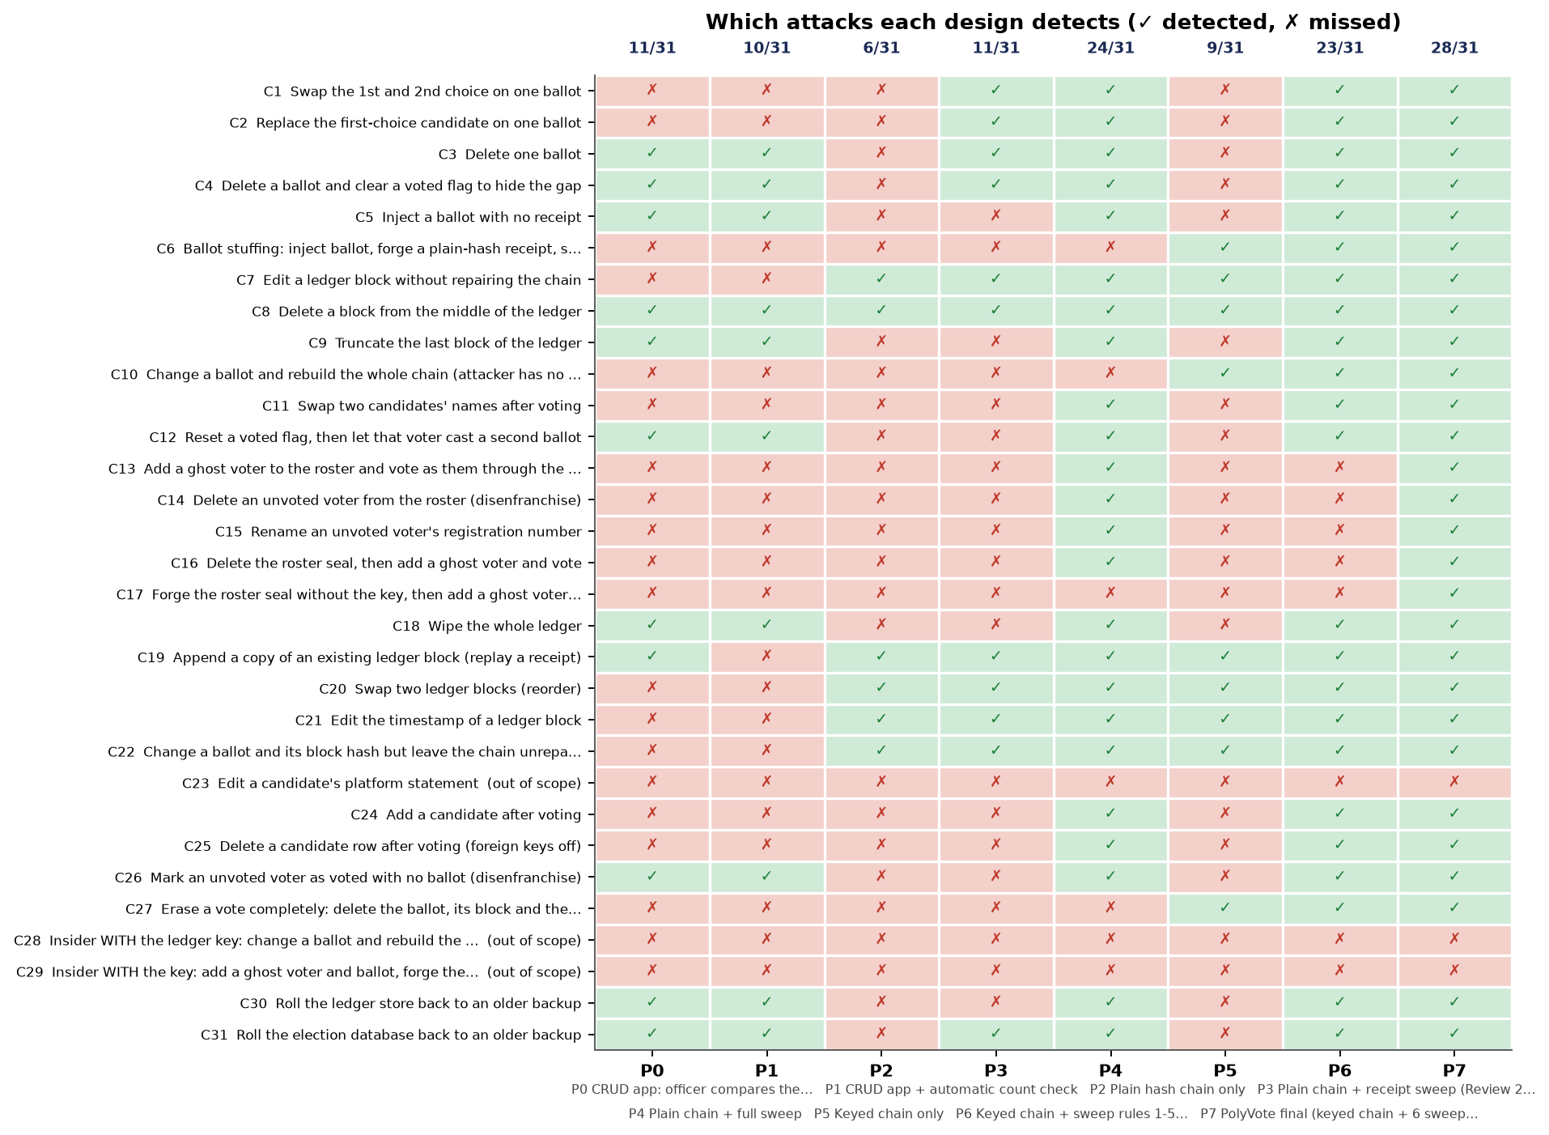
Figure 19: Which of the 31 attacks each of the eight design profiles detects (green) or misses (red).
6.11.3 Ablation
Detector removed from the final design | Still detected | Attacks lost
Chain check | 21/31 | C6 C10 C19 C20 C21 C22 C27
Rule 1 modified | 26/31 | C1 C2
Rule 2 deleted | 28/31 | -
Rule 3 injected | 28/31 | -
Rule 4 candidate seal | 25/31 | C11 C24 C25
Rule 5 count mismatch | 26/31 | C12 C26
Rule 6 voter seal | 23/31 | C13 C14 C15 C16 C17
Table 18: Leave-one-out ablation (31 scenarios, keyed chain).
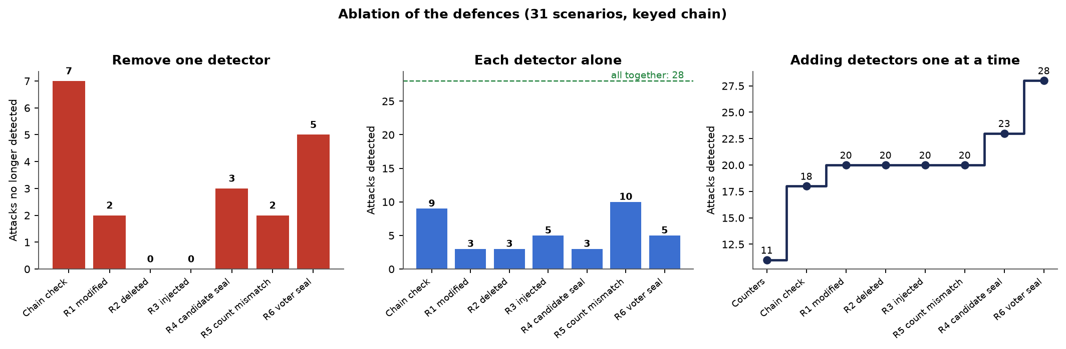
Figure 20: Ablation of the defences: attacks lost when one detector is removed, attacks each detector finds alone, and cumulative detection.
No single detector is enough: the strongest alone finds 10 of 31. Removing rule 2 or rule 3 loses nothing, because the chain check and counters also see those attacks, but the rules are kept because they name the tampered ballots.
6.11.4 Accuracy and correctness
Across 399 sweeps over 120 randomised clean elections (bulk registration, late voters, ballots, closing) there were 0 false alarms. When 1, 5 or 20 ballots in each category were modified, deleted or injected, the sweep named exactly those ballots: precision and recall were 1.0 in all nine cases. The instant-runoff tally agreed with an independent implementation that explores every tie-break in 500 of 500 random elections of 3 to 8 candidates and 5 to 300 ballots (66 had a tie path).
6.11.5 Passwords
Password class | Unsalted SHA-256 (before) | Salted PBKDF2 (after)
6 digits | 1.4 seconds | 5.8 days
8 digits | 2.3 minutes | 1.6 years
8 lowercase letters | 3.3 days | 3,303 years
8 letters and digits | 9.5 years | 3,453,747 years
10 letters and digits | 36,675 years | 13,276,201,859 years
Hashes per second, 1 CPU thread | 725,672 | 2.0
Verify time at login | <0.01 ms | 477.5 ms
Table 19: Time to try every password in a class on one CPU thread.
Each offline guess is about 361,996 times slower, and every hash has its own random salt, so precomputed tables cannot be reused. Verification takes about 478 ms; the round count is configurable (PASSWORD_HASH_ITERATIONS) for slower hosts.
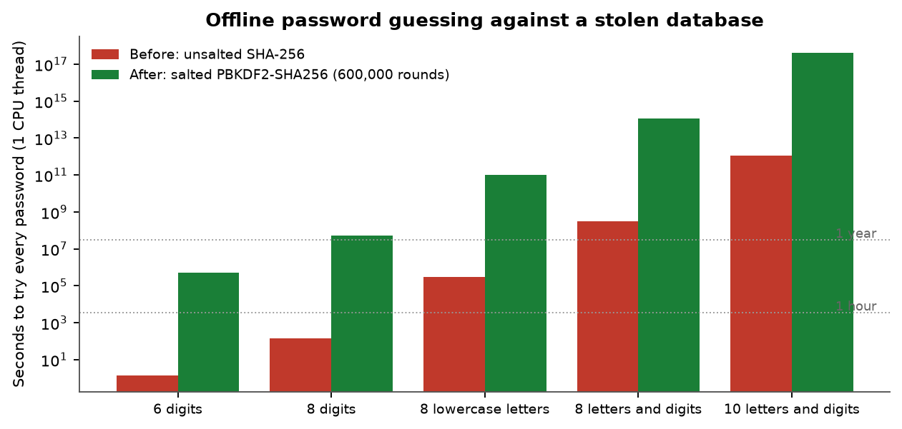
Figure 21: Offline guessing cost before and after the change.
6.11.6 Performance and concurrency
Ballots | Sweep (ms) | Sweep without voter seal (ms) | Chain check (ms) | Tally (ms) | Cast p50 (ms)
100 | 6 | 3 | 2 | 6 | 14
1,000 | 22 | 18 | 13 | 14 | 45
10,000 | 269 | 168 | 121 | 95 | 251
50,000 | 1,604 | 1,121 | 653 | 634 | 1,235
100,000 | 5,985 | 4,356 | 2,731 | 2,689 | 4,658
Table 20: Median times with the keyed file ledger, 100 to 100,000 ballots.
Audit and tally grow roughly linearly. At 10,000 ballots the sweep takes 269 ms and at 100,000 it takes 6.0 s; the voter seal accounts for a minority of that. The file ledger rewrites the file on every append, so casting slows as the ledger grows; MongoDB Atlas appends stay flat (see the Atlas benchmark earlier in this section). With one to 16 simultaneous voters there were no errors, and the chain and sweep were intact after every run (up to 16 casts per second on a laptop). The timings in this table were taken on a busier machine than the first edition's benchmarks, so the two sets of figures should be compared as trends, not exact values.
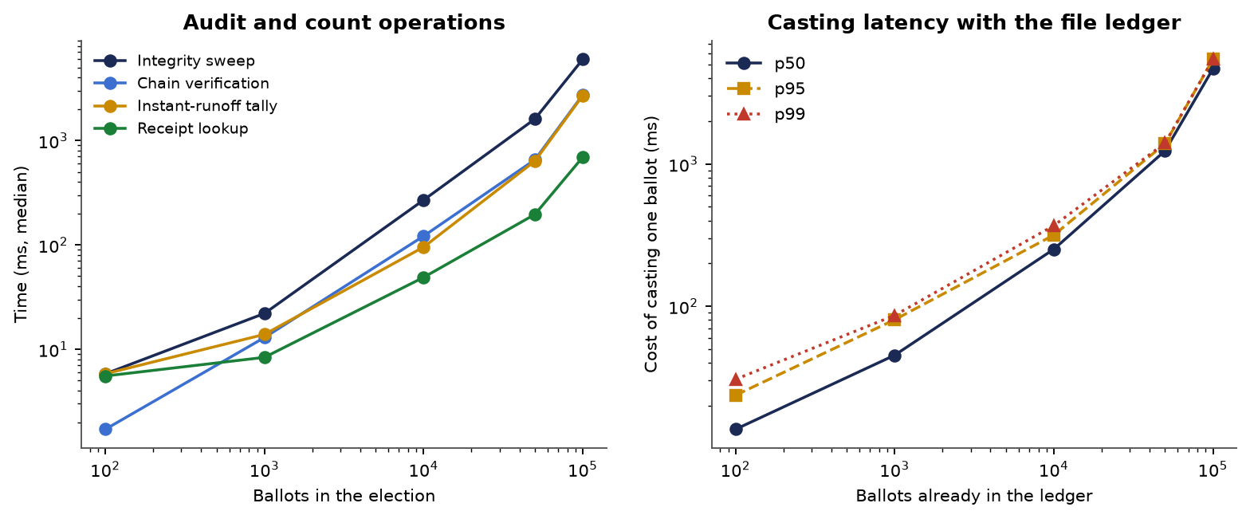
Figure 22: Audit time against election size (left) and cost of casting one ballot with the file ledger (right), log scales.
6.11.7 Security probes and privacy
Probe | Result | Verdict
Brute-force password guesses | 40 attempts, 0.9/s, locked out: False | Limitation: no lock-out on the password step (the emailed code is a second factor)
Fuzzing (hostile and malformed input) | 117 requests, 0 server errors, tables intact: True | Pass
Admin endpoints without a token | elections: 401, integrity: 401, voters: 401, admins: 401, ledger: 401, outbox: 404 | Pass
User enumeration | unknown voter 404, wrong password 401 | Limitation: a roster lookup reveals whether a number is registered
Session expiry | session fields: role, username | Limitation: sessions live in memory until sign-out or restart
API security headers | content-security-policy: absent, x-content-type-options: absent, x-frame-options: absent, referrer-policy: absent, permissions-policy: absent, strict-transport-security: absent, cache-control: absent | Limitation (see live-site headers)
CORS from a foreign origin | None | Pass
Receipt token guessing | 122 random bits (UUID v4) | Pass
Table 21: Probes of the running application.
Privacy check | Result
Columns shared by ballot and voter tables | none
Timestamp on the ballot table | yes (ledger only)
Ledger block fields | ballot_token, curr_hash, election_id, index, prev_hash, roster_hash, timestamp, vote_data_hash, voters_sealed
Ordering attack on 150 API casts in random voter order | 0 correct guesses (chance: about 1.0)
Simulation tool casts in roster order | block order mirrors roster order; demo tool only
Table 22: Voter privacy checks.
The probes found real gaps that we have not fixed and list as limitations: no lock-out on the password step, a login response that distinguishes an unknown registration number from a wrong password, no session expiry, and no security headers on API responses. An attacker with two database copies and one cast in between links a voter to a ballot with probability one over the number of casts, a known limit of any design that stores a voted flag.
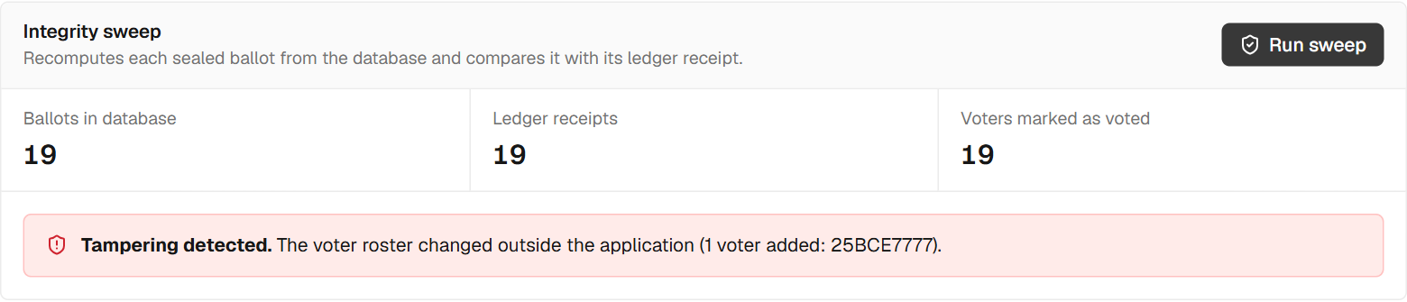 | 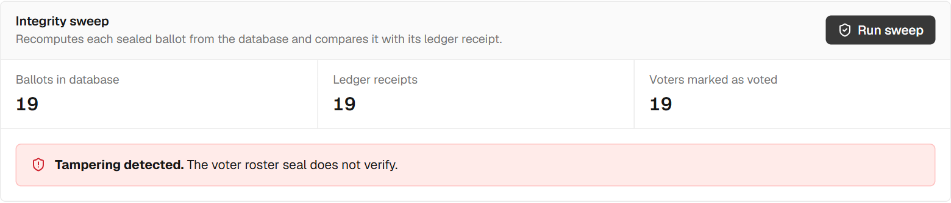
Figure 23: Sweep after a ghost voter was added and used (C13, left) and after the roster seal was forged without the key (C17, right).
6.11.8 Code and dependencies
The repository has about 10,949 non-blank lines of code and documentation, 36 API routes and 110 analysed functions with a mean cyclomatic complexity of 3.13. The security linter reports 6 findings (3 medium, 3 low). The front-end dependency audit reports 0 known vulnerabilities; the hosted Python requirements report 0. The legacy desktop requirements report 39 advisories, all in an image library used only by the old Streamlit interface, which the hosted service does not install.
6.11.9 Comparison with related systems
We read the documentation of 33 related systems and recorded nine features (Section 7). Only 1 system documents in-database integrity rules and 2 document an emailed one-time code; in the strict form used here, none documents a keyed tamper-evident ledger with a reconciling sweep and published attack results, and none documents the combination of ranked-choice counting, in-database rules, such a ledger and an emailed second factor. "Not documented" means we did not find it, not that it is absent, and the competing products were not run: they are placed in the nearest measured design class from their documentation.
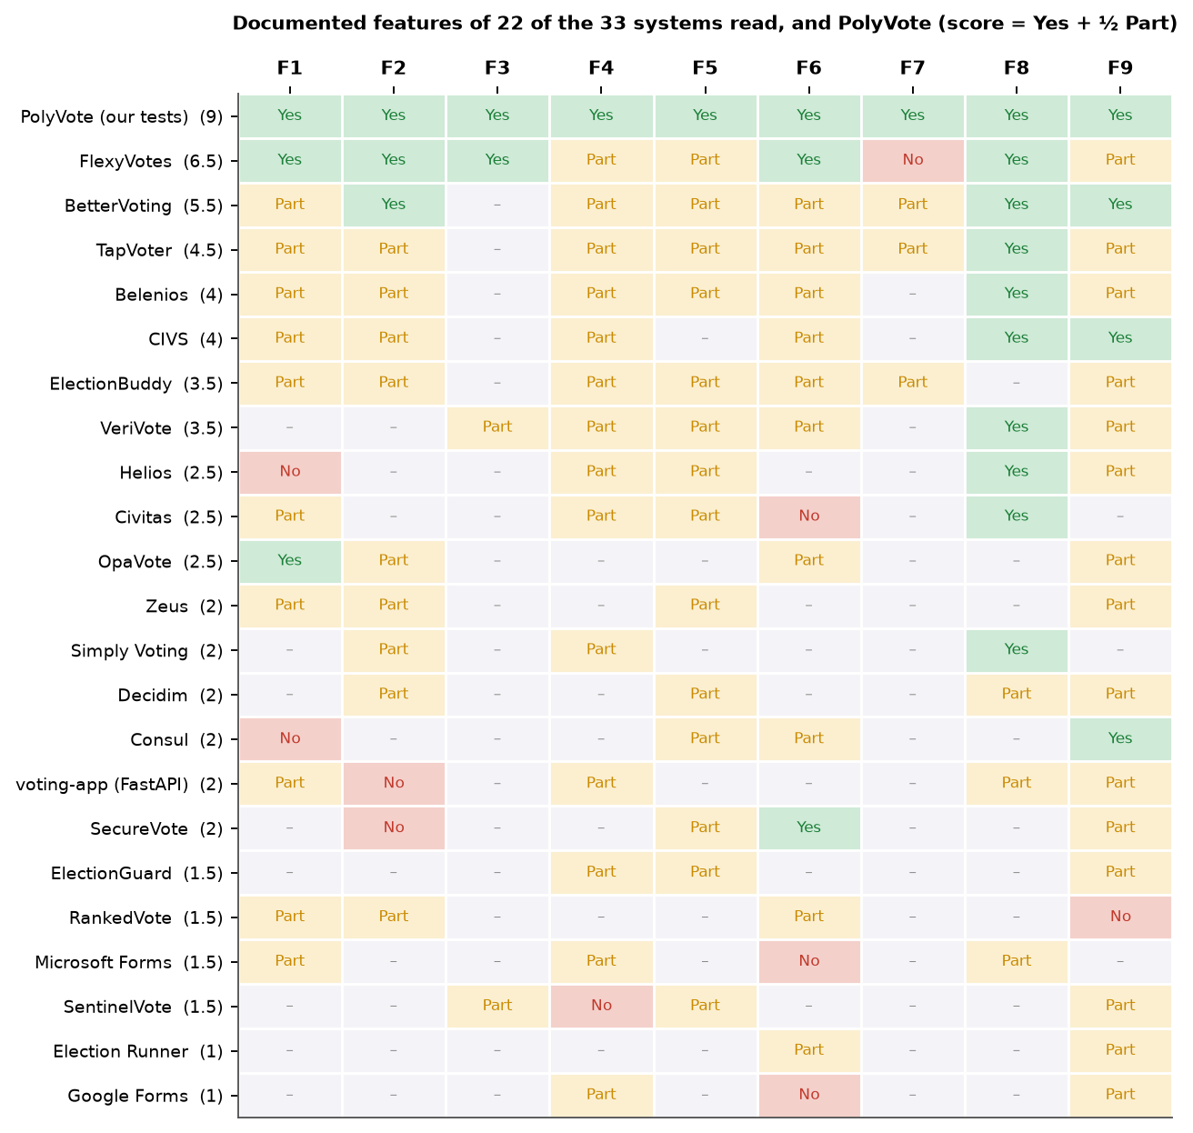
Figure 24: Documented feature coverage of 22 of the systems, and PolyVote.
Where related systems are stronger. Helios, Belenios and ElectionGuard let a voter check that the recorded ballot is the one cast and let anyone check the tally; PolyVote's receipts show only that a ballot is recorded and counted. A hostile administrator who holds the ledger key defeats PolyVote and does not defeat them. They also have years of use and public analysis. PolyVote's claim is cost and fit: free, open source, one command to run and a detection result that anyone can re-run.
6.11.10 Limits of the extended evaluation
- The 31 scenarios were written by the authors, so the 28 of 28 result shows coverage of the attacks we thought of, not of all attacks. An independently written attack list is future work.
- Competing designs are emulated classes from documentation, not products run under test.
- One early prevention test (A3) was flaky and was fixed; the earlier pass was partly luck, and the dossier says so.
- No user study has been run. A protocol, consent form, task cards and analysis script are prepared in docs/user_study/, but no participant has been tested, so no usability claim is made.
7. Comparative Study
PolyVote is a combination of parts, so we compare it part by part with the related projects and technologies that do the same job. For every part we show what the others offer, what PolyVote achieved in our tests, and where the proof is in this report. We separate two kinds of evidence. Measured evidence comes from our own tests and benchmarks (Section 6) and is exact. Published evidence comes from the papers and vendor pages in the reference list; we did not run those systems, so statements about them are only as strong as their sources.
7.1 Method and verdict rule
- Seven parts: integrity rules inside the database, voter/ballot separation, the audit ledger, voter authentication, vote counting, storage architecture, and access (phone, QR code, setup).
- Verdict rule: we write Better only where a test or benchmark in this report shows it. We write Comparable where the mechanism matches the alternative, and Not better where the alternative is stronger. Nothing is claimed without a table or figure to point to.
- Baseline: for the ledger part we also measure a plain hash-chain design (the conventional approach in [10]-[12]) with the same attacks, so the comparison there is measured, not argued.
7.2 Part 1: integrity rules inside the database
The job: refuse a second vote, a bad rank or a ballot for a missing candidate.
Compared with | What it offers (source) | PolyVote: proven result | Evidence
Form tools and typical student apps | One vote per person depends on sign-in or application code; the owner or administrator can edit stored answers | 6 of 7 database statements rejected by the engine; 13 of 13 API abuse tests refused; 20 simultaneous casts stored exactly 1 ballot | Table 8, Table 9
Server database constraints and triggers [29], [30] | The same mechanisms, enforced on every connection | The same mechanisms (trigger, CHECK, UNIQUE, foreign key). Gap found: SQLite enforces foreign keys only when switched on per connection (test A5) | Table 8, test A5
Table 23: Part 1 compared with related approaches.
Verdict. Better than apps that enforce the rule only in application code (measured). Comparable to server databases in mechanism; not better on foreign-key enforcement until a server database is used.
7.3 Part 2: voter and ballot separation
The job: make sure nobody can look up who voted for whom.
Compared with | What it offers (source) | PolyVote: proven result | Evidence
Helios [1], Belenios [2] | Ballots are encrypted; privacy depends on the server and trustees | No column links a ballot to a voter (automated check found none); voter emails are in a separate database (test F14) | Table 12, test F14
Commercial hosted voting | Storage design is not published | Cannot be compared; we show our own evidence only | Table 12
Table 24: Part 2 compared with related systems.
Verdict. Comparable for a small election: privacy comes from how the data is stored, which we tested. Not better than encryption: a voter who shows their receipt token reveals their ballot to anyone with database access (Section 9).
7.4 Part 3: the audit ledger
The job: prove afterwards that stored ballots were not edited, deleted or added.
Compared with | What it offers (source) | PolyVote: proven result | Evidence
Plain hash chain [10], [11] (our baseline) | Detects edits inside the log, but an attacker who can write the log can recompute it | Baseline found 6 of 13 attacks automatically; a forged receipt (C6) and a consistent rewrite (C10) went unnoticed | Table 10, Figure 6
Merkle-tree logs [12], [13] | Short proofs that an entry is in the log; heavier to build | PolyVote (keyed chain plus sweep) found 13 of 13; C6 and C10 now caught. Whole-chain check reads every block: 3.0 s at 10,000 blocks on Atlas | Table 10, Table 14
Ledger databases such as SQL Ledger [26] | Verifiable history built into the database engine | Similar goal using MongoDB Atlas and a sweep; cost of the extra protection: sweep +15% at 10,000 ballots | Table 13
Blockchain voting [14] | Criticised for adding risk without solving core voting problems | PolyVote uses no blockchain; one keyed chain with the key kept outside the stores | Section 2.2
Table 25: Part 3 compared with related approaches.
Verdict. Better than a plain hash chain (measured: 6 to 13 of 13). Simpler than Merkle logs but not better: checking is linear in the chain length, and anyone holding the key can still forge blocks.
7.5 Part 4: voter authentication
The job: make sure the person voting is the person whose password is used.
Compared with | What it offers (source) | PolyVote: proven result | Evidence
Password only (form tools, typical student apps) | A leaked or shared password is enough | A correct password alone gives no session; the emailed code is also needed (tests F1, F2) | Table 11
NIST guidance [31] | Recommends a second factor held by the user | 14 of 14 tests: replay refused, lock after 3 wrong codes, expiry, resend and rate limits | Table 11
Email and phone channels [36], [37] | Convenient, but only as strong as the mailbox or device | Same limit applies; a mail failure never blocks sign-in (test F13); code also visible in the admin outbox | Table 11, Figure 10
Hardware tokens and authenticator apps [32], [33] | A stronger second factor | Not implemented (future work) | Section 9
Table 26: Part 4 compared with related approaches.
Verdict. Better than password-only sign-in (14 of 14 tests, and the tests also found and fixed a real defect, Section 5.3). Not better than hardware tokens.
7.6 Part 5: vote counting
The job: produce a winner with majority support and show how it was reached.
Compared with | What it offers (source) | PolyVote: proven result | Evidence
Plurality tools (forms, many student apps) | The winner can lack majority support | Instant-runoff rounds with a full transcript; ties for last place are flagged | Figure 15
Audit research for ranked ballots [15]-[18] | Margin computation and risk-limiting audits | Not implemented: PolyVote counts and reports, with no statistical audit | Section 9
Table 27: Part 5 compared with related approaches.
Verdict. Better than plurality counting on the same ballots (the rounds are shown). Not better than audit tools, which PolyVote does not offer.
7.7 Part 6: storage architecture
The job: keep ballots, emails and the ledger in the right kind of store and keep it fast as it grows.
Compared with | What it offers (source) | PolyVote: proven result | Evidence
Single-file or single-store designs | Ledger and data live in one place | File ledger: cost of one cast grows from 9 ms to 205 ms between 100 and 10,000 ballots | Table 13
Polyglot persistence [21], [22]; shared multi-tenant schema [19], [20] | Different stores for different data; one schema for many tenants | MongoDB Atlas append about 147 ms at any size; several elections and organisations ran in one install in the tests | Table 14, tests B8, B13
Table 28: Part 6 compared with related approaches.
Verdict. Better than a single file ledger once ballots grow (crossover near 10,000); for a very small election the file is faster. Multiple tenants and stores were exercised in the tests.
7.8 Part 7: access and ease of running
The job: let voters join easily from any device and let a small team run the election.
Compared with | What it offers (source) | PolyVote: proven result | Evidence
Estonian i-voting [6] | National ID card and installed software | A web page opened by scanning a QR code; nothing to install; demonstrated from a phone | Table 15, Figure 8, Figure 13
Voatz [7], Democracy Live [8] | Mobile or web voting products; independent analyses found serious vulnerabilities | PolyVote has had no independent security analysis; we ran 47 tests ourselves | Table 8 to Table 11
Helios [1] | Needs key set-up and audit participation | One command starts the system; set-up steps in Section 5.4 | Section 5.4
Table 29: Part 7 compared with related systems.
Verdict. Better for a small team to run and for voters to join (demonstrated), with the caveat that internet voting in general remains contested [9].
7.9 Side-by-side comparison with CRUD apps, form tools, SaaS and cryptographic systems
A typical student voting project is a CRUD application: one table of votes, one password per user and no audit trail. Form tools (such as Google Forms) and commercial hosted voting services (SaaS) are the other things people actually use for small elections, and Helios and Belenios are the cryptographic reference points. We compare PolyVote with all four, first with a measurement and then property by property.
Measurement. Eight of our thirteen tampering scenarios apply to every design because they only change stored votes or voter flags (C1 to C5, C11, C12, C13); the other five (C6 to C10) forge or edit ledger entries, which a CRUD app does not have. We scored each design on those eight using only the checks it has. A typical CRUD app can compare its voted flags with its ballot count. The plain hash-chain baseline adds a receipt per ballot and a two-rule sweep. PolyVote adds the keyed chain and six sweep rules.
Design | Checks it has | Detected of the 8 shared scenarios | Which ones
Typical CRUD app | Voted flags compared with the ballot count | 3 of 8 | C3, C5, C12
Plain hash-chain baseline | Receipt per ballot, two-rule sweep, chain check | 4 of 8 automatically | C1, C2, C3, C4
PolyVote (final) | Keyed chain, six-rule sweep, voter-roster seal | 8 of 8 automatically | C1, C2, C3, C4, C5, C11, C12, C13
Table 30: Measured detection on the scenarios that apply to every design.
A CRUD app notices only the attacks that change a count (C3, C5, C12). It misses edited ballots (C1, C2), a deletion that is hidden by clearing a flag (C4), and renamed candidates (C11). The baseline catches edited and deleted ballots but not renamed candidates or ghost voters; PolyVote adds the candidate seal, the extra rules and the keyed voter-roster seal, which catches ghost voters (C13).
Property | CRUD app | Form tools | Commercial SaaS | Helios / Belenios | PolyVote | PolyVote evidence
Ranked-choice counting | No | No | Advertised | Varies | Yes | Figure 15
Many organisations | No | No | Yes | Partly | Yes | Tests B8, B13
One-vote rule in the database | Rare | No | Not documented | n/a (crypto) | Yes | Table 8, test B11
Voter/ballot separation | Rare | No | Not documented | Yes [1], [2] | Yes | Table 12
Tamper detection | Counts only (3 of 8) | No | Vendor logs | Yes [1], [2] | 8 of 8 | Table 30
Second factor at sign-in | Rare | Account login | Often email links | Credential email | Emailed OTP | Table 11
Scan-to-vote on a phone | No | No | Varies | No | Yes | Table 15
Voter verifies ballot content | No | No | Varies | Yes [1], [2] | No | Section 9
Open source, one command | Often | No | No | Yes | Yes | Section 5.4
Cost for a small election | Free | Free | Paid per voter | Free, operations-heavy | Free | Section 4.10
Table 31: Property comparison; entries for other systems come from published designs and vendor pages (marked "Varies" or "Not documented" where we could not confirm).
7.10 Part-by-part summary
Part | Compared with | PolyVote proven result | Evidence | Verdict
1 Integrity rules | Form tools; server databases | 6/7 DB tests, 13/13 API tests, 1 of 20 simultaneous casts | Table 8, Table 9 | Better than apps; comparable to server databases
2 Voter/ballot separation | Helios, Belenios | No shared column; email in separate store | Table 12 | Comparable; weaker than encryption
3 Audit ledger | Plain hash chain; Merkle logs; ledger databases | 13 of 13 attacks found vs 6 for plain chain | Table 10 | Better than plain chain; simpler than Merkle logs
4 Authentication | Password only; hardware tokens | 14 of 14 OTP tests | Table 11 | Better than password only; weaker than tokens
5 Counting | Plurality; audit tools | Instant-runoff transcript, ties flagged | Figure 15 | Better than plurality; no audit
6 Storage | Single file ledger | Atlas about 147 ms flat vs file 205 ms at 10,000 | Table 14 | Better at scale
7 Access | National and mobile apps; Helios | QR on a phone; one-command start; live demo | Table 15 | Easier to run and join
Table 32: Part-by-part comparison and verdicts.
7.11 Closest existing projects, and what is different
We searched the literature, vendor pages and GitHub (about 23 web queries and 20 repository searches, 33 systems read; the full search log and a source for every cell are in docs/review3/uniqueness_evidence.md). Every single feature of PolyVote exists in some system, so we do not claim that PolyVote is the first or the only one. What we did not find is one free small-election tool that documents all of the following together. The three closest projects differ as follows.
Closest project (source) | What it has | What we found it does not document
FlexyVotes, Django and PostgreSQL (github.com/deOpty/flexyvotes) | Many organisations; instant-runoff and STV counting; database triggers that block even direct SQL edits; ballot rows with no voter key; hash-chained audit log; hashed single-use email OTP with limits | QR scan-to-vote; a keyed (HMAC) chain; a separate document store and separate email database; a sweep that reconciles ballots, receipts, flags and candidates; published attack-test results
VeriVote, Node, React and MongoDB (github.com/9022574361/Online_Voting_System) | SHA-256 chain in MongoDB with an audit endpoint; ballots without voter identity; email OTP with rate limits; receipt hash | Ranked-choice counting; many organisations; database-level rules; HMAC key; reconciliation; automated attack suite
BetterVoting (github.com/Equal-Vote/bettervoting) | Ranked-choice voting; teams and organisations; QR sharing; receipts; free and open source (AGPL) | Database-enforced rules; a hash-chain ledger of ballots (its audit log covers administrator actions); one-time-code second factor; reconciliation and attack tests
Table 33: Closest projects found, from their own repositories and pages.
The cryptographic systems (Helios, Belenios, Civitas, ElectionGuard) are far stronger on ballot verifiability, and PolyVote does not claim to be more secure than them. Our claim is narrower and checkable: among the systems we examined, none documents the combination of database-enforced rules, an HMAC-keyed chain in a separate store with a reconciling sweep, an emailed second factor and QR phone voting, with published results of an executable attack suite. Limits of this search: commercial products may have features that are not documented, GitHub code search and non-English repositories were not covered, and the search ran on 23 October 2026.
7.12 Conclusions drawn from the evidence
# | Conclusion | Evidence | Limit
C-1 | PolyVote finds more than twice as many tampering attacks automatically as a plain hash chain. | 6 to 13 of 13 attacks; baseline identical across 3 runs, final design re-run after the update (Table 10) | Attacks are the ones we designed; the 31-scenario set in Section 6.11 is also ours.
C-1b | A typical CRUD voting app notices only the tampering that changes a count. | 3 of 8 shared scenarios (Table 30) | The CRUD model is our reasoned minimal design, not a specific product.
C-2 | A keyed chain stops attacks that a plain hash chain cannot. | C6 and C10 undetected by the baseline, detected by PolyVote | Whoever holds the key can still forge.
C-3 | The sweep catches changes that the counters hide. | Figure 16: deletion plus injection kept counters at 46/46/46 yet both were named | Needs the officer to run the sweep.
C-4 | Email OTP makes a stolen password insufficient and resists guessing. | 14 of 14 tests (F1 to F14), including limits and replay | Email is a weaker factor than a hardware token.
C-5 | The extra protection costs little time. | Sweep +15% at 10,000 ballots; Atlas append flat | Synthetic data on one laptop.
C-6 | The whole system works end to end, including on a phone. | Table 15 and the live demonstration | Small demonstration group.
C-7 | PolyVote is not an end-to-end verifiable system. | Voter cannot check ballot content (Section 9) | Helios and Belenios are stronger on this one property.
Table 34: Conclusions, their evidence and their limits.
Overall finding. Part by part, PolyVote is better than the simpler alternatives on integrity rules, the audit ledger, authentication, counting, storage at scale and ease of access, comparable on voter privacy, and weaker than cryptographic systems on ballot verifiability. For small and medium elections that need ranked-choice results, tested tamper detection and a one-command setup, it is the better fit; it is not a substitute for cryptographic systems where the administrator cannot be trusted or voters must verify their own ballot content.
8. Final Implementation Status
8.1 What is implemented
Everything in the project plan is implemented and was exercised in the tests and the live demonstration. Table 35 lists each component and the evidence.
Component | Status | Evidence
Normalised multi-tenant relational schema, constraints, trigger and views | Implemented | Table 8, Table 3
Voter and admin web application (React and FastAPI), including QR-code voting | Implemented | Table 15, Figure 8
Instant-runoff counting with a round-by-round transcript | Implemented | Figure 15
Keyed audit ledger in MongoDB Atlas with file fallback | Implemented | Table 14, Figure 18
Integrity sweep with six rules | Implemented | Table 10, Figure 16
Email one-time-code verification, voter emails and Mail outbox | Implemented | Table 11, Figure 9, Figure 10
Public HTTPS link: tunnel for live demos; Docker image and free cloud demo at https://polyvote-bacse202.onrender.com with a /demo guide to every page | Implemented | Table 15; Section 4.10
Executable test suite (47 scenarios) and benchmarks | Implemented | Table 13, Table 34
Live demonstration with email OTP and QR voting | Done, worked end to end | Table 15
Table 35: Implemented components and their evidence.
8.2 What was left out
The one deliberate substitution is the database engine. The plan named Oracle SQL with PL/SQL; we opted for SQLite for the relational layer. SQLite gives the same constraints, trigger and views that the project relies on, and the design is portable, but it has no PL/SQL stored procedures and no DCL roles, so those Oracle-specific features were not built. Two smaller extensions, several positions per election and a production-grade cloud deployment with persistent storage (the free demo host wipes its data on restart), are listed as future work in Section 9.
8.3 Mapping to course outcomes
The mapping below follows our reading of the course outcomes for BACSE202 and should be adjusted to the official wording.
Outcome | Evidence in this report
Design a normalised relational schema with constraints | Section 4.2; ER diagram; rules table; prevention tests A1 to A7
Use triggers, views and transactions for integrity | Sections 4.4 and 5.2; duplicate-vote trigger; atomic cast; concurrency test B11
Apply database security and access separation | Sections 3, 4.3 and 4.8; voter/ballot separation; verification database; OTP tests
Use a NoSQL store appropriately (polyglot persistence) | Sections 4.5 and 6.7; MongoDB Atlas ledger; benchmark against the file ledger
Evaluate a design empirically and compare with alternatives | Sections 6 and 7; 47 scenarios; part-by-part comparison with related projects
Communicate the work | This report, the review slides, the repository and the running public demonstration
Table 36: Course outcomes and where they are addressed.
9. Limitations and Future Work
Limitation | Why it matters | Direction
Host compromise or key theft (A6) | Whoever holds LEDGER_KEY and the stores can forge a consistent chain | Periodically publish the chain head to an external, append-only witness, in the manner of transparency logs [13]; keep the key in a managed secret store
Roster provenance (A7, scenario C13) | The voter-roster seal detects later changes, but cannot show that the roster was right when sealed, and an insider with the key can re-seal | Dual control or an external record when registration closes; publish the roster hash to a witness
Not end-to-end verifiable | A receipt shows a ballot is recorded and counted, not what it contains [38] | Add a cast-as-intended mechanism, or adopt a verifiable protocol where the threat model demands it [1], [2]
Foreign keys depend on a per-connection setting (A5) | A console with default settings can insert dangling ballots | Move to Oracle or PostgreSQL, where constraints cannot be bypassed per connection [29]
Default administrator password; demo voters share a password | Passwords are now salted PBKDF2 (first edition: plain SHA-256) [34], [35], but the public demo deliberately uses known passwords | Force a password change on first login in a real deployment
No account lock-out, no session expiry, login reveals whether a registration number exists, no security headers on API responses | Measured in the November 2026 probes (Section 6.11); the emailed code is a second factor but not a lock-out | Add lock-out with back-off, session expiry, uniform login errors and response headers
Email is a weak second factor | Whoever reads the mailbox passes the check [36], [37] | Offer an authenticator app (TOTP [33]) or a printed one-time slip as alternatives
Receipt token links to the ballot content in the database | A voter who shows the token under duress reveals the ballot to anyone with database access | Encrypt ranks to a key not held by the database administrator
IRV tie-breaking is arbitrary; no statistical audit | Close contests depend on an unprincipled rule [15], [16] | Define a published tie-break rule; add risk-limiting audit support
Ledger append follows the database commit | A crash between them leaves a ballot with no receipt | The sweep detects it; a write-ahead outbox would remove it
Single node, SQLite writer | Limits throughput and availability | A server database and a replicated service for larger elections
Whole-chain verification reads every block | Verification time grows with the chain | Verify incrementally from a trusted checkpoint; Merkle structures [12]
Oracle SQL not used | SQLite replaces Oracle SQL, so there are no PL/SQL procedures or DCL roles; several positions per election and a production-grade cloud deployment with persistent storage are also future work | Move the relational layer to Oracle with PL/SQL and roles, then deploy with persistent storage
Table 37: Known limitations and planned work.
10. Conclusion
PolyVote started as an election application whose integrity rested on trusting whoever could write to its database. This report shows how far that trust can be reduced using database features alone. Constraints and a trigger enforce one-person-one-vote and well-formed ballots in the engine; ballots and voters are stored without a linking column; a keyed hash-chained ledger in a separate document store seals each ballot; and a sweep that reconciles ballots, receipts, flags and the candidate roster exposes tampering. A second factor, a standalone emailed one-time code, addresses the weakness of password-only sign-in.
The evidence is executable. Of 13 tampering scenarios, a plain hash-chain baseline detected 6 automatically and the final design detects 13. The two attacks a plain hash chain cannot stop, forging a receipt and rebuilding the chain, are caught once the chain is keyed. The cost is small: the sweep is about 14% slower at 10,000 ballots. One scenario, roster injection, is not detected, and we have said so, along with the other limits of a design that is not end-to-end verifiable.
We therefore claim a specific improvement: over a plain hash-chain design and over unprotected relational election applications, PolyVote substantially raises the cost of undetected tampering at the database layer and strengthens voter authentication, while remaining simple to run. We do not claim parity with cryptographic voting systems. The only planned feature left out is Oracle SQL with PL/SQL, because we opted for SQLite. Future work is the move to Oracle, an external witness for the chain head and a committed roster, is well defined and follows directly from the limitations reported here.
References
[1] B. Adida, “Helios: Web-based Open-Audit Voting,” in Proc. 17th USENIX Security Symposium (USENIX Security 08), San Jose, CA, 2008. [Online]. Available: https://www.usenix.org/conference/17th-usenix-security-symposium/helios-web-based-open-audit-voting
[2] V. Cortier, P. Gaudry, and S. Glondu, “Belenios: A Simple Private and Verifiable Electronic Voting System,” in Foundations of Security, Protocols, and Equational Reasoning (Lecture Notes in Computer Science), Springer, 2019, pp. 214–238. doi: 10.1007/978-3-030-19052-1_14.
[3] M. R. Clarkson, S. Chong, and A. C. Myers, “Civitas: Toward a Secure Voting System,” in Proc. 2008 IEEE Symposium on Security and Privacy, 2008, pp. 354–368. doi: 10.1109/sp.2008.32.
[4] P. Y. A. Ryan, D. Bismark, J. Heather, S. Schneider, and Z. Xia, “Prêt à Voter: a Voter-Verifiable Voting System,” IEEE Transactions on Information Forensics and Security, vol. 4, no. 4, pp. 662–673, 2009. doi: 10.1109/TIFS.2009.2033233.
[5] D. Chaum et al., “Scantegrity II: End-to-End Verifiability by Voters of Optical Scan Elections Through Confirmation Codes,” IEEE Transactions on Information Forensics and Security, vol. 4, no. 4, pp. 611–627, 2009. doi: 10.1109/tifs.2009.2034919.
[6] D. Springall et al., “Security Analysis of the Estonian Internet Voting System,” in Proc. 2014 ACM SIGSAC Conference on Computer and Communications Security (CCS '14), 2014, pp. 703–715. doi: 10.1145/2660267.2660315.
[7] M. A. Specter, J. Koppel, and D. Weitzner, “The Ballot is Busted Before the Blockchain: A Security Analysis of Voatz, the First Internet Voting Application Used in U.S. Federal Elections,” in Proc. 29th USENIX Security Symposium (USENIX Security 20), 2020, pp. 1535–1553. [Online]. Available: https://www.usenix.org/conference/usenixsecurity20/presentation/specter
[8] M. A. Specter and J. A. Halderman, “Security Analysis of the Democracy Live Online Voting System,” in Proc. 30th USENIX Security Symposium (USENIX Security 21), 2021, pp. 3077–3092. [Online]. Available: https://www.usenix.org/conference/usenixsecurity21/presentation/specter-security
[9] National Academies of Sciences, Engineering, and Medicine, Securing the Vote: Protecting American Democracy. National Academies Press, Washington, DC, 2018. doi: 10.17226/25120.
[10] S. Haber and W. S. Stornetta, “How to time-stamp a digital document,” Journal of Cryptology, vol. 3, no. 2, pp. 99–111, 1991. doi: 10.1007/BF00196791.
[11] B. Schneier and J. Kelsey, “Secure audit logs to support computer forensics,” ACM Transactions on Information and System Security, vol. 2, no. 2, pp. 159–176, 1999. doi: 10.1145/317087.317089.
[12] S. A. Crosby and D. S. Wallach, “Efficient Data Structures for Tamper-Evident Logging,” in Proc. 18th USENIX Security Symposium (USENIX Security 09), Montreal, Canada, 2009. [Online]. Available: https://www.usenix.org/conference/usenixsecurity09/technical-sessions/presentation/efficient-data-structures-tamper-evident
[13] B. Laurie, A. Langley, and E. Kasper, “Certificate Transparency,” IETF, RFC 6962, 2013 (Experimental). [Online]. Available: https://www.rfc-editor.org/info/rfc6962
[14] S. Park, M. Specter, N. Narula, and R. L. Rivest, “Going from bad to worse: from Internet voting to blockchain voting,” Journal of Cybersecurity, vol. 7, no. 1, 2021. doi: 10.1093/cybsec/tyaa025.
[15] T. R. Magrino, R. L. Rivest, E. Shen, and D. Wagner, “Computing the Margin of Victory in IRV Elections,” in Proc. 2011 Electronic Voting Technology Workshop / Workshop on Trustworthy Elections (EVT/WOTE '11), San Francisco, CA, 2011. [Online]. Available: https://www.usenix.org/conference/evtwote-11/computing-margin-victory-irv-elections
[16] M. Blom, P. J. Stuckey, and V. Teague, “RAIRE: Risk-Limiting Audits for IRV Elections,” arXiv preprint arXiv:1903.08804 [cs.DS], 2019. [Online]. Available: https://arxiv.org/abs/1903.08804
[17] M. Blom, V. Teague, P. J. Stuckey, and R. Tidhar, “Efficient Computation of Exact IRV Margins,” in Proc. 22nd European Conference on Artificial Intelligence (ECAI 2016), Frontiers in Artificial Intelligence and Applications, 2016. doi: 10.3233/978-1-61499-672-9-480.
[18] A. D. Sarwate, S. Checkoway, and H. Shacham, “Risk-limiting Audits and the Margin of Victory in Nonplurality Elections,” Statistics, Politics and Policy, vol. 4, no. 1, 2013. doi: 10.1515/spp-2012-0003.
[19] S. Aulbach, T. Grust, D. Jacobs, A. Kemper, and J. Rittinger, “Multi-tenant databases for software as a service: schema-mapping techniques,” in Proc. 2008 ACM SIGMOD International Conference on Management of Data, 2008, pp. 1195–1206. doi: 10.1145/1376616.1376736.
[20] D. Jacobs and S. Aulbach, “Ruminations on Multi-Tenant Databases,” in Datenbanksysteme in Business, Technologie und Web (BTW 2007), Lecture Notes in Informatics P-103, Gesellschaft fuer Informatik, Bonn, 2007, pp. 514–521. [Online]. Available: https://dl.gi.de/handle/20.500.12116/31821
[21] P. J. Sadalage and M. Fowler, NoSQL Distilled: A Brief Guide to the Emerging World of Polyglot Persistence. Addison-Wesley Professional, 2012. [Online]. Available: https://martinfowler.com/books/nosql.html
[22] M. Fowler, “Polyglot Persistence,” martinfowler.com (bliki), 2011. [Online]. Available: https://martinfowler.com/bliki/PolyglotPersistence.html (accessed Oct. 22, 2026).
[23] R. Cattell, “Scalable SQL and NoSQL data stores,” ACM SIGMOD Record, vol. 39, no. 4, pp. 12–27, 2011. doi: 10.1145/1978915.1978919.
[24] M. Stonebraker, “SQL databases v. NoSQL databases,” Communications of the ACM, vol. 53, no. 4, pp. 10–11, 2010. doi: 10.1145/1721654.1721659.
[25] E. Bertino and R. Sandhu, “Database security - concepts, approaches, and challenges,” IEEE Transactions on Dependable and Secure Computing, vol. 2, no. 1, pp. 2–19, 2005. doi: 10.1109/TDSC.2005.9.
[26] P. Antonopoulos et al., “SQL Ledger: Cryptographically Verifiable Data in Azure SQL Database,” in Proc. 2021 International Conference on Management of Data (SIGMOD '21), 2021, pp. 2437–2449. doi: 10.1145/3448016.3457558.
[27] K. E. Pavlou and R. T. Snodgrass, “Forensic analysis of database tampering,” ACM Transactions on Database Systems, vol. 33, no. 4, pp. 1–47, 2008. doi: 10.1145/1412331.1412342.
[28] R. T. Snodgrass, S. S. Yao, and C. Collberg, “Tamper Detection in Audit Logs,” in Proc. 2004 VLDB Conference, 2004, pp. 504–515. doi: 10.1016/b978-012088469-8.50046-2.
[29] “PostgreSQL 18 Documentation, Section 5.5: Constraints,” PostgreSQL Global Development Group, PostgreSQL Documentation. [Online]. Available: https://www.postgresql.org/docs/current/ddl-constraints.html (accessed Oct. 22, 2026).
[30] “PostgreSQL 18 Documentation, Chapter 37: Triggers,” PostgreSQL Global Development Group, PostgreSQL Documentation. [Online]. Available: https://www.postgresql.org/docs/current/triggers.html (accessed Oct. 22, 2026).
[31] D. Temoshok et al., “Digital Identity Guidelines: Authentication and Authenticator Management,” NIST Special Publication 800-63B-4, National Institute of Standards and Technology, 2025. doi: 10.6028/NIST.SP.800-63b-4.
[32] D. M'Raihi, M. Bellare, F. Hoornaert, D. Naccache, and O. Ranen, “HOTP: An HMAC-Based One-Time Password Algorithm,” IETF, RFC 4226, 2005 (Informational). [Online]. Available: https://www.rfc-editor.org/info/rfc4226
[33] D. M'Raihi, S. Machani, M. Pei, and J. Rydell, “TOTP: Time-Based One-Time Password Algorithm,” IETF, RFC 6238, 2011 (Informational). [Online]. Available: https://www.rfc-editor.org/info/rfc6238
[34] M. Sönmez Turan, E. Barker, W. Burr, and L. Chen, “Recommendation for Password-Based Key Derivation: Part 1: Storage Applications,” NIST Special Publication 800-132, National Institute of Standards and Technology, 2010. doi: 10.6028/NIST.SP.800-132.
[35] OWASP, “Password Storage Cheat Sheet,” OWASP Cheat Sheet Series, OWASP Foundation. [Online]. Available: https://cheatsheetseries.owasp.org/cheatsheets/Password_Storage_Cheat_Sheet.html (accessed Oct. 22, 2026).
[36] A. Dmitrienko, C. Liebchen, C. Rossow, and A.-R. Sadeghi, “On the (In)Security of Mobile Two-Factor Authentication,” in Financial Cryptography and Data Security (FC 2014), Lecture Notes in Computer Science, Springer, 2014, pp. 365–383. doi: 10.1007/978-3-662-45472-5_24.
[37] S. L. Garfinkel, “Email-based identification and authentication: an alternative to PKI?,” IEEE Security & Privacy, vol. 1, no. 6, pp. 20–26, 2003. doi: 10.1109/MSECP.2003.1253564.
[38] D. Chaum, “Secret-ballot receipts: true voter-verifiable elections,” IEEE Security & Privacy, vol. 2, no. 1, pp. 38–47, 2004. doi: 10.1109/MSECP.2004.1264852.
[39] J. Benaloh and D. Tuinstra, “Receipt-free secret-ballot elections (extended abstract),” in Proc. 26th Annual ACM Symposium on Theory of Computing (STOC '94), 1994, pp. 544–553. doi: 10.1145/195058.195407.
[40] A. Juels, D. Catalano, and M. Jakobsson, “Coercion-resistant electronic elections,” in Proc. 2005 ACM Workshop on Privacy in the Electronic Society (WPES '05), 2005, pp. 61–70. doi: 10.1145/1102199.1102213.

Appendix A: Schema Definitions
Election database (setup_db.py):
CREATE TABLE IF NOT EXISTS ORGANIZATION (
org_id INTEGER PRIMARY KEY AUTOINCREMENT,
org_name TEXT NOT NULL,
admin_contact TEXT
)
CREATE TABLE IF NOT EXISTS ELECTION (
election_id INTEGER PRIMARY KEY AUTOINCREMENT,
org_id INTEGER,
status TEXT DEFAULT 'ACTIVE',
start_time DATETIME,
end_time DATETIME,
FOREIGN KEY (org_id) REFERENCES ORGANIZATION(org_id)
)
CREATE TABLE IF NOT EXISTS CANDIDATE (
candidate_id INTEGER PRIMARY KEY AUTOINCREMENT,
election_id INTEGER,
name TEXT NOT NULL,
platform_statement TEXT,
FOREIGN KEY (election_id) REFERENCES ELECTION(election_id)
)
CREATE TABLE IF NOT EXISTS VOTER_PARTICIPATION (
participation_id INTEGER PRIMARY KEY AUTOINCREMENT,
election_id INTEGER,
student_reg_no TEXT NOT NULL,
password_hash TEXT NOT NULL,
has_voted INTEGER DEFAULT 0 CHECK(has_voted IN (0, 1)),
FOREIGN KEY (election_id) REFERENCES ELECTION(election_id),
UNIQUE (student_reg_no, election_id)
)
# Enforcing strict Top-3 ranking constraint at the database layer
CREATE TABLE IF NOT EXISTS BALLOT_RANKS (
ballot_token TEXT NOT NULL,
candidate_id INTEGER,
election_id INTEGER,
preference_rank INTEGER NOT NULL CHECK (preference_rank BETWEEN 1 AND 3),
PRIMARY KEY (ballot_token, candidate_id),
FOREIGN KEY (candidate_id) REFERENCES CANDIDATE(candidate_id),
FOREIGN KEY (election_id) REFERENCES ELECTION(election_id)
)
# 2. Native SQL Trigger: Hard block against duplicate voting
CREATE TRIGGER IF NOT EXISTS trg_block_duplicate_vote
BEFORE UPDATE OF has_voted ON VOTER_PARTICIPATION
FOR EACH ROW
WHEN OLD.has_voted = 1 AND NEW.has_voted = 1
BEGIN
SELECT RAISE(ABORT, 'DBMS Trigger Violation: Voter has already submitted a ballot.');
END;
# 3. Native SQL Views: Analytics for DBA Review
CREATE VIEW IF NOT EXISTS VIEW_ELECTION_TURNOUT AS
SELECT
e.election_id,
o.org_name,
COUNT(v.participation_id) AS total_roster,
SUM(v.has_voted) AS total_voted,
ROUND((CAST(SUM(v.has_voted) AS FLOAT) / COUNT(v.participation_id)) * 100, 2) AS turnout_percentage
FROM ELECTION e
JOIN ORGANIZATION o ON e.org_id = o.org_id
LEFT JOIN VOTER_PARTICIPATION v ON e.election_id = v.election_id
GROUP BY e.election_id;
CREATE VIEW IF NOT EXISTS VIEW_FIRST_PREFERENCES AS
SELECT
c.candidate_id,
c.name AS candidate_name,
COUNT(b.ballot_token) AS first_preference_votes
FROM CANDIDATE c
LEFT JOIN BALLOT_RANKS b ON c.candidate_id = b.candidate_id AND b.preference_rank = 1
GROUP BY c.candidate_id, c.name;
Verification database (verification/otp.py):
CREATE TABLE IF NOT EXISTS VOTER_CONTACT (
election_id INTEGER NOT NULL,
reg_no TEXT NOT NULL,
email TEXT NOT NULL,
PRIMARY KEY (election_id, reg_no));
CREATE TABLE IF NOT EXISTS OTP_CHALLENGE (
challenge_id TEXT PRIMARY KEY,
election_id INTEGER NOT NULL,
reg_no TEXT NOT NULL,
code_hash TEXT NOT NULL,
created_at REAL NOT NULL,
expires_at REAL NOT NULL,
last_sent_at REAL NOT NULL,
sends INTEGER NOT NULL DEFAULT 1,
attempts INTEGER NOT NULL DEFAULT 0,
state TEXT NOT NULL DEFAULT 'open' CHECK (state IN ('open','used','locked')));
CREATE TABLE IF NOT EXISTS MAIL_LOG (
log_id INTEGER PRIMARY KEY AUTOINCREMENT,
sent_at REAL NOT NULL,
election_id INTEGER NOT NULL,
reg_no TEXT NOT NULL,
email TEXT NOT NULL,
status TEXT NOT NULL);
Appendix B: REST Interface
Method and path | Who | Purpose
POST /api/voter/login | Voter | Check password; return a session, or an OTP challenge when verification is on
POST /api/voter/otp/verify | Voter | Exchange challenge and code for a voting session
POST /api/voter/otp/resend | Voter | Send a fresh code (rate-limited)
GET, POST /api/voter/ballot | Voter | Fetch candidates; cast the ranked ballot
GET /api/receipts/{token} | Public | Check that a ballot is sealed and counted
GET /api/elections, /api/config, /api/health | Public | Open elections; public URL; ledger backend and sealing mode
POST /api/admin/login | Admin | Administrator sign-in
/api/admin/elections (GET, POST), .../{id}, .../status | Admin | Create, inspect and advance elections
.../candidates, .../candidates/seed | Admin | Manage candidates (Nomination only)
.../voters, .../voters/bulk | Admin | Manage the roster
.../contacts, .../contacts/fill | Admin | Voter emails and bulk plus-address fill
GET /api/admin/otp/status, /api/admin/otp/outbox | Admin | Verification settings; recent codes
GET .../integrity, .../tally, /api/admin/ledger | Admin | Sweep, instant-runoff count, ledger and chain check
.../studio/* | Admin | Simulated rogue-administrator edits for the tamper demonstration
Table 38: Principal endpoints.
Appendix C: Reproducing the Experiments
From the project directory, with Python 3.12 and the requirements installed:
python experiments/run_experiments.py patched_r1 # final design (keyed chain on)
python experiments/run_experiments.py nokey # final design, key off
python experiments/summarize.py # medians, summary.json, charts
python experiments/bench_mongo.py # Atlas append latency (needs MONGO_URI)
The baseline was produced by pointing the same script at an earlier checkout with EXP_SRC=<path>. Each run writes experiments/results/<tag>.json. Runs use temporary copies of the application and never read or write the real database, ledger or .env.
Appendix E: Demo Walkthrough and Workflow
Public demo link: https://polyvote-bacse202.onrender.com (free hosting: the first visit after idle can take about a minute). Source code: https://github.com/Tharakeshtj/polyvote-election-platform. The /demo page inside the application lists every page.
E.1 Workflow of one election
Step | Who | What happens | Where
1 | Officer | Creates the organisation and election | Admin, New election
2 | Officer | Adds candidates (only before voting opens) | Election, Candidates
3 | Officer | Registers voters and their email addresses | Election, Voters
4 | Officer | Opens voting | Election, Overview
5 | Voter | Opens the vote page (or scans the QR code), signs in with registration number and password | Vote page
6 | Voter | Enters the 6-digit code received by email | Vote page
7 | Voter | Ranks three candidates, reviews and casts; keeps the receipt token | Vote page
8 | Anyone | Checks that the receipt is sealed and counted | Check receipt
9 | Officer | Closes voting, runs the integrity sweep, counts the ballots | Election, Results
10 | Officer | Tamper test: edits or deletes a ballot in DB Studio, runs the sweep again | Election, DB Studio and Results
Table 39: Workflow of one election from set-up to audit.
E.2 Three-minute tour of the public demo
- Open the demo link and read the "Demo mode" banner; click Demo guide to see every page.
- Click Vote and sign in as 25BCE0025 with password vote123 (voters 25BCE0019 to 25BCE0030 have not voted).
- Read the 6-digit code from the blue "Demo mode" box, type it in, rank three candidates, review and cast. Copy the receipt token.
- Open Check receipt, paste the token: the ballot is sealed in the ledger and counted.
- Open Admin (admin / admin123 on the public demo only). Go to Election 1, Results, and run the sweep: it passes.
- In DB Studio, delete a ballot, return to Results and run the sweep again: the deleted ballot is named. Open Audit ledger: the chain is intact. Open Mail outbox: every code issued is listed.
E.3 Class demonstration with real email codes
- Start the sample build with START_DEMO.bat and connect a Gmail App Password once with SET_GMAIL.bat.
- Create a new election, add five candidates, bulk-register five voters, and set their emails; open voting. Add two more voters by hand, each with their own email.
- Run the ballot simulation for the first four voters, then vote for the remaining three from a phone by scanning the QR code: each voter signs in, receives their own code by email, and casts.
- Close the election, run the sweep and the count, then edit one block in MongoDB Atlas and reload the Audit ledger to show the red "tampered" banner.
Appendix D: Detail of Tampering Scenarios
ID | Scenario | Final design: evidence
C1 | Swap the 1st and 2nd choice on one ballot | flags: sweep; counts {'voted_flags': 40, 'ballots': 40, 'receipts': 40}
C2 | Replace the first-choice candidate on one ballot | flags: sweep; counts {'voted_flags': 40, 'ballots': 40, 'receipts': 40}
C3 | Delete one ballot | flags: sweep, counters; counts {'voted_flags': 40, 'ballots': 39, 'receipts': 40}
C4 | Delete a ballot and clear a voted flag to hide the gap | flags: sweep, counters; counts {'voted_flags': 39, 'ballots': 39, 'receipts': 40}
C5 | Inject a ballot with no receipt | flags: sweep, counters; counts {'voted_flags': 40, 'ballots': 41, 'receipts': 40}
C6 | Ballot stuffing: inject ballot, forge receipt, set a voted flag | flags: chain; counts {'voted_flags': 41, 'ballots': 41, 'receipts': 41}
C7 | Edit a ledger block without repairing the chain | flags: sweep, chain; counts {'voted_flags': 40, 'ballots': 40, 'receipts': 40}
C8 | Delete a block from the middle of the ledger | flags: sweep, chain, counters; counts {'voted_flags': 40, 'ballots': 40, 'receipts': 39}
C9 | Truncate the last block of the ledger | flags: sweep, counters; counts {'voted_flags': 40, 'ballots': 40, 'receipts': 39}
C10 | Change a ballot and rebuild the whole chain consistently (attacker has no secret key) | flags: chain; counts {'voted_flags': 40, 'ballots': 40, 'receipts': 40}
C11 | Swap two candidates’ names after voting | flags: sweep; counts {'voted_flags': 40, 'ballots': 40, 'receipts': 40}
C12 | Reset a voted flag, then let that voter cast a second ballot | flags: sweep, counters; counts {'voted_flags': 40, 'ballots': 41, 'receipts': 41}
C13 | Add a ghost voter to the roster and vote as them through the API | flags: sweep; counts {'voted_flags': 41, 'ballots': 41, 'receipts': 41}
Table 40: Evidence recorded for each scenario under the final design.
"flags" lists which checks fired: sweep, chain, or counters. "counts" are voted flags, ballots and receipts as seen by the administrator interface.

