**THARAKESHWARI S**

**727721EUIT170**

**CIA-1**

**QUES-1:**

**package** com.cia1.cia1;

**import** org.openqa.selenium.By;

**import** org.openqa.selenium.JavascriptExecutor;

**import** org.openqa.selenium.WebDriver;

**import** org.openqa.selenium.WebElement;

**import** org.openqa.selenium.chrome.ChromeDriver;

**import** org.openqa.selenium.chrome.ChromeOptions;

**import** io.github.bonigarcia.wdm.WebDriverManager;

**public** **class** Ques1 {

**public** **static** **void** main(String[] args) **throws** InterruptedException {

// **TODO** Auto-generated method stub

ChromeOptions co=**new** ChromeOptions();

co.addArguments ("--remote-allow-origins=*");

WebDriverManager.*chromedriver*().setup ();

WebDriver driver=**new** ChromeDriver(co);

driver.get ("https://www.amazon.in/Sparx-Golden-Walking-Shoes-8-SX0500G_BKGO0008/dp/B07ZC76YBQ/ref=sr_1_1_sspa?crid=22IG3E6CI3C1A&keywords=shoes&qid=1681290970&sprefix=%2Caps%2C1133&sr=8-1-spons&sp_csd=d2lkZ2V0TmFtZT1zcF9hdGY&psc=1");

driver.manage().window().maximize() ;

String currentTitle=driver.getTitle();

System.***out***.println(currentTitle);

String expectedTitle="Buy Sparx Men's Sm-500 Black Running Shoe-8 UK (SM500BKGD008) at Amazon.in";

**if**(currentTitle.equals(expectedTitle)) {

System.***out***.println("TITLE MATCHED");

}

**else** {

System.***out***.println("TITLE NOT MATCHED");

}

driver.findElement(By.*xpath*("//*[@id=\"add-to-cart-button\"]")).click();

driver.findElement(By.*xpath*("//*[@id=\"nav-cart\"]")).click();

driver.findElement(By.*xpath*("//*[@id=\"a-autoid-0-announce\"]")).click();

driver.findElement(By.*xpath*("//*[@id=\"quantity_4\"]")).click();

driver.findElement(By.*xpath*("//*[@id=\"sc-buy-box-ptc-button\"]/span/input")).click();

Thread.*sleep*(5000);

}

}

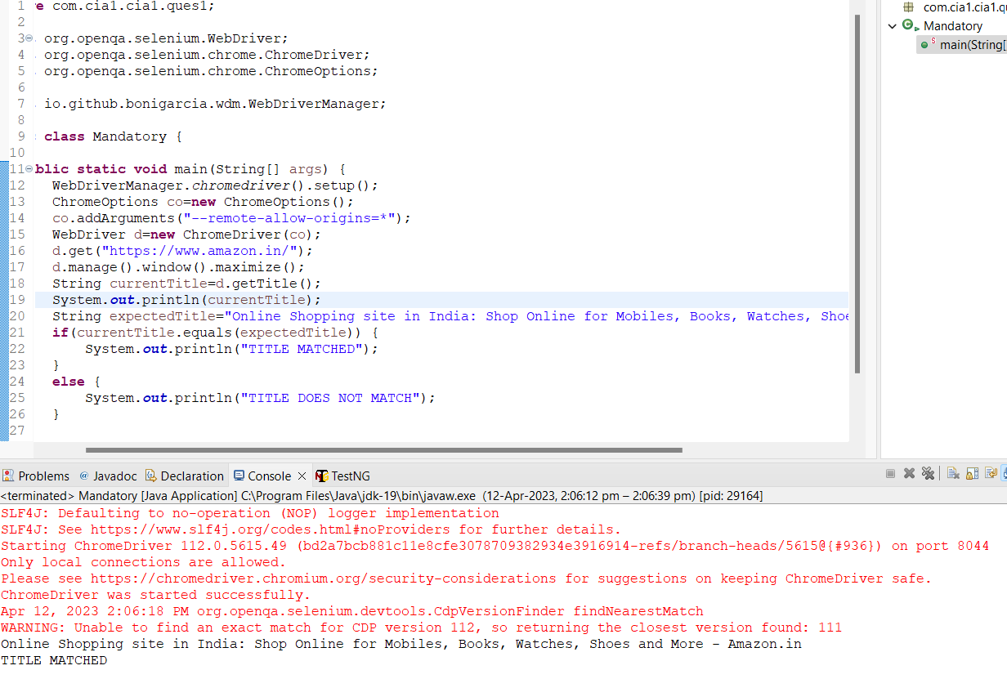

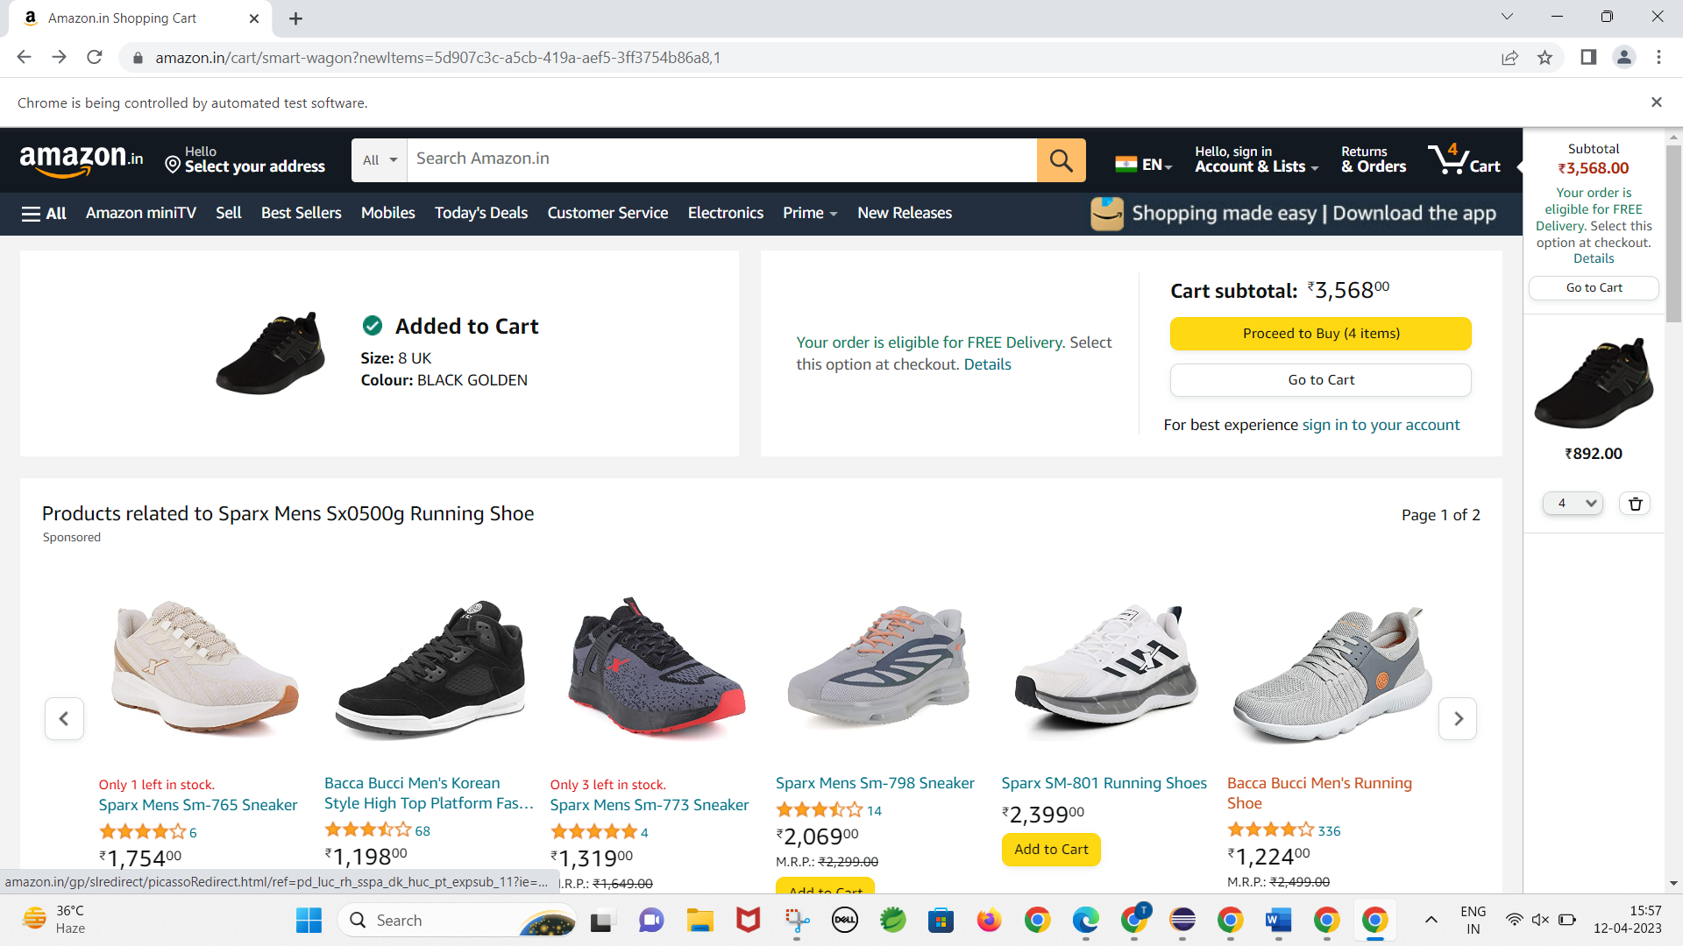

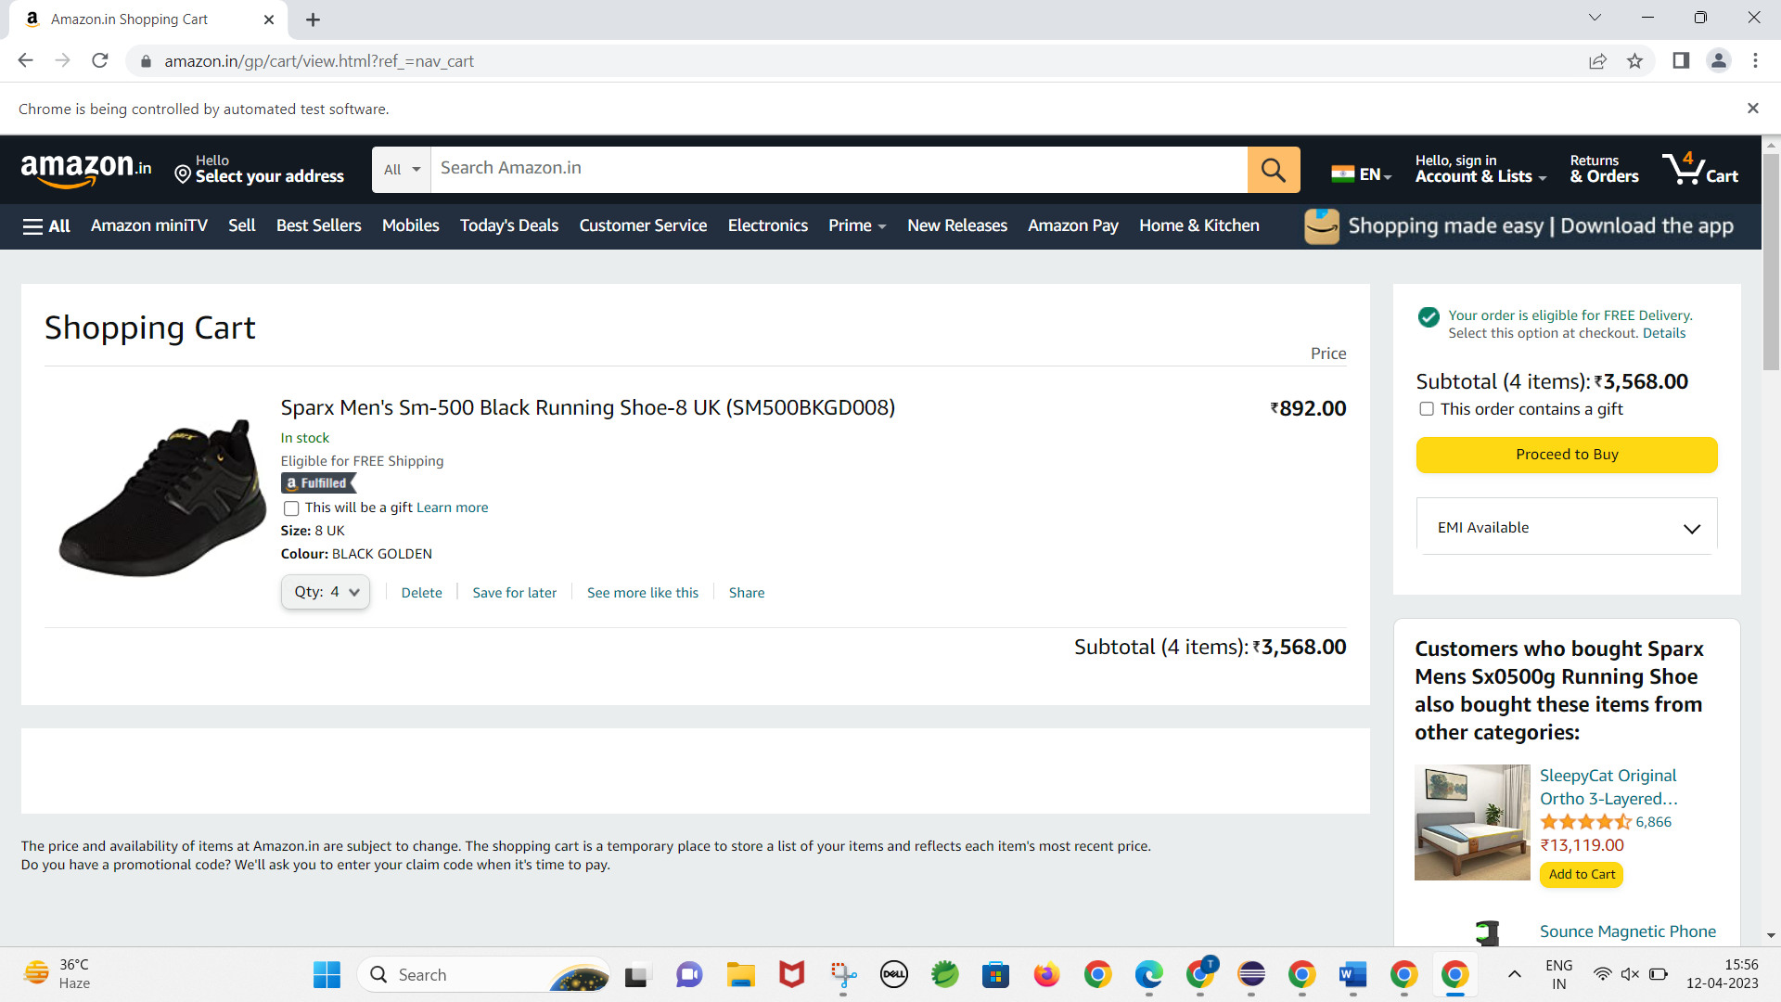 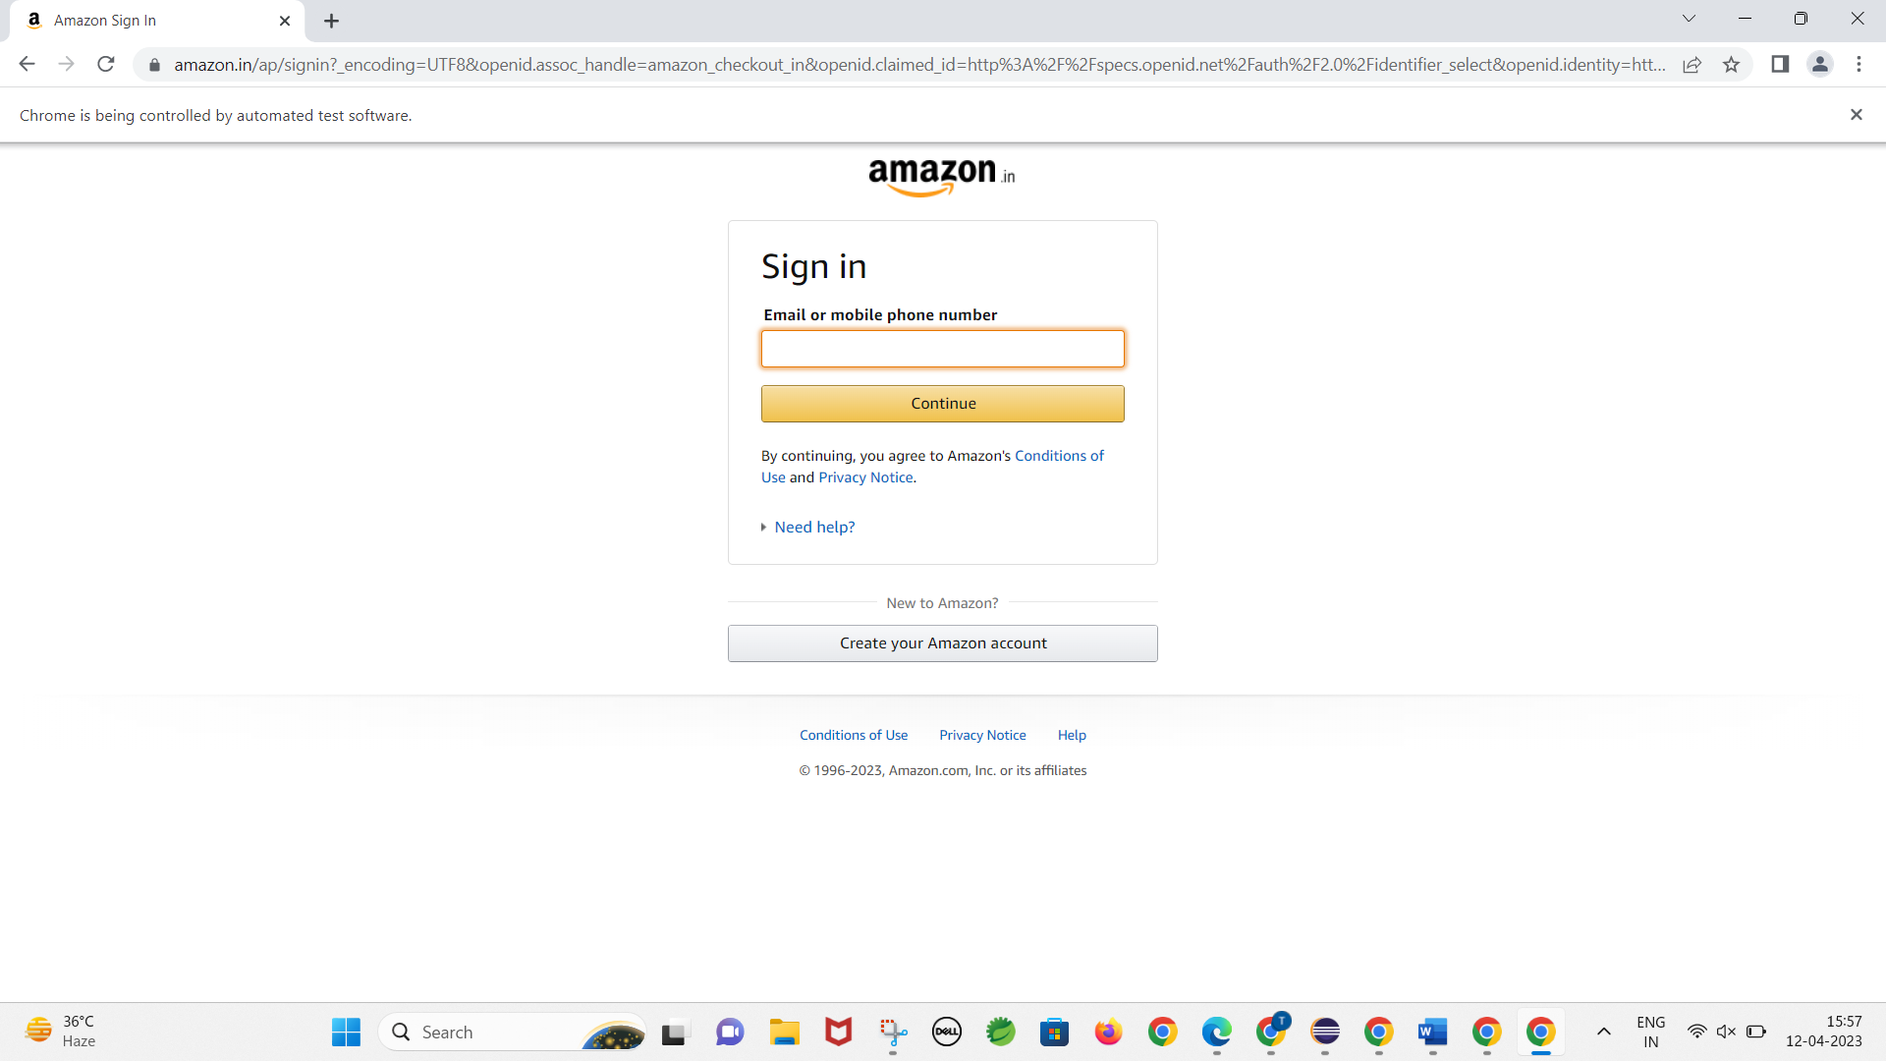

**Q2.**

**package** ques2;

**import** java.util.List;

**import** org.openqa.selenium.By;

**import** org.openqa.selenium.WebDriver;

**import** org.openqa.selenium.WebElement;

**import** org.openqa.selenium.chrome.ChromeDriver;

**import** org.openqa.selenium.chrome.ChromeOptions;

**import** io.github.bonigarcia.wdm.WebDriverManager;

**public** **class** que2 {

**public** **static** **void** main( String[] args ) **throws** InterruptedException

{

ChromeOptions co=**new** ChromeOptions();

co.addArguments("--remote-allow-origins=*");

WebDriverManager.chromedriver().setup();

WebDriver driver=**new** ChromeDriver(co);

driver.get("https://www.amazon.in/");

driver.manage().window().maximize();

String CurrentTitle=driver.getTitle();

System.out.println(CurrentTitle);

String ExpectedTitle="Online Shopping site in India: Shop Online for Mobiles, Books, Watches, Shoes and More - Amazon.in";

**if**(CurrentTitle.equals(ExpectedTitle))

{

System.out.println("Title Matched.");

}

**else**

{

System.out.println("Title not Matched");

}

driver.findElement(By.xpath("//*[@id=\"twotabsearchtextbox\"]")).sendKeys("sneakers");

driver.findElement(By.xpath("/html/body/div[1]/header/div/div[1]/div[2]/div/form/div[3]/div/span/input")).click();

List<WebElement> li=driver.findElements(By.className("s-line-clamp-1"));

**for**(**int** i=0;i<5;i++) {

System.out.println(li.get(i).getText());

}

driver.findElement(By.xpath("/html/body/div[1]/div[2]/div[1]/div[2]/div/div[3]/span/div[1]/div/div/div[5]/ul/li[2]/span/a/span")).click();

}

}**OUTPUT:**

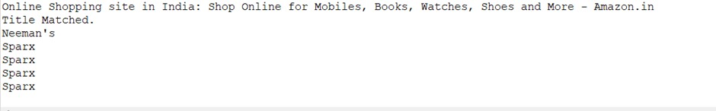

**Q3.**

**package** com.cia1.cia1;

**import** org.openqa.selenium.By;

**import** org.openqa.selenium.WebDriver;

**import** org.openqa.selenium.WebElement;

**import** org.openqa.selenium.chrome.ChromeDriver;

**import** org.openqa.selenium.chrome.ChromeOptions;

**import** io.github.bonigarcia.wdm.WebDriverManager;

**public** **class** Ques3 {

**public** **static** **void** main(String[] args) {

ChromeOptions co=**new** ChromeOptions();

co.addArguments ("--remote-allow-origins=*");

WebDriverManager.*chromedriver*().setup ();

WebDriver driver=**new** ChromeDriver(co);

driver.get ("https://www.amazon.in/");

driver.manage().window().maximize() ;

String currentTitle=driver.getTitle();

System.***out***.println(currentTitle);

String expectedTitle="Online Shopping site in India: Shop Online for Mobiles, Books, Watches, Shoes and More - Amazon.in";

**if**(currentTitle.equals(expectedTitle)) {

System.***out***.println("Title Matched");

}

**else** {

System.***out***.println("Title not Matched");

}

driver.findElement(By.*xpath*("//*[@id=\"nav-link-accountList\"]")).click();

WebElement txtBoxl=driver.findElement(By.*xpath*("//*[@id=\"ap_email\"]"));

txtBoxl.sendKeys("9994977285");

driver.findElement(By.*xpath*("//*[@id=\"continue\"]")).click();

WebElement txtBox2=driver.findElement(By.*xpath*("//*[@id=\"ap_password\"]"));

txtBox2.sendKeys("2525@ssktjsr");

driver.findElement(By.*xpath*("//*[@id=\"signInSubmit\"]")).click();

driver.findElement(By.*xpath*("//*[@id=\"nav-link-accountList\"]")).click();

driver.findElement(By.*xpath*("//*[@id=\"a-page\"]/div[2]/div/div[2]/div[1]/a/div/div")).click();

driver.findElement(By.*xpath*("//*[@id=\"a-autoid-2-announce\"]")).click();

driver.findElement(By.*xpath*("//*[@id=\"ordersInPackage-container\"]/div/div/a[1]")).click();

}

}

**OUTPUT:**



