**DAY-4**

**CLASS EXERCISE**

**Task-1:**

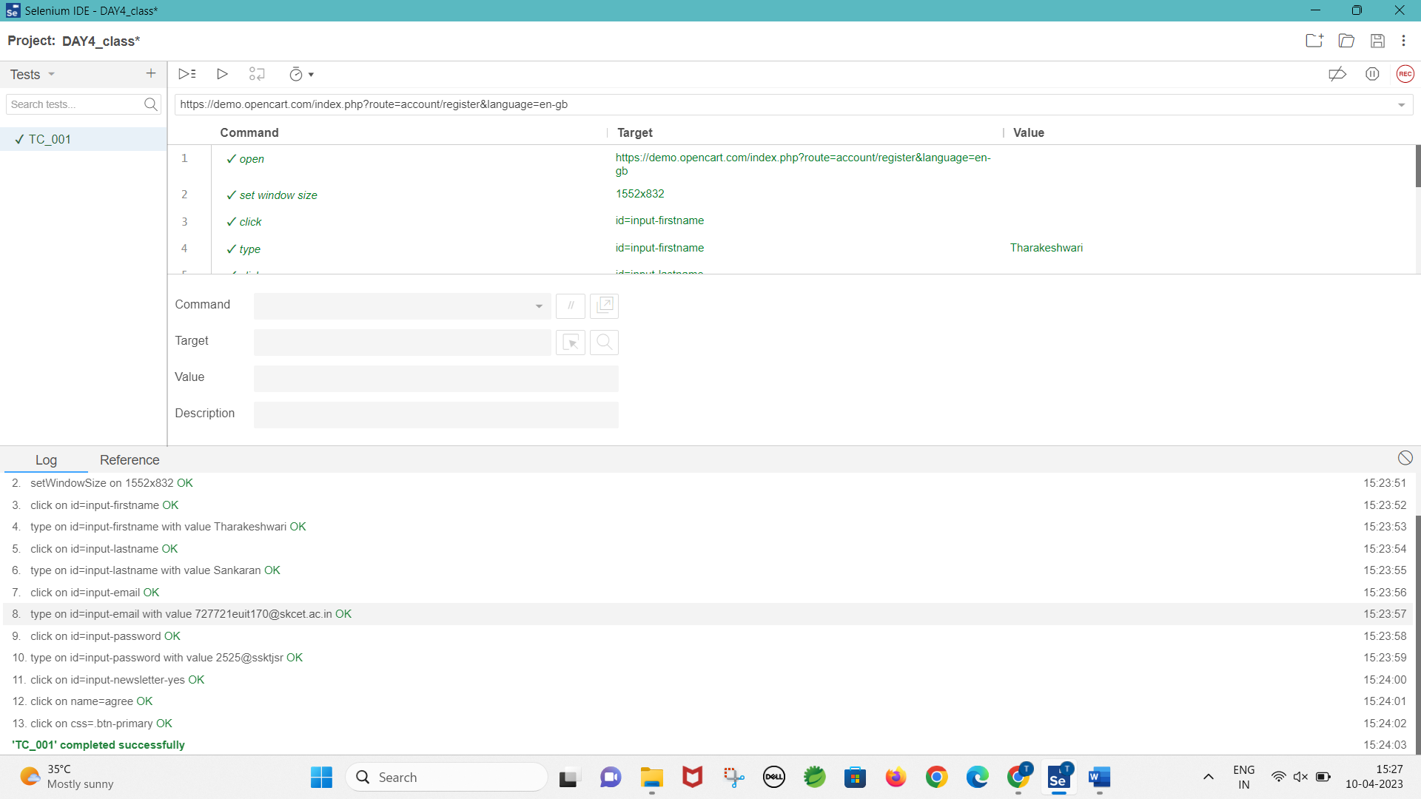

**Task-2:**

**package** com.test.test;

**import** org.openqa.selenium.By;

**import** org.openqa.selenium.JavascriptExecutor;

**import** org.openqa.selenium.WebDriver;

**import** org.openqa.selenium.chrome.ChromeDriver;

**import** org.openqa.selenium.chrome.ChromeOptions;

**import** io.github.bonigarcia.wdm.WebDriverManager;

**public** **class** ClassExercise2 {

**public** **static** **void** main(String[] args) **throws** InterruptedException{

WebDriverManager.*chromedriver*().setup();

ChromeOptions co=**new** ChromeOptions();

co.addArguments("--remote-allow-origins=*");

WebDriver d=**new** ChromeDriver(co);

d.get("https://demo.opencart.com/index.php?route=account/register&language=en-gb");

d.manage().window().maximize();

d.findElement(By.*xpath*("//input[@id=\"input-firstname\"]")).sendKeys("Tharakeshwari");

d.findElement(By.*xpath*("//input[@id=\"input-lastname\"]")).sendKeys("Sankaran");

d.findElement(By.*xpath*("//input[@id=\"input-email\"]")).sendKeys("abc@gmail.com");

d.findElement(By.*xpath*("//input[@id=\"input-password\"]")).sendKeys("abc123");

JavascriptExecutor js=(JavascriptExecutor) d;

js.executeScript("window.scrollBy(0,500)","");

Thread.*sleep*(3000);

d.findElement(By.*xpath*("//input[@id=\"input-newsletter-yes\"]")).click();

d.findElement(By.*xpath*("//input[@name=\"agree\"]")).click();

d.findElement(By.*xpath*("//button[@class=\"btn btn-primary\"]")).click();

}

}

**Task-3:**

**package** com.test.test;

**import** org.openqa.selenium.By;

**import** org.openqa.selenium.JavascriptExecutor;

**import** org.openqa.selenium.WebDriver;

**import** org.openqa.selenium.chrome.ChromeDriver;

**import** org.openqa.selenium.chrome.ChromeOptions;

**import** io.github.bonigarcia.wdm.WebDriverManager;

**public** **class** ClassExercise3 {

**public** **static** **void** main(String[] args) **throws** InterruptedException {

WebDriverManager.*chromedriver*().setup();

ChromeOptions co=**new** ChromeOptions();

co.addArguments("--remote-allow-origins=*");

WebDriver d=**new** ChromeDriver(co);

d.get("https://demo.opencart.com/index.php?route=checkout/voucher&language=en-gb");

d.manage().window().maximize();

d.findElement(By.*xpath*("//input[@id=\"input-to-name\"]")).sendKeys("Kail");

d.findElement(By.*xpath*("//input[@id=\"input-to-email\"]")).sendKeys("kail@gmail.com");

d.findElement(By.*xpath*("//input[@id=\"input-from-name\"]")).sendKeys("Thara");

d.findElement(By.*xpath*("//input[@id=\"input-from-email\"]")).sendKeys("thara@gmail.com");

d.findElement(By.*xpath*("//input[@id=\"input-theme-7\"]")).click();

d.findElement(By.*xpath*("//textarea[@id=\"input-message\"]")).sendKeys("Happy Birthday");

JavascriptExecutor js=(JavascriptExecutor) d;

js.executeScript("window.scrollBy(0,500)","");

Thread.*sleep*(3000);

d.findElement(By.*xpath*("//input[@name=\"agree\"]")).click();

d.findElement(By.*xpath*("//button[@class=\"btn btn-primary\"]")).click();

}

}

**Task-4:**

**package** com.test.test;

**import** org.openqa.selenium.By;

**import** org.openqa.selenium.JavascriptExecutor;

**import** org.openqa.selenium.WebDriver;

**import** org.openqa.selenium.chrome.ChromeDriver;

**import** org.openqa.selenium.chrome.ChromeOptions;

**import** io.github.bonigarcia.wdm.WebDriverManager;

**public** **class** ClassExercise4 {

**public** **static** **void** main(String[] args) **throws** InterruptedException {

WebDriverManager.*chromedriver*().setup();

ChromeOptions co=**new** ChromeOptions();

co.addArguments("--remote-allow-origins=*");

WebDriver d=**new** ChromeDriver(co);

d.navigate().to("https://j2store.net/free/");

d.manage().window().maximize();

JavascriptExecutor js=(JavascriptExecutor) d;

js.executeScript("window.scrollBy(0,800)","");

Thread.*sleep*(3000);

d.findElement(By.*xpath*("//a[@href=\"/free/index.php/shop?filter_catid=11\"]")).click();

d.navigate().back();

d.navigate().forward();

d.navigate().refresh();

d.close();

}

}

**Task-5-(i):**

**package** com.test.test;

**import** org.openqa.selenium.By;

**import** org.openqa.selenium.JavascriptExecutor;

**import** org.openqa.selenium.WebDriver;

**import** org.openqa.selenium.chrome.ChromeDriver;

**import** org.openqa.selenium.chrome.ChromeOptions;

**import** io.github.bonigarcia.wdm.WebDriverManager;

**public** **class** ClassExercise5_1 {

**public** **static** **void** main(String[] args) **throws** InterruptedException{

WebDriverManager.*chromedriver*().setup();

ChromeOptions co=**new** ChromeOptions();

co.addArguments("--remote-allow-origins=*");

WebDriver d=**new** ChromeDriver(co);

d.get("https://j2store.net/free/");

String currentUrl1=d.getCurrentUrl();

String expectedUrl1="https://j2store.net/free/";

**if**(currentUrl1.equals(expectedUrl1)) {

System.***out***.println("URL MATCHED");

}

**else** {

System.***out***.println("URL NOT MATCHED");

}

JavascriptExecutor js=(JavascriptExecutor) d;

js.executeScript("window.scrollBy(0,800)","");

Thread.*sleep*(3000);

d.findElement(By.*xpath*("//a[@href=\"/free/index.php/shop?filter_catid=11\"]")).click();

String currentUrl2=d.getCurrentUrl();

String expectedUrl2="https://j2store.net/free/index.php/shop?filter_catid=11";

**if**(currentUrl2.equals(expectedUrl2)) {

System.***out***.println("URL MATCHED");

}

**else** {

System.***out***.println("URL NOT MATCHED");

}

}

}

**CONSOLE:**

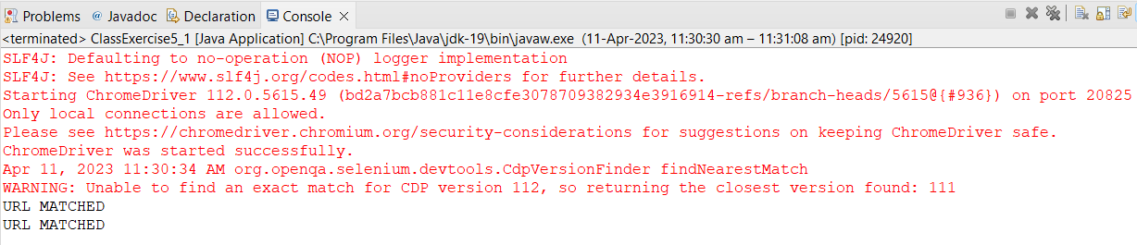

**TASK-5-(ii):**

**package** com.test.test;

**import** java.util.List;

**import** org.openqa.selenium.By;

**import** org.openqa.selenium.JavascriptExecutor;

**import** org.openqa.selenium.WebDriver;

**import** org.openqa.selenium.WebElement;

**import** org.openqa.selenium.chrome.ChromeDriver;

**import** org.openqa.selenium.chrome.ChromeOptions;

**import** io.github.bonigarcia.wdm.WebDriverManager;

**public** **class** ClassExercise5_2 {

**public** **static** **void** main(String[] args) **throws** InterruptedException{

WebDriverManager.*chromedriver*().setup();

ChromeOptions co=**new** ChromeOptions();

co.addArguments("--remote-allow-origins=*");

WebDriver d=**new** ChromeDriver(co);

d.get("https://j2store.net/free/");

JavascriptExecutor js=(JavascriptExecutor) d;

js.executeScript("window.scrollBy(0,800)","");

Thread.*sleep*(3000);

d.findElement(By.*xpath*("//a[@href=\"/free/index.php/shop?filter_catid=11\"]")).click();

List<WebElement> li=d.findElements(By.*xpath*("//h2[@itemprop=\"name\"]"));

**for**(WebElement list:li) {

System.***out***.println(list.getText());

}

}

}

**CONSOLE:**

