SIMATS ENGINEERING
Department of Computer Science & Engineering
ASSESSMENT TOOL 1- EXPERIMENTS

Course Code: | CSA1223 | Course Title: | Computer Architecture
CO Assessed: | CO3 | Assessment: | ASSESSMENT TOOL 1- EXPERIMENTS
Weightage: | 40% | Total Marks: | 100
CO3 Statement: | Design processor organization by constructing pipelined datapath structures, identifying hazard types (data, control, structural), and comparing superscalar techniques such as out-of-order execution, speculative execution, and simultaneous multithreading (SMT). (BL6)
Student Name: | G.THARAKNATHREDDY | Reg.No.: | 192472032
Department: | CSE-AI | Date:

ANNEXURE A

- Design and simulate a system that performs register transfer operations along with basic arithmetic and logic operations such as addition, subtraction, AND, and OR. Use multiple registers to demonstrate how data is transferred between them during execution, and analyze the sequence of operations and the role of the ALU in processing data.
- Create a model of a computer system using single-bus and multi-bus organization, and perform data transfer operations between registers, memory, and I/O. Compare the time taken and efficiency of both approaches, and analyze how multiple bus structures improve parallel data transfer and reduce bottlenecks.
- Simulate a 5-stage instruction pipeline (Fetch, Decode, Execute, Memory, Write-back) and execute a set of instructions. Measure the performance in terms of speedup and throughput, and compare it with a non-pipelined system to evaluate the effectiveness of pipelining.
- Develop a pipeline execution scenario where data hazards, control hazards, and structural hazards occur. Observe their impact on instruction execution, and implement techniques such as stalling, data forwarding, and branch prediction to resolve these hazards and improve performance.
- Analyze a processor supporting superscalar execution, including out-of-order and speculative execution, and extend the study to include hyper-threading and simultaneous multithreading (SMT). Evaluate how multiple instructions are executed in parallel and compare the performance improvements in terms of instruction throughput and resource utilization.

Code of Conduct:

I G.THARAKANTHREDDY(192472032) (Name / Reg No) certify that this submission is my original work and that I have adhered to the guidelines specified for this assessment.I understand that any violation of academic integrity rules will result in disciplinary action.

Signature of the student:G.THARAKNATHREDDY

MARKS ALLOCATION
 | Understanding of Concepts (20%) | Experimental Design (20%) | Use of Tools (25%) | Analysis of Results (20%) | Documentation (15%)
Q1
Q2
Q3
Q4
Q5

RUBRICS FOR CALCULATION:

Criteria | Weightage | Level 4 – Exemplary | Level 3 – Proficient | Level 2 – Developing | Level 1 – Beginning
Understanding of Concepts | 25 | Demonstrates thorough understanding and effectively integrates multiple concepts/technologies(5) | Good understanding with proper integration of most concepts(4) | Basic understanding; limited or partial integration(3) | Poor understanding; unable to integrate concepts
Experimental Design | 30 | Well-planned, systematic implementation with optimal solution(6) | Correct implementation with minor issues(4) | Basic implementation with errors or inefficiencies(3) | Incorrect or incomplete implementation
Use of Tools | 20 | Effective and advanced use of tools/technologies with proper configuration(4) | Appropriate use of tools with correct execution(3) | Limited or inconsistent use of tools(2) | Incorrect or minimal use of tools
Analysis of Results | 15 | Insightful analysis with accurate interpretation and validation of results(3) | Good analysis with reasonable interpretation(2) | Basic analysis with limited insights(1) | Poor or incorrect analysis of results
Documentation | 10 | Clear, well-structured documentation with diagrams, code, and results(2) | Organized documentation with necessary details(1.5) | Basic documentation with missing details(1) | Poor or incomplete documentation

ANSWERS:

Q1. Register Transfer and ALU Operations
Aim

To simulate data transfer between registers and perform addition, subtraction, AND, and OR operations using an ALU.

Concept

Registers are small storage locations inside the CPU. Data can be transferred from one register to another. The ALU (Arithmetic Logic Unit) performs arithmetic and logical operations.

Example:

R1 = 20
R2 = 10

R3 ← R1
R3 ← R1 + R2
R3 ← R1 - R2
R3 ← R1 AND R2
R3 ← R1 OR R2

Simple Diagram
R1 ─────┐
├──► ALU ───► R3
R2 ─────┘

Simulation
R1 = 20
R2 = 10

print("Transfer:", R1)
print("Addition:", R1 + R2)
print("Subtraction:", R1 - R2)
print("AND:", R1 & R2)
print("OR:", R1 | R2)

OUTPUT:
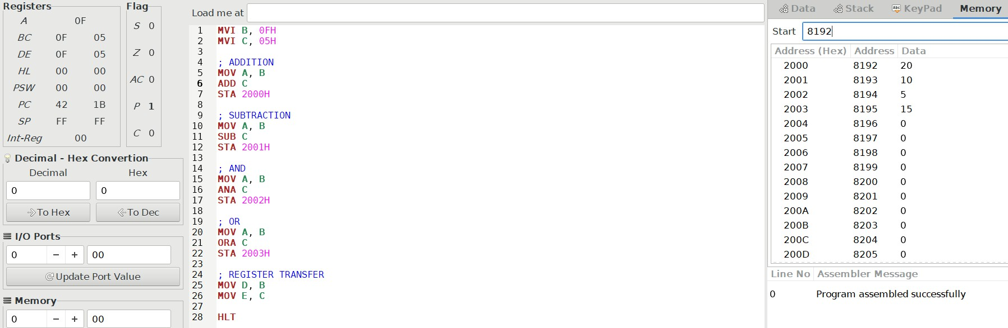

Result
Transfer = 20
Addition = 30
Subtraction = 10
AND = 0
OR = 30

Analysis

The experiment shows that registers store the data and the ALU performs the required operation. The result is then stored in the destination register.

Conclusion

Register transfer and basic ALU operations were successfully simulated.

Q2. Single-Bus and Multi-Bus Organization
Aim

To simulate data transfer using single-bus and multi-bus systems and compare their performance.

Concept

A single-bus system uses one common bus for data transfer.

R1 ─┐
R2 ─┼──► BUS ──► ALU
R3 ─┘

A multi-bus system uses more than one bus, so multiple data transfers can happen at the same time.

R1 ──► Bus A ──┐
├──► ALU ──► Bus C ──► R3
R2 ──► Bus B ──┘

Example
R1 = 20
R2 = 10

R3 = R1 + R2

In a single-bus system, data is transferred sequentially. In a multi-bus system, R1 and R2 can be supplied to the ALU through separate buses.

OUTPUT:
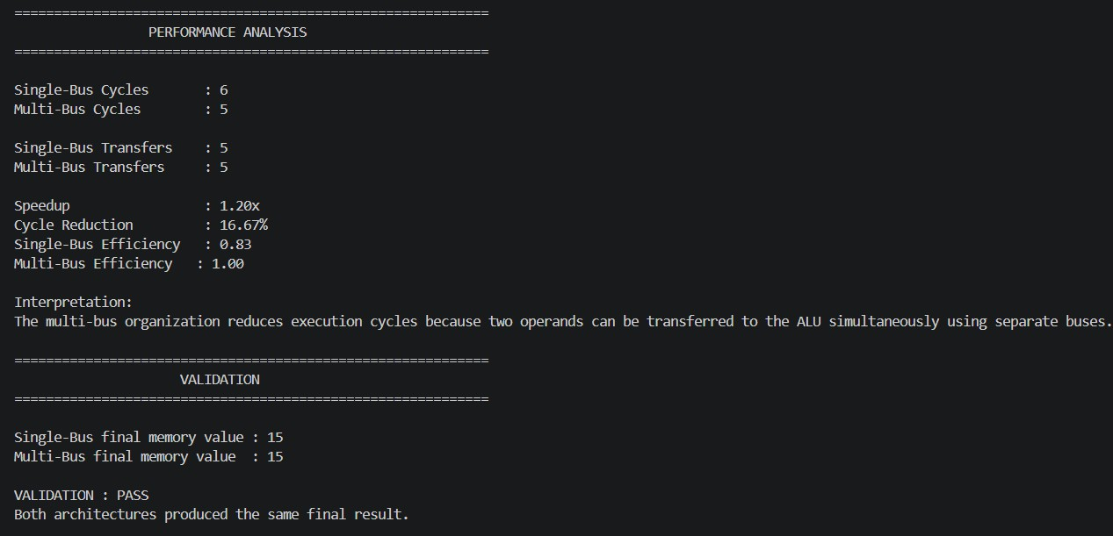

Comparison
Feature Single Bus Multi Bus
Number of buses One Two or more
Data transfer Sequential More parallel
Speed Lower Higher
Hardware Simple Complex
Bottleneck More Less
Analysis

The multi-bus system is faster because it allows more than one data transfer at a time. The single-bus system is simpler but can become a bottleneck.

Conclusion

Multi-bus organization provides better performance than single-bus organization because of parallel data transfer.

Q3. Five-Stage Instruction Pipeline
Aim

To simulate a five-stage instruction pipeline and compare it with a non-pipelined system.

Concept

The five pipeline stages are:

IF → ID → EX → MEM → WB

IF – Instruction Fetch
ID – Instruction Decode
EX – Execute
MEM – Memory Access
WB – Write Back
Example
Instructions
I1: ADD
I2: SUB
I3: AND
I4: OR

Pipeline Table
Cycle I1 I2 I3 I4
1 IF
2 ID IF
3 EX ID IF
4 MEM EX ID IF
5 WB MEM EX ID
6 WB MEM EX
7 WB MEM
8 WB

OUTPUT:

Calculation

For 4 instructions and 5 stages:

Non-pipelined:

4 × 5 = 20 cycles

Pipelined:

5 + 4 - 1 = 8 cycles

Speedup:

20 / 8 = 2.5

Analysis

Pipelining allows different instructions to use different stages at the same time. Therefore, more instructions can be completed in less time.

Conclusion

The pipelined processor provides better instruction throughput than the non-pipelined processor.

Q4. Pipeline Hazards
Aim

To study data, control, and structural hazards in a pipeline and understand methods to reduce their effects.

Concept

A pipeline hazard occurs when an instruction cannot execute in its normal clock cycle.

1. Data Hazard
I1: ADD R1,R2,R3
I2: SUB R4,R1,R5

I2 needs the result of I1.

Solution: Data forwarding or stalling.

2. Control Hazard
I1: BEQ R1,R2,Target

The processor does not immediately know which instruction should execute next.

Solution: Branch prediction.

3. Structural Hazard

Two instructions need the same hardware resource at the same time.

Solution: Add more resources or insert a stall.

Hazard Handling
Hazard Solution
Data Forwarding / Stalling
Control Branch Prediction
Structural Additional Hardware / Stalling
Analysis
OUTPUT:
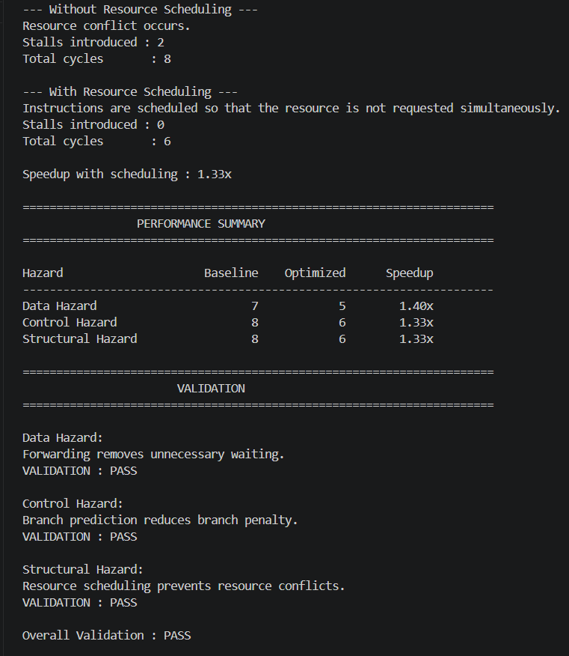

Hazards reduce pipeline performance because they can introduce extra clock cycles. Forwarding reduces data delays, while branch prediction reduces branch-related delays.

Conclusion

Proper hazard-handling techniques improve pipeline performance and reduce unnecessary stalls.

Q5. Superscalar, Out-of-Order and SMT
Aim

To study superscalar, out-of-order, speculative execution, and SMT techniques used in modern processors.

Concept

A superscalar processor can execute more than one instruction in a clock cycle.

Example:

Cycle 1 → I1, I2
Cycle 2 → I3, I4
Cycle 3 → I5, I6

Out-of-order execution allows an independent instruction to execute before an earlier instruction if the earlier one is waiting.

Speculative execution executes instructions based on a predicted branch result.

SMT (Simultaneous Multithreading) allows multiple threads to use the processor at the same time.

CPU Core
/ \
Thread 1 Thread 2
\ /
Shared Resources

Comparison
Technique Main Benefit
Superscalar Multiple instructions/cycle
Out-of-order Better resource utilization
Speculation Reduces branch delay
SMT Executes multiple threads
Example

For 10 independent instructions:

Single issue = approximately 10 cycles
2-wide issue = approximately 5 cycles

The theoretical speedup is approximately:

10 / 5 = 2×
OUTPUT:
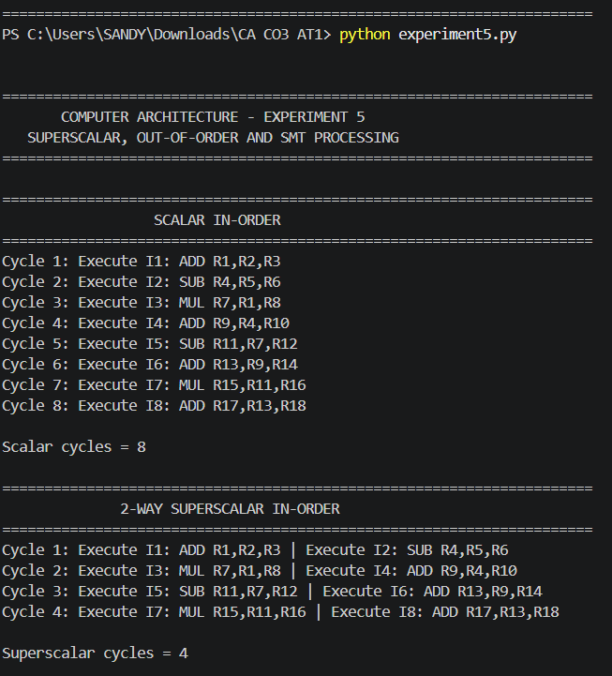

Analysis

These techniques increase parallelism and improve processor throughput. However, actual performance is affected by dependencies, branch misprediction, memory delays, and limited hardware resources.

Conclusion

Superscalar execution, out-of-order execution, speculation, and SMT improve processor performance by allowing more instructions or threads to execute in parallel.

