Ex No-3  Date: | PERFORM STATISTICAL OPERATIONS MEAN, MEDIAN, MODE AND STANDARD DEVIATION, VARIANCE, SKEWNESS, KURTOSIS

AIM:
To perform and understand statistical operations including mean, median, mode, standard deviation, variance, skewness, and kurtosis using MS Excel.
PROCEDURE
Mean, median, and mode: Mean, median, and mode are different measures of center in a numerical data set. They each try to summarize a dataset with a single number to represent a "typical" data point from the dataset.
Enter the sample data into cells H1:H142526:
Calculate Mean
The "average" number; found by adding all data points and dividing by the number of data points.
1. Enter Data: Input the sample data into cells H1 to H142526.
2. Calculate Mean:
- Click on cell P2.
- Type =AVERAGE(H1:H142526) and press Enter.
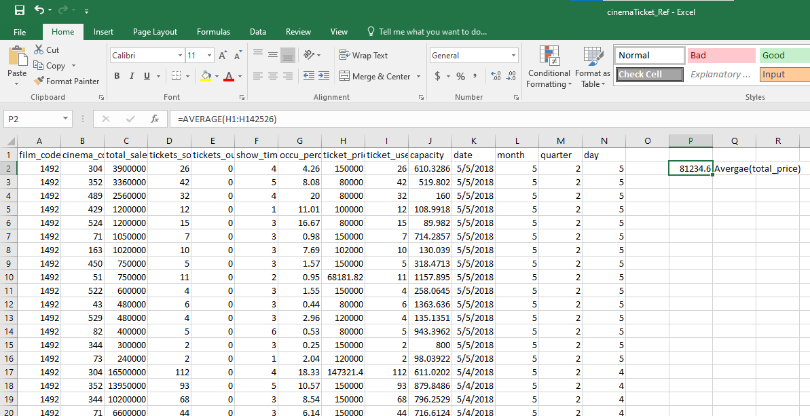

Calculate Median
The middle number; found by ordering all data points and picking out the one in the middle
(or if there are two middle numbers, taking the mean of those two numbers).
1. Calculate Median:
- Click on cell P3.
- Type =MEDIAN(F2:F142526) and press Enter
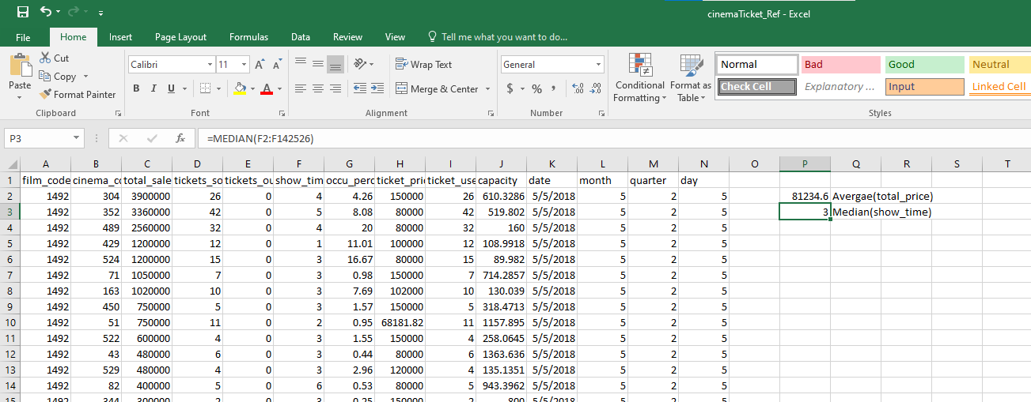
Calculate Mode
The most frequent number—that is, the number that occurs the highest number of times.
1. Calculate Mode:
- Click on cell P4.
- Type =MODE.SNGL(F1:F142526) and press Enter
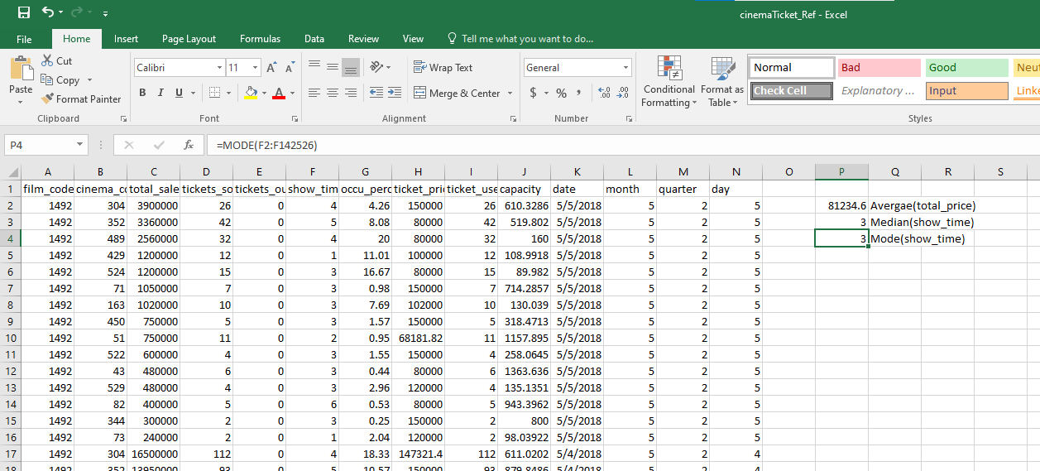
Standard Deviation
The spread of statistical data is measured by the standard deviation. Distribution measures the deviation of data from its mean or average position. The degree of dispersion is computed by
the method of estimating the deviation of data points. It is denoted by the symbol, ‘σ’.
Properties of Standard Deviation
• It describes the square root of the mean of the squares of all values in a data set and is also called the root-mean-square deviation.
• The smallest value of the standard deviation is 0 since it cannot be negative.
• When the data values of a group are similar, then the standard deviation will be very low or close to zero. But when the data values vary with each other, then the standard variation is high or far from zero.
Calculate Standard Deviation
1. Calculate Standard Deviation:
- Click on cell P5.
- Type =STDEV.S(I2:I142526) and press Enter.
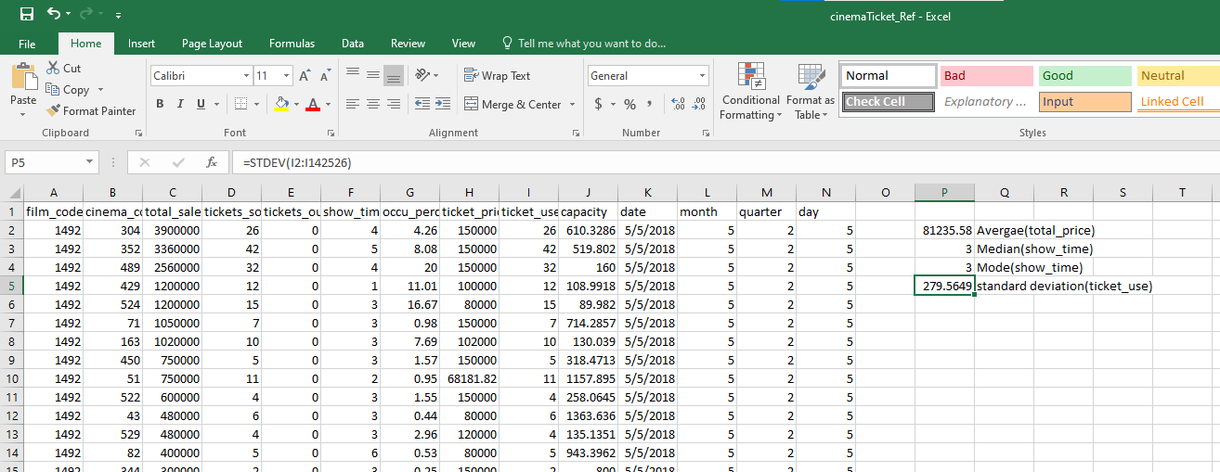
Variance
According to layman’s words, the variance is a measure of how far a set of data are dispersed out from their mean or average value. It is denoted as ‘σ2’.
Properties of Variance
• It is always non-negative since each term in the variance sum is squared and therefore the result is either positive or zero.
• Variance always has squared units. For example, the variance of a set of weights estimated in kilograms will be given in kg squared. Since the population variance is squared, we cannot
compare it directly with the mean or the data themselves.
Calculate Variance
1. Calculate Variance:
- Click on cell P6.
- Type =VAR.S(D2:D142526) and press Enter
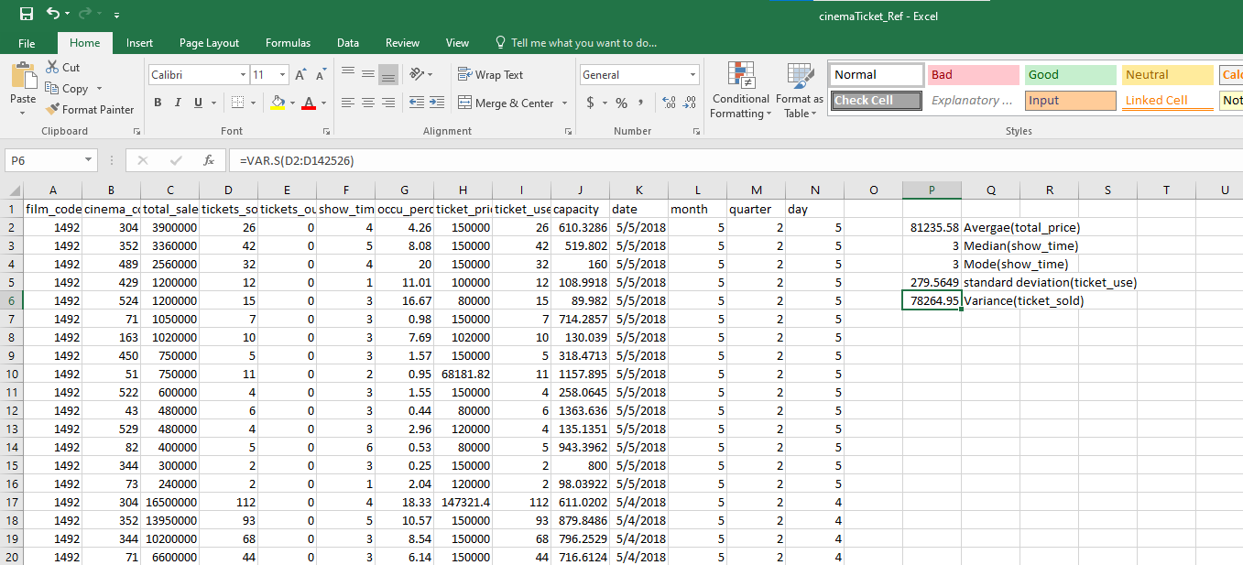
Calculate Skewness
1. Calculate Skewness:
- Click on cell P7.
- Type =SKEW(D2:D142526) and press Enter.
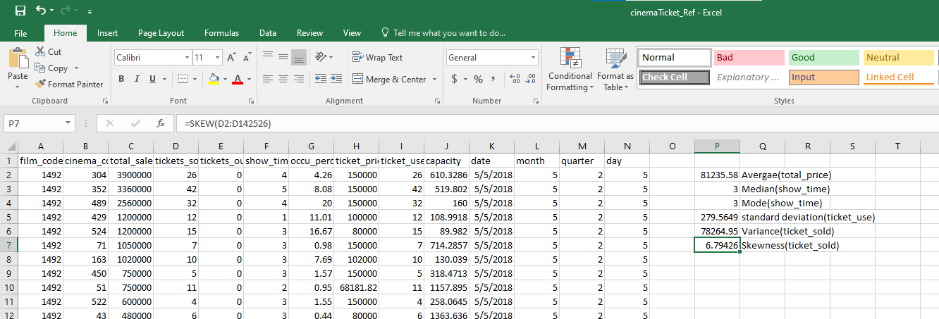

Calculate Kurtosis
1. Calculate Kurtosis:
- Click on cell P8.
- Type =KURT(D2:D142526) and press Enter
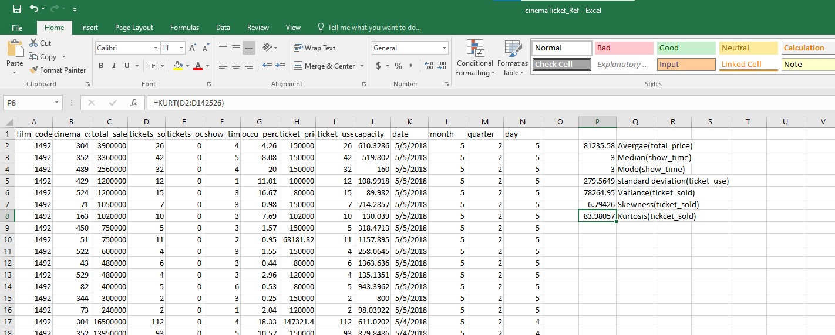
OUTPUT:
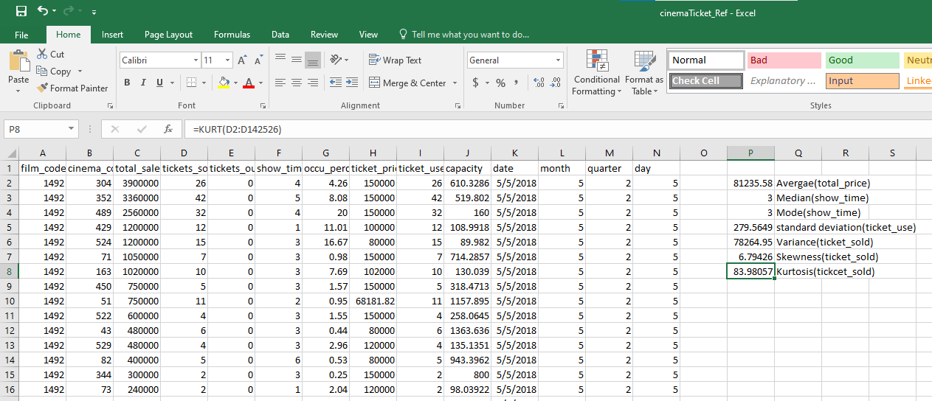

RESULT:
Thus the statistical operations were performed successfully using MS-EXCEL and the desired output was displayed in neat format.
Performance(25)
Viva-Voce(10)
Record(15)
Total(50)

Ex No-4  Date: | PERFORM Z-TEST, T-TEST & ANOVA
AIM:

To perform and understand Z-test, T-test, and ANOVA using MS Excel for statistical analysis.

PROCEDURE:

Z-Test: A Z-test is a statistical test used to determine whether there is a significant difference between the means of two groups. It is typically used when the sample size is large (n > 30) and the population variance is known.

T-Test: A T-test is a statistical test used to compare the means of two groups to see if they are
significantly different from each other. It is used when the sample size is small (n ≤ 30) and the population variance is unknown. There are three types of T-tests: independent samples T-test, paired sample T-test, and one-sample T-test.

ANOVA (Analysis of Variance): ANOVA is a statistical method used to compare the means of three or more groups to see if at least one of the group means is significantly different fromthe others. It helps to determine if the observed differences among sample means are genuine or if they occurred by chance.

T- TEST

Step 1: Start Ms Excel application in Ms- office.
Step 2: Create datasheet for student marks in Ms Excel application.
Step 3: If you haven't already installed the Analysis ToolPak, Click the Microsoft Office button, thenclick on the Excel Options, and then select Add-Ins, Click Go, check the Analysis ToolPak box, and click Ok

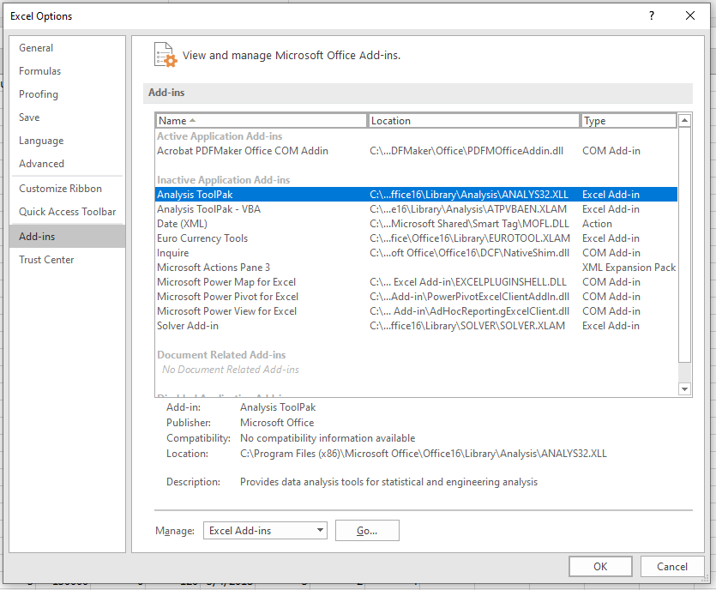
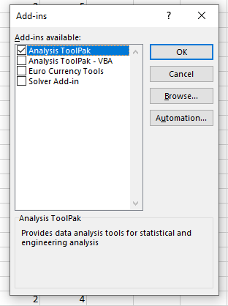
Step 4: Select Data tab, then click on the Data Analysis option, then selects Descriptive Statistics from the list and Click Ok. [Data tab >> Data Analysis >> T-test Paired two sample for means]
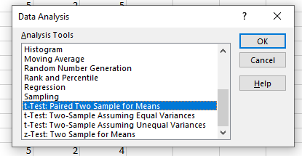

Step 5: In the Input Range we select range of the data for variable 1 and variable 2 and Give alpha value as 0.05. then select Output Range where you want the output to be stored. If you don’t specify the output range, it will throw output in the new worksheet.
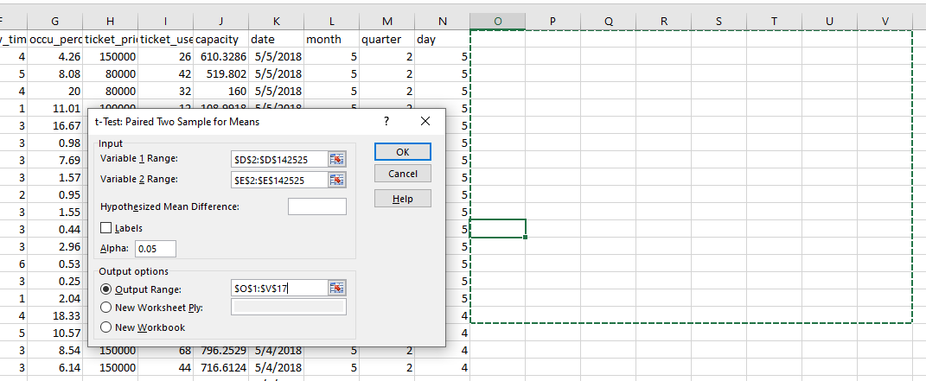
Step 6: Then select Output Range where you want the output to be stored. If you don’t specify the output range, it will throw output in the new worksheet.
Step 7: When you click Ok, you will see the result in the selected output range.
Step 8: Save the excel file and Close the Ms Excel application.
Output:
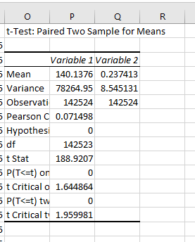

Z- TEST

Step 1: Start Ms Excel application in Ms- office.
Step 2: Create datasheet for student marks in Ms Excel application.
Step 3: If you haven't already installed the Analysis ToolPak, Click the Microsoft Office button, thenclick on the Excel Options, and then select Add-Ins, Click Go, check the Analysis ToolPak box, and click Ok
Step 4: Select Data tab, then click on the Data Analysis option, then selects Descriptive
Statistics from the list and Click Ok. [Data tab >> Data Analysis >>z-test two sample
means]
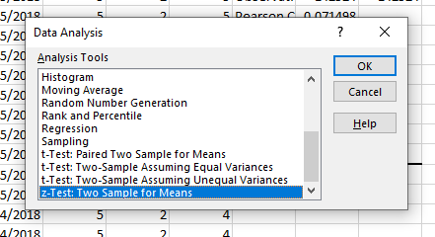

Step 5: In the Input Range we select range of the data for variable 1 and variable 2 and Give variable 1 and variable 2 value as 0.5. then select Output Range where you want the output to be stored. If you don’t specify the output range, it will throw output in the new worksheet.

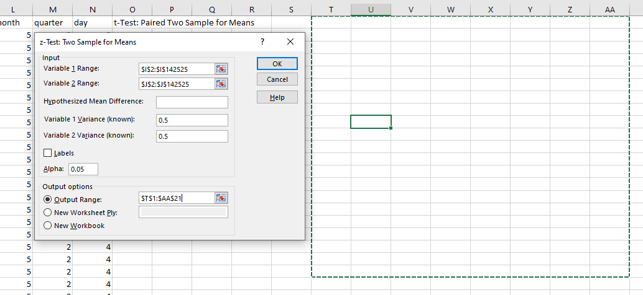

Step 6: Then select Output Range where you want the output to be stored. If you don’t specify the output range, it will throw output in the new worksheet.
Step 7: When you click Ok, you will see the result in the selected output range.
Step 8: Save the excel file and Close the Ms Excel application’s.

Output:
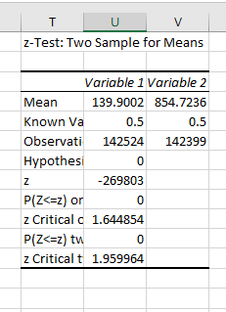

ANOVA

Step 1: Start Ms Excel application in Ms- office.
Step 2: Create datasheet for student marks in Ms Excel application.
Step 3: If you haven't already installed the Analysis ToolPak, Click the Microsoft Office button, then click on the Excel Options, and then select Add-Ins, Click Go, check the Analysis ToolPak box, and click Ok
Step 4: Select Data tab, then click on the Data Analysis option, then selects Descriptive Statistics from the list and Click Ok. [Data tab >> Data Analysis >> Anova: Single factor ]
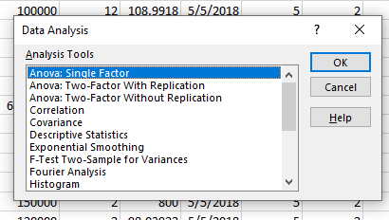

Step 5: In the Input Range we select range of the data and Give alpha value as 0.05. then select Output Range where you want the output to be stored. If you don’t specify the output range, it will throw output in the new worksheet.

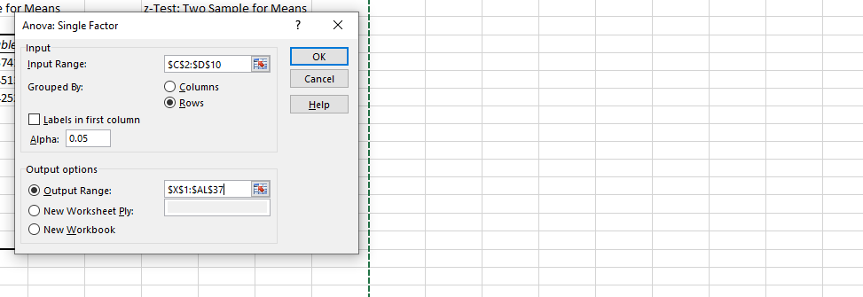
Step 6: Then select Output Range where you want the output to be stored. If you don’t specify the output range, it will throw output in the new worksheet.
Step 7: When you click Ok, you will see the result in the selected output range.
Step 8: Save the excel file and Close the Ms Excel application.
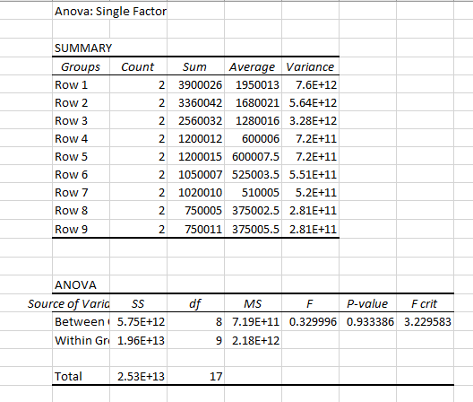

RESULT

Thus the Z-Test, T-Test and ANOVA operations was performed successfully using MS-
EXCEL and the desired output was displayed in neat format.
Performance(25)
Viva-Voce(10)
Record(15)
Total(50)

Ex No-7  Date: | PERFORM BIVARIATE AND MULTIVARIATE ANALYSIS ON THE DATASET

AIM:
To perform bivariate and multivariate analysis using MS Excel.

PROCEDURE:
Bivariate Analysis: Bivariate analysis involves the analysis of two variables to determine the empirical relationship between them. Common methods include scatter plots, correlation, and linear regression.

Step 1: Start Ms Excel application in Ms- office.
Step 2: Create datasheet for Cinema ticket in Ms Excel application.
Step 3: If you haven't already installed the Analysis ToolPak, Click the Microsoft Office button, thenclick on the Excel Options, and then select Add-Ins, Click Go, check the Analysis ToolPak box, and click Ok
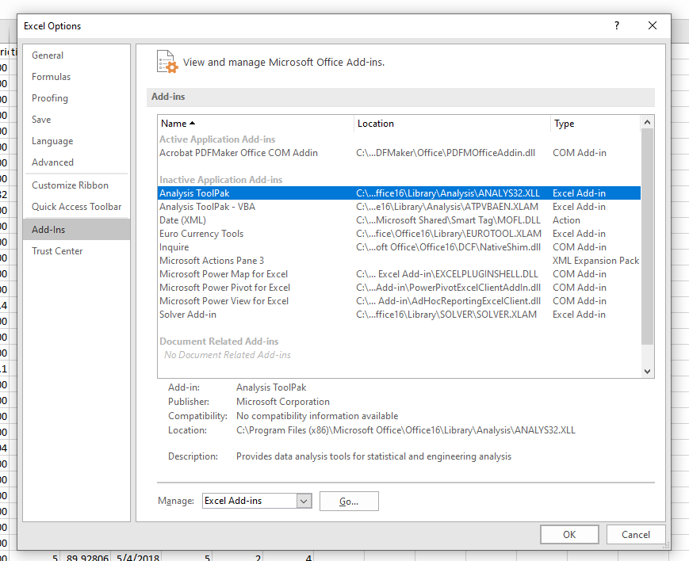
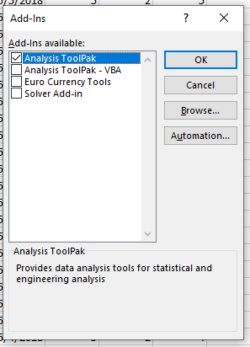
Step 4: Select Data tab, then click on the Data Analysis option, then selects Descriptive
Statistics from the list and Click Ok. [Data tab >> Data Analysis >>Regression]

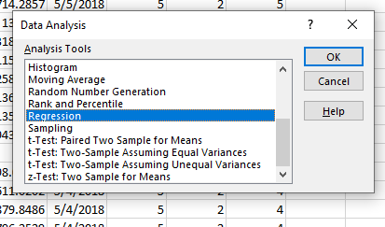

Step 5: In the Input Range we select quantity as x range and discount as y range then select Output Range where you want the output to be stored. If you don’t specify the output range, it will throw output in the new worksheet.
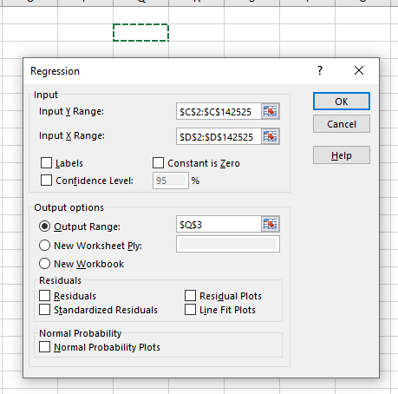

Step 6: Then select Output Range where you want the output to be stored. If you don’t specify the output range, it will throw output in the new worksheet.
Step 7: When you click Ok, you will see the result in the selected output range.
Step 8: Save the excel file and Close the Ms Excel application.
Enter Data: Input the sample data into cells A1

Output

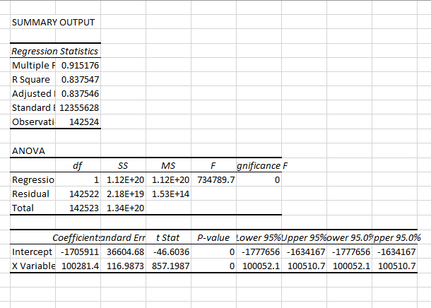

Create Scatter Plot:
- Select the data range.
- Go to the Insert tab.
- Select Scatter Plot from the Charts group.
- Choose the desired scatter plot style.

Correlation
Calculate Correlation:
Click on an empty cell where you want the correlation coefficient to appear.
Use the CORREL function. For example, =CORREL(A2:A11, B2:B11) to find the correlation
between Variable1 and Variable2.

MULTIVARIATE ANALYSIS

Step 1: Start Ms Excel application in Ms- office.
Step 2: Create datasheet for student marks in Ms Excel application.
Step 3: If you haven't already installed the Analysis ToolPak, Click the Microsoft Office
button, then click on the Excel Options, and then select Add-Ins, Click Go, check the Analysis
ToolPak box, and click Ok
Step 4: Select Data tab, then click on the Data Analysis option, then selects Descriptive
Statistics from the list and Click Ok. [Data tab >> Data Analysis >>Regression]
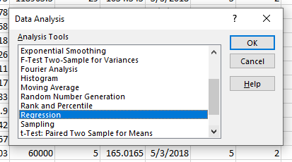
Step 5: In the Input Range We Select as ticket sold and ticket out x range and Total sales as y range, then select Output Range where you want the output to be stored. If you don’t specify the output range, it will throw output in the new worksheet.
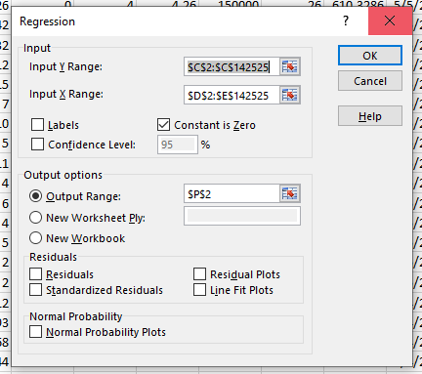
Step 6: Then select Output Range where you want the output to be stored. If you don’t specify the output range, it will throw output in the new worksheet.
Step 7: When you click Ok, you will see the result in the selected output range.
Step 8: Save the excel file and Close the Ms Excel application.

Output
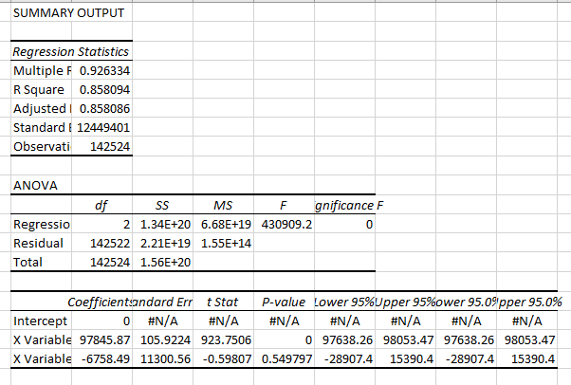

RESULT:
Thus the bivariate and multivariate analysis on the dataset was performed successfully
using MS-EXCEL and the desired output was displayed in neat format.
Performance(25)
Viva-Voce(10)
Record(15)
Total(50)

Ex No-8  Date: | APPLY AND EXPLORE VARIOUS PLOTTING FUNCTIONS ON THE DATA SET

AIM:
To apply and explore various plotting functions using MS Excel for visualizing data.

PROCEDURE:
Step 1: Start Ms Excel application in Ms- office.
Step 2: Create datasheet for Cinema ticket booking in Ms Excel application.
Step 3: select the data for which a chart is to be created.
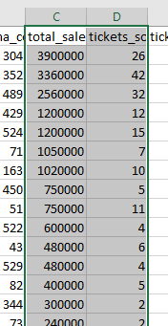
Step 4: In the INSERT menu, select Recommended Charts.
Step 5: Choose any chart from the list of charts Excel recommends for your data on the Recommended Charts tab, and click it to preview how it will look with your data.
Step 6: Click on All Charts if you are unable to locate a chart you like.
Step 7: Click on the chart that you prefer and then click OK.
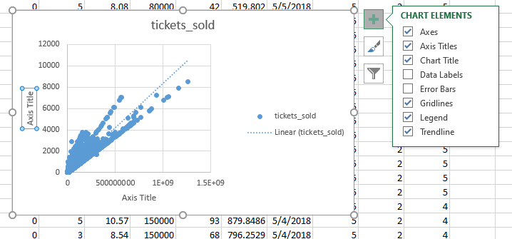
Step 8: Add chart elements such as axis titles or data labels, customize the appearance of the chart, or change the data displayed in the chart by clicking on Chart Elements, Chart Styles, and Chart Filters in the upper-right corner of the chart.
Step 9: Click on the chart TOOLS tab on the ribbon to add additional design and formatting capabilities and then click the options you desire under the DESIGN and FORMAT tabs.
Step 10: When you click Ok, you will see the result in the selected output range.
Step 11: Save the excel file and Close the Ms Excel application.

Output:

RESULT:

The plotting functions was applied and explored on the data set successfully using MS-
EXCEL and the desired output was displayed in neat format.
Performance(25)
Viva-Voce(10)
Record(15)
Total(50)

Ex No-5  Date: | PERFORM DATA PRE-PROCESSING OPERATIONS  I) HANDLING MISSING DATA II) NORMALIZATION

AIM:

To perform data pre-processing operations, specifically handling missing data and normalization, using MS Excel.

Data Pre-Processing Definitions

Handling Missing Data: In real-world data, some values might be missing. Handling missing data involves identifying and addressing these gaps to prepare the data for analysis. Common methods include deletion, imputation (filling with mean, median, mode), and prediction.

Normalization: Normalization is the process of scaling individual data points to ensure they contribute equally to the analysis. It involves transforming data into a standard range, usually between 0 and 1, or -1 and 1. This helps in improving the accuracy and efficiency of models.

PROCEDURE
Let’s say, we have got a dataset of some people registered for watching a cinema, their relevant ID, and the person who watched the film.

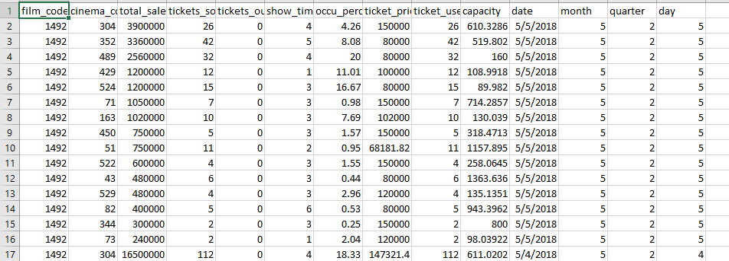

You can see that some persons are missing on the day of taking the vaccine and we want to find out the missing persons. Here we will use ISERROR, VLOOKUP functions to deal with the missing data.

In order to do so, proceed with the following steps.
Steps:
• First of all, create a column and apply the following formula to the selected cell.


Here,
- B2= the data to find
- $C$2:$C$30= Lookup array

Formula Breakdown
The VLOOKUP function considers b2 as the lookup_value and $C$2:$C$30as lookup array, 1 as col_index_num, and 0 as range lookup.
The ISERROR function returns TRUE as it finds an error or FALSE where it doesn’t find an
error.
So, when the LOOKUP function doesn’t find a value and makes an error, the ISERROR
function returns TRUE, otherwise FALSE.

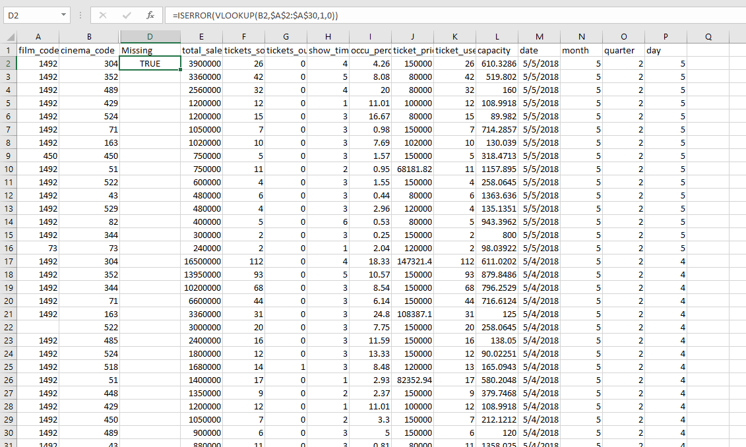

Then, use the Fill Handle tool to Autofill the formula for the next cells and you will get the output for the missing data.
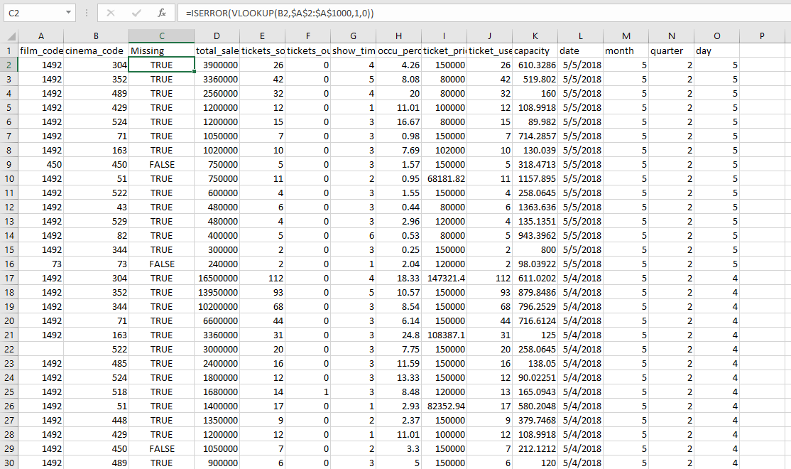

PROCEDURE:
Normalization refers to scaling data so that the minimum value is equal to 0 and the maximum value is equal to 1. This process is often referred to as min-max scaling. Standardization is often also referred to as normalization – in this case, the dataset is modified so that the mean is equal to 0 and the standard deviation is equal to 1.
Standardization and normalization allow you to work with data of different scales more effectively.

Imagine having a dataset that compares a person’s income and height in centimeters. Likely, these values will be in completely different scales. Because of this, looking at their means or standard deviations would not be comparable.
Standardizing data is quite simple using built-in operators and functions, such as the MIN() and MAX() functions.
Mathematically, we normalize value using the formula below:
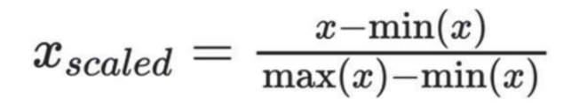

The formula for min-max scaling normalization
In the example above, you scale each value in a dataset by subtracting the minimum value from the value and dividing it by the difference between the max and minimum values. Let’s break this down,
step-by-step:

1. Subtract the minimum value in the dataset from the value
2. Divide this difference by the difference between the maximum and minimum values of the
Dataset
3. Repeat this for each item in the dataset

Let’s see how we can normalize data in Excel:
Step 1: Load the dataset you want to normalize
The dataset for the tutorial, In our sample dataset, we have values ranging from 4 to 31. By using min-max scaling, all of our values will range from 0 to 1.
Step 2: Calculate the minimum value in the dataset using the MIN() function.
Calculate the minimum value of the dataset
Use the MIN() function to calculate the minimum value of the dataset. In this case, this returns 4. Step
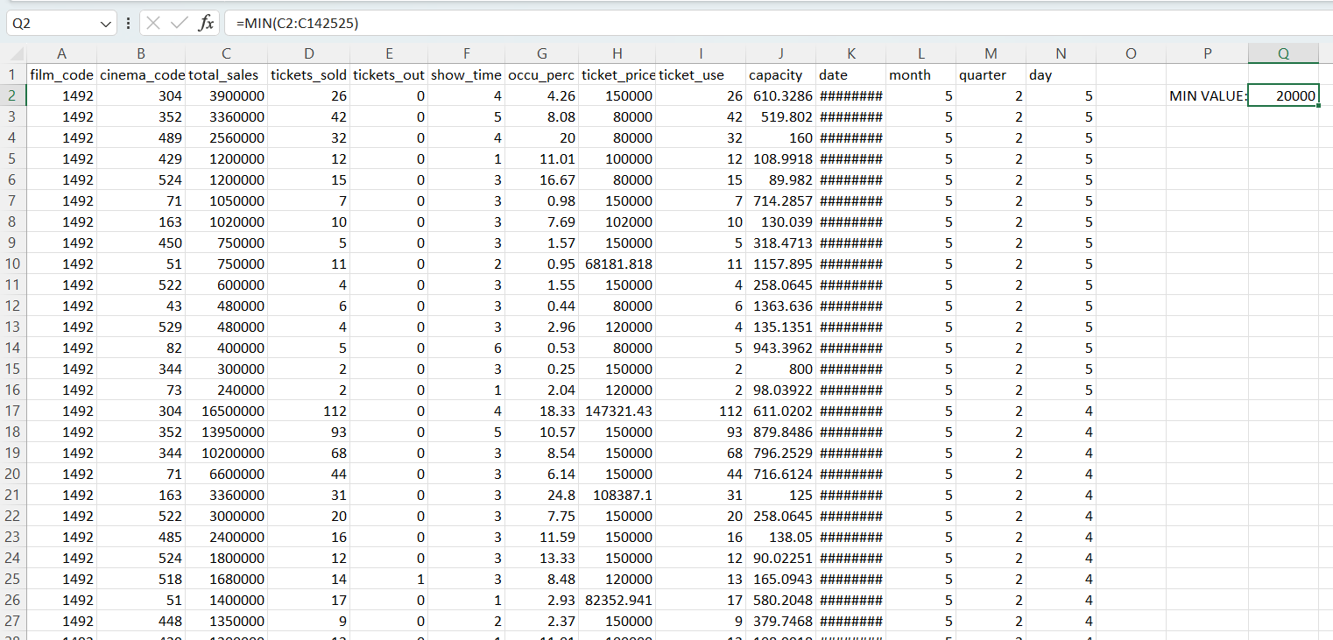
Step 3: Calculate the maximum value in the dataset using the MAX() function
Calculate the maximum value of the dataset, Use the MAX() function to calculate the
maximum value of the dataset. In this case, this returns 31.
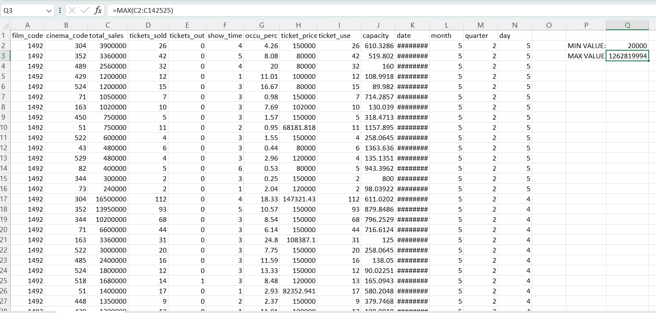
Step 4: Normalize the first record by subtracting the minimum value from the observation and
dividing by the range of the dataset.
Subtract the minimum value from the record and divide by the difference between the
maximum and minimum values
To normalize a single value, subtract that minimum value from the record itself. Then, divide this number by the range of the data (the maximum value subtracted by the minimum value).
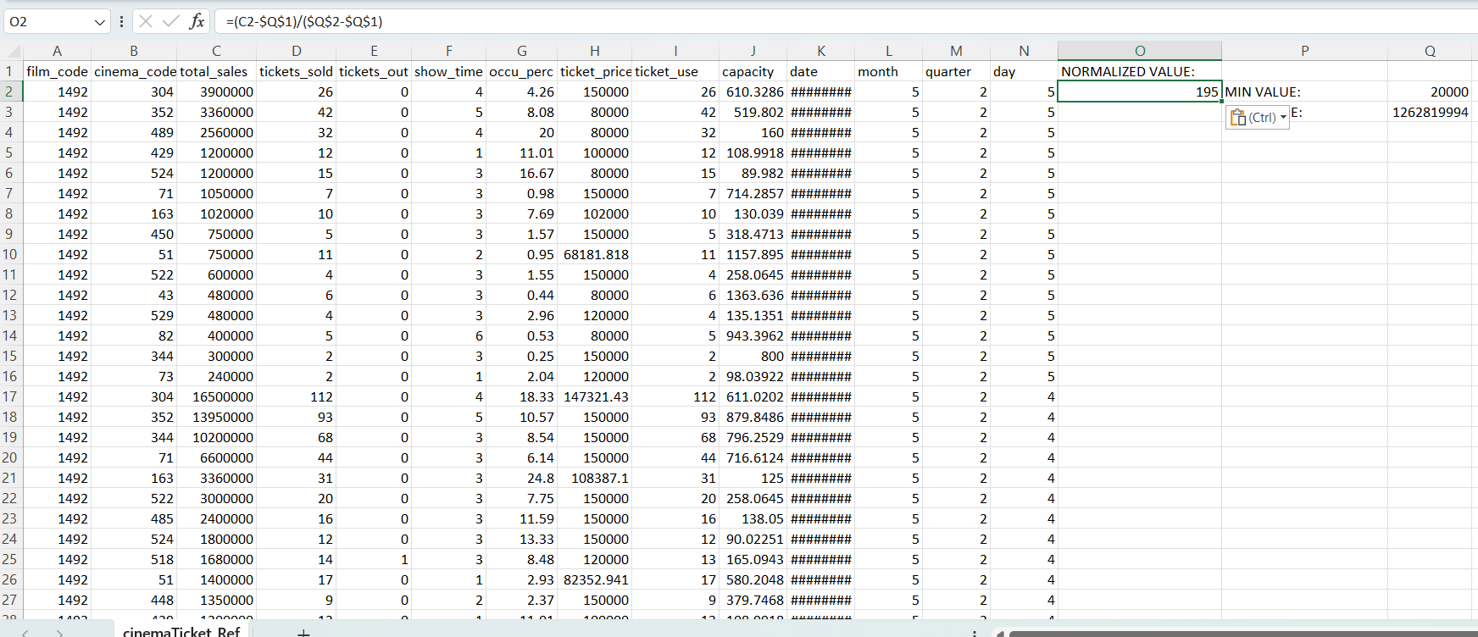

Step 5: Drag the fill handle down to normalize all records in the dataset Drag the fill handle all the way down to normalize all values in Excel.
To normalize the entire dataset, simply drag the fill handle all the way down. Because we’re using absolute references for the minimum and maximum values of the dataset, we don’t have to worry about values changing through relative references.

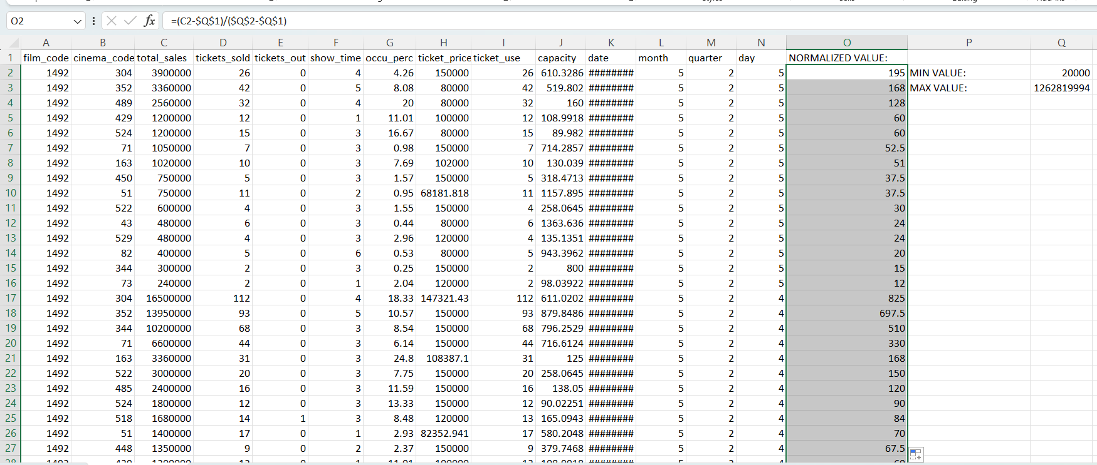

RESULT:
Performance(25)
Viva-Voce(10)
Record(15)
Total(50)
Thus the handling of missing data and normalizing of data in excel was executed successfully.

