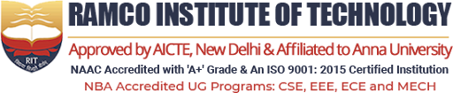

FULL STACK DEVELOPMENT
Internship Report Submitted by
THARANAA S (953622104107)



Department of Computer Science and Engineering

RAMCO INSTITUTE OF TECHNOLOGY
(Approved by AICTE, New Delhi & Affiliated to Anna University, Chennai)

Rajapalayam-626117

OCTOBER 2025

BONAFIDE CERTIFICATE

Certified that this internship report on “FULL STACK DEVELOPMENT” at “RAMCO CEMENTS LIMITED” is the bonafide work of THARANAA S (953622104107) who carried out the Internship under my supervision.

SIGNATURE  Dr.K.Vijayalakshmi M.E., Ph.D.  HEAD OF THE DEPARTMENT  Department of Computer Scienceand Engineering  Ramco Institute of TechnologyNorth Venganallur Village  Rajapalayam – 626117 | SIGNATURE  Mrs.M.Dhivya M.E.,  Faculty In-charge  Assistant Professor  Department of Computer Science and Engineering  Ramco Institute of Technology North Venganallur Village  Rajapalayam– 626117

INTERNAL EXAMINER EXTERNAL EXAMINER

INTRODUCTION

Name of the student : THARANAA S

Register No 953622104107

Branch : Computer Science and Engineering

Year/Semester : IV/VII

Name of the Industry : RAMCO CEMETS LIMITED

Duration : 24.09.2025 - 24.10.2025

Role : FULL STACK DEVELOPMENT
INTRODUCTION ABOUT COMPANY

COMPANY : RAMCO CEMENTS LIMITED
LOCATION : R R NAGAR VIRUDHUNAGAR

DURATION : 24.09.2025 – 24.10.2025

ROLE :FULL STACK DEVELOPMENT

About the Company:
- Supraja Technologies is an emerging IT services company based in Vijayawada, Andhra Pradesh, India. Founded in 2018 under the parent company CHSMRLSS Technologies Pvt. Ltd., the company specializes in cybersecurity solutions, digital marketing services, and professional training in cybersecurity.
- The organization focuses on providing robust solutions to protect digital assets, enhancing businesses’ online presence, and equipping individuals with the necessary skills to address modern cyber threats.
- The company is headquartered at Door No: 11-9-18, 1st Floor, Majjivari Street, Kothapeta, Vijayawada, with a branch office at Prabhu Villas, Plot No: 124, 1st Floor, Church Road, Ayyappa Nagar, Vijayawada.
- Led by Founder and CEO Santosh Chaluvadi, Supraja Technologies emphasizes understanding client requirements, integrating advanced technologies, and aligning services with client objectives to achieve mutual success.
- Supraja Technologies maintains a positive work culture that values employee development and work-life balance. Employees rate the company highly, reflecting its supportive environment and career growth opportunities.
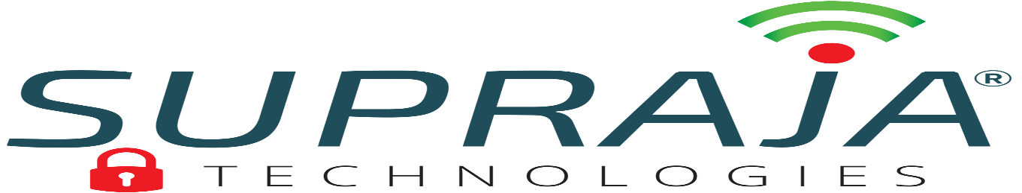
- With a strong online presence through platforms such as LinkedIn, Facebook, and Instagram, the company continues to engage with clients and professionals, enhancing its reach and reputation in the IT services sector.

Week 1: Orientation and Technology Fundamentals

The internship at Winzone Softech began with an orientation program aimed at familiarizing me with the objectives of the company and the fundamental concepts of digital marketing and IT. The focus was on understanding how modern technology supports business growth and how digital marketing strategies integrate with IT tools to improve online presence, engagement, and efficiency.

Introduction to the Company and Digital Marketing
During the orientation, I was introduced to the core services of Winzone Softech, which include website design and development, software solutions, e-commerce platforms, and digital marketing services such as SEO, SEM, SMO, and SMM.

The trainers explained the significance of digital marketing in today's competitive market, highlighting how businesses use online strategies to reach their audience effectively. It was emphasized that a strong foundation in technology and IT concepts is essential for executing successful campaigns.

Key Learning Points from Orientation

The orientation focused on three main areas:
- Understanding the Importance of Technology and IT
  - Technology serves as a tool to save time, provide value, and streamline tasks in both business and marketing.
  - Information Technology (IT) enables efficient information exchange, for example, sharing data, communications, and tracking analytics.
  - Innovation was discussed as a necessity when traditional methods are insufficient, with examples of AI and automation enhancing business efficiency.

- Professional Skills and Workplace Etiquette
  - The importance of self-confidence, clear communication, and presenting oneself professionally was emphasized.
  - Team collaboration and reporting structures were introduced, along with tools like Slack for communication and shared drives for documentation.
  - Thinking critically and logically, like a tree structure, was encouraged for problem-solving and decision-making in marketing projects.

- Introduction to Digital Tools and Concepts
  - Overview of essential tools like Canva for design, SEO tools like RankMath and Ubersuggest, and Google tools (Ads, Trends, and Search Console) for digital campaigns.
  - Understanding basic website elements and social media platforms for marketing purposes.
  - Exposure to creative concepts like branding, color theory, and poster design principles.

Initial Contributions
Even in the first week, I started engaging with practical tasks to familiarize myself with tools and workflows:
- Created sample posters on Canva to understand layout, typography, and color usage.
- Explored different templates and design elements for professional social media marketing.
- Documented the orientation learnings, software setup steps, and project requirements for future reference.

Reflection and Takeaways
The first week was crucial in building my foundational knowledge of digital marketing and IT concepts. It helped me transition from theoretical understanding to practical application. I learned the importance of combining technical tools with creativity and strategic thinking, which is essential for achieving effective marketing results.
By the end of the week, I had gained confidence in using basic digital marketing tools, understood the significance of professional communication, and prepared myself to contribute meaningfully to upcoming projects like poster design and SEO optimization.

Week 2: Canva and Social Media Marketing – Design and Implementation

The second week of my internship at Winzone Softech focused on learning and applying Canva for social media marketing. This phase was crucial for understanding how visual content impacts digital campaigns and how design principles can influence engagement, brand identity, and user perception. The week was a mix of theoretical learning, hands-on design practice, and real-time project work.

Introduction to Canva and Social Media Marketing

During this week, I was introduced to Canva, a powerful graphic design tool used for creating social media posts, banners, flyers, and promotional content. The trainers emphasized the importance of clear communication through visuals and how well-designed content can significantly enhance brand visibility and customer engagement.

I also learned about the basics of social media marketing, including choosing the right platform for a target audience, the role of aesthetics in campaigns, and adhering to brand guidelines.

Designing Posters on Canva
The design process began with understanding client requirements, choosing appropriate color schemes, typography, and layouts. Key steps included:

- Color and Theme Selection

  - For industry-specific themes, colors were chosen carefully:
    - Hospitals → Calm tones like blue, green, and white.
    - IT Companies → Modern tones such as purple gradients with clean designs.
    - Food Brands → Warm and vibrant colors like orange, yellow, and red.
  - I ensured that the color palette matched the client’s branding and was visually appealing to the target audience.

- Typography and Layout

  - Professional fonts were selected from Google Fonts to maintain readability and professionalism.
  - Heading sizes ranged from 14–18, and content sizes were kept at 10–12 for visibility.
  - Text alignment, spacing, and hierarchy were applied consistently to create clean and organized designs.

- Creating Engaging Taglines and Content

  - Innovative and catchy taglines were developed to grab the audience’s attention.
  - Pain points and benefits were highlighted in a simple and understandable manner.

  - Content placement was optimized for clarity, ensuring that the message was communicated effectively.
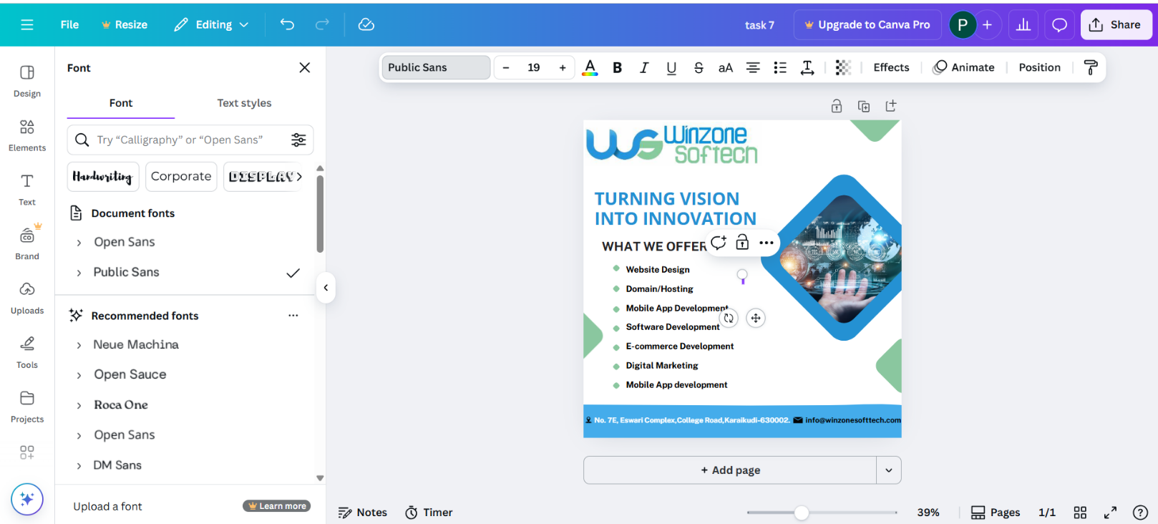

Real-Time Project Contributions
During this week, I contributed to real-time projects that provided hands-on experience:

- Poster for RSP Hospital
  - Designed using calm colors to reflect a soothing environment.
  - Created taglines emphasizing trust, care, and patient focus.
  - Ensured alignment with hospital branding and social media guidelines.

- Poster for Winzone softech
  - Designed modern, gradient-based visuals to reflect the IT company’s innovative services.
  - Chose professional fonts and layouts suitable for digital marketing campaigns.
  - Focused on creating engaging designs for social media promotion.

Learning Social Media Rules and Best Practices
The week also covered important rules for effective digital design and social media marketing:
- Clarity of message was essential.
- Backgrounds were limited to 2–3 colors to avoid distraction.
- Logos and brand colors were consistently applied.
- Professional, readable fonts ensured the message was understood.
- Posters followed industry-specific themes for relevance.
- Content was made concise, innovative, and engaging to maximize audience impact.

Challenges Faced
Several challenges were encountered during this phase:
- Balancing Creativity and Brand Consistency
  - Ensuring that innovative designs still adhered to client brand guidelines required multiple revisions and careful attention.

- Time Management
  - Designing posters for multiple clients within deadlines was challenging, which required prioritization and efficient workflow management.

- Learning Design Tools
  - Although Canva is user-friendly, mastering advanced features like gradient overlays, layering, and template customization took dedicated practice.

Reflection and Takeaways

The second week was instrumental in developing my design skills and understanding the role of visuals in digital marketing campaigns. I gained:
- Hands-on experience in Canva for professional poster creation.
- Knowledge of social media marketing principles and audience engagement strategies.
- Confidence in creating industry-specific designs that meet client requirements.

By the end of the week, I had successfully designed multiple posters for real-time projects, understood design principles, and was ready to apply these skills in more complex campaigns in the subsequent weeks. This experience significantly enhanced my practical knowledge and creative abilities, laying the foundation for deeper exploration of digital marketing concepts.

Week 3: SEO Projects – On-Page and Technical Optimization

In the third week of my internship at Winzone Softech, I applied the digital marketing and SEO knowledge I had gained in the previous weeks to real client websites. The focus was on improving the search engine visibility, performance, and usability of Cwin Infotech and Chennai SN Packers & Movers websites. This week was crucial in understanding how both on-page and technical SEO directly impact website ranking and user experience.

SEO for Cwin Infotech Website
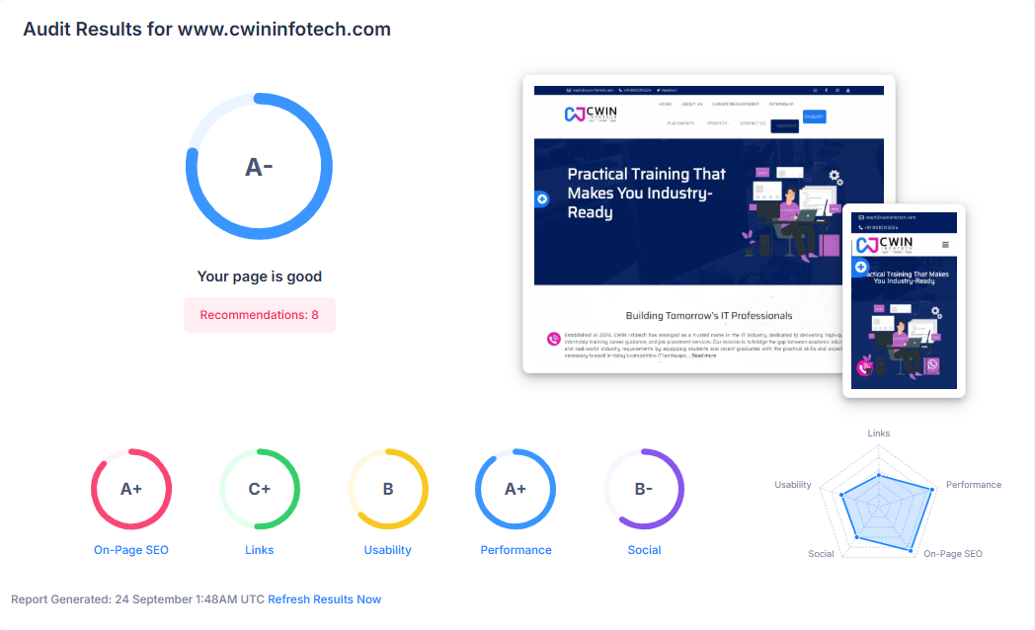
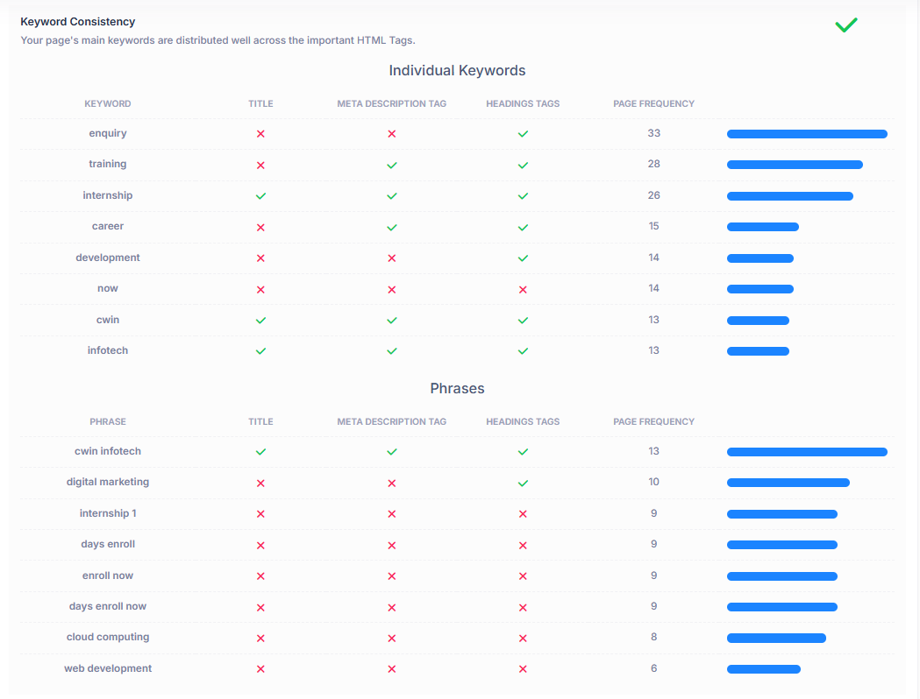

- Website Audit and Analysis: I started by auditing the website using tools such as Ubersuggest, RankMath, and GTMetrix. The audit revealed issues with title length, meta descriptions, internal linking, and content structure.

- Title Tag Optimization: I updated the title tags to ensure they were unique, concise, and included high-priority keywords relevant to IT services offered by Cwin Infotech. This helped search engines understand the main content of each page.

- Meta Description Updates: The meta descriptions were rewritten to be informative, keyword-rich, and appealing to potential visitors, which improved click-through rates.

- Content Optimization: I incorporated focus keywords naturally into the content, maintained proper heading hierarchy (H1, H2, H3), and ensured readability for users.

- Internal Linking: Related pages were linked properly to improve navigation and help search engines crawl the website efficiently.

- Sitemap and Robots.txt: I updated the sitemap.xml to include all relevant pages and checked the robots.txt to avoid blocking important content from search engines.

- Performance Enhancement: I optimized images, fixed broken links, and improved page loading speed to enhance user experience and SEO performance.

SEO for Chennai S N Packers & Movers Website
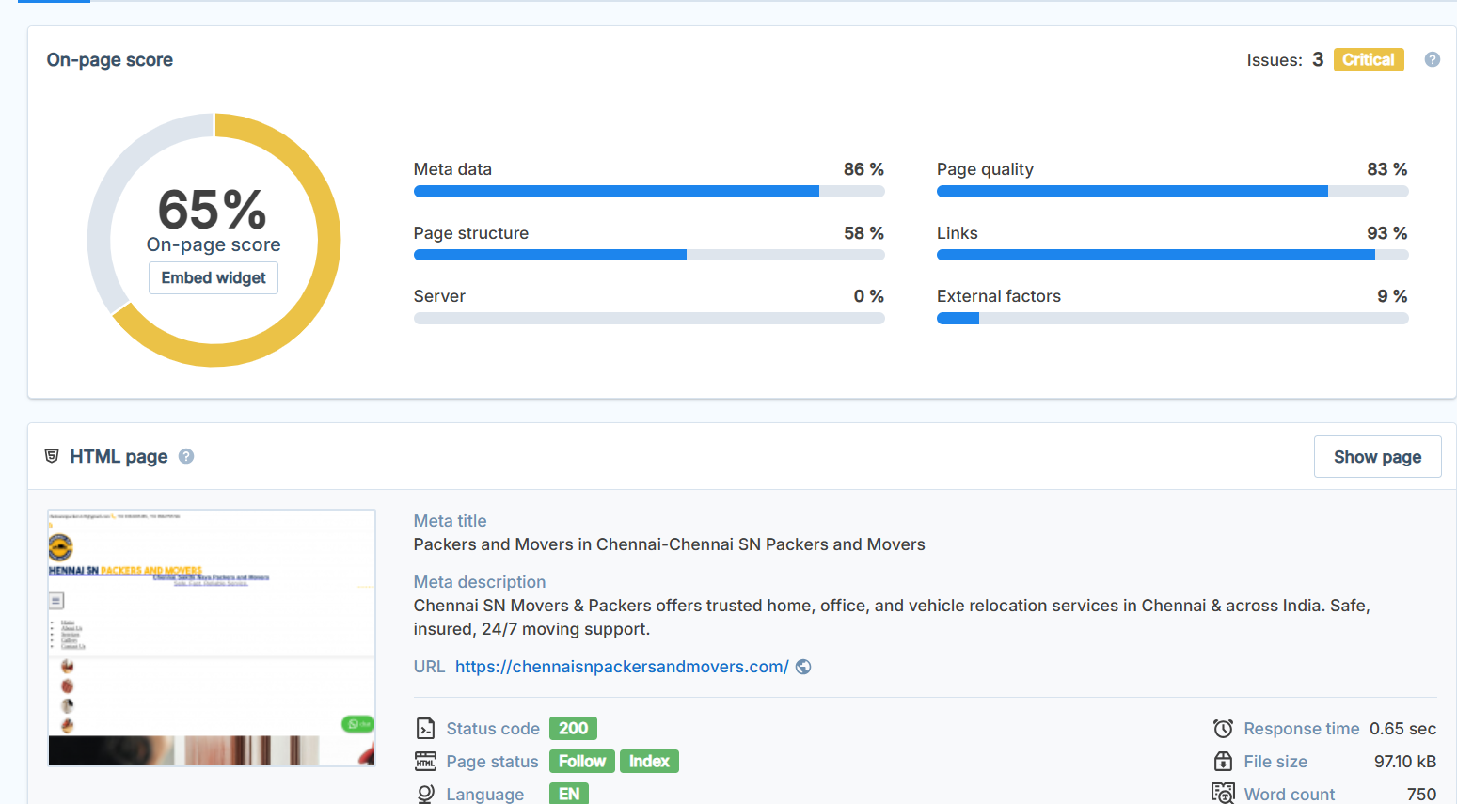

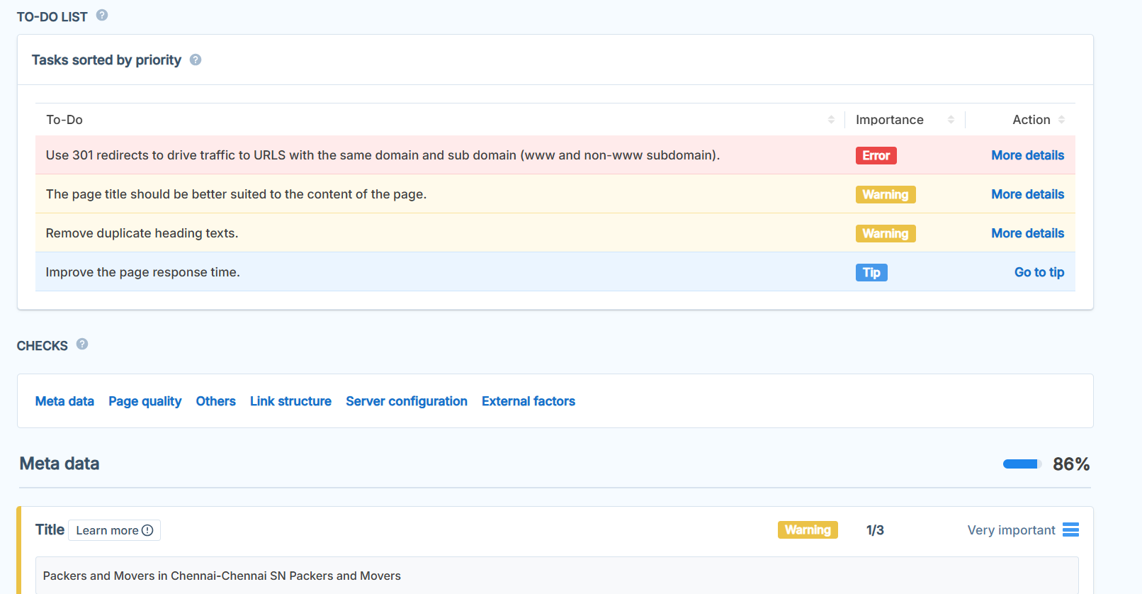

- Technical SEO Fixes: I addressed HTTP redirect issues, ensuring smooth page transitions and preventing errors that could negatively affect search engine ranking.

- Page Speed Optimization: I improved loading times by compressing images, reducing CSS file sizes, and removing unnecessary scripts. Fast loading pages are essential for user retention and SEO ranking.

- Broken Link Resolution: I conducted a thorough check for broken links and resolved them to maintain website integrity and improve crawling by search engines.

- Domain and URL Optimization: Long and complex URLs were shortened and made SEO-friendly, ensuring easier indexing.

- Mailto Integration: Added a mailto link in the contact section for easy communication with clients.

- Content and Keyword Enhancement: Updated and optimized page content with relevant keywords to target potential customers more effectively.

Key Learning Outcomes:

- Understood the importance of on-page SEO elements like title tags, meta descriptions, headings, and internal links in improving website ranking.
- Learned to implement technical SEO fixes, including redirect management, page speed optimization, and broken link resolution, which directly impact user experience and search engine crawling.
- Gained practical experience using SEO tools such as RankMath, Ubersuggest, GTMetrix, and Google Search Console for auditing and monitoring website performance.

- Developed a systematic approach for improving website visibility, content relevance, and technical health simultaneously.

By the end of the week, both websites were significantly improved in terms of SEO performance, user experience, and search engine ranking. This hands-on experience provided deep insight into how SEO strategies are implemented professionally to enhance digital presence.

Week 4: Advanced Digital Marketing Tasks and Client Project Completion

In the fourth week of my internship at Winzone Softech, I focused on consolidating the skills I had learned in the previous weeks and applied them to real-time client projects. The main emphasis was on refining SEO strategies, completing website optimization, and exploring additional digital marketing tasks that enhanced the overall digital presence of the client websites.

Advanced SEO Implementation
- Performance Tracking: I monitored key metrics like page loading speed, FCP (First Contentful Paint), LCP (Largest Contentful Paint), and overall GTMetrix performance scores to ensure the websites performed optimally.

- Content Analysis: Reviewed all website content for readability, keyword density, meta tags, heading structures, and proper image alt tags. Updated and optimized where necessary to improve search visibility.

- User Experience (UX) Improvements: Suggested improvements for website navigation and mobile responsiveness to enhance the visitor’s experience, which is a critical factor for SEO ranking.

Additional Digital Marketing Tasks

- Google Maps Optimization: Placed accurate location markers for the client companies to enhance local SEO, making it easier for potential customers to find them online.

- SSL Certificate Verification: Checked SSL certificates for the client websites, monitored expiry dates, and suggested renewals to maintain secure HTTPS browsing.

- Google Tools Usage: Practiced using Google Search Console, Google Ads, and Google Trends to track website performance, understand user search behavior, and discover trending keywords.

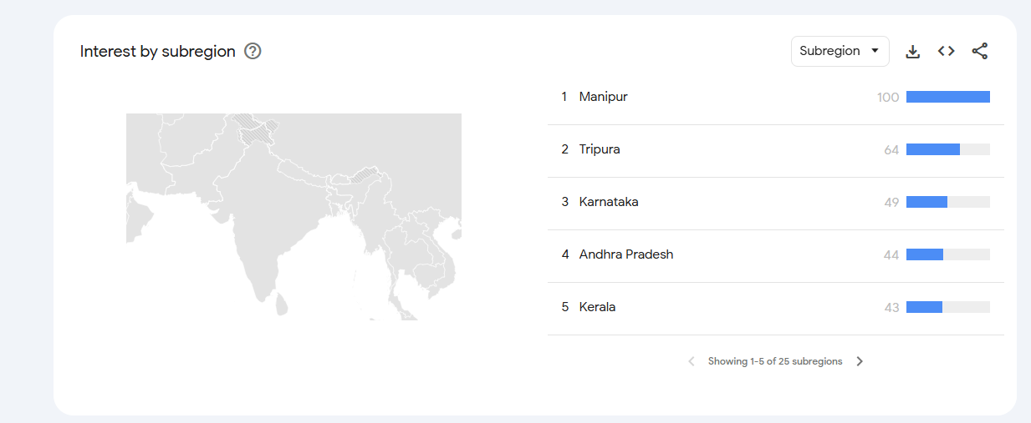
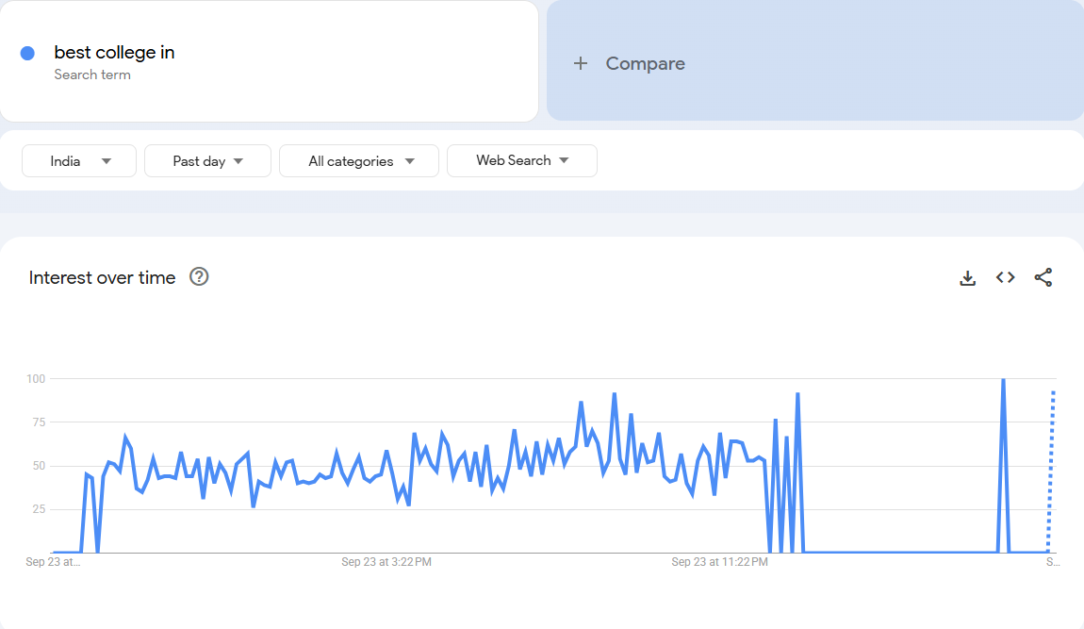
- Website Security and Maintenance: Assisted in identifying broken links, outdated content, and slow-loading pages to improve both site security and user engagement.

Client Projects Worked On
- Cwin Infotech: Finalized SEO improvements, updated meta descriptions, optimized headings, and added internal linking for better crawlability.

- Chennai S N Packers & Movers: Implemented redirect fixes, optimized CSS for faster loading, and enhanced overall website usability.

Reflections and Outcomes
- Learned to analyze websites holistically by combining SEO optimization with UX improvements and performance metrics.

- Understood the importance of regular monitoring and maintenance in keeping a website competitive in search engine rankings.

- Gained confidence in using multiple digital marketing tools to track, report, and enhance client projects.

By the end of Week 4, I had successfully completed all assigned client projects, ensured websites were fully optimized, and gained practical experience in managing digital marketing campaigns with a focus on measurable results. This week also taught me the value of attention to detail and continuous learning in the dynamic field of digital marketing.

Conclusion

My 4-week internship at Winzone Softech, Karaikudi, has been an invaluable learning experience that bridged the gap between theoretical knowledge and practical application in the field of Digital Marketing.

Throughout the internship, I gained hands-on experience in poster designing using Canva, website optimization, on-page SEO, technical SEO fixes, and performance tracking for real client projects, including Cwin Infotech and Chennai S N Packers & Movers.

I also developed skills in using tools such as Ubersuggest, RankMath, GTMetrix, Google Search Console, Google Ads, and Google Trends, which enhanced my understanding of website analytics, keyword research, and search engine optimization.

Additional tasks like Google Maps location marking, SSL certificate verification, and website maintenance provided insights into holistic digital marketing practices and the importance of security and user experience.

This internship strengthened my professional skills, including teamwork, communication, problem-solving, and time management. It also deepened my understanding of how digital marketing integrates with technology to drive business growth.

As a final-year Computer Science student at Ramco Institute of Technology, this experience has boosted my confidence and prepared me for future roles in digital marketing and IT, while motivating me to continue learning and applying innovative solutions in the industry.

Overall, this internship has been a transformative experience, equipping me with both technical expertise and professional competence to contribute effectively in a real-world digital marketing environment

Mentor Class Advisor Internship-Coordinator HOD

