**Day-3 MongoDB Task**

1. Find all the information about each products

**db.products.find()**

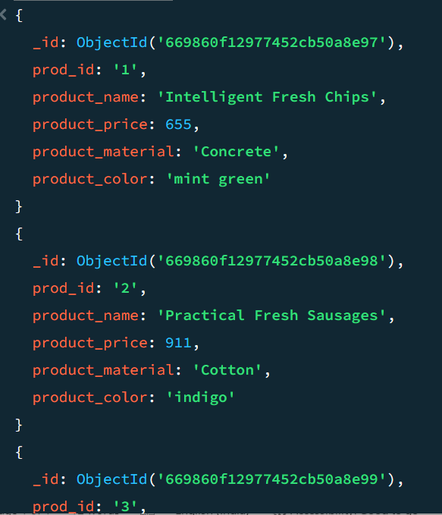

**//Displays all the 25 Products**

1. Find the product price which are between 400 to 800

**db.products.find({$and:[{"product_price":{$gte:400}},{"product_price":{$lte:800}}]},{prod_id:1,product_name:1,product_price:1,_id:0})**

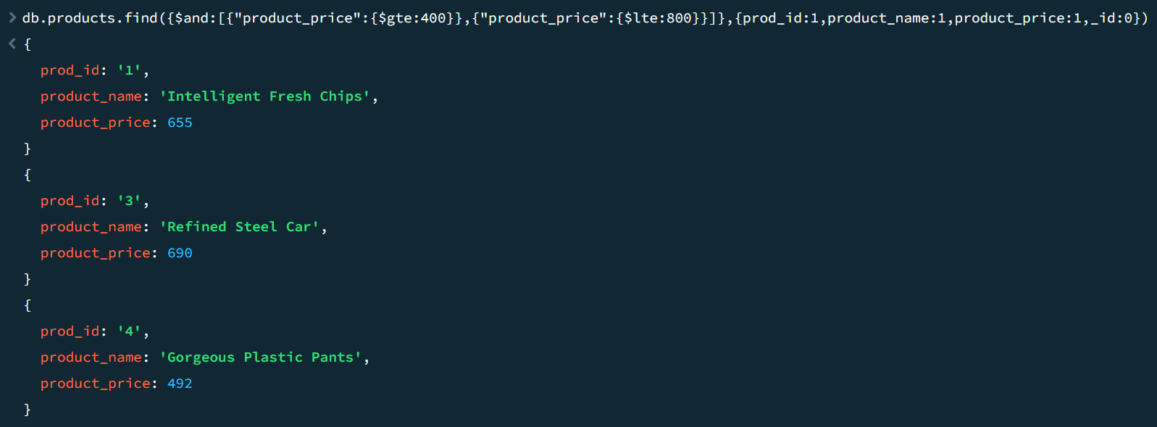

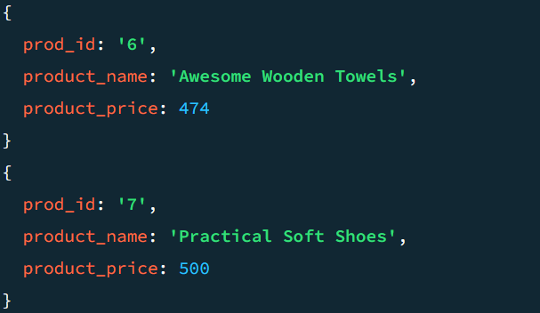

1. Find the product price which are not between 400 to 600

**db.products.find({$and:[{"product_price":{$ne:{$gte:400}}},{"product_price":{$ne:{$lte:600}}}]},{prod_id:1,product_name:1, product_price:1,_id:0})**



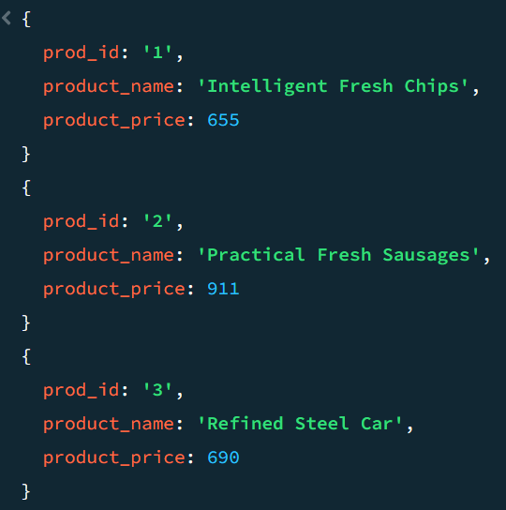 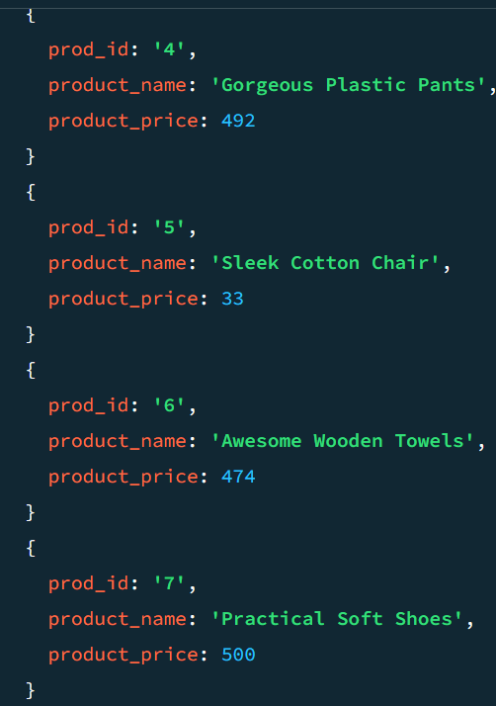 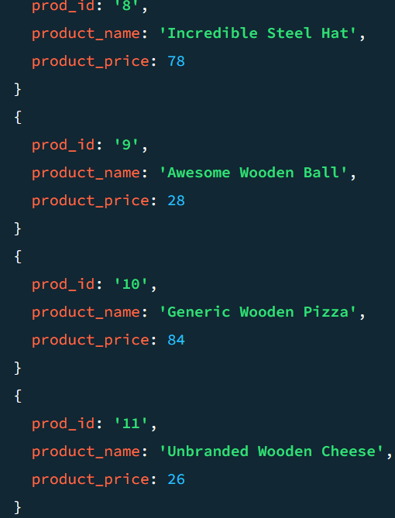

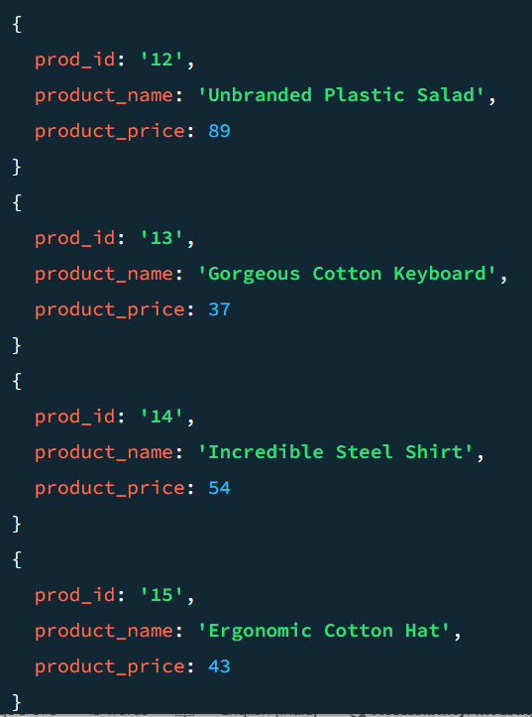 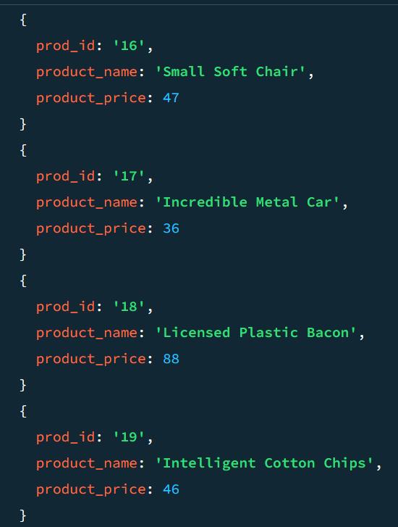 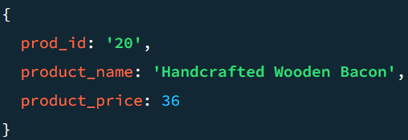

1. List the four product which are greater than 500 in price

**db.products.find({"product_price":{$gte:500}},{prod_id:1,product_name:1,product_price:1,_id:0}).limit(4)**



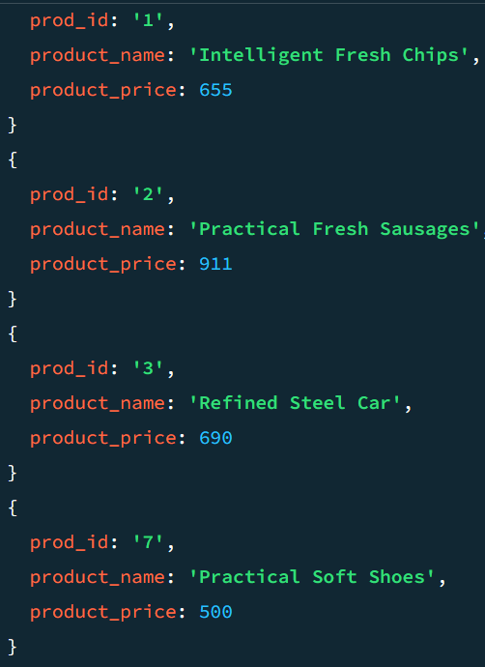

1. Find the product name and product material of each products

**db.products.find({},{prod_id:1,product_name:1,product_material:1,_id:0})**



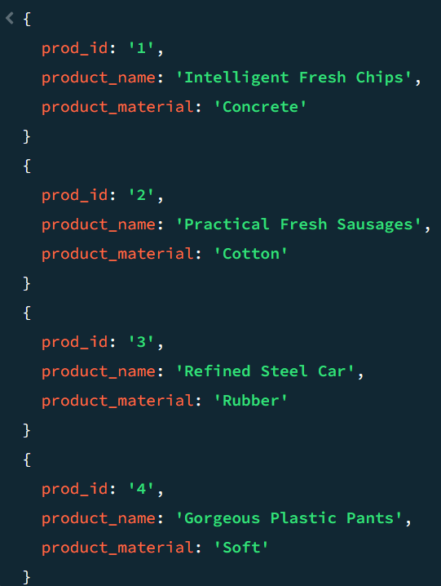 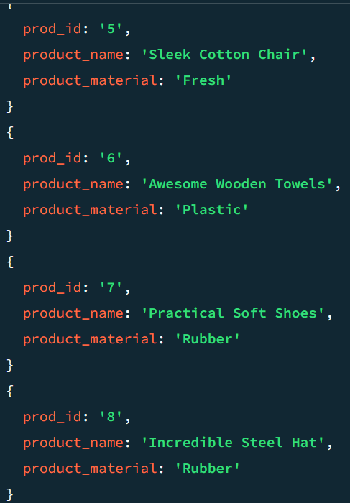 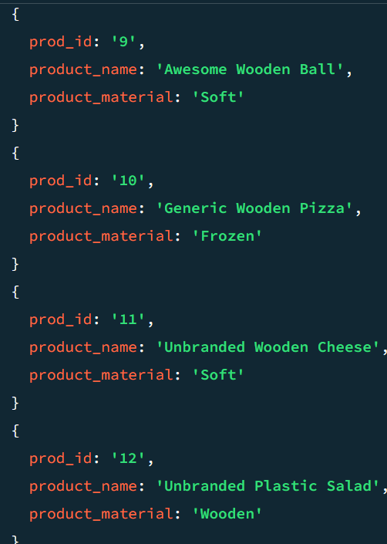

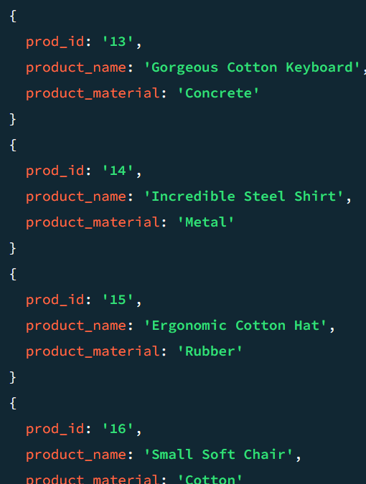 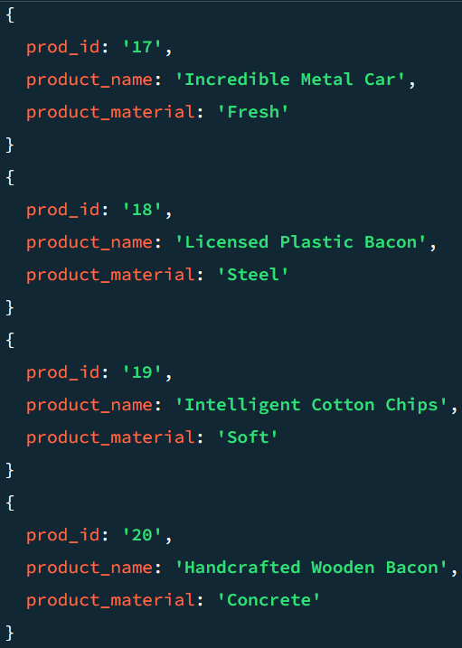 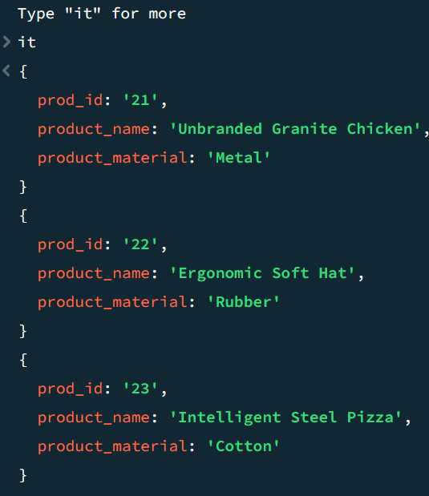

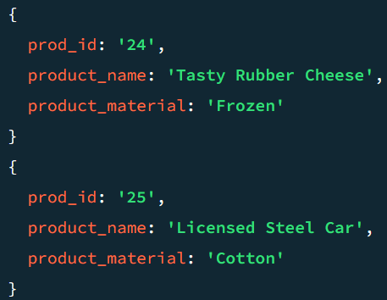

1. Find the product with a row id of 10

**db.products.find({"prod_id":"10"})**



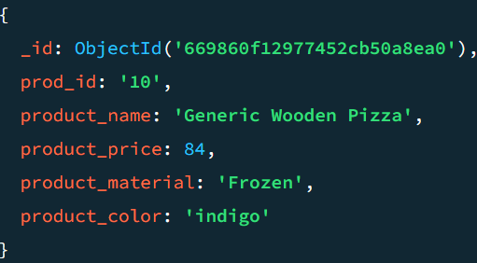

1. Find only the product name and product material

**db.products.find({},{product_name:1,product_material:1,_id:0})**

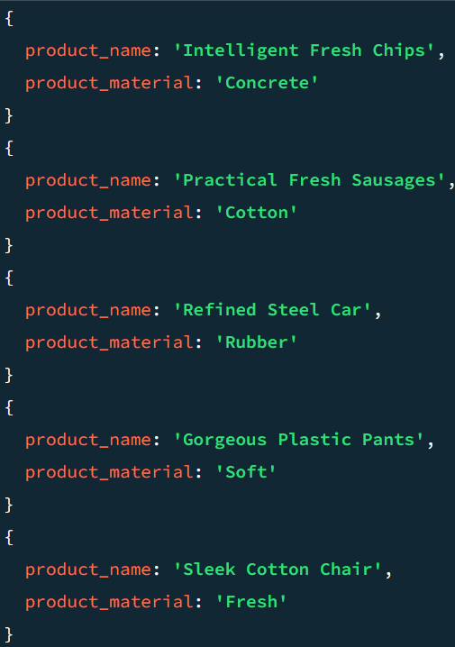 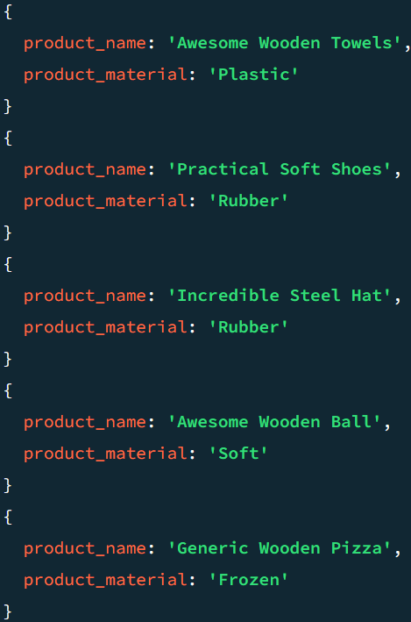 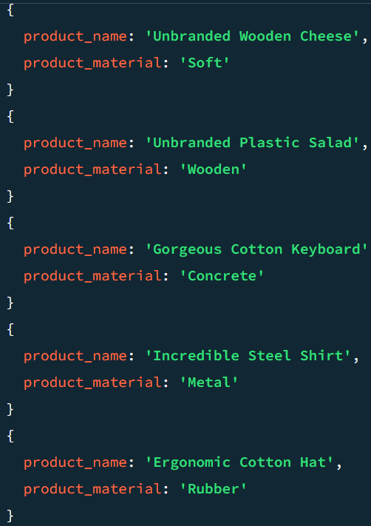x

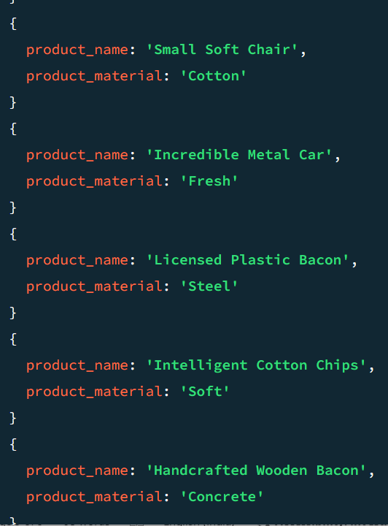

**8.** Find all products which contain the value of soft in product material

**db.products.find({"product_material":"Soft"})**



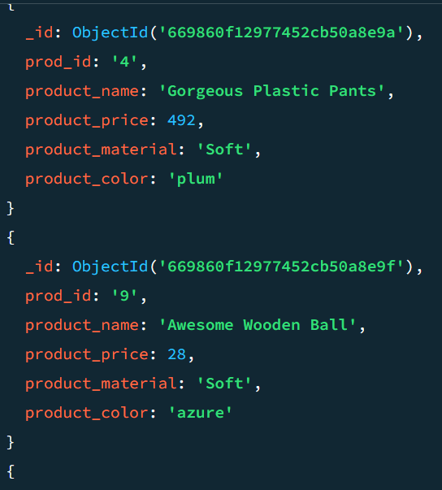 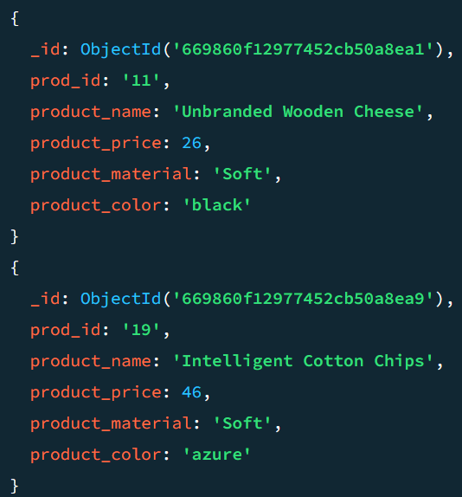

9. Find products which contain product color indigo  and product price 492.00

**db.products.find({$and:[{"product_price":492.00},{"product_color":"indigo"}]})**



**//No result for above combination**

10. Delete the products which product price value are 28

**db.products.deleteOne({"product_price":28})**

