**Day-4 MongoDB Task [Zen Class]**

1. **Find all the topics and tasks which are thought in the month of October**

**db.topics.aggregate({$match:{"$expr" : {"$eq" : [{"$month":"$topic_date"},10]}}},**

**{ $lookup: { from: "tasks", localField: "task_id", foreignField: "task_id", as: "topic_task"}},**

**{$unwind: { "path": "$topic_task", "preserveNullAndEmptyArrays": true }},**

**{$project:{ topic_name : 1, topic_date : 1, task_id : 1, task_link : "$topic_task.task_link"}})**

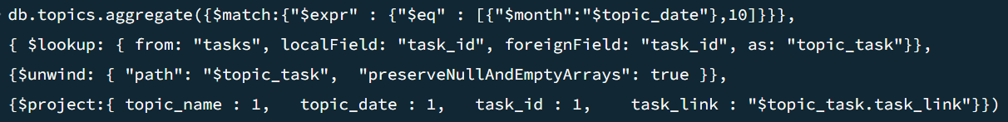

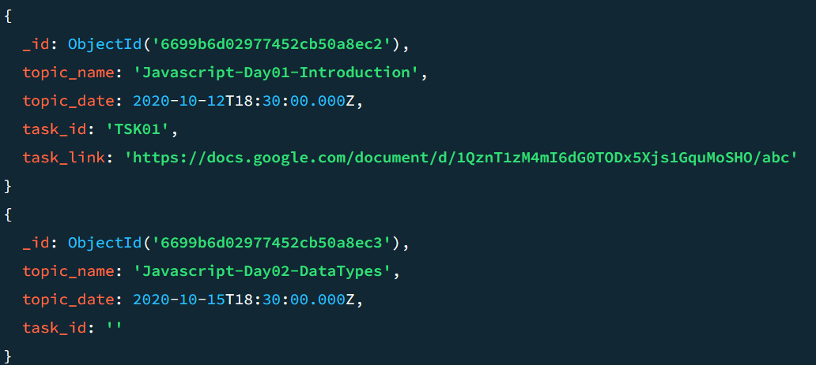 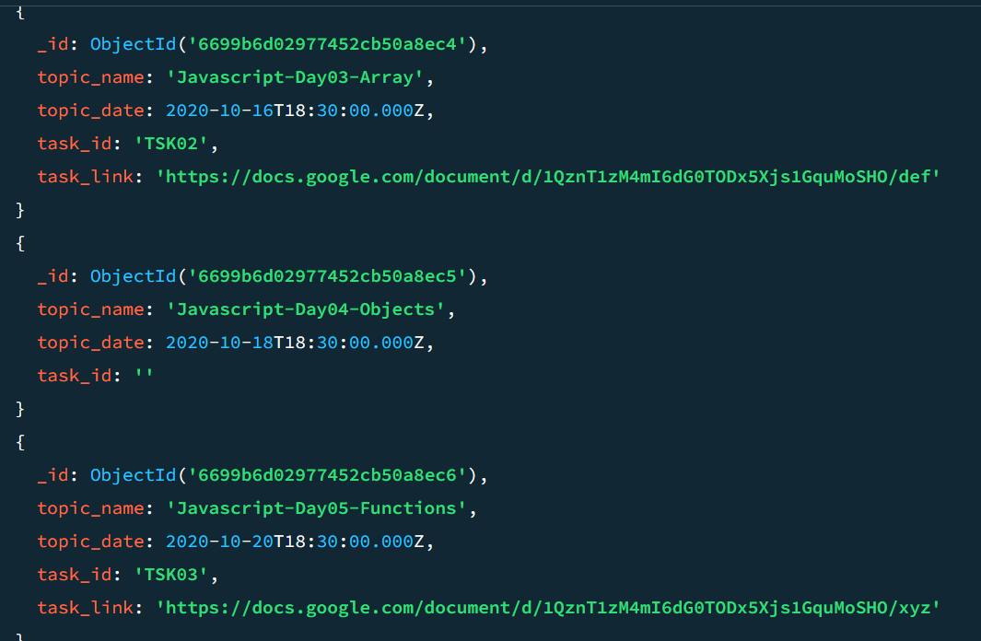

1. **Find all the company drives which appeared between 15 oct-2020 and 31-oct-2020**

**db.company_drives.aggregate({$match :{**

**"drive_date" : {$gte: ISODate("2020-10-15T00:00:00.000Z"),**

**$lte: ISODate("2020-10-31T00:00:00.000Z")}**

**}})**

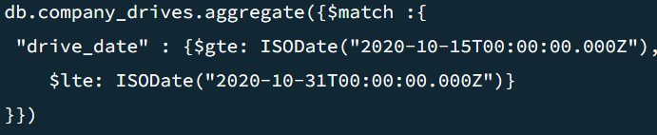

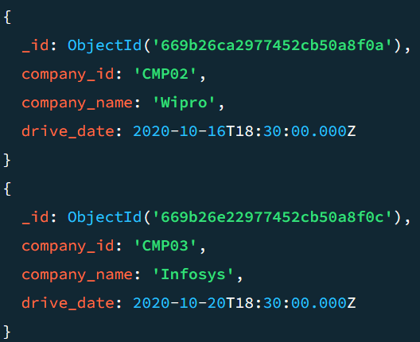 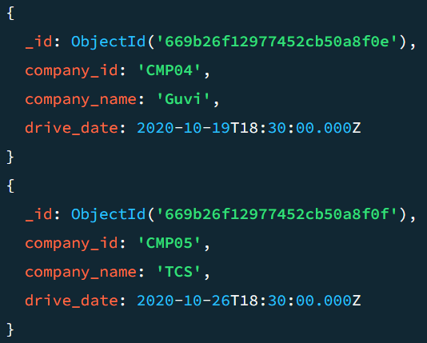

1. **Find all the company drives and students who are appeared for the placement.**

**db.company_drives.aggregate({$lookup: { from: "users", localField: "company_id", foreignField: "company_drives", as: "company_users"}}, {$project: { _id:0, company_id : 1, company_name : 1, students_name : "$company_users.student_name"}})**



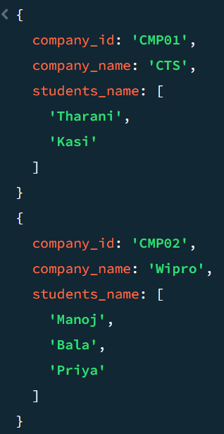 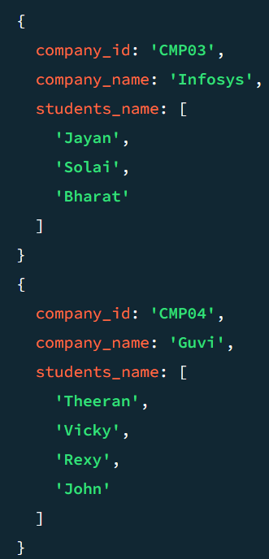 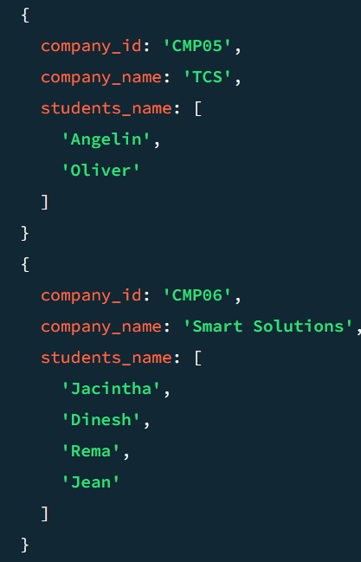

1. **Find the number of problems solved by the user in codekata**

**db.codekata.aggregate({$lookup:{ from: "users", localField: "student_id", foreignField: "student_id", as: "stud_code" }}, {$unwind: "$stud_code"},{$project: {_id : 0, student_id:1, student_name : "$stud_code.student_name", prob_solved : 1}})**



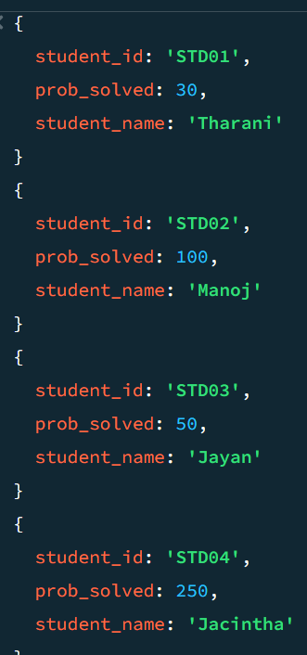 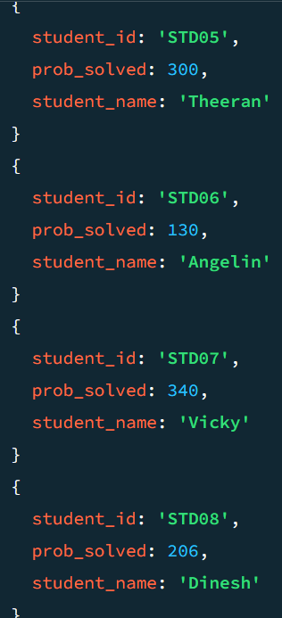 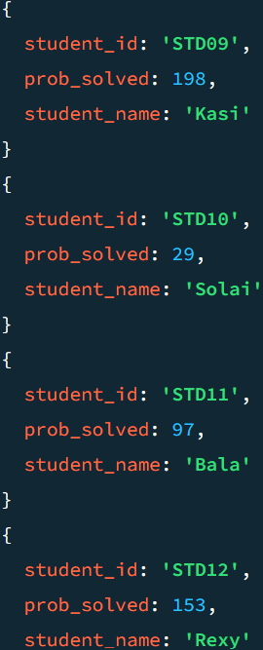 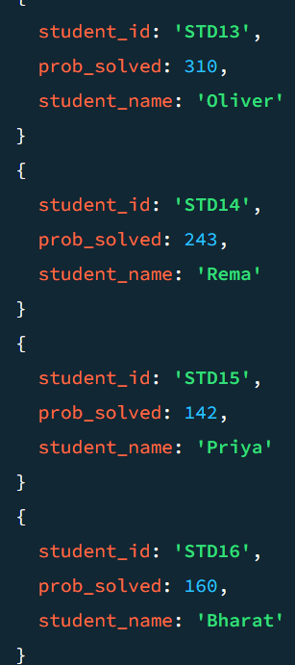

1. **Find all the mentors with who has the mentee's count more than 15**

**db.mentors.aggregate({$lookup : { from: "users", localField: "mentor_id", foreignField: "mentor_id", as: "mentor_user"}},**

**{$project: {_id : 0, mentor_id:1, mentor_name :1, stud_name : "$mentor_user.student_name"}},**

**{$group : { _id: "$mentor_id", mentor_name : {$first : "$mentor_name"}, "students_names": {"$push": "$stud_name"}}},**

**{$unwind: "$students_names"},**

**{$match:{ $expr:{$gt:[{$size: {$ifNull:["$students_names",[]]}},15]}}})**

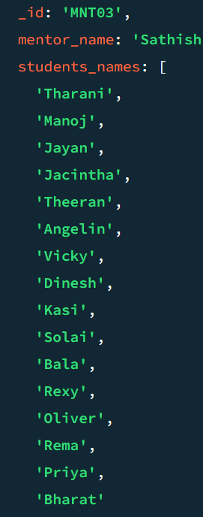

1. **Find the number of users who are absent and task is not submitted  between 15 oct-2020 and 31-oct-2020**

**db.users_task.aggregate({$lookup:{ from: "users", localField: "student_id", foreignField: "student_id", as: "students"}},**

**{$unwind : "$students"},**

**{$lookup : { from: "attendance", localField: "student_id", foreignField: "student_id", as: "user_attendance"}},**

**{$unwind : "$user_attendance"},**

**{$project : {_id : 0, student_id : 1, student_name : ("$students.student_name"), task_id : 1,**

**task_submitted_on:1, crs_date : "$user_attendance.crs_date", isPresent : "$user_attendance.isPresent"}},**

**{$match : { task_submitted_on: {$lte: ISODate("2020-10-15T00:00:00.000Z") },**

**crs_date: { $lte: ISODate("2020-10-15T00:00:00.000Z") }, isPresent : false}})**

