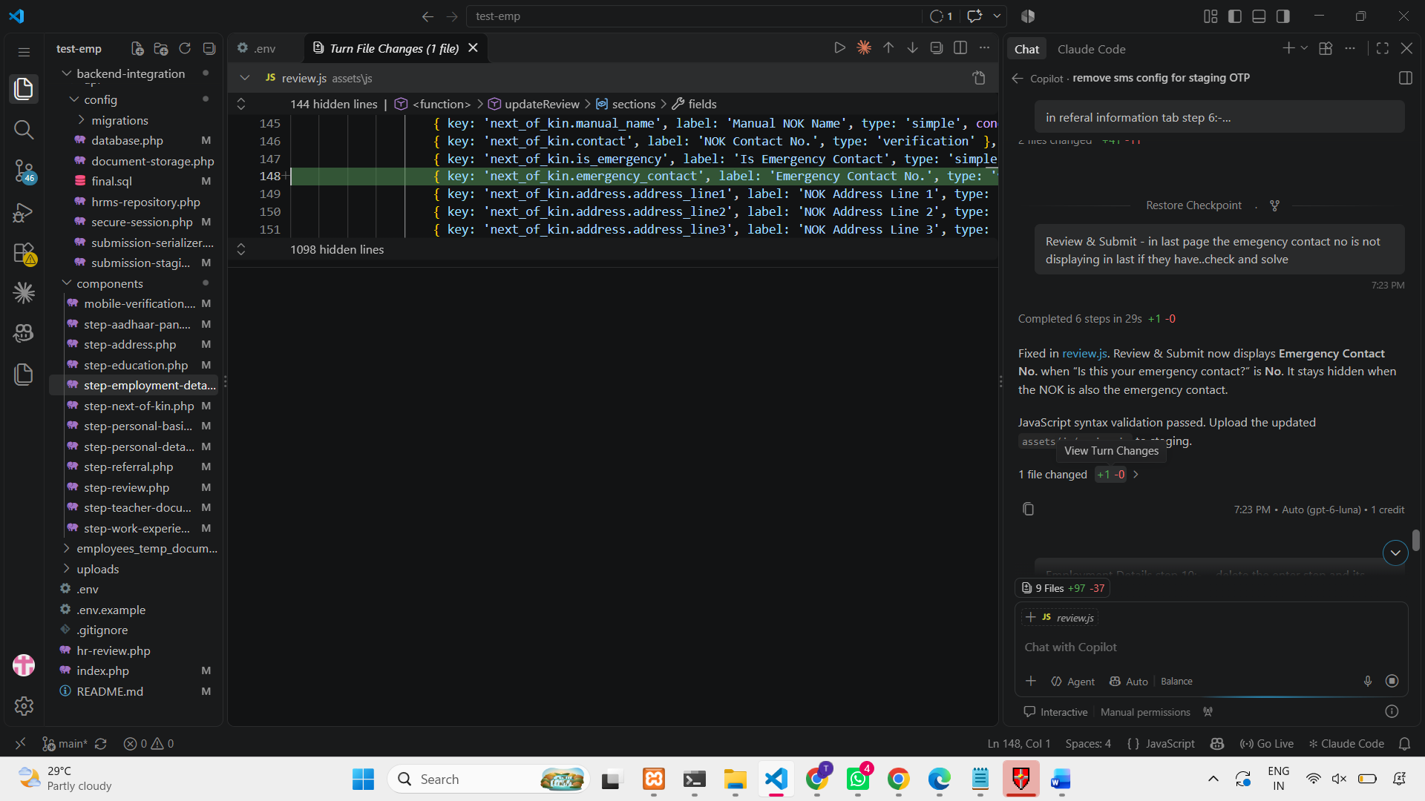

{ key: 'next_of_kin.emergency_contact', label: 'Emergency Contact No.', type: 'verification', condition: (s) => getEffectiveValue(s.next_of_kin?.is_emergency) === 'No' },

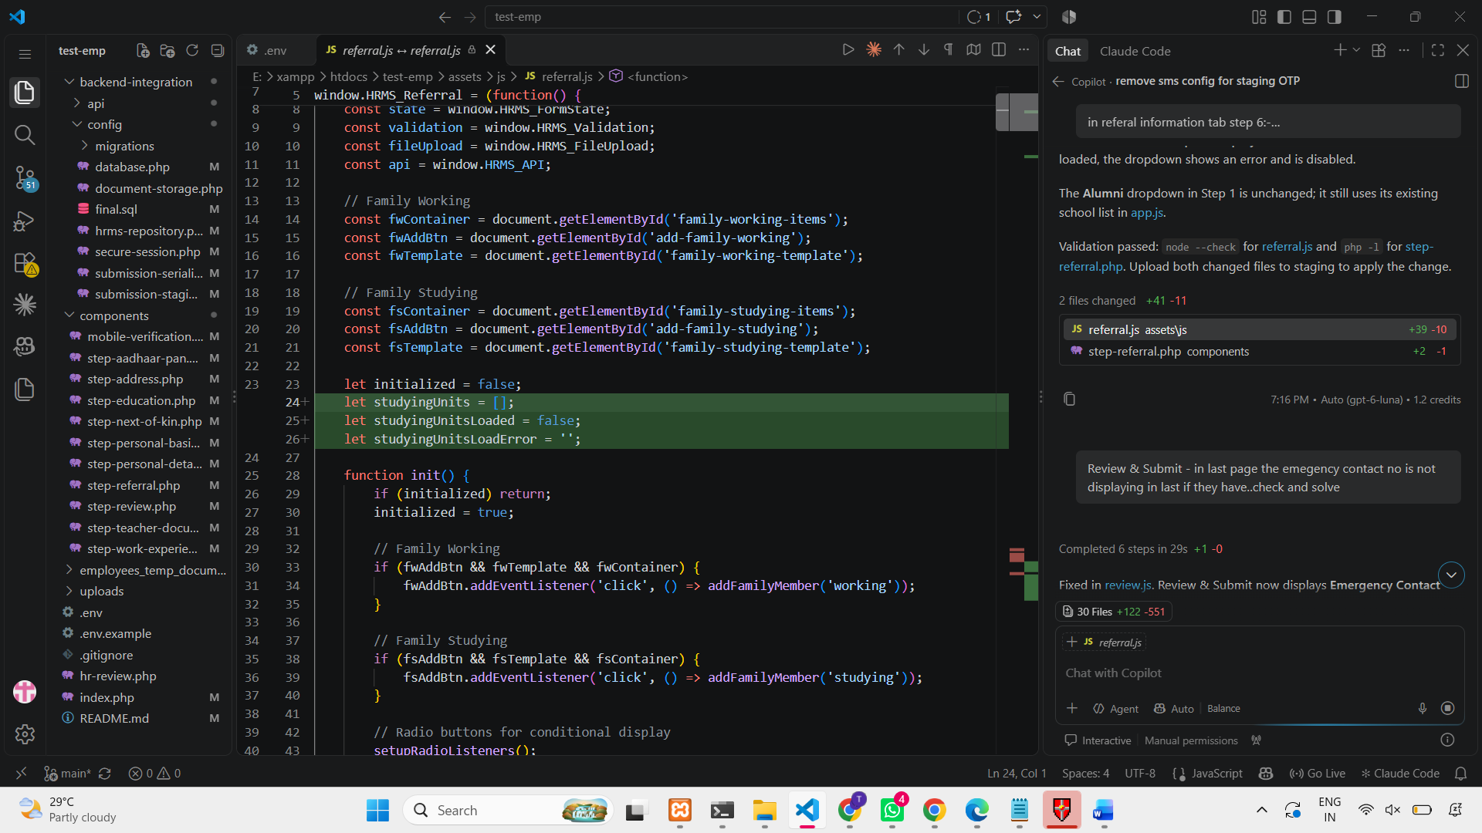
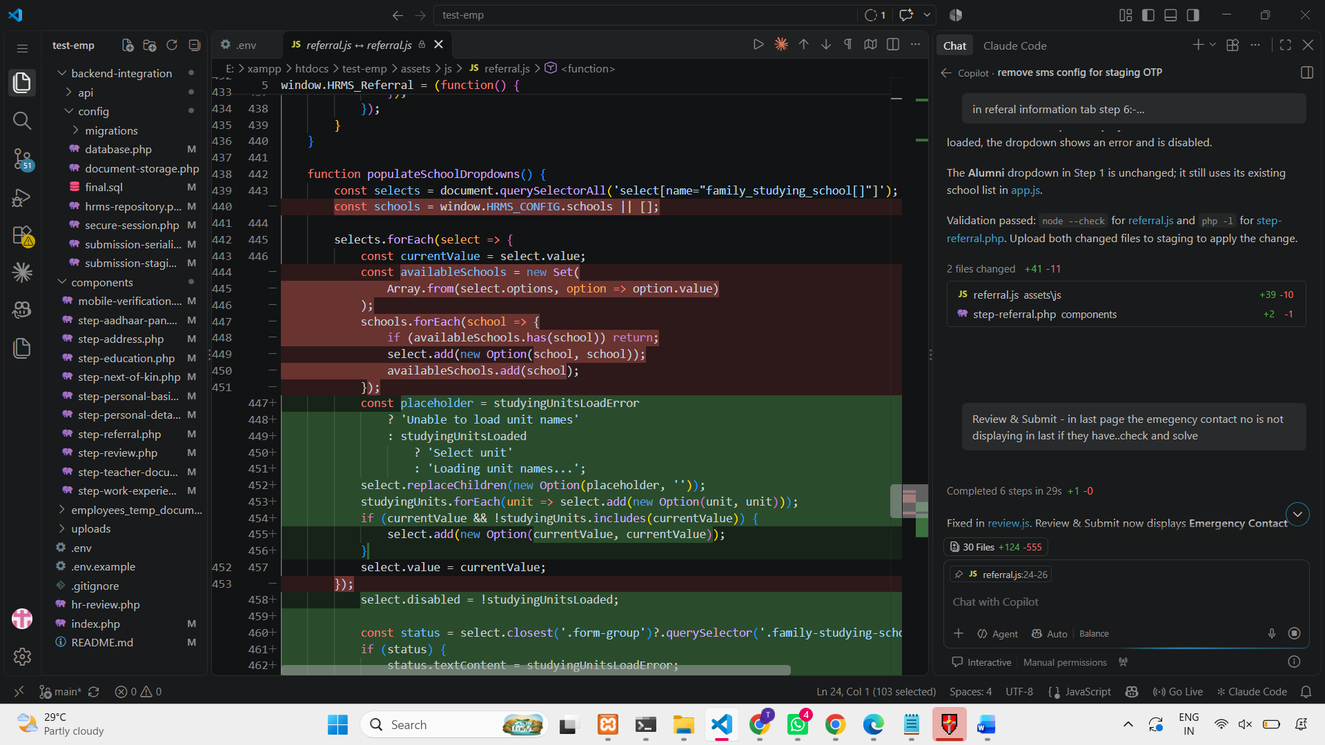

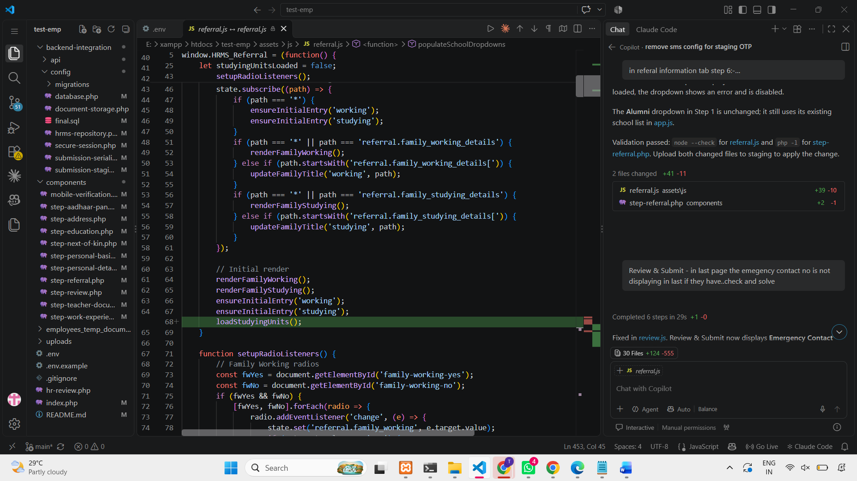
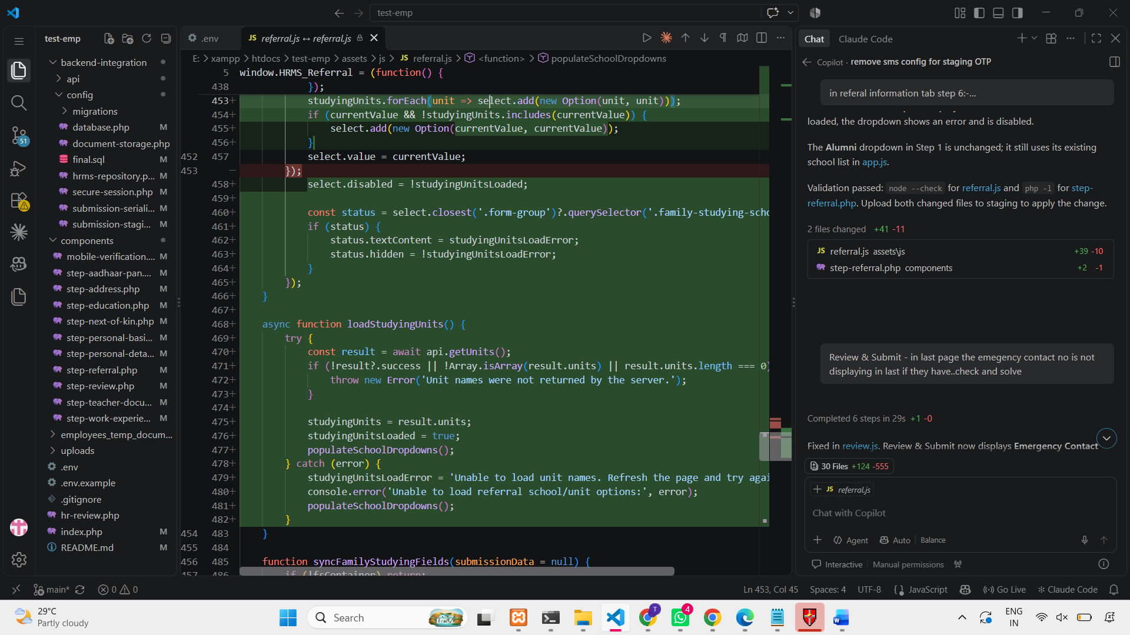

let studyingUnits = [];
let studyingUnitsLoaded = false;
let studyingUnitsLoadError = '';

loadStudyingUnits();

const placeholder = studyingUnitsLoadError
? 'Unable to load unit names'
: studyingUnitsLoaded
? 'Select unit'
: 'Loading unit names...';
select.replaceChildren(new Option(placeholder, ''));
studyingUnits.forEach(unit => select.add(new Option(unit, unit)));
if (currentValue && !studyingUnits.includes(currentValue)) {
select.add(new Option(currentValue, currentValue));
}

select.disabled = !studyingUnitsLoaded;

const status = select.closest('.form-group')?.querySelector('.family-studying-school-status');
if (status) {
status.textContent = studyingUnitsLoadError;
status.hidden = !studyingUnitsLoadError;
}
});
}

async function loadStudyingUnits() {
try {
const result = await api.getUnits();
if (!result?.success || !Array.isArray(result.units) || result.units.length === 0) {
throw new Error('Unit names were not returned by the server.');
}

studyingUnits = result.units;
studyingUnitsLoaded = true;
populateSchoolDropdowns();
} catch (error) {
studyingUnitsLoadError = 'Unable to load unit names. Refresh the page and try again.';
console.error('Unable to load referral school/unit options:', error);
populateSchoolDropdowns();
}

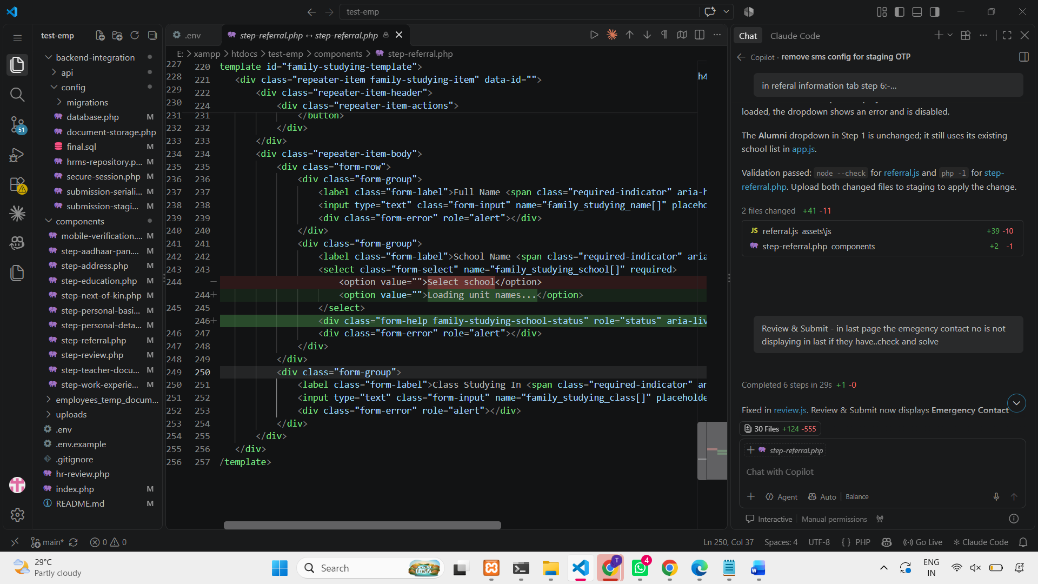

<option value="">Loading unit names...</option>
<div class="form-help family-studying-school-status" role="status" aria-live="polite" hidden></div>

