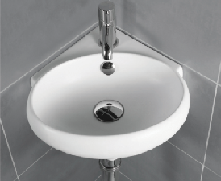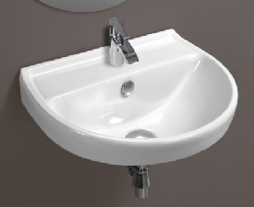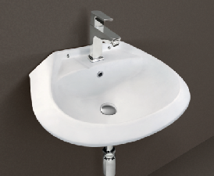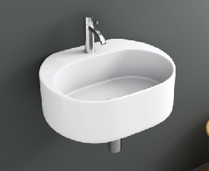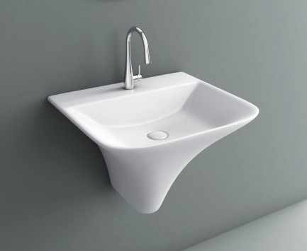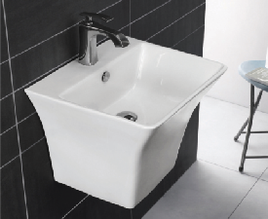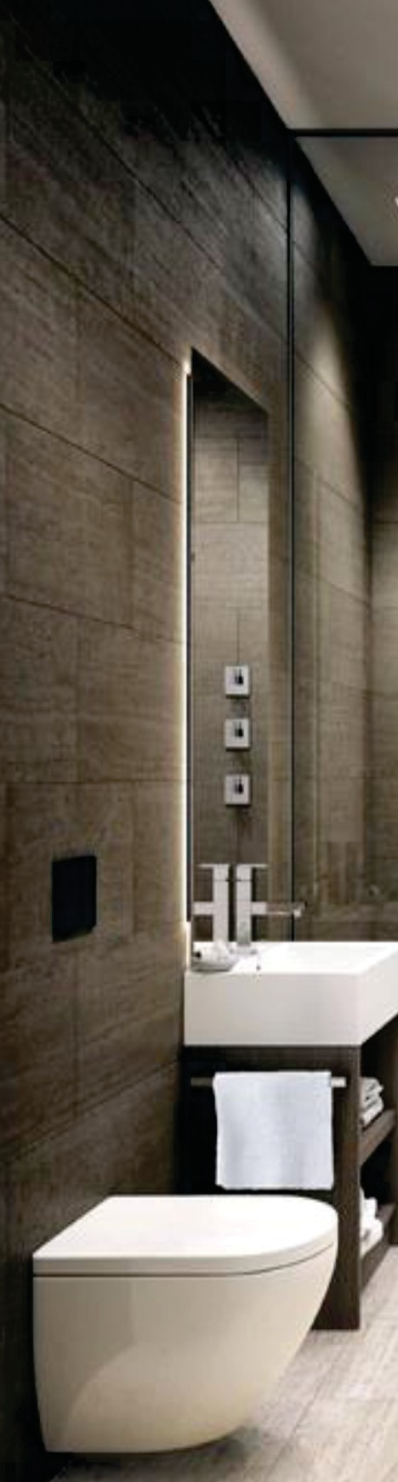

PR EM I UM SA N I TA RYWA R E

SANITA RYWA R E

WALL-HUNG BASIN

MINI

MRP

Basin Table Top / Wall-Hung T 2155/- L4OO W355 H14Omm

Weight: 9 kg.

TRENZ

Basin Wall- Hung L35O W35O H14Omm

Weight: 8.5 kg.

MRP

T 1320/-

NORRIS

Basin Wall-Hung L44O W34O H185mm

Weight: 10 kg.

MRP Cl060/-

SHARP

Basin Wall- Hung L45O W33O H18Omm

Weight: 8.5 kg.

MRP T 855/-

INTEGRATED BASIN

SELGE

Basin Wall Mounted L46O W41O H35Omm

Weight: 21 kg.

MRP

T 7775/-

KUBIX

Basin Wall Mounted L485 W43O H385mm

Weight: 25 kg.

MRP

T 6870/-

PR EM UM SA N TA RYWA R E

PR EM UM SA NI TA RYWA R E

PR EM UM SA NI TA RYWA R E

PR EM UM SA NI TA RYWA R E

## ONE PIECE CLOSET

SANITARYWAR E

%

## WALL MOUNDED COUPLE CLOSET

SANITARYWARE

# WALL-HUNG

SANITARYWARE

## TABLE TOP BASIN

SANITARYWARE

# PAN

LUV

MRP

# SOFIA

MRP

## CUBE

MR^

# OPAL

MRP

## EVA

MRP

# NEON

MRP

## BEETLE PREMIUM

MRP MRP

## PANDORA

Rimless Wall- Hung L57O W36O H Z55mm

Weight: 35 kg.

## SANITEE

7 11630/- Rimless Wall- Hung

L51O WZ6O H360mm

Weight: 26 kg.

MRP

Z 5550/-

Basin Table Top LSSO W37O H15Omm

Weight: 12 kg.

T 4090/- Basin Table Top

LSOO W365 H145mm

Weipht: 11 kp.

I 3285/-

Basin Wall- Hung / Table Top T 2010/- L41O W33O H13Omm

Weight: 11 kg.

One Piece Closet

Rimless with Symphonic L715 W38O H775mm

Weipht: 46 kg.

T 11320/-

One Piece Closet P & S Trap z 8s40/- L715 W4O5 H685mm

Weight: 45 kg.

S Trap - 225mm, P Trap - 18Omm

One Piece Closet S Trap Symphonic

L675 W355 H730mm

Weight: 48 kg.

S Trap - 225mm & 300mm

T 12465/-

Wall Mounted Couple Closet Z 10630/- Wall Mounted Couple Closet Z 7385/- L66O W35O H76Omm L67O W37O H755mm

Weight: 43.5 kg. Weight: 38.5 kg.

# EWC

# EWC

ORISA PAN 20”

CT Pan

L51O W41O H15Omm

Weight: 16.5 kg.

# URINAL

MRP 7 1155/-

## VERO

MRP

## FERN

MRP

Basin Table Top

L6OO W36O H1OOmm

Weight: 13 kg.

T 2875/- Basin Table Top

L6OO W38O H185mm

Weight: 12 kg.

T 3380/-

## BEETLE

MRP

# AMAZONE

MRP

TOP / UNDER COUNTER BASIN

# P TRAP

MRP

Concealed Wall-Hung L535 W345 H36Omm

Weight: 25 kg.

¢ 5120/- Concealed Wall- Hung

L545 W36O H37Omm

Weight: 24 kg.

7 5190/-

## BEETLE

MRP

# NATALIA

MR P

P TRAP - 4 pcs, T 650/— L51O W41O H15Omm

Weight: 10 kg.

## COMFORT

One Piece Closet P & S Trap z sol- L655 W35O H74Omm

Weight: 46.5 kg.

One Piece Closet S Trap Rimless with Symphonic L675 W39O H79Omm

I l5440/—

# OZONE

Concealed EWC S Trap

MRP

## EUROPIE

MRP

Fiat Back Urinal

L28O W3O5 H39Omm

MRP

T 1330/-

S Trap - 1OOmm & 225mm, P Trap 180mm

Weight: 51 kg.

S Trap - 225mm & 300mm

L57O W365 H4O5mm

Weight: 23.5 kg.

T 2010/- EWC P & S Trap

L51O W35O H4OOmm

Weight: 15 kg.

T ló40/-

Weight: 11 kg.

## OPTRA

MRP

## SAFFRONY

MRP

Basin Under Counter L56O W385 H215mm

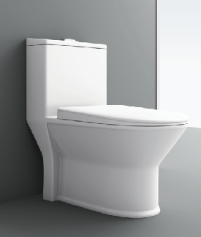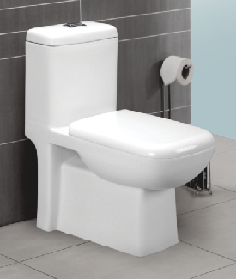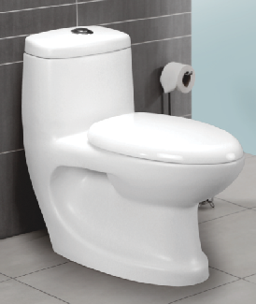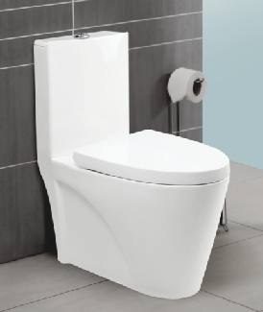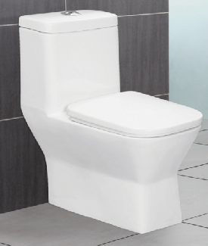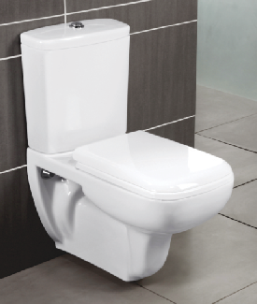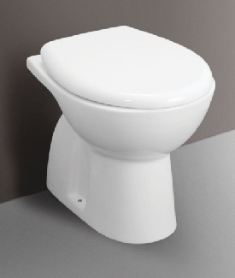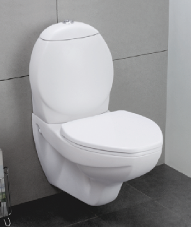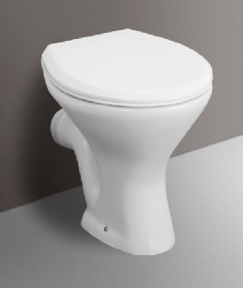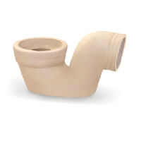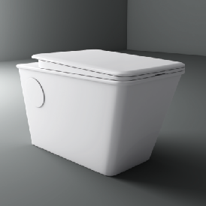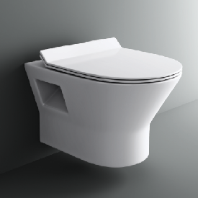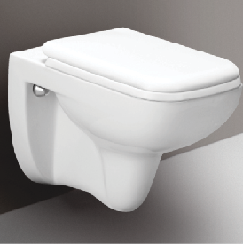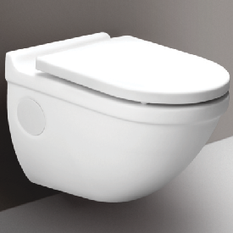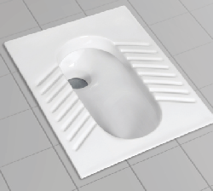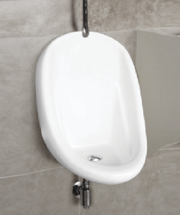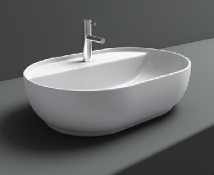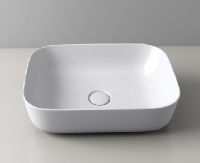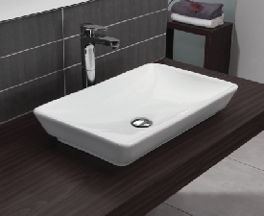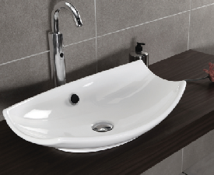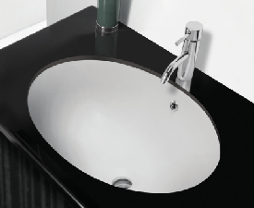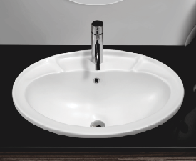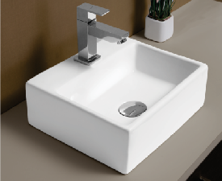

Weight: 14.5 kg.

T 1740/- Basin Counter Top

L595 W42O H215mm

Weight: 16 kg.

T 1740/-