Task – 3

Tharani G

22CSR222

Step 1 : Starting minikubes

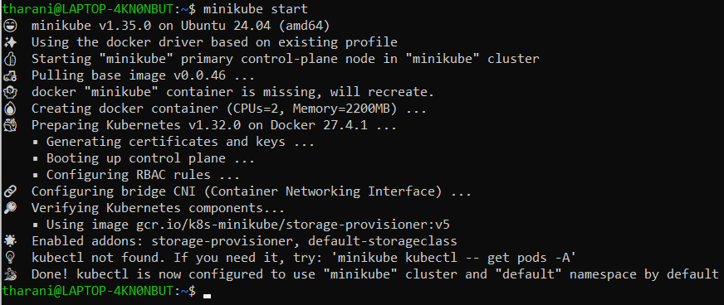

Step 2 : Install kubectl

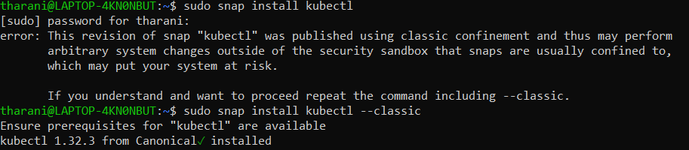

Step :3 create and deploy image

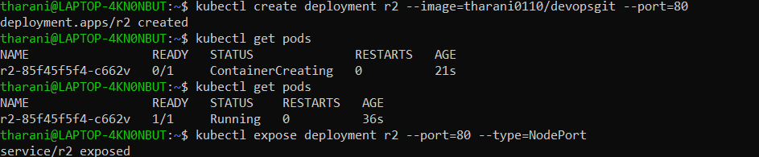

Step 4 :

