Task -5

Step 1: clone the repo

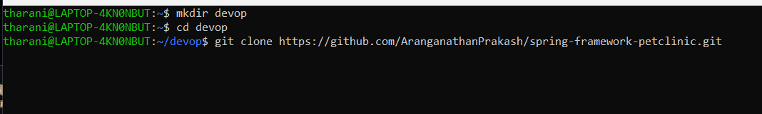

Step 2: go to the directory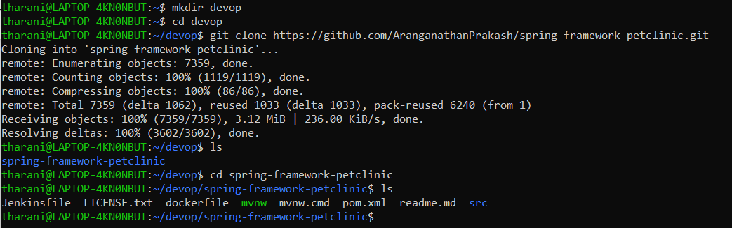

Step 3 :

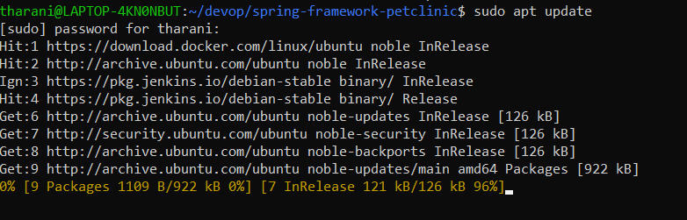

Step 4: install maven

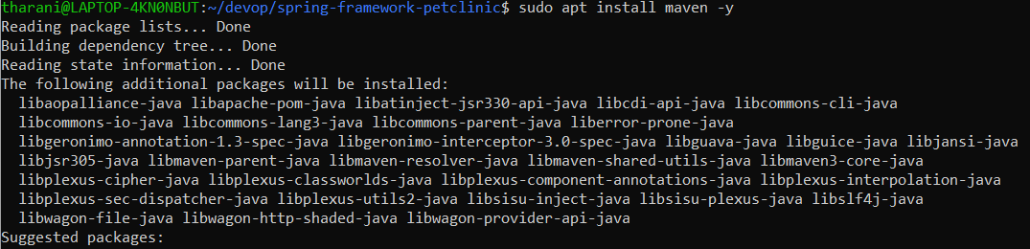

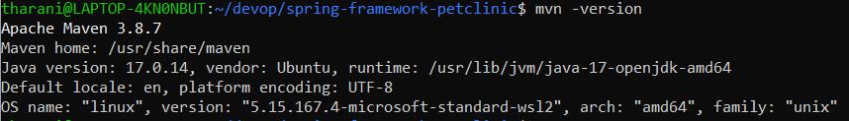

Step 5: Maven test

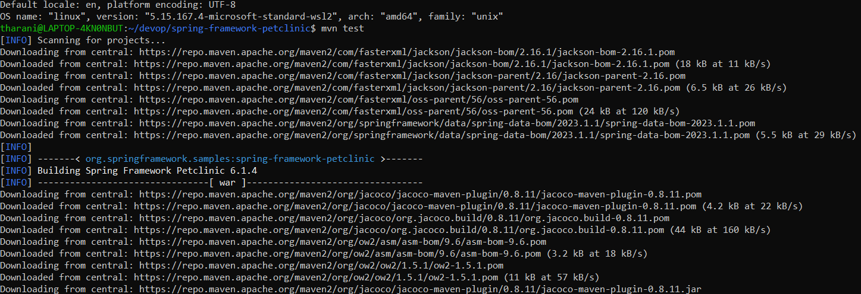

Step 6 : Maven clean

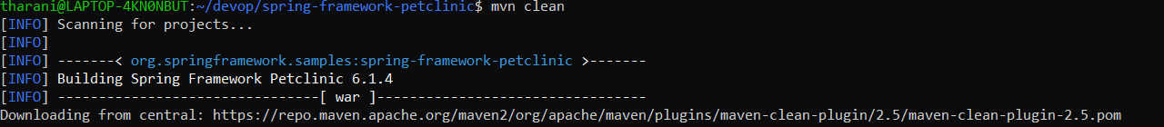

Step 7: Maven install

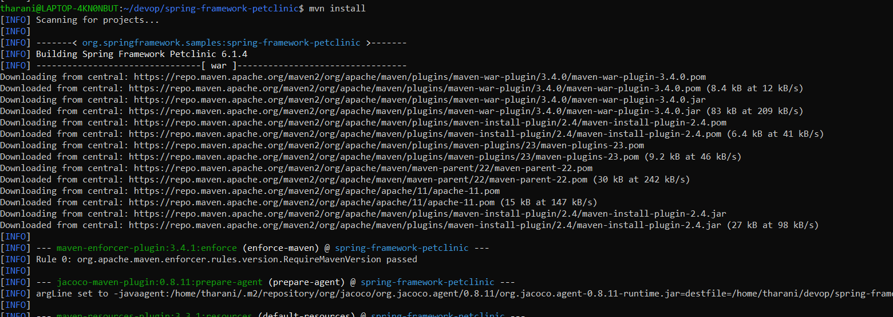

Step 8: Maven package

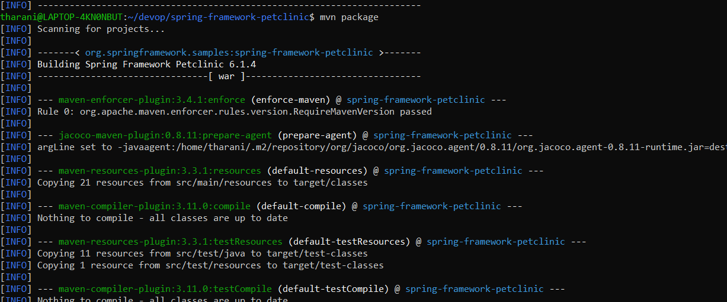

Step 9 :

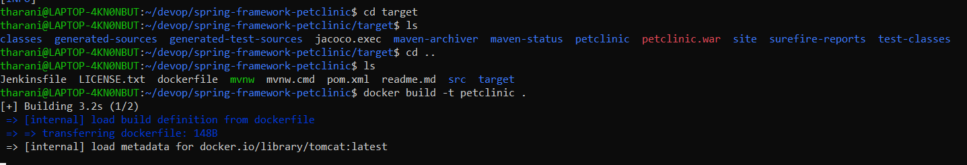

Step 10 :login and push to docker hub

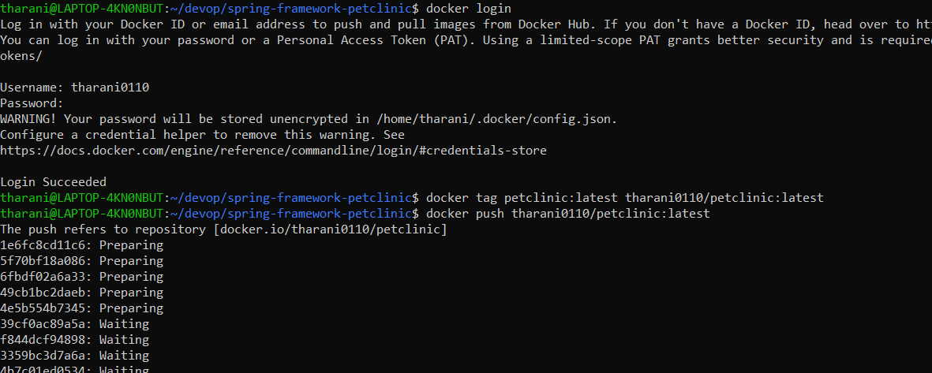

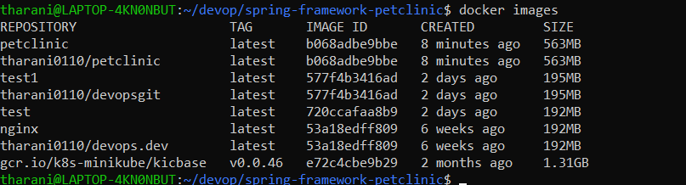

Step 11: start the minikube

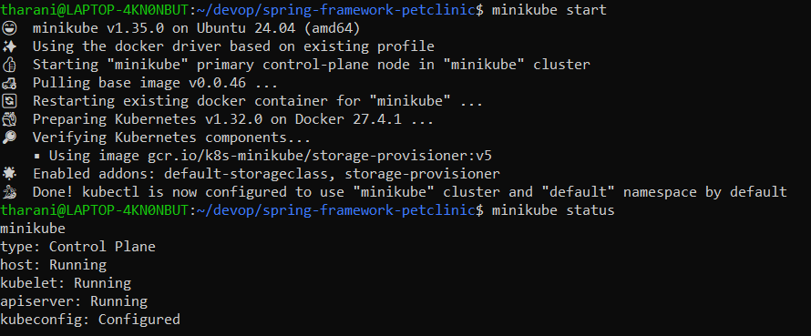

Step 12: deploy the image

