# Fall 2020: CSCI 4/5588 Programming Assignment #2

## Name: Tharani Maaneeivaannan and ID:2575198

### Question-1: Describe each classifier in 5 to 10 sentences and provide an appropriate reference(s).

Classifier-1 SMO/SVM (Support Vector Machine)

SVM is a hyperplane that separates a set of positive examples from a set of negative examples with maximum margin. In the linear case, the margin is defined by the distance of the hyperplane to the nearest of the positive and negative examples.

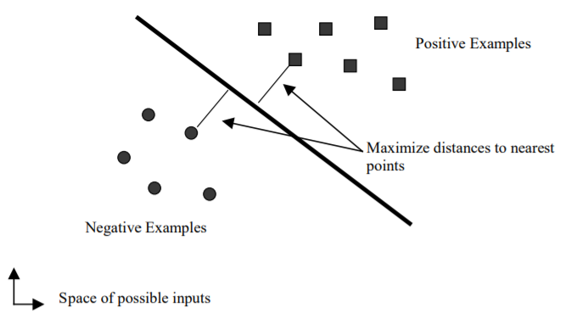

Figure 1 Linear Support Vector Machine

The new SVM learning algorithm is called Sequential Minimal Optimization (or SMO). Instead of previous SVM learning algorithms that use numerical quadratic programming (QP) as an inner loop, SMO uses an analytic QP step. Sequential Minimal Optimization (SMO) is a simple algorithm that can quickly solve the SVM QP problem without any extra matrix storage and without using numerical QP optimization steps at all.

Classifier-2 Lazy IBK

IBK algorithm implements the k-nearest neighbor algorithm. It works by storing the entire training dataset and querying it to locate the k most similar training patterns when making a prediction. As such, there is no model other than the raw training dataset and the only computation performed is the querying of the training dataset when a prediction is requested. An object is classified by a plurality vote of its neighbors, with the object being assigned to the class most common among its k nearest neighbors (k is a positive integer, typically small). If k = 1, then the object is simply assigned to the class of that single nearest neighbor. k-NN is a type of instance-based learning, or lazy learning, where the function is only approximated locally and all computation is deferred until function evaluation. Instance-based learning generates classification predictions using only specific instances. Instance-based learning algorithms do not maintain a set of abstractions derived from specific instances.

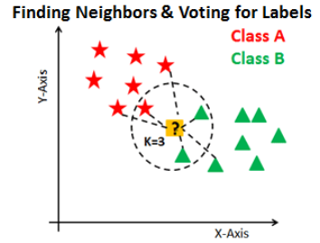

Figure 2 K-NN algorithm

Classifier-3 Naïve Bayes

It is a classification technique based on Bayes Theorem with an assumption of independence among predictors. Naive Bayes classifier assumes that the presence of a particular feature in a class is unrelated to the presence of any other feature. Even if these features depend on each other or upon the existence of the other features, a Naive Bayes classifier would consider all of these properties to independently contribute to the probability. Naive Bayes model is easy to build and particularly useful for very large data sets. Along with simplicity, Naive Bayes is also known to outperform even highly sophisticated classification methods. Naive Bayes is a supervised learning algorithm for classification which will find the class of observation (data point) given the values of features. Naive Bayes classifier calculates the probability of a class given a set of feature values. The algorithm needs to store probability distributions of features for each class independently. The type of distributions depend on the characteristics of features:

For binary features (Y/N, True/False, 0/1): Bernoulli distribution

For discrete features (i.e. word counts): Multinomial distribution

For continuous features: Gaussian (Normal) distribution

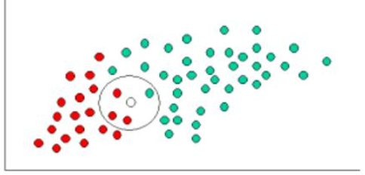

Figure 3 Naive Bayes classifier

Classifier-4 Trees J48

A decision tree be a flowchart-like tree structure, where each internal node represents a test happening an attribute, each branch represents an ending of the test, class label is represented by each leaf node or terminal node. Quinlan's C4.5 algorithm actualizes J48 to create a trimmed C4.5 decision tree. The information is split into minor subsets. The minor subsets are returned by the algorithm. The split strategies stop if a subset has a place with a similar class in all the instances. J48 decision tree can deal with particular characteristics, lost or missing attribute estimations of the data and varying attribute cost.

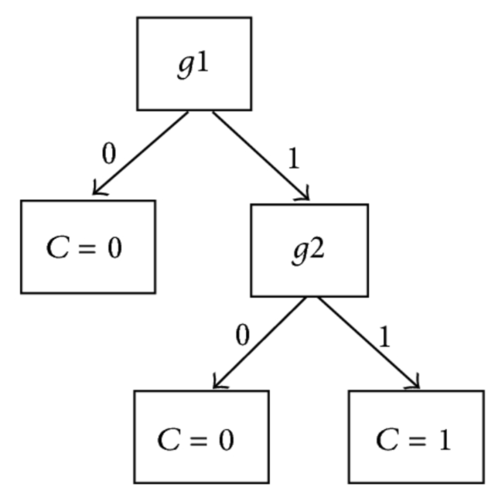

Figure 4 J-48 tree

Classifier-5 Multilayer Perceptron

A multilayer perceptron (MLP) is a class of feedforward artificial neural network (ANN). Except for the input nodes, each node is a neuron that uses a nonlinear activation function. MLP utilizes a supervised learning technique called backpropagation for training. Its multiple layers and non-linear activation distinguish MLP from a linear perceptron. It can distinguish data that is not a linearly separable. The perceptron is an algorithm for supervised learning of binary classifiers. A binary classifier is a function decide whether input belongs to some specific class based on a linear predictor function combining a set of weights with the feature vector.

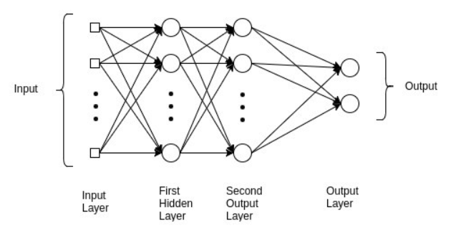

Figure 5 Multilayer Perceptron

### References:

1. <https://www.microsoft.com/en-us/research/wp-content/uploads/2016/02/tr-98-14.pdf>
2. <https://link.springer.com/article/10.1023/A:1022689900470>
3. <https://towardsdatascience.com/naive-bayes-classifier-explained-50f9723571ed>
4. <https://arxiv.org/ftp/arxiv/papers/1302/1302.4964.pdf>
5. <https://link.springer.com/article/10.1007/BF00993309>
6. <https://www.researchgate.net/publication/266396438_A_Gentle_Introduction_to_Backpropagation>

### Question-2: Describe the parameters/hyper-parameters that you have chosen to train the classifiers.

##### SMO

-C 1.0 -L 0.001 -P 1.0E-12 -N 0 -V -1 -W 1 -K

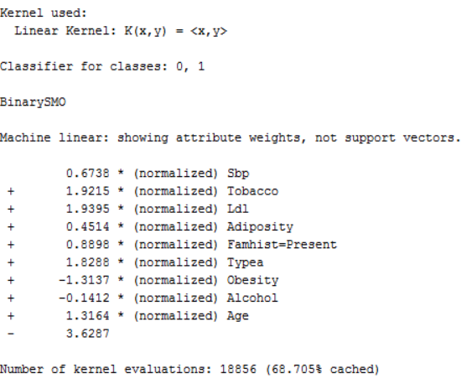

##### Lazy IBK

weka.classifiers.lazy.IBk -K 1 -W 0 -A

##### J-48

weka.classifiers.trees.J48 -C 0.25 -M 2

##### Naïve Bayes

weka.classifiers.bayes.NaiveBayes

##### Multilayer perceptron

weka.classifiers.functions.MultilayerPerceptron -L 0.3 -M 0.2 -N 500 -V 0 -S 0 -E 20 -H a

### Question-3: Define and describe the following terms (provide an appropriate reference(s)) for measuring the performances of a classifier:

True Positive (TP) rate- refers to a situation where predicted as positive are set of positive examples.

False Positive (FP) rate- refers to a situation where predicted as positive but they are set of negative examples.

Precision- Precision is also known as the positive predictive value. Precision is the number of correct positive results divided by the number of positive results predicted by the classifier. Precision is defined as the accuracy of the judgment. 𝑃𝑟𝑒𝑐𝑖𝑠𝑖𝑜𝑛= 𝑇𝑃/(𝑇𝑃+𝐹𝑃)

Recall- Recall is also known as the true positive rate, sensitivity, probability of detection, hit rate. Recall is the ratio of predicted positive data with respect to all positive data. Recall = 𝑇𝑃/(𝑇𝑃+𝐹𝑁)

F-Measure- F-measure combines both precision and recall which is calculated as percentages and combined as harmonic mean to assign a single number. This is also known as F1 score or balanced F-score. 𝐹- measure=2 (𝑝𝑟𝑒𝑐𝑖𝑠𝑖𝑜𝑛 ×𝑟𝑒𝑐𝑎𝑙𝑙)/(𝑝𝑟𝑒𝑐𝑖𝑠𝑖𝑜𝑛+𝑟𝑒𝑐𝑎𝑙𝑙) = (2 𝑇𝑃)/(2𝑇𝑃+𝐹𝑃+𝐹𝑁)

Receiver Operating Characteristic (ROC) Area- ROC curve is a graph showing the TPR (True Positive Rate) and FPR (False Positive Rate) at thresholds. AUC is the area under the curve of the ROC. AUC close to or equal to 1.0 indicates the best performance. Higher the AUC, better the model is at predicting 0s as 0s and 1s as 1s.

Confusion Matrix- A Confusion matrix is an N x N matrix used for evaluating the accuracy of a classification model, where N is the number of target classes. The confusion matrix is as follows:

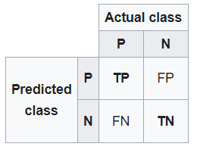

where: P = Positive; N = Negative; TP = True Positive; FP = False Positive; TN = True Negative; FN = False Negative.

### Question-4: Describe the performance of the classifiers in terms of

### Correctly Classified Instances

##### 5-FCV

##### SMO

Correctly Classified Instances 323 69.9134 %

Incorrectly Classified Instances 139 30.0866 %

Kappa statistic 0.3143

Mean absolute error 0.3009

Root mean squared error 0.5485

Relative absolute error 66.4131 %

Root relative squared error 115.2823 %

Total Number of Instances 462

##### Lazy IBk

Correctly Classified Instances 292 63.2035 %

Incorrectly Classified Instances 170 36.7965 %

Kappa statistic 0.1727

Mean absolute error 0.3687

Root mean squared error 0.605

Relative absolute error 81.3815 %

Root relative squared error 127.1487 %

Total Number of Instances 462

##### NaiveBayes

Correctly Classified Instances 325 70.3463 %

Incorrectly Classified Instances 137 29.6537 %

Kappa statistic 0.3592

Mean absolute error 0.3271

Root mean squared error 0.4775

Relative absolute error 72.2014 %

Root relative squared error 100.3666 %

Total Number of Instances 462

##### J48

Correctly Classified Instances 308 66.6667 %

Incorrectly Classified Instances 154 33.3333 %

Kappa statistic 0.2322

Mean absolute error 0.3896

Root mean squared error 0.4977

Relative absolute error 86.0003 %

Root relative squared error 104.6002 %

Total Number of Instances 462

##### Multilayer Perceptron

Correctly Classified Instances 307 66.4502 %

Incorrectly Classified Instances 155 33.5498 %

Kappa statistic 0.2212

Mean absolute error 0.3733

Root mean squared error 0.4994

Relative absolute error 82.4108 %

Root relative squared error 104.9536 %

Total Number of Instances 462

|  |  |  |  |  |  |
| --- | --- | --- | --- | --- | --- |
|  | SMO | Lazy IBK | Naïve Bayes | J48 | Multilayer Perceptron |
| Correctly Classified Instances | 323 | 292 | 325 | 308 | 307 |
| Incorrectly Classified Instances | 139 | 170 | 137 | 154 | 155 |
| Kappa statistic | 0.3143 | 0.1727 | 0.3592 | 0.2322 | 0.2212 |
| Mean absolute error | 0.3009 | 0.3687 | 0.3271 | 0.3896 | 0.3733 |
| Root mean squared error | 0.5485 | 0.605 | 0.4775 | 0.4977 | 0.4994 |
| Relative absolute error | 66.4131 % | 81.3815 % | 72.2014 % | 86.0003 % | 82.4108 % |
| Root relative squared error | 115.2823 % | 127.1487 % | 100.3666 % | 104.6002 % | 104.9536 % |
| Total Number of Instances | 462 | 462 | 462 | 462 | 462 |

##### 10 FCV

##### SMO

Correctly Classified Instances 328 70.9957 %

Incorrectly Classified Instances 134 29.0043 %

Kappa statistic 0.3299

Mean absolute error 0.29

Root mean squared error 0.5386

Relative absolute error 64.028 %

Root relative squared error 113.1898 %

Total Number of Instances 462

##### Lazy IBk

Correctly Classified Instances 292 63.2035 %

Incorrectly Classified Instances 170 36.7965 %

Kappa statistic 0.1652

Mean absolute error 0.3686

Root mean squared error 0.6052

Relative absolute error 81.3691 %

Root relative squared error 127.1864 %

Total Number of Instances 462

##### NaiveBayes

Correctly Classified Instances 331 71.645 %

Incorrectly Classified Instances 131 28.355 %

Kappa statistic 0.3855

Mean absolute error 0.3238

Root mean squared error 0.4725

Relative absolute error 71.4816 %

Root relative squared error 99.3063 %

Total Number of Instances 462

##### J48

Correctly Classified Instances 327 70.7792 %

Incorrectly Classified Instances 135 29.2208 %

Kappa statistic 0.328

Mean absolute error 0.3689

Root mean squared error 0.4733

Relative absolute error 81.4419 %

Root relative squared error 99.4841 %

Total Number of Instances 462

##### Multilayer Perceptron

Correctly Classified Instances 316 68.3983 %

Incorrectly Classified Instances 146 31.6017 %

Kappa statistic 0.2765

Mean absolute error 0.3516

Root mean squared error 0.4749

Relative absolute error 77.6125 %

Root relative squared error 99.8205 %

Total Number of Instances 462

|  |  |  |  |  |  |  |  |  |  |  |  |  |  |  |  |  |  |  |  |  |  |  |  |  |  |  |  |  |  |  |  |  |  |  |  |  |  |  |  |  |  |  |  |  |  |  |  |  |  |  |  |  |  |  |
| --- | --- | --- | --- | --- | --- | --- | --- | --- | --- | --- | --- | --- | --- | --- | --- | --- | --- | --- | --- | --- | --- | --- | --- | --- | --- | --- | --- | --- | --- | --- | --- | --- | --- | --- | --- | --- | --- | --- | --- | --- | --- | --- | --- | --- | --- | --- | --- | --- | --- | --- | --- | --- | --- | --- |
| |  |  |  |  |  |  | | --- | --- | --- | --- | --- | --- | |  | SMO | Lazy IBK | Naïve Bayes | J48 | Multilayer Perceptron | | Correctly Classified Instances | 328 | 292 | 331 | 327 | 316 | | Incorrectly Classified Instances | 134 | 170 | 131 | 135 | 146 | | Kappa statistic | 0.3299 | 0.1652 | 0.3855 | 0.328 | 0.2765 | | Mean absolute error | 0.29 | 0.3686 | 0.3238 | 0.3689 | 0.3516 | | Root mean squared error | 0.5386 | 0.6052 | 0.4725 | 0.4733 | 0.4749 | | Relative absolute error | 64.028 % | 81.3691 % | 71.4816 % | 81.4419 % | 77.6125 % | | Root relative squared error | 113.1898 % | 127.1864 % | 99.3063 % | 99.4841 % | 99.8205 % | | Total Number of Instances | 462 | 462 | 462 | 462 | 462 | |

##### SMO

##### 5-FCV

|  |  |  |  |  |  |  |  |  |  |
| --- | --- | --- | --- | --- | --- | --- | --- | --- | --- |
|  | TP Rate | FP Rate | Precision | Recall | F-Measure | MCC | ROC Area | PRC Area | Class |
|  | 0.805 | 0.500 | 0.752 | 0.805 | 0.778 | 0.316 | 0.652 | 0.733 | 0 |
|  | 0.500 | 0.195 | 0.576 | 0.500 | 0.535 | 0.316 | 0.652 | 0.461 | 1 |
| Weighted avg. | 0.699 | 0.394 | 0.691 | 0.699 | 0.694 | 0.316 | 0.652 | 0.639 |  |

##### 10-FCV

|  |  |  |  |  |  |  |  |  |  |
| --- | --- | --- | --- | --- | --- | --- | --- | --- | --- |
|  | TP Rate | FP Rate | Precision | Recall | F-Measure | MCC | ROC Area | PRC Area | Class |
|  | 0.828 | 0.513 | 0.753 | 0.828 | 0.789 | 0.334 | 0.658 | 0.736 | 0 |
|  | 0.488 | 0.172 | 0.600 | 0.488 | 0.538 | 0.334 | 0.658 | 0.470 | 1 |
| Weighted avg. | 0.710 | 0.395 | 0.700 | 0.710 | 0.702 | 0.334 | 0.658 | 0.644 |  |

##### Lazy IBK

##### 5-FCV

|  |  |  |  |  |  |  |  |  |  |
| --- | --- | --- | --- | --- | --- | --- | --- | --- | --- |
|  | TP Rate | FP Rate | Precision | Recall | F-Measure | MCC | ROC Area | PRC Area | Class |
|  | 0.738 | 0.569 | 0.710 | 0.738 | 0.724 | 0.173 | 0.590 | 0.701 | 0 |
|  | 0.431 | 0.262 | 0.466 | 0.431 | 0.448 | 0.173 | 0.590 | 0.412 | 1 |
| Weighted avg. | 0.632 | 0.462 | 0.626 | 0.632 | 0.628 | 0.173 | 0.590 | 0.601 |  |

##### 10-FCV

|  |  |  |  |  |  |  |  |  |  |
| --- | --- | --- | --- | --- | --- | --- | --- | --- | --- |
|  | TP Rate | FP Rate | Precision | Recall | F-Measure | MCC | ROC Area | PRC Area | Class |
|  | 0.748 | 0.588 | 0.706 | 0.748 | 0.727 | 0.166 | 0.587 | 0.698 | 0 |
|  | 0.413 | 0.252 | 0.465 | 0.413 | 0.437 | 0.166 | 0.587 | 0.409 | 1 |
| Weighted avg. | 0.632 | 0.471 | 0.623 | 0.632 | 0.626 | 0.166 | 0.587 | 0.598 |  |

##### Naïve Bayes

##### 5-FCV

|  |  |  |  |  |  |  |  |  |  |
| --- | --- | --- | --- | --- | --- | --- | --- | --- | --- |
|  | TP Rate | FP Rate | Precision | Recall | F-Measure | MCC | ROC Area | PRC Area | Class |
|  | 0.748 | 0.381 | 0.787 | 0.748 | 0.767 | 0.360 | 0.745 | 0.842 | 0 |
|  | 0.619 | 0.252 | 0.566 | 0.619 | 0.591 | 0.360 | 0.745 | 0.567 | 1 |
| Weighted avg. | 0.703 | 0.336 | 0.711 | 0.703 | 0.706 | 0.360 | 0.745 | 0.747 |  |

##### 10-FCV

|  |  |  |  |  |  |  |  |  |  |
| --- | --- | --- | --- | --- | --- | --- | --- | --- | --- |
|  | TP Rate | FP Rate | Precision | Recall | F-Measure | MCC | ROC Area | PRC Area | Class |
|  | 0.762 | 0.369 | 0.796 | 0.762 | 0.778 | 0.386 | 0.749 | 0.843 | 0 |
|  | 0.631 | 0.238 | 0.584 | 0.631 | 0.607 | 0.386 | 0.749 | 0.580 | 1 |
| Weighted avg. | 0.716 | 0.324 | 0.722 | 0.716 | 0.719 | 0.386 | 0.749 | 0.752 |  |

##### J-48

##### 5-FCV

|  |  |  |  |  |  |  |  |  |  |
| --- | --- | --- | --- | --- | --- | --- | --- | --- | --- |
|  | TP Rate | FP Rate | Precision | Recall | F-Measure | MCC | ROC Area | PRC Area | Class |
|  | 0.791 | 0.569 | 0.724 | 0.791 | 0.756 | 0.234 | 0.647 | 0.742 | 0 |
|  | 0.431 | 0.209 | 0.523 | 0.431 | 0.473 | 0.234 | 0.647 | 0.450 | 1 |
| Weighted avg. | 0.667 | 0.444 | 0.654 | 0.667 | 0.658 | 0.234 | 0.647 | 0.64 |  |

##### 10-FCV

|  |  |  |  |  |  |  |  |  |  |
| --- | --- | --- | --- | --- | --- | --- | --- | --- | --- |
|  | TP Rate | FP Rate | Precision | Recall | F-Measure | MCC | ROC Area | PRC Area | Class |
|  | 0.821 | 0.506 | 0.754 | 0.821 | 0.786 | 0.331 | 0.667 | 0.754 | 0 |
|  | 0.494 | 0.179 | 0.594 | 0.494 | 0.539 | 0.331 | 0.667 | 0.481 | 1 |
| Weighted avg. | 0.708 | 0.393 | 0.698 | 0.708 | 0.701 | 0.331 | 0.667 | 0.660 |  |

##### Multilayer Perceptron

##### 5-FCV

|  |  |  |  |  |  |  |  |  |  |
| --- | --- | --- | --- | --- | --- | --- | --- | --- | --- |
|  | TP Rate | FP Rate | Precision | Recall | F-Measure | MCC | ROC Area | PRC Area | Class |
|  | 0.798 | 0.588 | 0.719 | 0.798 | 0.757 | 0.224 | 0.657 | 0.787 | 0 |
|  | 0.413 | 0.202 | 0.520 | 0.413 | 0.460 | 0.224 | 0.657 | 0.488 | 1 |
| Weighted avg. | 0.665 | 0.453 | 0.650 | 0.665 | 0.654 | 0.224 | 0.657 | 0.684 |  |

##### 10-FCV

|  |  |  |  |  |  |  |  |  |  |
| --- | --- | --- | --- | --- | --- | --- | --- | --- | --- |
|  | TP Rate | FP Rate | Precision | Recall | F-Measure | MCC | ROC Area | PRC Area | Class |
|  | 0.798 | 0.531 | 0.739 | 0.798 | 0.768 | 0.278 | 0.706 | 0.808 | 0 |
|  | 0.469 | 0.202 | 0.551 | 0.469 | 0.507 | 0.278 | 0.706 | 0.546 | 1 |
| Weighted avg. | 0.684 | 0.417 | 0.674 | 0.684 | 0.677 | 0.278 | 0.706 | 0.717 |  |

##### Confusion Matrix

##### SMO

##### 5-FCV

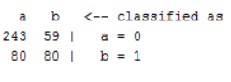

##### 10-FCV

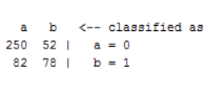

##### Lazy IBK

##### 5-FCV

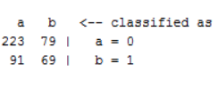

##### 10-FCV

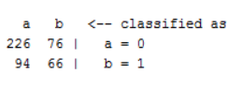

##### Naïve Bayes

##### 5-FCV

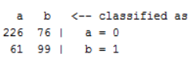

##### 10-FCV

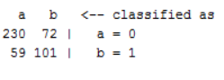

##### J-48

##### 5-FCV

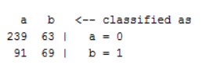

##### 10-FCV

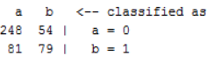

##### Multilayer perceptron

##### 5-FCV

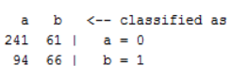

##### 10-FCV



 