# “Fall 2020: CSCI 4/5588 Programming Assignment #3”

# Name: Tharani Maaneeivaannan and ID:2575198

# Graphs for each ANN

## ANN with 1 hidden layer

L=[256 65 10]

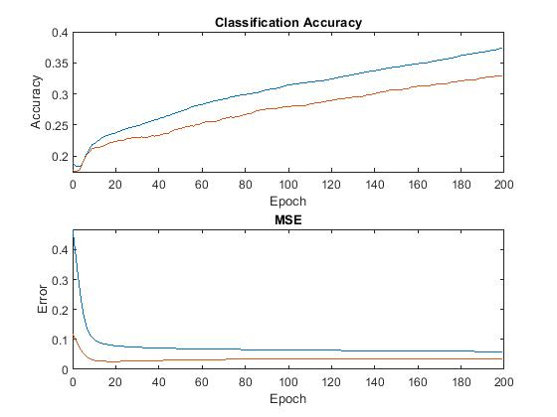

## ANN with 2 hidden layers

L=[256 66 86 10]

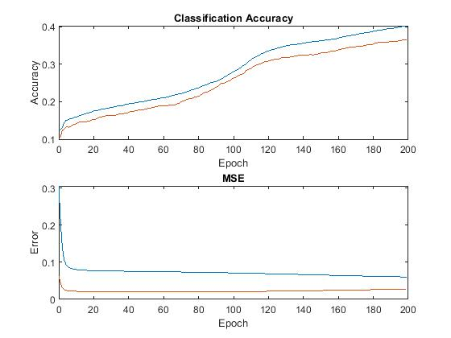

## ANN with 5 hidden layers

L=[256 66 76 86 96 72 10]

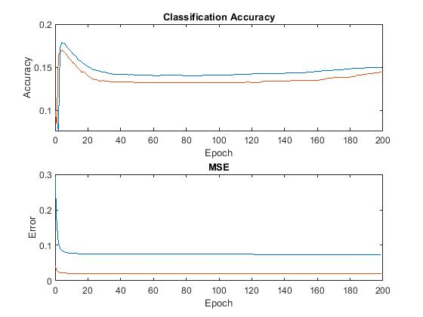

## ANN with 10 hidden layers

L=[256 65 68 74 75 79 81 85 87 91 96 10]

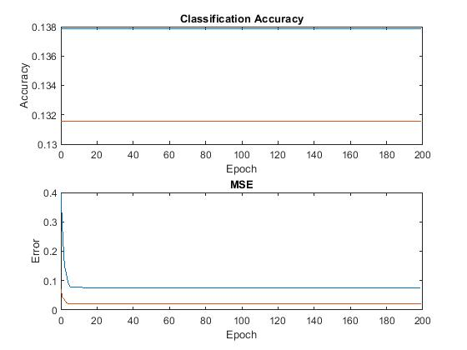

## Table showing minimum training and test-error (i.e., MSE) collected from each of the ANNs, running at least 2000 epochs

|  |  |  |  |  |
| --- | --- | --- | --- | --- |
|  | ANN-01 | ANN-02 | ANN-05 | ANN-10 |
| Minimum training error | 0.0165 | 0.0178 | 0.0278 | 0.064 |
| Minimum training error epoch | 1999 | 1999 | 1999 | 1999 |
| Minimum testing error | 0.0217 | 0.021 | 0.0205 | 0.0205 |
| Minimum testing error epoch | 35 | 75 | 67 | 326 |