**PROJECT REPORT**

**PROJECT TITLE : UNVEILING MARKETING INSIGHTS**

**INTRODUCTION :**

**Market analysis is a detailed assessment of your business’s target market and the competitive landscape within a specific industry. This analysis lets you project the success you can expect when you introduce your brand and its products to consumers within the market. Market analysis includes quantitative data such as the actual size of the market you want to serve, prices consumers are willing to pay, revenue projections, and qualitative data such as consumers’ values, desires, and buying motives.**

**Emphathy Mapping :**

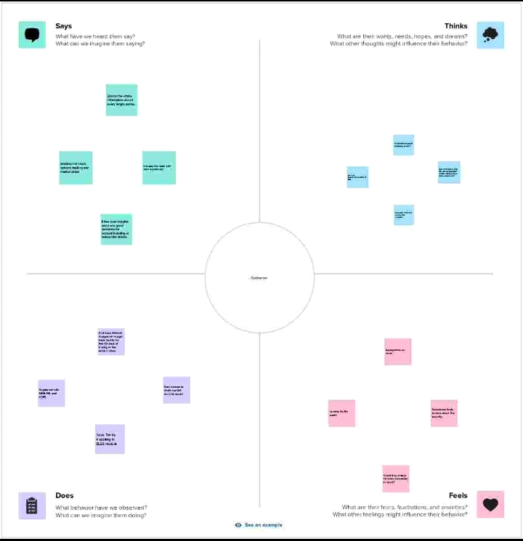

**Brainstorm and idea prioritization :**

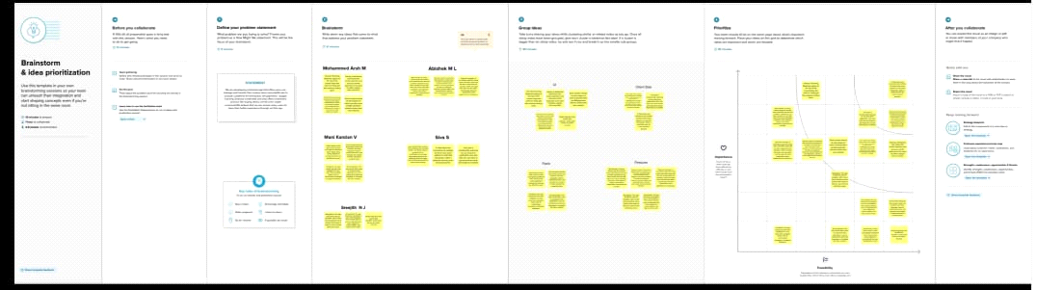

**Dashboard:**

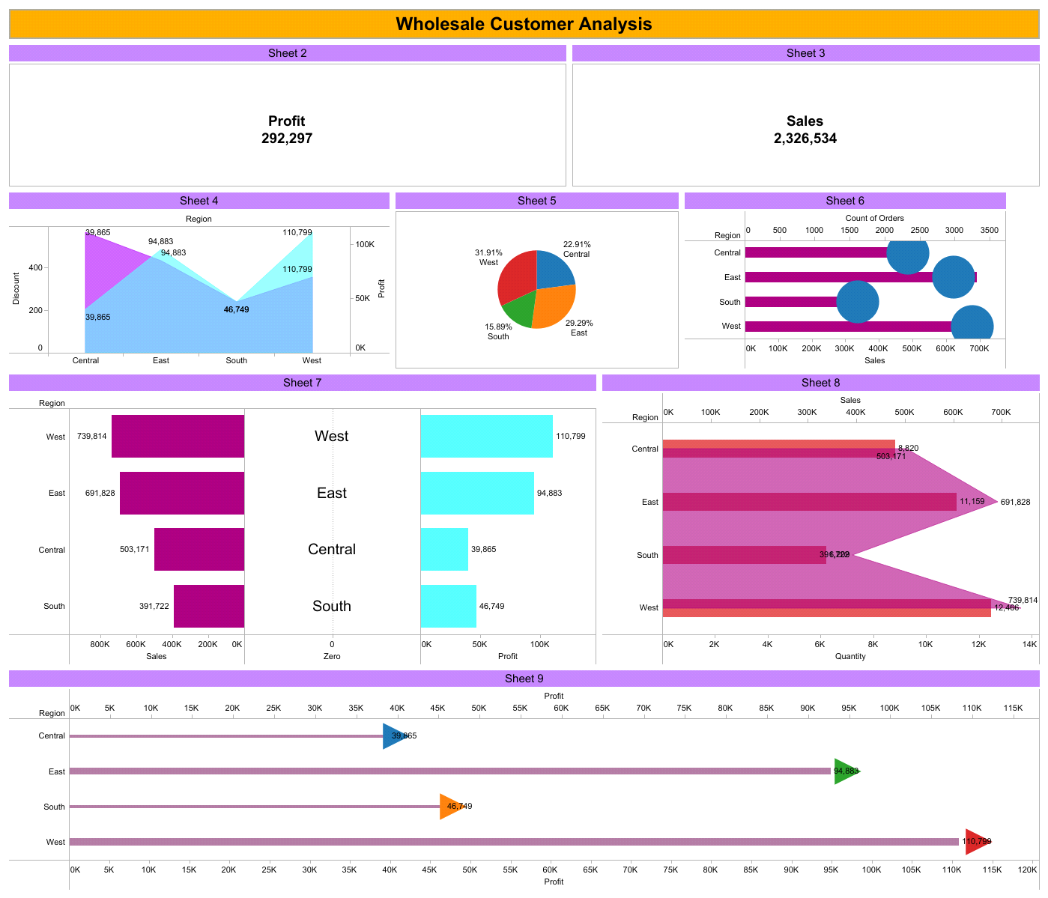

**Advantages and Disadvantages:**

**Advantages:**

**Understanding consumer behavior.**

**Making informed decisions.**

**Integrating marketing data for comprehensive analysis.**

**Enhancing brand awareness.**

**Staying ahead of competition.**

**Application of marketing analytics with examples.**

**Marketing analytics skills.**

**Disadvantages:**

**There is a lot of competition.**

**Working overtime is sometimes necessary.**

**You may have to cope with tense deadlines.**

**Scope:**

**Market Analysis is a broad topic that includes the worlds of market research and strategic analysis. Understanding our competitors, markets, and how customers perceive our products is fundamental to market analysis.**

**Conclusion:**

**The marketing concept is he philosophy where each and every firms should analyze the needs of their cusomers and makes good decision in oder to satisfy their needs. This also can enhance a good relationship between the customers.**