By: Dhiraj Thareja

Course: Algorithmic Trading in Python

Assignment: Homework 3

I am testing our strategies on Tesla (TSLA) for the date range of January 1, 2020 until June 1, 2021. I will be using the simple moving average (SMA) crossover strategy. For this date range we do not know which long and short combination is good. Your return and risk can vary greatly by using different long and short days. The moving average can change based on the number of days you test. I will be testing SMA Short values of 20-40 and I will be testing SMA Long values from 150-250. So I will be testing each short and long combo by using 2 nested for loops in Python. I created two heatmaps, one to show CAGR and another to show Daily Sharpe.

CAGR shows which combos have the better return. As you can see below 31 or 32 for short and 150 for long comes out with the best CAGR.

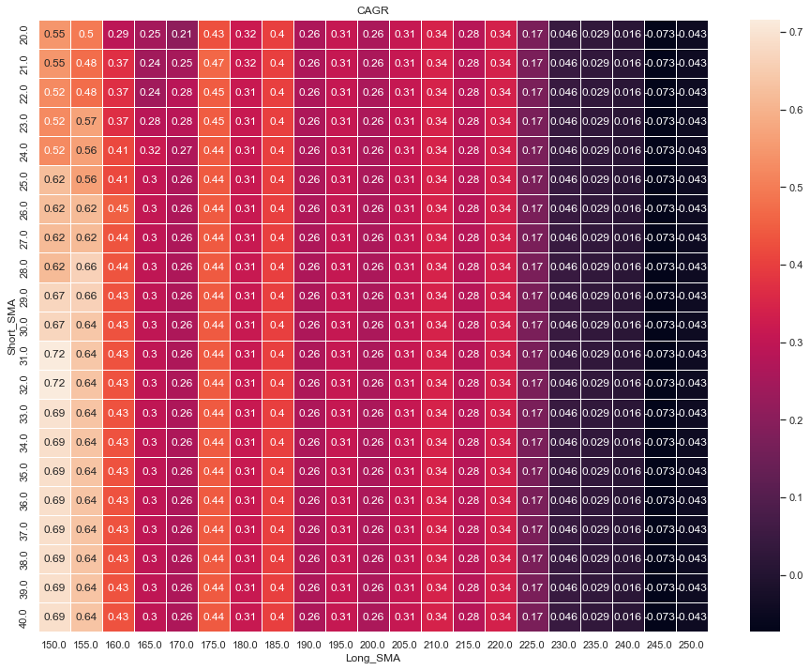

Daily Sharpe shows which combos have the better return and less risk. As you can see below 31 or 32 for short and 150 for long comes out with the best Daily Sharpe value. What’s interesting is that both the CAGR & Daily Sharpe are best at the same long & short combo

Next my script finds the index in the date frame of the best CAGR combo and best Daily Sharpe combo for long and short. So I decided to plot their equity progression with a benchmark of just buy and holding Tesla for the same time period.

I couldn’t see the different between the Best CAGR & Best Daily Sharpe strategies. So I plotted them separately as well in the script. You can see the graphs below. And they are exactly the same. The interesting part is that the buy and hold strategy performs better. And I double checked this on another asset as well. I tried on Google. And it was the same result. Buy and holding definitely yielded the better result.

