**Experiment Title: Develop a personal portfolio webpage using basic HTML and CSS**

**Aim:**

To design and develop a **personal portfolio webpage** using basic HTML and CSS showcasing personal details, education, skills, projects, and contact information.

**Tools Required:**

* Web browser (Chrome/Firefox)
* Text editor (VS Code/Notepad++)
* GitHub (optional for hosting)

**Procedure:**

1. Create a folder named portfolio.
2. Inside the folder, create two files:
   * index.html
   * style.css
3. Write the basic structure of an HTML document in index.html.
4. Link the CSS file inside the HTML using the <link> tag.
5. Add sections to the HTML file:
   * Header (Name, Title)
   * About Me
   * Education
   * Skills
   * Projects
   * Contact
6. Style the webpage using style.css with selectors for each section.
7. Save and run the HTML file in a browser.
8. Verify that all sections are styled properly and display expected content.

**Source Code:**

***index.html:***

<!DOCTYPE html>

<html lang="en">

<head>

<meta charset="UTF-8">

<title>Udayakumar P | Portfolio</title>

<link rel="stylesheet" href="style.css">

</head>

<body>

<header>

<h1>Udayakumar P</h1>

<p>PhD Research Scholar | AI in Neuroimaging</p>

</header>

<section id="about">

<h2>About Me</h2>

<p>I am a PhD scholar at VIT, working on brain connectome mapping using deep learning. I specialize in AI, neuroimaging, and graph-based modeling.</p>

</section>

<section id="education">

<h2>Education</h2>

<ul>

<li>PhD in Computer Science and Engineering, VIT</li>

<li>M.E. in Computer Science, Anna University</li>

<li>B.E. in Computer Science, Anna University</li>

</ul>

</section>

<section id="skills">

<h2>Skills</h2>

<ul>

<li>Python, MATLAB, R</li>

<li>TensorFlow, PyTorch</li>

<li>Git, HTML, CSS</li>

<li>FSL, FreeSurfer, SPM12, ANTs</li>

</ul>

</section>

<section id="projects">

<h2>Projects</h2>

<ul>

<li>Connectome-based Schizophrenia Prediction using GNN</li>

<li>Multimodal Brain Classification with Graph Attention Network</li>

<li>fMRI Functional Connectivity Matrix Generator</li>

</ul>

</section>

<section id="contact">

<h2>Contact</h2>

<p>Email: udaya@example.com</p>

<p>LinkedIn: <a href="https://linkedin.com/in/udayakumar-palanivelu-934bb941">Profile</a></p>

<p>GitHub: <a href="https://github.com/udayameister">Profile</a></p>

</section>

<footer>

<p>&copy; 2025 Udayakumar P. All rights reserved.</p>

</footer>

</body>

</html>

***style.css:***

body {

font-family: Arial, sans-serif;

margin: 0;

background-color: #f2f2f2;

color: #333;

}

header {

background-color: #007acc;

color: white;

padding: 30px;

text-align: center;

}

section {

padding: 20px;

background-color: white;

margin: 20px;

border-radius: 10px;

box-shadow: 0 2px 5px rgba(0,0,0,0.1);

}

h2 {

color: #007acc;

}

ul {

list-style: square;

padding-left: 20px;

}

footer {

background-color: #333;

color: white;

text-align: center;

padding: 10px;

}

**Expected Output:**

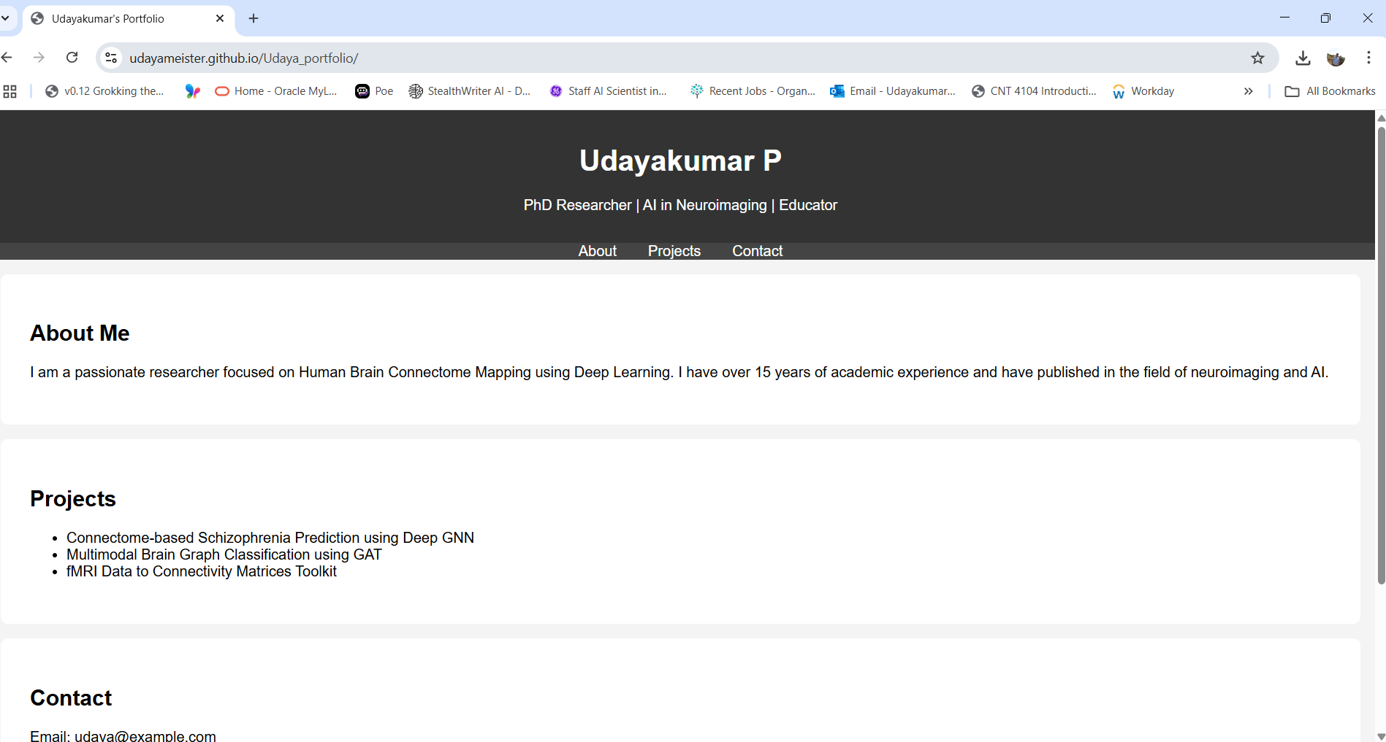

**Result:**

The personal portfolio webpage was successfully created using basic HTML and CSS. The webpage is structured, readable, and displays the required sections such as About, Education, Skills, Projects, and Contact.

<!DOCTYPE html>

<html lang="en">

<head>

<meta charset="UTF-8">

<meta name="viewport" content="width=device-width, initial-scale=1.0">

<title>Durga Prasad Papugani | Portfolio</title>

<link rel="stylesheet" href="styles.css">

</head>

<body>

<header>

<h1>Durga Prasad Papugani</h1>

<p>Machine Learning & Web Development Enthusiast</p>

</header>

<section id="about">

<h2>About Me</h2>

<p>I am passionate about Machine Learning, Web Development, and AI applications. I have experience building ML models, creating interactive web apps, and integrating AI solutions into real-world projects.</p>

</section>

<section id="education">

<h2>Education</h2>

<ul>

<li>B.Tech in Computer Science (Ongoing)</li>

<li>Specialized courses in Machine Learning, Web Development, and Cybersecurity</li>

</ul>

</section>

<section id="skills">

<h2>Skills</h2>

<ul>

<li>Python</li>

<li>HTML & CSS</li>

<li>JavaScript</li>

<li>Java</li>

<li>Machine Learning</li>

<li>Flask</li>

<li>Streamlit</li>

<li>Git</li>

</ul>

</section>

<section id="projects">

<h2>Projects</h2>

<ul>

<li>Employee Salary Prediction App</li>

<li>Garment Worker Productivity Prediction</li>

<li>Weather Dashboard Web App</li>

</ul>

</section>

<section id="contact">

<h2>Contact</h2>

<p>Email: durgaprasad@example.com</p>

<p>LinkedIn: <a href="https://linkedin.com/in/durgaprasad">Profile</a></p>

<p>GitHub: <a href="https://github.com/durgaprasad">Profile</a></p>

</section>

<footer>

<p>&copy; 2025 Durga Prasad Papugani. All rights reserved.</p>

</footer>

</body>

</html>

/* style.css - simple and easy to remember */

body {

font-family: sans-serif;

margin: 0;

padding: 0;

background: #ffdbac ;

}

header {

background: #39FF14;

color: black;

text-align: center;

padding: 15px;

}

section {

background: #fff;

margin: 15px;

padding: 15px;

border-radius: 5px;

}

h1, h2 {

color: red;

}

ul {

padding-left: 20px;

}

footer {

background: #333;

color: #fff;

text-align: center;

padding: 10px;

}