Experiment2: Initialize a Git repository and push a static web project to GitHub

**Aim**

To learn how to initialize a Git repository locally, connect it to a GitHub repository, and push a static web project (containing HTML, CSS, and JS files) to GitHub. Optionally, host the website using GitHub Pages.

**Tools Required**

* Git (Installed from <https://git-scm.com>)
* GitHub account (<https://github.com>)
* Code Editor (e.g., VS Code, Sublime Text)
* Basic static website files (index.html, style.css)
* Internet connection

**Folder Structure Example**

personal_portfolio/

├── index.html

└── style.css

**Procedure**

**Step 1: Create or Prepare Your Static Website:** Create a folder called personal_portfolio and add index.html and style.css.

**Step 2: Initialize Git in Local Folder:** Open **Terminal / Git Bash / Command Prompt** and navigate to your project directory:

cd path/to/personal_portfolio

git init

**Step 3: Configure Git (First-time only)**

git config --global user.name "Your Name"

git config --global user.email "your.email@example.com"

**Step 4: Add Files and Commit**

git add .

git commit -m "Initial commit with static web files"

**Step 5: Create a New Repository on GitHub**

1. Go to <https://github.com>
2. Click ➕ → New repository
3. Name it personal_portfolio
4. Do not initialize with README, .gitignore, or license
5. Click Create repository

**Step 6: Connect GitHub Remote Repository:** Copy the GitHub repository link, then in your terminal:

git remote add origin https://github.com/your-username/personal_portfolio.git

git branch -M main

git push -u origin main

**Step 7: Verify Upload:** Visit your repository on GitHub to see the files.

https://github.com/udayameister/personal_portfolio

**Step 8: (Optional) Enable GitHub Pages Hosting**

1. Go to the **Settings** tab of your repository
2. Click **Pages** (left sidebar)
3. Under **"Source"**, choose:
   * Branch: main
   * Folder: / (root)
4. Click **Save**

Your site will be hosted at: <https://udayameister.github.io/Udaya_portfolio/>

**Step 9: (Optional) Workflow to Reflect Code Updates Online (GitHub Pages)**

If you make any **changes locally** (in your HTML, CSS, JS files), follow these steps to update the online (GitHub Pages) version:

1. **Edit your code locally** (e.g., update index.html)
2. **Stage and commit your changes**:

git add .

git commit -m "Updated portfolio content"

1. **Push changes to GitHub**:

git push origin main

1. **Wait 30–60 seconds**, then refresh your GitHub Pages URL:

Your Updated site will be hosted at: <https://udayameister.github.io/Udaya_portfolio/>

**Expected Output / Result:**

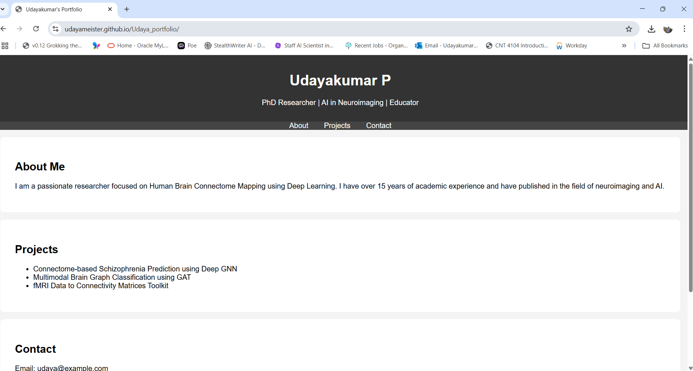

**6. Screenshots to Include in Report**

* Screenshot of the terminal showing git init, add, and commit
* Screenshot of GitHub repository after pushing
* Screenshot of the GitHub Pages URL showing the live website

**Result**

Successfully initialized a Git repository, added and committed files, pushed them to GitHub, and optionally deployed the static site using GitHub Pages.

**Viva Questions**

1. What is Git and how does it differ from GitHub?
2. What is the purpose of git init?
3. What does git add . do?
4. What is a commit in Git?
5. How do you link a local Git repository to GitHub?
6. What is GitHub Pages?

Viva Questions and Answers: Git & GitHub

## 1. What is Git and how does it differ from GitHub?

Git is a distributed version control system that helps developers track changes in source code during software development. It allows multiple people to work on the same codebase without conflict.  
  
GitHub is a cloud-based platform built on top of Git. It provides a web interface to host Git repositories, collaborate with others, review code, manage projects, and deploy static websites via GitHub Pages.  
  
Git = Tool, GitHub = Platform using Git.

## 2. What is the purpose of git init?

The git init command is used to initialize a new Git repository in your project folder. It creates a hidden .git/ directory that stores all the version control metadata.  
  
It tells Git to start tracking changes in that folder.

## 3. What does git add . do?

The command git add . stages all modified and new files in the current directory (and subdirectories) to be committed.  
  
It prepares your files to be saved in the next commit.

## 4. What is a commit in Git?

A commit is a snapshot of your project at a specific point in time. It records changes you made to the tracked files along with a message describing the change.  
  
Think of a commit as a “save point” in your project history.

## 5. How do you link a local Git repository to GitHub?

To connect your local project to a remote GitHub repository:  
  
git remote add origin https://github.com/your-username/repository-name.git  
git branch -M main  
git push -u origin main  
  
remote add origin sets the URL of your GitHub repo.  
push uploads your local commits to GitHub.

## 6. What is GitHub Pages?

GitHub Pages is a free web hosting feature offered by GitHub that allows you to host static websites (HTML/CSS/JS) directly from a GitHub repository.  
  
When enabled, it creates a public URL like:  
https://your-username.github.io/repository-name/  
  
It’s great for portfolios, documentation, and simple websites.

