Experiment: Create a multi-page static website with navigation and layout for Madanapalle Institute of Technology and Science (MITS)

**Aim:**

To design and develop a multi-page static website with a consistent layout and navigation for MITS using HTML and CSS.

**Tools Required:**

* Web browser (Chrome/Firefox)
* Text editor (VS Code, Sublime, or Notepad++)

**Directory Structure:**

mits-website/

├── index.html

├── about.html

├── departments.html

├── contact.html

├── css/

│ └── style.css

└── images/

└── mits-logo.png (optional)

**Procedure:**

1. Create the main project folder and subfolders for CSS and images.
2. Create 4 HTML pages: index.html, about.html, departments.html, contact.html.
3. Add a shared navigation bar to each page using HTML.
4. Style all pages using css/style.css to ensure a consistent layout.
5. Open pages in a browser and test all links and layout responsiveness.

**Source Code:**

***index.html – Home Page***

<!DOCTYPE html>

<html lang="en">

<head>

<meta charset="UTF-8" />

<title>MITS | Home</title>

<link rel="stylesheet" href="css/style.css" />

</head>

<body>

<header>

<h1>Madanapalle Institute of Technology and Science</h1>

<nav>

<a href="index.html">Home</a>

<a href="about.html">About</a>

<a href="departments.html">Departments</a>

<a href="contact.html">Contact</a>

</nav>

</header>

<main>

<section>

<h2>Welcome to MITS</h2>

<p>MITS is an autonomous institution and Deemed University located in Madanapalle, Andhra Pradesh, offering a wide range of undergraduate, postgraduate, and doctoral programs in engineering and sciences.</p>

</section>

</main>

<footer>

<p>&copy; 2025 MITS. All rights reserved.</p>

</footer>

</body>

</html>

***about.html***

<!DOCTYPE html>

<html lang="en">

<head>

<meta charset="UTF-8" />

<title>MITS | About Us</title>

<link rel="stylesheet" href="css/style.css" />

</head>

<body>

<header>

<h1>Madanapalle Institute of Technology and Science</h1>

<nav>

<a href="index.html">Home</a>

<a href="about.html">About</a>

<a href="departments.html">Departments</a>

<a href="contact.html">Contact</a>

</nav>

</header>

<main>

<section>

<h2>About Us</h2>

<p>Established in 1998, MITS is recognized by UGC and AICTE. The institution is known for academic excellence and innovation in research and development. The campus is Wi-Fi enabled and equipped with state-of-the-art facilities.</p>

</section>

</main>

<footer>

<p>&copy; 2025 MITS. All rights reserved.</p>

</footer>

</body>

</html>

***departments.html***

<!DOCTYPE html>

<html lang="en">

<head>

<meta charset="UTF-8" />

<title>MITS | Departments</title>

<link rel="stylesheet" href="css/style.css" />

</head>

<body>

<header>

<h1>Madanapalle Institute of Technology and Science</h1>

<nav>

<a href="index.html">Home</a>

<a href="about.html">About</a>

<a href="departments.html">Departments</a>

<a href="contact.html">Contact</a>

</nav>

</header>

<main>

<section>

<h2>Departments</h2>

<ul>

<li>Computer Science and Engineering</li>

<li>Electronics and Communication Engineering</li>

<li>Electrical and Electronics Engineering</li>

<li>Mechanical Engineering</li>

<li>Civil Engineering</li>

<li>Artificial Intelligence and Data Science</li>

<li>Physics, Chemistry, Mathematics & Humanities</li>

</ul>

</section>

</main>

<footer>

<p>&copy; 2025 MITS. All rights reserved.</p>

</footer>

</body>

</html>

***contact.html***

<!DOCTYPE html>

<html lang="en">

<head>

<meta charset="UTF-8" />

<title>MITS | Contact</title>

<link rel="stylesheet" href="css/style.css" />

</head>

<body>

<header>

<h1>Madanapalle Institute of Technology and Science</h1>

<nav>

<a href="index.html">Home</a>

<a href="about.html">About</a>

<a href="departments.html">Departments</a>

<a href="contact.html">Contact</a>

</nav>

</header>

<main>

<section>

<h2>Contact Information</h2>

<p><strong>Address:</strong> Angallu, Madanapalle, Andhra Pradesh – 517325</p>

<p><strong>Email:</strong> info@mits.ac.in</p>

<p><strong>Phone:</strong> +91-8571-280255</p>

</section>

</main>

<footer>

<p>&copy; 2025 MITS. All rights reserved.</p>

</footer>

</body>

</html>

***css/style.css***

* {

margin: 0;

padding: 0;

box-sizing: border-box;

}

body {

font-family: 'Segoe UI', sans-serif;

background-color: #f4f4f4;

color: #333;

}

header {

background-color: #004080;

color: white;

padding: 20px;

text-align: center;

}

nav {

margin-top: 10px;

}

nav a {

color: white;

text-decoration: none;

margin: 0 15px;

font-weight: bold;

}

nav a:hover {

text-decoration: underline;

}

main {

padding: 30px;

background-color: #ffffff;

margin: 20px auto;

max-width: 900px;

border-radius: 10px;

box-shadow: 0 2px 8px rgba(0,0,0,0.1);

}

section h2 {

margin-bottom: 15px;

color: #004080;

}

footer {

text-align: center;

background-color: #222;

color: white;

padding: 15px;

position: relative;

bottom: 0;

width: 100%;

}

**Expected Output:**

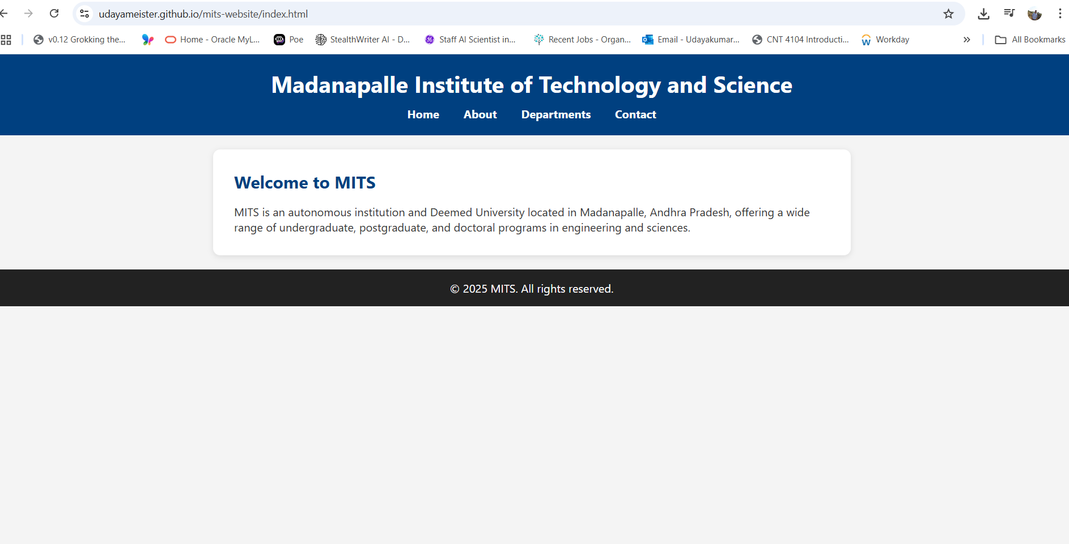

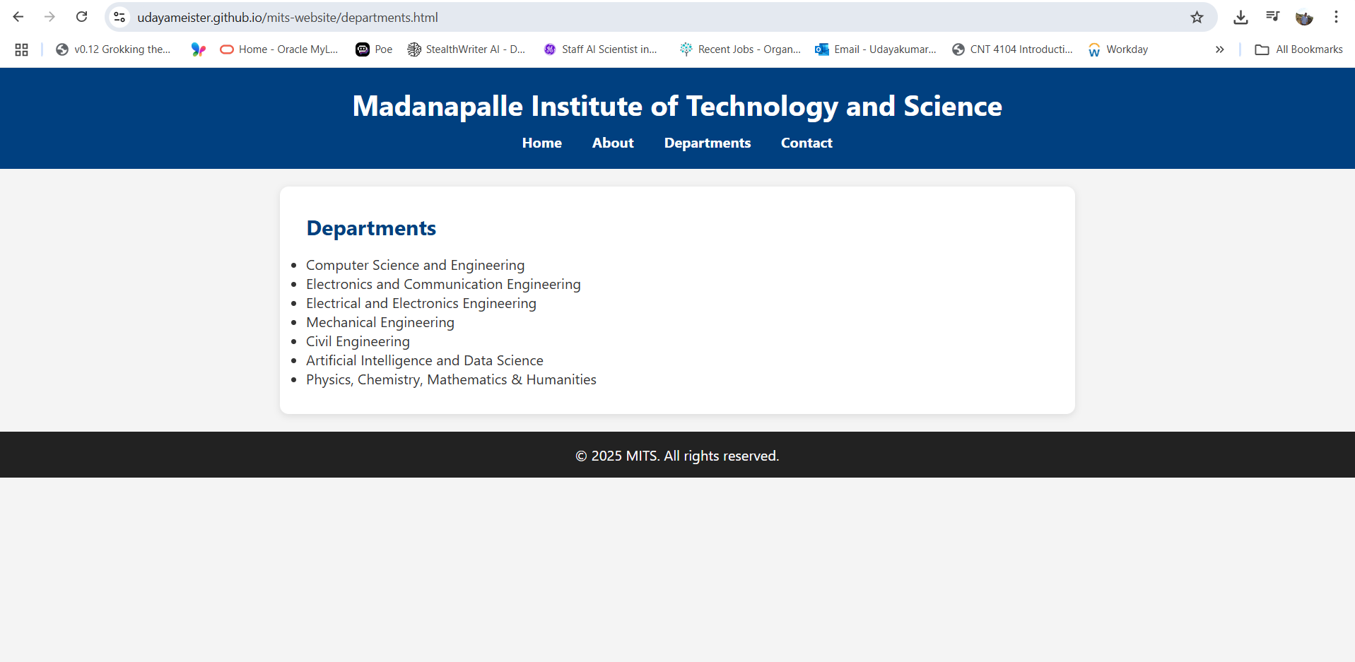

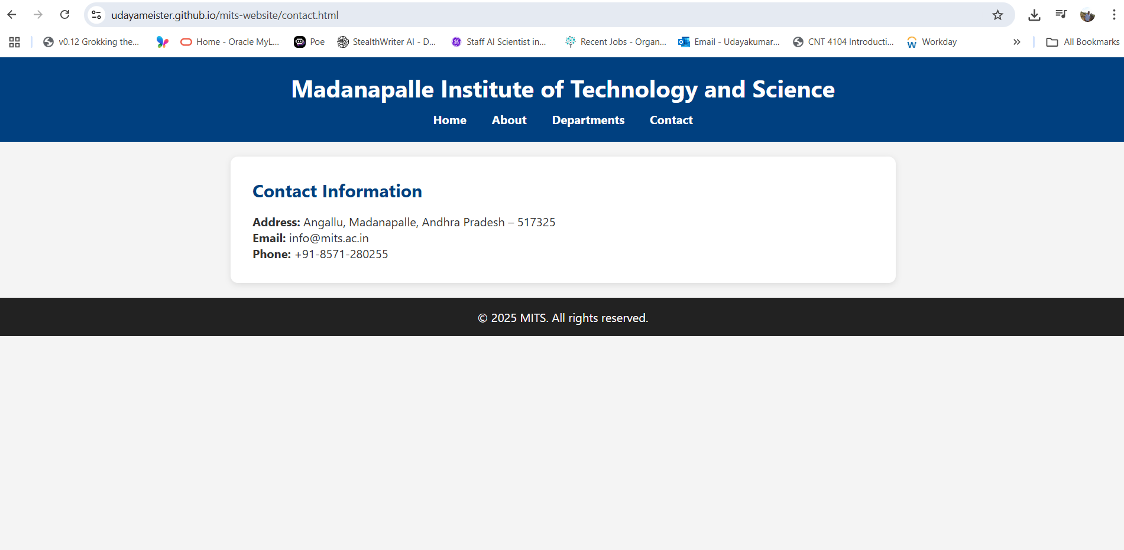

**Result:**

The static website for MITS (Deemed University) was successfully created using HTML and CSS with functional navigation across all pages and a consistent layout.