## PYTHON

Internship Training report submitted to the

**GTN ARTS COLLEGE (AUTONOMOUS)**

**DINDIGUL.**

**(Affiliated to Madurai Kamaraj University)**

**(Accredited by NAAC with “B” Grade)**

In partial fulfillment of the requirement for the award degree of

## MASTER OF SCIENCE IN COMPUTER SCIENCE

**Submitted by**

## M.MOHAMEDTHARIK (22PCSA012)

Under the guidance of

## Dr. C. KIRUBAKARAN., MCA. M.Phil., Ph.D.,

**(Assistant Professor of PG Computer Science)**



## PG DEPARTMENT OF M.SC COMPUTER SCIENCE GTN ARTS COLLEGE (AUTONOMOUS)

**DINDIGUL-5. NOV-2023**

**GTN ARTS COLLEGE (AUTONOMOUS)**

## DINDIGUL-624005

**PG DEPARTMENT OF M.SC COMPUTER SCIENCE**



**BONAFIDE CERTIFICATE**

This is to certify that the Internship training report entitled **“PYTHON”** is a bonafide record work of **M.MOHAMEDTHARIK (Reg.No:22PCSA012)** in partial fulfillment of the requirement for the Degree of Master of Science in computer Science during the year 2022- 2023 and this represents the original work of the candidates.

Submitted for the viva – voce examination held on

**INTERNSHIP GUIDE HEAD OF**

**THE DEPARTMENT**

**INTERNAL EXAMINER EXTERNAL EXAMINER**

**GTN ARTS COLLEGE (AUTONOMOUS)**

## DINDIGUL-624005

# PG DEPARTMENT OF COMPUTER SCIENCE



**DECLARATION**

## I hereby declare that the Internship Training entitled “PYTHON”

is developed and submitted to **PG Department Of computer Science, GTN ARTS COLLEGE** for the fulfillment of the Requirement for the degree of **PG DEPARTMENT OF M.SC COMPUTER SCIENCE** is a record of Bonafide work carried out under the guidance of **DR.C.KIRUBAKARAN .,MCA., M.Phil., Ph.D. (**Assistant Professor, Of M.sc Computer Science.**)**

## PLACE: DINDIGUL M.MOHAMEDTHARIK

**DATE: (22PCSA012)**

**ACKNOWLEDGEMENET**

We express our gratitude and thanks to our beloved principle **Dr. BALAGURUSAMY., MA., M.Phil., M.ED., PGDCA., Ph.D.** GTN Arts College for promoting us to develop this project.

We should deem it is a pleasure to thanks our beloved vice principle **Dr. U. NATARAJAN., M.A., B.Ed., M.Phil., MBA., Ph.D.** GTN Arts College for

motivating us to develop this project.

We express our sincere gratitude to **Dr. K.BOOPATHI., MCA., M.Phil., Ph.D., Head ,PG Department in M.sc Computer Science**. He is man with distinct qualities, Who immediately helped us to develop the project successfully by giving necessary guide lines.

I extended our deep gratitude to our guide **Dr. C.KIRUBAKARAN., MCA., M.Phil., Ph.D.** Assistant professor, Department of M.sc Computer Science for show interest at every stage of development in this project programmed for her valuable suggestion and having Guide us in every aspect right from the beginning of this project.

We thanks our parents for their cooperation and encouragement for the completion of our project.

Finally we thank all our friends who have helped in successful completion of this project.

# ABSTRACT

Grocery shops are using different system to running different business activities. In the system, cashier to handle business transactions like sales and purchase and manually maintain the record of stock information and staff personal detail or recording all the information. Normally, the problem caused by the shop are just started the business or still in growing of the business. This method is used to running daily operation of the management activities which could not performed efficiently. Shop Management System is a software application to be developed to manage most of the activities or tasks running in a grocery shop. This system divided in to three main categories: cashier/stock management, supplier information management/generating report, staff management. This application will provide the basic features such as cashier to handle sales transaction, stock management to control.

# CONTENT

|  |  |  |
| --- | --- | --- |
| **CHAPTER** | **Title** | **Page No** |
| **1** | **INTRODUCTION** | **1** |
| **2** | **SYSTEM ANALYSIS**   * 1. **Existing system** | **2** |
| * 1. **Proposed System** | **2** |
| * 1. **Feasibility study** | **3** |
| **3** | **SYSTEM ENVIRONMENT**   * 1. **Hardware Specification** | **5** |
| * 1. **Software Specification** | **5** |
| * 1. **Software Description** | **6** |
| **4** | **SYSTEM DESIGN**   * 1. **Dataflow Diagram** | **15** |
| * 1. **Database design** | **17** |
| * 1. **Input design** | **22** |
| * 1. **Output Design** | **22** |
| **5** | **PROJECT DESCRIPTION** | **23** |
| **6** | **TESTING**  **6.1 UNIT TESTING** | **25** |
| **6.2 INTEGRATION TESTING** | **27** |
| **6.3 SECURITY TESTING** | **31** |
| **7** | **SYSTEM IMPLEMENTATION** | **33** |
| **8** | **SCREEN LAYOUTS** | **34** |
| **9** | **CONCLUSION** | **42** |
| **10** | **FUTURE ENCHANEMENT** | **43** |
| **11** | **BIBLIOGRAPHY** | **44** |
| **12** | **SAMPLE CODING** | **45** |

**CHAPTER-1**

**INTRODUCTION**

Grocery store is a web based mini project which maintains a centralized database about the stocks that has been available in the shop. By this system owner can update or it can be updated automatically regarding to how much stock of goods and products available in the store. From this retailer shop owners or people can able to know what are all the products are available in the store .This system has provided a user id and password to the admin (owner). Then they will update all the available products as well as their prices. This system divided in to three main categories: cashier/stock management, supplier information management/generating report, staff management. This application will provide the basic features such as cashier to handle sales transaction, stock management to control.

# CHAPTER-2

# SYSTEM ANALYSIS

## EXISTING SYSTEM

Grocery Shop Whole Sale Stock Maintenance System deals with online communicating between all users in this system. In the existing manual system huge expenditure and a lot of time is spent in collecting the stock information and printing the bill based on category chosen. So, there is a need for an integrated automated system, which has some centralized control over the entire process.

The following drawbacks of the existing system emphasize the need for Grocery Shop Whole Sale Stock Maintenance management system:

* + - Conventional system makes use of huge amounts of time for providing the information about the inventory to the manager.

Difficulty in tracking and retrieving data from the related inventory. So, there is a need for computerization. With computerized systems paper work drastically reduces, data retrieval becomes easy, duplication of work is avoided.

## PROPOSED SYSTEM

The proposed system consists of full stock data entry with validations on field and referential checking. The goal of this system is to bring down the workload with the increased efficiency and to speed up the activities. The major objective of Grocery Shop Whole Sale Stock Maintenance System is to effectively manage and carry out the activites of the grocery shop. The other advantages are:

* + - A computerized inventory management system that solves the problem inherent in the manual system.
    - A computerized stock management system to ascertain stock level of a grocery shop, when to order for more goods, keep status and updates of transactions, thereby helping managerial decisions, progress level and stock taking.
    - Availability of the information immediately after data captures.
    - An integrated normalized relational database will be maintained for the process.
    - Pre defined queries for generation of any specific enquiry purposes.
    - Easy to maintain stock and customer “sms” report.

## FEASIBILITY STUDY

The main objective of the feasibility study is to treat the technical, operational, logical and economic feasibility of developing the computerized system are feasible, given unlimited resources and infinite time. It is both necessary to evaluate the feasibility of the project at system study phase itself. The feasibility study to be conducted for this project involves.

* + - Technical feasibility
    - Operational feasibility
* Economic feasibility

**2.3.1 TECHNICAL FEASIBILITY**

Technical feasibility includes risk resources availability and technologies. The management provides latest hardware and software facilities for the successful completion of the project. The assessment of technical feasibility is based on an outline design of the system requirement in terms of inputs, outputs, programs and procedures. This can then be quantified in terms of volumes of data, trends frequency of updating etc. Since almost all the activities of this system are being computerized, require hardware and software are already available. So to computerize the proposed system is feasible.

This project is based on web application. The web application is more reliable and comfortable while using of php, mysql, and xampp server. These software are more user friendly and flexible to any level of application.

**2.3.2 OPERATIONAL FEASIBILITY**

The development of the system was started because of the requirement put forward. The developed system is a web based system. This system is more economical to current needs when compared to all other existing system in terms of operating and installation cost. Performance characteristics of application system are very good in terms of accuracy, control flexibility, response time, usability, storage requirement etc.

**2.3.3 ECONOMIC FEASIBILITY**

In the economic feasibility the development cost of the system is evaluated weighting is against the ultimate benefit derived from the new system. With the help of the new system the work can be done with less number of people in less time.

So people can concentrate on other works which brings lot of benefits to the establishment. Hence it is found that the benefit, from the proposed system would be more than the cost and time involved in its development.

# CHAPTER-3

# SYSTEM ENVIRONMENT

## 3.1. HARDWARE SPECIFICATION

Processor Type : I3

Hard Disk : 500 GB – SAMSUNG

RAM : 4 GB - Transcend

Mother Board : Mercury

Input device : Standard Keyboard and Mouse.

Output device : VGA and High Resolution Monitor

Key Board : 106 keys (TVS Key board)

## SOFTWARE SPECIFICATION

Operating System : Windows 7

Programming Package : PHP

Back end : MYSQL

Tools : XAMMP server

## SOFTWARE DESCRIPTION

* + 1. **HTML**

HTML is the standard markup language for creating Web pages.

* HTML stands for Hyper Text Markup Language
* HTML describes the structure of Web pages using markup
* HTML elements are the building blocks of HTML pages
* HTML elements are represented by tags
* HTML tags label pieces of content such as "heading", "paragraph", "table", and so on
* Browsers do not display the HTML tags, but use them to render the content of the page

**ADVANTAGES OF HTML**

* First advantage it is widely used.
* Every browser supports HTML language.
* Easy to learn and use.
* It is by default in every windows so you don't need to purchase extra software.
  + 1. **BOOTSTRAP**

Bootstrap is a powerful front-end framework for faster and easier web development. It includes HTML and CSS based design templates for common user interface components like Typography, Forms, Buttons, Tables, Navigations, Dropdowns, Alerts, Modals, Tabs, Accordion, Carousel and many other as well as optional JavaScript extensions. Bootstrap also gives your ability to create responsive layout with much less efforts.

**ADVANTAGES OF BOOTSTRAP**

The biggest advantage of using Bootstrap is that it comes with free set of tools for creating flexible and responsive web layouts as well as common interface components.

Additionally, using the Bootstrap data APIs you can create advanced interface components like Scrollspy and Typeaheads without writing a single line of JavaScript.

Here are some more advantages, why one should opt for Bootstrap:

* + - * **Save lots of time** — you can save lots of time and efforts using the Bootstrap predefined design templates and classes and concentrate on other development work.
      * **Responsive features** — Using Bootstrap you can easily create responsive designs. Bootstrap responsive features make your web pages to appear more appropriately on different devices and screen resolutions without any change in markup.
      * **Consistent design** — All Bootstrap components share the same design templates and styles through a central library, so that the designs and layouts of your web pages are consistent throughout your development.
      * **Easy to use** — Bootstrap is very easy to use. Anybody with the basic working knowledge of HTML and CSS can start development with Bootstrap.
      * **Compatible with browsers** — Bootstrap is created with modern browsers in mind and it is compatible with all modern browsers such as Mozilla Firefox, Google Chrome, Safari, Internet Explorer, and Opera.
      * **Open Source** — And the best part is, it is completely free to download and use.

## HYPERTEXT PRE-PROCESSOR (PHP)

PHP is a server side scripting language and interpreter that is available on a wide range of platforms, including some versions of apache, and **Internet InformationServer (IIS).** The original program was called personal home page tools, which is where the initials PHP come from.

PHP is a recursive three letter acronym meaning, PHP Hypertext Pre-processor. The PHP script is embedded in the web page, and interpreted on the server before being sent to client who requested the page. PHP is open source software.

PHP is a scripting language based on the Zend engine that is usually embedded in HTML code. As such it is primarily used to develop HTML documents, although it can be used just as nicely to develop other type document, such as XML.

PHP 5 was released in July 2004 after long development and several pre-releases. It is mainly driven by its core, the Zend Engine 2.0 with a new object model and dozens of other new features.

PHP's development team includes dozens of developers, as well as dozens others working on PHP-related and supporting projects, such as PEAR, PECL, and documentation, and an underlying network infrastructure of well over one-hundred individual web servers on six of the seven continents of the world. Though only an estimate based upon statistics from previous years, it is safe to presume PHP is now installed on tens or even perhaps hundreds of millions of domains around the world.

Using forms in a web based application is very common. Most forms are used to gather information like in a signup form, survey / polling, guestbook, etc. A form can have the method set as post or get. When using a form with method="post" user can use

$_POST to access the form values. And when the form is using method="get" user can use $_GET to access the values. The $_REQUEST super global can be used to access form values with method="post" and method="get" but it is recommended to use

$_POST or $_GET instead so user will know from what method did the values come from.

### PHP Environment Setup

In order to develop and run PHP Web pages three vital components need to be installed on your Computer system.

**Web Server** - PHP will work with virtually all Web Server software, including Microsoft’s Internet Information Server (IIS) but then most often used is freely available Apache Server.

**Database** - PHP will work with virtually all database software, including Oracle and Sybase but most commonly used is freely available MYSQL database.

**PHP Parser** - In order to process PHP script instructions a parser must be installed to generate HTML output that can be sent to the Web Browser.

### Driver

A driver is a piece of software designed to communicate with a specific type of database server. The driver may also call a library, such as the MYSQL Client Library or the MYSQL Native Driver. These libraries implement the low-level protocol used to communicate with the MYSQL database server. By way of an example, the PHP Data Objects (PDO) [94] database abstraction layer may use one of several database-specific drivers. One of the drivers it has available is the PDO MYSQL driver, which allows it to interface with the MYSQL server. In the MYSQL-related documentation the term “driver” is reserved for software that provides the database-specific part of a connector package.

### Extension

In the PHP documentation will come across another term - extension. The PHP code consists of a core, with optional extensions to the core functionality. PHP's MYSQL- related extensions, such as the MYSQL extension, and the MYSQL extension, are implemented using the PHP extension framework. An extension typically exposes an API to the PHP programmer, to allow its facilities to be used programmatically. However, some extensions which use the PHP extension framework do not expose an API to the PHP programmer.

### Working with Cookies

HTTP cookies (or just cookies) are parcels of text sent by a server to a Web client (usually a browser) and then sent back unchanged by the client each time it accesses that server. Each cookie has a name and value. It may also have an expiration time. Cookies are sent by web server inside the HTTP response before any html content. Cookies are stored in the client computer.

In PHP, to create cookie, the function set cookie is used.

### ADVANTAGES

* Vastly improved object-oriented capabilities: improvements to PHP’s object- oriented architecture are version 5’s most visible features. Version 5 include numerous functional additions such as explicit constructors and destructors, object cloning, class abstraction, variable scoping, interface, and a major improvement regarding how PHP handles object management.
* Try/catch exception handling: devising custom error – handling strategies within structural programming languages is, ironically, error-prone and inconsistent. To remedy this problem, version5 now supports exception handling. Long a mainstay of error management in many languages, c++, c#, python and java included.
* Improved string handling: prior versions of PHP have treated strings as arrays by default, a practice indicative of the languages loose-knit attitude towards data types.
* Improved XML and web services support: XML support is now based on the livxml2 library, and a new and rater promising extension for parsing and manipulating XML, known as simple XML, has been introduced.

### PHP Environment Setup

In order to develop and run PHP Web pages three vital components need to be installed on your computer system.

**Web Server** - PHP will work with virtually all Web Server software, including Microsoft’s Internet Information Server (IIS) but then most often used is freely available Apache Server. Download Apache for free here: <http://httpd.apache.org/download.cgi>

**Database** - PHP will work with virtually all database software, including Oracle and Sybase but most commonly used is freely available MySQL database. Download MySQL for free here: <http://www.mysql.com/downloads/index.html>

**PHP Parser** - In order to process PHP script instructions a parser must be installed to generate HTML output that can be sent to the Web Browser. This tutorial will guide and how to install PHP parser on your computer, intermediate libraries where necessary. This software is known generically as a connector, as it allows your application to connect to a database server.

## 3.3.3 XAMPP

Xampp is a free and open source cross-platform web server solution stack package, consisting mainly of the Apache HTTP Server, MySQL database, and interpreters for scripts written in the PHP and Perl programming languages.

XAMPP requires only one zip, tar, 7z, or exe file to be downloaded and run, and little or no configuration of the various components that make up the web server is required. XAMPP is regularly updated to incorporate the latest releases of Apache, MySQL, PHP and Perl. It also comes with a number of other modules including OpenSSL and phpMyAdmin.

Self-contained, multiple instances of XAMPP can exist on a single computer, and any given instance can be copied from one computer to another.It is offered in both a full, standard version and a smaller version.

Officially, XAMPP's designers intended it for use only as a development tool, to allow website designers and programmers to test their work on their own computers without any access to the Internet. To make this as easy as possible, many important security features are disabled by default. In practice, however, XAMPP is sometimes used to actually serve web pages on the World Wide Web [citation needed]. A special tool is provided to password-protect the most important parts of the package.

XAMPP also provides support for creating and manipulating databases in MySQL and SQLite among others.

Once XAMPP is installed, it is possible to treat a localhost like a remote host by connecting using an FTP client. Using a program like FileZilla has many advantages when installing a content management system (CMS) like Joomla or Word Press. It is also possible to connect to localhost via FTP with an HTML editor.

## MYSQL

MYSQL, the most popular open source sql database management system, is developed distributed, and supported by MySQL AB is a commercial company, founded by the MYSQL developers.

### MySQL is a database management system.

A database is a structured collection of data. .it may be anything from a simple shopping list to a picture gallery other vast amounts of information in a corporate network. To add, access, and process data stored in a computer database, needs a database management system such as MYSQL server. since computer are very good at handling large amount of data, database management systems play a central role in computing, as standalone utilities, oat as parts of other application.

### MYSQL is a relation database management system.

A relation database stores data in separate tables rather than putting all the data in one bit store room. This adds speed and flexibility. The SQL part of “MYSQL” stands for “structured” query language. “SQL is the most common standardized language used to access database and is defined by the ansi/iso SQL standard.

### MYSQL Software in open source.

Open source means that it is possible for anyone to use and modify the software. Anybody can download the MYSQL software from the internet and used it without paying anything. User wish, may study the source code and change it to suit your needs.

### The MYSQL database server is very fast, reliable, and easy to use.

If that’s what are looking for should give it a try. MYSQL server also has a practical set of futures developed in close cooperation with our user can find a performance comparison of MYSQL server with other database managers on over benchmark.

### ADVANTAGES

A web developer, MySql is easy to use, yet extremely powerful, source, and scalable. And because of its small size and speed, it is the ideal database solution for web sites.

Some of its advantage includes the following:

* **It’s easy to use**: While a basic knowledge of SQL is required and most relational database require the same knowledge MySQL is very easy to use.
* **It’s secure**: MySQL is including solid data security layers that protect sensitive data from intruders. Rights can be set to allow some or all privileges to individuals. Passwords are encrypted.
* **It’s inexpensive**: MySQL is including for free with NetWare and available by free download from MYSQL websites.
* **Its fast**: In the interest of speed, MYSQL designers made the decision to offer fewer features than other major database competitors, such as Sybase and oracle.

# CHAPTER-4

# SYSTEM DESIGN

### DATA FLOW DIAGRAM

The Data Flow diagram is a graphic tool used for expressing system requirements in a graphical form. The DFD also known as the “bubble chart” has the purpose of clarifying system requirements and identifying major transformations that to become program in system design.

Thus DFD can be stated as the starting point of the design phase that functionally decomposes the requirements specifications down to the lowest level of detail.

The DFD consists of series of bubbles joined by lines. The bubbles represent data transformations and the lines represent data flows in the system. A DFD describes what data flow is rather than how they are processed, so it does not depend on hardware, software, data structure or file organization.

**Level 0**

Grocery

GroceryDB

Home

**Fig. no 4.1. Level 0**

**Level 1 for Grocery**



Login

Register Table

Purchase

Purchase Table

Product

Sales

Sales Table

Stock

Stock Table

Customer

CustomerTable

Employee

Employee Table

Credit

Credit Table

Cashier

Debit

Debit Table

16

Report

Grocery

**Fig no 4.2. Level 1 for grocery**

## DATABASE DESIGN

### Table 4.1. CASHIER TABLE:

|  |  |  |  |
| --- | --- | --- | --- |
| **S.NO** | **FIELD NAME** | **TYPE** | **SIZE** |
| **1** | Id | Int | - |
| **2** | Date | Date/Time | - |
| **3** | Type | Varchar | 50 |
| **4** | Amount | Int | - |
| **5** | Purpose | Varchar | 50 |

**Table 4.2. CUSTOMER TABLE:**

|  |  |  |  |
| --- | --- | --- | --- |
| **S.NO** | **FIELD NAME** | **TYPE** | **SIZE** |
| **1** | Id | Int | - |
| **2** | Cusid | Int | - |
| **3** | Name | Varchar | 50 |
| **4** | Address | Varchar | 50 |
| **5** | Mob | Double | - |
| **6** | Amount | Int | - |

### Table 4.3. EMPLOYEE TABLE:

|  |  |  |  |
| --- | --- | --- | --- |
| **S.NO** | **FIELD NAME** | **TYPE** | **SIZE** |
| **1** | Id | Int | - |
| **2** | Eid | Int | - |
| **3** | Ename | Varchar | 50 |
| **4** | Position | Varchar | 50 |
| **5** | Addr | Varchar | 50 |
| **6** | Mob | Double | - |
| **7** | Salary | Int | - |

**Table 4.4. PAYMENT TABLE:**

|  |  |  |  |
| --- | --- | --- | --- |
| **S.NO** | **FIELD NAME** | **TYPE** | **SIZE** |
| **1** | Id | Int | - |
| **2** | cid | Int | - |
| **3** | Purchase | Varchar | 50 |
| **4** | Old | Varchar | 50 |
| **5** | Pay | Int | - |
| **6** | Bal | Int | - |

### Table 4.5. PRODUCT TABLE:

|  |  |  |  |
| --- | --- | --- | --- |
| **S.NO** | **FIELD NAME** | **TYPE** | **SIZE** |
| **1** | Id | Int | - |
| **2** | Pid | Int | - |
| **3** | Pname | Varchar | 50 |
| **4** | Company name | Varchar | 50 |
| **5** | Mobile | Double | - |

**Table 4.6. PURCHASE TABLE:**

|  |  |  |  |
| --- | --- | --- | --- |
| **S.NO** | **FIELD NAME** | **TYPE** | **SIZE** |
| **1** | Id | Int | - |
| **2** | Pname | Varchar | 50 |
| **3** | Date | Date/Time | 50 |
| **4** | Netwt | Varchar | 50 |
| **5** | Quantity | Int | - |
| **6** | Purchase | Int | - |
| **7** | Sales | Int | - |

### Table 4.7 SALES TABLE:

|  |  |  |  |
| --- | --- | --- | --- |
| **S.NO** | **FIELD NAME** | **TYPE** | **SIZE** |
| **1** | Id | Int | - |
| **2** | Pname | Varchar | 50 |
| **3** | Date | Date/Time | 50 |
| **4** | Netwt | Varchar | 50 |
| **5** | Cost | Varchar | 50 |
| **6** | Quantity | Int | - |
| **7** | Total | Int | - |
| **8** | Billno | Int | - |
| **9** | cid | Int | - |

**Table 4.8. SALES-TEMP TABLE:**

|  |  |  |  |
| --- | --- | --- | --- |
| **S.NO** | **FIELD NAME** | **TYPE** | **SIZE** |
| **1** | **Pname** | **Varchar** | **50** |
| **2** | **Date** | **Date/Time** | **50** |
| **3** | **Netwt** | **Varchar** | **50** |
| **4** | **Cpp** | **Varchar** | **50** |
| **5** | **Quantity** | **Int** | **-** |
| **6** | **Total** | **Int** | **-** |
| **7** | **Billno** | **Int** | **-** |
| **8** | **Cname** | **Varchar** | **50** |

### 4.4 INPUT OUTPUT DESIGN

**INPUT DESIGN**

Input design forms basis for the creations of screen layout that depict graphical design placement of icons, definition of descriptive screen test, specification and titling for windows and its specification of major and minor menu items. Tools are used to prototype and ultimately the design model and the result evaluated for quality.

Design allows a software engineer to model the system or product that is to be built. This model can be accessed for quality and improved before code is generated, tests are conducted and end users become involved in large numbers, design is the place where software quality is established. Design depicts the software in a number of different ways. First the architecture of the system or product must be represented then; the interfaces that connect the software to end user to the other systems and devices and to its own constituent components are modeled. Finally the software components that are used

to construct the system are designed. Each of these views represents a different design action but all must confirm to a set of basic design concepts that guide all software design work

### OUTPUT DESIGN

Output design forms basis for the creations of screen layout that depict graphical design placement of icons, definition of descriptive screen test, specification and titling for windows and its specification of major and minor menu items. Tools are used to prototype and ultimately the design model and the result evaluated for quality.

## CHAPTER-5

## PROJECT DESCRIPTION

* 1. **PROJECT DESCRIPTION**
     1. Product
     2. Company details
     3. Purchase details
     4. Sales details
     5. Stock Allotment
     6. Employee

### Product

This product module is used for adding new products to the system. It will require some basic details like Product Category, Product Name, cost price, selling price, its quantity. One other interesting feature this system can have is an alert system. You can set a particular quantity for each item. Now a notification will be given to the user if a particular item’s quantity gets below the set quantity. This will help the user in getting notifications of the items getting low in stock.

### Company details

In this module the owner register the company details belong for purchasing the product in future from that the particular company based on the needs of product for sales.

### Purchase details

In this module purchasing the product from the registered company based on their needs for selling the product as wholesale. In this it has details about the product name, quantity,cost,etc.

### Sales details

In this module it has the details about the sales information such as order number, customer name, item list, cost, quantity, total payment, discount and balance payment.

### Stock Allotment

In stock module the sales of each day is recorded. Whenever a sales is done there will be decreasing in the stock. The user can be able to check the sales in the every occasional. Every stock is stored in the database and SMS will be sent to the company automatically.

### Employee

Employee module maintains the salary details of the employee working in this grocery shop. The admin should be maintained the details.

# CHAPTER-6

# SYSTEM TESTING

Testing is the process of detecting errors. Testing performs a very critical role for quality assurance and for ensuring the reliability of software. The results of testing are used later on during maintenance also.

## UNIT TESTING

Unit testing focuses verification effort on the smallest unit of the software design module. The relative complexity of the tests and the errors detected as a result is limited by the constrained scope, which is established for unit testing. Unit testing is a white-box testing and the steps can be conducted in multiple modules parallely.

* + - A unit is the smallest testable part of an application like functions, classes, procedures, interfaces. Unit testing is a method by which individual units of source code are tested to determine if they are fit for use.
    - Unit tests are basically written and executed by software developers to make sure that code meets its design and requirements and behaves as expected.
    - The goal of unit testing is to segregate each part of the program and test that the individual parts are working correctly.
    - This means that for any function or procedure when a set of inputs are given then it should return the proper values. It should handle the failures gracefully during the course of execution when any invalid input is given.
    - A unit test provides a written contract that the piece of code must assure.

### ADVANTAGES OF UNIT TESTING:

1. Issues are found at early stage. Since unit testing are carried out by developers where they test their individual code before the integration. Hence the issues can be found very early and can be resolved then and there without impacting the other piece of codes.
2. Unit testing helps in maintaining and changing the code. This is possible by making the codes less interdependent so that unit testing can be executed. Hence chances of impact of changes to any other code get reduced.
3. Since the bugs are found early in unit testing hence it also helps in reducing the cost of bug fixes. Just imagine the cost of bug found during the later stages of development like during system testing or during acceptance testing.
4. Unit testing helps in simplifying the debugging process. If suppose a test fails then only latest changes made in code needs to be debugged.

## INTEGRATION TESTING

When all the modules and sub modules tested are together to form the system, integrated testing is made to check the degree to which the software system is designed to satisfy the client’s requirement including their details in the database.

* + - Integration testing tests integration or interfaces between components, interactions to different parts of the system such as an operating system, file system and hardware or interfaces between systems.
    - Also after integrating two different components together do the integration testing. As displayed in the image below when two different modules ‘Module A’ and ‘Module B’ are integrated then the integration testing is done.

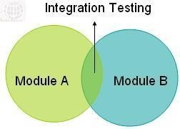

### Integration testing diagram

* + - Integration testing is done by a specific integration tester or test team.
    - Integration testing follows two approach known as ‘Top Down’ approach and ‘Bottom Up’ approach as shown in the image below:

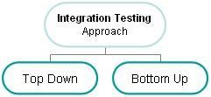

### Integration testing techniques:

1. **BIG BANG INTEGRATION TESTING:**

Big Bang Integration Testing is an integration testing strategy wherein all units are linked at once, resulting in a complete system. When this type of testing strategy is adopted, it is difficult to isolate any errors found, because attention is not paid to verifying the interfaces across individual units. In this approach individual modules are not integrated until and unless all the modules are ready.

In Big Bang integration testing all components or modules are integrated simultaneously, after which everything is tested as a whole. As per the below image all the modules from ‘Module 1′to ‘Module 6′ are integrated simultaneously then the testing is carried out.

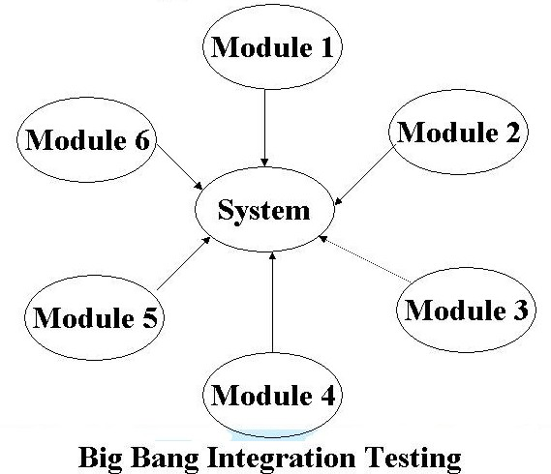

**Advantage:** Big Bang testing has the advantage that everything is finished before integration testing starts.

**Disadvantage:** The major disadvantage is that in general it is time consuming and difficult to trace the cause of failures because of this late integration.

### Top-down integration testing:

Top-down integration testing is an integration testing technique used in order to simulate the behaviour of the lower-level modules that are not yet integrated. Stubs are the modules that act as temporary replacement for a called module and give the same output as that of the actual product.

The replacement for the 'called' modules is known as 'Stubs' and is also used when the software needs to interact with an external system. Testing takes place from top to bottom, following the control flow or architectural structure (e.g. starting from the GUI or main menu). Components or systems are substituted by stubs.

**Diagram of ‘Top down Approach’**

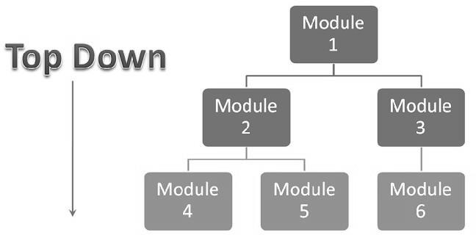

### Advantages of top-down approach:

* + The tested product is very consistent because the integration testing is basically performed in an environment that almost similar to that of reality
  + Stubs can be written with lesser time because when compared to the drivers then Stubs are simpler to author.

### Disadvantages of top-down approach:

* + Basic functionality is tested at the end of cycle

1. **Bottom-up integration testing:** Testing takes place from the bottom of the control flow upwards. Components or systems are substituted by drivers. Below is the image of

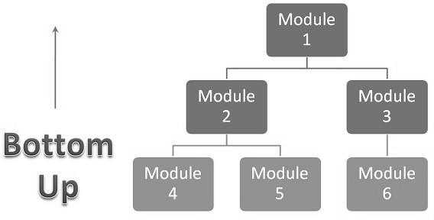

### Bottom up approach

**Advantage of bottom-up approach:**

* + In this approach development and testing can be done together so that the product or application will be efficient and as per the customer specifications.

### Disadvantages of bottom-up approach:

* + It can catch the Key interface defects at the end of cycle
  + It is required to create the test drivers for modules at all levels except the top control

### [INCREMENTAL TESTING](http://istqbexamcertification.com/what-is-incremental-testing-in-software/):

* + - Another extreme is that all programmers are integrated one by one, and a test is carried out after each step.
    - The incremental approach has the advantage that the defects are found early in a smaller assembly when it is relatively easy to detect the cause.
    - A disadvantage is that it can be time-consuming since stubs and drivers have to be developed and used in the test.
    - Within incremental integration testing a range of possibilities exist, partly depending on the system architecture.

**Functional Incremental:** Integration and testing takes place on the basis of the functions and functionalities, as documented in the functional specification.

### Example

In the developed system, integration testing has been done using different scenario. For eg., Purchase stock details and sales details are integrated with the stock maintenance. Thus the stock details considered as the integration of product details in different forms is done using this field.

## SECURITY TESTING

This is a type of non-functional testing. Security testing is basically a type of software testing that’s done to check whether the application or the product is secured or not. The security testing is performed to check whether there is any information leakage.

**VERIFICATION AND VALIDATION**

Verification and Validation is the process of checking that a software system meets specifications and that it fulfills its intended purpose.

### Example

**Null Value Validation**

In my project All Forms are Checking Null values For the Input Data.

### Input:

User Directly Enter the Submit Button on Application Forms

### Output:

Display the Error Message on “Must Enter the all Fields”.

### Verification

**Input:**

User Enter the Mobile No Field is less than 10 Number in the Application Form

### Output:

Display the Error Message on “Mobile Number Must Have 10 Digits”.

# CHAPTER-7

# SYSTEM IMPLEMENTATION

Grocery shop whole sale stock manintenance system is implement successfully to overcome the existing system drawbacks. Implementation is the process of having the system personal checks out and put new equipment to use, train the user to use the new system and construct any file that are needed to see it. The final and important phase in the system life cycle is the implementation of the new system. The file conversion is the most time consuming and expensive activity in the implementation stage.

System implementation refers to the step necessary to install a new system to put into operation. The implementation has different meaning, ranging from the conversion of a basic application to complete replacement of computer system. Implementation includes all these activities that take place to convert from old system to new one. The new system may be totally new replacing an existing manual or automated system or it may be major modification to an existing system.

The method of implementation and time scale adopted is found out initially. The system is tested properly and at the same time the users are trained in the new procedure. Proper implementation is essential to provide a reliable system to meet organization requirements. Successful implementation may not guarantee improvement in the organization using the new system, but it will prevent improper installation. The implementation involves the following things:

* + - Careful planning
    - Investigation of the system and constraints
    - Design the methods to achieve the change over
    - Train the staff in the changed phase
    - Evaluation of change over method

# CHAPTER-8

# SCREENSHOTS

# 

**Login:**

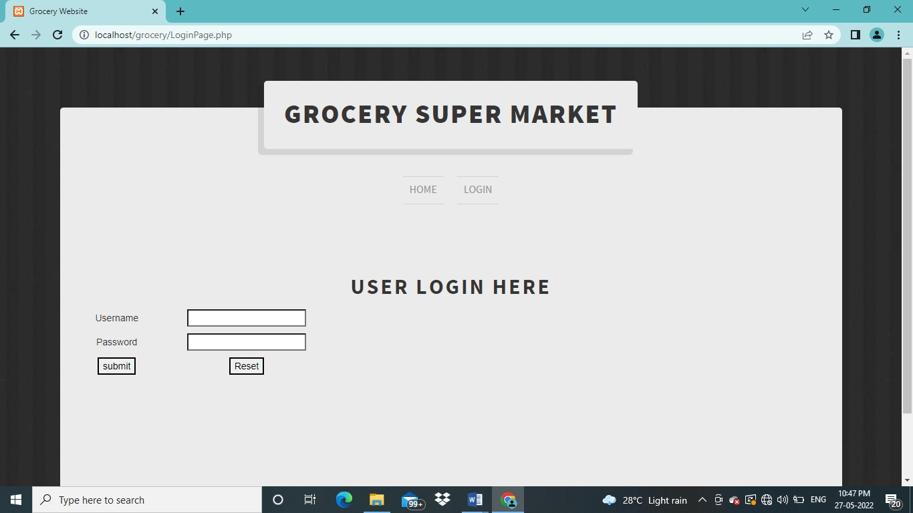

**Fig 8.1. Login**

# Company:

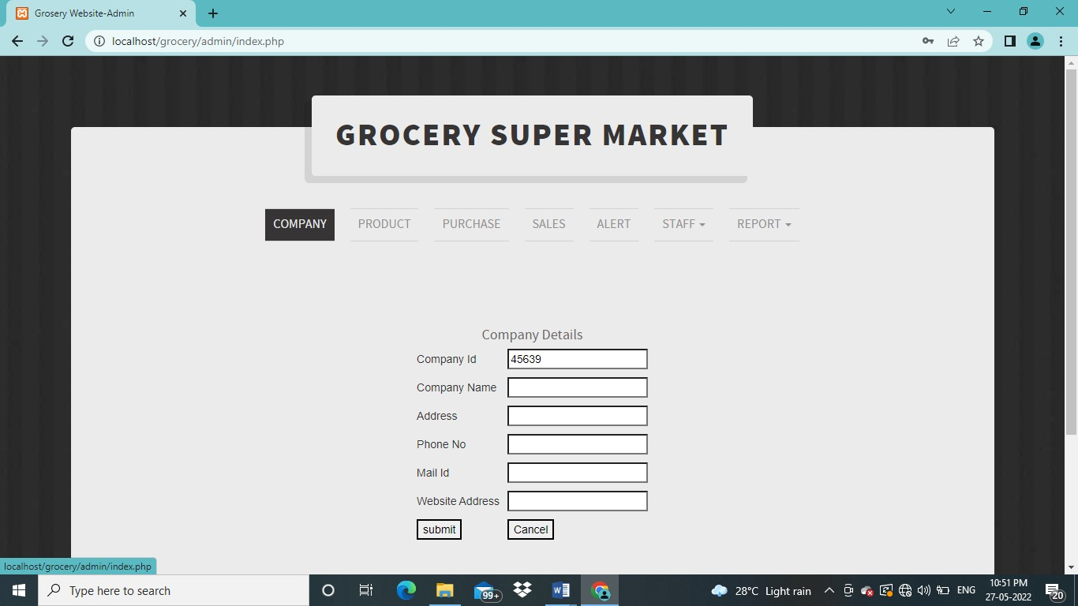

**Fig 8.2. Company**

**Product:**

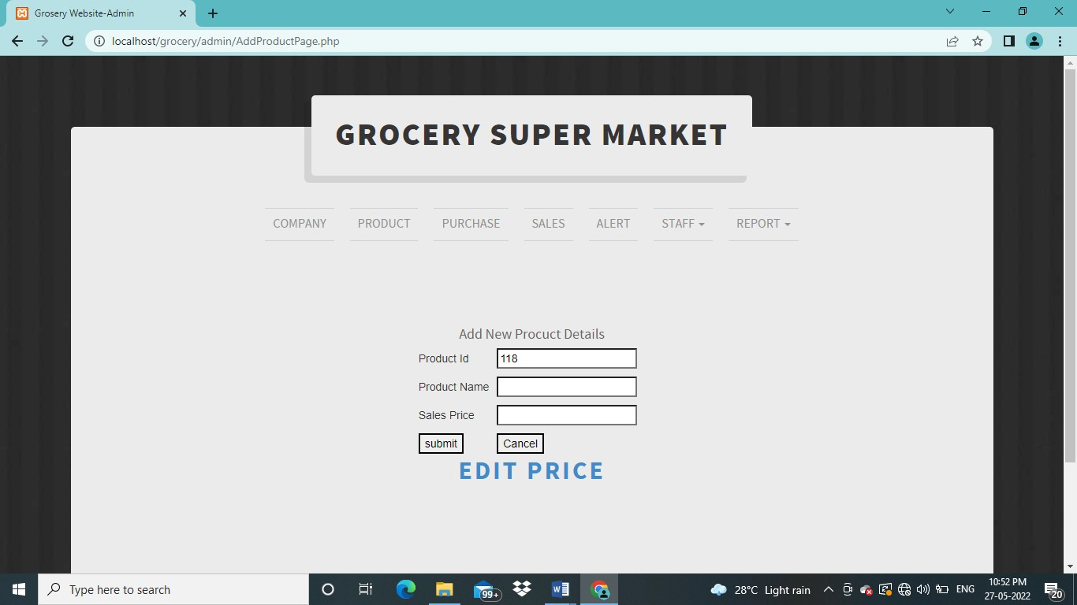

**Fig 8.3. Product**

# Purchase:

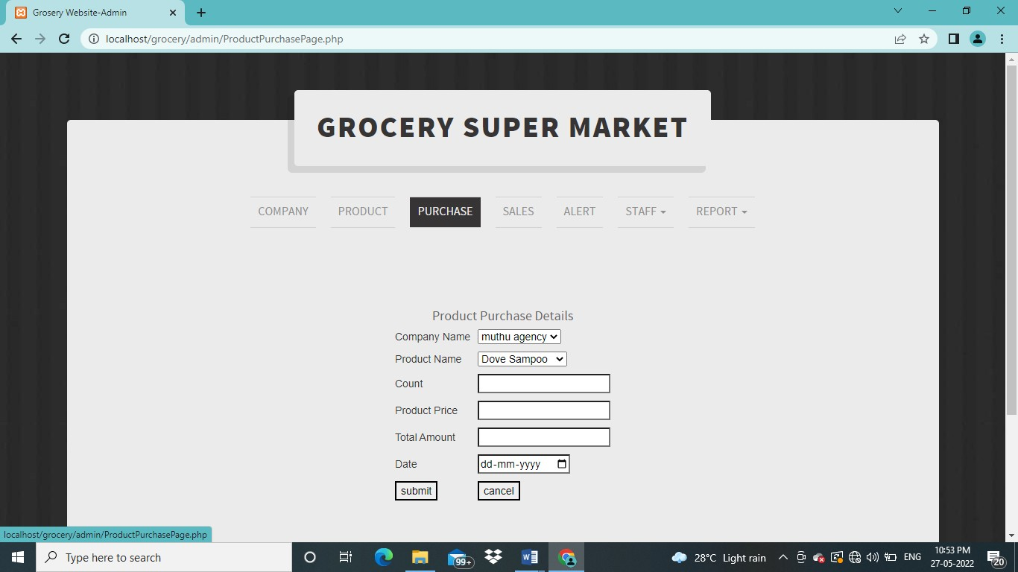

**Fig 8.4. Purchase**

**Sales:**

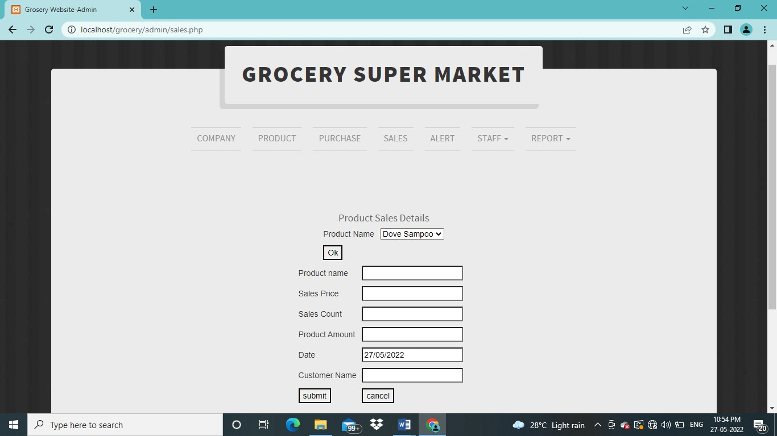

**Fig 8.5. Sales**

# Alert:

# 

**Fig 8.6. Alert**

**Staff:**

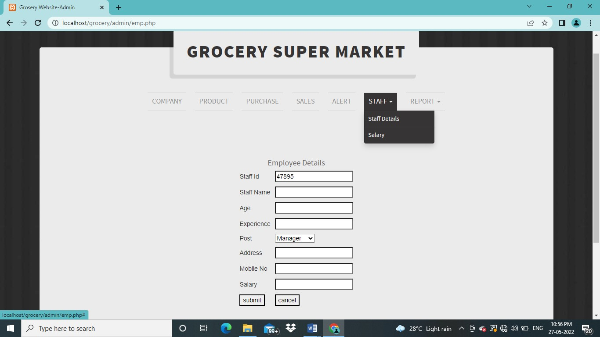

**Fig 8.7. Staff**

# Report:

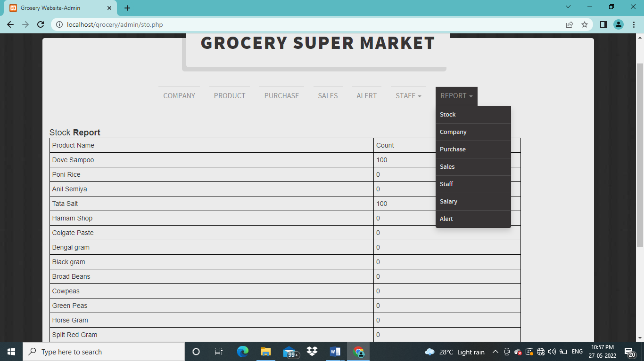

**Fig 8.8. Report**

**CHAPTER-9**

**CONCLUSION**

In this project, analysis of the solutions available for the implementation of grocery management system. Grocery Management system is cost effective and user friendly system for customers. It not only helps to induce organized for grocery shopping, it additionally saves our time and money. With this grocery system, one can be relax and stop worrying of continuously being in follow, and checking the grocery stock in our shop. Shopkeeper gets notification about the low level of grocery and place order for particular item. This helps in ease of society and one step forward of making our city smart.

# CHAPTER-10

# FUTURE ENHANCEMENT

Future work for grocery management system is user can directly place order by android application in our smart phones, so developing an application to automatically placing order to grocery shops is further implementation in this system. We can add multiple usernames and passwords with user- wise separate access and authorities. We can implement search function using different information also. It is also possible to integrate an employee’s time card and a payroll management system in this application. There is another idea to implement SIM card management system. Using bar code scanner and smart card reader, we can minimize manual data entry, which will potentially decrease the amount of time to enter data. But at the same time it will increase the cost of this application.

# CHAPTER-11

# BIBLIOGRAPHY

### BOOKS:

1. “PHP and MySQL Web Development”, Luke Welling, Tata McGraw –Hill, Third Edition, New Delhi, 2010
2. “[PHP: Your Visual Blueprint for Creating Open Source, Server-Side Content](http://www.amazon.com/PHP-Blueprint-Creating-Server-Side-Content/dp/0764535617/ref%3Dcm_lmf_tit_2/192-3150747-4203104)”, Paul Whitehead prentice Hall Publishing, Tata McGraw –Hill, sixth Edition, New Delhi, 2013.
3. “[PHP 4 Bible](http://www.amazon.com/PHP-4-Bible-Tim-Converse/dp/076454716X/ref%3Dcm_lmf_tit_3/192-3150747-4203104)”, Tim Converse McCarty, Tata McGraw Hill, second Edition, New Delhi, 2012
4. “[PHP Functions Essential Reference](http://www.amazon.com/Functions-Essential-Reference-Torben-Wilson/dp/073570970X/ref%3Dcm_lmf_tit_4/192-3150747-4203104) ”, Torben Wilson, McCarty, Tata McGrawHill, First Edition, New Delhi, 2013
5. Web Application Design and Implementation: Apache 2, PHP5, MySQL, JavaScript and Linux/UNIX (Quantitative Software…by Steven A. Gabarro)
6. A PHP and MySQL Web Development (5th Edition) by Luke Welling and Laura Thomson
7. A Head First PHP & MySQL by Lynn Beighley and Michael Morrison

### WEBSITES:

1.[www.w3schools.com/php](http://www.w3schools.com/php) [2.www.php.net](http://www.php.net/) [3.www.tutorialspoint.com/php](http://www.tutorialspoint.com/php)

### Login:

<?php error_reporting(0);

# CHAPTER-12

## SAMPLE CODING

if($_POST["submit"]=='submit')

{

$uname=$_POST['uname']

<?php

$sel=mysql_query("select * from sales"); while($h=mysql_fetch_array($sel))

{

$a=$h[0]; echo"

<tr>

<td>$h[1]</td>

<td>$h[2]</td>

<td>$h[3]</td>

<td>$h[4]</td>

<td>$h[5]</td>

$pword=$_POST['pass']; If($uname=="grosery" and $pword=="grosery")

{

echo "<script>alert('Welcome');</script>";

echo ("<script>location.href='[http://localhost/grosery/home.php'](http://localhost/grosery/home.php%27)</script>");

}

else

{

echo "<script>alert('Enter correct Usernme and password');</script>";

echo ("<script>location.href='[http://localhost/grosery/index.php'](http://localhost/grosery/index.php%27)</script>");

}

}

?>

### Product:

<?php error_reporting(0);

if($_POST["submit"]=='submit')

{

$a=$_POST['pid'];

$b=$_POST['pname'];

$ins=mysql_query("insert into product values('','$a','$b')"); echo "<script>alert('Registration successfull');</script>";

echo ("<script>location.href='[http://localhost/grosery/home.php'](http://localhost/grosery/home.php%27)</script>");

}

?>

### Purchase:

<?php if($_POST["submit"]=='submit')

{

$a=$_POST['pname'];

$b=$_POST['datee'];

$c=$_POST['net'];

$d=$_POST['quan'];

$e=$_POST['purchase'];

$f=$_POST['sales'];

$ins=mysql_query("insert into purchase values('','$a','$b','$c','$d','$e','$f')"); echo "<script>alert('Registration successfull');</script>";

echo ("<script>location.href='[http://localhost/grosery/purchase.php'](http://localhost/grosery/purchase.php%27)</script>");

}

?>

### Purchase Edit:

<?php error_reporting(0);

if($_POST["update"]=='update')

$aa=$_POST['pname'];

$b=$_POST['net'];

$c=$_POST['tot'];

$d=$_POST['purchase'];

$e=$_POST['sales']; echo $aa;

$ins=mysql_query("UPDATE purchase SET quantity='$c' , purch='$d', sales='$e' WHERE pname='$aa' ");

echo "<script>alert('Product Detail Updated successfully');</script>";

}

?>

### Sales:

<?php if($_POST["submit"]=='submit')

{

$a=$_POST['pname'];

$b=$_POST['datee'];

$c=$_POST['net'];

$d=$_POST['cost'];

$e=$_POST['quan'];

$f=$_POST['tot'];

$g=$_POST['bill'];

$h=$_POST['name'];

$i=$_POST['add'];

$j=$_POST['mob'];

$ee=$_POST['quan1'];

$ins=mysql_query("insert into sales values('','$a','$b','$c','$d','$e','$f','$g','$h','$i','$j')");

$ins1=mysql_query("UPDATE purchase SET quantity='$ee' WHERE pname='$a' "); echo "<script>alert('Registration successfull');</script>";

echo ("<script>location.href='[http://localhost/grosery/sales.php'](http://localhost/grosery/sales.php%27)</script>");

}?>

### Stock:

<?php

$sel=mysql_query("select * from purchase"); while($h=mysql_fetch_array($sel))

{

$a=$h[0]; echo"

<tr>

<td>$h[1]</td>

<td>$h[3]</td>

<td>$h[4]</td>

</tr>";

}

?>

### Employee:

<?php if($_POST["submit"]=='submit')

{

$a=$_POST['eid'];

$b=$_POST['ename'];

$c=$_POST['posi'];

$d=$_POST['addr'];

$e=$_POST['mob'];

$f=$_POST['salary'];

$ins=mysql_query("insert into employee values('','$a','$b','$c','$d','$e','$f')"); echo "<script>alert('Employee Registration successfull');</script>";

echo ("<script>location.href='[http://localhost/grosery/employee.php'](http://localhost/grosery/employee.php%27)</script>");

}

?>

### Cashier:

<?php if($_POST["submit"]=='submit')

{

$a=$_POST['date'];

$b=$_POST['type'];

$c=$_POST['amt'];

$d=$_POST['purpose'];

$ins=mysql_query("insert into cashier values('','$a','$b','$c','$d')"); echo "<script>alert('Account Details Added successfully');</script>";

echo ("<script>location.href='[http://localhost/grosery/cashier.php'](http://localhost/grosery/cashier.php%27)</script>");

}?>

### Purchase Report:

<?php

$sel=mysql_query("select * from purchase"); while($h=mysql_fetch_array($sel))

{

$a=$h[0]; echo"

<tr>

<td>$h[1]</td>

<td>$h[2]</td>

<td>$h[3]</td>

<td>$h[4]</td>

<td>$h[5]</td>

<td>$h[6]</td>

</tr>";

}?>

### Sales Report:

<?php

$sel=mysql_query("select * from sales"); while($h=mysql_fetch_array($sel))

{

$a=$h[0]; echo"

<tr>

<td>$h[1]</td>

<td>$h[2]</td>

<td>$h[3]</td>

<td>$h[4]</td>

<td>$h[5]</td>

<td>$h[6]</td>

<td>$h[7]</td>

<td>$h[8]</td>

<td>$h[9]</td>

<td>$h[10]</td>

</tr>";

}?>

### Employee Report:

<?php

$sel=mysql_query("select * from employee"); while($h=mysql_fetch_array($sel))

{

$a=$h[0]; echo"

<tr>

<td>$h[1]</td>

<td>$h[2]</td>

<td>$h[3]</td>

<td>$h[4]</td>

<td>$h[5]</td>

<td>$h[6]</td>

</tr>";

}?>

### Cash Report:

<?php

$sel=mysql_query("select * from cashier"); while($h=mysql_fetch_array($sel))

{

$a=$h[0]; echo"

<tr>

<td>$h[1]</td>

<td>$h[2]</td>

<td>$h[3]</td>

<td>$h[4]</td>

</tr>";

}?>