**Front-End UI/UX Mini Project**

**Project Title:** Business Card Template

**Submitted by:**

* **Team members:** Thirisha Babu Velu

Aishwarya S

Tharika K

* **Roll Number:** 2460464

2460315

2460463

* **College E-mail id:** thirisha.babu@btech.christuniversity.in

aishwarya.s@btech.christuniversity.in

tharika.k@btech.christuniversity.in

**Course:** Front-End UI/UX Development

**Instructor Name:** Mr. Narendran

**Institution:** Christ University

**Date of Submission:**26.09.2025

**2.Abstract:**

* This project involves designing a customizable business card template using HTML and CSS.
* It includes fields for contact details such as name, title, phone number, email, and website.
* The layout leverages CSS Grid and Flexbox for structure and uses semantic tags for clarity and accessibility.

**3.Objectives:**

* Develop a visually balanced business card layout using semantic HTML and CSS.
* Apply responsive design techniques to ensure adaptability across devices.
* Use CSS variables and modular styling for easy customization.
* Optimize the template for print output with dedicated media queries.

**4.Scope of the Project:**

* Focused on front-end layout and styling of a digital business card.
* No dynamic data or interactivity beyond hover effects.
* Designed to be responsive and print-friendly.
* Customizable for different professions and branding styles.
* Built using semantic HTML and modular CSS.

**5.Tools & Technologies Used:**

|  |  |
| --- | --- |
| **Tool/Technology** | **Purpose** |
| HTML5 | Semantic markup for contacts details |
| CSS3 | Styling, layout and print optimization |
| Flexbox/Grid | Structured layout and alignment |
| CSS Variables | Easy theme customization |
| VS Code | Code editor |
| Chrome DevTools | Inspecting elements and testing responsiveness |

**6.HTML Structure Overview:**

* Semantic tags used: <section>, <article>, <h1>, <p>, <address>, <footer>.
* Structure:

1. <section class= ”card”>: Main container.
2. <article>: Name and title.
3. <address>: Contact details.
4. <footer>: Branching or social links.

* Clean hierarchy for easy customization and accessibility.

**7.CSS Styling Strategy:**

* External CSS file (card-style.css) with clear comments.
* Layout:

1. CSS Grid for structured placement of elements.
2. Flexbox for alignment and spacing.

* Styling Techniques:

1. CSS Variables for color themes and font sizes.
2. Hover effects on contact links.
3. Print media queries for crisp output.

* Typography: Professional fonts with readable sizes.
* Responsive tweaks: Adjust card size and spacing for mobile view.

**8.Key Features:**

**8.Key Features:**

|  |  |
| --- | --- |
| **Key Features** | **Description** |
| Custom Layout | Can arrange name, title and contact info in any way |
| Responsive design | Looks good on phones, tablets and computers |
| Semantic HTML | Uses clean tags that help with understanding and access |
| Print Styling | Prints neatly with special styles for paper |
| Hover effects | Links change when you move mouse over them |
| CSS theme variables | Easy to switch colours and styles using simple settings |

**9.Challenges Faced & Solutions:**

|  |  |
| --- | --- |
| **Challenges Faced** | **Solutions** |
| Making the card look good on all devices | Used CSS Grid and Flexbox for responsive layout |
| Keeping the design clean and readable | Chose simple fonts and good spacing |
| Printing the card without layout issues | Added print-specific CSS with media queries |
| Allowing easy customization | Used CSS variables for colours and font sizes |
| Aligning contact info neatly | Structured content with semantic HTML and Flexbox |
| Making hover effects smooth | Added transitions for links and icons |

**10.Outcome:**

* A sleek, professional business card layout adaptable to various industries.
* Print-ready and mobile-friendly design.
* Easy customization for branding and personal style.
* Clean code structure for scalability and reuse.

**11.Future Enhancements:**

* Add QR code linking to portfolio or LinkedIn.
* Include downloadable PDF or image export option.
* Offer multiple layout presets (minimalist, bold, elegant).
* Add interactive elements like social media icons.

**12.Sample Code:**

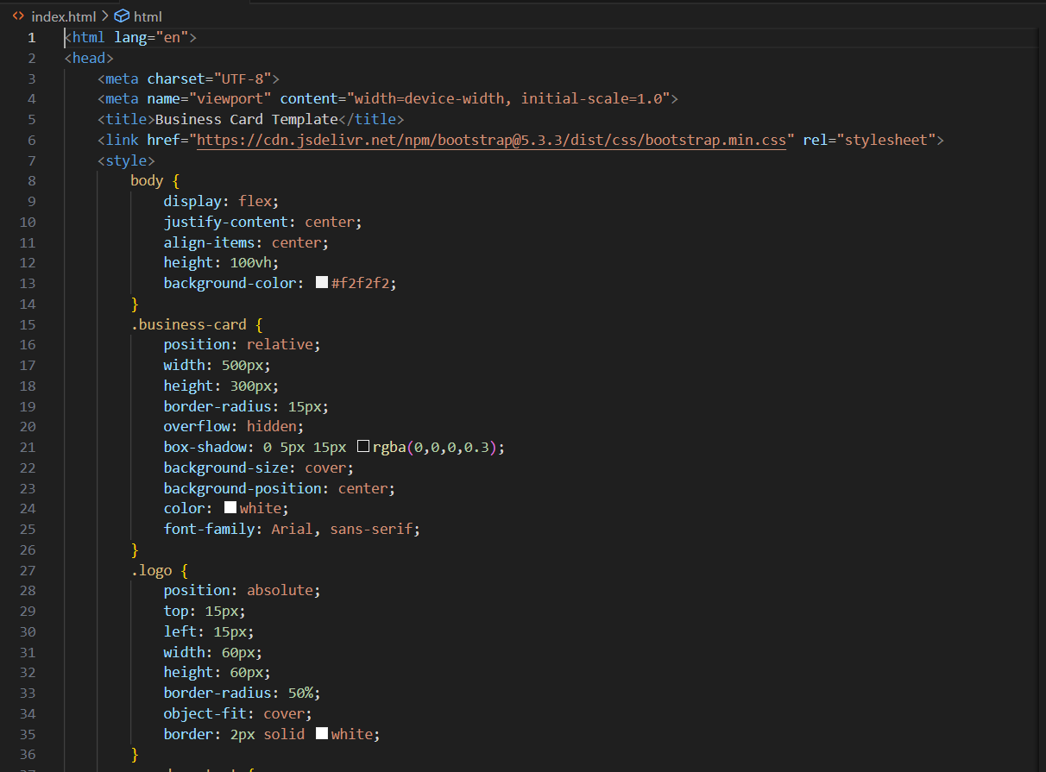

**13.Screenshots of Final Output:**

* Output as seen on laptop

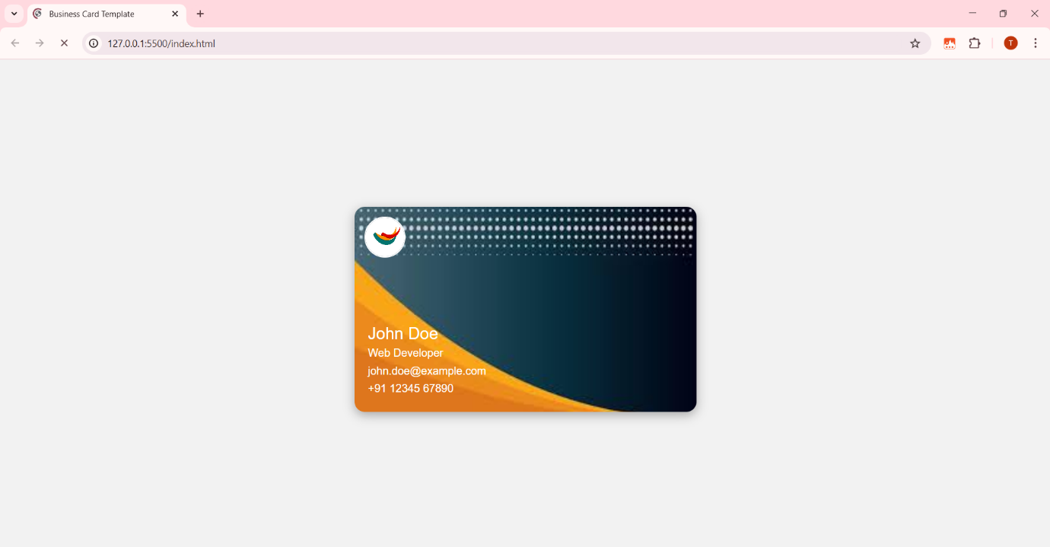

* Output as seen on mobile phone

**14.Conclusion:**

* The Business Card Template project showcases how HTML and CSS can be used to create elegant, responsive, and print-ready digital assets.
* Its clean codebase and modular styling allow for easy updates and branding adjustments. This project highlights the potential of front-end design in crafting impactful personal and professional identity tools.

**15.References:**

* L&T LMS: https://learn.lntedutech.com/Landing/My