**Sample project – Online Computer Store.**

This sample project will help you to understand what are the basic functions you should have in your project.

|  |  |
| --- | --- |
| **Front end:**  Home page  Category page  Product page  Contact us page  Register page  Login page  User profile page  Search page | **Back end**  Admin login  Category page – Display category  Add category page – Add new Category  Product page – Display all the product  Add product page – Add products  Users page – user /customer details |

Folder structure should be as below.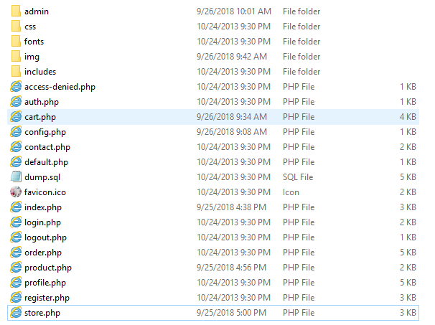

As you can see all the pages are php, and dynamic, you can run and study this project. database dump is inside database folder.