**Authentication Implementation and CRUD operations ( IT18135862)**

This app has a user panel and admin panel. From a user panel, Customers can sign up and then sign in to the account and order items. From the admin panel, administrator can sign in, manage orders and items. User can register, update and delete their account.

* Create account

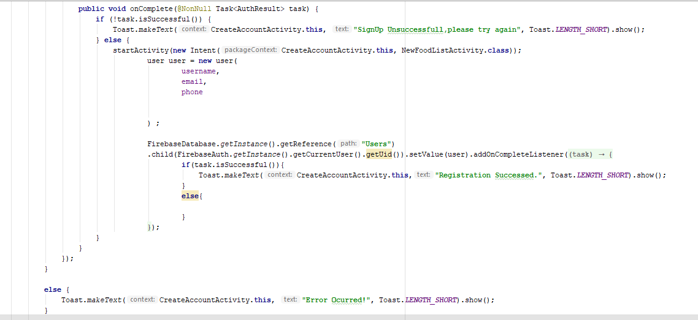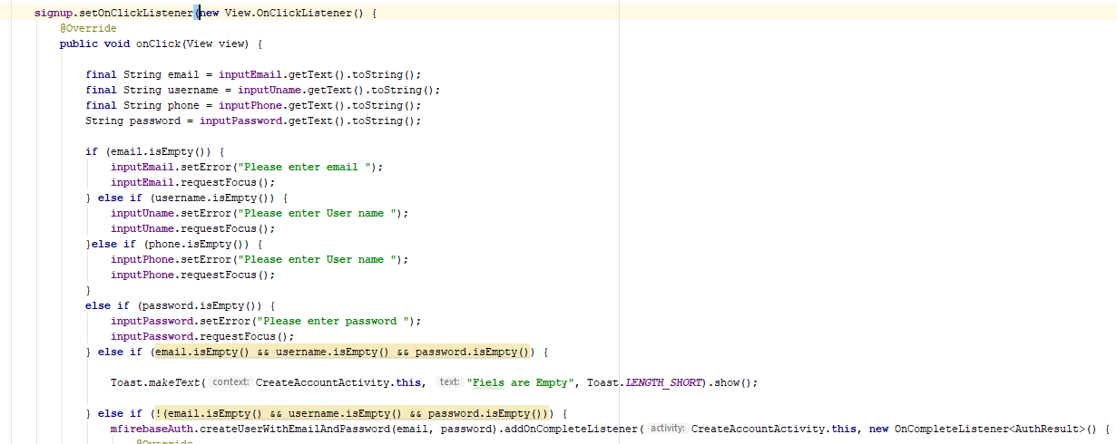Users should enter username, phone number, email, and password. I added validation to each textbox. It will show, message in the textbox that called fill empty fields. When the user entered information correctly system will log into the food list page. When the user did not fill text fields correctly app will show toast message called "signup in unsuccessful, please try again".

* Update Account

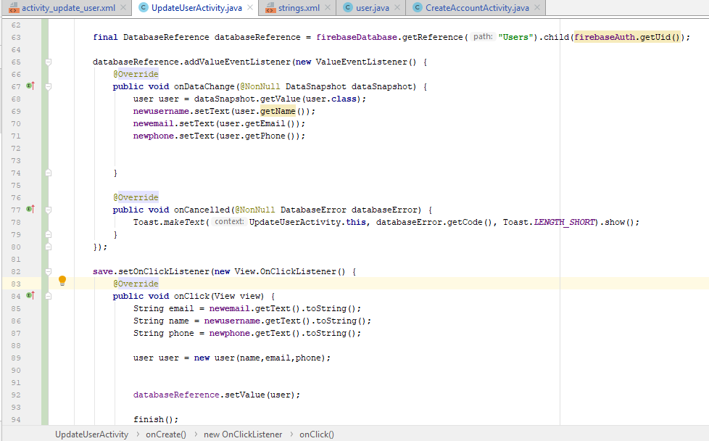Users can update their details. Such as user name , email and password. And Users can see their information in that activity.

* Delete Account

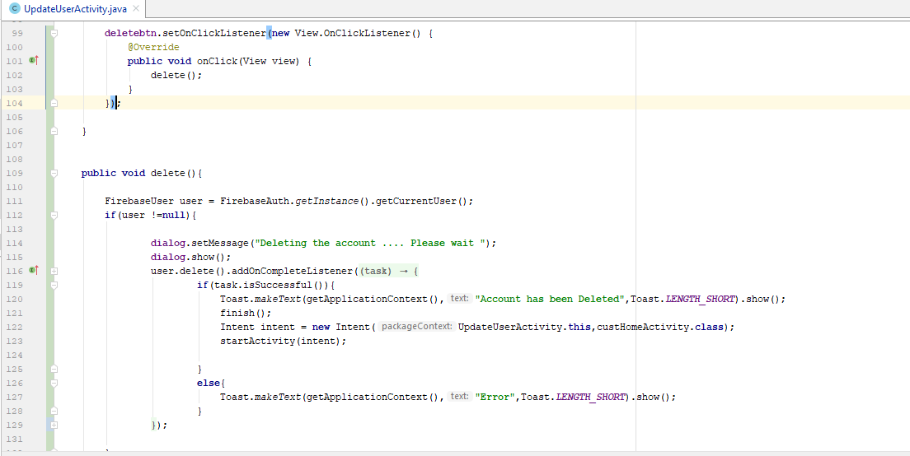Users can delete their account from delete account button.

**Menu Management – IT18149654**

* In this system, the users can log in as both customer and administrator. In both cases, the app displays a list of available food items, but with different functionalities.
* If the user is logged in as a customer, tapping on a food item in the list will show an activity with necessary details like quantity and unit price for the customer to order that food item.
* If the user is logged in as an administrator, tapping on a food item in the list will show an activity with all the details of the food item such as name, unit price, description, image and discount.
* The administrator can perform the CRUD operations regarding food items such as updating all the details of the food item and if necessary, deleting the food item.
* The administrator also can add a new food item to the list by entering all the necessary details of the new food item.
* All the forms that users must fill when updating and inserting are validated to prompt the user to enter correct and valid details.
* A confirmation alert dialog is displayed each time the user wants to insert, update and delete food item to confirm the decision.
* Search functionality is also available to search food items by name.

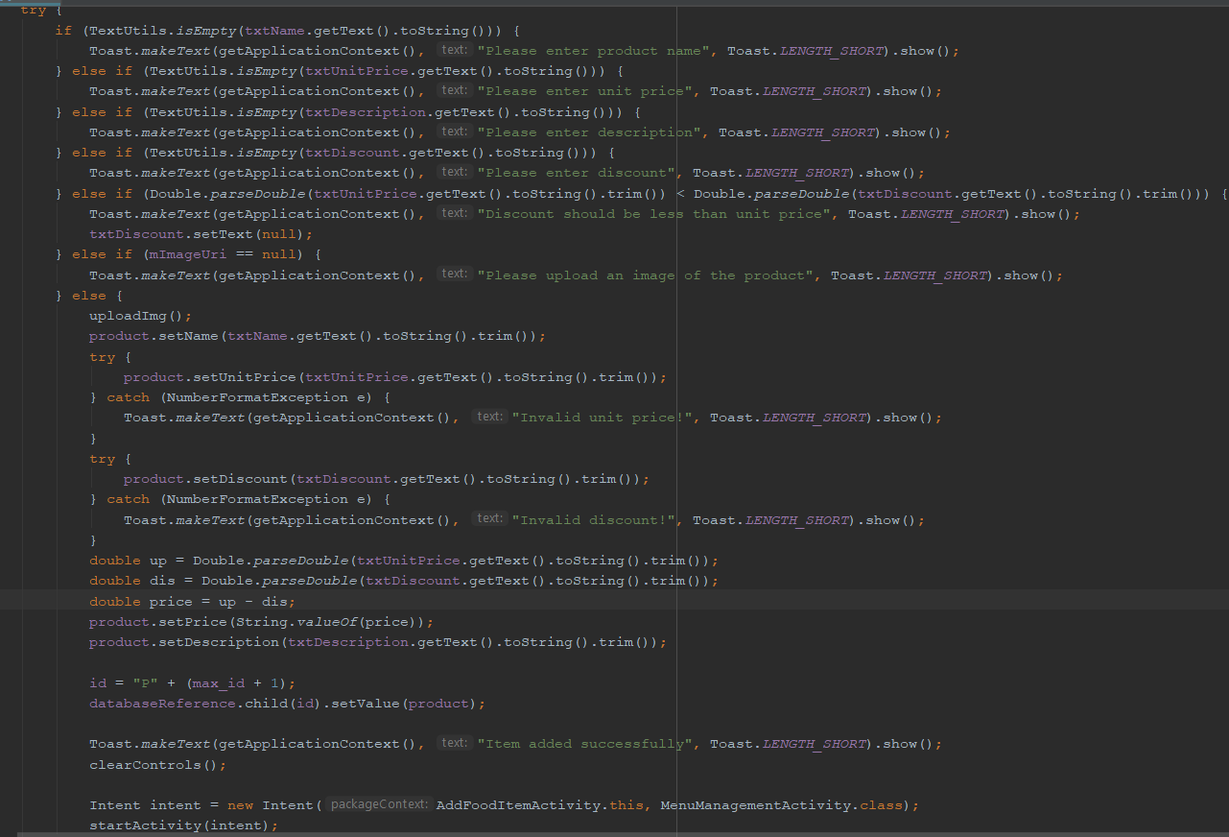Insert Food Item

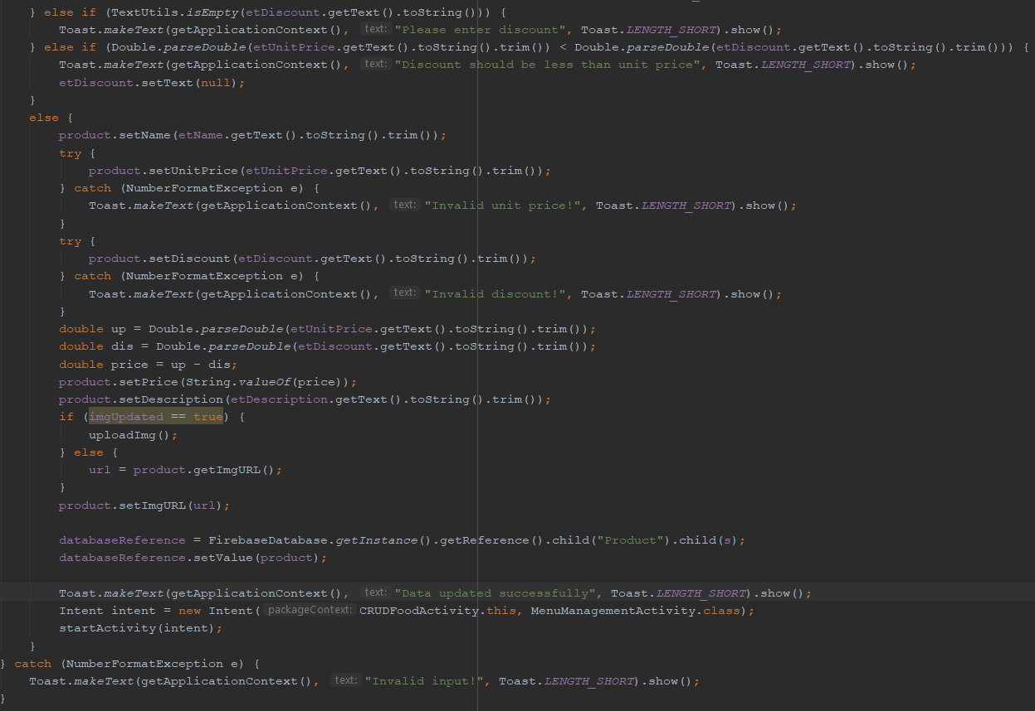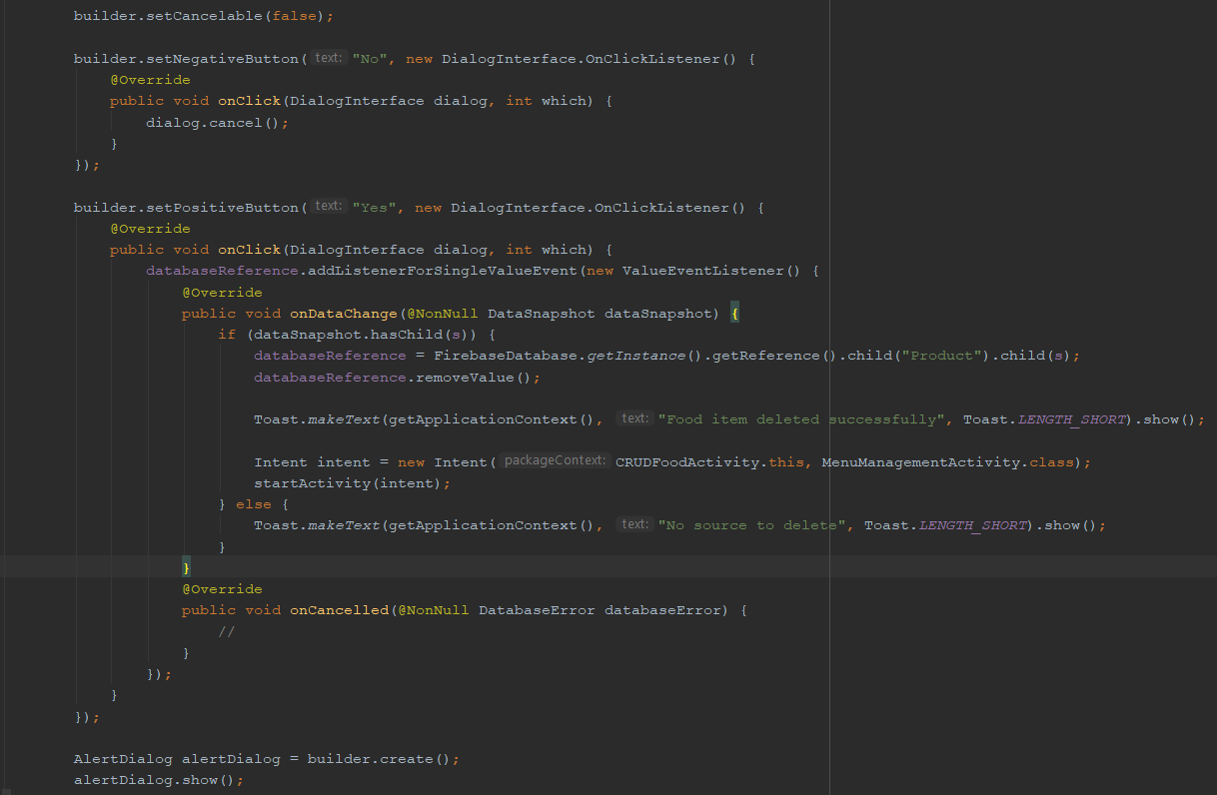Update Food Item

Delete Food Item

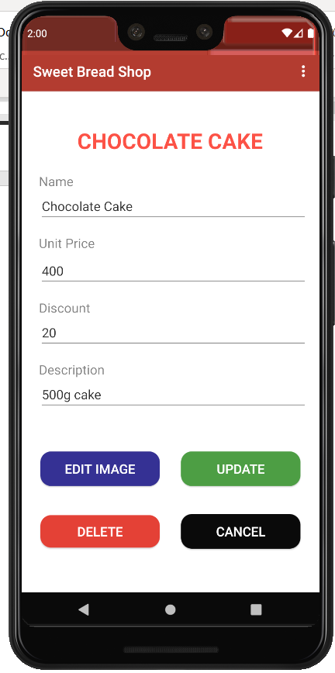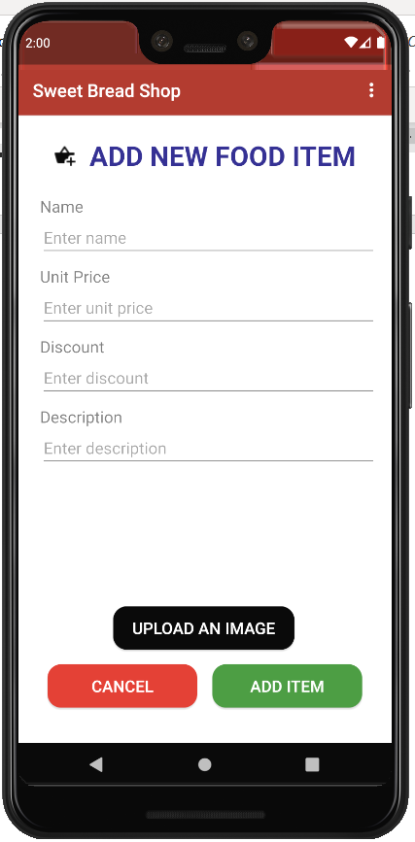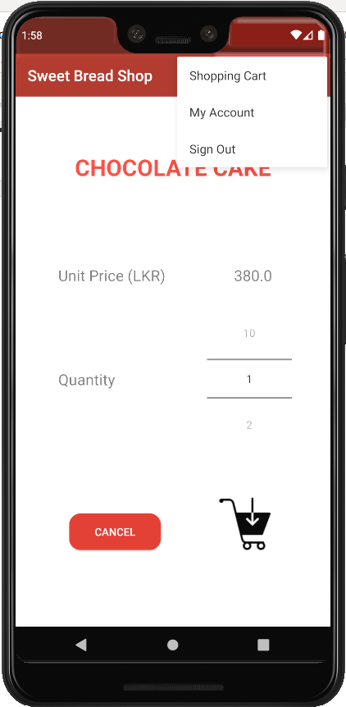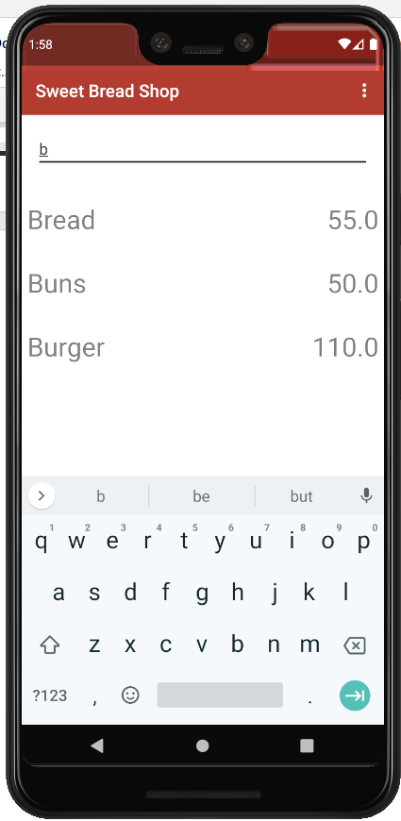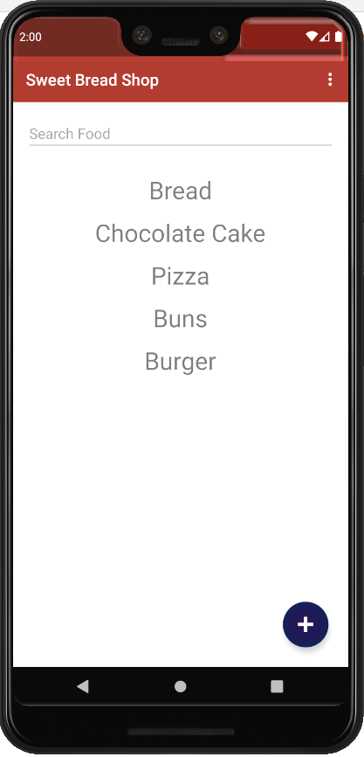

**Update/Delete Food Items UI**

**Add New Food Item UI**

**View Food Details UI**

**Search Functionality UI**

**Menu Management UI**

Sweet Bread Shop Food Cart

* In this functionality, the users of the app can go through the menu list of the food items and they can add the food items they want to the cart. And later they can go through the list of the food items they have added to the cart .
* Food cart shows the total amount to be paid for all the items in the cart.
* By clicking the item names in the list of the cart, they can get the descriptions of that particular food items.
* If the users want to update the quantity of a particular food item, they can change that by using the update button.
* Users can delete whatever the items they don’t need from the list of the food cart.
* At last the users can confirm the delivery orders of the items they need by clicking the delivery button.

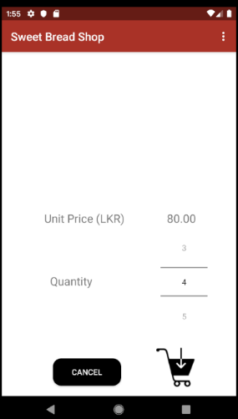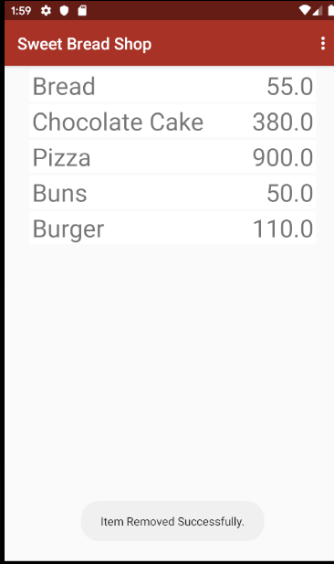

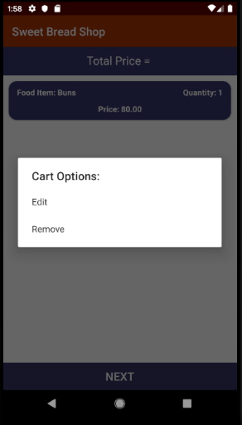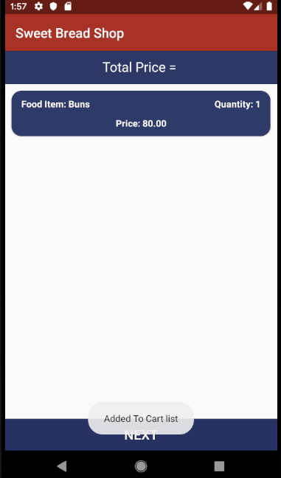

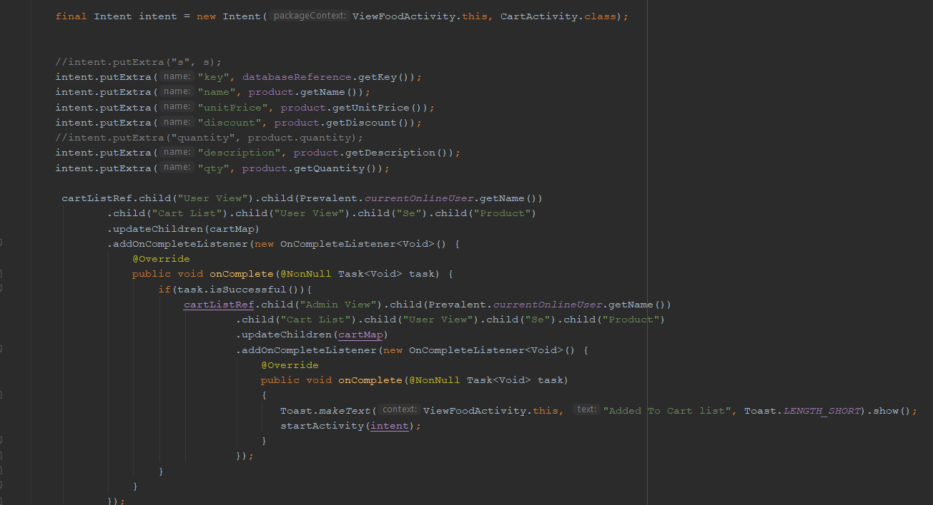

Add Food Items to the Cart

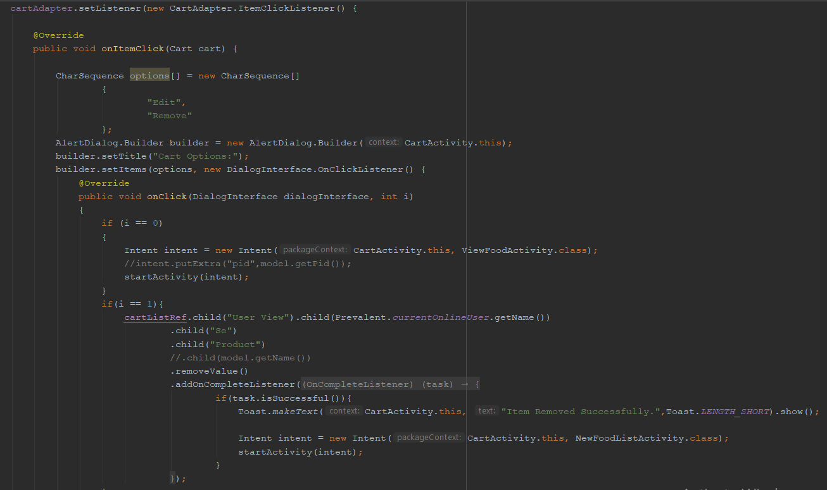

Update and Delete the Cart List Items

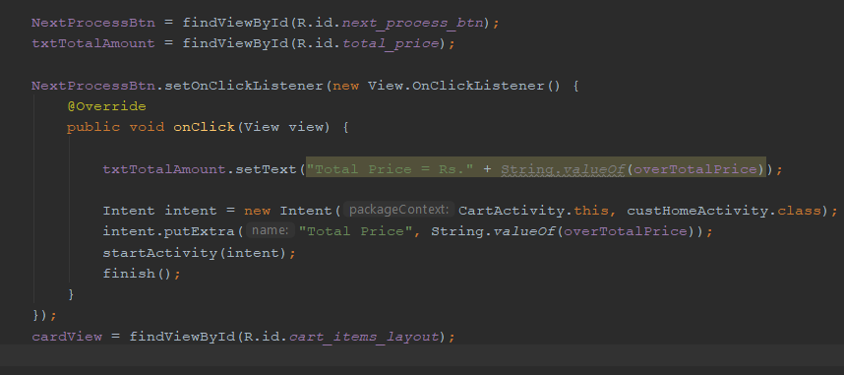

Get the total of the food items