EE5351: CONTROL SYSTEM DESIGN

LABORATORY 01

NAME : BANDARA KMTON

REG.NO. : EG/2021/4432

GROUP NO. : CE 07

DATE : 20/01/2024

Summative Laboratory Form

|  |  |
| --- | --- |
| Semester | 05 |
| Module Code | EE5351 |
| Module Name | Control Systems Design |
| Lab Number | 01 |
| Lab Name | Laboratory Session 1 |
| Lab Conducted Date | 2024.11.05 |
| Report Submission Date | 2025.01.24 |

Table of Contents

1 OBSERVATIONS 5

2 REFERENCES 14

Table of Figures

Figure 1:MathLAB code for the Speed Response 6

Figure 2: Graph For the Speed Response When input Voltage as 3V 6

Figure 3:Simulink for Speed Response 7

Figure 4: Simulink for simplified version 7

Figure 5: Combination of the Simulink for 2,4,5,6,7 Questions 8

Figure 6: Speed Response given by the Model that had created 9

Figure 7: The graph given by state space model and Simulink Model 9

Figure 8: Time Domain Response 10

Figure 9: Time Domain Response (Kp= 1) 11

Figure 10: Time Domain Response (Kp= 1.25) 11

Figure 11: Time Domain Response (Kp= 1.50) 12

Figure 12: Time Domain Response (Kp= 1.75) 12

Figure 13: Time Domain Response(Kp= 2.00) 13

# OBSERVATIONS

Q1)

1. $V_{m}$ = $i_{m}R_{m}$ + $L_{m}\frac{{di}_{m}}{dt}$ + $e_{b}$ $⋯$ 1

$e_{b}$ = $k_{m}ω_{m}$ $⋯$ 2

$T_{m}$ = $J_{eq}\frac{{dω}_{m}}{dt}$ $⋯$ 3

$T_{m}$ = $i_{m}k_{t}$ $⋯$ 4

1. Considering the above equations Speed Control Given as:

$\frac{ω_{m}(S)}{V_{m}(S)}$ = $\frac{k_{t}}{[J_{eq}S\left(R_{m}+L_{m}S\right]+k_{m}k_{t}]}$

= $\frac{0.042}{[2.09×{10}^{-5}S\left(8.4+1.16×{10}^{-3}S\right)+0.042×0.042]}$

= $\frac{0.042}{2.424×{10}^{-8}S^{2}+1.756×{10}^{-4}S+1.764×{10}^{-3}}$

Considering the above equations Position Control Given as:

$\frac{θ_{m}(S)}{V_{m}(S)}$ = $\frac{k_{t}}{S[J_{eq}S\left(R_{m}+L_{m}S\right]+k_{m}k_{t}]}$

= $\frac{0.042}{2.424×{10}^{-8}S^{3}+1.756×{10}^{-4}s^{2}+1.764×{10}^{-3}S}$

1. 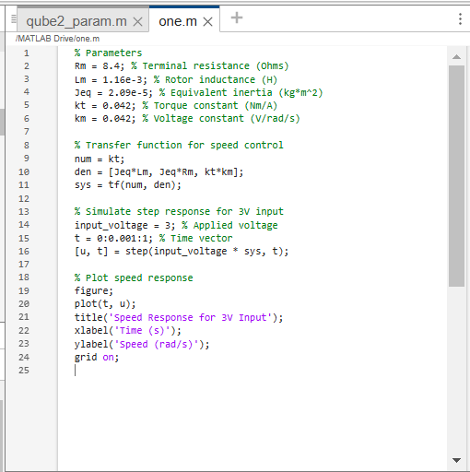

Figure 1:MathLAB code for the Speed Response

Figure 2: Graph For the Speed Response When input Voltage as 3V

Figure 3:Simulink for Speed Response

1. Speed Control Given as:

$\frac{ω_{m}(S)}{V_{m}(S)}$ = $\frac{k_{t}}{[J_{eq}S\left(R_{m}\right]+k_{m}k_{t}]}$

= $\frac{0.042}{1.756×{10}^{-4}S+1.764×{10}^{-3}}$

Position Control Given as:

$\frac{θ_{m}(S)}{V_{m}(S)}$ = $\frac{k_{t}}{S[J_{eq}S\left(R_{m}\right]+k_{m}k_{t}]}$

= $\frac{0.042}{1.756×{10}^{-4}s^{2}+1.764×{10}^{-3}S}$

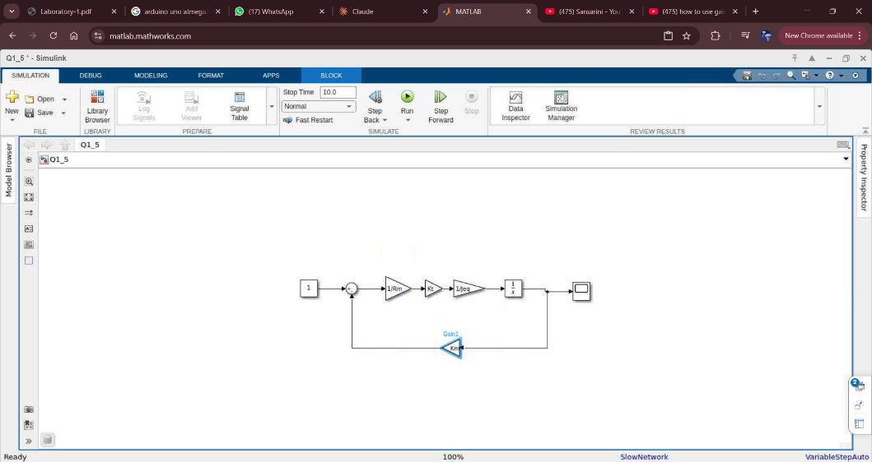

Figure 4: Simulink for simplified version

1. Considering the equations given above:

$\dot{i_{m}}$ = $-\left(\frac{R_{m}}{L_{m}}\right)I_{m}-\left(\frac{k_{m}}{L_{m}}\right)ω_{m}+\frac{V_{m}}{L_{m}}$

$\dot{ω_{m}}$ = $-\left(\frac{k_{t}}{J_{eq}}\right)I_{m}-0×ω_{m}+{0×V}_{m}$

$ω_{m}$ = 0 $×I_{m}+1×ω_{m}+{0×V}_{m}$

$\left({\dot{i_{m}} \atop \dot{ω_{m}}}\right)$ = $\left[\begin{matrix}-\frac{R_{m}}{L_{m}} & -\frac{k_{m}}{L_{m}} \\ \frac{k_{t}}{J_{eq}} & 0\end{matrix}\right]\left({I_{m} \atop ω_{m}}\right)+\left({\frac{1}{L_{m}} \atop 0}\right)V_{m}$

$\left({\dot{i_{m}} \atop \dot{ω_{m}}}\right)$ = $\left[\begin{matrix}-7241.38 & -36.21 \\ 2009.57 & 0\end{matrix}\right]\left({I_{m} \atop ω_{m}}\right)$ + $\left({862.07 \atop 0}\right)V_{m}$

$ω_{m}$ = $\left[0 1\right]×\left({I_{m} \atop ω_{m}}\right)+{0×V}_{m}$

1. Considering the simplified version

$\dot{θ}$ = $0×θ_{m}+ω_{m}+0×v_{m}$

$\dot{ω_{m}}$ = $0×θ_{m}-\left(\frac{k_{t}k_{m}}{R_{m}J_{eq}}\right)ω_{m}+\left(\frac{K_{t}}{J_{eq}R_{m}}\right)V_{m}$

$ω_{m}$ = 0 $×θ_{m}+1×ω_{m}+{0×V}_{m}$

$\left({\dot{θ} \atop \dot{ω_{m}}}\right)$ = $\left[\begin{matrix}0 & 1 \\ 0 & -\left(\frac{k_{t}k_{m}}{R_{m}J_{eq}}\right)\end{matrix}\right]\left({θ_{m} \atop ω_{m}}\right)+\left({0 \atop \frac{K_{t}}{J_{eq}R_{m}}}\right)V_{m}$

$\left({\dot{θ} \atop \dot{ω_{m}}}\right)$ = $\left[\begin{matrix}0 & 1 \\ 0 & -10.05\end{matrix}\right]\left({θ_{m} \atop ω_{m}}\right)+\left({0 \atop 239.23}\right)V_{m}$

$ω_{m}$ = $\left[0 1\right]×\left({θ_{m} \atop ω_{m}}\right)+{0×V}_{m}$

1. 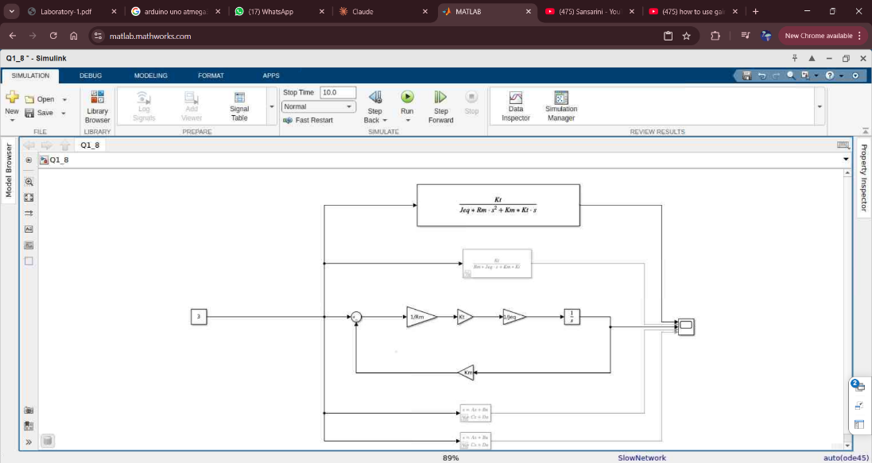

Figure 5: Combination of the Simulink for 2,4,5,6,7 Questions

Q2)

1. A screen shot of a white screen

   Description automatically generated

Figure 6: Speed Response given by the Model that had created

Figure 7: The graph given by state space model and Simulink Model

1. Comparing the graphs there can be error as 10 .

So considering the error the reasons can be achieved by the models value was get by running the rotor so there can be a error that has negligible . not only that but also considering the assumption that the rotor and the modelspace there can be done the errors doing in the the simulate of the equations. As well as when running of the software which can be also happened the errors as can be stucked etc.

Q3)

1. A graph on a white surface

   Description automatically generated

Figure 8: Time Domain Response

Steady State Error: $1-0.938$: 0.062

1. When Kp= 1

Steady State Error : $1-0.938$: 0.062

Overshoot :

: 42.32%

Figure 9: Time Domain Response (Kp= 1)

When Kp= 1.25

Steady State Error : $1-1.012$: 0.012

Overshoot :

: 35.77%

Figure 10: Time Domain Response (Kp= 1.25)

When Kp= 1.50

Steady State Error : $1-1.009$: 0.009

Overshoot :

: 39.246%

Figure 11: Time Domain Response (Kp= 1.50)

When Kp= 1.75

Steady State Error : $1-0.9603$: 0.039

Overshoot :

: 50.16%

Figure 12: Time Domain Response (Kp= 1.75)

When Kp= 2.00

Steady State Error : $1-0.9633$: 0.0367

Overshoot :

: 52.18%

Figure 13: Time Domain Response(Kp= 2.00)

# REFERENCES

|  |  |
| --- | --- |
| [1] | “GREEKFOGGREEK,” [Online]. Available: https://www.geeksforgeeks.org/proportional-controller-in-control-system/. |
| [2] | “Control Tutorials,” [Online]. Available: https://ctms.engin.umich.edu/CTMS/index.php?example=Introduction&section=ControlPID. |