EE5351: CONTROL SYSTEM DESIGN

LABORATORY 01

NAME : BANDARA LRTD

REG No. : EG/ 2021/ 4433

GROUP NO: CE07

DATE : 24/01 /2025

Table : Summative Laboratory Form

|  |  |
| --- | --- |
| Semester | 05 |
| Module Code | EE5351 |
| Module Name | Control System Design |
| Lab Number | 01 |
| Lab Name | Laboratory Section 1 |
| Lab conduction date | 2024.11.05 |
| Report Submission date | 2025.01.24 |

**Contents**

1 OBSERVATION 6

2 CALCULATION 7

3 REFERENCES 17

**List of Tables**

Table : Summative Laboratory Form

Table 2: Observations 6

**List of Figures**

Figure 1: MathLab code for the Speed Response 8

Figure 2: Speed Response Get by Mathlab 8

Figure 3: Speed Response Given by Simulink 8

Figure 4: Simulink for simplified transfer function 9

Figure 5: Simulink for combination of the state space vector, transfer function 11

Figure 6: Speed Response in the Model 12

Figure 7: Comparing of the Speed Response with Model and State Vector 12

Figure 8: The Speed Response when KP=1 13

Figure 9: Speed Response from Simulink when KP=1.25 14

Figure 10: Speed Response from Simulink when KP=1.50 14

Figure 11: Speed Response from Simulink when KP=1.75 15

Figure 12: Speed Response from Simulink when KP=2.0 15

# OBSERVATION

Table : Observations

|  |  |  |
| --- | --- | --- |
| Terminal Resistance (Rm) | 8.4 | Ω |
| Rotor inductance (Lm) | 1.16 | mH |
| Equivalent(Jen) | 2.09×10⁻⁵ | kgm² |
| Torque constant (Kt) | 0.042 | Nm/A |
| Voltage constant (Km) | 0.042 | Nm/A |

# CALCULATION

Q1.

1. .
2. Voltage equation:

2. Back EMF equation:

3. Torque equation:

4. Motor torque relationship:

$$T_{m}=i_{m}k_{t}$$

1. From equations (1), (2), (3), and (4), the speed control transfer function is derived as:

$$\frac{ω\left(s\right)}{V_{m}\left(s\right)}=\frac{k_{t}}{J_{e}qs\left[R_{m}+L_{m}s\right]+k_{m}k_{t}}$$

$$\frac{ω\left(s\right)}{V_{m}\left(s\right)}=\frac{0.042}{2.09×{10}^{-5}s\left[8.4+1.16×{10}^{-3}s\right]+0.042×0.042}$$

$$\frac{ω\left(s\right)}{V_{m}\left(s\right)}=\frac{0.042}{2.4244×{10}^{-8}s^{2}+17.556×{10}^{-5}s+1.764×{10}^{-3}}$$

From equations (1), (2), (3), and (4):

$$\frac{θ_{m}\left(s\right)}{V_{m}\left(s\right)}=\frac{k_{t}}{s\{J_{eq}s\left[R_{m}+L_{m}s\right]+k_{m}k_{t}\}}$$

$$\frac{θ_{m}\left(s\right)}{V_{m}\left(s\right)}=\frac{0.042}{2.4244×{10}^{-8}s^{3}+17.556×{10}^{-5}s^{2}+1.764×{10}^{-3}s}$$

1. 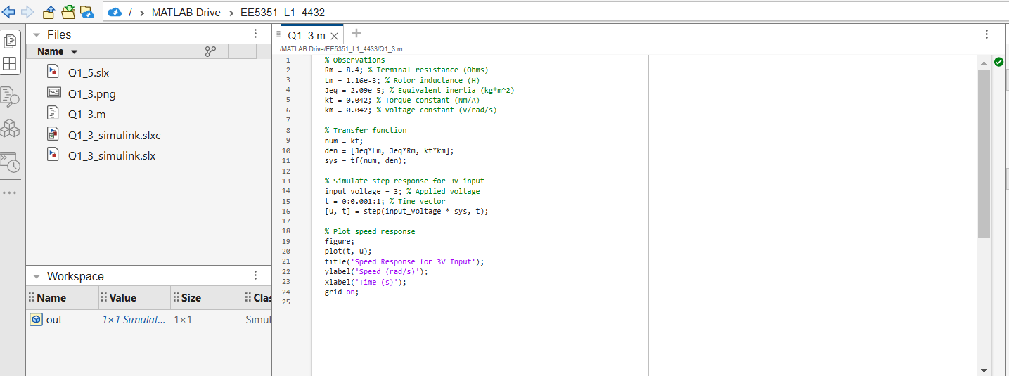

Figure : MathLab code for the Speed Response

Figure : Speed Response Get by Mathlab

Figure : Speed Response Given by Simulink



Simplified Equations for Speed Control Transfer Function

$$\frac{ω\left(s\right)}{V_{m}\left(s\right)}=\frac{k_{t}}{J_{eq}R_{m}s+k_{m}k_{t}}$$

$$\frac{ω\left(s\right)}{V_{m}\left(s\right)}=\frac{0.042}{\{2.09×{10}^{-5}⋅8.4s+0.042×0.042\}}$$

$$\frac{ω\left(s\right)}{V_{m}\left(s\right)}=\frac{0.042}{\{1.7556×{10}^{-4}s+1.764×{10}^{-3}\}}$$

Simplified Equations for Position Control Transfer Function



Figure : Simulink for simplified transfer function



From the equations 1, 2, 3, 4;

$\dot{i_{m}}$ = $-\left(\frac{R_{m}}{L_{m}}\right)i_{m}-\left(\frac{k_{m}}{L_{m}}\right)ω_{m}+\frac{V_{m}}{L_{m}}$

$\dot{ω_{m}}$ = $\left(\frac{k_{t}}{J_{\text{eq}}}\right)i_{m}+0×ω_{m}+0×V_{m}$

$\left[\begin{matrix}\dot{i_{m}} \\ \dot{ω_{m}}\end{matrix}\right]$ = $\left[\begin{matrix}-\left(\frac{R_{m}}{L_{m}}\right) & -\left(\frac{k_{m}}{L_{m}}\right) \\ \left(\frac{k_{t}}{J_{\text{eq}}}\right) & 0\end{matrix}\right]\left[\begin{matrix}i_{m} \\ ω_{m}\end{matrix}\right]$ + $\left[\begin{matrix}\frac{1}{L_{m}} \\ 0\end{matrix}\right]V_{m}$

$\left[\begin{matrix}\dot{i_{m}} \\ \dot{ω_{m}}\end{matrix}\right]$ = $\left[\begin{matrix}-7241.38 & -36.21 \\ 2009.57 & 0\end{matrix}\right]\left[\begin{matrix}i_{m} \\ ω_{m}\end{matrix}\right]$ + $\left[\begin{matrix}862.07 \\ 0\end{matrix}\right]V_{m}$

$ω_{m}$ = $0×i_{m}+1×ω_{m}+0×V_{m}$

$ω_{m}$ = $\left[0 1\right]×\left[\begin{matrix}i_{m} \\ ω_{m}\end{matrix}\right]+0×V_{m}$

From the simplified equations

$\dot{θ_{m}}=0⋅θ_{m}+ω_{m}+0⋅V_{m}$

$$\dot{ω_{m}}=0⋅θ_{m}-\left(\frac{k_{t}k_{m}}{R_{m}J_{\text{eq}}}\right)ω_{m}+\left(\frac{k_{t}}{J_{\text{eq}}R_{m}}\right)V_{m}$$

$\left[\begin{matrix}\dot{θ_{m}} \\ \dot{ω_{m}}\end{matrix}\right]$ = $\left[\begin{matrix}0 & 1 \\ 0 & -\left(\frac{k_{t}k_{m}}{R_{m}J_{\text{eq}}}\right)\end{matrix}\right]\left[\begin{matrix}θ_{m} \\ ω_{m}\end{matrix}\right]$ + $\left[\begin{matrix}0 \\ \left(\frac{k_{t}}{J_{\text{eq}}R_{m}}\right)\end{matrix}\right]V_{m}$

$\left[\begin{matrix}\dot{θ_{m}} \\ \dot{ω_{m}}\end{matrix}\right]$ = $\left[\begin{matrix}0 & 1 \\ 0 & -10.05\end{matrix}\right]\left[\begin{matrix}θ_{m} \\ ω_{m}\end{matrix}\right]$ + $\left[\begin{matrix}0 \\ 239.23\end{matrix}\right]V_{m}$

$ω_{m}$ = $0×θ_{m}+1×ω_{m}+0×V_{m}$

$ω_{m}$ = $\left[0 1\right]×\left[\begin{matrix}θ_{m} \\ ω_{m}\end{matrix}\right]+0×V_{m}$

1. 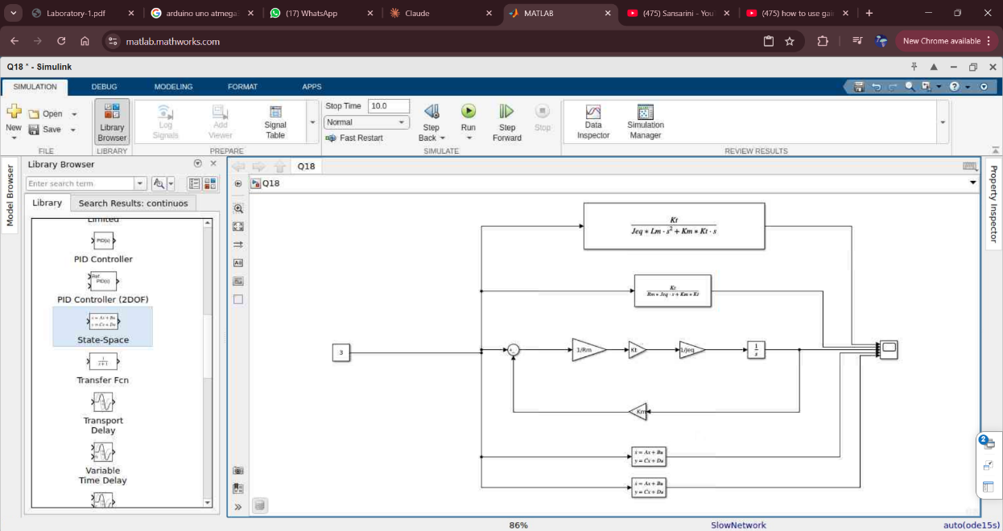

Figure : Simulink for combination of the state space vector, transfer function

Q2.

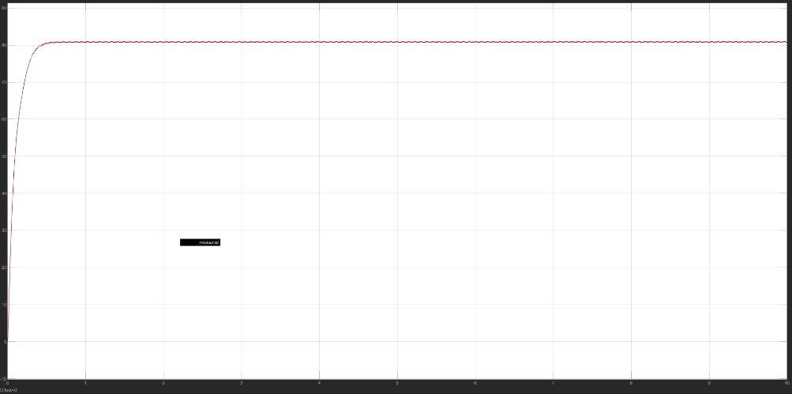

Figure : Speed Response in the Model

Figure : Comparing of the Speed Response with Model and State Vector

1. According to my knowledge I think the basic thing for happening those kind of the error is negiligence of the resistance where having in the rotor and also mathlab is the software which required the best performance of the computers so considering the computers which has been used there can be errors as the performance.

Q3)

1.

Figure : The Speed Response when KP=1

2.

Steady State Error: 1-0.938 : 0.062

$\text{Overshoot}=\frac{1.335-0.938}{0.938}×100\%$

$= 42.324\%$

3.

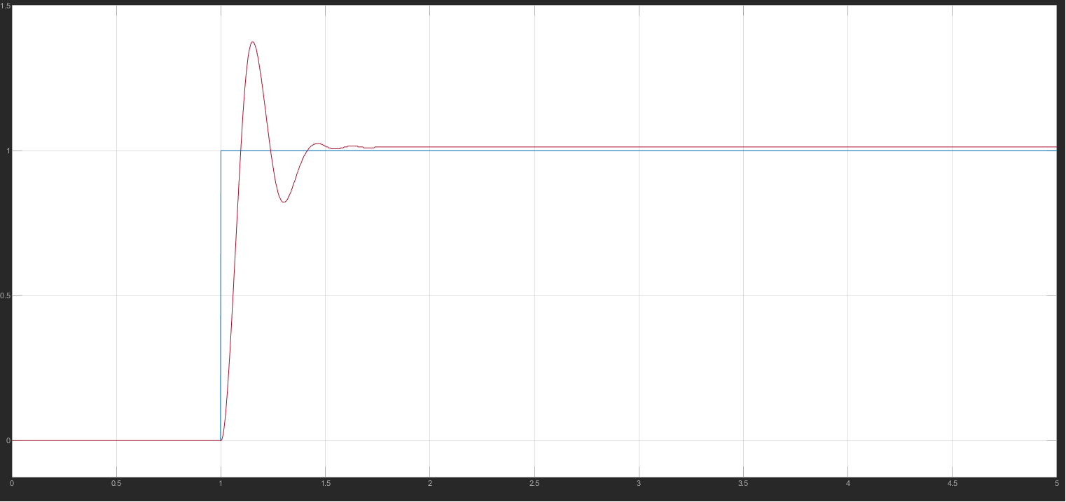

Figure : Speed Response from Simulink when KP=1.25

According to the Figure 5 when Kp = 1.25,

Steady state error = 1-1.012 =0.012

Figure : Speed Response from Simulink when KP=1.50

According to the Figure 6 when Kp = 1.5,

Steady state error = 1-1.009 = 0.009

Figure : Speed Response from Simulink when KP=1.75

According to the Figure 7 when Kp = 1.75,

Steady state error = 1-0.96 = 0.04

Figure : Speed Response from Simulink when KP=2.0

According to the Figure 8 when Kp = 2,

Steady state error = 3.35 × 10-2

# REFERENCES

|  |  |
| --- | --- |
| [1] | M. H. Center. [Online]. Available: https://in.mathworks.com/matlabcentral/answers/292859-how-to-find-kp-ki-kd-values-from-transfer-function?requestedDomain=. |
| [2] | "Write Gate University," [Online]. Available: https://cecs.wright.edu/~krattan/courses/419/lecture5.pdf. |