EE5351: CONTROL SYSTEM DESIGN

LABORATORY 02

NAME : BANDARA KMTON

REG.NO. : EG/2021/4432

GROUP NO. : CE 07

DATE : 20/01/2024

Summative Laboratory Form

|  |  |
| --- | --- |
| Semester | 05 |
| Module Code | EE5351 |
| Module Name | Control Systems Design |
| Lab Number | 02 |
| Lab Name | Laboratory Session 2 |
| Lab Conducted Date | 2024.11.05 |
| Report Submission Date | 2025.01.24 |

Table of Contents

1 OBSERVATIONS 5

2 REFERENCES 10

Table of Figures

Figure 1: Simulink for Simplified version 5

Figure 2: Simulink for the unity feedback system 6

Figure 3:output from the unity feedback system 6

Figure 4: Time domain response [**θm(t)]** of the closed loop position control system for an applied **θref(t)** of **1 rad.** 8

Figure 5: Reducing the overshoot by 30% 8

Figure 6: Design of PD controller 9

# OBSERVATIONS

Q1)

1. $V_{m}$ = $i_{m}R_{m}$ + $L_{m}\frac{{di}_{m}}{dt}$ + $e_{b}$ $⋯$ 1

$e_{b}$ = $k_{m}ω_{m}$ $⋯$ 2

$T_{m}$ = $J_{eq}\frac{{dω}_{m}}{dt}$ $⋯$ 3

$T_{m}$ = $i_{m}k_{t}$ $⋯$ 4

1. Considering the above equations Transfer Function Given as:

$\frac{θ_{m}(S)}{V_{m}(S)}$ = $\frac{k_{t}}{S[J_{eq}S\left(R_{m}+L_{m}S\right]+k_{m}k_{t}]}$

= $\frac{0.042}{2.424×{10}^{-8}S^{3}+1.756×{10}^{-4}s^{2}+1.764×{10}^{-3}S}$

Simplified t/f:

$\frac{θ_{m}(S)}{V_{m}(S)}$ = $\frac{k_{t}}{J_{eq}R_{m}S^{2}+k_{m}k_{t}S}$

= $\frac{0.042}{1.756×{10}^{-4}s^{2}+1.764×{10}^{-3}S}$

1. 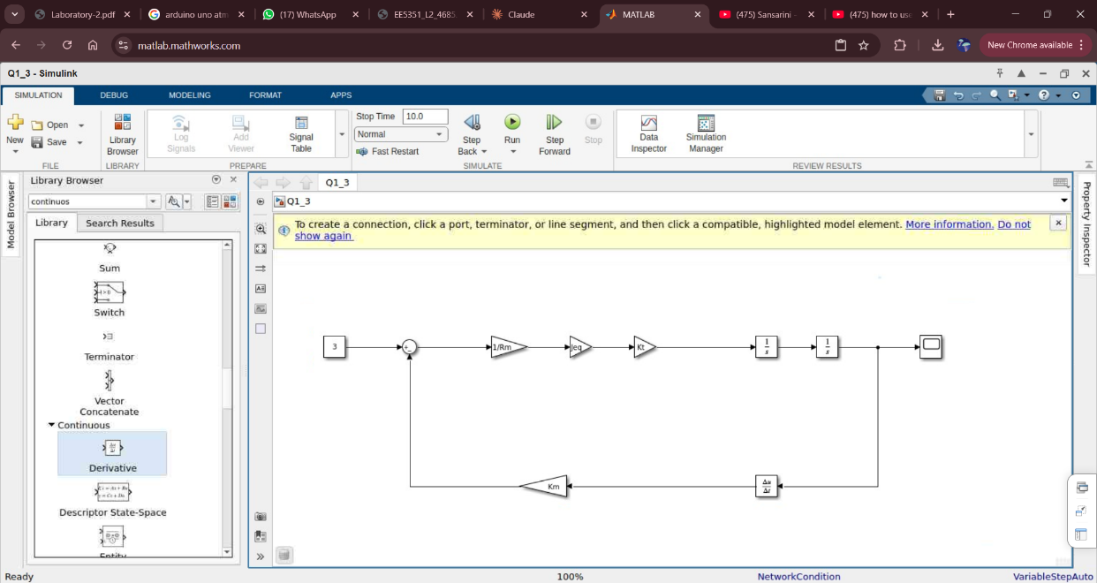

Figure 1: Simulink for Simplified version

1. This is unity feedback system

$\frac{θ_{m}(S)}{θ_{ref}(S)}$ = $\frac{G(s)}{1+G(S)}$

= $\frac{k_{t}}{J_{eq}R_{m}S^{2}+k_{m}k_{t}S+k_{t}}$

= $\frac{0.042}{1.756×{10}^{-4}s^{2}+1.764×{10}^{-3}S+0.042}$

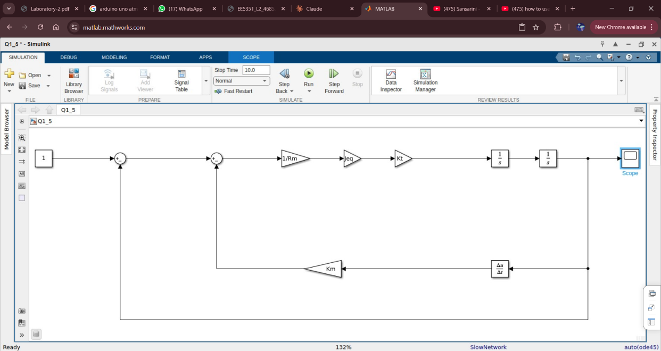

Figure 2: Simulink for the unity feedback system

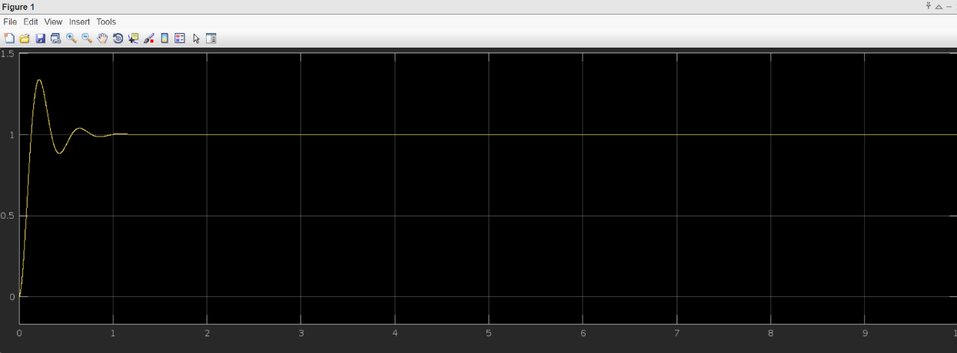

Figure 3:output from the unity feedback system

Overshoot = $\frac{1.339-1}{1}×100\%$

= 33.9%

Q2)

$\frac{θ_{m}(S)}{θ_{ref}(S)}$ = $\frac{0.042}{1.756×{10}^{-4}s^{2}+1.764×{10}^{-3}S+0.042}$

By considering above t/f the characteristic equation given as follows:

$1.756×{10}^{-4}s^{2}+1.764×{10}^{-3}S+0.042$ =0

$s^{2}+10.04S+239.199$ =0

1. For the standard 2nd order system characteristic eqn>>

$s^{2}+2εω_{n}S+{ω_{n}}^{2}$ =0

Thus :

$ω_{n}$ =15.465rad/s

$ε$ =5.70 $×{10}^{-5}$

=0.325

Overshoot = $e^{-\frac{0.325π}{\sqrt{1-{0.325}^{2}}}}×100\%$

=33.97%

1. By reducing overshoot new overshoot is 0.7 $×$ 34.60% =23.78%

23.78 = $e^{-\frac{επ}{\sqrt{1-ε^{2}}}}×100$

$ε$ =0.415

Then

By considering the PD controllers characteristic equation:

$S^{2}+2\left(ε_{old}+\frac{k_{dω_{n}}}{2}\right)ω_{n}S+\sqrt{k_{p}}ω_{n}$ =0

Considering Tp <2

$2$ > $\frac{π}{{\sqrt{k_{p}}ω}_{n}\sqrt{1-0.415}}$

$k_{p}$ > 0.01763

By considering as $k_{p}$ =1

$ε_{new}$ = $ε$ + $\frac{k_{D}ω_{n}}{2}$

0.325+ $\frac{k_{dω_{n}}}{2}$ =0.415

KD  =0.016

Q3)

1. 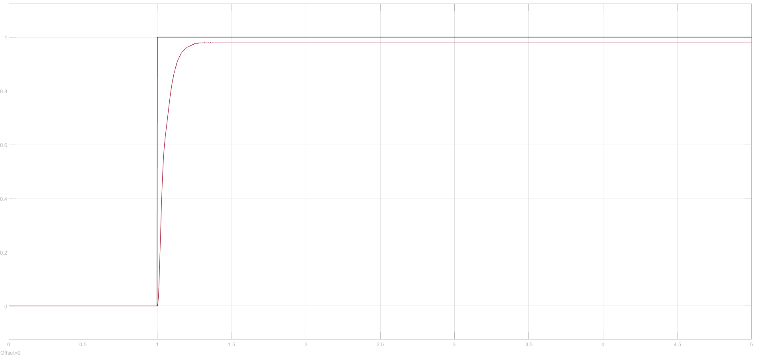

Figure : Time domain response [**θm(t)]** of the closed loop position control system for an applied **θref(t)** of **1 rad.**

1. Calculated Overshoot:

=

=

Figure 5: Reducing the overshoot by 30%

Figure 6: Design of PD controller

# REFERENCES

|  |  |
| --- | --- |
| [1] | “PD,PI,PID Controllers,” [Online]. Available: https://eng.libretexts.org/Bookshelves/Industrial_and_Systems_Engineering/Introduction_to_Control_Systems_(Iqbal)/03%3A_Feedback_Control_System_Models/3.3%3A_PI_PD_and_PID_Controllers. |
| [2] | “Tutors Point,” [Online]. Available: https://www.tutorialspoint.com/control_systems/control_systems_controllers.htm. |