EE5351: CONTROL SYSTEM DESIGN

LABORATORY 02

NAME : BANDARA LRTD

REG No. : EG/ 2021/ 4433

GROUP NO: CE07

DATE : 24/01 /2025

Table : Summative Laboratory Form

|  |  |
| --- | --- |
| Semester | 05 |
| Module Code | EE5351 |
| Module Name | Control System Design |
| Lab Number | 02 |
| Lab Name | Laboratory Section 2 |
| Lab conduction date | 2024.11.05 |
| Report Submission date | 2025.01.24 |

**Contents**

1 OBSERVATION 6

2 CALCULATION 7

3 REFERENCES 12

**List of Tables**

Table : Summative Laboratory Form

Table 2: Observations 6

**List of Figures**

Figure 1: Simplified Simulink 8

Figure 2: Closed Loop T/f 8

Figure 3: O/p diagram 9

Figure 4:output from closed loop transfer function 9

Figure 5:Time domain response of the closed loop function 11

Figure 6: Design a PD Controller 11

Figure 7: Overshoot is reduced by 30% 11

# OBSERVATION

Table : Observations

|  |  |  |
| --- | --- | --- |
| Terminal Resistance (Rm) | 8.4 | Ω |
| Rotor inductance (Lm) | 1.16 | mH |
| Equivalent(Jen) | 2.09×10⁻⁵ | kgm² |
| Torque constant (Kt) | 0.042 | Nm/A |
| Voltage constant (Km) | 0.042 | Nm/A |

# CALCULATION

Q1.

1. .
2. Voltage equation:

2. Back EMF equation:

3. Torque equation:

4. Motor torque relationship:

$$T_{m}=i_{m}k_{t}$$

1. Transfer function

By using equations (1), (2), (3), and (4):

$$\frac{θ_{m}\left(s\right)}{V_{m}\left(s\right)}=\frac{k_{t}}{s\{J_{eq}s\left[R_{m}+L_{m}s\right]+k_{m}k_{t}\}}$$

$$\frac{θ_{m}\left(s\right)}{V_{m}\left(s\right)}=\frac{0.042}{2.4244×{10}^{-8}s^{3}+17.556×{10}^{-5}s^{2}+1.764×{10}^{-3}s}$$

Due to the negligible rotor inductance the simplified version is:-

1. H

Figure : Simplified Simulink

1. By considering the closed loop transfer function
$$\frac{θ_{m}\left(s\right)}{θ_{ref}\left(s\right)}=\frac{\frac{θ_{m}\left(s\right)}{V_{m}\left(s\right)}}{1+\frac{θ_{m}\left(s\right)}{V_{m}\left(s\right)}}$$

$$\frac{θ_{m}\left(s\right)}{θ_{ref}\left(s\right)}=\frac{0.042}{1.756×{10}^{-4}S^{2}+1.764×{10}^{-3}S+0.042}$$

2. 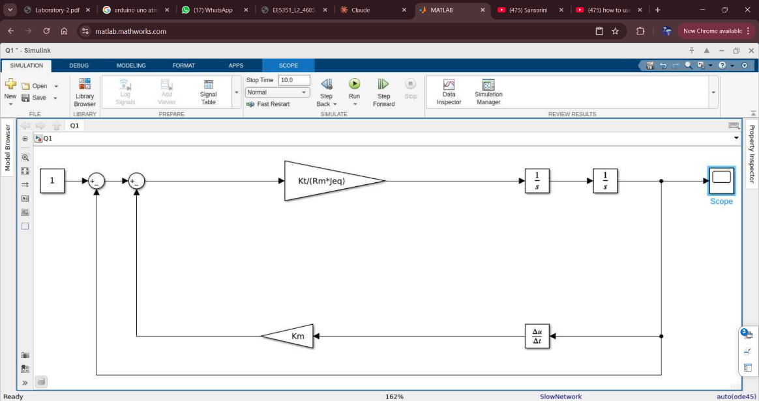

Figure : Closed Loop T/f

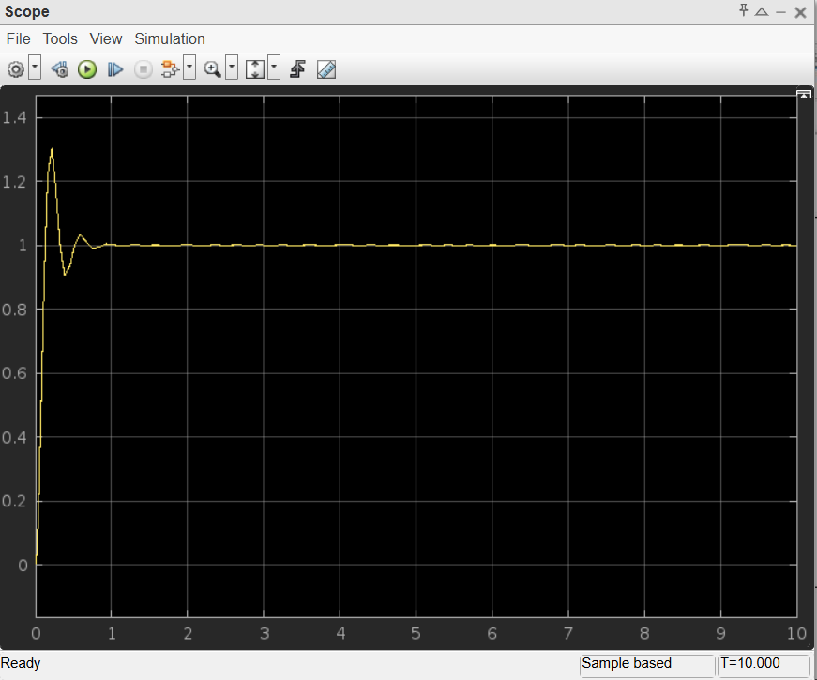

Figure : O/p diagram

Figure :output from closed loop transfer function

Overshoot given as = $\frac{1.33-1}{1}×100\%$

= 33%

Q2.

1. Characteristic equation given as :

$S^{2}+10.047S+239.23$ =0

1. By considering ;

2єɷ = 10.047

${ω_{n}}^{2}$ = 239.23

Є = 0.3248

$ω_{n}$ = 15.47rad/s

Overshoot = $e^{-\frac{π∈}{\sqrt{1-∈^{2}}}}×$ 100%

= $e^{-\frac{π×15.47}{\sqrt{1-{15.47}^{2}}}}×$ 100%

= 33.99%

1. $\frac{33.99×70}{100}$ = $e^{-\frac{π∈}{\sqrt{1-∈^{2}}}}×$ 100%

$ε_{new}$ = 0.415

$t_{p}$ < 2

$\frac{π}{ω_{n\left(new\right)}\sqrt{1-{ε_{\left(new\right)}}^{2}}}$ < 2

According to that to maintain $t_{p}$ < 2

The PD characteristics equation is given as

$S^{2}+2\left(ε_{old}+\frac{k_{d}ω_{n\left(new\right)}}{2}\right)ω_{n\left(new\right)}S+\sqrt{k_{p}}{ω_{n\left(old\right)}}^{1}$ =0

Considering that $ω_{n\left(new\right)}$ can replace by $\sqrt{k_{p}}{ω_{n\left(old\right)}}^{1}$.

From that given as:

$\frac{π}{\sqrt{k_{p}}{ω_{n\left(old\right)}}^{1}\sqrt{1-{ε_{\left(new\right)}}^{2}}}$ < 2

$k_{p}$ >0.01762

From that $k_{p}$ can consider as 1.

According to that

$ε_{new}$ = $\left(ε_{old}+\frac{k_{d}ω_{n}}{2}\right)$

0.415= $\left(0.325+\frac{k_{d}15.47}{2}\right)$

$k_{d}$ = 0.011635

Q3)

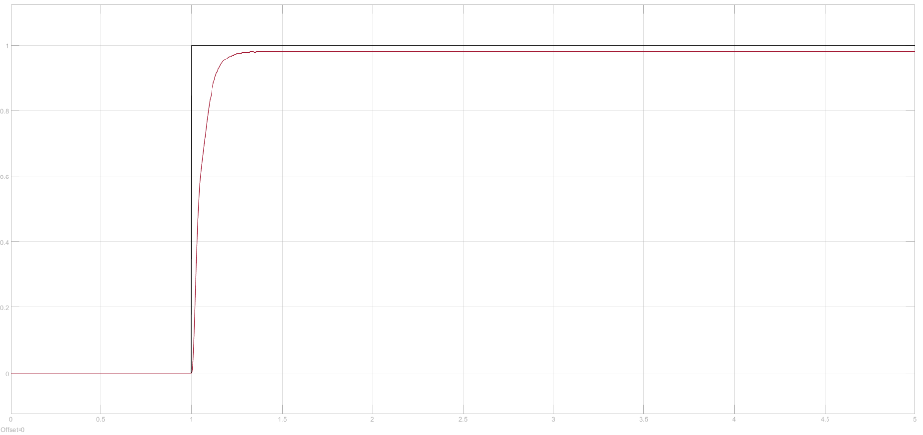

Figure :Time domain response of the closed loop function

1. The overshoot is given by: $\frac{1.3622-0.9725}{0.9725}×100\%$

:40.0717%

1. 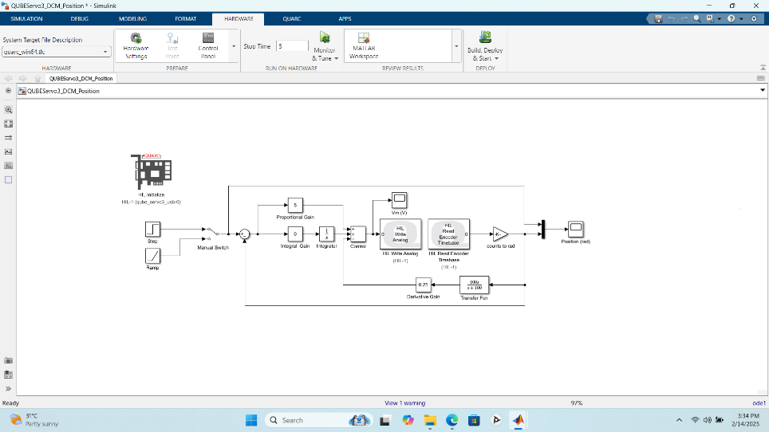

Figure : Design a PD Controller

Figure : Overshoot is reduced by 30%

# REFERENCES

|  |  |
| --- | --- |
| [1] | M. H. Center. [Online]. Available: https://www.mathworks.com/help/slcontrol/ug/create-i-pd-and-pi-d-controllers.html. |
| [2] | MEDIUM. [Online]. Available: https://medium.com/@mmwong920/a-brief-introductino-to-pd-controller-bac79c4f3fef. |
| [3] | GREEKFOGGREEK. [Online]. Available: https://www.geeksforgeeks.org/compensators/. |