EE5351: CONTROL SYSTEM DESIGN

LABORATORY 03

NAME : BANDARA KMTON

REG.NO. : EG/2021/4432

GROUP NO. : CE 07

DATE : 20/01/2024

Summative Laboratory Form

|  |  |
| --- | --- |
| Semester | 05 |
| Module Code | EE5351 |
| Module Name | Control Systems Design |
| Lab Number | 03 |
| Lab Name | Laboratory Session 3 |
| Lab Conducted Date | 2024.11.05 |
| Report Submission Date | 2025.01.24 |

Table of Contents

1 OBSERVATIONS 5

2 References 13

Table of Figures

Figure 1: Simulink for the Question 3 5

Figure 2: Simulink for updated version from Q3 6

Figure 3: Time domain response for Q5 6

Figure 4: Code for Root locus of closed loop 7

Figure 5: Root Locus 7

Figure 6: Root Locus after increasing Omega 9

Figure 7: Comparison of the time responses 11

Figure 8:Designing Comapesator 12

Figure 9: Time domain response [**θm(t)]** of the closed loop position control system of DC motor 12

# OBSERVATIONS

Question1)

1. $V_{m}$ = $i_{m}R_{m}$ + $L_{m}\frac{{di}_{m}}{dt}$ + $e_{b}$ $⋯$ 1

$e_{b}$ = $k_{m}ω_{m}$ $⋯$ 2

$T_{m}$ = $J_{eq}\frac{{dω}_{m}}{dt}$ $⋯$ 3

$T_{m}$ = $i_{m}k_{t}$ $⋯$ 4

Considering the above equations t/f Given as:

$\frac{θ_{m}(S)}{V_{m}(S)}$ = $\frac{k_{t}}{S[J_{eq}S\left(R_{m}+L_{m}S\right]+k_{m}k_{t}]}$

By negliting the rotor inductance (Due to the Small value)

=

=

1. A screenshot of a computer screen

   AI-generated content may be incorrect.

Figure 1: Simulink for the Question 3

1. To get the closed loop transfer function

=

=

1. A screenshot of a computer

   AI-generated content may be incorrect.

Figure 2: Simulink for updated version from Q3

Figure 3: Time domain response for Q5

Question2)

1. 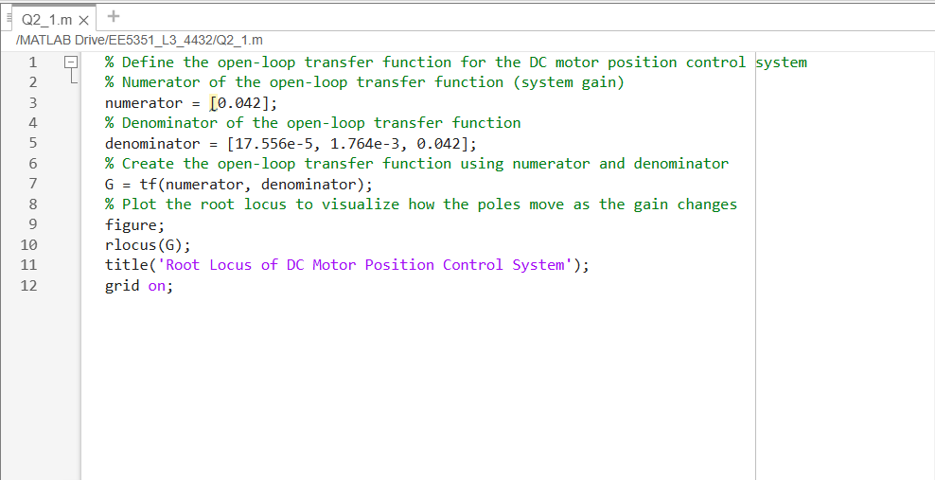

Figure 4: Code for Root locus of closed loop

1. A graph of a graph

   AI-generated content may be incorrect.

Figure 5: Root Locus

1. By considering the characteristic equation

2 $εω_{n}$ = $\frac{1.764×{10}^{-3}}{1.756×{10}^{-4}}$

$ω_{n}$ = 10.045

clc; clear; close all;

%% Define the Open-Loop Transfer Function for DC Motor Position Control

numerator = [0.042]; % System gain

denominator = [17.556e-5, 1.764e-3, 0.042]; % Denominator coefficients

G = tf(numerator, denominator);

%% Plot the Root Locus of the Open-Loop System

figure;

rlocus(G);

title('Root Locus of DC Motor Position Control System');

grid on;

%% Increase Natural Frequency by 10%

omega_n = 10.045; % Current natural frequency (example value)

omega_n_new = 1.1 * omega_n; % New desired natural frequency (increase by 10%)

% Now, we will modify the system to achieve the new natural frequency.

% We need to adjust the parameters of the system such that the new ωn is achieved.

% Adjust the denominator to increase ωn by 10%

denominator_new = denominator;

denominator_new(1) = denominator_new(1) * (omega_n_new / omega_n); % Adjust the first denominator term to scale with ωn

% Create the new transfer function

G_new = tf(numerator, denominator_new);

%% Plot the Root Locus of the Modified System

figure;

rlocus(G_new);

title('Root Locus After Increasing Natural Frequency by 10%');

grid on;

Figure 6: Root Locus after increasing Omega

clc; clear; close all;

%% Define the Open-Loop Transfer Function for DC Motor Position Control

numerator = [0.042]; % System gain

denominator = [17.556e-5, 1.764e-3, 0.042]; % Denominator coefficients

G = tf(numerator, denominator);

%% Plot the Root Locus of the Open-Loop System

figure;

rlocus(G);

title('Root Locus of DC Motor Position Control System');

grid on;

%% Increase Natural Frequency by 10%

omega_n = 10.045; % Current natural frequency (example value)

omega_n_new = 1.1 * omega_n; % New desired natural frequency (increase by 10%)

% Now, we will modify the system to achieve the new natural frequency.

% We need to adjust the parameters of the system such that the new ωn is achieved.

% Adjust the denominator to increase ωn by 10%

denominator_new = denominator;

denominator_new(1) = denominator_new(1) * (omega_n_new / omega_n); % Adjust the first denominator term to scale with ωn

% Create the new transfer function

G_new = tf(numerator, denominator_new);

%% Plot the Root Locus of the Modified System

figure;

rlocus(G_new);

title('Root Locus After Increasing Natural Frequency by 10%');

grid on;

% Calculate and plot the time response of both systems

figure;

step(G, 'b', G_new, 'r'); % Original in blue, Modified in red

title('Comparison of Time Responses: Original vs Modified System');

legend('Original System', 'Modified System');

grid on;

Figure 7: Comparison of the time responses

Question3)

1.

Figure 8:Designing Comapesator

2.

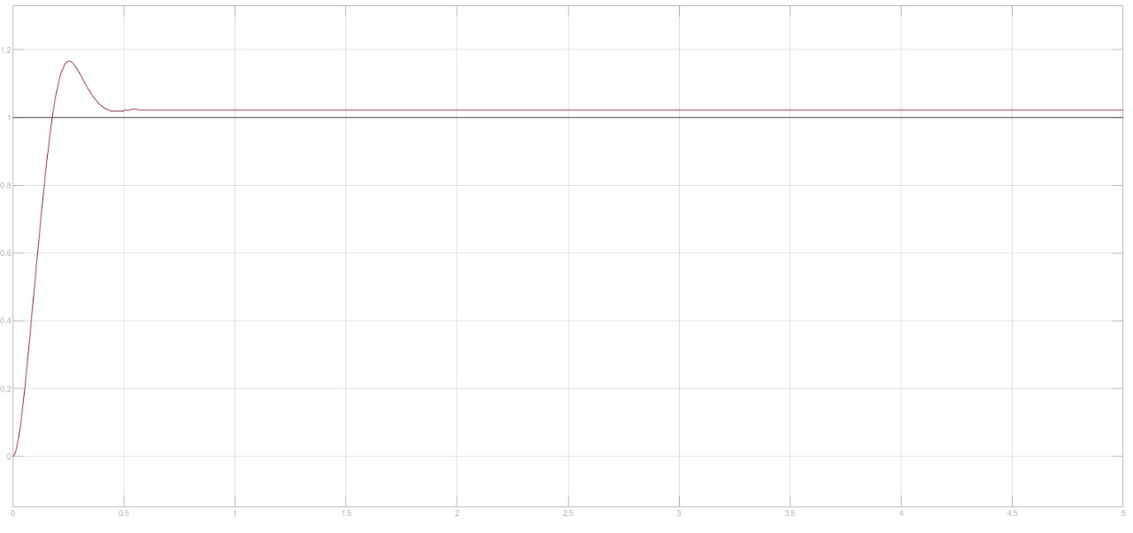

Figure : Time domain response [**θm(t)]** of the closed loop position control system of DC motor

# References

|  |  |
| --- | --- |
| [1] | “Tutorials Point,” [Online]. Available: https://www.tutorialspoint.com/control_systems/control_systems_construction_  root_locus.htm. |
| [2] | “Mathwworks,” [Online]. Available: https://in.mathworks.com/help/control/ref/dynamicsystem.rlocus.html. |
| [3] | [Online]. Available: https://www.geeksforgeeks.org/control-systems-controllers/. |