EE5351: CONTROL SYSTEM DESIGN

LABORATORY 03

NAME : BANDARA LRTD

REG No. : EG/ 2021/ 4433

GROUP NO: CE07

DATE : 24/01 /2025

Table : Summative Laboratory Form

|  |  |
| --- | --- |
| Semester | 05 |
| Module Code | EE5351 |
| Module Name | Control System Design |
| Lab Number | 03 |
| Lab Name | Laboratory Section 3 |
| Lab conduction date | 2024.11.05 |
| Report Submission date | 2025.01.24 |

**Contents**

1 OBSERVATION 6

2 CALCULATION 7

3 REFERENCES 13

**List of Tables**

Table : Summative Laboratory Form

Table 2: Observations 6

**List of Figures**

Figure 1: Simplified t/f Simulink Model 8

Figure 2: By creating closed loop function giving input as 1 8

Figure 3: Output from the closed loop function 9

Figure 4: Root Locus of DC Motor Position Control System 9

Figure 5: Math Lab code for increase the Omega by 10% 10

Figure 6: Root Locus for By increasing the omega 10

Figure 7: MathLab code for implement Step response 11

Figure 8: Time response before and after changing the omega 11

Figure 9: Time Domain Response [θm(t)] of the closed loop 12

Figure 10: Design a compensator **for** the DC motor position control system 12

# OBSERVATION

Table : Observations

|  |  |  |
| --- | --- | --- |
| Terminal Resistance (Rm) | 8.4 | Ω |
| Rotor inductance (Lm) | 1.16 | mH |
| Equivalent(Jen) | 2.09×10⁻⁵ | kgm² |
| Torque constant (Kt) | 0.042 | Nm/A |
| Voltage constant (Km) | 0.042 | Nm/A |

# CALCULATION

Q1.

1. .
2. Voltage equation:

2. Back EMF equation:

3. Torque equation:

4. Motor torque relationship:

$$T_{m}=i_{m}k_{t}$$

By using equations (1), (2), (3), and (4):

$$\frac{θ_{m}\left(s\right)}{V_{m}\left(s\right)}=\frac{k_{t}}{s\{J_{eq}s\left[R_{m}+L_{m}s\right]+k_{m}k_{t}\}}$$

$$\frac{θ_{m}\left(s\right)}{V_{m}\left(s\right)}=\frac{0.042}{2.4244×{10}^{-8}s^{3}+17.556×{10}^{-5}s^{2}+1.764×{10}^{-3}s}$$

Due to the negligible rotor inductance the simplified version is:-

1. A computer screen shot of a computer program

   AI-generated content may be incorrect.

Figure : Simplified t/f Simulink Model

1. By considering the closed loop transfer function
$$\frac{θ_{m}\left(s\right)}{θ_{ref}\left(s\right)}=\frac{\frac{θ_{m}\left(s\right)}{V_{m}\left(s\right)}}{1+\frac{θ_{m}\left(s\right)}{V_{m}\left(s\right)}}$$

$$\frac{θ_{m}\left(s\right)}{θ_{ref}\left(s\right)}=\frac{0.042}{1.756×{10}^{-4}S^{2}+1.764×{10}^{-3}S+0.042}$$

2. 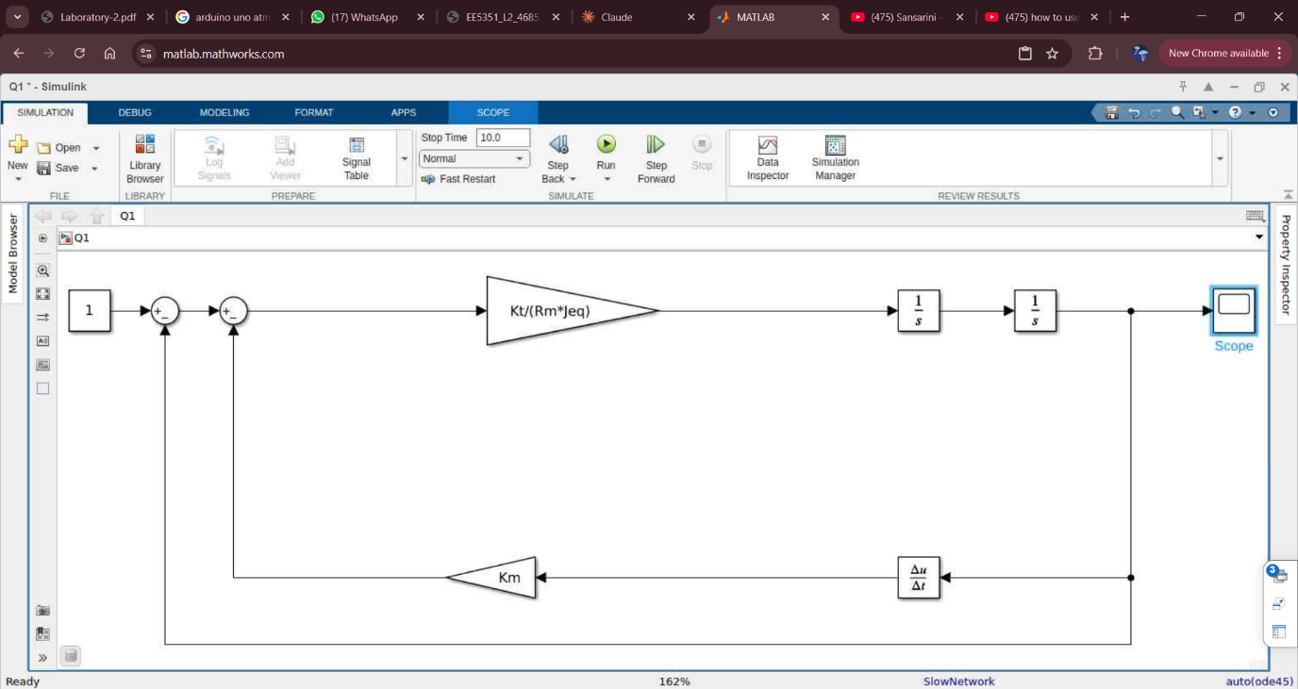

Figure : By creating closed loop function giving input as 1

Q2.

Figure : Output from the closed loop function

% Define numerator and denominator of the transfer function

num = 0.042;

den = [17.556e-5, 1.764e-3, 0.042];

% Create the transfer function

G = tf(num, den);

% Plot the root locus

rlocus(G);

title('Root Locus of DC Motor Position Control System');

grid on;

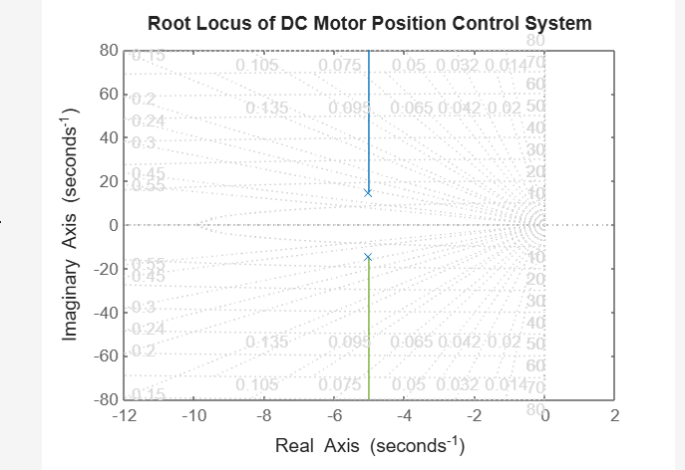

Figure : Root Locus of DC Motor Position Control System

Characteristic equation given as ;

$1.756×{10}^{-4}S^{2}+1.764×{10}^{-3}S+0.042$ =0

By calculating the $ω$ given as

2 $εω_{n}$ = 10.0455

= 10.05

Figure : Math Lab code for increase the Omega by 10%

Figure : Root Locus for By increasing the omega

Figure : MathLab code for implement Step response

Figure : Time response before and after changing the omega

Q3)

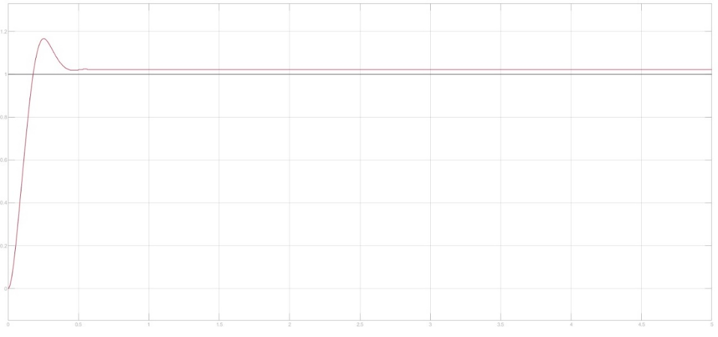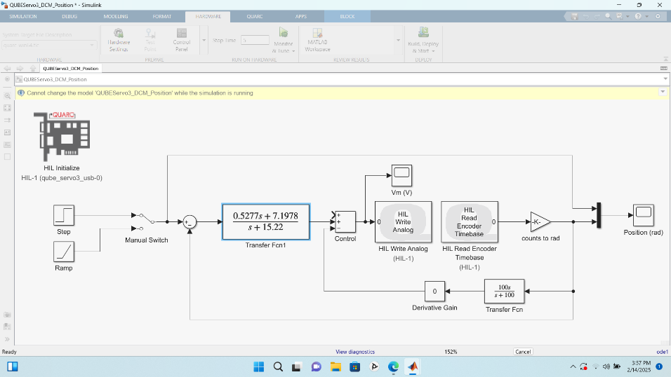

Figure 9: Time Domain Response [θm(t)] of the closed loop

Figure 10: Design a compensator **for** the DC motor position control system

# REFERENCES

|  |  |
| --- | --- |
| [1] | "Control Tutorial," [Online]. Available: https://ctms.engin.umich.edu/CTMS/index.php?example=Introduction&section=ControlRootLocus. |
| [2] | [Online]. Available: https://medium.com/@csoham358/a-hackers-guide-to-understanding-controllers-62fb26bed952. |
| [3] | "LibreTexts," [Online]. Available: https://eng.libretexts.org/Bookshelves/Industrial_and_Systems_Engineering/Chemical_Process_Dynamics_and_Controls_(Woolf)/09%3A_Proportional-Integral-Derivative_(PID)_Control/9.02%3A_P_I_D_PI_PD_and_PID_control. |