Contents

1. Tech Stack 1

2. MongoDB Setup 1

2.1 PRD_LDS 1

2.2 Data-Catalog 1

3 Dream Factory Setup 2

3.1 Create API Service 2

3.2 Create Roles 3

3.3 Add Scripts 3

3.4 Add users and set roles 4

3.5 Create App 5

4 Data-Catalog Portal 6

4.1 Pull Code from Github 6

4.2 Add Email service code 6

4.3 Add Environment Variables 6

4.5 Deploy 7

**4.5.1 Build File** 7

# Tech Stack

PRD_LDS

Data-catalog

ReactJS

Dream Factory

Front End

Back End

Data Base - MongoDB

# MongoDB Setup

## PRD_LDS

* Create PRD_LDS if it does not exist
* This database contains all the datasets that is available to users
* Import/create datasets that are to be displayed on data-catalog portal.

Sample data can be imported from <https://github.com/JTC-DataEngineering/Data-Catalog/tree/master/database>

## Data-Catalog

* Create data-catalog database if doesn’t exist in mongodb
* This database contains the metadata of datasets available and collections that is required for various data-catalog portal features.
* Import/create the following collections
  + collection_metadata
  + attribute_metadata
  + collection_rating
  + collection_comment

Sample data can be imported from <https://github.com/JTC-DataEngineering/Data-Catalog/tree/master/database>

# Dream Factory Setup

## 3.1 Create API Service

Navigate to Home>Services>Create.

* Select service type > Database> MongoDB > Enter service Details > Config > Enter MongoDB Config
* Create service for both data-catalog and PRD_LDS (if doesn’t exist)

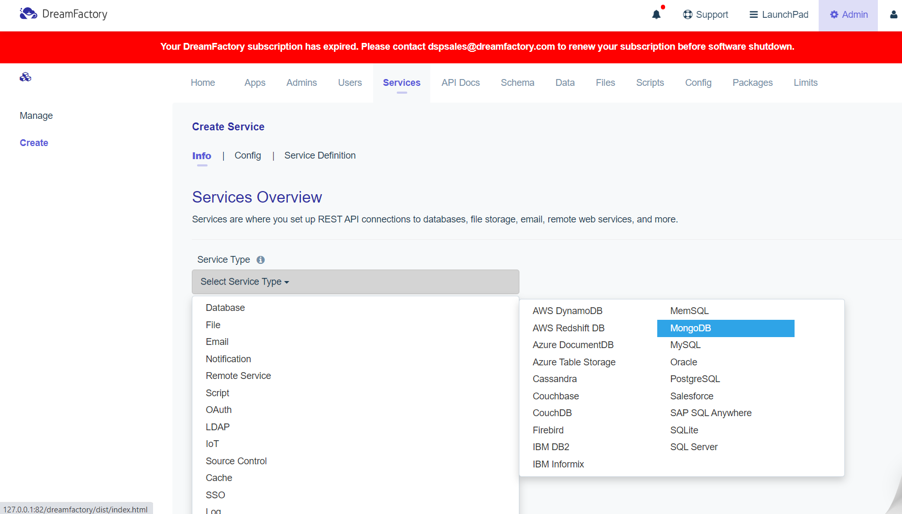

## 3.2 Create Roles

Navigate to Home>Roles>Create

* + 1. **Enter Role details**
* Enter desired role name and description for the role. Make sure active checkbox is checked.

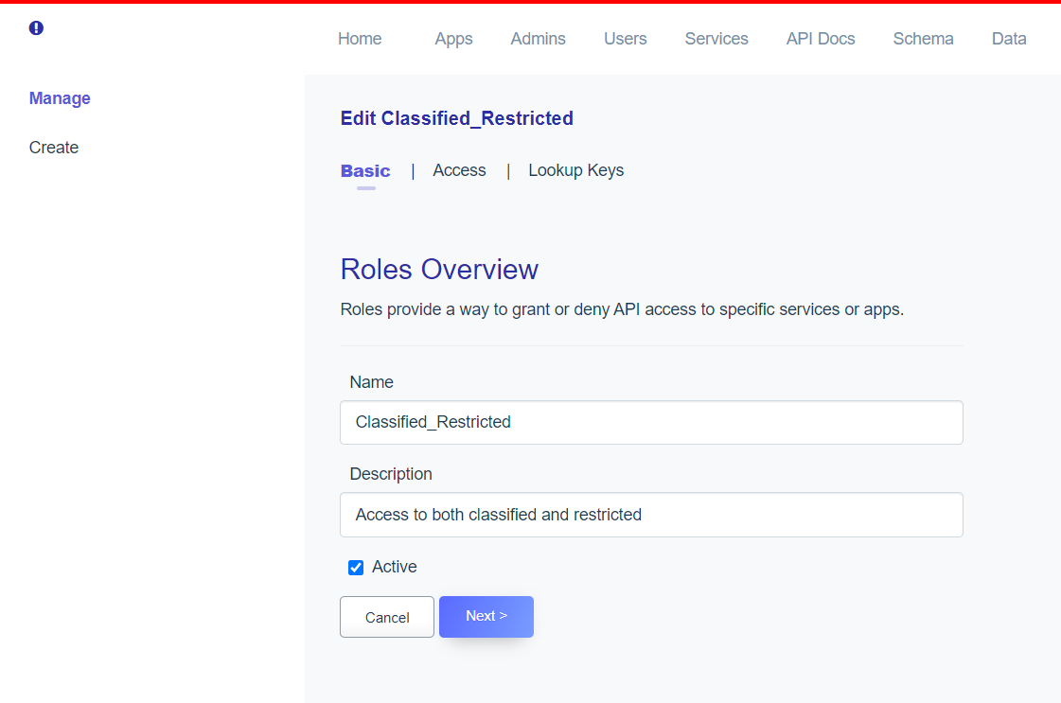

* + 1. **Add all the access rights for this role.**
* Click Access tab and click the + sign to add the access rights for this role, the GET/POST/PATCH access rights has also to be specified.

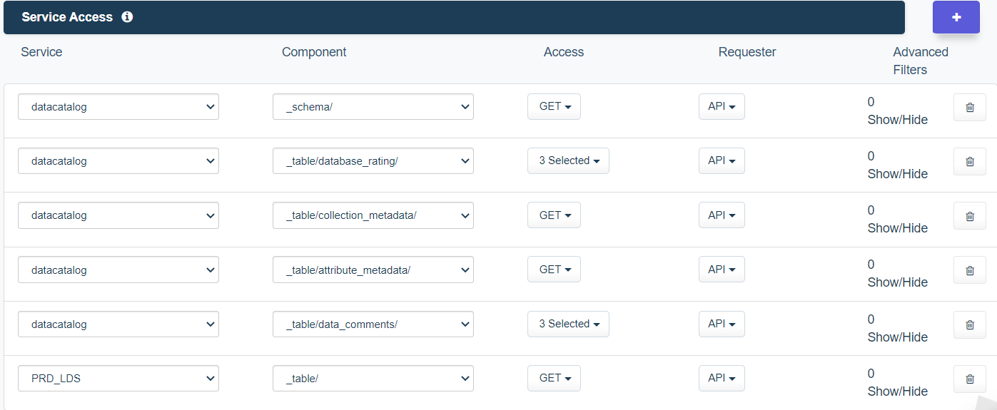

* + 1. **Repeat for all the roles required**

## Add Scripts

* + 1. **Flattening Script**
* Navigate to Home>Scripts>PRD_LDS>datacatalog.{table_name}.get.post_process
* Add the following script to PRD_LDS._table.{table_name}.get.post_proces

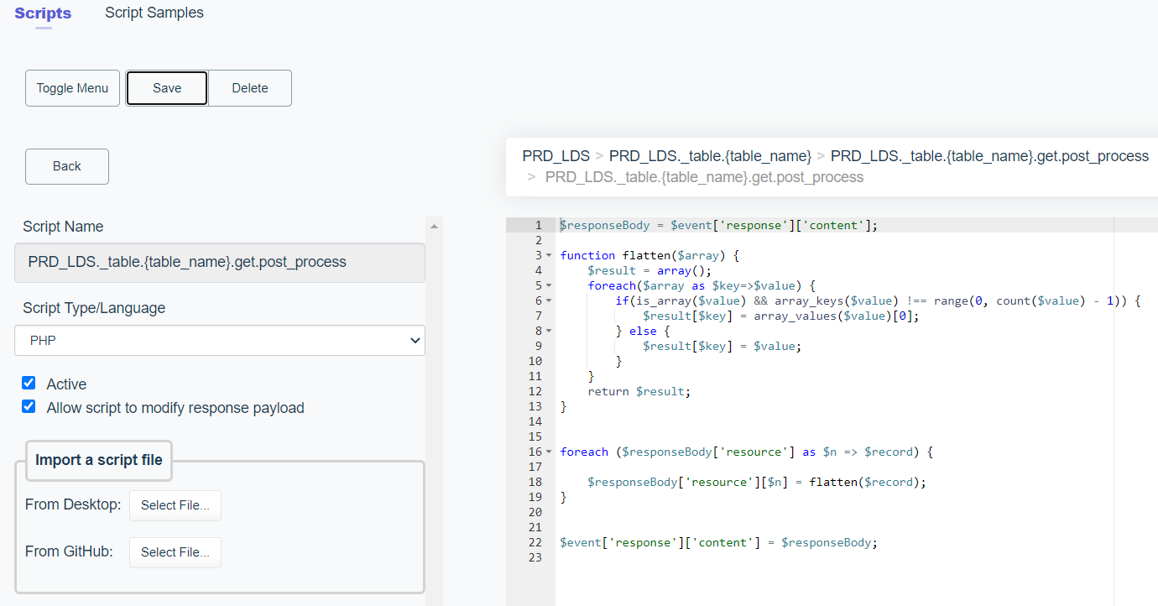

* + 1. **Rating Script**
* Navigate to Home>Scripts>datacatalog>datacatalog.{table_name}.get.post_process
* Add the following script to datacatalog._table.collection_rating>get>post_process

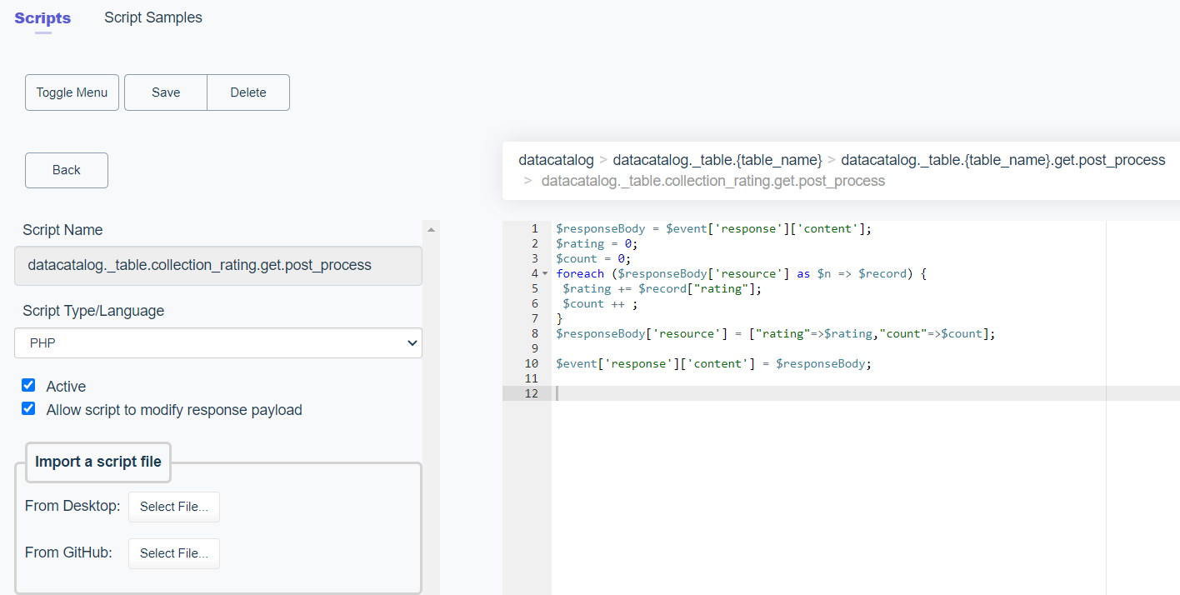

## 3.4 Add users and set roles

Navigate to Users>Create

* + 1. **User Details**
* Enter user details and set password to the default password.
* Active has to be checked

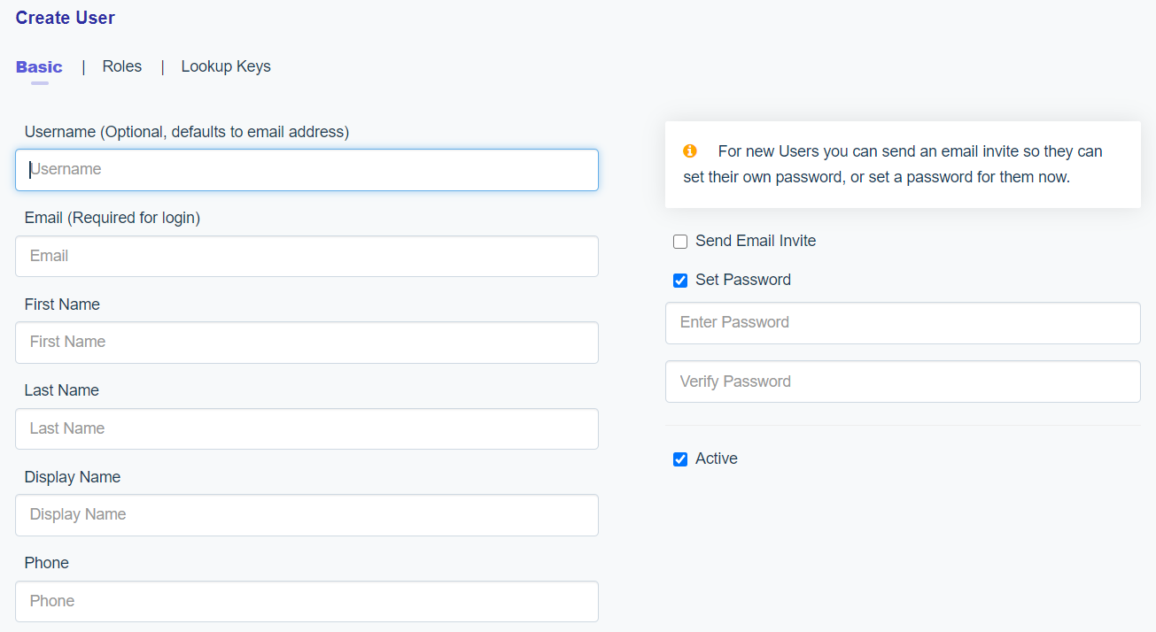

* + 1. **Roles**
* Click Roles and assign roles for the user according to access rights

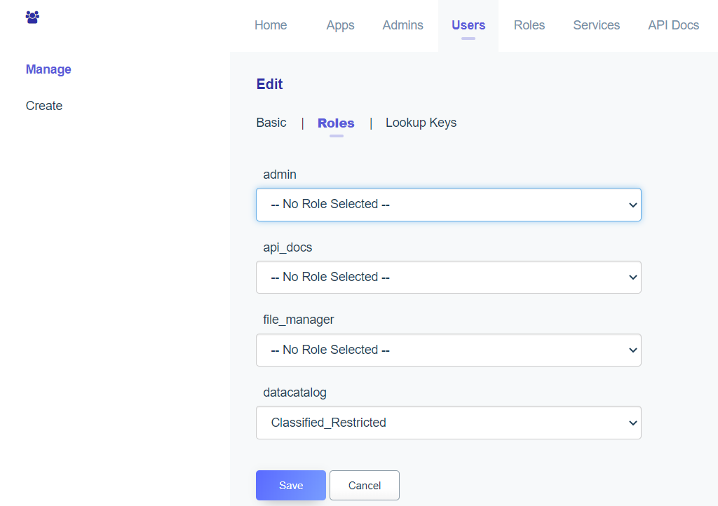

## Create App

Navigate to Apps>Create

* Enter App details and check the active check box.
* An API key will be generated after app is created. This key will be used by users to access the data-catalog app.

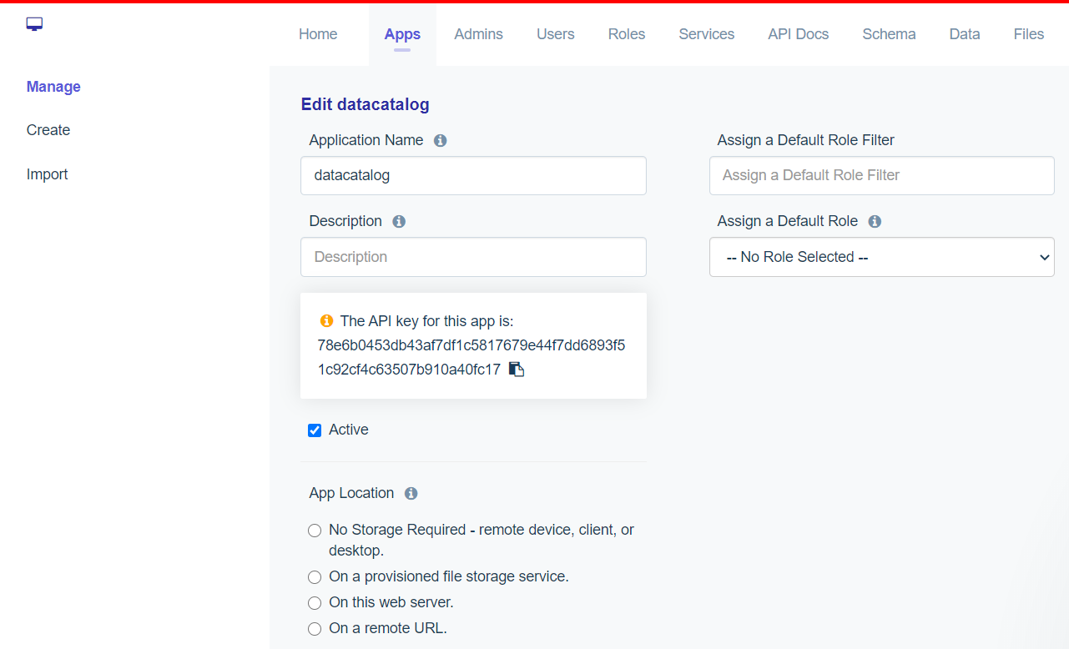

# Data-Catalog Portal

## 4.1 Pull Code from Github

* Code can be pulled from <https://github.com/JTC-DataEngineering/Data-Catalog>

## 4.2 Add Email service code

Add Email service code in Login.js

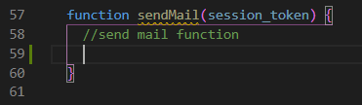

## Add Environment Variables

* + 1. **Add a .env file in the root folder**

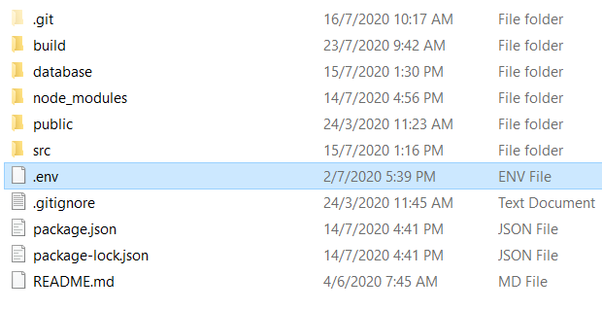

* + 1. **Add the following variables**
* REACT_APP_DF_APP_KEY , app key generated at step 3.5
* REACT_APP_API_URL, URL where the data-catalog is going to be hosted
* PORT, port where the data-catalog is going to be hosted
* REACT_APP_DEV_PORT, same as above, but will be used in the app
* REACT_APP_DF_PASSWORD, default password set to every user

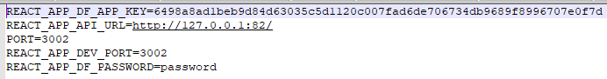

## 4.4 Deploy

### **4.5.1 Build File**

Enter npm run build to build the app for production to the build folder.

**4.5.2 Deploy the build**

Enter Serve -s build. Web app will be hosted at the port number specified in the .env file