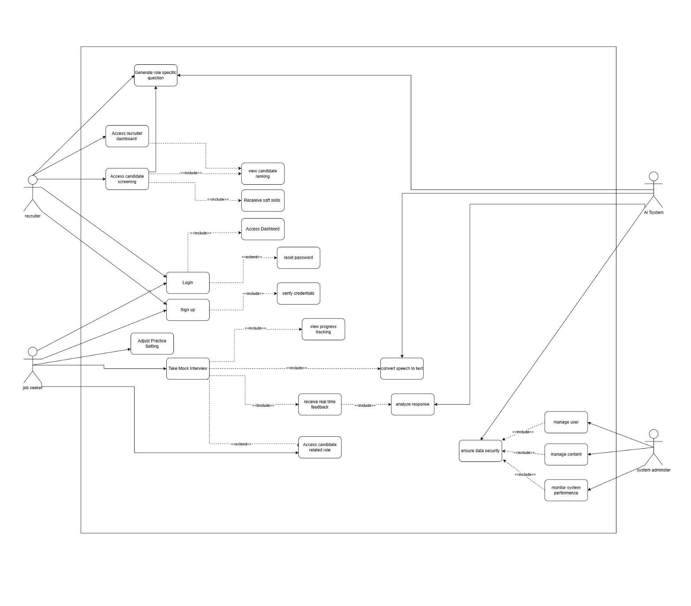

|  |  |  |
| --- | --- | --- |
| **Use Case Name** |  | |
| **Use Case ID** | **UC-001** | |
| **Description** |  | |
| **Priority** |  | |
| **Primary Actor** |  | |
| **Supporting Actors** |  | |
| **Pre-Conditions** |  | |
| **Trigger** |  | |
| **Main flow** | **Actors** | **System** |
|  |  |
| **Exception flow** | **Actors** | **System** |
|  |  |
| **Alternate flow** | **Actors** | **System** |
|  |  |
| **Exclusions** |  | |
| **Post Conditions** |  | |