01

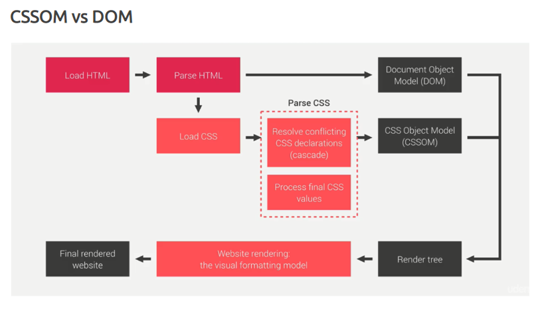

02

03

04

05

06

***names***.forEach(function (v){

***console***.log(v);

});

07

for(var ***i*** in ***names***){

***console***.log( ***i***,***names***[***i***]);// i refer **index** of the array

}

08

for(var ***i*** of ***names***){

***console***.log(***i***);// i refer **values** of the array

}

09

function greet() {

console.log("Hello, World!");

}

10

function greetUser(name) { // 'name' is a parameter

console.log("Hello, " + name + "!");

}

greetUser("Alice"); // 'Alice' is an argument passed to the function

// Output: Hello, Alice!

11

const sayHello = function() { // Function expression

console.log("Hello!");

};

sayHello(); // Output: Hello!

12

const greet = (name) => {

return "Hello, " + name;

};

console.log(greet("John")); // Output: Hello, John

13

const square = num => num * num;

console.log(square(4)); // Output: 16

14

const showMessage = function() {

console.log("This is an anonymous function!");

};

showMessage(); // Output: This is an anonymous function!

15

function executeFunction(fn) {

fn(); // Calls the function passed as an argument

}

executeFunction(function() {

console.log("Hello from a higher-order function!");

});

16

(function() {

console.log("This is an IIFE!");

})();

17

function outer() {

let outerVar = "I am from outer function!";

function inner() {

console.log(outerVar); // inner function can access outerVar

}

return inner;

}

const innerFunction = outer();

innerFunction(); // Output: I am from outer function!

18

function greet(name = "Guest") {

console.log("Hello, " + name);

}

greet(); // Output: Hello, Guest

greet("Alice"); // Output: Hello, Alice

19

function sum(...numbers) {

return numbers.reduce((total, num) => total + num, 0);

}

console.log(sum(1, 2, 3, 4)); // Output: 10

20

const arr = [1, 2, 3];

console.log(...arr); // Output: 1 2 3

21

**Html**

<p id="message">Hello, World!</p>

**js**

const message = document.getElementById("message");

// Change the content

message.innerHTML = "Hello, DOM Manipulation!";

message.textContent = "Updated Text Content"; // This will only set plain text

22

**html**

<img id="myImage" src="image1.jpg">

**js**

const image = document.getElementById("myImage");

// Changing attributes

image.setAttribute("src", "image2.jpg");

// OR

image.src = "image2.jpg";

23

**html**

<div id="box" style="width: 100px; height: 100px; background-color: red;"></div>

**js**

const box = document.getElementById("box");

// Change style

box.style.backgroundColor = "blue";

box.style.width = "200px";

24

const elementToRemove = document.getElementById("box");

elementToRemove.remove(); // Removes the element

25

**Html**

<button id="myButton">Click Me!</button>

**js**

const button = document.getElementById("myButton");

button.addEventListener("click", function() {

alert("Button was clicked!");

});

26

const parent = document.getElementById("box").parentNode; // Get parent element

const children = document.getElementById("box").children; // Get child elements

const nextSibling = document.getElementById("box").nextSibling; // Get next sibling

const previousSibling = document.getElementById("box").previousSibling; // Get previous sibling

27

fruits.push("Grapes"); // Adds "Grapes"

console.log(fruits); // ["Apple", "Mango", "Orange", "Grapes"]

fruits.pop(); // Removes "Grapes"

console.log(fruits); // ["Apple", "Mango", "Orange"]

28

fruits.unshift("Strawberry"); // Adds "Strawberry" at the beginning

console.log(fruits); // ["Strawberry", "Apple", "Mango", "Orange"]

fruits.shift(); // Removes "Strawberry"

console.log(fruits); // ["Apple", "Mango", "Orange"]

29

// Remove 1 element at index 1 ("Mango") and insert "Pineapple"

fruits.splice(1, 1, "Pineapple");

console.log(fruits); // ["Apple", "Pineapple", "Orange"]

30

const slicedFruits = fruits.slice(0, 2); // Copy first two elements

console.log(slicedFruits); // ["Apple", "Pineapple"]

31

const index = fruits.indexOf("Orange");

console.log(index); // 2

32

33

35

fruits.forEach(function(fruit) {

console.log(fruit);

});

// Same Output

34

for (let i = 0; i < fruits.length; i++) {

console.log(fruits[i]);

}

// Output:

// Apple

// Pineapple

// Orange

36

for (let fruit of fruits) {

console.log(fruit);

}

// Same Output

37

setTimeout(function () {

***console***.log("Hello there how are you.?")

}, 2000);

38

var ***testTimer*** = setTimeout(function () {

***console***.log("Hello there how are you.?")

}, 2000);

// stop timeout

clearTimeout(***testTimer***);

39

let ***x*** = 0;

setInterval(function () {

***x***++;

***console***.log(***x***);

}, 1000);

40

let ***x*** = 0;

var ***timerId*** = setInterval(function () {

***x***++;

***console***.log(***x***);

   if (***x*** > 5) {

       clearInterval(***timerId***);// stop the set Interval

   }

}, 1000);

41

let ***decimal***=20;

***console***.log(typeof ***decimal***);//number

let ***binaryNumber***=0b101;

***console***.log(typeof ***binaryNumber***);//number

let ***octalNumber***=0o17;

***console***.log(typeof ***octalNumber***);//number

let ***hexaDecimal***=0xA;

***console***.log(typeof ***hexaDecimal***);//number

let ***floatingPoint***=20.34;

***console***.log(typeof ***floatingPoint***);//number

**String related methods**

let ***sampleText*** = " Hello, Hi there! ";

***console.log(sampleText);*** //  Hello, Hi there!

let ***a*** = ***sampleText***.toUpperCase();

***console.log(a);*** //  HELLO, HI THERE!

let ***b*** = ***sampleText***.toLowerCase();

***console.log(b);*** //  hello, hi there!

let ***c*** = ***sampleText***.trim();

//දෙපැත්තෙම white spaces අයින් කරනො

***console.log(c);*** //Hello, Hi there!

let ***d*** = ***sampleText***.trimRight();

//white spaces අයින් කරනො (Right side)

***console.log(d);*** // Hello, Hi there!

let ***e*** = ***sampleText***.trimLeft();

//white spaces අයින් කරනො (Left side)

***console.log(e);*** //Hello, Hi there! !

let ***f*** = ***sampleText***.charAt(5);

//pass කරන index එකට අදාල character එක return කරනො

***console.log(f);*** //o

let ***g*** = ***sampleText***.charCodeAt(5);

//pass කරන index එකට අදාල character ASCII code එක return කරනො

***console.log(g);*** //111 (o වල ASCII code එක)

let ***h*** = ***sampleText***.indexOf("e");

//pass කරන character එක මුලින්ම හම්බුවෙන index number එක return කරනො

***console.log(h);*** //2

let ***hh*** = ***sampleText***.indexOf("A");

//string එකෙ නැති character එකක් නම් -1 return කරනො

***console.log(hh);*** //-1

let ***i*** = ***sampleText***.substring(0,5);

//දෙන index range එකක් අතර තියෙන string කොටස return කරනො

***console.log(i);*** // Hell

let ***k*** = ***sampleText***.split("e");

//string array එක split කරනො array කෑලි වලට

***console.log(k);*** // [' H', 'llo, Hi th', 'r', '! ']

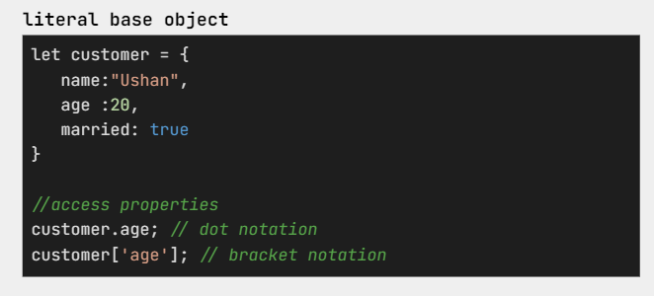42

43

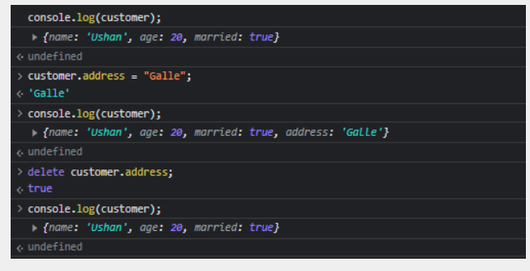

44

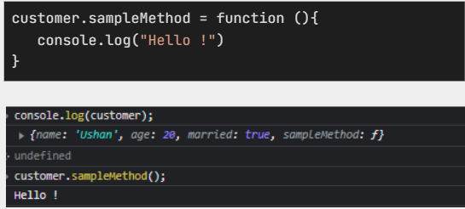

45

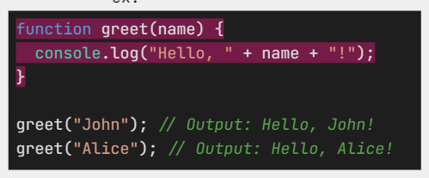

46

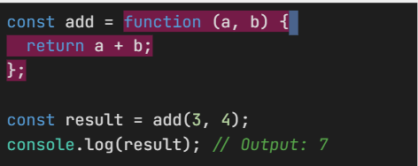

47

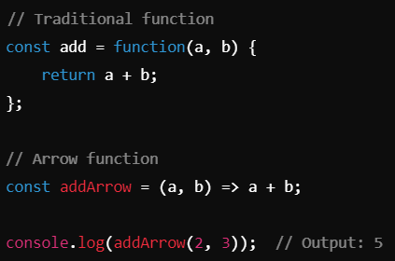

48

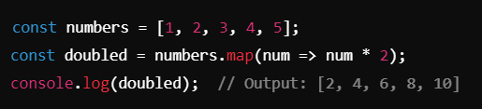

49

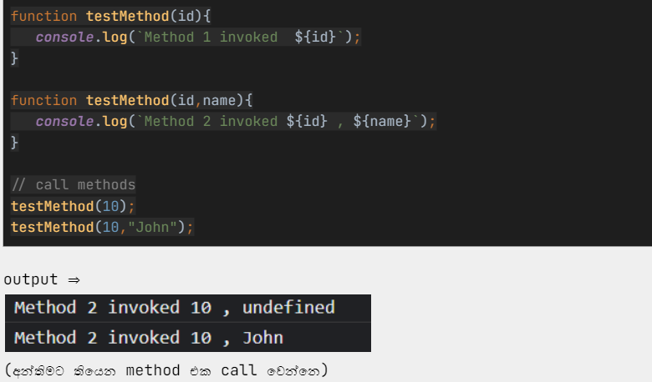

50

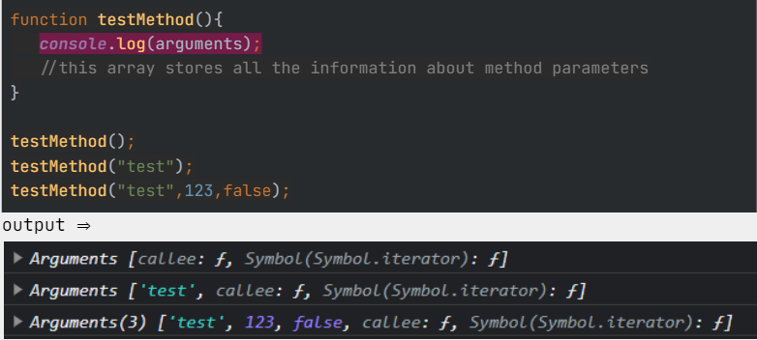

51

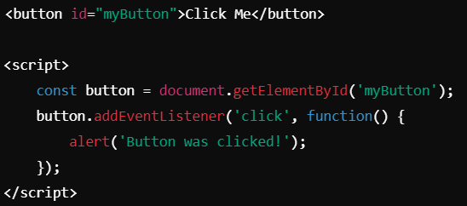

52

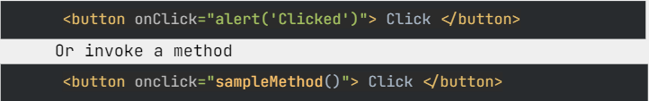

53

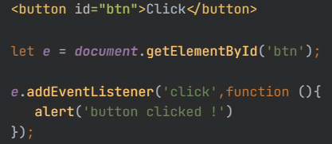

54

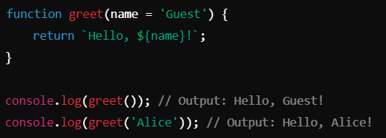

55

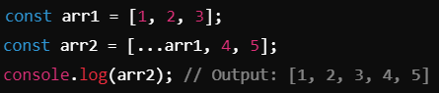

56

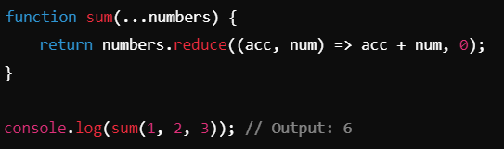

57