01

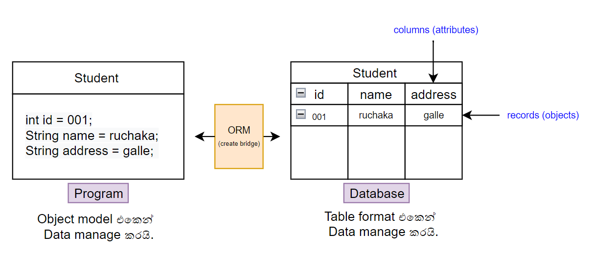

02

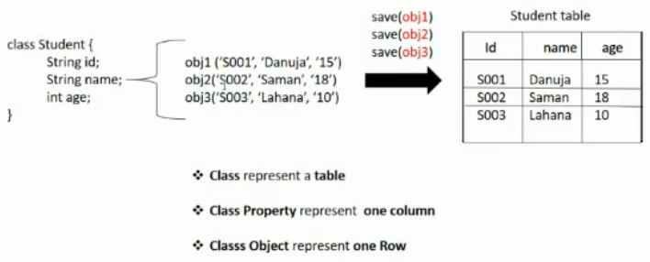

03

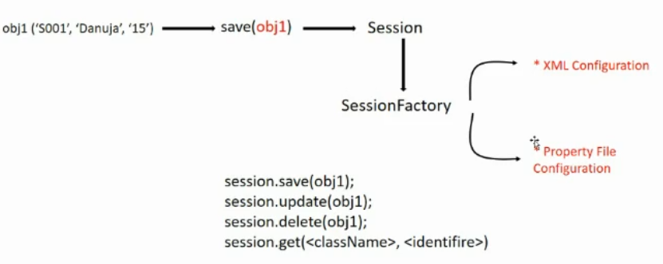

04

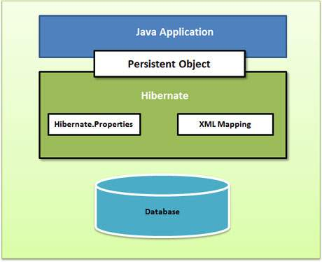

05

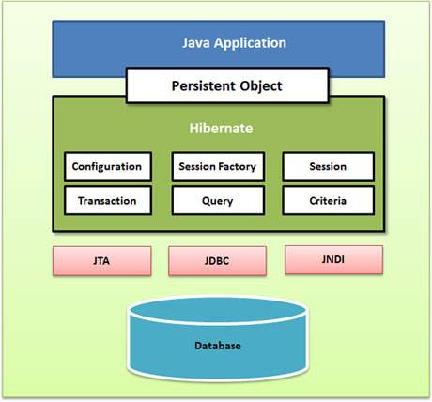

06

07

<?xml version='1.0' encoding='utf-8'?>  
<!DOCTYPE hibernate-configuration PUBLIC  
       "-//Hibernate/Hibernate Configuration DTD//EN"  
       "http://www.hibernate.org/dtd/hibernate-configuration-3.0.dtd">  
<**hibernate-configuration**>  
   <**session-factory**>  
       <!--MySQL Driver-->  
       <**property** name="connection.driver_class">com.mysql.cj.jDBc.Driver</**property**>  
       <!--Dialect-->  
       <**property** name="dialect">org.hibernate.dialect.MySQL8Dialect</**property**>  
       <!--MySQL connection url-->  
       <**property** name="connection.url">jDBc:mysql://localhost:3306/testSample</**property**>  
  
       <!--MySQL User name & password-->  
       <**property** name="connection.username">root</**property**>  
       <**property** name="connection.password">1234</**property**>  
  
       <!--Create/Update/create-drop ... -->  
       <**property** name="hibernate.hbm2ddl.auto">update</**property**>  
       <!--Show quarries in CLI //optional-->  
       <**property** name="hibernate.show_sql">true</**property**>  
   </**session-factory**>  
</**hibernate-configuration**>

08

// Configuration object  
Configuration configuration = new Configuration();  
configuration.addAnnotatedClass(Customer.class); // add annotated class

configuration.configure("hibernate.cfg.xml"); // pass the xml class  
  
// Session Factory object  
SessionFactory sessionFactory = configuration.buildSessionFactory();  
  
// Session object  
Session session = sessionFactory.openSession();  
  
// Transaction object  
Transaction transaction = session.beginTransaction();  
  
Customer c1 = new Customer(1,"kamal","galle");  
session.save(c1);  
  
transaction.commit();  
  
session.close();

09

hibernate.connection.driver_class=com.mysql.cj.jDBc.Driver  
hibernate.dialect=org.hibernate.dialect.MySQL5Dialect  
hibernate.connection.url=jDBc:mysql://localhost:3306/db-name  
hibernate.connection.username=root  
hibernate.connection.password=1234  
hibernate.show_sql=true  
hibernate.hbm2ddl.auto=update

hibernate.connection.url=jdbc:mysql://localhost:3306/dbname**?createDatabaseIfNotExist=true**