24

import React, { useEffect, useState } from 'react';  
  
export const Home = () => {  
    let [num, add] = useState(1);  
  
    const increaseValue = () => {  
        num++;  
        add(num);  
        console.log(num);  
    }  
  
    useEffect(() => {  
        console.log("useEffect hook triggers on every render");  
    });  
  
    return (  
        <div className="home">  
            <p>{num}</p>  
            <button onClick={increaseValue}>Add</button>  
        </div>  
    )  
}

25

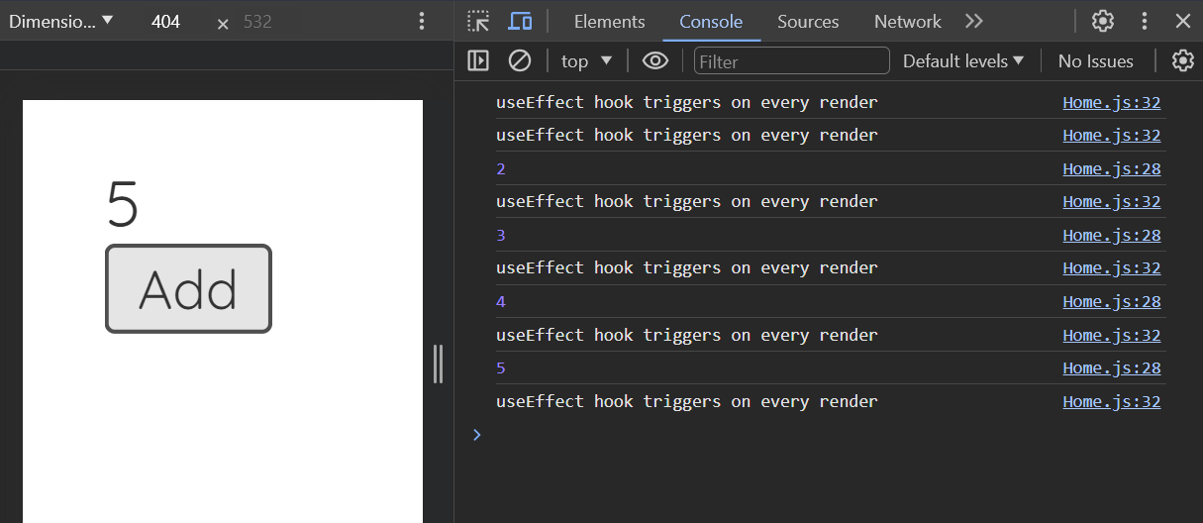

26

*// This useEffect runs only once after the initial render*  
    useEffect(() => {  
        console.log("Triggers once after initial render");  
    }, []);  
  
*// This useEffect triggers when greet state changes*  
    useEffect(() => {  
        console.log("Triggers when dependency changed");  
    }, [greet]);

27

import React, { useState } from 'react';  
  
export const Home = () => {  
    const [blogs, setBlogs] = useState([  
        { title: 'Title 01', body: 'Lorem ipsum 1...', author: 'John', id: '1' },  
        { title: 'Title 02', body: 'Lorem ipsum 2...', author: 'Peter', id: '2' },  
        { title: 'Title 03', body: 'Lorem ipsum 3...', author: 'Thomas', id: '3' }  
    ]);  
  
    return (  
        <div className="home">  
            {/* JS code to iterate and display items */}  
            {blogs.map((blog) => (  
                <div className="blog-preview" key={blog.id}>  
                    <h2>{blog.title}</h2>  
                    <p>Written by {blog.author}</p>  
                </div>  
            ))}  
        </div>  
    )  
}

28

29

**App.tsx**

|  |
| --- |
| import { BrowserRouter, Route, Routes } from 'react-router-dom'; import DefaultLayout from './view/common/DefaultLayout/DefaultLayout'; import Login from './view/pages/Login/Login';  function App() {   return (     <BrowserRouter>       <Routes>         <Route path='/*' Component={DefaultLayout}></Route>         <Route path='/login' Component={Login}></Route>       </Routes>     </BrowserRouter>   ); }  export default App; |

30

Add links

|  |
| --- |
| import React, { Component } from 'react' import { Link } from 'react-router-dom';  export default class Login extends Component {     render() {         return (             <div>                 <Link to="/"> Back to Home </Link>             </div>         );     } } |

31

|  |
| --- |
| import { BrowserRouter, Route, Routes } from 'react-router-dom';  function App() {   return (     <BrowserRouter>       <div className="App">         <Navbar />         <div className="content">           <Routes>             <Route path='/blogs/:id' Component={BlogDetails}></Route>           </Routes>         </div>       </div>     </BrowserRouter>   ); }  export default App; |

|  |
| --- |
| import React from 'react' import { useParams } from 'react-router-dom'  export const BlogDetails = () => {   const { id } = useParams();    return (     <div className="blog-details">       <h2> Blog Details - {id}</h2>     </div>   ) } |