1

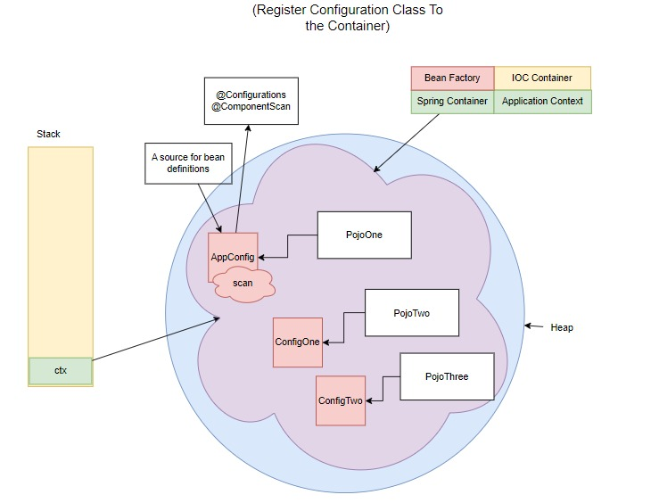

2

public class AppInitializer {

   public static void main(String[] args) {

       AnnotationConfigApplicationContext ctx = new

AnnotationConfigApplicationContext();

       ctx.register(AppConfig.class);

       ctx.register(ConfigOne.class);

       ctx.register(ConfigTwo.class);

       ctx.refresh();

       ctx.registerShutdownHook();

   }

}

3

4

@Configuration

@ComponentScan(basePackages = "lk.ijse.spring.pojo")

@Import({ConfigOne.class,ConfigTwo.class})

public class AppConfig {

   public AppConfig() {

       System.*out*.println("AppConfig Instantiated");

   }

}

5

6

@Configuration

@ComponentScan(basePackages = "lk.ijse.spring.pojo")

public class AppConfig {

   public AppConfig() {

       System.*out*.println("AppConfig Instantiated");

   }

   // Bean method එකක් through value එක set කරන්න,

   @Bean

   public String setName() {

       return "John";

   }

}

7

@Component

public class Customer {

   public Customer(@Value("John") String name) {

      System.*out*.println("Customer : Instantiated : " + name);

   }

}

8

@Component

public class Item implements InitializingBean {

   @Value("Test")

   public String name;

   public Item(){

       System.*out*.println("Item: Instantiated");

       // Instantiate step එකේ ඉන්නෙ, populate properties වෙලා නෑ

       System.*out*.println(name); // output-> null

   }

   @Override

   public void afterPropertiesSet() throws Exception {

       // Bean එකේ ready වුනාම output එක ගන්න පුලුවන්.

       System.*out*.println(name); // output-> Test

   }

}

9

@Component

public class Customer {

   @Autowired

   public Customer(@Value("Tommy") String name) {

       System.*out*.println("Constructor 1");

   }

   public Customer(@Value("Tommy,John") String names[]) {

       System.*out*.println("Constructor 2");

   }

}

10

@Component

public class Customer {

   @Autowired(required = false)

   public Customer(@Value("Tommy") String name) {

       System.*out*.println("Constructor 1");

   }

   @Autowired(required = false)

   public Customer(@Value("Tommy") String name, @Value("25") int age) {

       System.*out*.println("Constructor 2");

   }

}

11

Map<String, String> getenv = System.*getenv*();

for (String key : getenv.keySet()) {

   String value = getenv.get(key);

   System.*out*.println(key+" : "+value);

}

12

Properties properties = System.*getProperties*();

for (Object key : properties.keySet()) {

   Object value = properties.get(key);

   System.*out*.println(key+" : "+value);

}

13

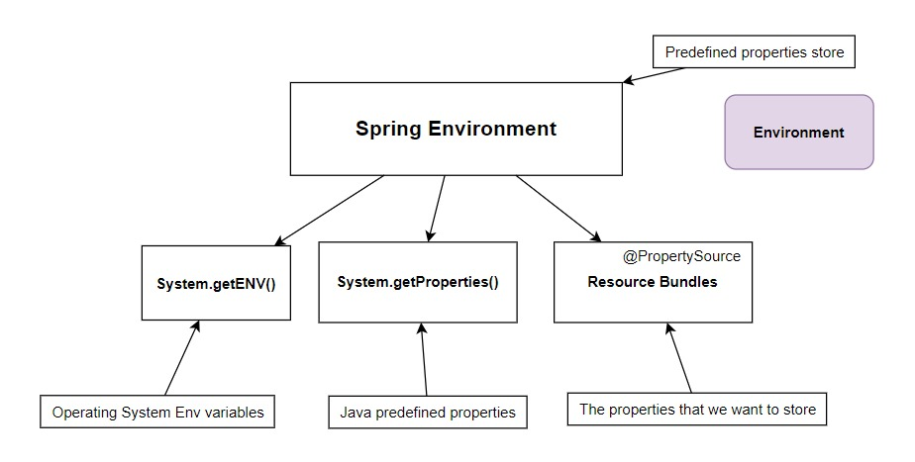

14

@Component

public class TestBean implements InitializingBean {

   @Value("${COMPUTERNAME}") // property placeholder

   private String userName;

   @Override

   public void afterPropertiesSet() throws Exception {

       System.*out*.println(userName); // John

   }

};

15

@Component

public class TestBean implements InitializingBean {

   @Autowired

   Environment environment;

   @Override

   public void afterPropertiesSet() throws Exception {

       String username = environment.getProperty("COMPUTERNAME");

       System.*out*.println(username); // John

   }

}

16

17

@Configuration

@ComponentScan(basePackages = "lk.ijse.spring.pojo")

@PropertySource("classpath:test.properties")

public class AppConfig {

}

18

  @Component

public class PojoOne implements InitializingBean {

   @Value("${my.test}") // property placeholder

   private String s;

   @Autowired

   Environment environment;

   @Override

   public void afterPropertiesSet() throws Exception {

       System.*out*.println(s); // hello

       String property = environment.getProperty("my.test");

       System.*out*.println(property); // hello

   }

}

19

@Value("${my.test.wrong}") // property placeholder

private String s;

. . .

@Override

public void afterPropertiesSet() throws Exception {

    System.*out*.println(s); // ${my.test.wrong}

}

20

@Autowired

Environment environment;

. . .

@Override

public void afterPropertiesSet() throws Exception {

    String property = environment.getProperty("my.test.wrong");

    System.*out*.println(property); // null

}

21

@Autowired

Environment environment;

. . .

@Override

public void afterPropertiesSet() throws Exception {

    String reqProperty = environment.getRequiredProperty("my.test.wrong");

    System.*out*.println(property); // throws exception

}

22

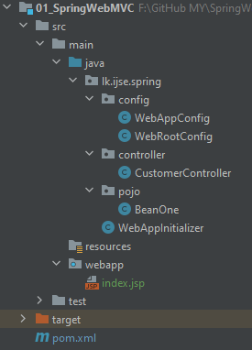

24

public class WebAppInitializer extends AbstractAnnotationConfigDispatcherServletInitializer {

   @Override

   protected Class<?>[] getRootConfigClasses() {

       return new Class[]{WebRootConfig.class};

   }

   @Override

   protected Class<?>[] getServletConfigClasses() {

       return new Class[]{WebAppConfig.class};

   }

   @Override

   protected String[] getServletMappings() {

       return new String[]{"/"};

   }

}

23

<?xml version="1.0" encoding="UTF-8"?>

<project xmlns="http://maven.apache.org/POM/4.0.0"

        xmlns:xsi="http://www.w3.org/2001/XMLSchema-instance"

        xsi:schemaLocation="http://maven.apache.org/POM/4.0.0 http://maven.apache.org/xsd/maven-4.0.0.xsd">

   <modelVersion>4.0.0</modelVersion>

   <groupId>lk.ijse.spring</groupId>

   <artifactId>01_SpringWebMVC</artifactId>

   <version>1.0.0</version>

   <packaging>war</packaging>

   <properties>

       <maven.compiler.source>8</maven.compiler.source>

       <maven.compiler.target>8</maven.compiler.target>

   </properties>

   <dependencies>

       <!--Spring Web MVC-->

       <dependency>

           <groupId>org.springframework</groupId>

           <artifactId>spring-webmvc</artifactId>

           <version>5.3.30</version>

       </dependency>

       <!--Tomcat-->

       <dependency>

           <groupId>javax.servlet</groupId>

           <artifactId>javax.servlet-api</artifactId>

           <version>4.0.1</version>

           <scope>provided</scope>

       </dependency>

   </dependencies>

</project>

25

@Configuration

public class WebRootConfig {

   public WebRootConfig(){

       System.*out*.println("WebRootConfig : Instantiated");

   }

}

26

@Configuration

@EnableWebMvc

@ComponentScan(basePackages = {"lk.ijse.spring.pojo","lk.ijse.spring.controller"})

public class WebAppConfig {

   public WebAppConfig() {

       System.*out*.println("WebAppConfig : Instantiated");

   }

}

27

@RestController

@RequestMapping("/customer")

public class CustomerController {

   @GetMapping

   public String helloSpring() {

       return "Hello Spring";

   }

}

28

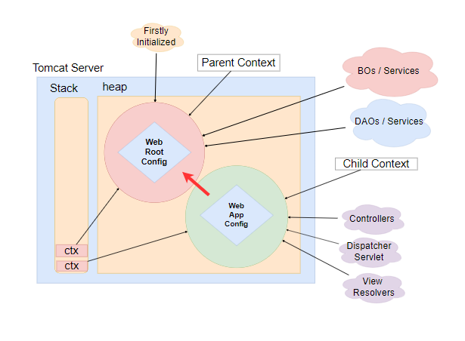

29

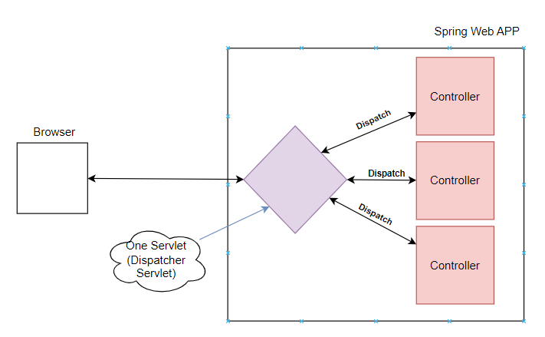

30

31

32

@Configuration

@EnableWebMvc

@ComponentScan(basePackages = "lk.ijse.spring.controller")

public class WebAppConfig {

   // create view resolver

   @Bean

   public InternalResourceViewResolver viewResolver() {

       InternalResourceViewResolver vr = new InternalResourceViewResolver();

       vr.setPrefix("/");

       vr.setSuffix(".jsp");

       return vr;

   }

}

33

@Controller

@RequestMapping("/a")

public class CustomerController {

   @GetMapping

   public ModelAndView test(){

     ModelAndView mv = new ModelAndView("/customer");//.jsp name in webapps

     mv.addObject("Id","C001");

     return mv;

   }

}

34

<%@ **page** contentType="text/html;charset=UTF-8" language="java" %>

<html>

<head>

   <title>Customer</title>

</head>

<body>

<h3>Customer ID : ${Id} </h3>

</body>

</html>

35

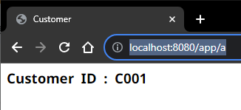

36

37

@RestController

@RequestMapping("/a")

public class CustomerController {

   @GetMapping

   public String getMappingTest(){

       return "getMappingTest invoked";

   }

   @PostMapping

   public String postMappingTest(){

       return "postMappingTest invoked";

   }

   @PutMapping

   public String putMappingTest(){

       return "putMappingTest invoked";

   }

   @DeleteMapping

   public String deleteMappingTest(){

       return "deleteMappingTest invoked";

   }

}

38

39

@GetMapping

public String getMapping(HttpServletRequest req, HttpServletResponse rsp) {

   String id = req.getParameter("id");

   System.*out*.println(id);

   return "Get" + id;

}

40

41

@GetMapping

public String getMapping1() {

   return "Get1";

}

@GetMapping

public String getMapping2() {

   return "Get2";

}

42

@RestController

@RequestMapping("/segment")

public class B_Path_Segments_Controller {

   //request narrow downing using path segments

   @GetMapping(path = "/two")

   public String getMapping2(){

       return "Get Mapping Invoked 2";

   }

   @GetMapping(path = "/three")

   public String getMapping3(){

       return "Get Mapping Invoked 3";

   }

   @GetMapping(path = "/three/four")

   public String getMapping4(){

       return "Get Mapping Invoked 3/4";

   }

}

43

@RestController

@RequestMapping("/pathVariable")

public class C_Path_Variables_Controller {

   @GetMapping(path = "/{name}")

   public String getMapping1(@PathVariable String name){

       return "Get Mapping Invoked 1 "+name;

   }

   @GetMapping(path = "/id/{name}")

   public String getMapping2(@PathVariable String name){

       return "Get Mapping Invoked 2 "+name;

   }

   @GetMapping(path = "/{id}/{name}")

   public String getMapping3(@PathVariable String id,@PathVariable String name){

       return "Get Mapping Invoked 3 "+id+" "+name;

   }

}

44

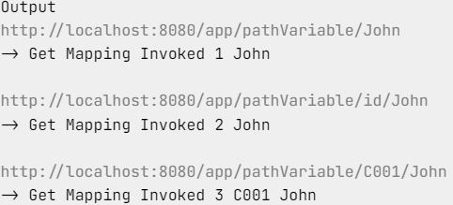

45

@GetMapping(path = "/{id}")

public String getMapping(@PathVariable("id") String ids){ //alias

   return "Get Mapping Invoked "+ids;

}

47

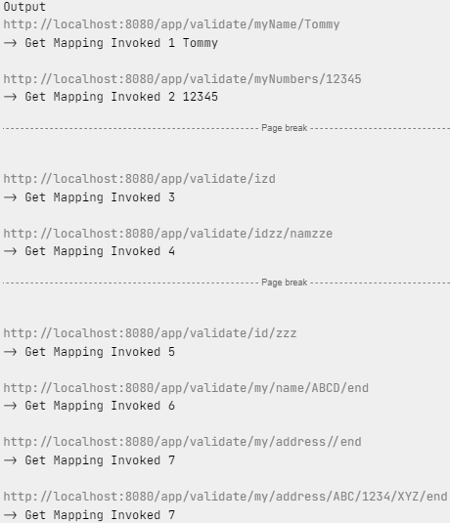

48

@RestController

@RequestMapping("/query")

public class E_Query_Sting_Parameters_Controller {

   @GetMapping(params = {"id", "name", "address"})

   public String getMapping1(@RequestParam String id, String name, String address) {

       return "Get Mapping Invoked 1 " + id + " " + name + " " + address;

   }

}

46

@RestController

@RequestMapping("/validate")

public class D_Validate_Path_Variables_Controller {

   //01) RegEx Validation path

   @GetMapping(path = "/myName/{name:[A-Z]{1}[a-z]{4}}")

   public String getMapping1(@PathVariable String name) {

       return "Get Mapping Invoked 1 " + name;

   }

   @GetMapping(path = "/myNumbers/{numbers:[0-9]{5}}")

   public String getMapping2(@PathVariable String numbers) {

       return "Get Mapping Invoked 2 " + numbers;

   }

   //02) Single Character Validations

   // ? තියෙන තැනට කැමති character එකක් දාන්න පුලුවන්, දන්නෙ නැති character

     path වලට use කරන්න පුලුවන්

   @GetMapping(path = "/i?d")

   public String getMapping3() {

       return "Get Mapping Invoked 3";

   }

   @GetMapping(path = "/id??/nam??e")

   public String getMapping4() {

       return "Get Mapping Invoked 4";

   }

   @GetMapping(path = "/id/???")

   public String getMapping5() {

       return "Get Mapping Invoked 5";

   }

   //03) Single Wild Card Validator (wildcard mapping)

   //* <- one or more characters inside a segment

   @GetMapping(path = "/my/name/*/end")

   public String getMapping6() {

       return "Get Mapping Invoked 6";

   }

   //04) Multiple Wild Card Validator (Dual wildcard mapping)

   //** <- zero or more segments with unlimited characters

   @GetMapping(path = "/my/address/**/end")

   public String getMapping7() {

       return "Get Mapping Invoked 7";

   }

}

49

@RestController

@RequestMapping("/headers")

public class F_Request_Headers_Controller {

   @GetMapping(consumes = "application/json")

   public String getMapping1() {

       return "Get Mapping Invoked 1";

   }

   @GetMapping(consumes = "text/html")

   public String getMapping2() {

       return "Get Mapping Invoked 2";

   }

}

50

51

@RestController

@RequestMapping("/headers")

public class F_Request_Headers_Controller {

   @GetMapping(produces = "text/html")

   public String getMapping3() {

       return "Get Mapping Invoked 3";

   }

   @GetMapping(produces = "application/json")

   public String getMapping4() {

       return "Get Mapping Invoked 4";

   }

}

52

53

@GetMapping(headers = {"Content-Type=application/json","Accept=text/html"})

public String getMapping5() {

   return "Get Mapping Invoked 5";

}

54

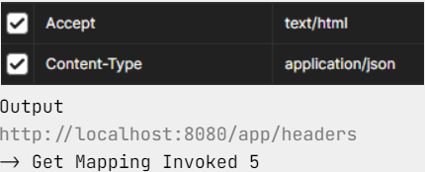

55

@RestController

@RequestMapping("/fetch")

public class A_Data_Fetch_Controller {

   @GetMapping(params = {"id","name"})

   public String receiveDataWithQueryString(String id,@RequestParam String name){

       return "Query String data : "+id+", "+name;

   }

}

56



57

@RestController

@RequestMapping("/form")

public class B_X_WWW_Url_Encoded_Controller {

   @PostMapping

   public String receiveDataWithFormData(String id, String name, String address) {

       return "X-WWW-Form-URL-Encoded-Data : " + id + " " + name + " " + address;

   }

}

58

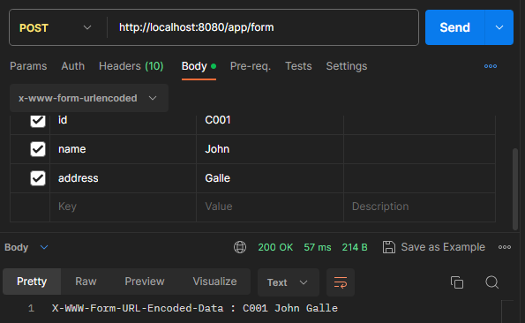

59

@Data

@AllArgsConstructor

@NoArgsConstructor

public class CustomerDTO {

   private String id;

   private String name;

   private String address;

   private double salary;

   private String tp;

}

60

@RestController

@RequestMapping("/form")

public class B_X_WWW_Url_Encoded_Controller {

   @PostMapping

   public String receiveData(@ModelAttribute CustomerDTO dto) {

       return "X-WWW-Form-URL-Encoded-Data : " +dto;

   }

}

61

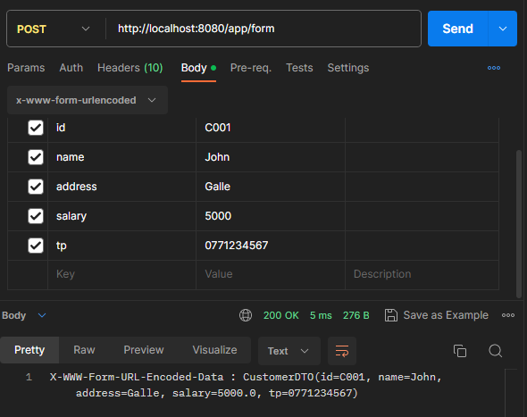

62

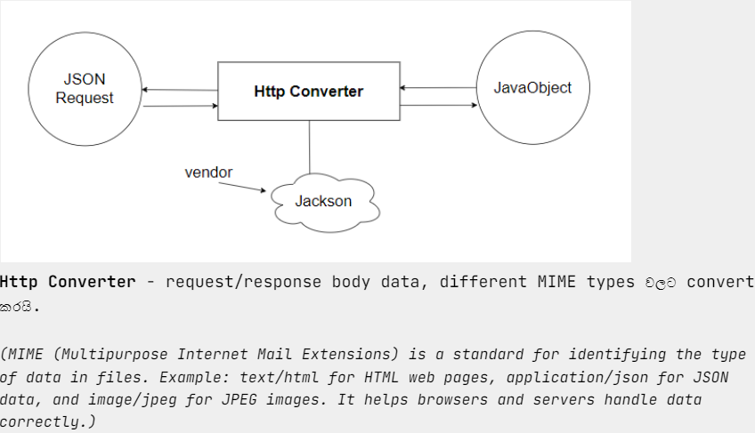

63

@Data

@AllArgsConstructor

@NoArgsConstructor

public class CustomerDTO {

   private String id;

   private String name;

   private String address;

   private double salary;

   private String tp;

   private ArrayList<ItemDTO> items;

}

64

@Data

@AllArgsConstructor

@NoArgsConstructor

public class ItemDTO {

   private String code;

   private String itemName;

}

65

**POST**

@RestController

@RequestMapping("/json")

public class C_JSON_Controller {

   @PostMapping

   public String receiveDataWithJson(@RequestBody CustomerDTO dto){

       return "Json Data : "+dto.toString();

   }

}

66

67

@RestController

@RequestMapping("/response")

public class D_Response_Controller {

   @GetMapping

   public ArrayList<CustomerDTO> sendJsonData(){

       ArrayList<CustomerDTO> allCustomers = new ArrayList<>();

       allCustomers.add(new CustomerDTO("C001","John","Galle",5000,"0771234567",null));

       allCustomers.add(new CustomerDTO("C002","Tommy","Matara",1000,"0777654321",null));

       return allCustomers;

   }

}

68

69

@RestController

@RequestMapping("/response")

public class D_Response_Controller {

   @PutMapping

   public CustomerDTO receiveDataWithJson(@RequestBody CustomerDTO dto) {

       return dto;

   }

}

70

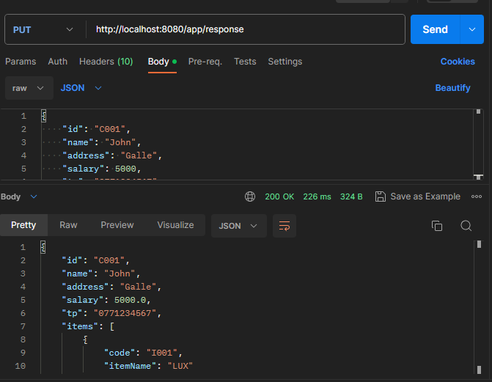

71

@ResponseStatus(HttpStatus.*INTERNAL_SERVER_ERROR*)

@RestControllerAdvice

public class AppWideExceptionHandler {

   @ExceptionHandler({RuntimeException.class})

   public ResponseUtil handleAllRuntimeException(RuntimeException e){

       return new ResponseUtil("Error", e.getMessage(), null);

   }

}

72

@ExceptionHandler({Exception.class})

public ResponseUtil handleAllExceptions(Exception e){

   return new ResponseUtil("Error", e.getMessage(), null);

}

73

@EnableWebMvc

@Configuration

@ComponentScan(basePackages = {"lk.ijse.spring.controller","lk.ijse.spring.adviser"})

public class WebAppConfig {

}

74

@RestController

@RequestMapping("/customer")

public class CustomerController {

   @DeleteMapping(params = "id")

   public ResponseUtil deleteCustomer(@RequestParam String id) {

       if (id.endsWith("C001"))

           throw new RuntimeException("This customer cannot deleted.!");

       return new ResponseUtil("Ok", "Successfully Delete", id);

   }

}

75



76

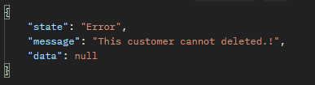

77

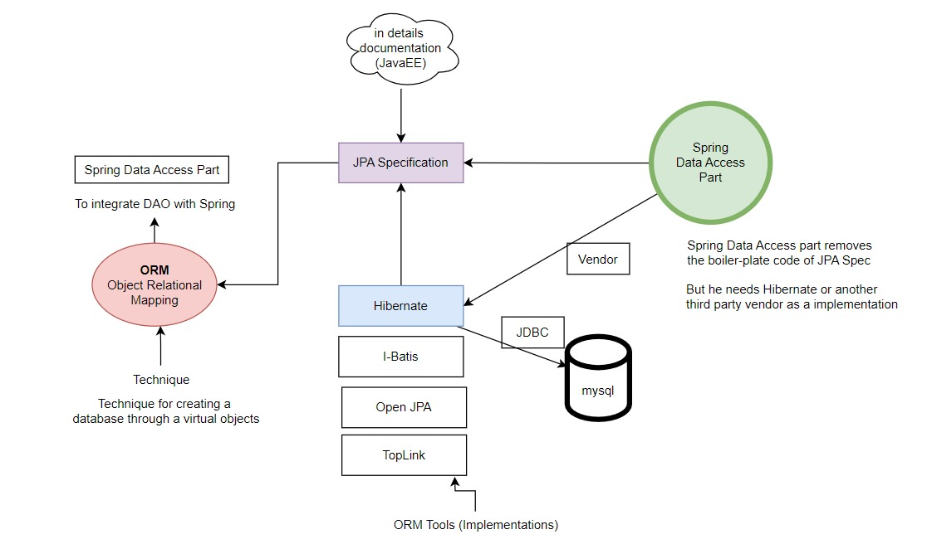

78

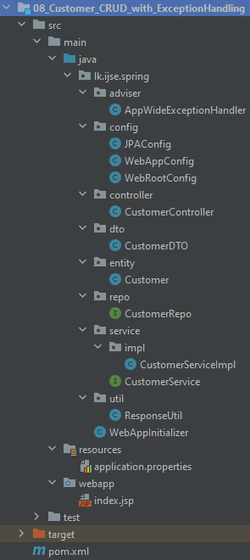

79

@Configuration

@EnableJpaRepositories(basePackages = "lk.ijse.spring.repo")

@EnableTransactionManagement

public class JPAConfig {

   @Bean

   public LocalContainerEntityManagerFactoryBean entityManagerFactory(DataSource ds, JpaVendorAdapter vad) {

       LocalContainerEntityManagerFactoryBean factory = new LocalContainerEntityManagerFactoryBean();

       factory.setDataSource(ds);

       factory.setJpaVendorAdapter(vad);

       factory.setPackagesToScan("lk.ijse.spring.entity"); // set entity locations

       return factory;

   }

   @Bean

   public DataSource dataSource() {

       DriverManagerDataSource ds = new DriverManagerDataSource();

       ds.setUsername("root");

       ds.setPassword("1234");

       ds.setDriverClassName("com.mysql.jdbc.Driver");    ds.setUrl("jdbc:mysql://localhost:3306/customerDB?createDatabaseIfNotExist=true");

       return ds;

   }

   @Bean

   public JpaVendorAdapter jpaVendorAdapter() {

       HibernateJpaVendorAdapter va = new HibernateJpaVendorAdapter();

       // Set the database platform to MySQL 8 Dialect

       va.setDatabasePlatform("org.hibernate.dialect.MySQL8Dialect");

       va.setDatabase(Database.*MYSQL*); // Set the database type to MySQL

       va.setGenerateDdl(true); // Generate Data Definition Language (DDL) queries

       va.setShowSql(true); // Show SQL queries in the logs

       return va;

   }

   @Bean

   public PlatformTransactionManager transactionManager(EntityManagerFactory factory) {

       return new JpaTransactionManager(factory);

   }

}

80

@Configuration

@Import(JPAConfig.class) // Import the JPA configuration class

public class WebRootConfig {

}

81

@CrossOrigin // Enable Cross-Origin Resource Sharing (CORS) for this controller

@RestController

@RequestMapping("/customer")

public class CustomerController {

   @Autowired

   private CustomerService service;

   @ResponseStatus(HttpStatus.*CREATED*)

   // get all

   @GetMapping

   public ResponseUtil getAllCustomers() {

       return new ResponseUtil("Ok", "Successfully Loaded", service.getAllCustomers());

   }

   // find

   @GetMapping(params = {"id"})

   public ResponseUtil findCustomer(String id) {

       return new ResponseUtil("Ok", "Successfully Searched", service.searchCustomer(id));

   }

   // add

   @PostMapping

   public ResponseUtil saveCustomer(@ModelAttribute CustomerDTO dto) {

       service.saveCustomer(dto);

       return new ResponseUtil("Ok", "Successfully Added", dto);

   }

   // update

   @PutMapping

   public ResponseUtil updateCustomer(@RequestBody CustomerDTO dto) {

       service.updateCustomer(dto);

       return new ResponseUtil("Ok", "Successfully Updated", dto);

   }

   // delete

   @DeleteMapping(params = {"id"})

   public ResponseUtil deleteCustomer(String id) {

       service.deleteCustomer(id);

       return new ResponseUtil("Ok", "Successfully Deleted", id);

   }

}

82

public interface CustomerService {

   ArrayList<CustomerDTO> getAllCustomers();

   CustomerDTO searchCustomer(String id);

   void saveCustomer(CustomerDTO dto);

   void updateCustomer(CustomerDTO dto);

   void deleteCustomer(String id);

}

83

@Service

@Transactional

public class CustomerServiceImpl implements CustomerService {

   @Autowired

   CustomerRepo repo;

   @Autowired

   ModelMapper mapper;

   @Override

   public ArrayList<CustomerDTO> getAllCustomers() {

       List<Customer> all = repo.findAll();

       return mapper.map(all, new TypeToken<ArrayList<CustomerDTO>>() {}.getType());

   }

   @Override

   public CustomerDTO searchCustomer(String id) {

       if (!repo.existsById(id)) throw new RuntimeException("Id not exists !");

       return mapper.map(repo.findById(id).get(), CustomerDTO.class);

   }

   @Override

   public void saveCustomer(CustomerDTO dto) {

       if (repo.existsById(dto.getId())) throw new RuntimeException("Error, Already added!");

       repo.save(mapper.map(dto, Customer.class));

   }

   @Override

   public void updateCustomer(CustomerDTO dto) {

       if (!repo.existsById(dto.getId())) throw new RuntimeException("Id not exists !");

       repo.save(mapper.map(dto, Customer.class));

   }

   @Override

   public void deleteCustomer(String id) {

       if (!repo.existsById(id)) throw new RuntimeException("Id not exists !");

       repo.deleteById(id);

   }

}

84

public interface CustomerRepo extends JpaRepository<Customer, String> {

}

85

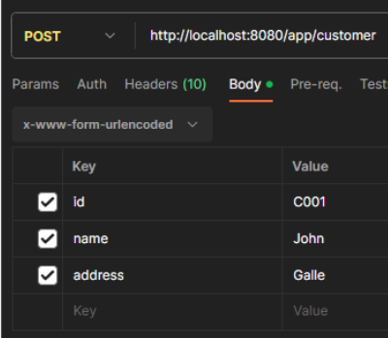

86

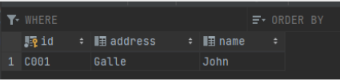

87

88

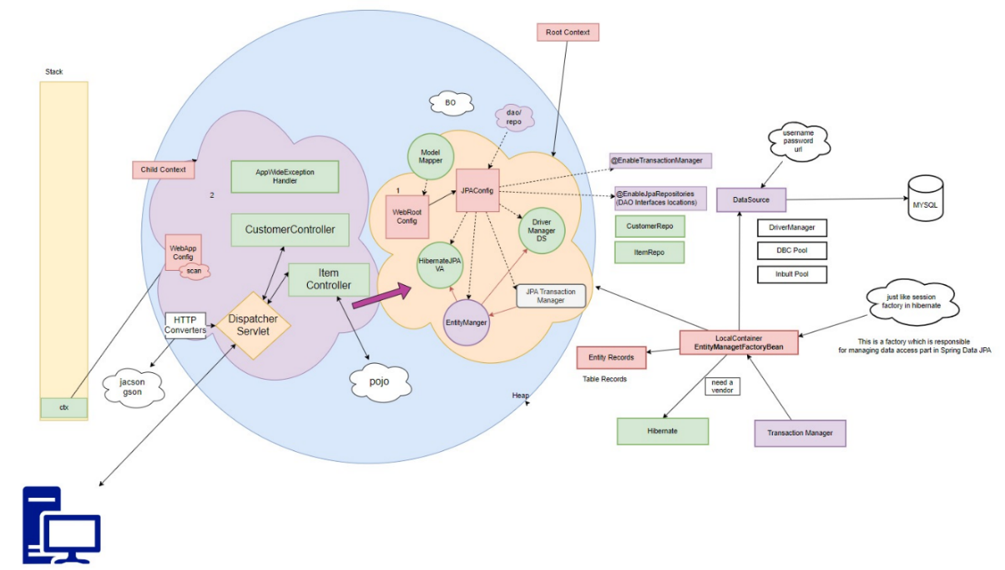

89

90

Customer customer = new Customer(dto.getId(),dto.getName(),dto.getAddress());

91

Customer customer = mapper.map(dto, Customer.class);

92

mapper.map(param1, param2.class);

93

@Override

public List<CustomerDTO> getAllCustomers() {

   List<Customer> all = customerRepo.findAll();

   return mapper.map(all, new TypeToken<List<CustomerDTO>>() {

   }.getType());

   //new TypeToken<>(){}.getType()

   //new TypeToken<List<CustomerDTO>>(){}.getType()

}

94

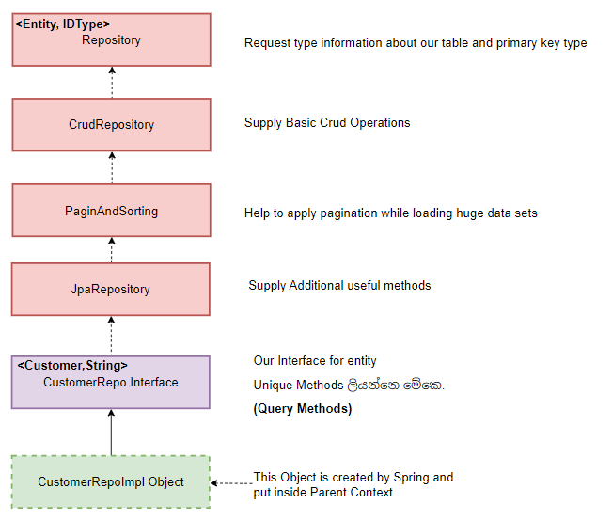

95

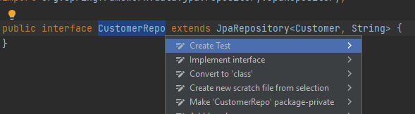

96

@WebAppConfiguration

@ContextConfiguration(classes = {WebRootConfig.class})

@ExtendWith(SpringExtension.class)

@Transactional

class CustomerRepoTest {

   @Autowired

   CustomerRepo repo;

   @Test

   public void testGetAllCustomers(){

       List<Customer> all = repo.findAll();

       for (Customer customer: all){

           System.*out*.println(customer.toString());

       }

   }

}

97

98

99

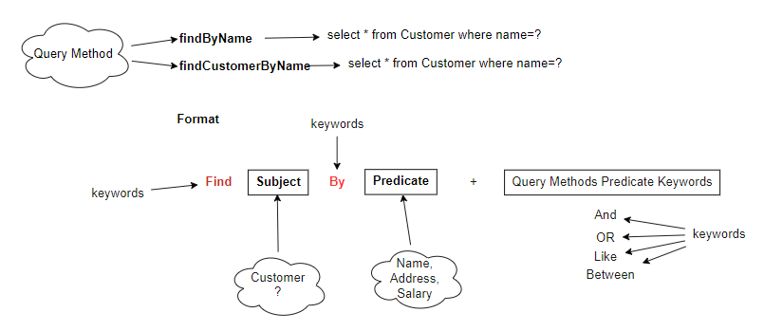

100

101

1. Native query

@Query(value = "select * from Customer",nativeQuery = true)

List<Customer> getAllCustomers1();

1. JPQL

@Query(value = "select c from Customer c")

List<Customer> getAllCustomers2();

1. HQL

@Query(value = "from Customer c")

List<Customer> getAllCustomers3();

**named parameters**

@Query(value = "select * from Customer where name=:nm",nativeQuery = true)

List<Customer> searchCustomerWithName(@Param("nm") String name);

**Positional parameters**

@Query(value = "select * from Customer where name=?1 and address=?2 ",nativeQuery = true)

List<Customer> searchCustomerWithName(String name, String address);