1
class Main {
public static void main(String[] args) {
Student st = new Student();
st.setAge(18);
System.out.println(st.getAge());
}
}

class Student {
private String name;
private int age;

public String getName() {
return name;
}

public void setName(String name) {
this.name = name;
}

public int getAge() {
return age;
}

public void setAge(int age) {
if (age > 0 && age < 100) { //<- Validation level Protection
this.age = age;
}
}
}

2
class A {
String name = "John";
int age = 18;

void say() {
System.out.println("Hi," + name);
}
}

class B extends A {

}

class Main {
public static void main(String[] args) {
B b = new B();
b.say();
System.out.println("age :" + b.age);
}
}

3
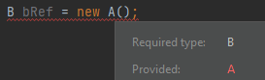
4
class Main{
public static void main(String [] args){
Numbers n1 = new Numbers();
n1.num();
n1.num(10);
n1.num(20,30);
n1.num(10.5);
}
}

class Numbers{
public void num(){
System.out.println("num() -- parameters 0");
}

public void num(int x){ //<<---------(1)
System.out.println("num(int x) -- parameters 1 ");
}

public void num(int x, int y){ //<<---------(2)
System.out.println("num(int x, int y -- parameters 2 ");
}

public void num(double x){ //<<---------(3)
System.out.println("num(double x) -- parameters 1");
}
}

// (1) and (2) --- same name & Different parameter count
// (1) and (3) --- same name & Different parameter type
// But all have same method name

5
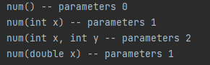

6
class Main{
public static void main(String[] args) {
Animal a1 = new Dog();
a1.say();
}
}

class Animal{
void say(){
System.out.println("I'm Animal");
}
}

class Dog extends Animal{
void say(){
System.out.println("I'm Dog");
}
}

7
abstract class Test{
abstract void method1(); // abstract method

void method2(){ // non-abstract method
System.out.println("method 2 body");
}
}
// (abstract method 1, non-abstract method 1 නිසා Test, 50% abstract class එකක්)

8
class Demo {
public static void main(String[] args) {
Animal a = new Cat();
a.eat(); // Method එක call කරන්නෙ programmer/user
}
}
// implementation (hide කරල තියෙන්නෙ user ගෙන්)
abstract class Animal {
abstract void eat();
}
class Cat extends Animal {
@Override
void eat() {
System.out.println("eat");
}
}

9
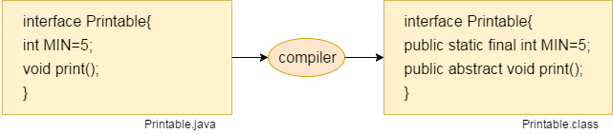
10
class Demo {
public static void main(String[] args) {
Animal a = new Cat();
a.eat(); // Method එක call කරන්නෙ programmer/user
}
}

// implementation (hide කරල තියෙන්නෙ user ගෙන්)
interface Animal {
abstract void eat();
}

class Cat implements Animal {
@Override
public void eat() {
System.out.println("eat");
}
}

11
interface Dog{ // Marker interface
}

interface Cat{ // Functional interface
void dance();
}

12
Cat c = new Cat() {
@Override
public void dance() {
//body
}
};

13
interface Animal{
default void run(){}; //<< concrete method
static void eat(){}; //<< concrete method
}

14
 | Abstract class | Interface
example | abstract class Test{  abstract void method1();  } | interface Test{  void method1();  }
objects | දෙකෙන්ම object හදන්න බෑ.
 | constructor එකට call කරන්න බෑ, ඒත් constructor එකක් තියෙනො | constructor එකක් නෑ
keyword | abstract keyword එකෙන් declare කරල තියෙන්නෙ. | interface keyword එකෙන් declare කරල තියෙන්නෙ..
methods | abstract , non-abstract methods තියෙන්න පුලුවන්. | abstract methods විතරයි.  (100% abstract)
variables | final, non-final, static and non-static variables තියෙන්න පුලුවන් . | static and final variables විතරයි.  (same line initialize කරන්න ඕන)  (already abstract, public, static and final)
multiple inheritance | multiple inheritance support නෑ. | multiple interfaces support.  (Multiple inheritance is achieved and implemented using interfaces)
extend / implement | extend keyword එකෙන් extend කරන්න පුලුවන්. | implement keyword එකෙන් implement කරන්න පුලුවන්.
 | Abstract class එකකට වෙන class එකක් extend කරන්න පුලුවන්.  multiple interfaces implement කරන්න පුලුවන්. | Interface වලට extend කරන්න පුලුවන් interface විතරයි.  multiple interfaces extend කරන්න පුලුවන්.
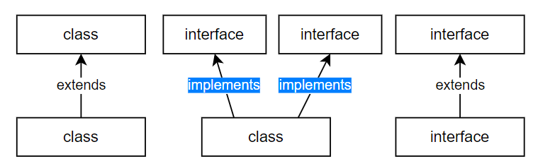
15
interface A {
int x = 10;
}

interface B {
int y = 11;
}

interface C extends A, B { // multiple interfaces
default void tot() {
System.out.println(x + y);
}
}

16
class ExampleClass {
// Static variable (Class variable)
static int staticVar = 0;

// Instance variable (Object variable)
int instanceVar;

void exampleMethod() {
// Local variable
int localVar = 10;
}
}

17
class A{
A(){
System.out.println("constructor");
}
static {
System.out.println("static block");
}

{
System.out.println("instance block");
}
}
class Main{
public static void main(String[] args) {
A a1 = new A();
A a2 = new A();
}
}

18

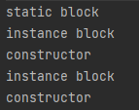

20
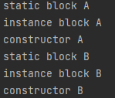

19
class A{
A(){
System.out.println("constructor A");
}

static {
System.out.println("static block A");
}

{
System.out.println("instance block A");
}
}

class B{
B(){
System.out.println("constructor B");
}

static {
System.out.println("static block B");
}

{
System.out.println("instance block B");
}
}

class Main{
public static void main(String[] args) {
A a = new A();
B b = new B();
}
}

### complete

