**TOURGURU: TOUR GUIDE MOBILE**

**APPLICATION FOR TOURISTS**

R.D.T.N.Rajarathna

(IT16003538)

B.Sc. (Hons) in Information Technology

Department of Information Technology

Sri Lanka Institute of Information Technology

Sri Lanka

August 2019

# Declaration

I declare that this is my own work and this dissertation does not incorporate without acknowledgement any material previously submitted for a degree or diploma in any other university or Institute of higher learning and to the best of my knowledge and belief it does not contain any material previously published or written by another person except where the acknowledgement is made in the text. Also, I hereby grant to Sri Lanka Institute of Information Technology the non-exclusive right to reproduce and distribute my dissertation in whole or part in print, electronic or other medium. I retain the right to use this content in whole or part in future works (such as article or books).

|  |  |  |
| --- | --- | --- |
| Name | Student ID | Signature |
| R.D.T.N. Rajarathna | IT16003538 |  |

The supervisor/s should certify the proposal report with the following declaration.

The above candidate is carrying out research for the undergraduate Dissertation under my supervision.

Signature of the Supervisor: Date

…............................................. ..............................

Signature of the Co-Supervisor: Date

…............................................. ..............................

**TOURGURU: TOUR GUIDE MOBILE**

**APPLICATION FOR TOURISTS**

Ranpati Dewage Tharindu Nuwan Rajarathna

(IT16003538)

Dissertation submitted in partial fulfillment of the requirements for the Bachelor of Science (Honors) degree in Information Technology Specialization in IT

Department of Information Technology

Sri Lanka Institute of Information Technology

Sri Lanka

August 2019

# Abstract

Sri Lanka have always been a major tourist attraction in the world. Many tourists from various countries pour into our nation each year. Of course, there are many guides and tours. But if someone wants to travel alone it is very difficult to find information on places of interest, historical monuments etc. And tours only cover mainstream locations leaving many delightful attractions untouched. Since the internet is not very reliable when it comes to our country tourists might not be able to enjoy their journey to the fullest.

These days hardly a travelling person without an Android or IOS mobile device. So, it makes sense for there to be a mobile based solution for this problem. We propose a tour guide mobile app which uses cloud computing, machine learning and augmented reality to give the user an amazing experience. This app would guide them through an appropriate route to see the attractions of their choosing. They would also be given the opportunity to listen to a narration about certain monuments while they are walking or driving through the suggested route. There could be people from the same country, or just people who are traveling in the same route. This feature would help bring them together and let them interact with each other by acting as a platform for them to introduce themselves. In this component basically shows the intelligent route mapping with google maps.

# Acknowledgement

The work described in this research paper was carried out as our 4th year research project for the subject Comprehensive Design Analysis Project. The completed final project is the result of combining all the hard work of the group members and the encouragement, support and guidance given by many others. Therefore, it is our duty to express our gratitude to all who gave us the support to complete this major task.

We are deeply indebted to our supervisor Ms. Asanthika Imbulpitiya and our co-supervisor Mr. Nuwan Kodagoda, lecturers of Sri Lanka Institute of Information Technology whose suggestions, constant encouragement and support in the development of this research, particularly for the many stimulating and instructive discussions. We are also extremely grateful to Mr. Jayantha Amararachchi, Senior Lecturer/ Head-SLIIT Centre for Research who gave and confirmed the permission to carry out this research and for all the encouragement and guidance given.

We also wish to thank all our colleagues and friends for all their help, support, interest and valuable advices. Finally, we would like to thank all others whose names are not listed particularly but have given their support in many ways and encouraged us to make this a success

# TABLE OF CONTENT

Declaration 2

Abstract 4

Acknowledgement 5

List of Tables 6

List of Figures 6

List of Definitions 6

1. Introduction 7

1. Background Literature 7

2. Research gap 7

3. Research Problem 8

4. Research Objectives 8

2. Methodology 9

1. User Case Diagrams and Scenarios 10

2. Commercialization Aspects of the Product 12

3. Testing & Implementation 12

3. Results & Discussion 13

1. Results 13

2. Research Findings 14

3. Discussion 14

4. Conclusion 15

References 16

# List of Tables

Table 1 : The Comparison of ontologies 7

Table 2 : Use case Scenario 1 11

Table 3: Use case Scenario 2 11

# List of Figures

Figure 1 : Use Case Diagram 10

Figure 2 : Class Diagram 10

Figure 3 : A generated route of Intelligent Route Generation component 13

Figure 4 : Search Mode of the component 13

Figure 5 : Showing nearby locations 13

# Introduction

## Background Literature

In the research [1], the researchers have concluded that combining the tour guide with the trip planning tool could integrate pre-trip plan with during-trip planning and provide more personalized and relevant information during a trip. In addition, post-trip evaluation can be integrated into the system in which the users will be able to rank the different properties they have gone to. Future development can also include an interface for tourism enterprises to update their information daily even hourly (for example, a special deal for the day) to market toward visitors on the road or 100 or 200 yards around them. Location and map-based tourist information tools based on Google Map API opened many opportunities to enhance visitor experience as well as connecting visitors with tourism properties in destinations.

## Research gap

|  |  |  |  |  |
| --- | --- | --- | --- | --- |
| Features |  |  |  | සිංහලංකා AR |
| Intelligent Trip routing (automatic route creation) |  |  |  |  |
| Trip editor (Add or update custom places) |  |  |  |  |
| Categorize locations  (monuments places, restaurant etc) |  |  |  |  |
| Map Filters |  |  |  |  |
| Shared user activity |  |  |  |  |
| Traffic management |  |  |  |  |
| Waypoint management |  |  |  |  |
| Collaborator management |  |  |  |  |

Table 1 : The Comparison of ontologies

## Research Problem

In our country, tourism is fast becoming a major industry, which is already bringing in millions of dollars in foreign income. It still has potential to bring much more to this country. But there are a few obstacles in our way hindering its growth. One of them is the general lack of information about our country. This is a major issue to the tourism industry because most tourists don’t like to travel blindly. There are existing tour services which guides the tourists to attractions, but most of them are scheduled services which takes away the freedom and the fun that many tourists crave. Therefore, the need for a proper guidance system for these tourists is a must.

When a tourist visits the country and stay in the hotel in an urban area. They might want to go for a stroll outside. But they would have no idea about where to go or what to do. So, there is a need for a system that can guide these people to places of interest that are not well known. Since there are many of these small attractions scattered around, there needs to be way for these location data to be collected and stored for the usage of travelers.

## Research Objectives

Main objective of the TourGuru mobile application is to help travelers navigate through places of interest without much hassle. It needs to be a simple but very exciting and interactive application. It focuses mainly on being a virtual tour guide by narrating details about the places and answering any questions the user might get during their travels.

* Guiding a tourist through a route by intelligent routing.
* Collect user flagged destinations.
* Merge Details with maps platforms.
* Machine learning is used for tracking usual locations, destinations and map route accordingly.
* Code the walk and Driving mode accordingly.
* Finally, Use of crowd sourced information further development of system.

# Methodology

At the first step, the process on the system development proceeds with sample of data. Data gathering or generation techniques are discussed in here for the research objectives intelligent route generation. For the guidance of a traveler the implementation on intelligent route generation research focusses on the techniques for solving VRP and TSP problems. Data gathering for this implementation is done through Google Maps Platform a cloud platform solution. With the use of RESTful API, system requests for nearby POI’s from Places API, a subcomponent of the cloud solution. Response from the cloud solution is received in JSON (JavaScript Object Notation) Data Interchange Syntax [2]. Set of nearby POI locations are within this JSON array and used as Primary data with the purpose on generating a route that suits best interests to a tourist through processing. For the generation of the dataset place request will be sent for place search. Place Search will take source geo coordinate and the radius that needed to search for POI’s nearby primarily. Response includes a JSON array on nearby POI’s with parameters on each of location name, type(s), geometry and rating. Next the request that sent with source geo coordinates and destination geo coordinates to the cloud service Google Directions API will give a response with JSON array containing the features distance to travel, time taken to travel and polyline of the map route.

Deep Learning algorithm executes processed data on Intelligent Route Generation component. The machine learning model will be hosted on Google Cloud Platform’s AutoML machine learning platform [3]. Processed data will be stored on the Firebase storage upon data cleaning ends and algorithm execution starts. Selection on the algorithm is based on solving Travelling Salesmen Problem with Heuristic Machine Learning (Q Learning, Nearest Neighbor, Genetic Algorithm, Ant Colony Optimization etc.) algorithms. Application on the research component starts with feature analysis on the dataset and training with the most important features. Then optimizing the training accuracy by tuning hyper-parameters and learning rates. Generated result from the Google AutoML compute engine will have a response with the corresponding POI’s to travel accordingly. This result will be graphically generated and presented to the user through Flutter app implemented map interface.

## User Case Diagrams and Scenarios

The interactions between the system and the people who uses the system are represented in a Use Case Diagram. The graphical replication of the system is shown in Figure 1.

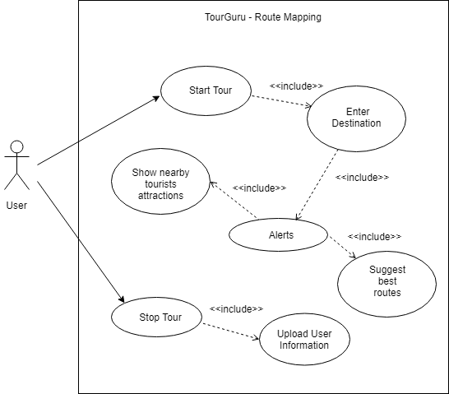

Figure 1 : Use Case Diagram

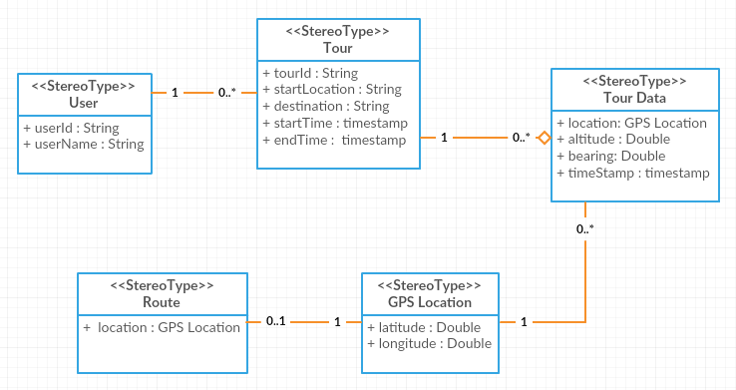

Figure 2 : Class Diagram

|  |  |  |
| --- | --- | --- |
| Use case ID | UC_01 | |
| Use case name | Start tour | |
| Goal in context | User starts the tour | |
| Pre-condition | The application started and internet and GPS connectivity are available. | |
| Post-condition | None | |
| Primary actor | User | |
| Secondary actor | None | |
| Main flow | Step | Action |
| 1 | User starts the tour |
| 2 | User receives alerts in screen. |

Table 2 : Use case Scenario 1

|  |  |  |
| --- | --- | --- |
| Use case ID | UC_02 | |
| Use case name | Stop tour | |
| Goal in context | User starts the tour | |
| Pre-condition | The application already started, and internet and GPS connectivity are available. | |
| Post-condition | None | |
| Primary actor | User | |
| Secondary actor | None | |
| Main flow | Step | Action |
| 1 | User stops the tour |
| 2 | Application request confirmation from user. |

Table 3: Use case Scenario 2

## Commercialization Aspects of the Product

## Testing & Implementation

# Results & Discussion

## Results

This section represents the results obtained for the solution implemented and discusses on feasibility on both technical and economic aspects and the marketability of the implementation. Fig. 1 and 2, This represents a user interface that resulted from the methodology of intelligent route generation. Fig. 3, Shows nearby locations using google directions API.

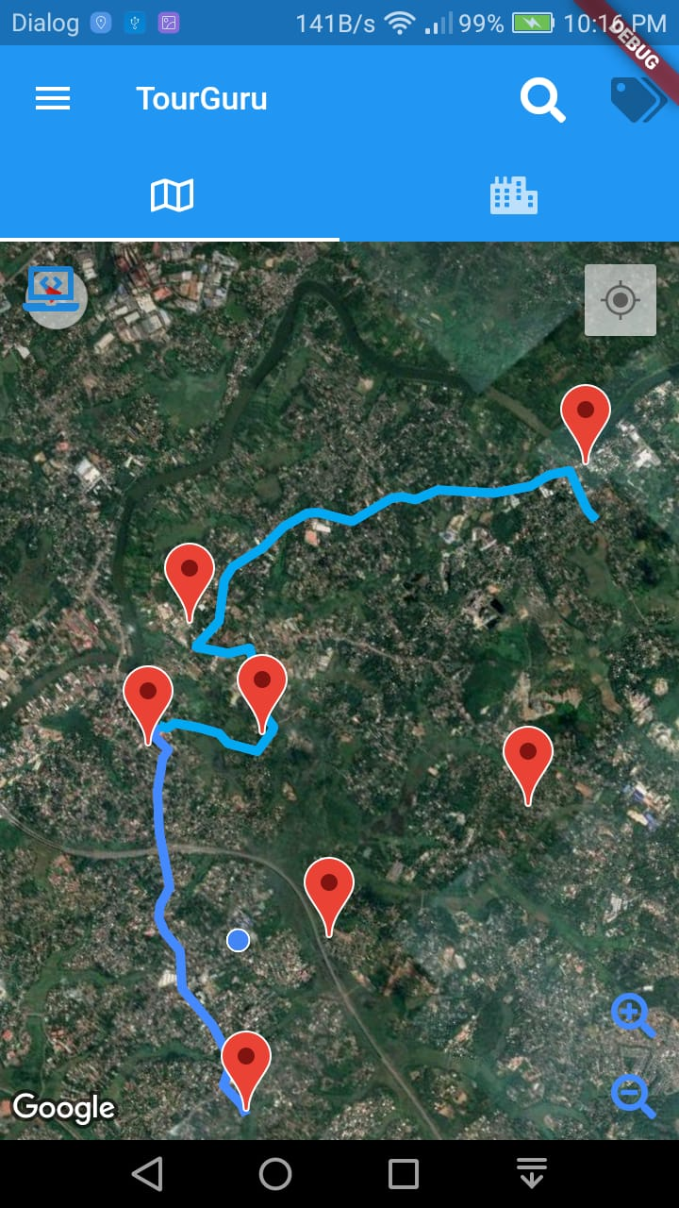

Figure 3 : A generated route of Intelligent Route Generation component

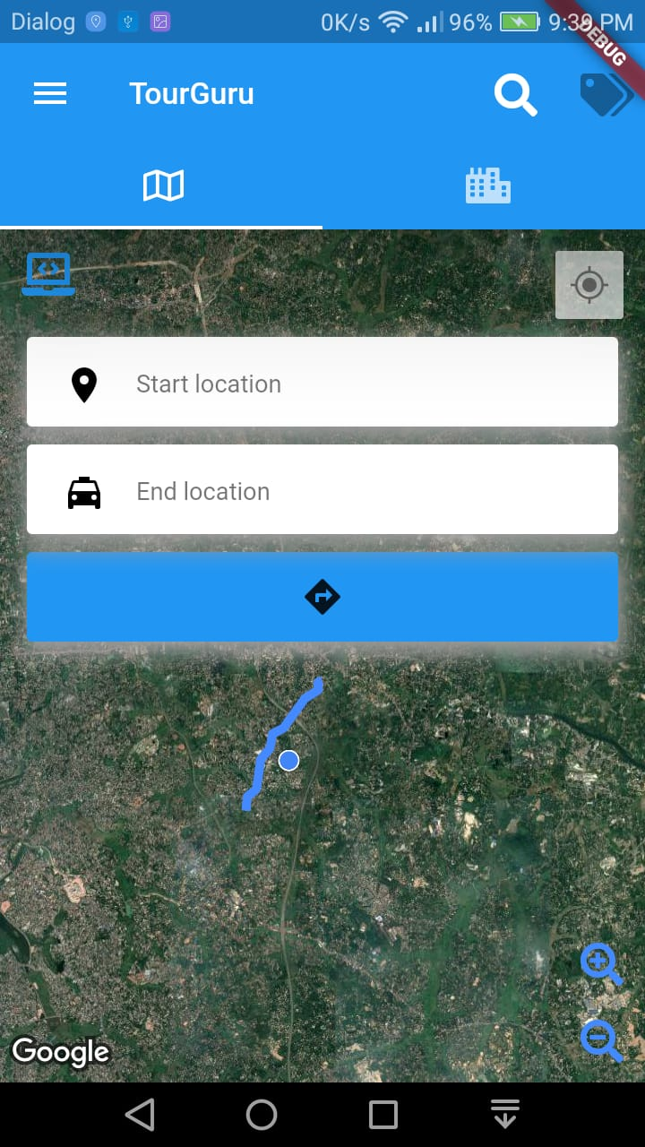

Figure 4 : Search Mode of the component

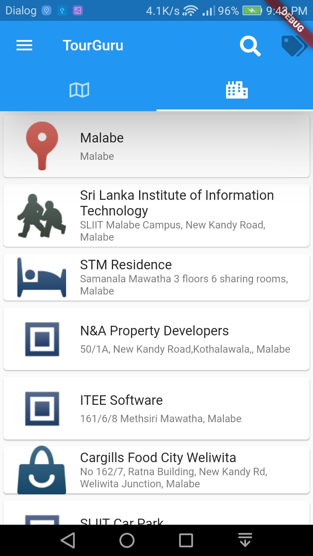

Figure 5 : Showing nearby locations

## Research Findings

## Discussion

# Conclusion

In the world of tourism, TourGuru mobile app will be a fast, reliable tourist guide application for tourists without any delay. This research paper proposes a practically useful solution called, TourGuru app to overcome this widely faced problem. The Basic Navigation part helps user to navigate through various tourist attractions without any hassle with the help of google API’s.

In future works, the overall TourGuru system can be tested and validated with actual users and based on the data crowdsourced by user reviews for better user-friendliness and accuracy. Furthermore, various other parameters to provide personalized experience to the app can be explored.

# References

|  |  |
| --- | --- |
| [1] | "(PDF) MobiAR: Tourist Experiences through Mobile Augmented Reality," 2010. |
| [2] | Douglas Crockford, "JSON," [Online]. Available: https://json.org/. |
| [3] | "Cloud AutoML - Custom Machine Learning Models  |  Google Cloud," 2019. [Online]. Available: https://cloud.google.com/automl/. |