**TOURGURU: TOUR GUIDE MOBILE**

**APPLICATION FOR TOURISTS**

S.P.B. Jayawickrema

(IT16024250)

B.Sc. (Hons) in Information Technology

Department of Information Technology

Sri Lanka Institute of Information Technology

Sri Lanka

August 2019

# Declaration

I declare that this is my own work and this dissertation does not incorporate without acknowledgement any material previously submitted for a degree or diploma in any other university or Institute of higher learning and to the best of my knowledge and belief it does not contain any material previously published or written by another person except where the acknowledgement is made in the text. Also, I hereby grant to Sri Lanka Institute of Information Technology the non-exclusive right to reproduce and distribute my dissertation in whole or part in print, electronic or other medium. I retain the right to use this content in whole or part in future works (such as article or books).

|  |  |  |
| --- | --- | --- |
| Name | Student ID | Signature |
| S.P.B. Jayawickrema | IT16024250 |  |

The supervisor/s should certify the proposal report with the following declaration.

The above candidate is carrying out research for the undergraduate Dissertation under my supervision.

Signature of the Supervisor: Date

…............................................. ..............................

Signature of the Co-Supervisor: Date

…............................................. ..............................

**TOURGURU: TOUR GUIDE MOBILE**

**APPLICATION FOR TOURISTS**

Sampathawaduge Pasan Bhagya Jayawickrema

(IT16024250)

Dissertation submitted in partial fulfillment of the requirements for the Bachelor of

Science (Honors) degree in Information Technology Specialization in IT

Department of Information Technology

Sri Lanka Institute of Information Technology

Sri Lanka

August 2019

# Abstract

Sri Lanka is fortunate to have a considerable attraction of tourists as a blessing of its natural beauty, historically important places and comfortable climate. A large number of tourists visit Sri Lanka annually and they are normally accompanied by a tourist guide in order to get a more efficient informative and safe travel experience. But sometimes tourists travel alone and might have no idea about the important monuments and places of interest there are. And even if they did know about these places. Some tourists only stay for a short period of time forcing them to shorten the number of travel destinations. Or they are simply tired or aren’t looking to travel much. Some tourists barely leave the hotel. For these type of casual travelers, in addition to images there also needs to be a way to view these monuments or buildings at the comfort of their hotels or residence. That’s why we have proposed an Augmented Reality(AR) solution to appeal to this problem. The proposed system is simple. The user chooses a building from a map interface. And the application will display a 3D model of said building on a plane surface in camera view. The user will be able to inspect the 3D model after it has been placed in the augmented reality. And for certain other monuments which are ruined but important. There can be a real scale 3D model placed at the location of the said ruin. This can be used to recreate historical places if implemented correctly. This document will describe how we went about actually creating this solution and its technologies.

# Acknowledgement

The work described in this research paper was done as our 4th year research project for the subject Comprehensive Design Analysis Project. The finished final output is the result of combining all the hours of hard work of the team members and the guidance, support and encouragement provided by many others. Therefore, it is our responsibility to show our immense gratitude to all of those who gave us the much-needed help to complete this research.

We are deeply thankful to our supervisor Ms. Asanthika imbulpitiya and our co-supervisor Mr. Nuwan Kodagoda, lecturers of Sri Lanka Institute of Information Technology whose suggestions, constructive criticism, constant encouragement and support in the proceedings of this research, particularly for the many discussions and brainstorming sessions. We are also very grateful to Mr. Jayantha Amararachchi, Senior Lecturer/ Head-SLIIT Centre for Research and Mr.Janaka wijekoon who gave us the needed permission to carry out this research and provided guidelines by conducting lectures.

We would also like to thank all our colleagues and friends for all their assistance, helpful advices, enthusiasm and different perspectives. Finally, we would like to thank other people whose names are not listed specifically but have offered their support in a lot of ways and helped us to make this a success.

TABLE OF CONTENTS

Declaration 2

Abstract 4

Acknowledgement 5

List of Tables 7

List of Figures 7

List of abbreviations 7

1 Introduction 8

1.1 Background Literature 8

1.2 Research Gap 9

1.3 Research Problem 10

1.4 Research Objectives 10

2 Methodology 11

2.1 Methodology 11

2.2 Commercialization aspects of the product 13

2.3 Testing & Implementation 13

3 Results & Discussion 14

3.1 Results 14

3.2 Research Findings 14

3.3 Discussion 14

3.4 Summary of Each Student’s contribution 14

Conclusion 15

References 15

Glossary 15

# List of Tables

# List of Figures

# List of abbreviations

# Introduction

## Background Literature

In the research [1], they have stated that in terms of software implementation, the MobiAR mobile application is an Android activity that encompasses the view of augmented reality, offering the user the ability to choose content in both 2D and 3D. The information about the POIs, received periodically from the server, is relative to the position of the user. The user’s position is discovered through the Global Positioning System (GPS) built into the terminal and the triangulation of phone masts. Considering context-based data and user profiles, the MobiAR application queries the content server for multimedia items that have been location-tagged (categorized by latitude, longitude and altitude data). When the appropriate contents are retrieved, the AR view is composed with the real-time images captured from the camera of the mobile device and the digital information (menus and POIs) overlaid. There are two possible modes to handle augmentation: 2D and 3D modes. The 2D mode shows multimedia content POIs enriching the real images captured by the camera. This mode is very suitable to discover interesting places nearby. The 3D mode has both the content and the user interface in 3D. Therefore, this mode is tailored to an enriched and leisure-oriented experience. All those POI representations would be completely static, if it was not due to information that is acquired through the sensors, namely the digital compass and the accelerometers. Thanks to those sensor readings, the information shown on the screen is dynamically positioned on the screen at the right coordinates.

Furthermore, they have gone on to describe similar applications like, Layar1, which is an Android and iPhone based mobile AR browser that was launched in 2009. Users can explore their physical surroundings, call up geo-tagged information from the web and superimpose it on the video captured by the camera of the device. The platform has an application programming interface that allows developers to contribute with different “layers” to the browser. Hundreds of new data layers are available to view on top of the camera viewer of the mobile device, from Wikipedia entries when one is looking at geographic Points of Interest (POI) to real estate listings that are viewable when pointing at homes for sale. Acrossair [2] has a similar interaction with “layers” of content. The application is only available on the iPhone and those “layers” are close managed by Acrossair developers.

Wikitude 2 is an Android, iPhone and Symbian application launched originally on Android in the fall of 2008. It pulls information from Wikipedia and Qype, the European user-generated review service, and overlays that geo-located data onto the display. Version 3 of Wikitude is integrated with the proprietary user-generated geo-tagging application Wikitude.me. Users can create their own POIs and location-based, hyper-linked digital content that can be viewed through the Wikitude browser application.

They have gone on to give two further examples of more user-centric world browsers, which are Junaio3 [3] and Tag what. They allow users to tag and upload content from the physical world and to share and discover the content that other users have uploaded. Junaio provides information about POIs and the ability to add 3D animations and share the edited images via the usual social networking sites. Each user generated geo-tagged POI is then visible by all the other users.

## Research Gap

|  |  |  |  |  |  |
| --- | --- | --- | --- | --- | --- |
| Features | TourGuru | Roadtrippers | Toureazy | Tour Buddy | සිංහලංකා AR |
| Intelligent Trip routing (automatic route creation) |  |  |  |  |  |
| Trip editor (Add or update custom places) |  |  |  |  |  |
| Categorize locations  (monuments places, restaurant etc) |  |  |  |  |  |
| Map Filters |  |  |  |  |  |
| Shared user activity |  |  |  |  |  |
| Traffic management |  |  |  |  |  |
| Narrations or alerts on point of interest |  |  |  |  |  |
| Waypoint management |  |  |  |  |  |
| Collaborator management |  |  |  |  |  |
| Distance slider for radius adjusting (proximity alert and activation) |  |  |  |  |  |
| AR object modelling |  |  |  |  |  |
| Identification location (using AR. location means historical places and important building |  |  |  |  |  |

## Research Problem

There are some tourists who are just traveling to take a break and are not willing to travel much or exhaust themselves. For these types of casual travelers there needs to be an interactive way of viewing certain buildings and monuments at the comfort of their hotels or residences. The obvious solution that comes to mind is images. But images only offer a limited perspective. There needs to be a more interactive solution. Here the for an Augmented reality feature arises. AR technology can allow the user to have a much more immersive experience. So in this research we are figuring out ways to make 3D models of monuments, make the phone detect a horizontal surface and place that model on said horizontal surface within the AR view, make that model interactive so the user can rotate and see all perspectives of that model, figure out a way to store 3D models in a database so the app won’t take up a lot of storage and finally a way to place a life size 3D recreation at a geo location. Since the AR technology is new, the amount of research done in this area is low. And it only supports a limited number of devices. Therefore, figuring out which technologies are best would also be a challenge.

## Research Objectives

* The first objective of this research would be to develop a way to detect a horizontal surface and place an 3D object on that surface within the camera view.
* A way should be developed to compress the texture and model files of an 3D object into one file and store it on a separate server.
* Develop a way to place existing 3D models on specific geo locations that would give the illusion of an actual building being there on a given coordinate.

# Methodology

## Methodology

1. Technologies

The first order of business was selecting technologies,

* Unity 3D
* Vuforia engine
* AR core

These powerful tools contain almost all the functions we would need to work on this research.

1. Detecting a surface

Once the camera is pointed at the surface the camera detects the edges, the textures and tries to figure out if the shown surface is horizontal or not. There are image recognition models available pre trained to identify flat surfaces in both AR core and Vuforia engine. With these technologies we can project a map of dot mesh on to the surfaces and then objects can be placed on those meshes (shown in fig.1). The mesh would be useful for the tracking on the surface. This would make the surface tracking much better and the 3D model is less likely to jitter using this method. If the dot mesh proves to be too distracting, we can also use the surface texture itself for the purpose of tracking. It would require the camera to detect certain features of the surface and use those as a reference for tracking. The likeliness of jittering is increased on this scenario but its less distracting in the user interface.

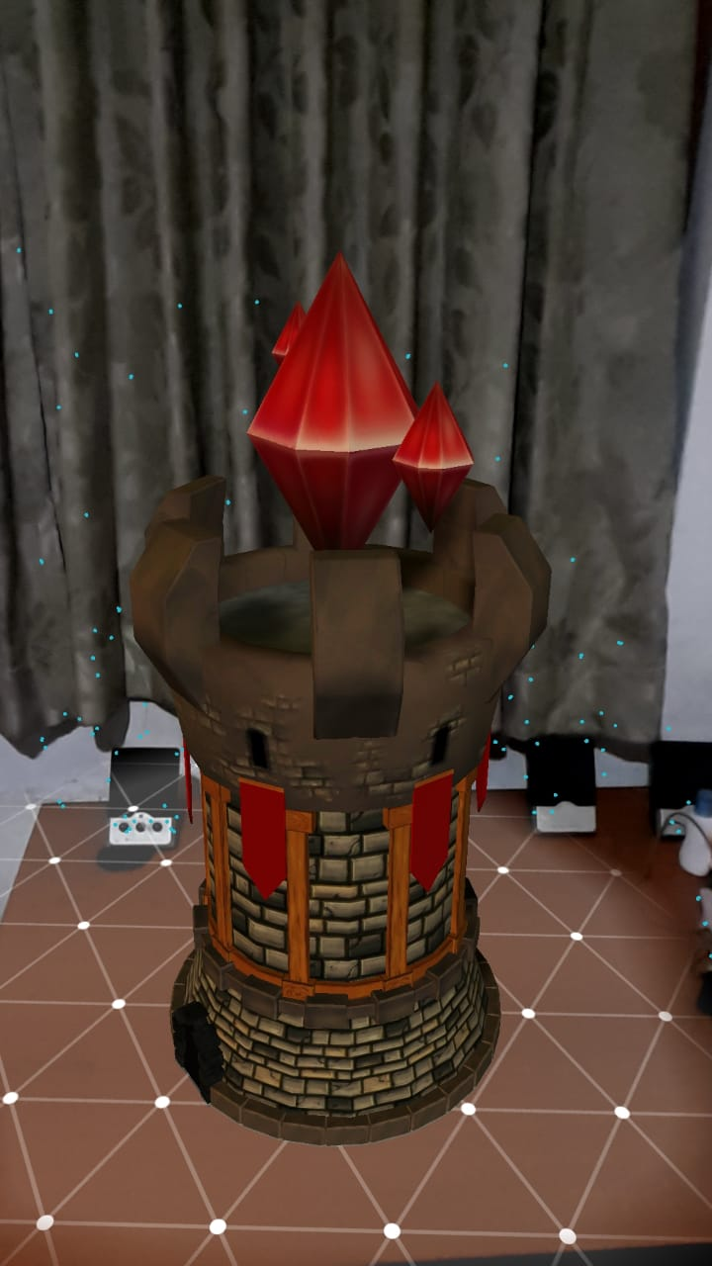

Figure 1

1. Storage and retrieval of 3D models

In order to display these 3D models, we must store them somewhere. Storing them locally is an easy option but it can lead to the app being too large if the scale of the app gets bigger, which might discourage users from using it.

There are multiple files that belongs to a 3D asset. For the ease of usage, we compress all those files into one file called an asset bundle as we finish creating a new model. Therefore, even if the asset is not stored locally we can stream it back into the 3D scene whenever we require it to. The temporary file can be deleted afterwards to save space in the storage device. These asset bundles can be stored in an external server like a cloud and with an internet connection they can be retrieved.

1. Placing a 3D object on a given set of coordinates

There are multiple ways to achieve this. By using an API called wikitude we can place AR objects directly on a geo location. But there are limitations for its usage and it is a paid API. Instead we came up with a different solution.

First, we need to create a scale between the real world and the AR environment to find out how much distance is represented by a unit in the AR world. This can be found by a simple trial and error method. Once we have acquired the scale we move to the next step.

In this step we can retrieve the geo coordinates of a location by accessing the google places libraries Jason objects. A Jason object of a location includes its longitudes and latitudes. We can use the user’s current location and calculate the distance and the direction of that location. Then using the scale that we created we can place the 3D object in the AR environment by changing object distance from the AR camera within Unity, giving the user the perception that we have placed an object at a geo coordinate.

## Commercialization aspects of the product

This AR component would be a feature of the TourGuru app. For it to be considered a good commercial product we need to check its responsiveness and user friendliness.

Example:

* When detecting a plane, it shouldn’t take a long time.
* The placed object shouldn’t jitter too much.
* All interactive buttons should serve a meaningful purpose.
* Load times of 3D models should be very low.
* The app shouldn’t be too large.
* Accuracy of the location-based AR should be high.
* The 3D models need to be detailed.

Also, aspects like reliability should be taken seriously in order to prevent the users from experiencing crashes that can break the immersion.

## Testing & Implementation

# Results & Discussion

## Results

## Research Findings

## Discussion

## Summary of Each Student’s contribution

# Conclusion

# References

1. David Marimon1 , Cristina Sarasua2 , Paula Carrasco3 , Roberto Álvarez4 , Javier Montesa5 , Tomasz Adamek1 , Idoia Romero2 , Mario Ortega3 , Pablo Gascó5 .(2010). MobiAR: Tourist Experiences through Mobile Augmented Reality, 1 Telefonica Research and Development, Barcelona, Spain; 2Visual Interaction Communication Technologies Vicomtech-IK4, San Sebastian, Spain; 3 LabHuman, Valencia, Spain, 4 Indra Software Labs, Madrid, Spain, 5Brainstorm, Valencia, Spain;

[Accessed 2019-03-02]

1. "acrossair - Nearest Tube Augmented Reality Tube Finder", Acrossair.com, 2019. [Online]. Available: https://www.acrossair.com/. [Accessed: 06- Aug- 2019].
2. [36] "Junaio", En.wikipedia.org, 2019. [Online]. Available: https://en.wikipedia.org/wiki/Junaio. [Accessed: 04- Jun- 2019].

# Glossary