**TOURGURU: TOUR GUIDE MOBILE**

**APPLICATION FOR TOURISTS**

M.P.D.S.M. Kmuara

(IT16117488)

B.Sc. (Hons) in Information Technology

Department of Information Technology

Sri Lanka Institute of Information Technology

Sri Lanka

August 2019

# Declaration

I declare that this is my own work and this dissertation does not incorporate without acknowledgement any material previously submitted for a degree or diploma in any other university or Institute of higher learning and to the best of my knowledge and belief it does not contain any material previously published or written by another person except where the acknowledgement is made in the text. Also, I hereby grant to Sri Lanka Institute of Information Technology the non-exclusive right to reproduce and distribute my dissertation in whole or part in print, electronic or other medium. I retain the right to use this content in whole or part in future works (such as article or books).

|  |  |  |
| --- | --- | --- |
| Name | Student ID | Signature |
| M.P.D.S.M. Kumara | IT16117488 |  |

The supervisor/s should certify the proposal report with the following declaration.

The above candidate is carrying out research for the undergraduate Dissertation under my supervision.

Signature of the Supervisor: Date

…............................................. ..............................

Signature of the Co-Supervisor: Date

…............................................. ..............................

**TOURGURU: TOUR GUIDE MOBILE**

**APPLICATION FOR TOURISTS**

Muthunayaka Pedi Durayalage Sajid Manjula Kumara

(IT16117488)

Dissertation submitted in partial fulfillment of the requirements for the Bachelor of

Science (Honors) degree in Information Technology Specialization in IT

Department of Information Technology

Sri Lanka Institute of Information Technology

Sri Lanka

August 2019

# Abstract

The purpose of this document is that to give an idea about the problem scope, solution and important findings related to the proposed research project. The methodology and the working procedure are also included for have a technical approach and further information. Sri Lanka is fortunate to have a considerable attraction of tourists as a blessing of its natural beauty, historically important places and comfortable climate. A very big amount of tourists visit Sri Lanka annually and they normally accompanied a tourist guide with them in order to get a description about the places they visit. But there’s a huge problem associated with tourism in Sri Lanka that, the absence of a more efficient and smart way of guiding tourists and giving them more details based on their requirements. As a solution to that problem, the TourGuru which is a mobile application for smart phones is designed. This app provides a brief description about the visiting location with the aid of mobile phone camera and Global Positioning System (GPS) technology. Another most specific feature is that a label of the location is displayed on the screen using Augmented Reality (AR) technology. Without limiting to that particular service, the app is capable of providing answers for the questions asked by the user by using a chat box with Question And Answer (Q&A) function. Although the app is originally designed to apply in tourism industry, this is very beneficial for both foreign and local travelers. This will be very important in earning adherence of tourists by providing more accurate information and more updated mode of service.

Keywords: Augmented Reality, Global Positioning System, Question And Answer, TourGuru

# Acknowledgement

The work described in this research paper was done as our 4th year research project for the subject Comprehensive Design Analysis Project. The finished final output is the result of combining all the hours of hard work of the team members and the guidance, support and encouragement provided by many others. Therefore, it is our responsibility to show our immense gratitude to all of those who gave us the much needed help to complete this research.

We are deeply thankful to our supervisor Ms. Ashanthika Imbulpitiya and our co-supervisor Mr. Nuwan Kodagoda, lecturers of Sri Lanka Institute of Information Technology whose suggestions, constructive criticism, constant encouragement and support in the proceedings of this research, particularly for the many discussions and brainstorming sessions. We are also very grateful to Mr. Jayantha Amararachchi, Senior Lecturer/ Head-SLIIT Centre for Research and Mr.Janaka Wijekoon who gave us the needed permission to carry out this research and provided guidelines by conducting lectures.

We would also like to thank all our colleagues and friends for all their assistance, helpful advices, enthusiasm and different perspectives. Finally, we would like to thank other people whose names are not listed specifically but have offered their support in a lot of ways and helped us to make this a success.

TABLE OF CONTENTS

Declaration i

Abstract iii

Acknowledgement iv

List of Tables vi

List of Figures vi

List of abbreviations vi

1 Introduction 1

1.1 Background Literature 1

1.2 Research Gap 2

1.3 Research Problem 3

1.4 Research Objectives 4

2 Methodology 5

2.1 Methodology 5

2.2 Testing & Implementation 7

3 Results & Discussion 9

3.1 Results 9

4 Conclusion 10

References 10

Appendices 11

# List of Tables

Table 1 Research Gap 9

# List of Figures

Fig: 1 system architecture diagram 13

Fig : 2 Main interface of AR 14

Fig: 3 Geo positioned location identifier label object on Augmented Reality Component 15

Fig: 4 Development Life-Cycle 17

Fig: 5 Project life-Cycle 18

# List of abbreviations

|  |  |
| --- | --- |
| **SRS** | Software requirements specification |
| **AR** | Augmented reality |
| **API** | Application programming interface |
| **GPS** | Global Positioning System |
| **OS** | Operating system |
| **WIFI** | Wireless Fidelity |
| **Q&A** | Question and Answer |
| **RAM** | Random Access memory |
| **POI** | Point Of Interest |

# Introduction

## Background Literature

In the research [1], the researchers have concluded that combining the tour guide with the trip planning tool could integrate pre-trip plan with during-trip planning and provide more personalized and relevant information during a trip. In addition, post-trip evaluation can be integrated into the system in which the users will be able to rank the different properties they have gone to. Future development can also include an interface for tourism enterprises to update their information daily even hourly (for example, a special deal for the day) to market toward visitors on the road or 100 or 200 yards around them. Location and map-based tourist information tools based on Google Map API opened many opportunities to enhance visitor experience as well as connecting visitors with tourism properties in destinations.

In the research [1], they have stated that in terms of software implementation, the MobiAR mobile application is an Android activity that encompasses the view of augmented reality, offering the user the ability to choose content in both 2D and 3D. The information about the POIs, received periodically from the server, is relative to the position of the user. The user’s position is discovered through the Global Positioning System (GPS) built into the terminal and the triangulation of phone masts. Considering context-based data and user profiles, the MobiAR application queries the content server for multimedia items that have been location-tagged (categorized by latitude, longitude and altitude data). When the appropriate contents are retrieved, the AR view is composed with the real-time images captured from the camera of the mobile device and the digital information (menus and POIs) overlaid. There are two possible modes to handle augmentation: 2D and 3D modes. The 2D mode shows multimedia content POIs enriching the real images captured by the camera. This mode is very suitable to discover interesting places nearby. The 3D mode has both the content and the user interface in 3D. Therefore, this mode is tailored to an enriched and leisure-oriented experience. All those POI representations would be completely static, if it was not due to information that is acquired through the sensors, namely the digital compass and the accelerometers. Thanks to those sensor readings, the information shown on the screen is dynamically positioned on the screen at the right coordinates.

Furthermore, they have gone on to describe similar applications like, Layar1, which is an Android and iPhone based mobile AR browser that was launched in 2009. Users can explore their physical surroundings, call up geo-tagged information from the web and superimpose it on the video captured by the camera of the device. The platform has an application programming interface that allows developers to contribute with different “layers” to the browser. Hundreds of new data layers are available to view on top of the camera viewer of the mobile device, from Wikipedia [2] entries when one is looking at geographic Points of Interest (POI) to real estate listings that are viewable when pointing at homes for sale. Acrossair [3] has a similar interaction with “layers” of content. The application is only available on the iPhone and those “layers” are close managed by Acrossair developers.

Wikitude 2 is an Android, iPhone and Symbian application launched originally on Android in the fall of 2008. It pulls information from Wikipedia and Qype, the European user-generated review service, and overlays that geo-located data onto the display. Version 3 of Wikitude is integrated with the proprietary user-generated geo-tagging application Wikitude.me. Users can create their own POIs and location-based, hyper-linked digital content that can be viewed through the Wikitude browser application. and the ability to add 3D animations and share the edited images via the usual social networking sites. Each user generated geo-tagged POI is then visible by all the other users.

## Research Gap

There are so many tourist Apps in currently use, that have been developed in different aims. The main difference between TourGuru and already existing design is that TourGuru display a 3D figure a description using AR technology. In addition the table (table 1) below shows other differences.

|  |  |  |  |  |  |
| --- | --- | --- | --- | --- | --- |
| **Features** | **TourGuru** | **Roadtrippers** | **Toureazy** | **Tour Buddy** | සිංහලංකා AR |
| **Intelligent Trip routing (automatic route creation)** |  |  |  |  |  |
| **Trip editor (Add or update custom places)** |  |  |  |  |  |
| **Categorize locations**  **(monuments places, restaurant etc)** |  |  |  |  |  |
| **Map Filters** |  |  |  |  |  |
| **Shared user activity** |  |  |  |  |  |
| **Traffic management** |  |  |  |  |  |
| **Narrations or alerts on point of interest** |  |  |  |  |  |
| **Waypoint management** |  |  |  |  |  |
| **Collaborator management** |  |  |  |  |  |
| **Distance slider for radius adjusting (proximity alert and activation)** |  |  |  |  |  |
| **Identification location(using AR, historical places, ruins, etc )** |  |  |  |  |  |
| **Question and answer.** |  |  |  |  |  |

Table 1 Research Gap

## Research Problem

In our country, tourism is fast becoming a major industry, which is already bringing in millions of dollars in foreign income. It still has potential to bring much more to this country. But there are a few obstacles in our way hindering its growth. One of them is the general lack of information about our country. This is a major issue to the tourism industry because most tourists don’t like to travel blindly. There are existing tour services which guides the tourists to attractions, but most of them are scheduled services which takes away the freedom and the fun that many tourists crave. Therefore, the need for a proper guidance system for these tourists is a must.

Currently most of the tourists who visit Sri Lanka get the aid of a tourist guide to have details about the places they visit. Since tourism industry is a rapidly developing field in Sri Lanka, there is a need of a more updated and advanced mode of guiding that can be applied in the industry. Because such smart methodologies enhance the existing attraction of tourists towards Sri Lanka. And also these are some problems associated with tourist guides that motivate the need of such advanced methods.

The tourist guides is a limited resource and the amount of details they can give to the tourists depend on the knowledge they have on a particular location and also their communication skills. Therefore it is better to have a broader range of information source about the frequently visited places in Sri Lanka.

Another specific problem is that some tourists specially young travelers prefer to travel along without any guide, because they enjoy travelling independently. In such cases there is huge requirement for a way to get more accurate information about the places they visit.

Because of the above mentioned problems to fulfill the gap between the further requirements and the existing method, the idea of designing TourGuru was arised.

## Research Objectives

General objective

Main objective of the TourGuru mobile application is to help travelers navigate through places of interest without much hassle. It needs to be a simple but very exciting and interactive application. It focuses mainly on being a virtual tour guide by narrating details about the places and answering any questions the user might get during their travels.

* Guiding a tourist through a route by intelligent routing.
* Providing the user with a voice narration while they are visiting attractions.
* Answering questions related to the tour which are asked by the user.
* Connecting travelers in proximity to each other.
* Updating location information and display the information related location using AR technology.
* Generate the 3D model using AR. (related location).

Specific objectives

The main objective of this research is to display a label like 3D object over a certain geo-location.The label object will have details of that given location displayed on it. Also a way to answer any tour related questions automatically is being researched.

* Updating location information and display the information related location using AR technology.
* Answering questions related to the tour which are asked by the user.

# Methodology

## Methodology

1. Technologies

The first order of business was selecting technologies,

* Unity 3D
* Vuforia engine
* AR core

These powerful tools contain almost all the functions we would need to work on this research.

1. Data Gathering and Generation

At the first step, the process on the system development proceeds with sample of data. Data gathering or generation techniques are discussed in here for the research objective POI representation on AR.

Implementing a system that consists with AR components of the POI’s locations in AR can help user on identification on the places if he is lost and can get more description on travel. First component that consists AR guidance focusses on providing user with a nearby POI’s labeling with the help of gathered data from Google cloud platform Places API and through web scraping to query for the related information. Prebuilt POI label object model is used in AR component. Label will be generated as primary data for these AR based research components.

1. Data Processing and Cleaning

After the first step, processing and cleaning on the data starts to apply them into the research methods. Data processing or cleaning techniques are discussed in here for the research objective POI representation on AR.

Data processing and cleaning done for the AR component on presenting POI’s description on label model. JSON object response from Google Places API is processed for geo-coordinates and related location names. This object has an array of POI locations and each of them will be processed for name, geometry and rating by excluding other parameters. Location name used for web scraping textual data and processed with the JSON object. Data gathered through web scraping must be verified for to remove unnecessary DOM elements and extract only the textual information from them.

1. Application of Research Method

AR component on presenting POI’s description on label model performs by positioning a label object in each of location elements in the processed data. POI location element geo-coordinate distance, angle/radius, altitude calculated, and the label positioned in virtual world of the camera view with these metrics. For each element in the JSON object array there will be an object label positioned using the metrics mentioned when distance is equal to an expected vicinity. This label positioned as when the traveler’s current location changed and regularly check whether POI at the vicinity or not.

For our system, the following system architecture diagram(figure) will be useful at the system planning phases helping partners in understanding the architecture, discussing changes and communicating intentions clearly [15].

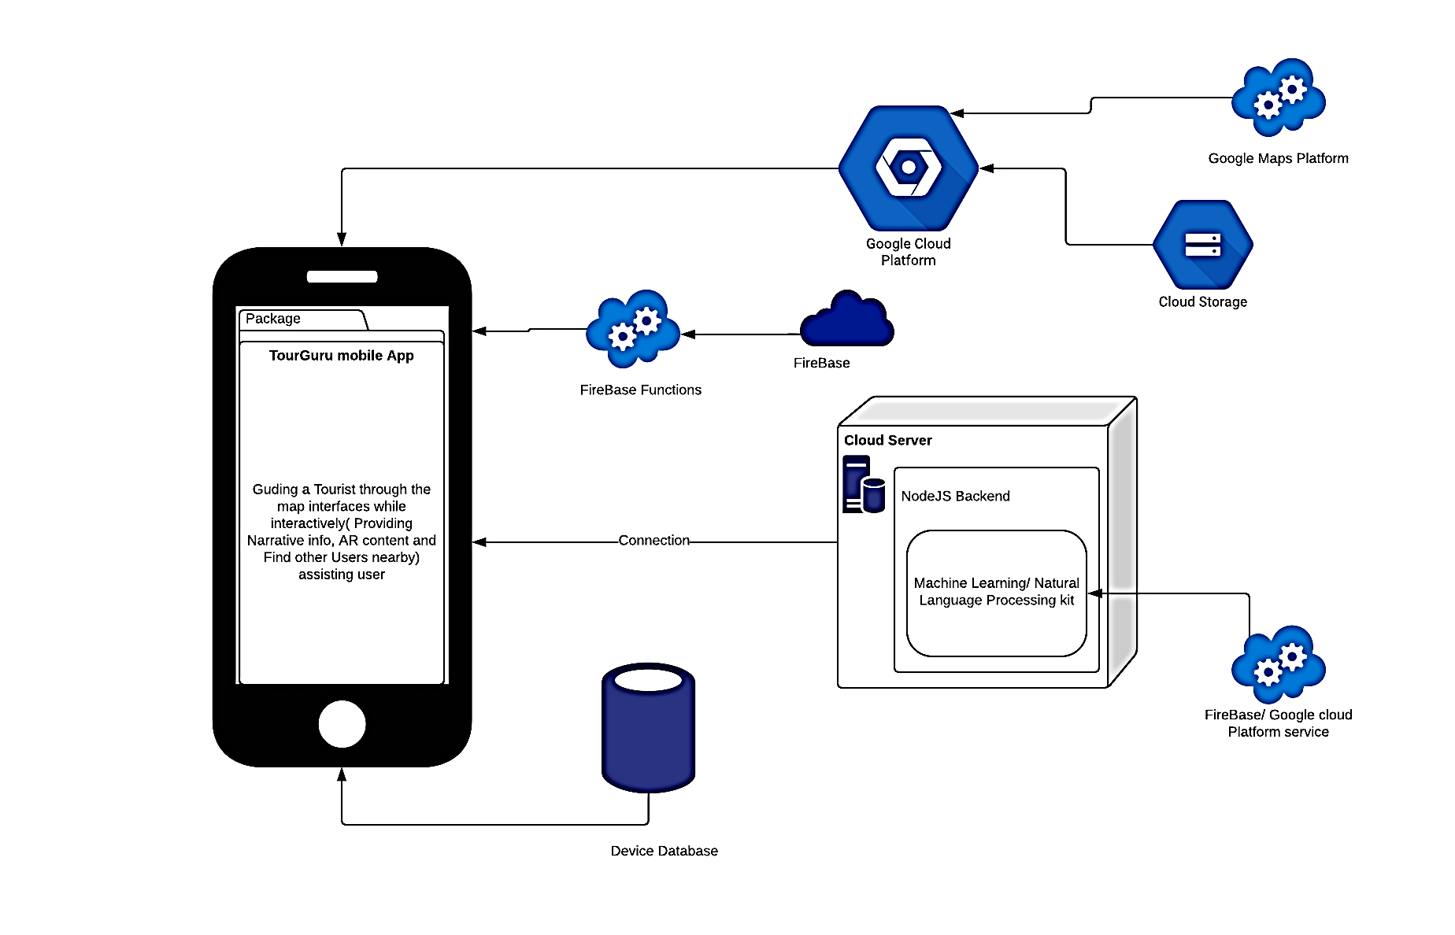

Fig: 1 system architecture diagram

## Testing & Implementation

Testing is the complex component of a mobile application was done to check whether the functionality of the system satisfied with the actual requirement or not. Testing process consists with strategy, performance, usability, security, etc.

Dynamic testing

* Unit testing
* Component testing
* Integration testing
* System testing

Unit Testing

While coding, each group member performs some test on that unit of program to know if it is error free. It is helps group members decide that individual unit of the system are working as per requirement and are error free.

Component Testing

Several bug free units will combine together and test. Each member will combine their tested units together.

Integration Testing

Individual units are combined and tested as a group. The purpose of this level of testing is to expose faults in the interaction between integrated units.

System testing

This is the level of testing complete software and integrated software is tested.

Application will at least have its Prototype then from the Mobile Software Development Methodology it may have an Alpha App, Beta App and lastly Candidate Application. Each in its process will be tested by UI Tests, Unit Tests, Component Tests, System Tests.

Set of UX evaluation testing will be done in its related period. Some of them are Design Evaluation (Wireframe, Story Boards, High Level Architecture Diagrams.), UI evaluation, User interaction evaluation, user review and update app.

# Results & Discussion

## Results

UserInterface.

This is main interface of AR components. Using flutter.

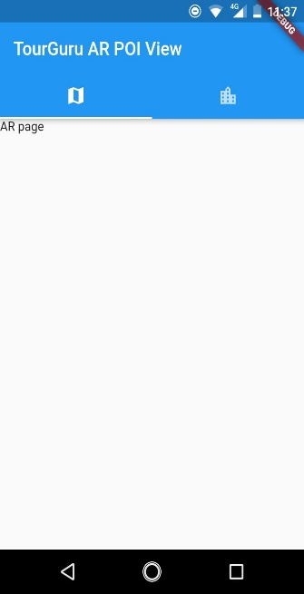

Fig : 2 Main interface of AR

Geo positioned location identifier label object on Augmented Reality Component. Using unity and firebase.

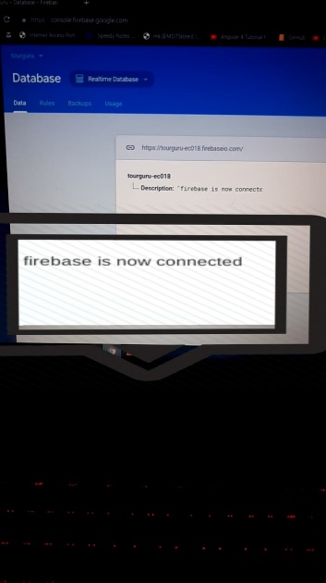

Fig: 3 Geo positioned location identifier label object on Augmented Reality Component

# Conclusion

In the world of tourism, TourGuru mobile app will be a fast, reliable tourist guide application for tourists without any delay. This research paper proposes a practically useful solution called, TourGuru app to overcome this widely faced problem. The Basic Navigation part helps user to navigate through various tourist attractions without any hassle with the help of google API’s. Then narration with detailed description is showed, when they started to travel. Next AR POI and AR Labeling helps us to navigate with AR functionality. Overall, this app serves as an easy, reliable and useful navigation application.

In future works, the overall TourGuru system can be tested and validated with actual users and based on the data crowdsourced by user reviews for better user-friendliness and accuracy. Furthermore, various other parameters to provide personalized experience to the app can be explored.

# References

|  |  |
| --- | --- |
| [1] | "(PDF) MobiAR: Tourist Experiences through Mobile Augmented Reality," 2010. |
| [2] | "Wikipedia, the free encyclopedia," [Online]. Available: https://en.wikipedia.org/wiki/Main_Page. |
| [3] | "acrossair - Nearest Tube Augmented Reality Tube Finder," 2019. [Online]. Available: https://www.acrossair.com/. |
| [4] | "Junaio," 2017. |
| [5] | J. M. Corchado, J. Pavón, E. S. Corchado and L. F. Castillo, "Development of CBR-BDI Agents: A Tourist Guide Application," 2004, pp. 547-559. |
| [6] | F.-M. Hsu, Y.-T. Lin and T.-K. Ho, "Design and implementation of an intelligent recommendation system for tourist attractions: The integration of EBM model, Bayesian network and Google Maps," *Expert Systems with Applications,* vol. 39, no. 3, pp. 3257-3264, 2 2012. |
| [7] | M. Nilashi, O. Ibrahim, E. Yadegaridehkordi, S. Samad, E. Akbari and A. Alizadeh, "Travelers decision making using online review in social network sites: A case on TripAdvisor," *Journal of Computational Science,* vol. 28, pp. 168-179, 9 2018. |
| [8] | Jake Morgan, Classification and Regression Tree Analysis, 2014. |
| [9] | Matej Gallo, Text Summarization byMachine Learning, 2016. |
| [10] | R. Nallapati, B. Zhou, C. dos Santos, C. Gulcehre and B. Xiang, "Abstractive Text Summarization using Sequence-to-sequence RNNs and Beyond," in *Proceedings of The 20th SIGNLL Conference on Computational Natural Language Learning*, Stroudsburg, PA, USA, 2016. |
| [11] | "How to Make a Text Summarizer - Intro to Deep Learning #10 - YouTube," [Online]. Available: https://www.youtube.com/watch?v=ogrJaOIuBx4. |
| [12] | Xin Pan Peter Liu, "models/research/textsum at master · tensorflow/models · GitHub," 2018. [Online]. Available: https://github.com/tensorflow/models/tree/master/research/textsum. |
| [13] | B. Pan, J. C. Crotts and B. Muller, "Developing Web-Based Tourist Information Tools Using Google Map," in *Information and Communication Technologies in Tourism 2007*, Vienna, Springer Vienna, pp. 503-512. |
| [14] | N. Davies, K. Cheverst, K. Mitchell and A. Efrat, "Using and determining location in a context-sensitive tour guide," *Computer,* vol. 34, no. 8, pp. 35-41, 2001. |
| [15] | “Architecture Diagram Overview”. [Online]. Available: https://www.edrawsoft.com/architecture-diagram.php. [Accessed: 12-Aug.-2019]. |
|  |
|  |
|  |
|  |

# Appendices

1. Development Life-Cycle

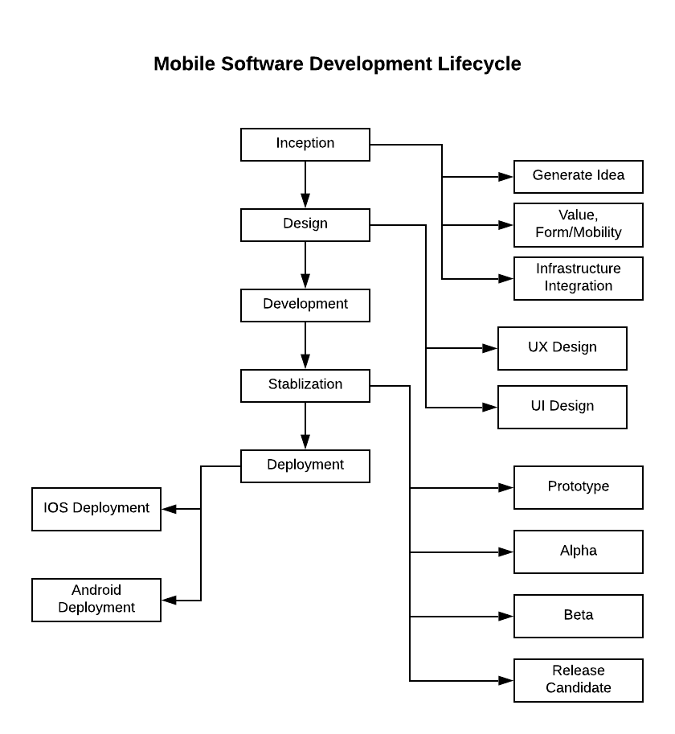

Fig: 4 Development Life-Cycle

1. Project life-Cycle

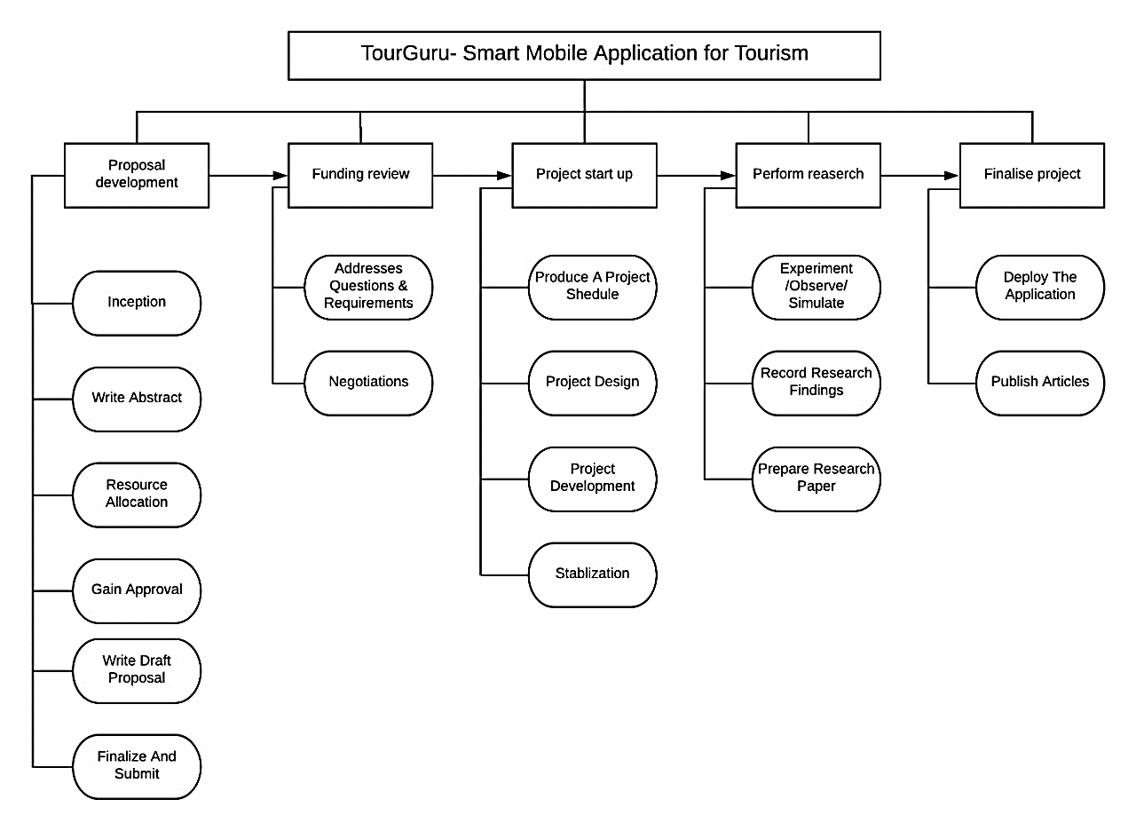

Fig: 5 Project life-Cycle