**TOURGURU: TOUR GUIDE MOBILE**

**APPLICATION FOR TOURISTS**

M.S.B.W.T.M.P.S.B. Thennakoon

(IT16160262)

B.Sc. (Hons) in Information Technology

Department of Software Engineering

Sri Lanka Institute of Information Technology

Sri Lanka

August 2019

**TOURGURU: TOUR GUIDE MOBILE**

**APPLICATION FOR TOURISTS**

THENNAKOON MUDIYANSELAGE PARAKRAMA SHASHITHA BANDARA THENNAKOON

(IT16160262)

Dissertation submitted in partial fulfillment of the requirements for the Bachelor of

Science (Honors) degree in Information Technology Specialization in IT

Department of Information Technology

Sri Lanka Institute of Information Technology

Sri Lanka

August 2019

# Declaration

I declare that this is my own work and this dissertation does not incorporate without acknowledgement any material previously submitted for a degree or diploma in any other university or Institute of higher learning and to the best of my knowledge and belief it does not contain any material previously published or written by another person except where the acknowledgement is made in the text. Also, I hereby grant to Sri Lanka Institute of Information Technology the non-exclusive right to reproduce and distribute my dissertation in whole or part in print, electronic or other medium. I retain the right to use this content in whole or part in future works (such as article or books).

|  |  |  |
| --- | --- | --- |
| Name | Student ID | Signature |
| M.S.B.W.T.M.P.S.B. Thennakoon | IT16160262 |  |

The supervisor/s should certify the proposal report with the following declaration.

The above candidate is carrying out research for the undergraduate Dissertation under my supervision.

Signature of the Supervisor: Date

…............................................. ..............................

Signature of the Co-Supervisor: Date

…............................................. ..............................

# Abstract

Even most of tour-guides may not have knowledge about historical places in between destinations. Implementation of a product that is reachable and delivering efficient user notifying on the Point of Interests(POI) is considered in this research. Nowadays smartphones have become a significant help to identify the location based information and travel navigation details from web or implemented native application on the device. In a context this report discusses travel assistance mobile-based system that would aid user on delivering narrations on places of interests such as destination or nearby attraction details.

# Acknowledgement

I would like to extend our gratitude to thank the university Sri Lanka Institute of Information Technology (SLIIT) and our Lecturer in Charge, Mr. Jayantha Amararachchi for providing a great opportunity to present the skills and abilities in this research project. Our sincere gratitude goes to our supervisor Ms. Asanthika Imbulpitiya for her guidance and support to make it a success. We also would like to thank our co-supervisor Mr. Nuwan Kodagoda for his continuous support from the beginning of the project. Their continuous feedback and valuable insights are highly appreciable. Finally, I would express our thanks to our family and friends for encouraging and supporting throughout this year.

Table of Contents

Declaration i

Abstract ii

Acknowledgement iii

List of Tables v

List of Figures v

List of abbreviations v

1 Introduction 1

1.1 Background Context 1

1.2 Research Gap 2

1.3 Research Problem 3

1.4 Research Objectives 4

2 Methodology 5

2.1 Methodology 5

2.1.1 Data Gathering 5

2.1.2 Data Preprocessing and Cleaning 6

2.1.3 Application of Research Method 6

2.2 Commercialization aspects of the product 7

2.3 Testing & Implementation 7

3 Results & Discussion 8

3.1 Results 8

4 Conclusion 11

References 11

# List of Tables

Table 1 : Comparison on Research Gap 9

# List of Figures

Fig. 1 : international tourism by number of arrivals Sri Lanka 8

Fig. 2 : Proximate voice alert activation configuration on Narrated Tour Guidance 14

Fig. 3 : Test audio configuration and apply a configuration 15

Fig. 4 : Google Cloud Function applied AutoML models invocation statistics 16

# List of abbreviations

|  |  |
| --- | --- |
| POI | Point Of Interests |
| JSON | JavaScript Object Notation |
| CSV | Comma Separated Values |
| REST | Representational State Transfer |
| HTTP | Hypertext Transfer Protocol |

# Introduction

## Background Context

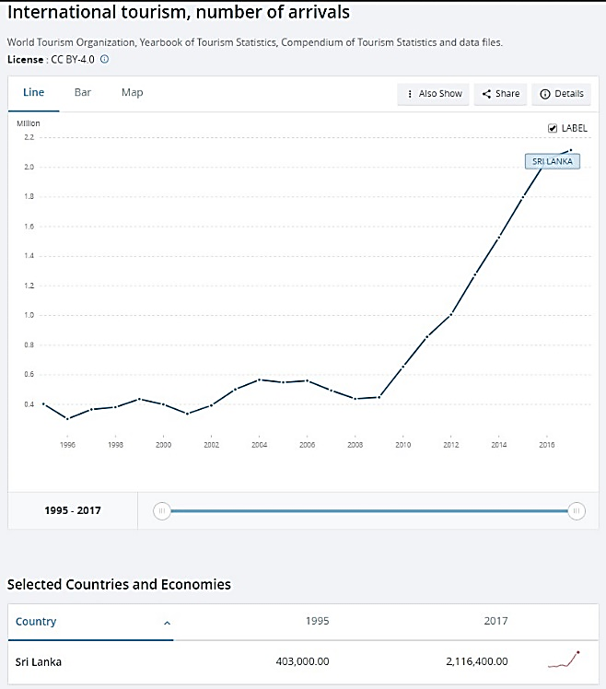

Fig. 1 : International tourism by number of arrivals Sri Lanka

According to statistics from the Fig. 1 Sri Lanka has undergone a marginal number of growth in arrivals from 448,000 to 2,115,400 throughout the years 2009-2017 [1]. For development of this Tourism area there were Travel Guides application solutions in these years for use with traveler’s alternative to a tour guide or used by tour guide to advise tourists when existing place with no knowledge of. Presently, these kinds of apps used worldwide to improve tourism income in a country by improving tourist experience, reduce travel time and to decide whether a place is up to their likelihood.

Existing such applications divided in to four types of deployments. There are mobile, web-based solutions, hybrid and lastly standalone desktop applications. Sri Lanka Tourism Board uses web-based solution to advertise well known places which attracts tourists. Web based solutions requires constant internet access from tourist to get to know about this information. Mobile application exists in Sri Lanka for tourism that provides self-guided tours and map-based navigation with point of interest updates regularly. Self-Guided Tours improve the traveler’s efficiency, reduces their stress in finding a travel place while most of these mobile applications has offline capability for their features.

To assess a solution for problems they face when moving to unknown locations and providing interactive implementation is majorly considered. Based on these observations it is best to improve the traveling community within Sri Lanka by introducing a mobile solution that addresses narrated tours as an approach to assisted travel.

## Research Gap

There has been many scaled services and marginal growth of technology for contribute and grow Tourism industry. Along with the radical growth on arrivals and use of Smartphones for the travel as aforementioned, there has been services that needed on travel to assess the traveler in making decision where to visit while traveling to a known destination. Alert on nearby location information while travel is most important identify and stay aware that possibilities on travel. This section is to compare and contrast the gap between existing products, thesis and principles with the proposed system. Also to identify enhancements by verifying the feasibility and analyze of the gap to deliver a better result.

This section elaborates on the component Narrated Tour Guidance and further elaborate on similar solutions seen through some commercialized products. It is an evident that one single problem related to the domain can have multiple solutions with different benefits or resources. The systems compared and contrasted in here are Roadtrippers [2], TourEazy [3], Tour Buddy [4], Sinhalanka AR and the proposed system Tourguru.

|  |  |  |  |  |  |
| --- | --- | --- | --- | --- | --- |
| Features | Existing Research/Product | | | | TourGuru |
| **Roadtrippers** | **Toureazy** | **Tour Buddy** | සිංහලංකා AR |
| Point of Interests narration alerts |  |  |  |  |  |
| Point of interest on-screen alerts |  |  |  |  |  |
| Proximate Point of Interests identification |  |  |  |  |  |
| Point of interest information querying |  |  |  |  |  |
| Background alerting |  |  |  |  |  |

Table 1 : Comparison on Research Gap

## Research Problem

There are existing tour services which guides the tourists to attractions, but most of them are scheduled services which takes away the freedom and the fun that many tourists crave. Therefore, the need for a proper guidance system for these tourists is a must.

When a tourist visits the country and stay in the hotel in an urban area. They might want to go for a stroll outside. But they would have no idea about where to go or what to do. So, there is a need for a system that can guide these people to places of interest that are not well known. Since there are many of these small attractions scattered around, there needs to be way for these location data to be collected and stored for the usage of travelers

Also, if someone is travelling without a guide, they would have no one to describe what a certain place is, what its history or importance is. And nearby locals might not know much about it either. Even if they did it would be difficult to communicate with them due to the language barrier. Therefore, a swift solution for this is required for travelers. Here are identified difficulties in research implementing.

* Traveler expect to make the trip on-foot or by vehicle. How much time can be associated with alert?
* Why and how the narration module implemented in response to user’s actions during travel?
* What are the difficulties guides face when identifying or alerting user with relevant information?
* What are available solutions?
* What are the resources needed for performing the research?
* Does proposed system covers the needed functionality and cover ups the drawbacks of other available systems?
* Is it important on delivery of information on a specific attractive way?

## Research Objectives

The main objective of the research is to address a solution that inform and alert a traveler, with real-time information on where they travel and what’s near them by a generated Narration. This isn’t implementation of a real guide agent but as a Voice Agent that supplies preprocessed and parameterized information through queried web or set of a local data.

Some of specific objectives that needs to be addressed while implementing the main objective are,

* To implement a cross-platform mobile application that delivers seamless experience.
* To provide real-time POI alerts based on geo-location data or web queried data.
* To implement keep the device awake or background alert feature.
* To query or feedback traveler’s data on geo-location.

# Methodology

## Methodology

This system is proposed to be a cross-platform mobile application which will be delivered through the Mobile Application Development Lifecycle.

The mobile application will connect to cloud services and access its deployed backend. Mobile application will be deployed with offline functionality that exclude some services related to the server (lost access to server connected database, unable to connect proximity travelers etc.). Upon such occasions app may activate its internal database to access information.

* User updated location information querying for narration
  + Research Area: Deep Learning, Natural Language Processing

When nearby attractions are identified our target is to supply user with a narration on its information. Crowdsourcing will be done to get regular updates to our own database which contains user updated locations information.

To validate these narrative paragraphs, the app will use Natural Language Understanding to get its meaningful content, then by Natural Language Generation these meaningful contents are formed as short narrative sentences without missing key points.

Following Data gathering, Data preprocessing and cleaning, Application of Research Method

### Data Gathering

At the first step, the process on the system development proceeds with sample of data. With the real-time proximity alerting with an audio description to inform the tourist on nearby location details can help user to reduce screen time and avoid missing on details. The data that needed for the audio description is textual information queried from a RESTful HTTP request from Wikipedia as a JSON object. Returned JSON [5] object contains description on POI in a few sentences. Primary data used to generate a summarized narration for the related POI and present to user. To implement a more attractive solution web scraping used for grabbing a media/web article link of the related POI from the web. When nearby POI’s and place details are taken from previous component with the Intent of generating a more descriptive alerting that focusses on the travel. This secondary data may be used in generating a sentence to narrate or alerting with user interface elements.

### Data Preprocessing and Cleaning

Datasets gathered as JSON representations are concatenated and are converted to CSV (Comma-separated values) format for the application of intelligent route generation. This processing helps for the applying data on research method discussed in next section. Processed data in the CSV format may contain ‘null’ valued fields, incorrect data representations for a column or URL encoded values. Data cleaning will be done for them on CSV data by removing rows with ‘null’ values, conversion of data types and decode URL values.

For the POI based Narrated Tour Guidance it is necessary to process the JSON data and convert into CSV format to be applied into the research method. JSON objects that taken from Google Places API, Google Directions API are processed for only their important data and created a single JSON representation from them. Wikipedia queried paragraph and web scraped DOM elements textual data and media links are added to that JSON objects afterwards. Data cleaning applied after processing JSON object and converting into CSV format. Data cleaning checks for null values, incorrect representation of data, encoded URL values in media links and checks for scraped texts whether has other DOM elements/HTML tags.

### Application of Research Method

Natural Language Processing is needed for the analysis on the processed dataset on POI based Narrated Tour Guidance component. Implementing model will have the functionality to summarize the Wikipedia queried text and evaluation on speech time on the travel. When system generates its route on the POI’s the system will automatically initiates the generation on dataset and begins the execution on the deep learning model. This model will consist with encoder, decode [6] each with either LSTM (Long short-term memory) or GRU (Gated Recurrent Units) or vanilla RNN (Recurrent Neural Network) cells. Encoder vector will encapsulate the information for all input elements. Decoder vector each recurrent unit accepts a hidden state from the previous unit and produces and output as well as its own hidden state. Output from the model presented to user at the end of process of returning JSON object to the system with POI coordinates and alerting the user on mobile interface with the audio description. The model resides on AutoML [7] compute engine.

## Commercialization aspects of the product

As a mobile app implemented for a domain problem the commercialization is feasible with various technologies. Deployment will be done for the TourGuru in each mobile platform app store. Also Backend services delivered through Firebase cloud functions and Google Cloud Platform’s (Platform as a Service) services.

## Testing & Implementation

There will be several levels of testing applied to test the system.

* Unit Testing

While coding, each group member performs some test on that unit of program to know if it is error free. It is helps group members decide that individual unit of the system are working as per requirement and are error free.

* Component Testing

Several bug free units will combine together and test. Each member will combine their tested units together.

* Integration Testing

Individual units are combined and tested as a group. The purpose of this level of testing is to expose faults in the interaction between integrated units.

Application will at least have its Prototype then from the Mobile Software Development Methodology it may have an Alpha App, Beta App and lastly Candidate Application. Each in its process will be tested by UI Tests, Unit Tests, Component Tests, System Tests.

# Results & Discussion

## Results

This section of the paper presents the results obtained from the system and discusses on the solution. First result that discussed is on the mobile interface that delivers the configuration methods for the component.

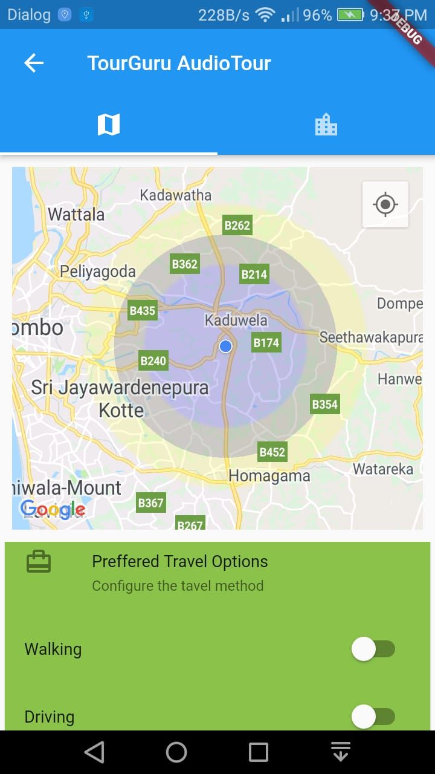

Fig. 2 : Proximate voice alert activation configuration on Narrated Tour Guidance

Fig. 2, discusses on the interface where traveler has the option to choose travel option and state whether app keeps awake while the alerting component activated. This is and tabbed interface that can test pre test the audio configuration on the other side.

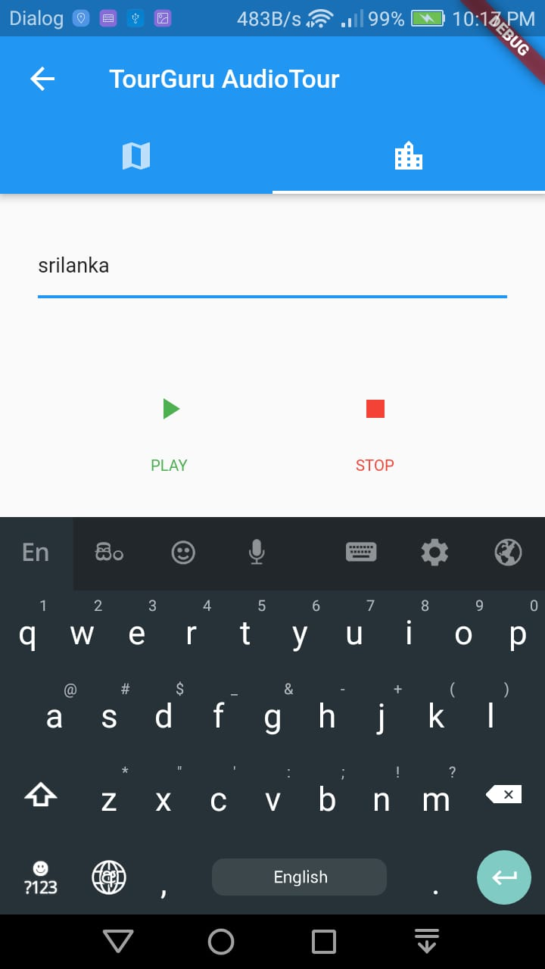

Fig. 3 : Test audio configuration and apply a configuration

Fig. 3, is the interface where user can set whether audio alert component is activated. If it is disabled user is only able to get on-screen alerts and notifications on nearby POIs.

Fig. 4, discusses on the statistics of invocation details on the cloud computing deployed machine learning model. Here it says that the model invoked five times and the first invocation crashed due to an error. Each error can be tested upon invocation due to real-time logging and reporting available in the Cloud Functions module.

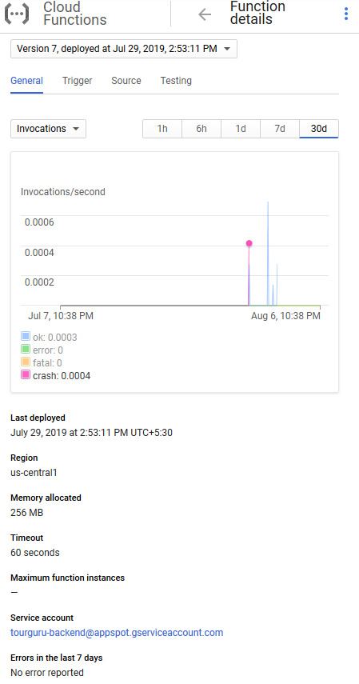

Fig. 4 : Google Cloud Function applied AutoML models invocation statistics

# Conclusion

In the world of tourism, TourGuru mobile app will be a fast, reliable tourist guide application for tourists without any delay. This research paper proposes a practically useful solution called, TourGuru app to overcome this widely faced problem. The Basic Navigation part helps user to navigate through various tourist attractions without any hassle with the help of google API’s. Then narration with detailed description is showed, when they started to travel. Next AR POI and AR Labeling helps us to navigate with AR functionality. Overall, this app serves as an easy, reliable and useful navigation application.

In future works, the overall TourGuru system can be tested and validated with actual users and based on the data crowdsourced by user reviews for better user-friendliness and accuracy. Furthermore, various other parameters to provide personalized experience to the app can be explored.

# References

|  |  |
| --- | --- |
| [1] | "Cloud AutoML - Custom Machine Learning Models  |  Google Cloud," 2019. [Online]. Available: https://cloud.google.com/automl/. |
| [2] | "How to Make a Text Summarizer - Intro to Deep Learning #10 - YouTube," [Online]. Available: https://www.youtube.com/watch?v=ogrJaOIuBx4. |
| [3] | "NLP vs NLU vs NLG (Know what you are trying to achieve) NLP engine (Part-1)," [Online]. Available: https://towardsdatascience.com/nlp-vs-nlu-vs-nlg-know-what-you-are-trying-to-achieve-nlp-engine-part-1-1487a2c8b696. |
| [4] | E.-H. Chung and A. Shalaby, "A Trip Reconstruction Tool for GPS-based Personal Travel Surveys," *Transportation Planning and Technology,* vol. 28, no. 5, pp. 381-401, 10 2005. |
| [5] | J. M. Corchado, J. Pavón, E. S. Corchado and L. F. Castillo, "Development of CBR-BDI Agents: A Tourist Guide Application," 2004, pp. 547-559. |
| [6] | Douglas Crockford, "JSON," [Online]. Available: https://json.org/. |
| [7] | Dr. Michael J. Garbade, "A Quick Introduction to Text Summarization in Machine Learning," 2018. [Online]. Available: https://towardsdatascience.com/a-quick-introduction-to-text-summarization-in-machine-learning-3d27ccf18a9f. |
| [8] | Matej Gallo, Text Summarization byMachine Learning, 2016. |
| [9] | N. K. Nagwani, "Summarizing large text collection using topic modeling and clustering based on MapReduce framework," *Journal of Big Data,* vol. 2, no. 1, p. 6, 26 12 2015. |
| [10] | R. Nallapati, B. Zhou, C. dos Santos, C. Gulcehre and B. Xiang, "Abstractive Text Summarization using Sequence-to-sequence RNNs and Beyond," in *Proceedings of The 20th SIGNLL Conference on Computational Natural Language Learning*, Stroudsburg, PA, USA, 2016. |
| [11] | J. L. Neto, A. A. Freitas and C. A. A. Kaestner, "Automatic Text Summarization Using a Machine Learning Approach," 2002, pp. 205-215. |
| [12] | M. Nilashi, O. Ibrahim, E. Yadegaridehkordi, S. Samad, E. Akbari and A. Alizadeh, "Travelers decision making using online review in social network sites: A case on TripAdvisor," *Journal of Computational Science,* vol. 28, pp. 168-179, 9 2018. |
| [13] | M. P. U. Sabina Yeasmin,Priyanka Basak Tumpa,Adiba Mahjabin Nitu and M. I. A. Emran Ali, "(PDF) Study of Abstractive Text Summarization Techniques," 2017. [Online]. Available: https://www.researchgate.net/publication/324438138_Study_of_Abstractive_Text_Summarization_Techniques. |
| [14] | S. A. Salloum, M. Al-Emran, A. A. Monem and K. Shaalan, "Using Text Mining Techniques for Extracting Information from Research Articles," 2018, pp. 373-397. |
| [15] | Simeon Kostadinov, "Understanding Encoder-Decoder Sequence to Sequence Model," 2019. [Online]. Available: https://towardsdatascience.com/understanding-encoder-decoder-sequence-to-sequence-model-679e04af4346. |
| [16] | Xin Pan Peter Liu, "models/research/textsum at master · tensorflow/models · GitHub," 2018. [Online]. Available: https://github.com/tensorflow/models/tree/master/research/textsum. |
| [17] | Z. Yu, H. Xu, Z. Yang and B. Guo, "Personalized Travel Package With Multi-Point-of-Interest Recommendation Based on Crowdsourced User Footprints," *IEEE Transactions on Human-Machine Systems,* vol. 46, no. 1, pp. 151-158, 2 2016. |
| [18] | "International tourism, number of arrivals | Data," 2017. [Online]. Available: https://data.worldbank.org/indicator/ST.INT.ARVL?locations=LK. |