TOURGURU: Tour Guide Mobile Application for Tourists

M.S.B.W.T.M.P.S.B.Thennakoon

Department of Software Engineering

Sri Lanka Institute of Information Technology

Malabe, Sri Lanka

[pshashitha@gmail.com](mailto:pshashitha@gmail.com)

R.D.T.N.Rajarathna  
Department of Information Technology  
Sri Lanka Institute of Information Technology

Malabe, Sri Lanka[rdtnraja01@gmail.com](mailto:rdtnraja01@gmail.com)

A.M. Imbulpitiya  
Department of Computer Science and Software Engineering

Sri Lanka Institute of Information Technology

Malabe, Sri Lanka

[asanthika.i@sliit.lk](mailto:asanthika.i@sliit.lk)

S.P.B. Jayawickrama  
Department of Information Technology

Sri Lanka Institute of Information Technology

Malabe, Sri Lanka

[swjayawickrema@gmail.com](mailto:swjayawickrema@gmail.com)

N. Kodagoda  
Department of Computer Science and Software Engineering

Sri Lanka Institute of Information Technology

Malabe, Sri Lanka  
[nuwan.k@sliit.lk](mailto:nuwan.k@sliit.lk)

M.P.D.S.M. Kumara  
Department of Information Technology

Sri Lanka Institute of Information Technology

Malabe, Sri Lanka

[mpds.manjula@gmail.com](mailto:mpds.manjula@gmail.com)

*Abstract*— We propose a tour guide mobile app which uses cloud computing, machine learning and Augmented Reality (AR) to give the user an amazing experience on tourism. This app would guide them through an appropriate route to a traveler’s destination a suggest the recommended attractions through the route. They would also be given the opportunity to listen to a narration about certain monuments while they are walking or driving through the suggested route. Additionally, one from the available two of the AR features can be useful when a tourist wants to find which direction a certain attraction is. This feature would be especially useful on a high vantage point allowing the user to enjoy several attractions from the same place all the while receiving interesting facts about them. Also, it would contain various details about that said attraction. Other feature of AR is on 3D object modelling that helps user to get the experience of Point Of interest (POI).

Keywords— Augmented Reality, Cloud computing, Machine Learning, 3D object modelling, Point of interest,

# Introduction

The recent surveys Sri Lanka cited as an emerging leader and one of world’s top destinations for 2019. For development of this Tourism area there were Travel Guides application solutions in these years for use with traveler’s alternative to a tour guide or used by tour guide to advise tourists when existing place with no knowledge of. Presently, these kinds of apps used worldwide to improve tourism income in a country by improving tourist experience, reduce travel time and to decide whether a place is up to their likelihood.

Currently existing such mobile solutions divided in to four types of deployments. There are mobile, web-based solutions, hybrid and lastly standalone desktop applications. Sri Lanka Tourism Board uses web-based solution to advertise well known places which attracts tourists. Web based solutions requires constant internet access from tourist to get to know about this information. Mobile application exists in Sri Lanka for tourism that provides self-guided tours and map-based navigation with point of interest updates regularly. Self-Guided Tours improve the traveler’s efficiency, reduces their stress in finding a travel place while most of these mobile applications has offline capability for their features.

Based on these observations it is best to improve the traveling community within Sri Lanka by introducing a mobile solution that addresses recommendation on travel route, narrated tours, AR based assisted tours.

# Literature Survey

In the research [1], the researchers have concluded that combining the tour guide with the trip planning tool could integrate pre-trip plan with during-trip planning and provide more personalized and relevant information during a trip. In addition, post-trip evaluation can be integrated into the system in which the users will be able to rank the different properties they have gone to. Future development can also include an interface for tourism enterprises to update their information daily even hourly (for example, a special deal for the day) to market toward visitors on the road or 100 or 200 yards around them. Location and map-based tourist information tools based on Google Map API opened many opportunities to enhance visitor experience as well as connecting visitors with tourism properties in destinations.

In the research [2], they have stated that in terms of software implementation, the MobiAR mobile application is an Android activity that encompasses the view of augmented reality, offering the user the ability to choose content in both 2D and 3D. The information about the POIs, received periodically from the server, is relative to the position of the user. The user’s position is discovered through the Global Positioning System (GPS) built into the terminal and the triangulation of phone masts. Considering context-based data and user profiles, the MobiAR application queries the content server for multimedia items that have been location-tagged (categorized by latitude, longitude and altitude data). When the appropriate contents are retrieved, the AR view is composed with the real-time images captured from the camera of the mobile device and the digital information (menus and POIs) overlaid. There are two possible modes to handle augmentation: 2D and 3D modes. The 2D mode shows multimedia content POIs enriching the real images captured by the camera. This mode is very suitable to discover interesting places nearby. The 3D mode has both the content and the user interface in 3D. Therefore, this mode is tailored to an enriched and leisure-oriented experience. All those POI representations would be completely static, if it was not due to information that is acquired through the sensors, namely the digital compass and the accelerometers. Thanks to those sensor readings, the information shown on the screen is dynamically positioned on the screen at the right coordinates.

Furthermore, they have gone on to describe similar applications like, Layar1, which is an Android and iPhone based mobile AR browser that was launched in 2009. Users can explore their physical surroundings, call up geo-tagged information from the web and superimpose it on the video captured by the camera of the device. The platform has an application programming interface that allows developers to contribute with different “layers” to the browser. Hundreds of new data layers are available to view on top of the camera viewer of the mobile device, from Wikipedia [3] entries when one is looking at geographic Points of Interest (POI) to real estate listings that are viewable when pointing at homes for sale. Acrossair [4] has a similar interaction with “layers” of content. The application is only available on the iPhone and those “layers” are close managed by Acrossair developers.

Wikitude 2 is an Android, iPhone and Symbian application launched originally on Android in the fall of 2008. It pulls information from Wikipedia and Qype, the European user-generated review service, and overlays that geo-located data onto the display. Version 3 of Wikitude is integrated with the proprietary user-generated geo-tagging application Wikitude.me. Users can create their own POIs and location-based, hyper-linked digital content that can be viewed through the Wikitude browser application.

They have gone on to give two further examples of more user-centric world browsers, which are Junaio3 [5] and Tag what. They allow users to tag and upload content from the physical world and to share and discover the content that other users have uploaded. Junaio provides information about POIs and the ability to add 3D animations and share the edited images via the usual social networking sites. Each user generated geo-tagged POI is then visible by all the other users.

In the research [6], the research was on a Tourist Guide application, called TOURIST GUIDEUSAL, has been developed as a multi-agent systems (MAS). With this system they wanted to show the feasibility and reliability of this technology, and that fully functional systems may be constructed within the time restrictions imposed by the industry. TOURIST GUIDE-USAL agents assist potential tourists in the organization of their tourist routes and enable them to modify their schedules on the move using wireless communication systems. This system has been constructed using an engineering framework developed to design and implement an agent-based tool, as well as integrating existing state of the art in order to create an open, flexible, global anticipatory system with mobile access for the promotion and management of inland and cultural tourism, which will be user-friendly, cost-effective and secure. The system has been standardized to run in any mobile device and is interlingua. The integrated, multi-platform computer system is composed of a guide agent (Planner Agent) that assesses the tourists and help them to identify tourist routes in a city with a given visiting period and under a number of restrictions related to cost, tourist interest, etc. There is one assistant agent for each user of the system, the Performer Agents. Each user willing to use the system must register and solicit one of these agents. Finally, there is a third type of agent, the Tracker agent, which maintains updated information about the monuments, the restaurants, public transport conditions, etc. This agent maintains horizontally and vertically compiled information on hotel accommodation, restaurants, the commercial sector and transport, in order to meet the needs of the potential visitor on an individually customized basis, and responds to requests for information, reservations and purchases in the precise moment that they are expressed.

By the research [7] on Intelligent Tourist Attractions System (ITAS) for tourist attractions the researchers have developed a decision support system for tourist attractions based on the EBM model (Decision-Making Model of Engel, Blackwell And Miniard (1995)). Bayesian network utilized to calculate the probability of tourist attraction of a place. The recommended routes and tourist attractions are presented by Google Maps and its accuracy validated by a ROC curve test.

This marks the importance for the prediction on best feasible routes and preserving it by acknowledgeable method. Here they have used EBM model, a decision-supporting model for user/consumer decision making process by predicting best route using the Bayesian probabilistic graphical model.

The research [8] done for the recommendation agent in TripAdvisor shows the importance of socially improved decision making on tourism or selecting site. They approached solution by machine learning algorithm CART Regression Trees [9] classification for their TripAdvisor dataset. Here they have approached with Classification and Regression Trees (CART) for their classification or regression predictive modelling problems. So, by analyzing online review in social network sites they have marked the importance of Data Mining applications for identifying whether their consumer preference is important. As their result they identified each consumer decision through a model and predicted the accurate hotel recommendation. Conclusion is that the analysis of social responses leads to best Tour travel recommendations.

In the research [10] on Text Summarization based on machine leaning, evaluates most of presently used techniques by Matej Gallo. Research starts by the Types of Summaries in Natural Language Processing. After he tests these techniques accuracy, he concludes that, Word Frequency Method yielded the most relevant sentences after summarization. So, as he identified more accurate way to summarize is Abstractive Text Summarization based on frequent patterns.

After reviewing most of the research articles on Text Summarization Techniques, it is concluded that presently applying techniques are mostly from Abstractive Text Summarization. This article [11] on Sequence2Sequence text summarization explains how they experienced the results in two different datasets with Encoder-Decoder RNN. And they end their research on Sequence-to-Sequence text summarization technique [12], concluding on planning to focus their efforts on [13] two different datasets and build more robust models for summaries consisting of multiple sentences.

Google Map API is a best cloud solution for background development, functionalities, map geocoding, route generation, place detail delivering and other features etc. It uses electronic devices GPS locations to show real-time location sensitive information for tourists. The development of this API is moved the tourist’s dreams higher satisfaction.

There are many Map API such as Google Maps, Bing Maps, MapQuest, OpenStreetMap, Here-WeGo, Apple Maps, Yandex Maps etc. most of the them have different types of features [14].

We are not just interested in the location but also other elements of the user's context, such as buildings in view, attractions and establishments [15] [16] nearby, such as Zoo, Temple etc. We are not just interested in the location but also other elements of the user's context, such as buildings in view, attractions and establishments nearby, such as Zoo, Temple etc.

Touch & Interact is an interaction technique which combines mobile phones and public displays [17]. when using private, public data and using audio outputs, video, touchable touch displays it is more resourceful to explore and test Touch & Interact in an environment with rich functionality.

All of details on this section summarized into the Table 1. Subjective comparison done for the features represented by each similar product. Each of the current research components are compared in here with a brief description on the feature.

# Research Problem

This section describes on the identified research problem for the solution Implementation. In the tourism industry map-based routing, alert narrations and AR technology are identified fields on the application technologies. Here from a traveler’s perspective the problems they face when moving to unknown locations and providing interactive implementation is majorly considered.

Problems identified are guiding these people to places of interest that are not well known by providing AR content, there needs to be way for recommending user on a route with small attractions scattered around and giving proximity alerts on places of interest that they travel through.

Table 1: Product Similarities

|  |  |  |  |  |  |
| --- | --- | --- | --- | --- | --- |
| Features | TourGuru | Roadtrippers | Toureazy | Tour Buddy | සිංහලංකා AR |
| Intelligent Trip routing (automatic route creation) |  |  |  |  |  |
| Trip editor (Add or update custom places) |  |  |  |  |  |
| Categorize locations  (monuments places, restaurant etc) |  |  |  |  |  |
| Map Filters |  |  |  |  |  |
| Shared user activity |  |  |  |  |  |
| Traffic management |  |  |  |  |  |
| Narrations or alerts on point of interest |  |  |  |  |  |
| Waypoint management |  |  |  |  |  |
| Collaborator management |  |  |  |  |  |
| Distance slider for radius adjusting (proximity alert and activation) |  |  |  |  |  |
| AR object modelling |  |  |  |  |  |
| Identification location (using AR. location means historical places and important building |  |  |  |  |  |

# Methodology

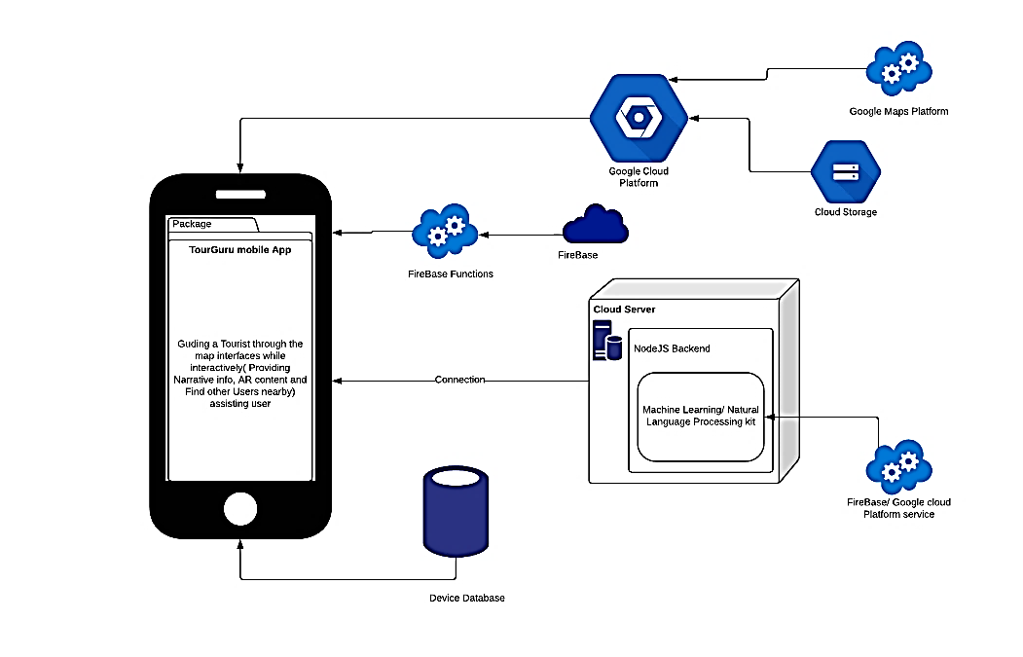

Fig. 1. Architecture Diagram

Figure 1: Architecture Diagram

Fig. 1, Diagram shows summary on how the system proceeds through data gathering or generation, cleaning and processing data, selection an appliance of research methods, data analysis. Each section discussed further in here:

## Data Gathering and Generation

At the first step, the process on the system development proceeds with sample of data. Data gathering or generation techniques are discussed in here for the research objectives intelligent route generation, narrated tour experience and POI representation on AR.

For the guidance of a traveler the implementation on intelligent route generation research focusses on the techniques for solving VRP and TSP problems. Data gathering for this implementation is done through Google Maps Platform a cloud platform solution. With the use of RESTful API, system requests for nearby POI’s from Places API, a subcomponent of the cloud solution. Response from the cloud solution is received in JSON (JavaScript Object Notation) Data Interchange Syntax [18]. Set of nearby POI locations are within this JSON array and used as Primary data with the purpose on generating a route that suits best interests to a tourist through processing. For the generation of the dataset place request will be sent for place search. Place Search will take source geo coordinate and the radius that needed to search for POI’s nearby primarily. Response includes a JSON array on nearby POI’s with parameters on each of location name, type(s), geometry and rating. Next the request that sent with source geo coordinates and destination geo coordinates to the cloud service Google Directions API will give a response with JSON array containing the features distance to travel, time taken to travel and polyline of the map route

With the real-time proximity alerting with an audio description to inform the tourist on nearby location details can help user to reduce screen time and avoid missing on details. The data that needed for the audio description is textual information queried from a RESTful https request from Wikipedia as a JSON object. Returned JSON object contains description on POI in a few sentences. Primary data used to generate a summarized narration for the related POI and present to user. To implement a more attractive solution web scraping used for grabbing a media/web article link of the related POI from the web. When Nearby POI’s and place details are taken from previous component with the Intent of generating a more descriptive alerting that focusses on the travel. This secondary data may be used in generating a sentence to narrate or alerting with user interface elements.

Implementing a system that consists with AR components of the POI’s locations in AR can help user on identification on the places if he is lost and can get more description on travel. First component that consists AR guidance focusses on providing user with a nearby POI’s labeling with the help of gathered data from google cloud platform Places API and through web scraping to query for the related information. Prebuilt POI label object model is used in AR component. Second part of the AR based solution focusses on representing a 3D object model for only specific POI’s in the real-world perspective. Label and 3D object model will be generated as primary data for these AR based research components.

## Data Processing and Cleaning

After the first step, processing and cleaning on the data starts to apply them into the research methods. Data processing or cleaning techniques are discussed in here for the research objectives intelligent route generation, narrated tour experience and POI representation on AR.

Datasets gathered as JSON representations are concatenated and are converted to CSV (Comma-separated values) format for the application of intelligent route generation. This processing helps for the applying data on research method discussed in next section. Processed data in the CSV format may contain ‘null’ valued fields, incorrect data representations for a column or URL encoded values. Data cleaning will be done for them on CSV data by removing rows with ‘null’ values, conversion of data types and decode URL values.

For the POI based narrated tour guidance it is necessary to process the JSON data and convert into CSV format to be applied into the research method. JSON objects that taken from Google Places API, Google Directions API are processed for only their important data and created a single JSON representation from them. Wikipedia queried paragraph and web scraped DOM elements textual data and media links are added to that JSON objects afterwards. Data cleaning applied after processing JSON object and converting into CSV format. Data cleaning checks for null values, incorrect representation of data, encoded URL values in media links and checks for scraped texts whether has other DOM elements/HTML tags.

Data processing and cleaning done for the AR component on presenting POI’s description on label model. JSON object response from Google Places API is processed for geo-coordinates and related location names. This object has an array of POI locations and each of them will be processed for name, geometry and rating by excluding other parameters. Location name used for web scraping textual data and processed with the JSON object. Data gathered through web scraping must be verified for to remove unnecessary DOM elements and extract only the textual information from them.

Finally, the AR component that represents a 3D object model of specific POI’s will have data generation on 3D object. For identified important places 3D object model will be created and stored in Firebase Storage. Data processing will be done for requesting and caching that model into the AR components platform.

## Application of Research Method

Deep Learning algorithm executes processed data on Intelligent Route Generation component. The machine learning model will be hosted on Google Cloud Platform’s AutoML machine learning platform [19]. Processed data will be stored on the Firebase storage upon data cleaning ends and algorithm execution starts. Selection on the algorithm is based on solving Travelling Salesmen Problem with Heuristic Machine Learning (Q Learning, Nearest Neighbor, Genetic Algorithm, Ant Colony Optimization etc.) algorithms. Application on the research component starts with feature analysis on the dataset and training with the most important features. Then optimizing the training accuracy by tuning hyper-parameters and learning rates. Generated result from the Google AutoML compute engine will have a response with the corresponding POI’s to travel accordingly. This result will be graphically generated and presented to the user through Flutter app implemented map interface.

Natural Language Processing is needed for the analysis on the processed dataset on POI based Narrated Tour Guidance component. Implementing model will have the functionality to summarize the Wikipedia queried text and evaluation on speech time on the travel. When system generates its route on the POI’s the system will automatically initiates the generation on dataset and begins the execution on the deep learning model. This model will consist with encoder, decode [20] each with either LSTM (Long short-term memory) or GRU (Gated Recurrent Units) or vanilla RNN (Recurrent Neural Network) cells. Encoder vector will encapsulate the information as in (1) for all input elements. Decoder vector each recurrent unit accepts a hidden state as in (2) from the previous unit and produces and output as in (3) as well as its own hidden state. Output from the model presented to user at the end of process of returning JSON object to the system with POI coordinates and alerting the user on mobile interface with the audio description. The model resides on AutoML compute engine.

ht = f (W(hh)ht-1 + W(hx)xt) (1)

ht = f (W(hh)ht-1) (2)

yt = softmax (WSht) (3)

AR component on presenting POI’s description on label model performs by positioning a label object in each of location elements in the processed data. POI location element geo-coordinate distance, angle/radius, altitude calculated, and the label positioned in virtual world of the camera view with these metrics. For each element in the JSON object array there will be an object label positioned using the metrics mentioned when distance is equal to an expected vicinity. This label positioned as when the traveler’s current location changed and regularly check whether POI at the vicinity or not.

Method on AR component of 3D object model activates when specific POI’S is in the vicinity and can be accessed and view them in anywhere. Main application on AR is that when a traveler near a POI that has its own 3D object model, traveler can view it through interacting with the AR POI label component’s view. The 3D model will be stored on the cloud storage and its automatically cached to the mobile system when corresponding POI label is visible. Users can directly view individual POI’s 3D object model separately by its own interface. When directly accessing the POI’s AR 3D model view, all the available 3D models and their place name, geometry will be displayed on the UI. User can select a POI from the list to view the location 3D model beforehand.

# Results and Disscussion

This section of the paper presents the results obtained for the solution implemented and discusses on feasibility on both technical and economic aspects and the marketability of the implementation.

Result observed through the application of AR engines like Vuforia and Wikitude contrasts the feasibility on integration to the cross-platform mobile app. A few years back the marker less support in AR SDK’s and engines were rarely seen [21], although the currently most of the said AR SDK’s supports the marker less implementations based on GPS technology [22] to some extent. From the experimented said two engines the most viable is Wikitude in aspect of integration to a cross platform application. Its, Javascript SDK delivers HTML content to the AR experience and more stable in aspect of bugs, technology and providing the capability on generating a collection of multiple targets.

Deep Learning model that based on encoder, decoder summarizes multiple sentences into fewer sentences and provide better summary on more than 2 sentences of inputs. So far, Q-learning has been a method is slowly learning to converge to best or near optimal values. When city size grows, the solution obtained is slowly becoming to diverge from the best one. It is observed that Q-learning also gives acceptable results if the city size is small, and its capability has been increased so that the encouraging performance improvement could be accomplished to make it more competitive with the other heuristic methods.

Fig 2, This represents a user interface that resulted from the methodology of intelligent route generation. Fig. 3, resulted through performing the methodology described on Narrated Tour Guidance component. Fig. 4,5, Presents an AR 3D object model positioned in Geo coordinates based on respective component. Fig. 6, Discusses about Google Cloud Function applied AutoML models invocation details report on a deployed Deep learning model.

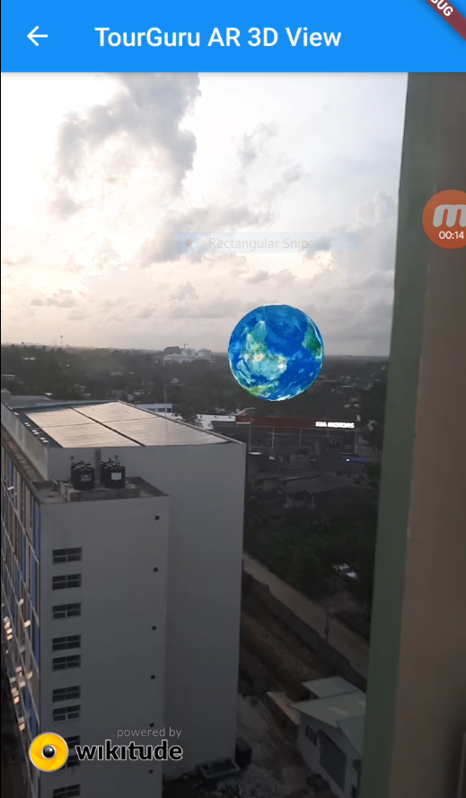

Fig. 4. An GPS positioned 3D object model on Augmented Reality component

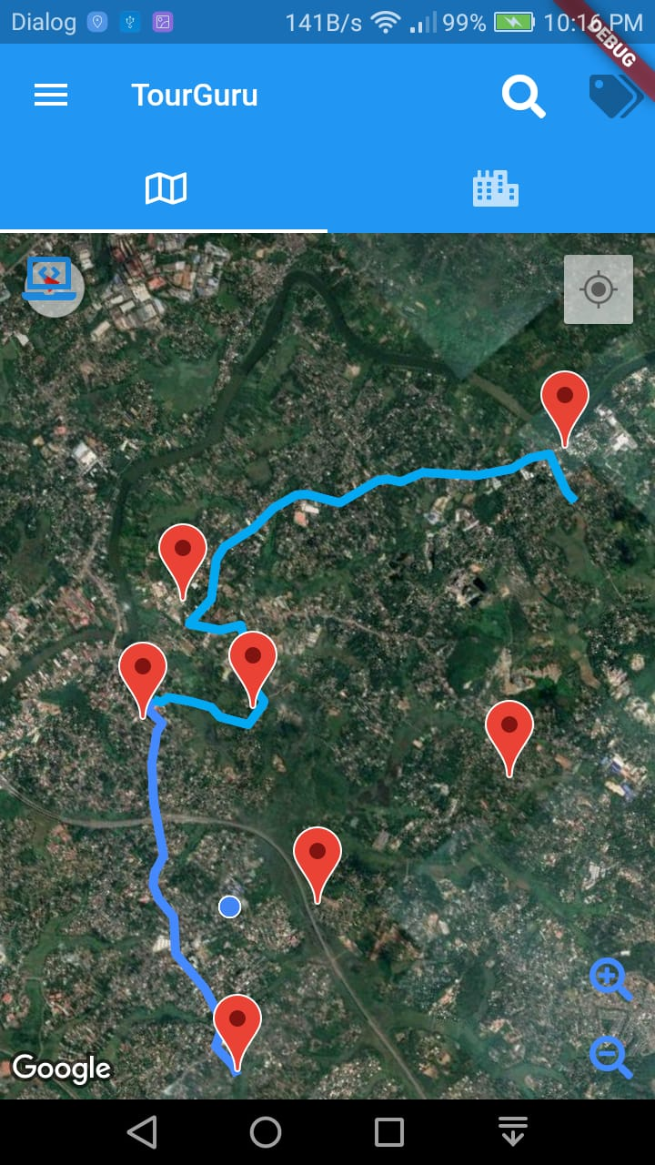

Fig. 2. A generated route of Intelligent Route Generation component.

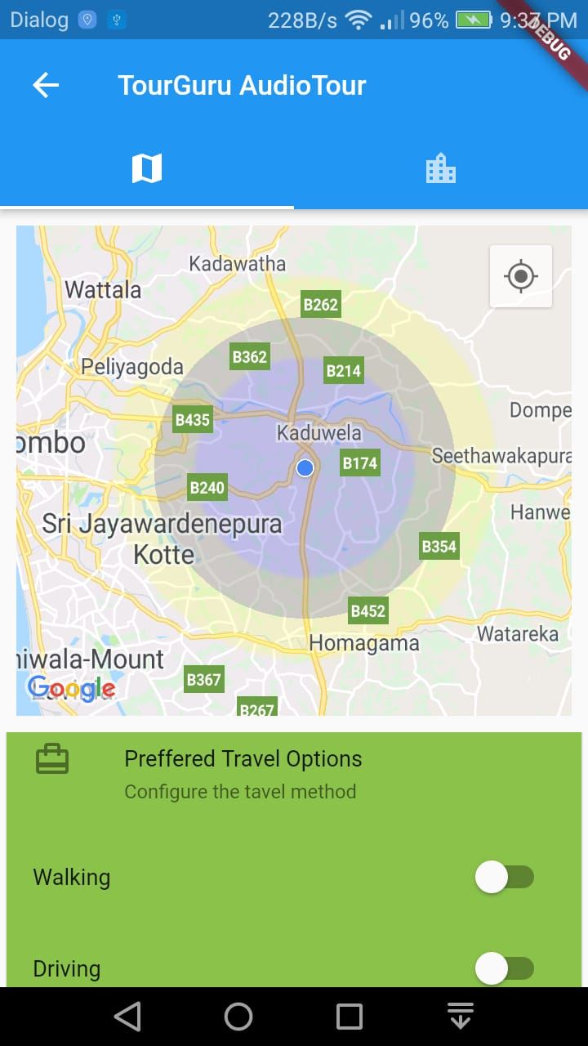

Fig. 3. Proximate voice alert activation configuration on Narrated Tour Guidance

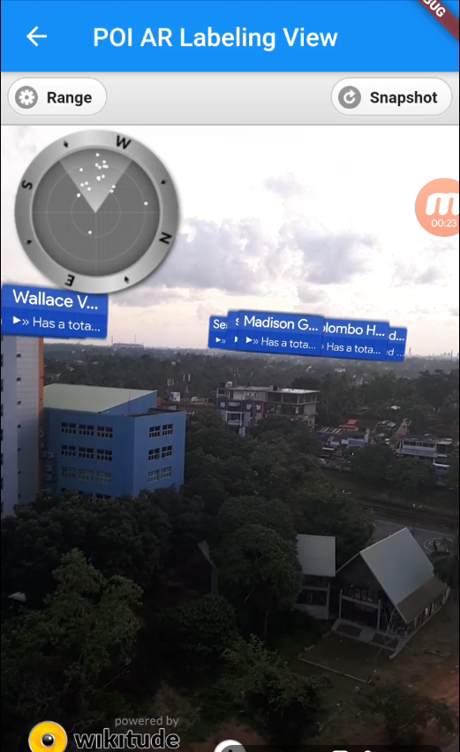

Fig. 5. Geo positioned location identifier label object on Augmented Reality Component

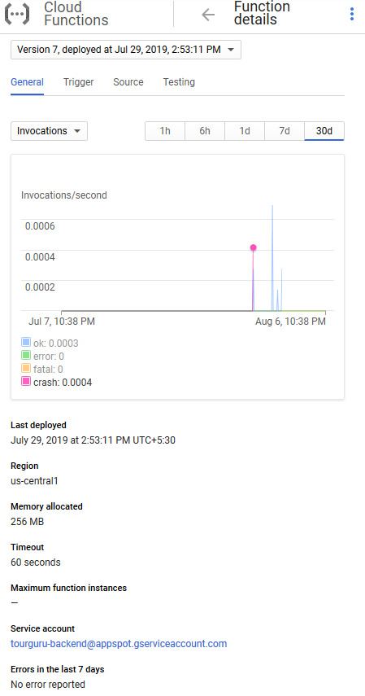

Fig. 6. Google Cloud Function applied AutoML models invocation details

+

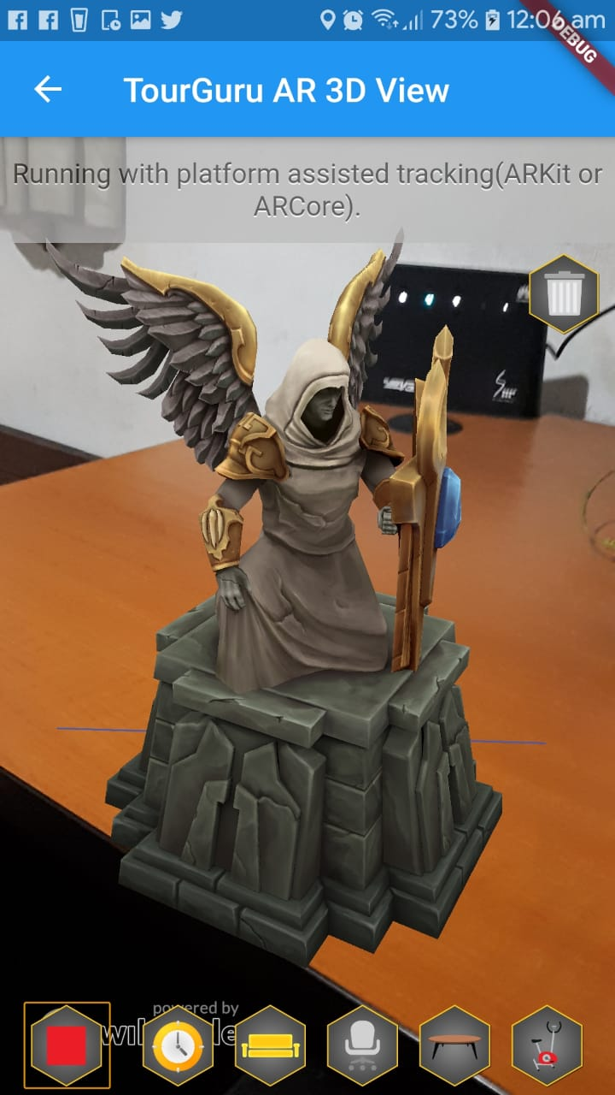

Fig. 7. Surface detection and object placement

# conclusion & Future Works

In the world of tourism, TourGuru mobile app will be a fast, reliable tourist guide application for tourists without any delay. This research paper proposes a practically useful solution called, TourGuru app to overcome this widely faced problem. The Basic Navigation part helps user to navigate through various tourist attractions without any hassle with the help of google API’s. Then narration with detailed description is showed, when they started to travel. Next AR POI and AR Labeling helps us to navigate with AR functionality. Overall, this app serves as an easy, reliable and useful navigation application.

In future works, the overall TourGuru system can be tested and validated with actual users and based on the data crowdsourced by user reviews for better user-friendliness and accuracy. Furthermore, various other parameters to provide personalized experience to the app can be explored.

##### Acknowledgment

We would like to convey our sincere appreciation to the administration of Sri Lanka Institute of Information Technology (SLIIT) for providing us with suitable environment and prerequisites to complete this project. We also want to express our gratitude to our kith and kin for their persistent support and understanding upon in making this project successful.

##### References

|  |  |
| --- | --- |
| [1] | J. C. C. B. M. Bing Pan, "Developing Web-Based Tourist Information Tools Using Google Map," [Online]. Available: https://www.researchgate.net/publication/221357221_Developing_Web-Based_Tourist_Information_Tools_Using_Google_Map. |
| [2] | "(PDF) MobiAR: Tourist Experiences through Mobile Augmented Reality," 2010. |
| [3] | "Wikipedia, the free encyclopedia," [Online]. Available: https://en.wikipedia.org/wiki/Main_Page. |
| [4] | "acrossair - Nearest Tube Augmented Reality Tube Finder," 2019. [Online]. Available: https://www.acrossair.com/. |
| [5] | "Junaio," 2017. |
| [6] | J. M. Corchado, J. Pavón, E. S. Corchado and L. F. Castillo, "Development of CBR-BDI Agents: A Tourist Guide Application," 2004, pp. 547-559. |
| [7] | F.-M. Hsu, Y.-T. Lin and T.-K. Ho, "Design and implementation of an intelligent recommendation system for tourist attractions: The integration of EBM model, Bayesian network and Google Maps," *Expert Systems with Applications,* vol. 39, no. 3, pp. 3257-3264, 2 2012. |
| [8] | M. Nilashi, O. Ibrahim, E. Yadegaridehkordi, S. Samad, E. Akbari and A. Alizadeh, "Travelers decision making using online review in social network sites: A case on TripAdvisor," *Journal of Computational Science,* vol. 28, pp. 168-179, 9 2018. |
| [9] | Jake Morgan, Classification and Regression Tree Analysis, 2014. |
| [10] | Matej Gallo, Text Summarization byMachine Learning, 2016. |
| [11] | R. Nallapati, B. Zhou, C. dos Santos, C. Gulcehre and B. Xiang, "Abstractive Text Summarization using Sequence-to-sequence RNNs and Beyond," in *Proceedings of The 20th SIGNLL Conference on Computational Natural Language Learning*, Stroudsburg, PA, USA, 2016. |
| [12] | "How to Make a Text Summarizer - Intro to Deep Learning #10 - YouTube," [Online]. Available: https://www.youtube.com/watch?v=ogrJaOIuBx4. |
| [13] | Xin Pan Peter Liu, "models/research/textsum at master · tensorflow/models · GitHub," 2018. [Online]. Available: https://github.com/tensorflow/models/tree/master/research/textsum. |
| [14] | B. Pan, J. C. Crotts and B. Muller, "Developing Web-Based Tourist Information Tools Using Google Map," in *Information and Communication Technologies in Tourism 2007*, Vienna, Springer Vienna, pp. 503-512. |
| [15] | N. Davies, K. Cheverst, K. Mitchell and A. Efrat, "Using and determining location in a context-sensitive tour guide," *Computer,* vol. 34, no. 8, pp. 35-41, 2001. |
| [16] | G. D. Abowd, C. G. Atkeson, J. Hong, S. Long, R. Kooper and M. Pinkerton, "Cyberguide: A mobile context‐aware tour guide," *Wireless Networks,* vol. 3, no. 5, pp. 421-433, 1997. |
| [17] | K. Cheverst, N. Davies, K. Mitchell and A. Friday, "Experiences of developing and deploying a context-aware tourist guide," in *Proceedings of the 6th annual international conference on Mobile computing and networking - MobiCom '00*, New York, New York, USA, 2000. |
| [18] | Douglas Crockford, "JSON," [Online]. Available: https://json.org/. |
| [19] | "Cloud AutoML - Custom Machine Learning Models  |  Google Cloud," 2019. [Online]. Available: https://cloud.google.com/automl/. |
| [20] | Simeon Kostadinov, "Understanding Encoder-Decoder Sequence to Sequence Model," 2019. [Online]. Available: https://towardsdatascience.com/understanding-encoder-decoder-sequence-to-sequence-model-679e04af4346. |
| [21] | D. Amin and S. Govilkar, "Comparative Study of Augmented Reality Sdk's," *International Journal on Computational Science & Applications,* vol. 5, no. 1, pp. 11-26, 28 2 2015. |
| [22] | J. C. P. Cheng, K. Chen and W. Chen, "Comparison of Marker-Based and Markerless AR: A Case Study of An Indoor Decoration System," in *Lean and Computing in Construction Congress - Volume 1: Proceedings of the Joint Conference on Computing in Construction*, Edinburgh, 2017. |
| [23] | Z. Yu, H. Xu, Z. Yang and B. Guo, "Personalized Travel Package With Multi-Point-of-Interest Recommendation Based on Crowdsourced User Footprints," *IEEE Transactions on Human-Machine Systems,* vol. 46, no. 1, pp. 151-158, 2 2016. |
| [24] | S. A. Salloum, M. Al-Emran, A. A. Monem and K. Shaalan, "Using Text Mining Techniques for Extracting Information from Research Articles," 2018, pp. 373-397. |
| [25] | M. P. U. Sabina Yeasmin,Priyanka Basak Tumpa,Adiba Mahjabin Nitu and M. I. A. Emran Ali, "(PDF) Study of Abstractive Text Summarization Techniques," 2017. [Online]. Available: https://www.researchgate.net/publication/324438138_Study_of_Abstractive_Text_Summarization_Techniques. |
| [26] | S. A. RÍOS and J. D. VELÁSQUEZ, "FINDING REPRESENTATIVE WEB PAGES BASED ON A SOM AND A REVERSE CLUSTER ANALYSIS," *International Journal on Artificial Intelligence Tools,* vol. 20, no. 01, pp. 93-118, 30 2 2011. |
| [27] | B. Parhizkar, A. A. M. Al-Modwahi, A. H. Lashkari, M. M. Bartaripou and H. R. Babae, "A Survey on Web-based AR Applications," 13 11 2011. |
| [28] | J. L. Neto, A. A. Freitas and C. A. A. Kaestner, "Automatic Text Summarization Using a Machine Learning Approach," 2002, pp. 205-215. |
| [29] | N. K. Nagwani, "Summarizing large text collection using topic modeling and clustering based on MapReduce framework," *Journal of Big Data,* vol. 2, no. 1, p. 6, 26 12 2015. |
| [30] | R. Hardy and E. Rukzio, "Touch &amp; Interact," in *Proceedings of the 10th international conference on Human computer interaction with mobile devices and services - MobileHCI '08*, New York, New York, USA, 2008. |
| [31] | Dr. Michael J. Garbade, "A Quick Introduction to Text Summarization in Machine Learning," 2018. [Online]. Available: https://towardsdatascience.com/a-quick-introduction-to-text-summarization-in-machine-learning-3d27ccf18a9f. |
| [32] | E.-H. Chung and A. Shalaby, "A Trip Reconstruction Tool for GPS-based Personal Travel Surveys," *Transportation Planning and Technology,* vol. 28, no. 5, pp. 381-401, 10 2005. |
| [33] | Y.-Y. Chen, A.-J. Cheng and W. H. Hsu, "Travel Recommendation by Mining People Attributes and Travel Group Types From Community-Contributed Photos," *IEEE Transactions on Multimedia,* vol. 15, no. 6, pp. 1283-1295, 10 2013. |
| [34] | A. Candido Junior, C. Magalhães, H. Caseli and R. Zangirolami, "Topic Modeling for Keyword Extraction: using Natural Language Processing methods for keyword extraction in Portal Min@s," *REVISTA DE ESTUDOS DA LINGUAGEM,* vol. 23, no. 3, p. 695, 22 12 2015. |
| [35] | "Telephone directory of businesses," [Online]. Available: https://www.yellowpages.com. |
| [36] | "NLP vs NLU vs NLG (Know what you are trying to achieve) NLP engine (Part-1)," [Online]. Available: https://towardsdatascience.com/nlp-vs-nlu-vs-nlg-know-what-you-are-trying-to-achieve-nlp-engine-part-1-1487a2c8b696. |
| [37] | "Comparison of web map services," 2018. [Online]. Available: https://en.wikipedia.org/wiki/Comparison_of_web_map_services. |
| [38] | "AUGMENTED REALITY IEEE PAPER 2018," [Online]. Available: https://www.engpaper.com/augmented-reality-2018.htm. |