**TOURGURU: TOUR GUIDE MOBILE**

**APPLICATION FOR TOURISTS**

M.S.B.W.T.M.P.S.B. Thennakoon, R.D.T.N. Rajarathna, M.P.D.S.M. Kumara, S.P.B. Jayawickrema

(IT16160262, IT16003538, IT16117488, IT16024250)

B.Sc. (Hons) in Information Technology

Department of Information Technology

Sri Lanka Institute of Information Technology

Sri Lanka

August 2019

**TOURGURU: TOUR GUIDE MOBILE**

**APPLICATION FOR TOURISTS**

M.S.B.W.T.M.P.S.B. Thennakoon, R.D.T.N.Rajarathna, M.P.D.S.M.Kumara, S.P.B.Jayawickrema

(IT16160262, IT16003538, IT16117488, IT16024250)

Dissertation submitted in partial fulfillment of the requirements for the Bachelor of

Science (Honors) degree in Information Technology Specialization in IT

Department of Information Technology

Sri Lanka Institute of Information Technology

Sri Lanka

August 2019

# DECLARATION

I declare that this is my own work and this dissertation does not incorporate without acknowledgement any material previously submitted for a degree or diploma in any other university or Institute of higher learning and to the best of my knowledge and belief it does not contain any material previously published or written by another person except where the acknowledgement is made in the text. Also, I hereby grant to Sri Lanka Institute of Information Technology the non-exclusive right to reproduce and distribute my dissertation in whole or part in print, electronic or other medium. I retain the right to use this content in whole or part in future works (such as article or books).

|  |  |  |
| --- | --- | --- |
| Name | Student ID | Signature |
| M.S.B.W.T.M.P.S.B. Thennakoon | IT16160262 |  |
| R.D.T.N. Rajarathna | IT16003538 |  |
| M.P.D.S.M. Kumara | IT16117488 |  |
| S.P.B. Jayawickrema | IT16024250 |  |

The supervisor/s should certify the proposal report with the following declaration.

The above candidate is carrying out research for the undergraduate Dissertation under my supervision.

Signature of the Supervisor: Date

…............................................. ..............................

Signature of the Co-Supervisor: Date

…............................................. ..............................

# ABSTRACT

Sri Lanka is one of emerging countries that generates a marginal revenue from tourism industry. Local travelers may not face issues on the travel place identification, but when it comes to foreign tourists, they will face difficulties during the process making a tour to a destination. There are many places without proper attractions from tourists that may be most important historical places. We propose a tour guide mobile app which uses cloud computing, machine learning and Augmented Reality (AR) to give the user an amazing experience on tourism. This app would guide them through an appropriate route to a traveler’s destination a suggest the recommended attractions through the route. They would also be given the opportunity to listen to a narration about certain monuments while they are walking or driving through the suggested route. Additionally, one from the available two of the AR features can be useful when a tourist wants to find which direction a certain attraction is. This feature would be especially useful on a high vantage point allowing the user to enjoy several attractions from the same place all the while receiving interesting facts about them. Also, it would contain various details about that said attraction. Other feature of AR is on 3D object modelling that helps user to get the experience of Point Of Interest (POI).

# ACKNOWLEDGEMENT

The work described in this research paper was carried out as our 4th year research project for the subject Comprehensive Design Analysis Project. The completed final project is the result of combining all the hard work of the group members and the encouragement, support and guidance given by many others. Therefore, it is our duty to express our gratitude to all who gave us the support to complete this major task.

We are deeply indebted to our supervisor Ms. Asanthika Imbulpitiya and our co-supervisor Mr. Nuwan Kodagoda, lecturers of Sri Lanka Institute of Information Technology whose suggestions, constant encouragement and support in the development of this research, particularly for the many stimulating and instructive discussions. We are also extremely grateful to Mr. Jayantha Amararachchi, Senior Lecturer/ Head-SLIIT Centre for Research who gave and confirmed the permission to carry out this research and for all the encouragement and guidance given.

We also wish to thank all our colleagues and friends for all their help, support, interest and valuable advices. Finally, we would like to thank all others whose names are not listed particularly but have given their support in many ways and encouraged us to make this a success.

TABLE OF CONTENTS

DECLARATION i

ABSTRACT i

ACKNOWLEDGEMENT iii

List of Tables v

List of Figures v

List of Abbreviations v

1 Introduction 1

1.1 Background Context 2

1.2 Research gap 5

1.2.1 Gap in products similar to Intelligent Route Generation 5

1.2.2 Product similarities with Narrated Tour feature 6

1.2.3 Research Gap with products similar to POI based AR view and also location-based and surface-based AR 3D object placement 7

1.3 Research Problem 8

1.4 Research Objectives 8

1.4.1 Research in Intelligent Route 8

1.4.2 Research in POI based Narrated Tour 8

1.4.3 Research in POI based AR labeling 9

1.4.4 Research in location-based and surface-based AR 3D object placement 9

2 Methodology 10

2.1 Addressing the Literature 10

2.2 Methodology 11

2.2.1 Technologies Applied 11

2.2.2 Intelligent Route 12

2.2.3 POI based Narrated Tour 12

2.2.4 POI based AR labeling 14

2.2.5 Location-based and surface-based AR 3D object placement 15

2.3 Commercialization aspects of the product 17

2.4 Testing & Implementation 18

3 Results & Discussion 20

3.1 Results 20

3.1.1 Intelligent Routing 20

3.1.2 POI based Narrated Tour 22

3.1.3 POI based AR Labeling 25

3.2 Research Findings 26

3.3 Discussion 26

4 Conclusion 27

5 References 28

6 Appendices 31

# List of Tables

Table 1 : Intelligent route mapping 5

Table 2 : Research Gap on Narrated Tour Guidance 6

Table 3 Research gap -POI based AR view 7

# List of Figures

Figure 1 : International tourism by number of arrivals Sri Lanka [1] 1

Figure 2 : Architecture Diagram 10

Figure 3 : AR POI Object 15

Figure 4 : Product Logo 17

Figure 4 : Google Cloud Platform averall SaaS statistics 18

Figure 5 : Log of Firebase Functions invocations 18

Figure 6 : An log of invocations of deployed models and SaaS Services on GCP 19

Figure 7: A generated route of Intelligent Route Generation component 20

Figure 8 : Search Mode of the component 20

Figure 9: Showing nearby locations 21

Figure 10 : Proximate voice alert activation configuration on 22

Figure 11 : Test audio configuration and apply a configuration 23

Figure 12 : Google Cloud Function applied AutoML models invocation statistics 24

Figure 13 :Geo positioned location identifier label object on AR Component 25

Figure 14 : Work Breakdown Chart 31

Figure 15 : Development Life Cycle 32

Figure 16 : Project Life Cycle 33

# List of Abbreviations

|  |  |
| --- | --- |
| SRS | Software Requirement Specification |
| GPS | Global Positioning system |
| POI | Point of Interest |
| MSDLC | Mobile Software Development Lifecycle |
| AR | Augmented Reality |
| TourGuru | Name of the proposed mobile application |
| VB | Visual Basic a IDE |
| VG | Visual Gaming |
| NTG | Narrative Tour Guidance |
| GCP | Google Cloud Platform |

# 

# Introduction

One of recent surveys on International Tourism [1] illustrates in Figure 1, that Sri Lanka continues to be seeming as one of emerging leader and present surveys such as [2], [3] states as one of world’s top attractions in 2019. Figure 1 analyses the number of arrivals on Sri Lanka in recent years, to clearly illustrate the importance of the development on tourism industry. Given that evidences before it’s indeed necessary to improve and protect such emerging industry. For development of this Tourism area there were Travel Guides application solutions in these years for use with traveler’s alternative to a tour guide or used by tour guide to advise tourists [4] when existing place with no knowledge of. Presently, these kinds of apps and solutions used worldwide to improve tourism income in a country by improving tourist experience, reduce travel time and to decide whether a place is up to their likelihood.

Existing such mobile solutions divided in to four types of deployments. There are mobile, web-based solutions, hybrid and lastly standalone desktop applications. Sri Lanka Tourism Board uses web-based solution to advertise well known places which attracts tourists. Web based solutions such as [5], requires constant internet access from tourist to get to know about this information. Mobile application exists in Sri Lanka for tourism that provides self-guided tours and map-based navigation with point of interest updates regularly. Self-Guided Tours improve the traveler’s efficiency, reduces their stress in finding a travel place while most of these mobile applications has offline capability for their features.

Based on these observations it is best to improve the traveling community within Sri Lanka by introducing a mobile solution that addresses recommendation on travel route, narrated tours, AR based assisted tours.

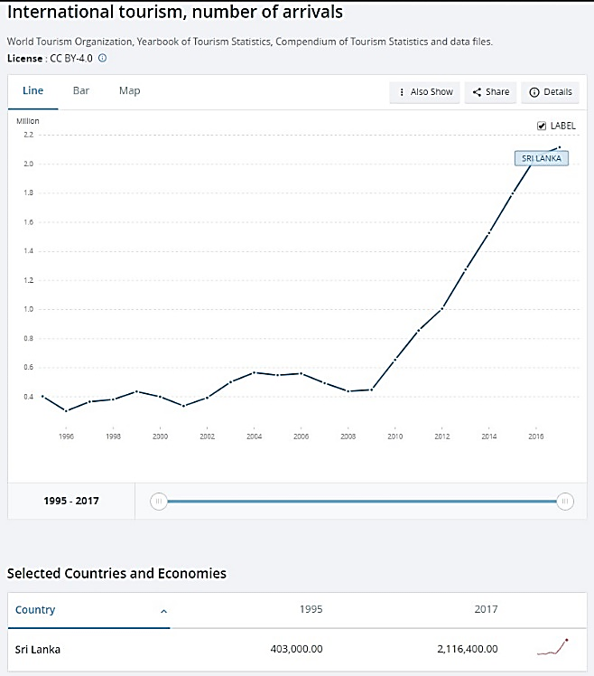

Figure 1 : International tourism by number of arrivals Sri Lanka [1]

## Background Context

In the research [6], the researchers have concluded that combining the tour guide with the trip planning tool could integrate pre-trip plan with during-trip planning and provide more personalized and relevant information during a trip. In addition, post-trip evaluation can be integrated into the system in which the users will be able to rank the different properties they have gone to. Future development can also include an interface for tourism enterprises to update their information daily even hourly (for example, a special deal for the day) to market toward visitors on the road or 100 or 200 yards around them. Location and map-based tourist information tools based on Google Map API opened many opportunities to enhance visitor experience as well as connecting visitors with tourism properties in destinations.

In the research [7], they have stated that in terms of software implementation, the MobiAR mobile application is an Android activity that encompasses the view of augmented reality, offering the user the ability to choose content in both 2D and 3D. The information about the POIs, received periodically from the server, is relative to the position of the user. The user’s position is discovered through the Global Positioning System (GPS) built into the terminal and the triangulation of phone masts. Considering context-based data and user profiles, the MobiAR application queries the content server for multimedia items that have been location-tagged (categorized by latitude, longitude and altitude data). When the appropriate contents are retrieved, the AR view is composed with the real-time images captured from the camera of the mobile device and the digital information (menus and POIs) overlaid. There are two possible modes to handle augmentation: 2D and 3D modes. The 2D mode shows multimedia content POIs enriching the real images captured by the camera. This mode is very suitable to discover interesting places nearby. The 3D mode has both the content and the user interface in 3D. Therefore, this mode is tailored to an enriched and leisure-oriented experience. All those POI representations would be completely static, if it was not due to information that is acquired through the sensors, namely the digital compass and the accelerometers. Thanks to those sensor readings, the information shown on the screen is dynamically positioned on the screen at the right coordinates.

Furthermore, they have gone on to describe similar applications like, Layar1, which is an Android and iPhone based mobile AR browser that was launched in 2009. Users can explore their physical surroundings, call up geo-tagged information from the web and superimpose it on the video captured by the camera of the device. The platform has an application programming interface that allows developers to contribute with different “layers” to the browser. Hundreds of new data layers are available to view on top of the camera viewer of the mobile device, from Wikipedia [8] entries when one is looking at geographic Points of Interest (POI) to real estate listings that are viewable when pointing at homes for sale. Acrossair [9] has a similar interaction with “layers” of content. The application is only available on the iPhone and those “layers” are close managed by Acrossair developers.

Wikitude 2 is an Android, iPhone and Symbian application launched originally on Android in the fall of 2008. It pulls information from Wikipedia and Qype, the European user-generated review service, and overlays that geo-located data onto the display. Version 3 of Wikitude is integrated with the proprietary user-generated geo-tagging application Wikitude.me. Users can create their own POIs and location-based, hyper-linked digital content that can be viewed through the Wikitude browser application.

They have gone on to give two further examples of more user-centric world browsers, which are Junaio3 [10] and Tag what. They allow users to tag and upload content from the physical world and to share and discover the content that other users have uploaded. Junaio provides information about POIs and the ability to add 3D animations and share the edited images via the usual social networking sites. Each user generated geo-tagged POI is then visible by all the other users.

In the research [11], the research was on a Tourist Guide application, called TOURIST GUIDEUSAL, has been developed as a multi-agent systems (MAS). With this system they wanted to show the feasibility and reliability of this technology, and that fully functional systems may be constructed within the time restrictions imposed by the industry. TOURIST GUIDE-USAL agents assist potential tourists in the organization of their tourist routes and enable them to modify their schedules on the move using wireless communication systems. This system has been constructed using an engineering framework developed to design and implement an agent-based tool, as well as integrating existing state of the art in order to create an open, flexible, global anticipatory system with mobile access for the promotion and management of inland and cultural tourism, which will be user-friendly, cost-effective and secure. The system has been standardized to run in any mobile device and is interlingua. The integrated, multi-platform computer system is composed of a guide agent (Planner Agent) that assesses the tourists and help them to identify tourist routes in a city with a given visiting period and under a number of restrictions related to cost, tourist interest, etc. There is one assistant agent for each user of the system, the Performer Agents. Each user willing to use the system must register and solicit one of these agents. Finally, there is a third type of agent, the Tracker agent, which maintains updated information about the monuments, the restaurants, public transport conditions, etc. This agent maintains horizontally and vertically compiled information on hotel accommodation, restaurants, the commercial sector and transport, in order to meet the needs of the potential visitor on an individually customized basis, and responds to requests for information, reservations and purchases in the precise moment that they are expressed.

By the research [12] on Intelligent Tourist Attractions System (ITAS) for tourist attractions the researchers have developed a decision support system for tourist attractions based on the EBM model (Decision-Making Model of Engel, Blackwell And Miniard (1995)). Bayesian network utilized to calculate the probability of tourist attraction of a place. The recommended routes and tourist attractions are presented by Google Maps and its accuracy validated by a ROC curve test.

This marks the importance for the prediction on best feasible routes and preserving it by acknowledgeable method. Here they have used EBM model, a decision-supporting model for user/consumer decision making process by predicting best route using the Bayesian probabilistic graphical model.

The research [13] done for the recommendation agent in TripAdvisor shows the importance of socially improved decision making on tourism or selecting site. They approached solution by machine learning algorithm CART Regression Trees [14] classification for their TripAdvisor dataset. Here they have approached with Classification and Regression Trees (CART) for their classification or regression predictive modelling problems. So, by analyzing online review in social network sites they have marked the importance of Data Mining applications for identifying whether their consumer preference is important. As their result they identified each consumer decision through a model and predicted the accurate hotel recommendation. Conclusion is that the analysis of social responses leads to best Tour travel recommendations.

In the research [15] on Text Summarization based on machine leaning, evaluates most of presently used techniques by Matej Gallo. Research starts by the Types of Summaries in Natural Language Processing. After he tests these techniques accuracy, he concludes that, Word Frequency Method yielded the most relevant sentences after summarization. So, as he identified more accurate way to summarize is Abstractive Text Summarization based on frequent patterns.

After reviewing most of the research articles on Text Summarization Techniques, it is concluded that presently applying techniques are mostly from Abstractive Text Summarization. This article [16] on Sequence2Sequence text summarization explains how they experienced the results in two different datasets with Encoder-Decoder RNN. And they end their research on Sequence-to-Sequence text summarization technique [16], concluding on planning to focus their efforts on [17] two different datasets and build more robust models for summaries consisting of multiple sentences.

Google Map API is a best cloud solution for background development, functionalities, map geocoding, route generation, place detail delivering and other features etc. It uses electronic devices GPS locations to show real-time location sensitive information for tourists. The development of this API is moved the tourist’s dreams higher satisfaction.

There are many Map API such as Google Maps, Bing Maps, MapQuest, OpenStreetMap, Here-WeGo, Apple Maps, Yandex Maps etc. most of the them have different types of features [18].

We are not just interested in the location but also other elements of the user's context, such as buildings in view, attractions and establishments nearby, such as Zoo, Temple etc. We are not just interested in the location but also other elements of the user's context, such as buildings in view, attractions and establishments [14] [15] nearby, such as Zoo, Temple etc. We are not just interested in the location but also other elements of the user's context, such as buildings in view, attractions and establishments nearby, such as Zoo, Temple etc.

Touch & Interact is an interaction technique which combines mobile phones and public displays [19] . When using private, public data and using audio outputs, video, touchable touch displays it is more resourceful to explore and test Touch & Interact in an environment with rich functionality.

All of details on this section summarized into the Table 1. Subjective comparison done for the features represented by each similar product. Each of the current research components are compared in here with a brief description on the feature.

## Research gap

### Gap in products similar to Intelligent Route Generation

|  |  |  |  |  |
| --- | --- | --- | --- | --- |
| **Features** |  |  |  | **සිංහලංකා AR** |
| Intelligent Trip routing (automatic route creation) |  |  |  |  |
| Trip editor (Add or update custom places) |  |  |  |  |
| Categorize locations  (monuments places, restaurant etc) |  |  |  |  |
| Map Filters |  |  |  |  |
| Shared user activity |  |  |  |  |
| Traffic management |  |  |  |  |
| Waypoint management |  |  |  |  |
| Collaborator management |  |  |  |  |

Table 1 : Intelligent route mapping

### Product similarities with Narrated Tour feature

This section elaborates on the component Narrated Tour Guidance and further elaborate on similar solutions seen through some commercialized products. It is an evident that one single problem related to the domain can have multiple solutions with different benefits or resources. The systems compared and contrasted in here are Roadtrippers [20], TourEazy [21], Tour Buddy [22], Sinhalanka AR and the proposed system TourGuru.

|  |  |  |  |  |  |
| --- | --- | --- | --- | --- | --- |
| Features | Existing Research/Product | | | | TourGuru |
| **Roadtrippers** | **Toureazy** | **Tour Buddy** | සිංහලංකා AR |
| Point of Interests narration alerts |  |  |  |  |  |
| Point of interest on-screen alerts |  |  |  |  |  |
| Proximate Point of Interests identification |  |  |  |  |  |
| Point of interest information querying |  |  |  |  |  |
| Background alerting |  |  |  |  |  |

Table 2 : Research Gap on Narrated Tour Guidance

### Research Gap with products similar to POI based AR view and also location-based and surface-based AR 3D object placement

There are so many tourist Apps in currently use, that have been developed in different aims. The main difference between TourGuru and already existing design is that TourGuru display a 3D figure a description using AR technology. In addition, the table (Table 3) below shows other differences.

|  |  |  |  |  |  |
| --- | --- | --- | --- | --- | --- |
| Features | TourGuru | Roadtrippers | Toureazy | Tour Buddy | සිංහලංකා AR |
| **Distance slider for radius adjusting (proximity alert and activation)** |  |  |  |  |  |
| **Identification location (using AR, historical places, ruins, etc )** |  |  |  |  |  |
| AR object model placement |  |  |  |  |  |
| Map Filters |  |  |  |  |  |
| Shared user activity |  |  |  |  |  |
| **Question and answer bot** |  |  |  |  |  |

Table 3 Research gap -POI based AR view

## Research Problem

This section describes on the identified research problem for the solution Implementation. In the tourism industry map-based routing, alert narrations and AR technology are identified fields on the application technologies. Here from a traveler’s perspective the problems they face when moving to unknown locations and providing interactive implementation is majorly considered.

Problems identified are guiding these people to places of interest that are not well known by providing AR content, there needs to be way for recommending user on a route with small attractions scattered around and giving proximity alerts on places of interest that they travel through.

## Research Objectives

### Research in Intelligent Route

The main objective is to implement cross platform mobile application that delivers a reliable route to the traveler.

* To implement interactive interface with the route and their waypoints.
* Generate nearby waypoints.
* To implement a machine learning model that processes POI as waypoints to generate a route.

In the route generating part, we must use Machine learning algorithm to generate best route through best waypoints in between source to destination.

### Research in POI based Narrated Tour

The main objective of the research is to address a solution that inform and alert a traveler, with real-time information on where they travel and what’s near them by a generated Narration. This isn’t implementation of a real guide agent but as a Voice Agent that supplies preprocessed and parameterized information through queried web or set of a local data.

Some of specific objectives that needs to be addressed while implementing the main objective are,

* To implement a cross-platform mobile application that delivers seamless experience in POI alerts.
* To provide real-time POI alerts based on geo-location data or web queried data.
* To implement keep the device awake or background alert feature.
* To query or feedback traveler’s data on geo-location.

### Research in POI based AR labeling

The main objective of this research is to display a label like 3D object over a certain geo-location. The label object will have details of that given location displayed on it. Also a way to answer any tour related questions automatically is being researched.

* Updating location information and display the information related location using AR technology.
* Answering questions related to the tour which are asked by the user.

### Research in location-based and surface-based AR 3D object placement

The main goal here is to create a system capable of placing a certain 3D object in a given location, whether it is on a surface or on a given location. And to get the data required through an external server.

* The first objective of this research would be to develop a way to detect a horizontal surface and place an 3D object on that surface within the camera view.
* A way should be developed to compress the texture and model files of an 3D object into one file and store it on a separate server.
* Develop a way to place existing 3D models on specific geo locations that would give the illusion of an actual building being there on a given coordinate.

# Methodology

## Addressing the Literature

As the given high-level architecture diagram in Figure 2, discussing system will have an implementation at its core with map based intelligent route solution, real time POI alerting narrated tour, POI based AR labeling and AR 3D Object placement in aspect of the travel. System operates through processing set of POIs that queried through cloud solutions and presenting them to the user in an interactive and attractive manner. First, set of waypoints will be generated according to user’s destination and a route suggested. The narrated tour will be activated upon user’s choice or on-travel at vicinity to POIs. As the high-level architecture diagram illustrates, POIs will be requested trough GCP’s Places API. Then through Google AutoML Machine Learning Engine, POIs processed data used to create waypoints for the route and summarizes POI detail for on-travel narration through a corresponding machine learning model. AR based labeling will be done for the processed POIs data through a Unity based solution to Geo Position a set of markers with labels on each POI location in a vicinity. Location and surface based AR 3D object placement will deliver user with an attractive 3D representation of some specific POIs through retrieval of the object model from an external database, surface detection and geo position the 3D model. Backend as a Service provided though Firebase Functions to integrate the methods that invokes services on endpoints.

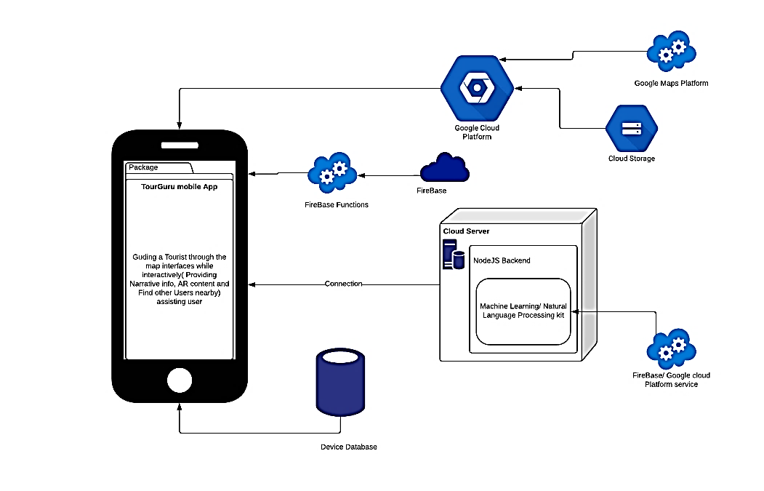

Figure 2 : Architecture Diagram

## Methodology

### Technologies Applied

* + Route Generation component Technologies

Out of most technologies we used flutter dart language, and Google technologies.

* + - * Using android studio
      * Flutter Framework for delivery of the information to the traveler in a native mobile app.
      * Google Maps Platform used as Direction API, Places API.
      * Cloud Computing Engine of Google Cloud Platform(GCP) used as an IaaS (Infrastructure as a Service) for running machine learning models.
  + Narration POI alerting Technologies

Selection on feasible technologies started with the review on literature survey.

* + - * Flutter Framework for delivery of the information in a native mobile app.
      * Google Maps Platform used as SaaS (Software as a Service) for querying location-based information.
      * Cloud Computing Engine of Google Cloud Platform used as an IaaS (Infrastructure as a Service) for running machine learning models.
  + AR Technologies

The first order of business was selecting technologies,

* Unity 3D
* Vuforia engine
* AR core

These powerful tools contain almost all the functions we would need to work on this research.

### Intelligent Route

* Data Gathering

At the first step, the process on the system development proceeds with sample of data. With the real-time proximity alerting with an audio description to inform the tourist on nearby location details can help user to reduce screen time and avoid missing on details. The data that needed for the audio description is textual information queried from a RESTful HTTP request from Wikipedia as a JSON object. Returned JSON [23] object contains description on POI in a few sentences.

### POI based Narrated Tour

This system is proposed to be a cross-platform mobile application which will be delivered through the Mobile Application Development Lifecycle.

The mobile application will connect to cloud services and access its deployed backend. Mobile application will be deployed with offline functionality that exclude some services related to the server (lost access to server connected database, unable to connect proximity travelers etc.). Upon such occasions app may activate its internal database to access information.

When nearby attractions are identified our target is to supply user with a narration on its information. Crowdsourcing will be done to get regular updates to our own database which contains user updated locations information.

To validate these narrative paragraphs, the app will use Natural Language Processing to get meaningful contents and formed as short narrative sentences without missing key points.

Following Data gathering, Data preprocessing and cleaning, Application of Research Method will further elaborate on this methodology.

1. Data Gathering

Primary data used to generate a summarized narration for the related POI and present to user. To implement a more attractive solution web scraping used for grabbing a media/web article link of the related POI from the web.

At the first step, the process on the system development proceeds with sample of data. With the real-time proximity alerting with an audio description to inform the tourist on nearby location details can help user to reduce screen time and avoid missing on details. The data that needed for the audio description is textual information queried from a RESTful HTTP request from Wikipedia as a JSON object. Returned JSON object contains description on POI in a few sentences. Primary data used to generate a summarized narration for the related POI and present to user. To implement a more attractive solution web scraping used for grabbing a media/web article link of the related POI from the web. When nearby POI’s and place details are taken from previous component with the Intent of generating a more descriptive alerting that focusses on the travel. This secondary data may be used in generating a sentence to narrate or alerting with user interface elements.

1. Data Preprocessing and Cleaning

Datasets gathered as JSON representations are concatenated and are converted to CSV (Comma-separated values) format for the application of intelligent route generation. This processing helps for the applying data on research method discussed in next section. Processed data in the CSV format may contain ‘null’ valued fields, incorrect data representations for a column or URL encoded values. Data cleaning will be done for them on CSV data by removing rows with ‘null’ values, conversion of data types and decode URL values.

For the POI based Narrated Tour Guidance it is necessary to process the JSON data and convert into CSV format to be applied into the research method. JSON objects that taken from Google Places API, Google Directions API are processed for only their important data and created a single JSON representation from them. Wikipedia queried paragraph and web scraped DOM elements textual data and media links are added to that JSON objects afterwards. Data cleaning applied after processing JSON object and converting into CSV format. Data cleaning checks for null values, incorrect representation of data, encoded URL values in media links and checks for scraped texts whether has other DOM elements/HTML tags.

1. Applying Research Method

Natural Language Processing is needed for the analysis on the processed dataset on POI based Narrated Tour Guidance component. Implementing model will have the functionality to summarize the Wikipedia queried text and evaluation on speech time on the travel. When system generates its route on the POI’s the system will automatically initiates the generation on dataset and begins the execution on the deep learning model. This model will consist with encoder, decode [24] each with either LSTM (Long short-term memory) or GRU (Gated Recurrent Units) or vanilla RNN (Recurrent Neural Network) cells. Encoder vector will encapsulate the information for all input elements. Decoder vector each recurrent unit accepts a hidden state from the previous unit and produces and output as well as its own hidden state. Output from the model presented to user at the end of process of returning JSON object to the system with POI coordinates and alerting the user on mobile interface with the audio description. The model resides on AutoML [25] compute engine.

### POI based AR labeling

1. Data Gathering and Generation

At the first step, the process on the system development proceeds with sample of data. Data gathering or generation techniques are discussed in here for the research objective POI representation on AR.

Implementing a system that consists with AR components of the POI’s locations in AR can help user on identification on the places if he is lost and can get more description on travel. First component that consists AR guidance focusses on providing user with a nearby POI’s labeling with the help of gathered data from Google cloud platform Places API and through web scraping to query for the related information. Prebuilt POI label object model is used in AR component. Label will be generated as primary data for these AR based research components.

1. Data Processing and Cleaning

After the first step, processing and cleaning on the data starts to apply them into the research methods. Data processing or cleaning techniques are discussed in here for the research objective POI representation on AR.

Data processing and cleaning done for the AR component on presenting POI’s description on label model. JSON object response from Google Places API is processed for geo-coordinates and related location names. This object has an array of POI locations and each of them will be processed for name, geometry and rating by excluding other parameters. Location name used for web scraping textual data and processed with the JSON object. Data gathered through web scraping must be verified for to remove unnecessary DOM elements and extract only the textual information from them.

1. Application of Research Method

AR component on presenting POI’s description on label model performs by positioning a label object in each of location elements in the processed data. POI location element geo-coordinate distance, angle/radius, altitude calculated, and the label positioned in virtual world of the camera view with these metrics. For each element in the JSON object array there will be an object label positioned using the metrics mentioned when distance is equal to an expected vicinity. This label positioned as when the traveler’s current location changed and regularly check whether POI at the vicinity or not.

For our system, Figure 2 will be useful at the system planning phases helping partners in understanding the architecture, discussing changes and communicating intentions clearly.

### Location-based and surface-based AR 3D object placement

* Technologies

The first order of business was selecting technologies,

* + Unity 3D
  + Vuforia engine
  + AR core

These powerful tools contain almost all the functions we would need to work on this research.

* Detecting a surface

Once the camera is pointed at the surface the camera detects the edges, the textures and tries to figure out if the shown surface is horizontal or not. There are image recognition models available pre trained to identify flat surfaces in both AR core and Vuforia engine. With these technologies we can project a map of dot mesh on to the surfaces and then objects can be placed on those meshes (shown in Figure2). The mesh would be useful for the tracking on the surface. This would make the surface tracking much better and the 3D model is less likely to jitter using this method. If the dot mesh proves to be too distracting, we can also use the surface texture itself for the purpose of tracking. It would require the camera to detect certain features of the surface and use those as a reference for tracking. The likeliness of jittering is increased on this scenario but its less distracting in the user interface.

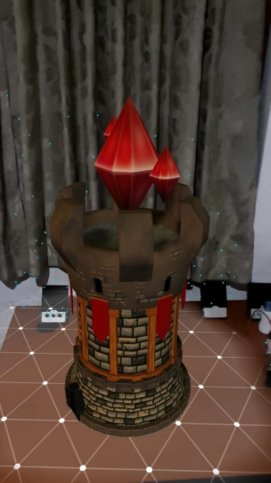

Figure 3 : AR POI Object

* Storage and retrieval of 3D models

In order to display these 3D models, we must store them somewhere. Storing them locally is an easy option but it can lead to the app being too large if the scale of the app gets bigger, which might discourage users from using it.

There are multiple files that belongs to a 3D asset. For the ease of usage, we compress all those files into one file called an asset bundle as we finish creating a new model. Therefore, even if the asset is not stored locally, we can stream it back into the 3D scene whenever we require it to. The temporary file can be deleted afterwards to save space in the storage device. These asset bundles can be stored in an external server like a cloud and with an internet connection they can be retrieved.

* Placing a 3D object on a given set of coordinates

There are multiple ways to achieve this. By using an API called Wikitude we can place AR objects directly on a geo location. But there are limitations for its usage, and it is a paid API. Instead we came up with a different solution.

First, we need to create a scale between the real world and the AR environment to find out how much distance is represented by a unit in the AR world. This can be found by a simple trial and error method. Once we have acquired the scale we move to the next step.

In this step we can retrieve the geo coordinates of a location by accessing the google places libraries Jason objects. A JSON object of a location includes its longitudes and latitudes. We can use the user’s current location and calculate the distance and the direction of that location. Then using the scale that we created we can place the 3D object in the AR environment by changing object distance from the AR camera within Unity, giving the user the perception that we have placed an object at a geo coordinate.

## Commercialization aspects of the product

As a mobile app implemented for a domain problem the commercialization is feasible with various technologies. Deployment will be done for the TourGuru in each mobile platform app store. Also, Backend services delivered through Firebase cloud functions and Google Cloud Platform’s (Platform as a Service) services. Final product will be available on app repositories and advertised with the logo in Figure 4.



Figure 4 : Product Logo

## Testing & Implementation

Figure 5 : Google Cloud Platform averall SaaS statistics

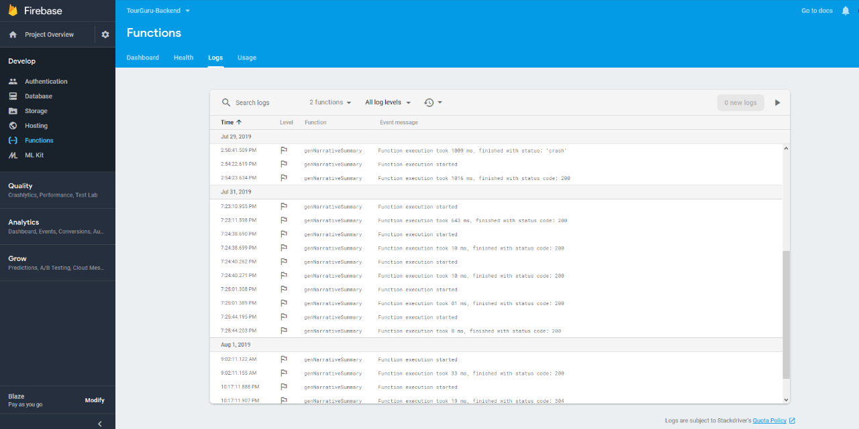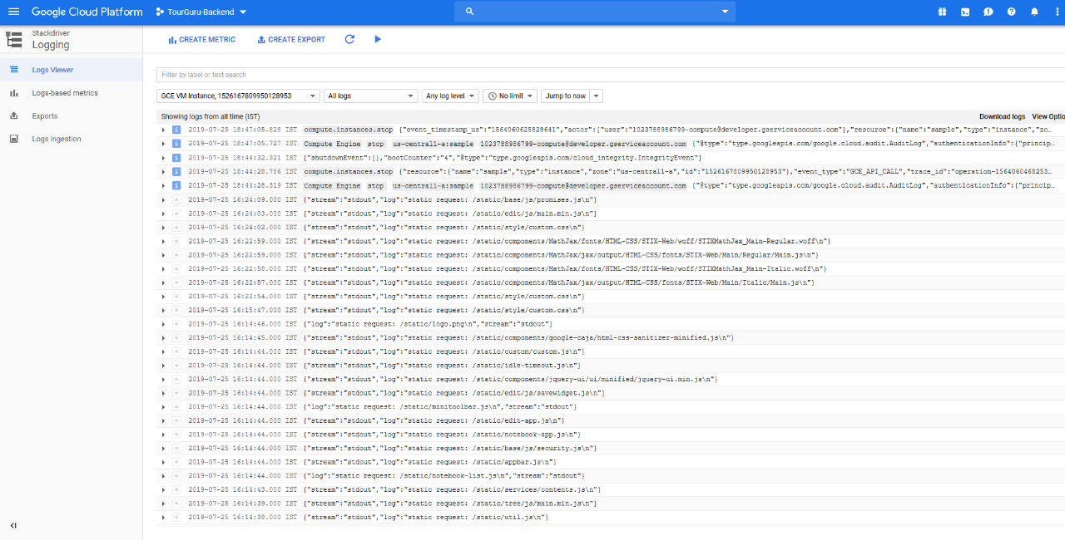

Figure 6 : Log of Firebase Functions invocations

Figure 7 : An log of invocations of deployed models and SaaS Services on GCP

# Results & Discussion

## Results

### Intelligent Routing

This section represents the results obtained for the solution implemented and discusses on feasibility on both technical and economic aspects and the marketability of the implementation. Figure 1 and 2, This represents a user interface that resulted from the methodology of intelligent route generation. Figure 3, Shows nearby locations using google directions API.

Figure 8: A generated route of Intelligent Route Generation component

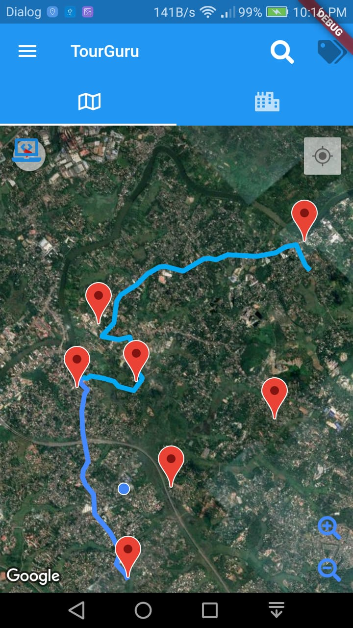

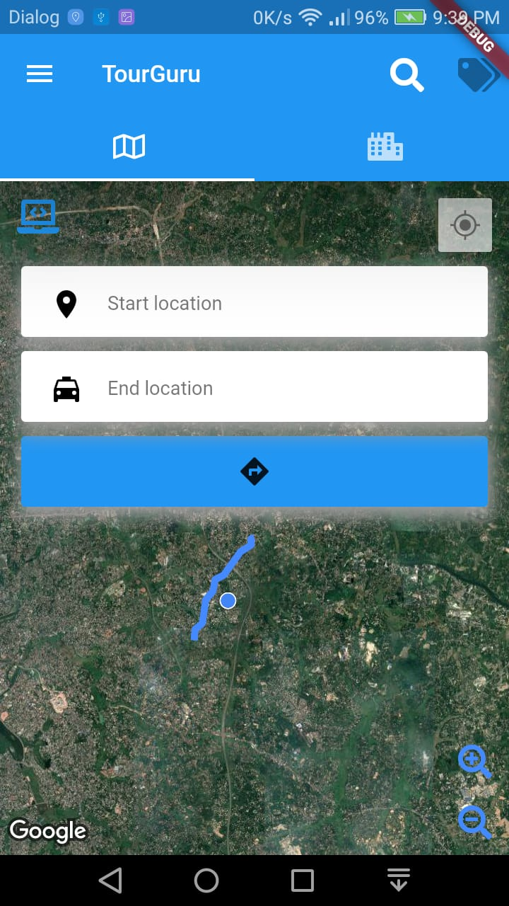

Figure 9 : Search Mode of the component

Figure 10: Showing nearby locations

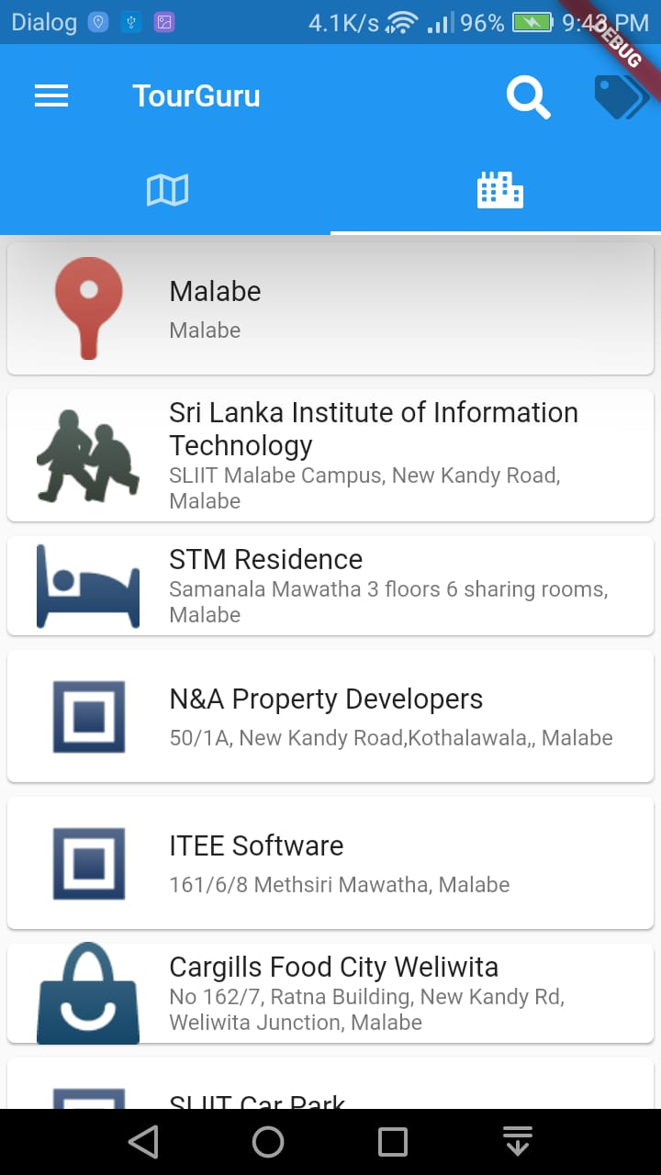

### POI based Narrated Tour

This section of the paper presents the results obtained from the system and discusses on the solution. First result that discussed is on the mobile interface that delivers the configuration methods for the component.

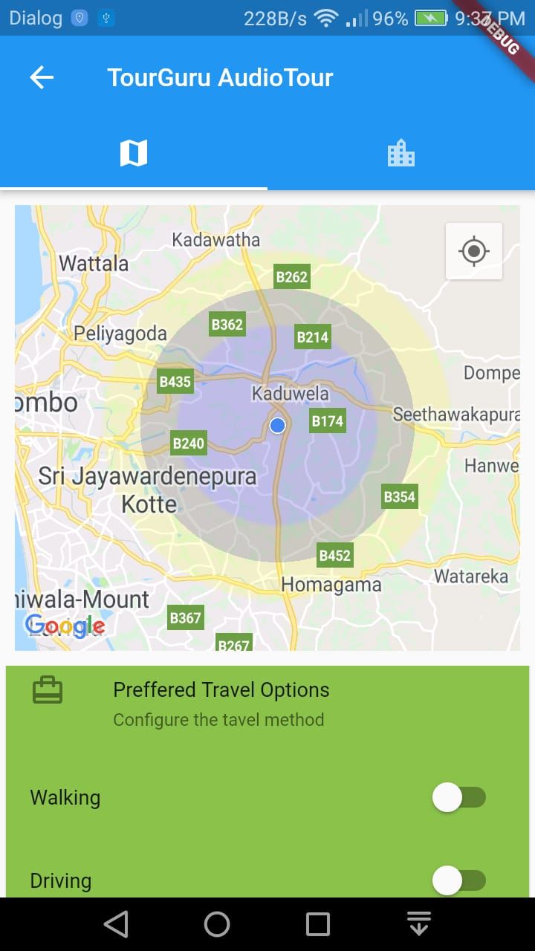

Figure 11 : Proximate voice alert activation configuration on

Narrated Tour Guidance

Figure 10 discusses on the interface where traveler has the option to choose travel option and state whether app keeps awake while the alerting component activated. This is and tabbed interface that can test pretest the audio configuration on the other side.

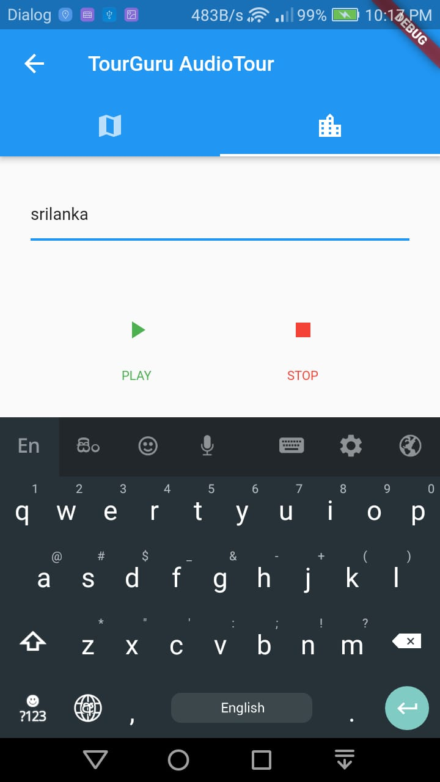

Figure 12 : Test audio configuration and apply a configuration

Figure 11, is the interface where user can set whether audio alert component is activated. If it is disabled user is only able to get on-screen alerts and notifications on nearby POIs.

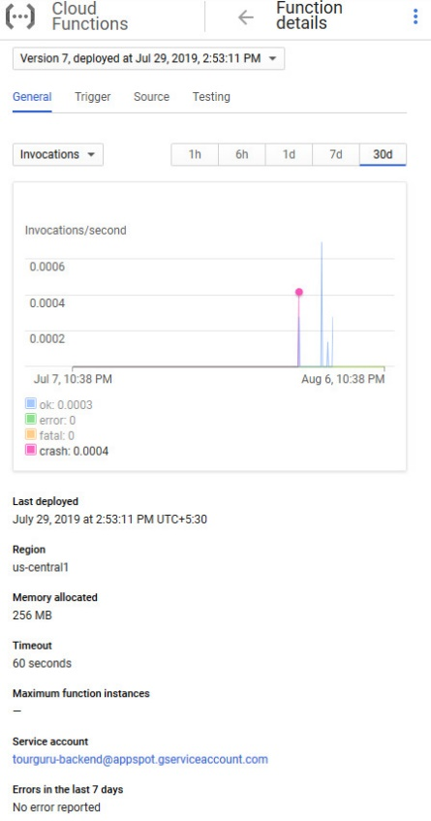

Figure 13 : Google Cloud Function applied AutoML models invocation statistics

Figure 12, discusses on the statistics of invocation details on the cloud computing deployed machine learning model. Here it says that the model invoked five times and the first invocation crashed due to an error. Each error can be tested upon invocation due to real-time logging and reporting available in the Cloud Functions module.

### POI based AR Labeling

UserInterface.

This is main interface of AR components. Using flutter.

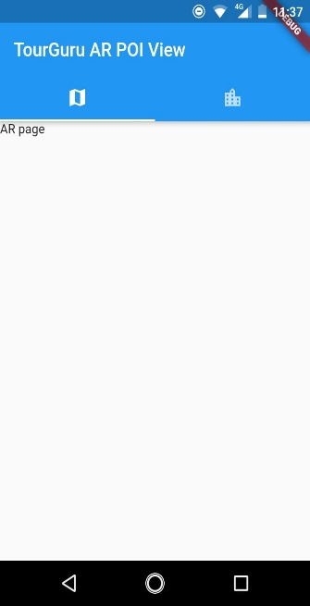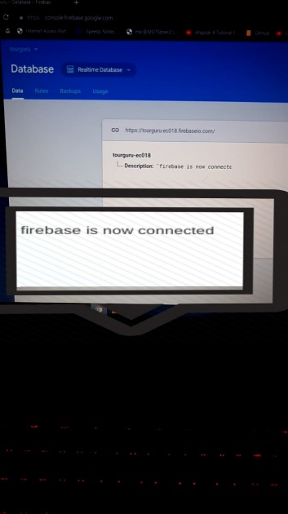

Figure 14 :Geo positioned location identifier label object on AR Component

Fig: 8 Main interfaces of AR

Geo positioned location identifier label object on AR Component. Using unity and firebase.

## Research Findings

## Discussion

# Conclusion

In the world of tourism, TourGuru mobile app will be a fast, reliable tourist guide application for tourists without any delay. This research paper proposes a practically useful solution called, TourGuru app to overcome this widely faced problem. The Basic Navigation part helps user to navigate through various tourist attractions without any hassle with the help of google API’s. Then narration with detailed description is showed, when they started to travel. Next AR POI and AR Labeling helps us to navigate with AR functionality. Overall, this app serves as an easy, reliable and useful navigation application.

In future works, the overall TourGuru system can be tested and validated with actual users and based on the data crowdsourced by user reviews for better user-friendliness and accuracy. Furthermore, various other parameters to provide personalized experience to the app can be explored.

# References

|  |  |
| --- | --- |
| [1] | "International tourism, number of arrivals | Data," [Online]. Available: https://data.worldbank.org/indicator/ST.INT.ARVL?locations=LK. |
| [2] | "International Endorsements," 2019. [Online]. Available: https://www.srilanka.travel/international-endorsements#endorsement. |
| [3] | "Best Islands to Visit: World's Best 2019 | Travel + Leisure," 2019. [Online]. Available: https://www.travelandleisure.com/worlds-best/islands. |
| [4] | "Travel Blog," [Online]. Available: https://www.srilanka.travel/travel_blog. |
| [5] | "Sri Lanka Tourism News," 2019. [Online]. Available: https://www.srilanka.travel/travel-news. |
| [6] | B. Pan, J. C. Crotts and B. Muller, "Developing Web-Based Tourist Information Tools Using Google Map," in *Information and Communication Technologies in Tourism 2007*, Vienna, Springer Vienna, pp. 503-512. |
| [7] | "(PDF) MobiAR: Tourist Experiences through Mobile Augmented Reality," 2010. |
| [8] | "Wikipedia, the free encyclopedia," [Online]. Available: https://en.wikipedia.org/wiki/Main_Page. |
| [9] | "acrossair - Nearest Tube Augmented Reality Tube Finder," 2019. [Online]. Available: https://www.acrossair.com/. |
| [10] | "Junaio," 2017. |
| [11] | J. M. Corchado, J. Pavón, E. S. Corchado and L. F. Castillo, "Development of CBR-BDI Agents: A Tourist Guide Application," 2004, pp. 547-559. |
| [12] | F.-M. Hsu, Y.-T. Lin and T.-K. Ho, "Design and implementation of an intelligent recommendation system for tourist attractions: The integration of EBM model, Bayesian network and Google Maps," *Expert Systems with Applications,* vol. 39, no. 3, pp. 3257-3264, 2 2012. |
| [13] | M. Nilashi, O. Ibrahim, E. Yadegaridehkordi, S. Samad, E. Akbari and A. Alizadeh, "Travelers decision making using online review in social network sites: A case on TripAdvisor," *Journal of Computational Science,* vol. 28, pp. 168-179, 9 2018. |
| [14] | Jake Morgan, Classification and Regression Tree Analysis, 2014. |
| [15] | Matej Gallo, Text Summarization byMachine Learning, 2016. |
| [16] | R. Nallapati, B. Zhou, C. dos Santos, C. Gulcehre and B. Xiang, "Abstractive Text Summarization using Sequence-to-sequence RNNs and Beyond," in *Proceedings of The 20th SIGNLL Conference on Computational Natural Language Learning*, Stroudsburg, PA, USA, 2016. |
| [17] | Xin Pan Peter Liu, "models/research/textsum at master · tensorflow/models · GitHub," 2018. [Online]. Available: https://github.com/tensorflow/models/tree/master/research/textsum. |
| [18] | "Comparison of web map services," 2018. [Online]. Available: https://en.wikipedia.org/wiki/Comparison_of_web_map_services. |
| [19] | R. Hardy and E. Rukzio, "Touch &amp; Interact," in *Proceedings of the 10th international conference on Human computer interaction with mobile devices and services - MobileHCI '08*, New York, New York, USA, 2008. |
| [20] | "Roadtrippers | Plan your journey, find amazing places, and take fascinating detours with the world's #1 roadtrip planning platform," [Online]. Available: https://roadtrippers.com/. |
| [21] | "Toureazy | An Augmented Reality Based Travel App," [Online]. Available: https://www.toureazy.com/. |
| [22] | "Home - Tour Buddy Apps," [Online]. Available: https://www.tourappbuilder.com/. |
| [23] | Douglas Crockford, "JSON," [Online]. Available: https://json.org/. |
| [24] | Simeon Kostadinov, "Understanding Encoder-Decoder Sequence to Sequence Model," 2019. [Online]. Available: https://towardsdatascience.com/understanding-encoder-decoder-sequence-to-sequence-model-679e04af4346. |
| [25] | "Cloud AutoML - Custom Machine Learning Models  |  Google Cloud," 2019. [Online]. Available: https://cloud.google.com/automl/. |
| [26] | "How to Make a Text Summarizer - Intro to Deep Learning #10 - YouTube," [Online]. Available: https://www.youtube.com/watch?v=ogrJaOIuBx4. |
| [27] | N. Davies, K. Cheverst, K. Mitchell and A. Efrat, "Using and determining location in a context-sensitive tour guide," *Computer,* vol. 34, no. 8, pp. 35-41, 2001. |
| [28] | G. D. Abowd, C. G. Atkeson, J. Hong, S. Long, R. Kooper and M. Pinkerton, "Cyberguide: A mobile context‐aware tour guide," *Wireless Networks,* vol. 3, no. 5, pp. 421-433, 1997. |
| [29] | K. Cheverst, N. Davies, K. Mitchell and A. Friday, "Experiences of developing and deploying a context-aware tourist guide," in *Proceedings of the 6th annual international conference on Mobile computing and networking - MobiCom '00*, New York, New York, USA, 2000. |
| [30] | Z. Yu, H. Xu, Z. Yang and B. Guo, "Personalized Travel Package With Multi-Point-of-Interest Recommendation Based on Crowdsourced User Footprints," *IEEE Transactions on Human-Machine Systems,* vol. 46, no. 1, pp. 151-158, 2 2016. |
| [31] | S. A. Salloum, M. Al-Emran, A. A. Monem and K. Shaalan, "Using Text Mining Techniques for Extracting Information from Research Articles," 2018, pp. 373-397. |
| [32] | M. P. U. Sabina Yeasmin,Priyanka Basak Tumpa,Adiba Mahjabin Nitu and M. I. A. Emran Ali, "(PDF) Study of Abstractive Text Summarization Techniques," 2017. [Online]. Available: https://www.researchgate.net/publication/324438138_Study_of_Abstractive_Text_Summarization_Techniques. |
| [33] | S. A. RÍOS and J. D. VELÁSQUEZ, "FINDING REPRESENTATIVE WEB PAGES BASED ON A SOM AND A REVERSE CLUSTER ANALYSIS," *International Journal on Artificial Intelligence Tools,* vol. 20, no. 01, pp. 93-118, 30 2 2011. |
| [34] | B. Parhizkar, A. A. M. Al-Modwahi, A. H. Lashkari, M. M. Bartaripou and H. R. Babae, "A Survey on Web-based AR Applications," 13 11 2011. |
| [35] | J. L. Neto, A. A. Freitas and C. A. A. Kaestner, "Automatic Text Summarization Using a Machine Learning Approach," 2002, pp. 205-215. |
| [36] | N. K. Nagwani, "Summarizing large text collection using topic modeling and clustering based on MapReduce framework," *Journal of Big Data,* vol. 2, no. 1, p. 6, 26 12 2015. |
| [37] | Dr. Michael J. Garbade, "A Quick Introduction to Text Summarization in Machine Learning," 2018. [Online]. Available: https://towardsdatascience.com/a-quick-introduction-to-text-summarization-in-machine-learning-3d27ccf18a9f. |
| [38] | E.-H. Chung and A. Shalaby, "A Trip Reconstruction Tool for GPS-based Personal Travel Surveys," *Transportation Planning and Technology,* vol. 28, no. 5, pp. 381-401, 10 2005. |
| [39] | Y.-Y. Chen, A.-J. Cheng and W. H. Hsu, "Travel Recommendation by Mining People Attributes and Travel Group Types From Community-Contributed Photos," *IEEE Transactions on Multimedia,* vol. 15, no. 6, pp. 1283-1295, 10 2013. |
| [40] | A. Candido Junior, C. Magalhães, H. Caseli and R. Zangirolami, "Topic Modeling for Keyword Extraction: using Natural Language Processing methods for keyword extraction in Portal Min@s," *REVISTA DE ESTUDOS DA LINGUAGEM,* vol. 23, no. 3, p. 695, 22 12 2015. |
| [41] | "Telephone directory of businesses," [Online]. Available: https://www.yellowpages.com. |
| [42] | "NLP vs NLU vs NLG (Know what you are trying to achieve) NLP engine (Part-1)," [Online]. Available: https://towardsdatascience.com/nlp-vs-nlu-vs-nlg-know-what-you-are-trying-to-achieve-nlp-engine-part-1-1487a2c8b696. |
| [43] | "AUGMENTED REALITY IEEE PAPER 2018," [Online]. Available: https://www.engpaper.com/augmented-reality-2018.htm. |

# Appendices

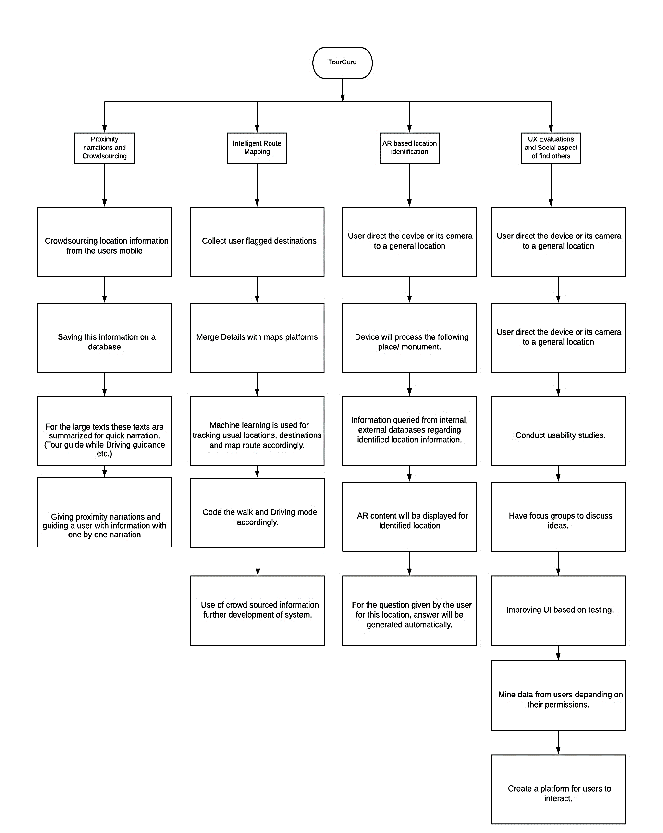

Figure 15 : Work Breakdown Chart

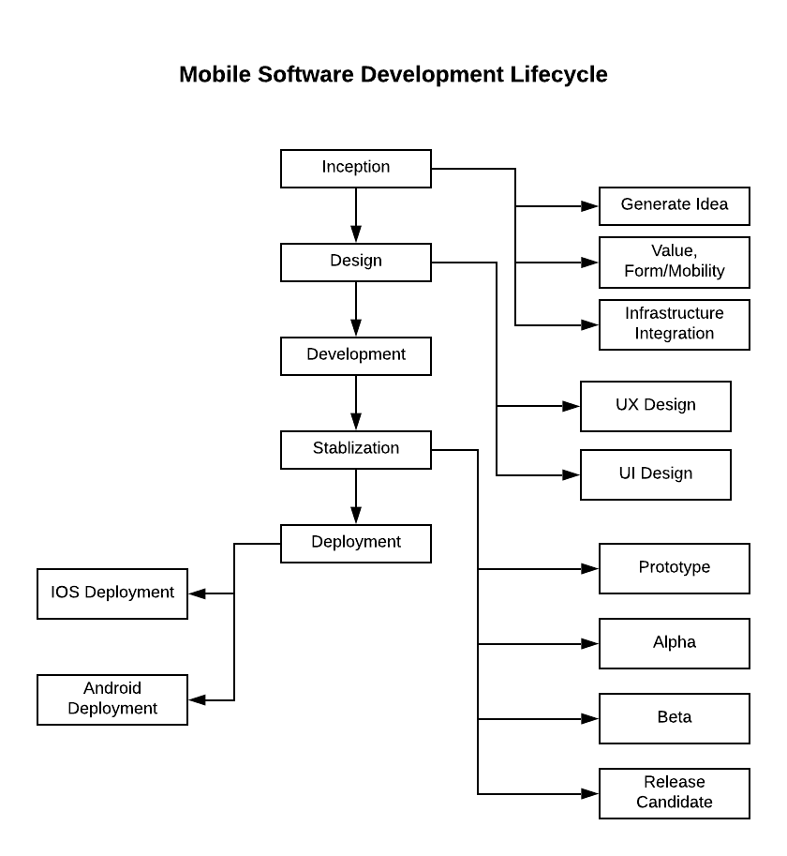

Figure 16 : Development Life Cycle

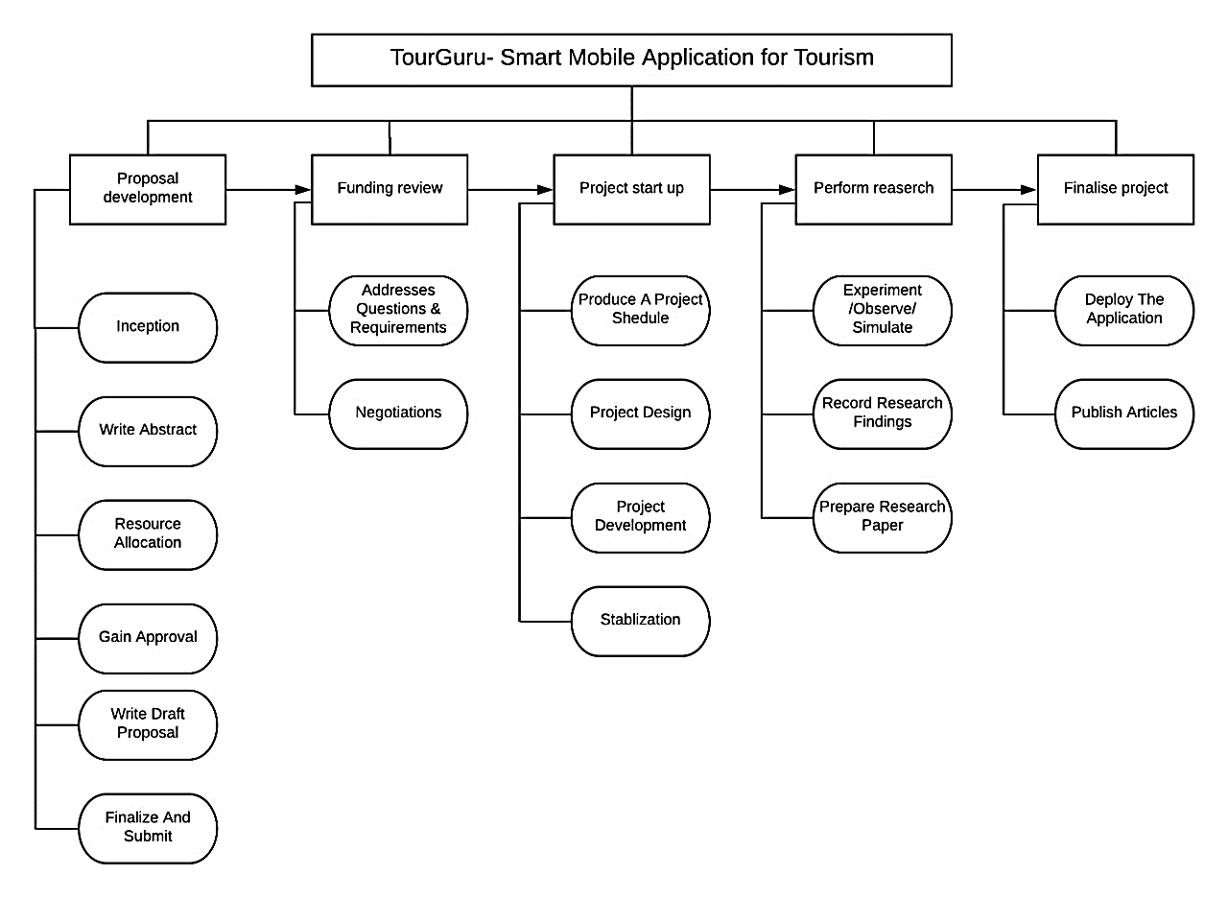

Figure 17 : Project Life Cycle